Supporting Information
A self-deliverable H₂O₂-responsive tocopherol dimer for enhanced antioxidant and liposomal delivery
Hanui Jo ª, Ayoung Kim ^{b}, Changhee Park ^{b}, Soyoon Baek ^{b,c}, Inki Hong ^{b}, , Kim Mingi ^{d}, Dongwon Lee ^{a,e,}*
ª Department of Bionanotechnology and Bioconvergence Engineering, Jeonbuk National University, Jeonju, Jeonbuk 54896, Korea
^{b} R&D Complex, Kolmar Korea, 61, 8-gil, Heolleungro, Seochogu, Seoul 06800, Korea
^{c} Department of Cosmetics Engineering, Konkuk University, 120 Neungdongro, Gwangjingu, Seoul 05029, Korea
^{d} Business Development Division, ICBIO, Naeyuri 1-gil 1, Ipjangmyeon, Seobuku, Chunan, Chungnam, 31027, Korea
^{e} Department of Polymer⋅Nano Science and Technology, Jeonbuk National University, Jeonju, Jeonbuk 54896, Korea
Corresponding author: Dongwon Lee (dlee@chonbuk.ac.kr)

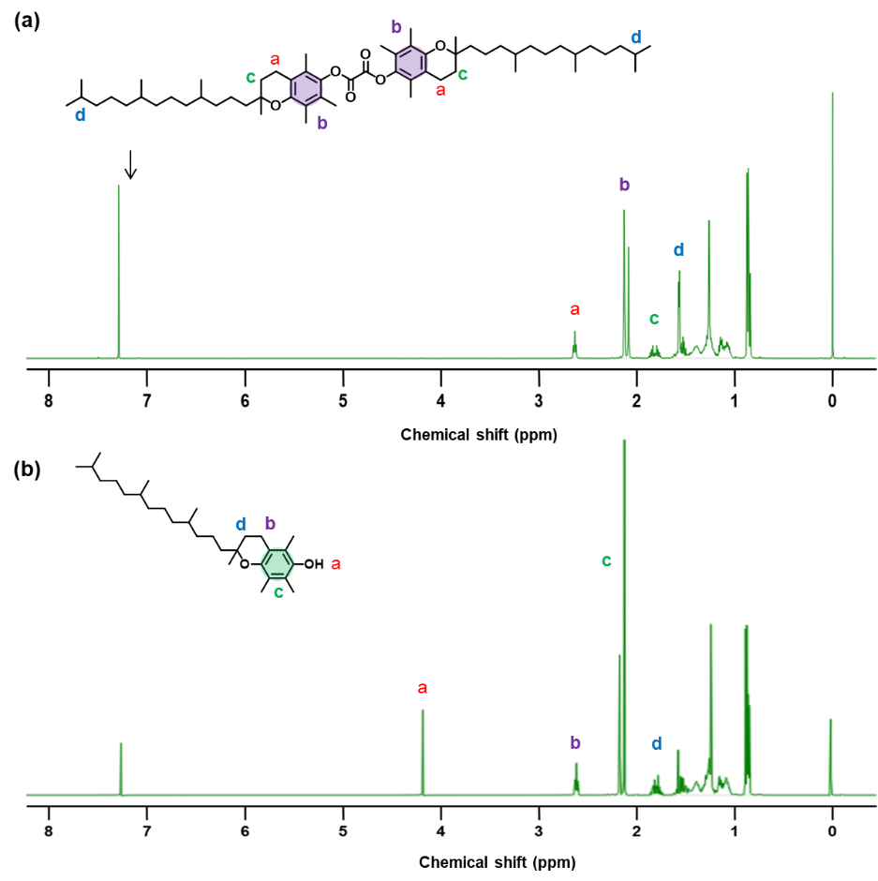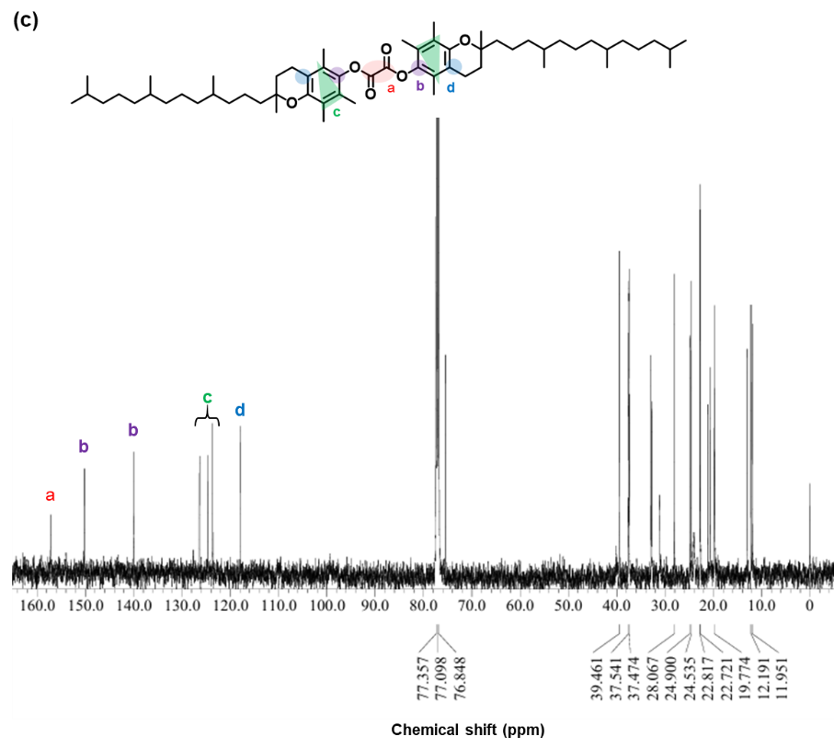
Figure S1. Characterization of TOT. (a) ¹H⁻NMR spectroscopy of tocopherol derivative TOT in CDCl₃. (b) ¹H⁻NMR spectroscopy of tocopherol derivative TCP in CDCl.

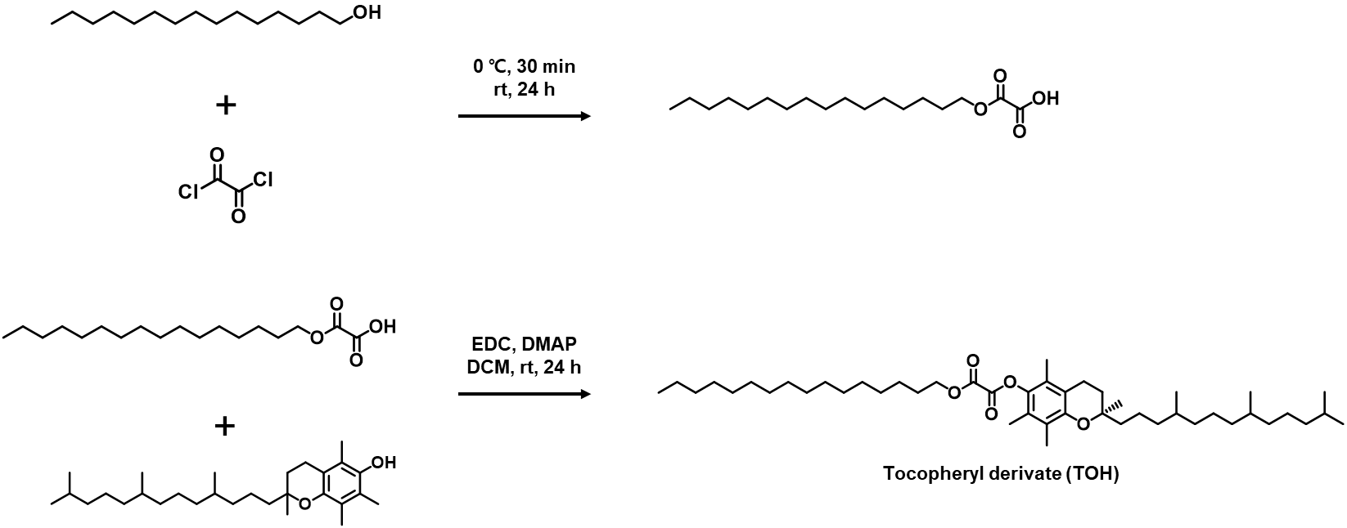
Figure S2. Synthetic route of TOH.

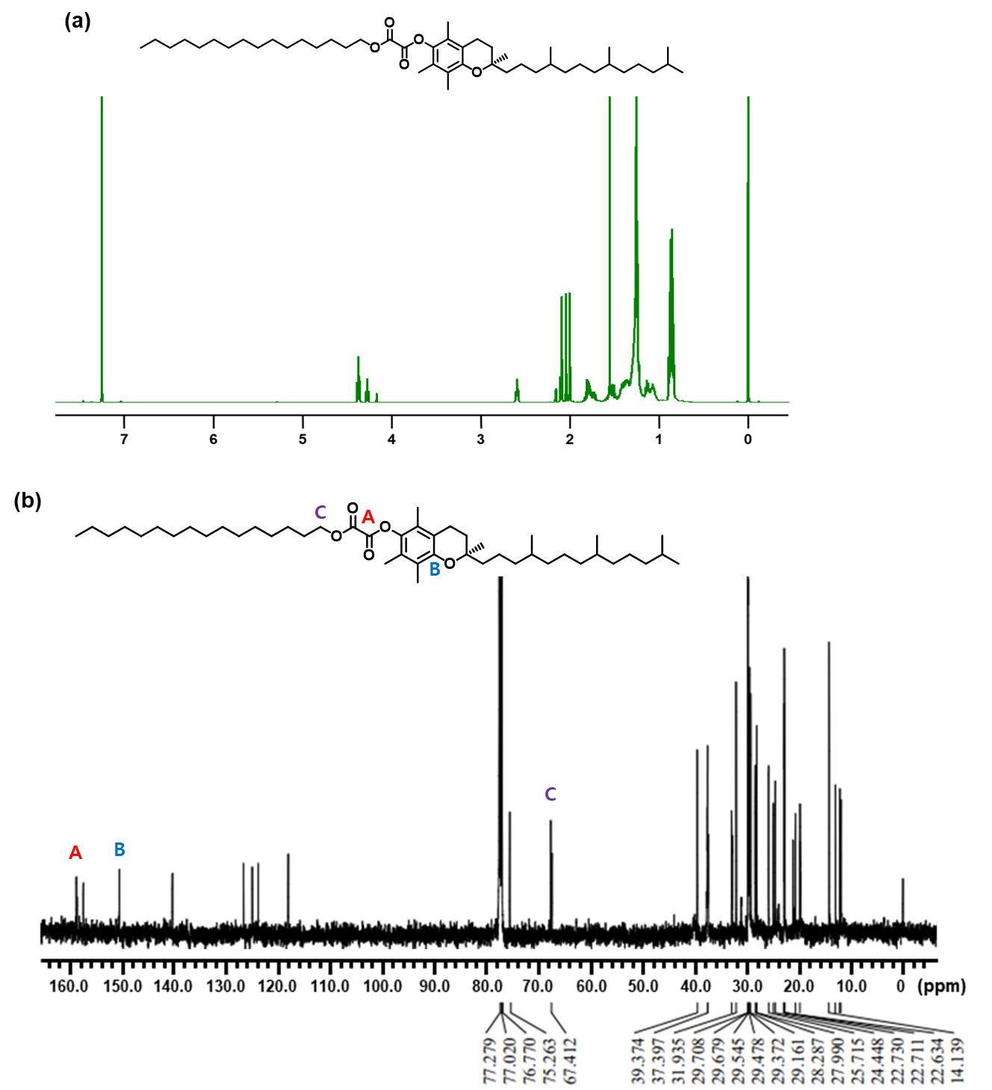
Figure S3. Characterization of TOH. (a) ¹H⁻NMR spectroscopy of tocopherol derivative TOT in CDCl₃. (b) ¹H⁻NMR spectroscopy of tocopherol derivative TCP in CDCl₃.

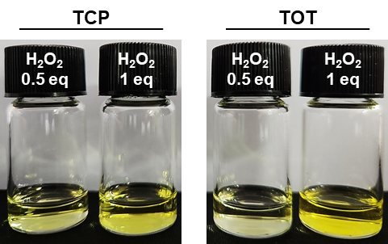
Figure S4. Photographs of TCT and TOT after H₂O₂ treatment.

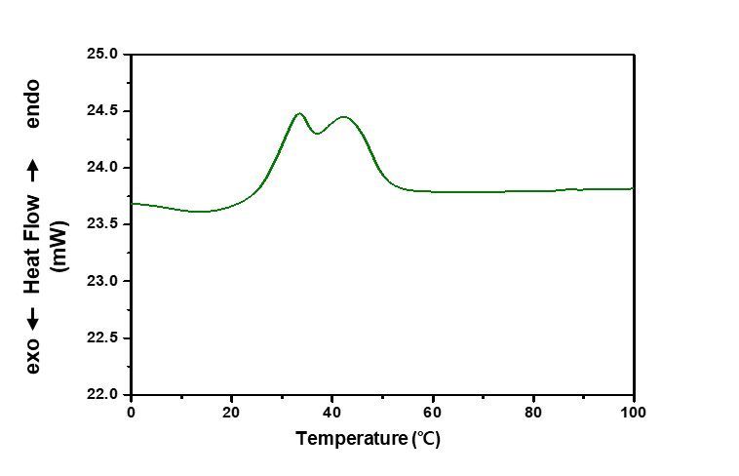
Figure S5. DSC thermogram of TOT.

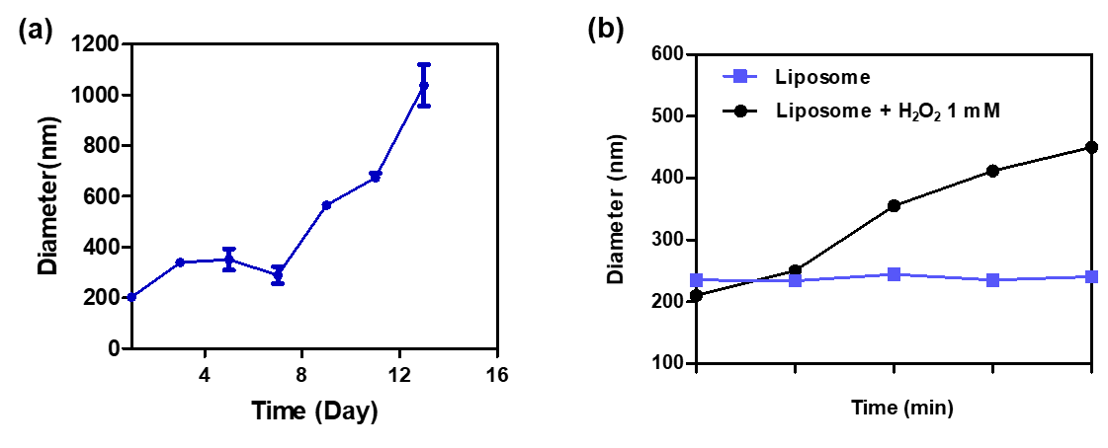
Figure S6. Change of hydrodynamic diameter of TOH-containing liposomes. (a) Changes in diameter with time. (b) Change in diameter of liposomes in the presence and absence of H₂O₂.

