Tuning the Structural Isomers of Phenylenediammonium Cations to Afford Efficient and Stable Perovskite Solar Cells and Modules
Cheng Liu,†^{1,2} Yi Yang,†^{1,2} Kasparas Rakstys,*³ Arup Mahata,⁴ Marius Franckevicius,⁵ Edoardo Mosconi,⁶ Raminta Skackauskaite,³ Bin Ding,² Onovbaramwen Jennifer Usiobo,⁷ Jean-Nicolas Audinot,⁷ Hiroyuki Kanda,² Simonas Driukas,⁵ Gabriele Kavaliauskaite,⁵ Vidmantas Gulbinas,⁵ Marc Dessimoz,² Vytautas Getautis,³ Filippo De Angelis,^{4,8,9} Yong Ding,*^{1,2} Songyuan Dai,*¹ Paul J. Dyson,*² Mohammad Khaja Nazeeruddin*^{2,10}

†These authors contributed equally to this work.

Materials
Chemicals required for the synthesis were purchased from Sigma-Aldrich and TCI Europe and used as received without additional purification. ¹H NMR spectra were recorded at 400 MHz on a Bruker Avance III spectrometer with a 5 mm double resonance broad band BBO z-gradient room temperature probe, ¹³C NMR spectra were collected using the same instrument at 101 MHz. The chemical shifts, expressed in ppm, were relative to tetramethylsilane (TMS). All the NMR experiments were performed at 25 °C. Reactions were monitored by thin-layer chromatography on ALUGRAM SIL G/UV254 plates and developed with UV light. Silica gel (grade 9385, 230–400 mesh, 60 Å, Aldrich) was used for column chromatography. Elemental analysis was performed with an Exeter Analytical CE-440 elemental analyser, Model 440 C/H/N/. MS were recorded on Waters SQ Detector 2 Spectrometer using electrospray ionization (ESI) technique. Lead iodide (PbI₂, 99.99%), lead bromide (PbBr₂, 98%), and phenethylammonium iodide (PEAI, >98.0%) were purchased from Tokyo Chemical Industry Co., LTD. Methylammonium iodide (MAI, >99.5%), cesium iodide (CsI, >99.9%), methylammonium chloride (MACl, >99.5%), formamidinium iodide (FAI, >99.5%) and Spiro-MeOTAD (>99.0%) were purchased from the Xi’an Polymer Light Technology Corp. All reagents were used as received without further purification.
Supplementary Scheme 1: Synthetic route for PDEAI₂ cations.
2,2’-(1,4-phenylene)diacetonitrile (1)
NaCN (1.85 g, 37.77 mmol) and 1,4-bis(bromomethyl)benzene (5.00 g, 18.94 mmol) were dissolved in EtOH (10 mL) and distilled H₂O (5 mL) and refluxed for 7 hours. After cooling to RT reaction mixture was extracted with EtOAc (3 x 100 mL), dried over anhydrous Na₂SO₄, filtered and solvent evaporated in vacuo. The product was purified by column chromatography on silica gel using 20-40% acetone in hexane. Yield 2.41 g (81%). ¹H NMR (400 MHz, Chloroform-d) δ 7.36 (s, 4H), 3.77 (s, 4H). ¹³C NMR (101 MHz, CDCl₃) δ 130.48, 129.23, 117.95, 23.79. Anal. calcd for C₁₀H₈N₂: C 76.90; H 5.16; N 17.94; found: C 76.95; H 5.32; N 17.77. C₁₀H₈N₂[M⁺] exact mass = 156.07, MS (ESI) = 156.18.
2,2’-(1,3-phenylene)diacetonitrile (2)
NaCN (2.04 g, 41.62 mmol) and 1,3-bis(bromomethyl)benzene (5.50 g, 20.83 mmol) were dissolved in EtOH (10 mL) and distilled H₂O (5 mL) and stirred for 1 hour under reflux. After that reaction mixture was extracted with EtOAc (3 x 100 mL), dried over Na₂SO₄, filtered and solvent evaporated. The product was purified by column chromatography on silica gel using 20% acetone in hexane. Yield 2.20 g (67%). ¹H NMR (400 MHz, Chloroform-d) δ 7.45 – 7.37 (m, 1H), 7.34 – 7.28 (m, 3H), 3.77 (s, 4H). ¹³C NMR (101 MHz, CDCl₃) δ 131.42, 130.36, 128.06, 127.82, 117.72, 23.81. Anal. calcd for C₁₀H₈N₂: C 76.90; H 5.16; N 17.96; found: C 75.78; H 5.37; N 17.65. C₁₀H₈N₂[M⁺] exact mass = 156.07, MS (ESI) = 154.96.
2,2’-(1,2-phenylene)diacetonitrile (3)
NaCN (1.85 g, 37.77 mmol) and 1,2-bis(bromomethyl)benzene (5.00 g, 18.94 mmol) were dissolved in EtOH (10 mL) and distilled H₂O (5 mL). After being refluxed for 3 hours, reaction mixture was extracted with EtOAc and dried over Na₂SO₄ then distilled. The product was purified by column chromatography on silica gel using 10% acetone in hexane. Yield 1.70 g (57%). ¹H NMR (400 MHz, Chloroform-d) δ 7.50 – 7.37 (m, 4H), 3.78 (s, 4H). ¹³C NMR (101 MHz, CDCl₃) δ 130.23, 129.79, 128.57, 116.84, 21.95. Anal. calcd for C₁₀H₈N₂: C 76.90; H 5.16; N 17.94; found: C 77.65; H 5.33; N 16.93. C₁₀H₈N₂[M⁺] exact mass = 156.07, MS (ESI) = 154.99.
1,4-phenylenediethylamine (4)
1 (1.00 g, 6.40 mmol) was dissolved in THF (50 mL) and a solution of 1 M borane tetrahydrofuran complex (45 mL, 542.69 mmol) was added dropwise under argon atmosphere and refluxed for 24 hours. The solution was cooled down in an ice bath and THF:H₂O (v:v; 1:1) (50 mL) was added dropwise leading to a white precipitate. The mixture was distilled to remove THF and then EtOH (100 mL) and concentrated H₂SO₄ (1 mL) were added. The mixture was refluxed for 30 min. The solvents were removed in vacuo, 1 M NaOH (100 mL) solution was added to neutralize the acid. The mixture was extracted with CHCl₃ (3 x 50 mL), dried over Na₂SO₄, filtered, and evaporated, leading to a white solid. The crude was used for the next step without further purification. Yield 1.05 g (99%). C₁₀H₁₆N₂[M⁺] exact mass = 164.13, MS (ESI) = 164.50.
1,3-phenylenediethylamine (5)
To a solution of 2 (1.10 g, 7.04 mmol) in THF (50 mL), 1 M borane tetrahydrofuran complex solution (45 mL, 542.69 mmol) was added dropwise under argon atmosphere and refluxed for 24 hours. The reaction mixture was cooled down to RT and placed in an ice bath. THF:H₂O (v:v; 1:1) (50 mL) was added dropwise to neutralize the complex, leading to a white precipitate. The mixture was distilled to remove THF and EtOH (100 mL) and concentrated H₂SO₄ (1 mL) were added. The mixture was refluxed for 30 min. The solvents were removed in vacuo, 1 M NaOH (100 mL) solution was added to neutralize the acid. The mixture was extracted with CHCl₃, dried over Na₂SO₄, filtered, and distilled, leading to a white solid. The crude was used for the next step without further purification. Yield 1.15 g (99%). C₁₀H₁₆N₂[M⁺] exact mass = 164.13, MS (ESI) = 164.47.
1,2-phenylenediethylamine (6)
To a solution of 3 (0.85 g, 5.44 mmol) in THF (50 mL), 1 M borane solution in THF (45 mL) was added dropwise under argon atmosphere and the mixture was refluxed for 24 hours. The solution was cooled down in an ice bath and THF:H₂O (v:v; 1:1) (50 mL) was added leading to a white precipitate. The mixture was distilled to remove THF and then EtOH (100 mL) and concentrated H₂SO₄ (1 mL) were added. The mixture was refluxed for 30 min. The solvents were removed in vacuo, 1 M NaOH (100 mL) solution was added to neutralize the acid. The mixture was extracted with CHCl₃, dried over Na₂SO₄, filtered, and distilled, leading to a white solid. The crude was used for the next step without further purification. Yield 0.62 g (69%). C₁₀H₁₆N₂[M⁺] exact mass = 164.13, MS (ESI) = 164.24.
1,4-(phenylene)di(ethylammonium) iodide (p-PDEAI₂)
4 (1.20 g, 7.30 mmol) was dissolved in CH₃OH (60 mL) and reaction flask was placed in an ice bath. HI (57 %, 12 mL) was added dropwise under argon atmosphere. The flask was covered with foil to avoid light exposure and stirred overnight at RT. Reaction mixture was evaporated in vacuo and the obtained crude was dissolved in methanol and precipitated into 20-fold excess of Et₂O. The product was filtered, washed with Et₂O and dried to yield 2.39 g of yellowish solid (77%). ¹H NMR (400 MHz, DMSO-d₆) δ 7.74 (s, 6H), 7.23 (s, 4H), 3.08 – 3.00 (t, J = 9.6 Hz, 4H), 2.85 – 2.81 (t, J = 9.9, 6.3 Hz, 4H). ¹³C NMR (101 MHz, DMSO) δ 135.00, 128.26, 38.23, 31.98. Anal. calcd for C₁₀H₁₈I₂N₂: C 28.59; H 4.32; N 6.67; I 60.42; found: C 30.02; H 4.24; N 6.4. C₁₀H₁₈I₂N₂[M⁺] exact mass = 419.96. MS (ESI) = 418.82.
1,3-(phenylene)di(ethylammonium) iodide (m-PDEAI₂)
5 (1.00 g, 6.08 mmol) was dissolved in CH₃OH (50 mL) under argon atmosphere. HI (57 %, 10 mL) was added dropwise while stirring the mixture in an ice bath. The flask was covered with foil to avoid light exposure and left to stir for 24 hours. Then the reaction mixture was evaporated in vacuo and the obtained crude was dissolved in methanol and precipitated into 20-fold excess of Et₂O. Precipitate was filtered, washed with Et₂O and dried to obtain the product as yellowish solid. Yield 0.62 g (23%). ¹H NMR (400 MHz, DMSO-d₆) δ 7.75 (s, 6H), 7.32 (t, J = 7.4 Hz, 1H), 7.16 (d, J = 8.3 Hz, 3H), 3.06 (dd, J = 9.5, 6.4 Hz, 4H), 2.85 (dd, J = 9.7, 6.3 Hz, 4H). ¹³C NMR (101 MHz, DMSO) δ 137.53, 129.06, 128.96, 127.13, 38.89, 32.94. Anal. calcd for C₁₀H₁₈I₂N₂: C 28.59; H 4.32; N 6.67; I 60.42; found: C 28.9; H 4.34; N 6.6. C₁₀H₁₈I₂N₂[M⁺] exact mass = 419.96. MS (ESI) = 418.83.
1,2-(phenylene)di(ethylammonium) iodide (o-PDEAI₂)
6 (0.50 g, 3.04 mmol) was dissolved in CH₃OH (25 mL) and HI (57 %, 5 mL) was added dropwise under argon atmosphere while stirring the mixture in an ice bath. The flask was covered with foil to avoid light exposure and left to stir for 24 hours. Reaction mixture was evaporated in vacuo and the obtained crude dissolved in methanol and precipitated into 20-fold excess of Et₂O. Precipitate was filtered, washed with Et₂O and dried to obtain the product as yellowish solid. Yield 1.00 g (78%). ¹H NMR (400 MHz, DMSO-d₆) δ 7.78 (s, 6H), 7.26 (s, 4H), 3.08 – 2.97 (m, 4H), 2.97 – 2.84 (m, 4H). ¹³C NMR (101 MHz, DMSO) δ 135.50, 129.61, 129.40, 127.27, 45.39, 40.20, 38.89, 29.69. Anal. calcd for C₁₀H₁₈I₂N₂: C 28.59; H 4.32; N 6.67; I 60.42; found: C 30,25; H 4,26; N 6,2. C₁₀H₁₈I₂N₂[M⁺] exact mass = 419.96. MS (ESI) = 418.83.
Computational details.
First-principles calculations based on density functional theory (DFT) are carried out as implemented in the PWSCF Quantum-Espresso package¹. Geometry optimization, including dispersion correction², was performed using GGA-PBE³ level of theory and the electrons-ions interactions were described by ultrasoft pseudo-potentials with electrons from I 5s, 5p; N, C 2s, 2p; H 1s; Pb, 6s, 6p, 5d; shells explicitly included in calculations. Plane wave basis set cutoffs for the smooth part of the wave functions and the augmented density were 50 and 400 Ry, respectively. Both ions and volume were relaxed during the optimization of the bulk 2D perovskites. Formation energies (E_{formation}) of the bulk 2D perovskites were calculated using the following formula: E_{formation} = E_{total} - E_{Pb2+} - E_{I-} - E_{cationic-molecule}, where E_{total}, E_{Pb2+}, E_{I-} and E_{cationic-molecule} are the total energy of the bulk 2D perovskite, Pb²⁺ cation, isolated I⁻ anion and isolated cationic molecule, respectively with the corresponding numbers of ions involves for the bulk 2D perovskites of four formula units. E_{Pb2+} was calculated from the energy of the bulk PbI₂ in its P_{3m1} crystal phase. Cationic molecules were optimized in 30×30×30 Å³ isolated box with Gamma kpoint sampling.
Perovskite surface was modeled by cutting 2 × 2 slabs from the bulk tetragonal MAPbI₃ crystal structure, which exposes MAI-terminated (001) surface. The 2 × 2 slabs (a = b = 17.7 Å) were optimized with Gamma point sampling. The experimental MAPbI₃ cell parameters were employed to build a periodic supercell in the x and y directions, whereas a vacuum of more than 10 Å is introduced along the surface truncation direction. The reaction thermodynamics of the cation replacement process were calculated by considering the following equilibrium: MAI-terminated slab + cationic molecule = cation inserted MAI-terminated slab + 2 MA molecules. Adsorption energy (E_{ads}) is calculated using the following formula: E_{ads} = Eslab+cationic molecule adsorbed - E_{slab} - E_{cationic molecule}, where Eslab+cationic molecule adsorbed represents the total energy of the adsorbed cationic molecules with the slab, E_{slab} is the total energy of the bare slab, and E_{cationic molecule} is the energy of the isolated cationic molecule in a large supercell. The absolute values of the adsorption energies are large because of the adsorption of a gas-phase cationic molecule.

Figures and tables
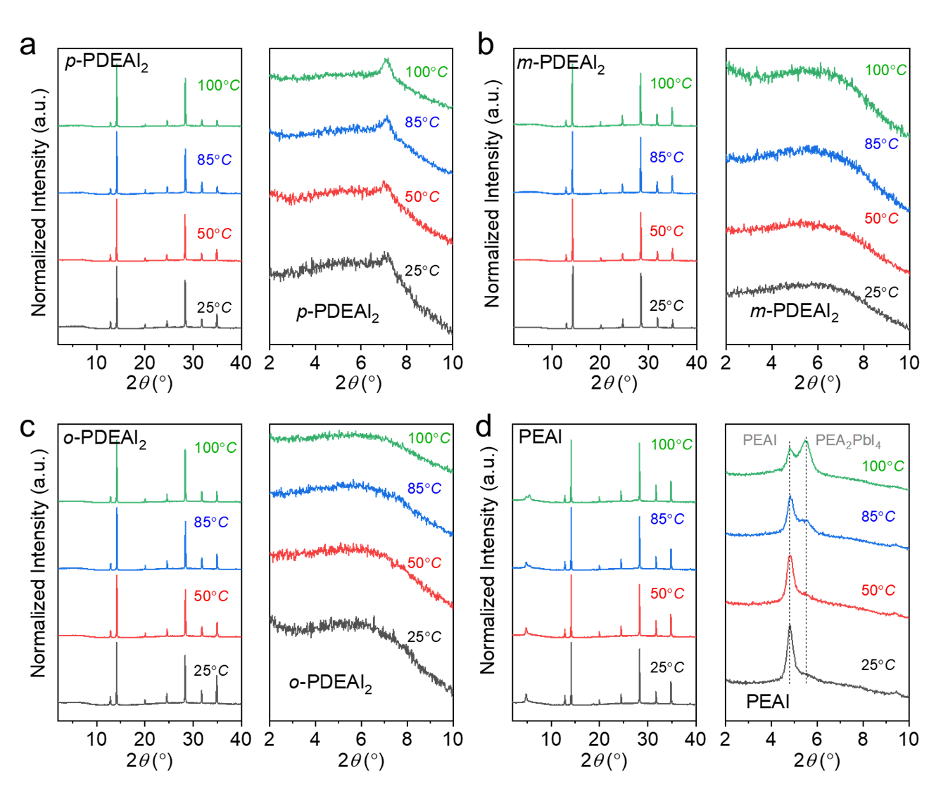
Supplementary Figure 1: XRD patterns for perovskite films with organic halide salt passivation at different annealing temperatures. a, p-PDEAI₂ passivation. b, m-PDEAI₂ passivation. c, o-PDEAI₂ passivation. d, PDEAI passivation.
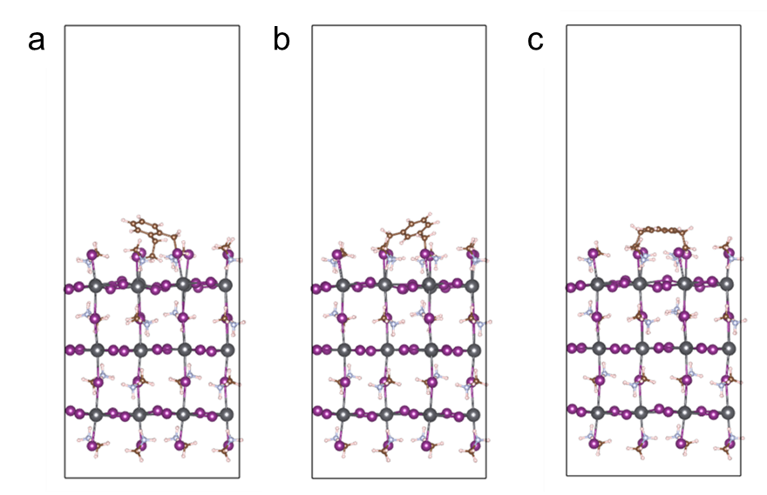
Supplementary Figure 2: The formation possibility of 2D perovskite for higher layer thickness. Optimized structures for the insertion of (a) o-PDEAI₂, (b) m-PDEAI₂ and (c) p-PDEAI₂ cations by replacing two methylammonium cations of perovskite surface.
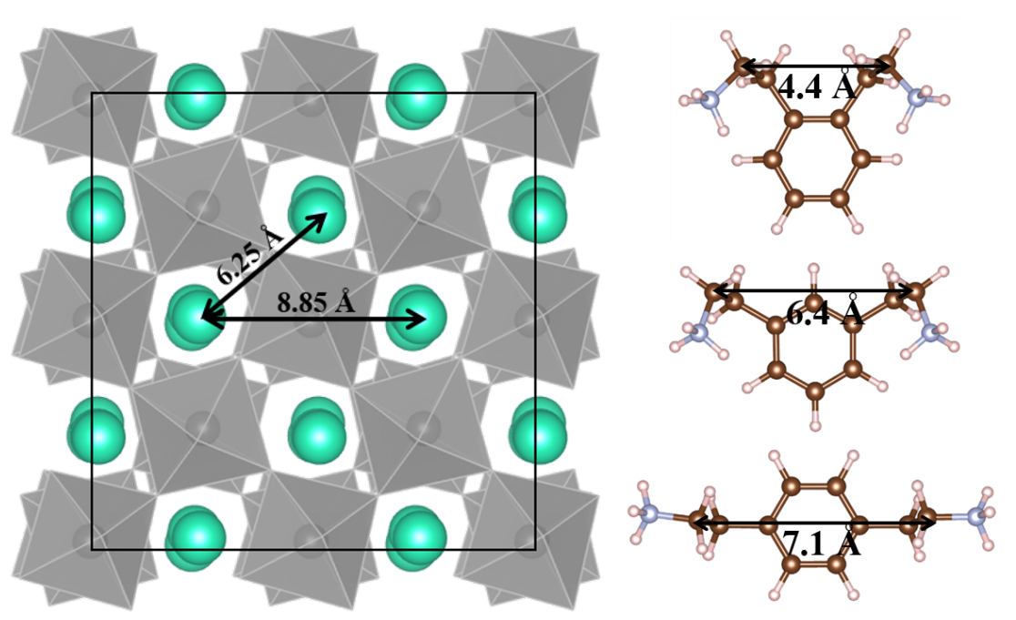
Supplementary Figure 3: Mismatching distance of PDEAI₂ and perovskite surface. Distance between the octahedra of MAI-terminated MAPbI₃ surface and the distance between the -CH₂-CH₂-NH₃⁺ groups of the 2D cations. The cyan color ball is placed on the middle of the C-N bond, thus fairly represents the distance between the octahedra.
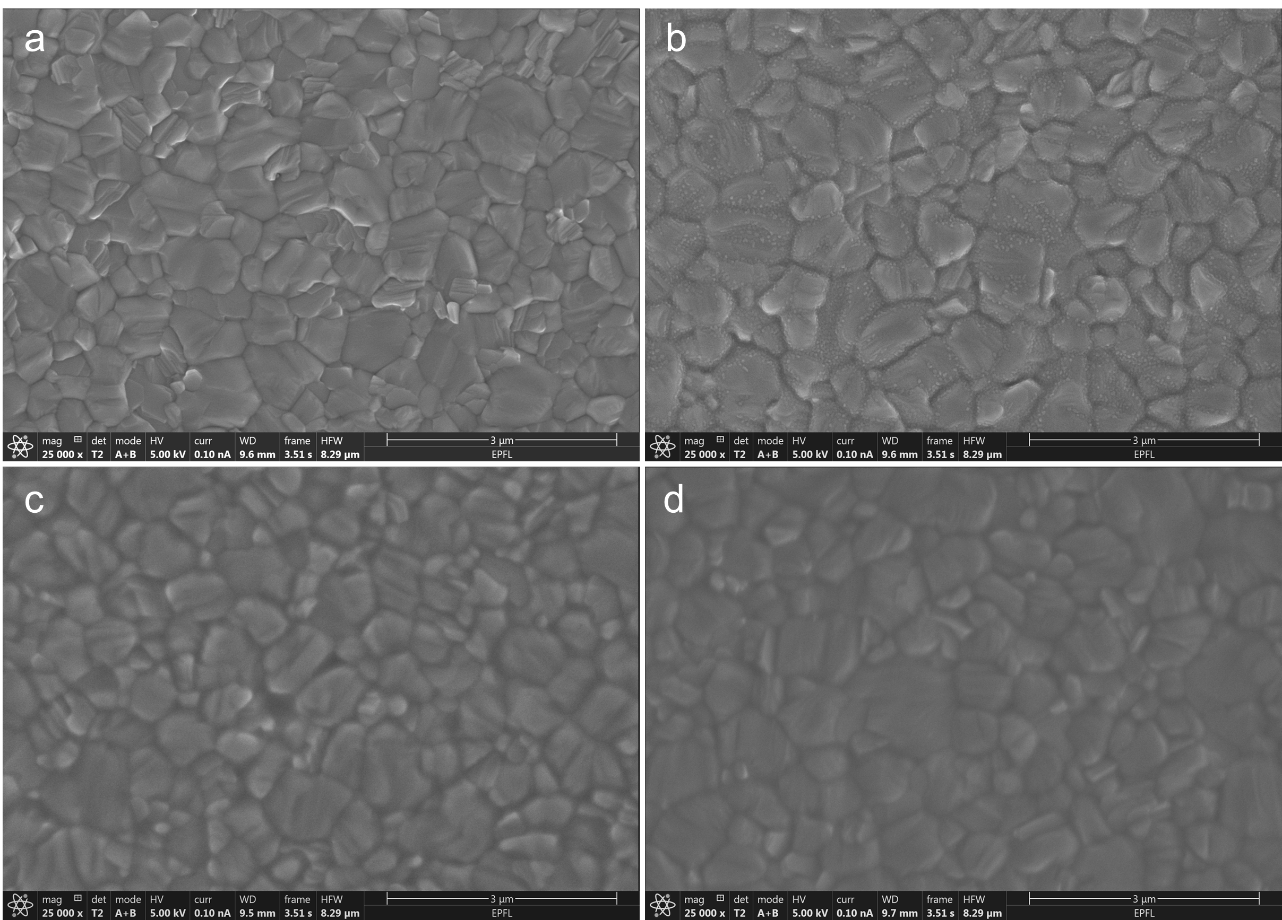
Supplementary Figure 4: Morphology of perovskite films after PDEAI₂ deposition. SEM images of the (a) pure perovskite surface, (b) with p-PDEAI₂, (c) with m-PDEAI₂ and (d) with o-PDEAI₂ passivation.
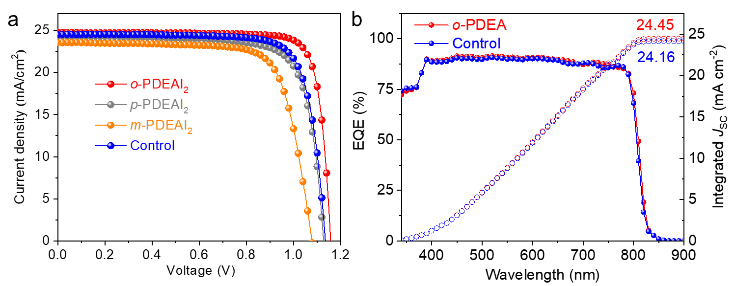
Supplementary Figure 5: Photovoltaic performance for devices with PDEAI₂ passivation. a, J-V characteristics of the devices with different isomer passivation. b, EQE spectra of the best-performing control and o-PDEAI₂-passivted devices.
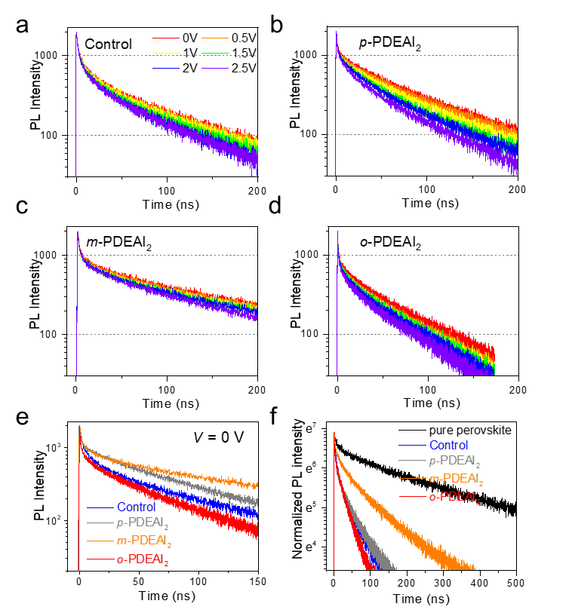
Supplementary Figure 6: Voltage-dependent transient PL and transient photocurrent investigations. a-e, PL decay kinetics at different applied voltages of the control and PDEAI₂ passivated devices. f, Transient PL kinetics of perovskite layers on glass substrates.
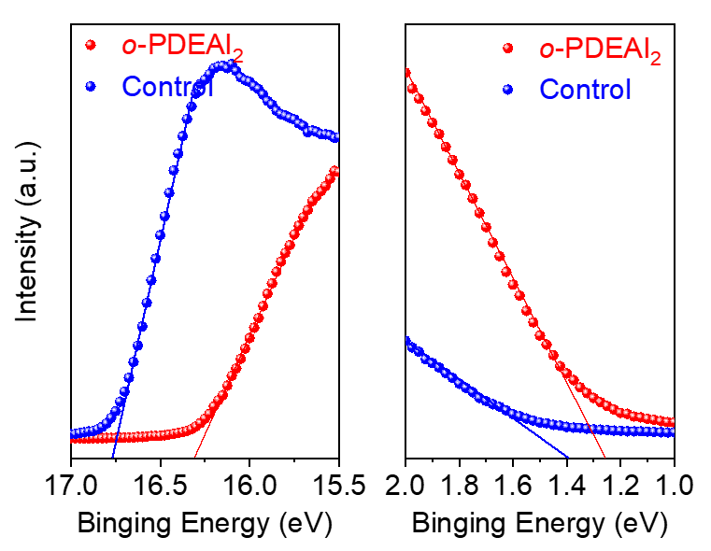
Supplementary Figure 7: Surface band structure. KPFM results of the pure and o-PDEAI₂-passivated perovskite surface.
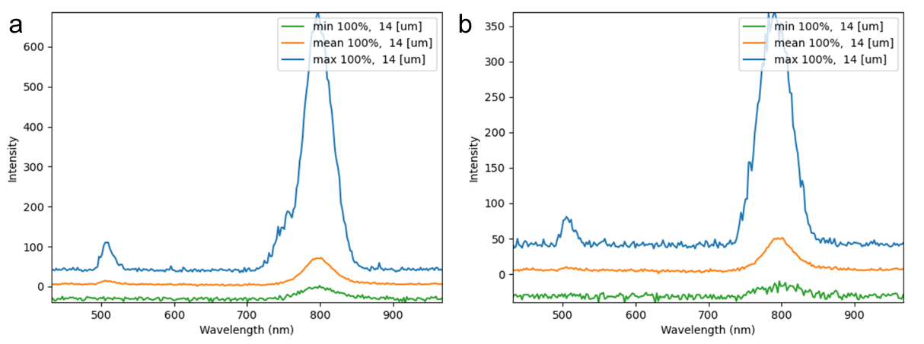
Supplementary Figure 8: Film uniformity revealed by the CL characterization. CL spectra of the (a) control and (b) o-PDEAI₂-passivated perovskite film.
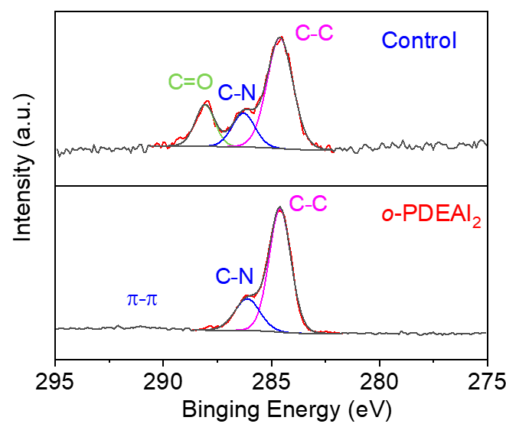
Supplementary Figure 9: The presence of o-PDEAI₂ on the perovskite surface. High-resolution XPS spectra of C 1s for the control and o-PDEAI₂-passivated perovskite film.
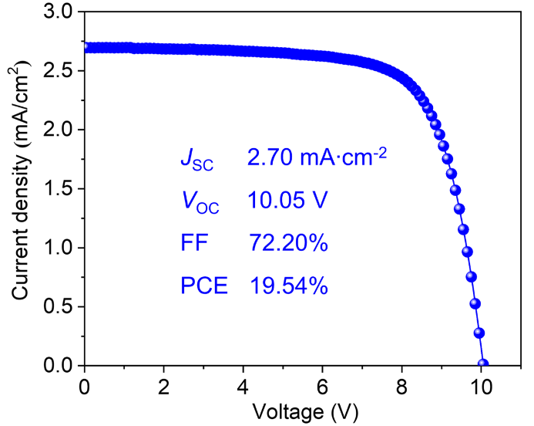
Supplementary Figure 10: Photovoltaic performance of perovskite solar modules. J-V characteristics of the control module without passivation.

Supplementary Table 1: Formation energies of the 2D and quasi-2D perovskites.
Structures | Energy (eV)
Structures | 2D perovskite | quasi-2D perovskite
p-PDEAI₂ | -7.19 | -0.76
m-PDEAI₂ | -7.22 | -0.97
o-PDEAI₂ | -6.41 | -0.59

Supplementary Table 2: Adsorption energies of the PDEAI₂ cations on perovskite surface considering both ethyl ammonium and phenyl adsorption modes.
Structures | Energy (eV)
Structures | -CH₂CH₂NH₃⁺ | phenyl
p-PDEAI₂ | -9.76 | -10.04
m-PDEAI₂ | -10.50 | -9.51
o-PDEAI₂ | -10.00 | -9.53

Supplementary Table 3: Summary of the device performance for the control and PDEAI₂-passivated devices.
Condition | V_{OC} (V) | J_{SC} (mA cm⁻²) | FF | PCE (%)
Control | 1.112±0.01 | 24.24±0.25 | 0.769±0.02 | 20.71±0.66
Best | 1.135 | 24.49 | 0.790 | 21.94
p-PDEAI₂ | 1.097±0.03 | 24.20±0.32 | 0.765±0.02 | 20.30±0.60
Best | 1.127 | 24.34 | 0.770 | 21.09
m-PDEAI₂ | 0.993±0.05 | 23.80±0.57 | 0.701±0.05 | 16.74±1.57
Best | 1.079 | 23.55 | 0.750 | 19.63
o-PDEAI₂ | 1.141±0.01 | 24.52±0.31 | 0.802±0.01 | 22.45±0.64
Best | 1.157 | 24.75 | 0.835 | 23.92

Supplementary Table 4: Summary of the fitting parameters of the perovskite films on glass substrates.
Condition | A₁ [%] | τ₁ [ns] | A₂ [%] | τ₂ [ns]
Pure perovskite w/o HTL | 32.5 | 14.3 | 67.5 | 284.4
Control with HTL | 65.6 | 4.5 | 34.4 | 47.2
p-PDEAI₂ with HTL | 57.1 | 2.5 | 42.9 | 38.2
m-PDEAI₂ with HTL | 45.6 | 6.6 | 54.4 | 90.0
o-PDEAI₂ with HTL | 38.3 | 2.4 | 61.7 | 28.9

Supplementary Table 5: Overview of the reported perovskite solar modules so far.
Year | Ref. | Active  Area (cm²) | Designated  Area (cm²) | GFF  (%) | Number of Subcells | J_{SC}  (mA∙cm²) | V_{OC}  (V) | FF  (%) | PCE  (%)
2018 | 4 | ‒ | 33 | 93.4 | 17 | 1.15 | 18.19 | 72.1 | 15.3
2019 | 5 | 8 | ‒ | ‒ | 4 | 5.82 | 3.98 | 68 | 15.79
2020 | 6 | ‒ | 36.1 | 85 | 10 | 1.77 | 11.19 | 64.91 | 12.85
2020 | 7 | ‒ | 36 | ‒ | 10 | 1.80 | 10.4 | 67.67 | 12.67
2020 | 8 | 7.92 | ‒ | 85.7 | 4 | 5.66 | 4.55 | 76.2 | 19.6
2020 | 9 | ‒ | 25.49 | 90.8 | 7 | 3.03 | 7.52 | 78.59 | 17.88
2020 | 10 | 2 | ‒ | 90 | 6 | 3.43 | 6.35 | 71 | 15.5
2020 | 11 | ‒ | 22.4 | 91 | 7 | 2.99 | 7.64 | 72.9 | 16.6
2021 | 12 | 8 | ‒ | ‒ | 4 | 5.63 | 4.17 | 71.11 | 16.69
2021 | 13 | 36.6 | ‒ | 90.3 | 7 | 3.04 | 7.44 | 71 | 16.06
2021 | 14 | 42.8 | ‒ | ‒ | 14 | 1.50 | 16.05 | 70.89 | 17.05
2021 | 15 | ‒ | 35.8 | ‒ | 10 | 2.04 | 11.70 | 77.3 | 18.5
2021 | 16 | 17.1 | ‒ | ‒‒ | 6 | 3.80 | 6.88 | 78.1 | 20.42
2021 | 17 | 27.14 | ‒ | 92 | 8 | 3.08 | 8.71 | 75.41 | 20.2
2021 | This work | 26 | ‒ | 90.2 | 9 | 2.71 | 10.30 | 76.4 | 21.36

References
1 Giannozzi, P. et al. QUANTUM ESPRESSO: a modular and open-source software project for quantum simulations of materials. J. Phys. Condens. Matter 21, 395502 (2009).
2 Grimme, S., Antony, J., Ehrlich, S. & Krieg, H. A consistent and accurate ab initio parametrization of density functional dispersion correction (DFT-D) for the 94 elements H-Pu. J. Chem. Phys. 132, 154104 (2010).
3 Perdew, J. P., Burke, K. & Ernzerhof, M. Generalized gradient approximation made simple. Phys. Rev. Lett. 77, 3865 (1996).
4 Deng, Y. et al. Surfactant-controlled ink drying enables high-speed deposition of perovskite films for efficient photovoltaic modules. Nature Energy 3, 560-566 (2018).
5 Xu, Z. et al. Br-containing alkyl ammonium salt-enabled scalable fabrication of high-quality perovskite films for efficient and stable perovskite modules. Journal of Materials Chemistry A 7, 26849-26857 (2019).
6 Ru, P. et al. High electron affinity enables fast hole extraction for efficient flexible inverted perovskite solar cells. Advanced Energy Materials 10, 1903487 (2020).
7 Li, E. et al. Synergistic Coassembly of Highly Wettable and Uniform Hole‐Extraction Monolayers for Scaling‐up Perovskite Solar Cells. Advanced Functional Materials 30, 1909509 (2020).
8 Du, M. et al. High‐Pressure Nitrogen‐Extraction and Effective Passivation to Attain Highest Large‐Area Perovskite Solar Module Efficiency. Advanced Materials 32, 2004979 (2020).
9 Ren, A. et al. Efficient perovskite solar modules with minimized nonradiative recombination and local carrier transport losses. Joule 4, 1263-1277 (2020).
10 Rolston, N. et al. Rapid open-air fabrication of perovskite solar modules. Joule 4, 2675-2692 (2020).
11 Liu, Z. et al. A holistic approach to interface stabilization for efficient perovskite solar modules with over 2,000-hour operational stability. Nature Energy 5, 596-604 (2020).
12 Chen, R. et al. Crown Ether‐Assisted Growth and Scaling Up of FACsPbI3 Films for Efficient and Stable Perovskite Solar Modules. Advanced Functional Materials 31, 2008760 (2021).
13 Huang, H.-H. et al. A simple one-step method with wide processing window for high-quality perovskite mini-module fabrication. Joule 5, 958-974 (2021).
14 Nia, N. Y. et al. Beyond 17% stable perovskite solar module via polaron arrangement of tuned polymeric hole transport layer. Nano Energy 82, 105685 (2021).
15 Chen, S., Xiao, X., Gu, H. & Huang, J. Iodine reduction for reproducible and high-performance perovskite solar cells and modules. Science Advances 7, eabe8130 (2021).
16 Bu, T. et al. Lead halide–templated crystallization of methylamine-free perovskite for efficient photovoltaic modules. Science 372, 1327-1332 (2021).
17 Deng, Y. et al. Defect compensation in formamidinium–caesium perovskites for highly efficient solar mini-modules with improved photostability. Nature Energy 6, 633-641, (2021).

