Optimization of critical parameters for coating of polymeric nanoparticles with plasma membrane vesicles

Feipeng Yang, ^{1,2} Maleen H. Cabe, ^{1,2} Veronica Sanchez,² and Kelly A. Langert ^{1,2}

Department of Molecular Pharmacology and Neuroscience
Loyola University Chicago, Stritch School of Medicine, Maywood, IL 60153 (U.S.A.) ¹
Research Service
Edward Hines Jr. VA Hospital, Hines, IL 60141 (U.S.A.) ²

Figure S1. PLGA nanoparticle surface coating with membrane vesicles through bath sonication.
Figure S2. Diagnostics of the DOE model.
Figure S3. Confocal images of PLGA nanoparticles and membrane vesicles.
Table S1. Report of actual and predicted response from the surface central composite design.
Table S2. Analysis of variance (ANOVA) results for sizes of the coated nanoparticles.
Table S3. Analysis of variance (ANOVA) results for PDI of the coated nanoparticles.

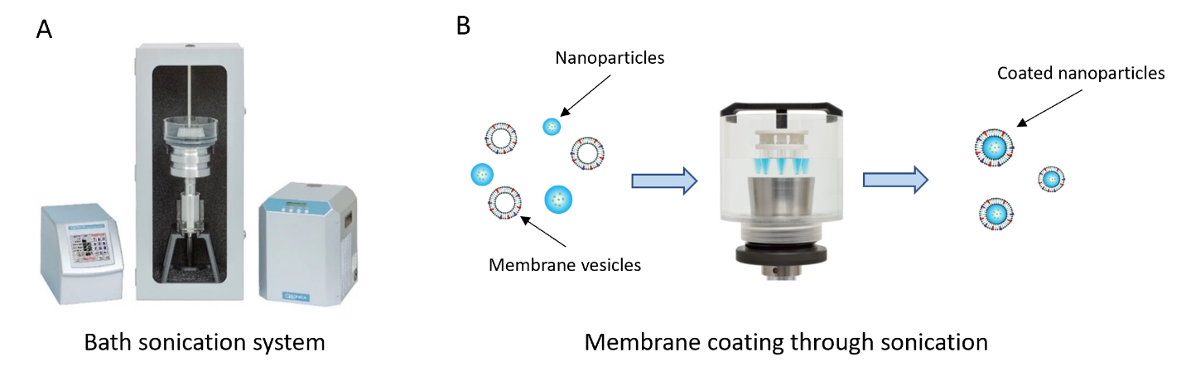

Figure S1. PLGA nanoparticle surface coating with membrane vesicles through bath sonication. (A) Bath sonication system composed of Fisherbrand Model 505 Sonic Dismembrator, a cup horn (Qsonica, LLC, #431C2), and a recirculating chiller (Qsonica, LLC, #4905). (B) Illustration of membrane coating process through bath sonication.

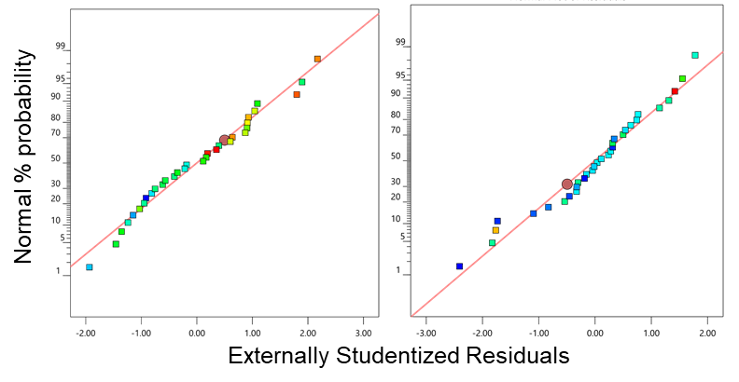

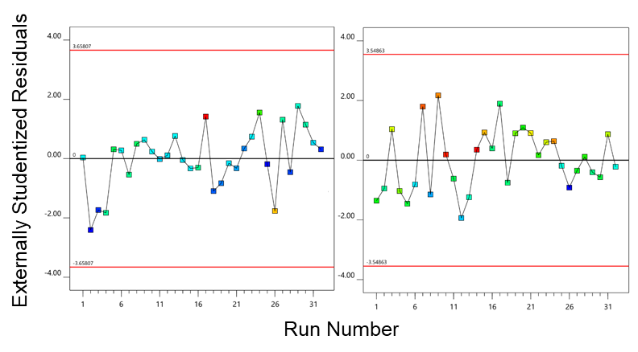

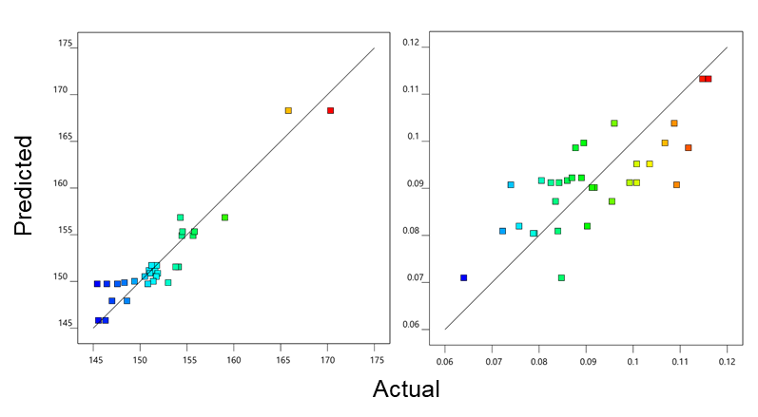

Figure S2. DOE diagnostics. Normal plots of residuals for NP size (A) and PDI (B). Scatter plots of externally studentized residuals versus run number for size (C) and PDI (D). Scatter plots of predicted value versus actual value from the established models for size (E) and PDI (F).

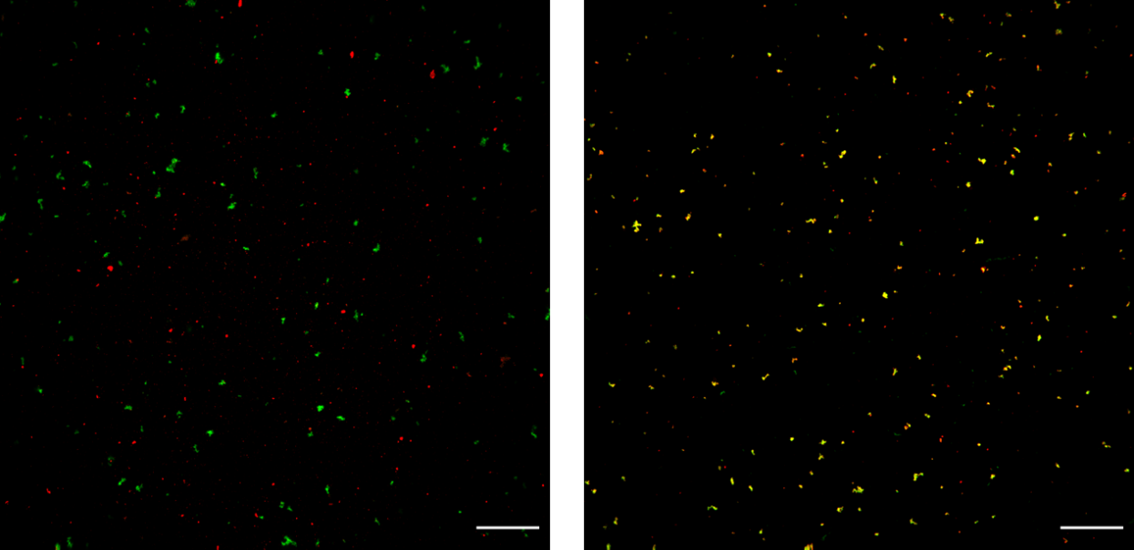

Figure S3. Confocal images of PLGA NPs and membrane vesicles. Co-suspensions of PLGA NPs (red) and membrane vesicles (green) before (A) and after (B) bath sonication. Scale bar: 20 µm.

Table S1. Report of actual and predicted response from the surface central composite design.

Variables |  |  |  | Response
 |  |  |  | Size(nm) |  |  |  | PDI
Run | A | B | C |  | Actual | Predicted | Actual |  | Predicted
1 | 20 | 5 | 25 |  | 151.8 | 151.7 | 0.090 |  | 0.100
2 | 60 | 3 | 15 |  | 145.4 | 149.7 | 0.083 |  | 0.091
3 | 60 | 3 | 15 |  | 146.5 | 149.7 | 0.101 |  | 0.091
4 | 100 | 1 | 25 |  | 154.3 | 156.8 | 0.096 |  | 0.104
5 | 20 | 1 | 25 |  | 155.8 | 155.3 | 0.088 |  | 0.099
6 | 20 | 5 | 5 |  | 151.6 | 151.2 | 0.076 |  | 0.082
7 | 20 | 1 | 25 |  | 154.5 | 155.3 | 0.112 |  | 0.099
8 | 20 | 1 | 5 |  | 155.7 | 154.9 | 0.072 |  | 0.081
9 | 40 | 3 | 15 |  | 151.9 | 150.9 | 0.109 |  | 0.091
10 | 100 | 1 | 5 |  | 151.5 | 151.1 | 0.115 |  | 0.113
11 | 80 | 3 | 15 |  | 150.5 | 150.5 | 0.086 |  | 0.092
12 | 40 | 3 | 15 |  | 151.1 | 150.9 | 0.074 |  | 0.091
13 | 80 | 3 | 15 |  | 151.7 | 150.5 | 0.081 |  | 0.092
14 | 100 | 1 | 5 |  | 151.1 | 151.1 | 0.116 |  | 0.113
15 | 20 | 5 | 25 |  | 151.2 | 151.7 | 0.107 |  | 0.100
16 | 20 | 1 | 5 |  | 154.5 | 154.9 | 0.084 |  | 0.081
17 | 100 | 5 | 25 |  | 170.3 | 168.3 | 0.085 |  | 0.071
18 | 60 | 3 | 15 |  | 147.6 | 149.7 | 0.084 |  | 0.091
19 | 60 | 4 | 15 |  | 148.3 | 149.9 | 0.0096 |  | 0.087
20 | 20 | 5 | 5 |  | 151. | 151.2 | 0.090 |  | 0.082
21 | 60 | 2 | 15 |  | 149.4 | 150.0 | 0.104 |  | 0.095
22 | 60 | 3 | 10 |  | 148.6 | 147.9 | 0.092 |  | 0.090
23 | 60 | 2 | 15 |  | 151.4 | 150.0 | 0.101 |  | 0.095
24 | 100 | 1 | 25 |  | 159.1 | 156.8 | 0.109 |  | 0.104
25 | 100 | 5 | 5 |  | 145.6 | 145.8 | 0.079 |  | 0.080
26 | 100 | 5 | 25 |  | 165.8 | 168.3 | 0.064 |  | 0.071
27 | 60 | 3 | 20 |  | 154.1 | 151.6 | 0.089 |  | 0.092
28 | 60 | 3 | 10 |  | 147.0 | 147.9 | 0.091 |  | 0.090
29 | 60 | 4 | 15 |  | 153.0 | 149.9 | 0.084 |  | 0.087
30 | 60 | 3 | 20 |  | 153.8 | 151.6 | 0.087 |  | 0.092
31 | 60 | 3 | 15 |  | 150.8 | 149.7 | 0.099 |  | 0.091
32 | 100 | 5 | 5 |  | 146.3 | 145.8 | 0.079 |  | 0.080

Table S2. Analysis of variance (ANOVA) results for sizes of the coated nanoparticles.

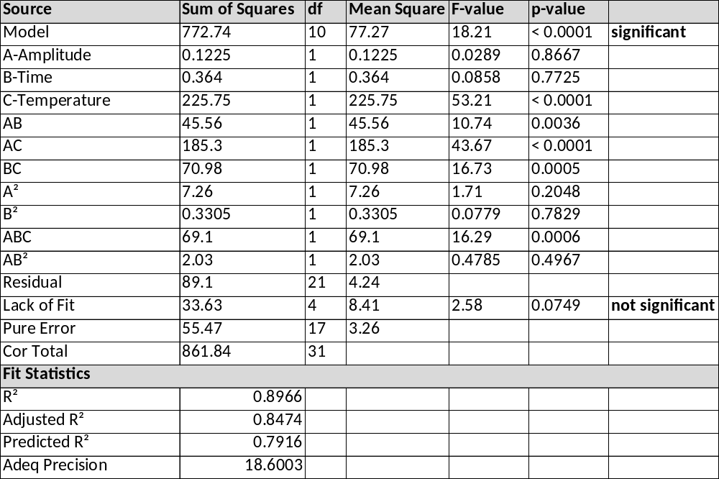

Table S3. Analysis of variance (ANOVA) results for PDI of the coated nanoparticles.

