Appendix: Relationship Between Exclusion Zone and Polar Plot Metrics

We performed a polar plot analysis to assess the impact of varying the exclusion zone, using CCI as the reference signal and esCCI, processed with a moving average of time τ, as the test signal. Two exclusion zone thresholds were evaluated: 0.0 and 0.6 L/min/m². The time interval for calculating differences (t₁) was set to 10 minutes. Polar plots for τ = 0, 25, and 60 minutes are shown in Figures A1, A2, and A3, respectively. Corresponding statistical results are presented in Table A1.

Table A1 Statistics of polar plots for CCI and esCCI when changing the exclusion zone (time interval t1 = 10 minutes, moving average time τ = 0, 25, 60 minutes)
The exclusion rate is calculated by dividing the exclusion data number by the data number.
Abbreviation: SD, Standard Deviation

In all cases, increasing the exclusion zone from 0.0 to 0.6 L/min/m² naturally increased the exclusion rate (i.e., the proportion of data points omitted from the analysis), which in turn led to a reduction in the polar angle standard deviation (SD).

Specifically, at an exclusion zone of 0.6 L/min/m², the exclusion rates for τ = 0, 25, and 60 minutes were 90.1%, 92.8%, and 94.5%, respectively. Corresponding polar angle SD values decreased to 29.3°, 13.9°, and 10.1°, respectively.

These results indicate that polar angle SD tends to decrease as the exclusion rate increases, likely reflecting the removal of high-variability or noisy data points. However, this also underscores the importance of balancing noise reduction with the risk of excluding clinically relevant signal dynamics.

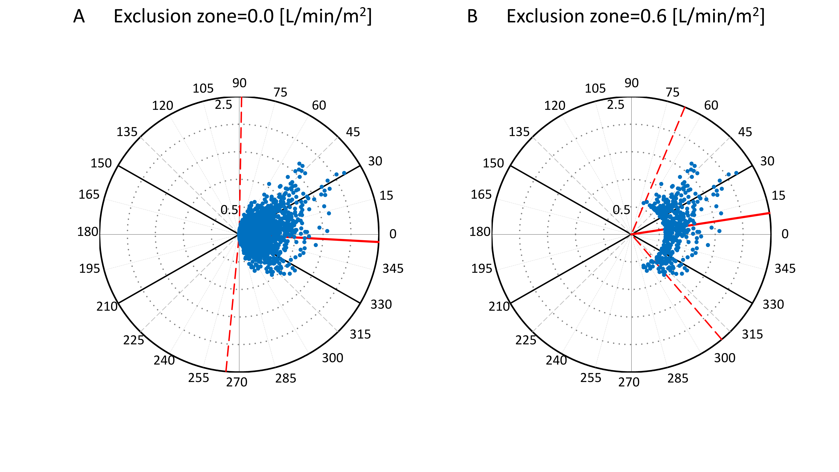
Fig A1. Polar plots for esCCI and CCI with different exclusion zones (τ = 0 min)
Polar plots for esCCI and CCI with τ fixed at 0 minutes (no moving average) and t1 fixed at 10 minutes, with different exclusion zones.
A represents no exclusion (exclusion zone = 0.0 [L/min/m²]), and B represents exclusion zone = 0.6 [L/min/m²].
The numbers outside the circles indicate the polar angle [°]. The radii of the five circles represent the average of the change in esCCI and the change in CCI. The radii are 0.5, 1.0, 1.5, 2.0 and 2.5 [L/min/m²].
The red solid line represents the mean polar angle, and the red dotted line represents the confidence intervals of the polar angle.

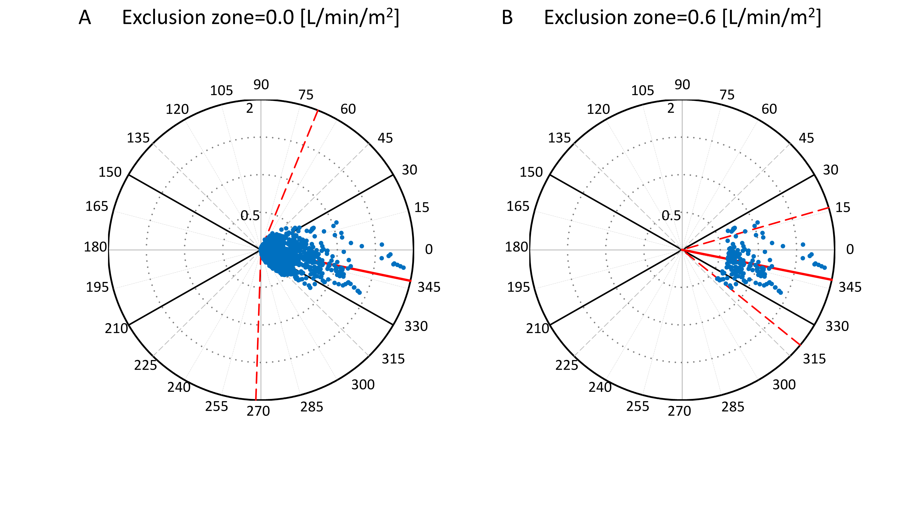
Fig A2. Polar plots for esCCI and CCI with different exclusion zones (τ = 25 min)
Polar plots for esCCI and CCI with τ fixed at 25 minutes, t1 fixed at 10 minutes, and different exclusion zones.
A represents no exclusion (exclusion zone = 0.0 [L/min/m²]), and B represents exclusion zone = 0.6 [L/min/m²].
The numbers outside the circles indicate the polar angle [°]. The radii of the four circles represent the average of the change in esCCI and the change in CCI. The radii are 0.5, 1.0, 1.5 and 2.0 [L/min/m²].
The red solid line represents the mean polar angle, and the red dotted line represents the confidence intervals of the polar angle.

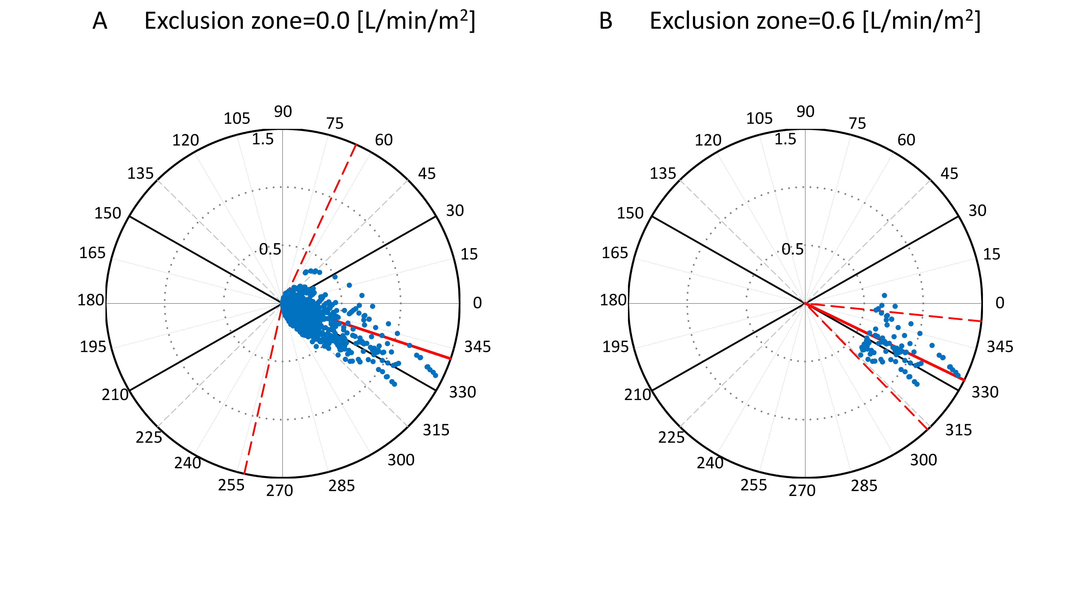
Fig A3. Polar plots for esCCI and CCI with different exclusion zones (τ = 60 min)
Polar plots for esCCI and CCI with τ fixed at 60 minutes, t1 fixed at 10 minutes, and different exclusion zones.
A represents no exclusion (exclusion zone = 0.0 [L/min/m²]), and B represents exclusion zone = 0.6 [L/min/m²].
The numbers outside the circles indicate the polar angle [°]. The radii of the three circles represent the average of the change in esCCI and the change in CCI. The radii are 0.5, 1.0 and 1.5 [L/min/m²].
The red solid line represents the mean polar angle, and the red dotted line represents the confidence intervals of the polar angle.

