Article Title:
Comparative Analysis of Open-Source vs. Commercial Models in Predicting Flood Risk under Climate Extremes
Journal: Natural Hazards
Md Sami Bin Shokranaª*, Katerina Boukin^{b} and Kenneth Strzepekª
ªCenter for Sustainability Science and Strategy, Massachusetts Institute of Technology, Cambridge, Massachusetts, USA
^{b}Center for Transportation and Logistics, Massachusetts Institute of Technology, Cambridge, Massachusetts, USA
*Corresponding author: Md Sami Bin Shokrana; Email: shokrana@mit.edu, ORCID ID: 0009-0009-0601-5725

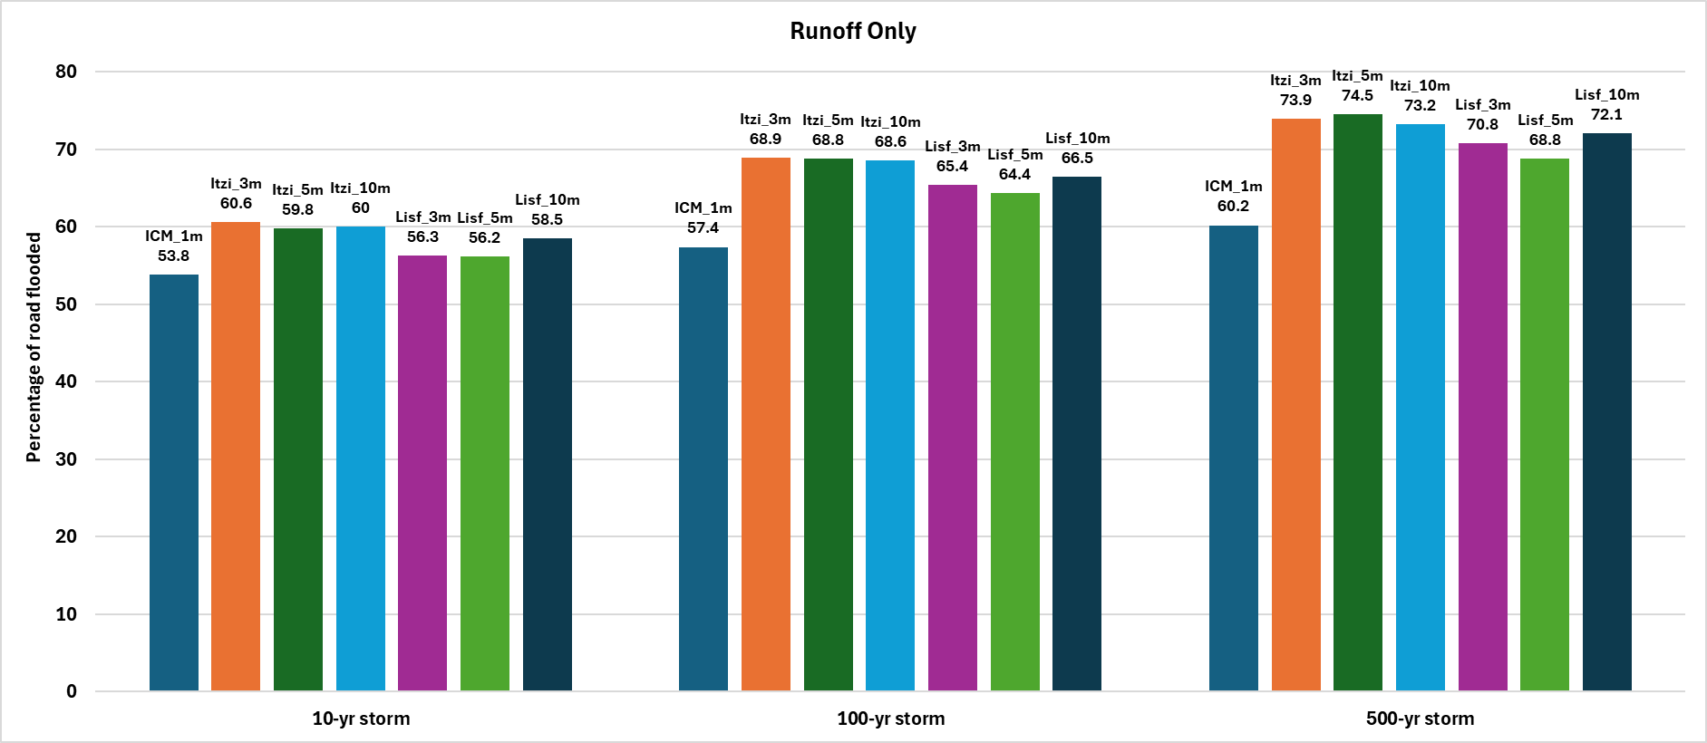
Fig. S1 Percentage of road inundation predicted by ICM, Itzi, and LISFLOOD for the runoff only scenario. ICM simulations were run at 1m resolution, whereas Itzi and LISFLOOD simulations were run at 3m, 5m, and 10m resolutions

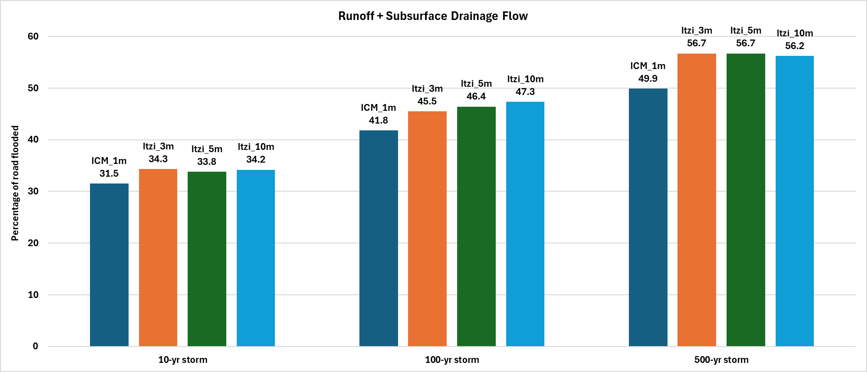
Fig. S2 Percentage of road inundation predicted by ICM, Itzi, and LISFLOOD for the combined runoff and subsurface drainage flow scenario. ICM simulations were run at 1m resolution, whereas Itzi and LISFLOOD simulations were run at 3m, 5m, and 10m resolutions

