Supplemental Information

Morphological Control of Microbial Ecosystems and Carbon Cycling in Greenlandic Cryoconite Holes

Takeuchi et al.

This PDF file includes:
Supplemental Table 1
Supplemental Figures 1–5

Table S1: Geochemical data for cryoconite and meltwater from cryoconite holes on Issunguata Sermia Glacier in southwest Greenland.

Site | Cryoconite |  |  |  |  |  | Meltwater
 | OM | N | C | C/N | δ¹⁵N | δ¹³C | δ¹⁸O | δD | Cl⁻ | NO₂⁻ | NO₃⁻ | PO₄³⁻ | SO₄²⁻ | Na⁺ | NH₄⁺ | K⁺ | Mg²⁺ | Ca²⁺
 | w% | w% | w% | w/w | ‰ | ‰ | ‰ | ‰ | ppb | ppb | ppb | ppb | ppb | ppb | ppb | ppb | ppb | ppb
S1 | 1.7 | 0.1 | 0.7 | 8.2 | -1.1 | -20.2 | -26.7 | -211 | 25.8 | 0.0 | 11.3 | 0.0 | 18.8 | 17.7 | 0.0 | 67.3 | 24.4 | 68.2
S2 | 1.4 | 0.1 | 0.6 | 9.5 | -1.7 | -22.4 | -27.2 | -214 | 9.0 | 0.0 | 9.4 | 0.0 | 0.0 | 5.7 | 0.0 | 22.9 | 13.0 | 56.0
S3 | 1.1 | 0.0 | 0.3 | 12.9 | -1.8 | -22.5 | -28.2 | -219 | 16.5 | 0.0 | 6.8 | 0.0 | 0.0 | 25.8 | 0.0 | 67.8 | 26.1 | 112.4
S4 | 2.9 | 0.1 | 1.3 | 10.5 | -1.3 | -22.5 | -33.5 | -265 | 12.1 | 0.0 | 24.7 | 62.5 | 689.9 | 12.1 | 0.0 | 24.7 | 62.5 | 689.9
S5 | 1.9 | 0.1 | 0.7 | 10.9 | -2.4 | -21.4 | -28.3 | -216 | 7.0 | 0.0 | 27.2 | 11.9 | 71.4 | 7.0 | 0.0 | 27.2 | 11.9 | 71.4
S6 | 3.0 | 0.1 | 1.1 | 9.6 | -0.6 | -23.1 | -26.8 | -208 | 53.4 | 0.0 | 26.0 | 6.7 | 37.7 | 53.4 | 0.0 | 26.0 | 6.7 | 37.7
S7 | 2.6 | 0.2 | 1.5 | 8.2 | 0.9 | -20.9 | -26.5 | -205 | 18.3 | 0.3 | 71.7 | 42.3 | 37.5 | 18.3 | 0.3 | 71.7 | 42.3 | 37.5
S8 | 1.3 | 0.1 | 0.6 | 9.1 | -2.0 | -23.6 | -25.9 | -194 | 64.6 | 0.0 | 28.9 | 9.2 | 33.3 | 64.6 | 0.0 | 28.9 | 9.2 | 33.3
S9 | 5.7 | 0.3 | 2.3 | 9.1 | -1.1 | -22.3 | -24.5 | -181 | 9.5 | 1.7 | 30.2 | 13.5 | 17.9 | 9.5 | 1.7 | 30.2 | 13.5 | 17.9
S10 | 5.4 | 0.2 | 2.3 | 9.2 | 0.7 | -21.7 | -27.2 | -200 | 108.7 | 0.0 | 28.1 | 36.0 | 33.0 | 108.7 | 0.0 | 28.1 | 36.0 | 33.0
S11 | 6.7 | 0.3 | 2.8 | 9.2 | 0.8 | -21.3 | -24.8 | -187 | 14.9 | 4.0 | 81.2 | 35.2 | 19.4 | 14.9 | 4.0 | 81.2 | 35.2 | 19.4
S12 | 4.9 | 0.2 | 2.4 | 9.7 | -0.8 | -22.4 | -27.4 | -211 | 46.4 | 0.0 | 169.7 | 51.8 | 41.5 | 46.4 | 0.0 | 169.7 | 51.8 | 41.5
S13 | 6.9 | 0.3 | 2.9 | 9.8 | 0.4 | -20.0 | -25.6 | -197 | 40.5 | 16.4 | 84.3 | 31.6 | 46.0 | 40.5 | 16.4 | 84.3 | 31.6 | 46.0
S14 | 8.0 | 0.4 | 3.5 | 9.9 | 0.6 | -19.7 | -27.1 | -207 | 7.9 | 1.4 | 41.8 | 14.1 | 11.6 | 7.9 | 1.4 | 41.8 | 14.1 | 11.6
S15 | 8.8 | 0.4 | 4.1 | 11.0 | 0.3 | -19.5 | -26.3 | -201 | 40.1 | 16.3 | 185.9 | 88.5 | 56.1 | 40.1 | 16.3 | 185.9 | 88.5 | 56.1
S16 | 6.7 | 0.3 | 3.1 | 10.0 | 0.3 | -20.2 | -25.3 | -192 | 23.5 | 28.7 | 103.9 | 65.7 | 40.2 | 23.5 | 28.7 | 103.9 | 65.7 | 40.2
S17 | 6.6 | 0.3 | 2.6 | 10.0 | 1.1 | -19.8 | -24.2 | -180 | 10.5 | 2.0 | 27.0 | 11.8 | 16.8 | 10.5 | 2.0 | 27.0 | 11.8 | 16.8
S18 | 6.9 | 0.3 | 2.6 | 10.1 | 0.6 | -19.9 | -25.3 | -193 | 21.2 | 11.3 | 79.1 | 42.4 | 26.6 | 21.2 | 11.3 | 79.1 | 42.4 | 26.6
S19 | 7.9 | 0.3 | 3.3 | 10.2 | 1.1 | -20.2 | -25.0 | -190 | 22.1 | 11.5 | 69.8 | 38.7 | 27.4 | 22.1 | 11.5 | 69.8 | 38.7 | 27.4
S20 | 6.0 | 0.3 | 3.2 | 10.4 | 1.0 | -19.7 | -25.2 | -190 | 25.2 | 7.8 | 59.7 | 48.4 | 32.0 | 25.2 | 7.8 | 59.7 | 48.4 | 32.0
Mean | 4.8 | 0.2 | 2.1 | 9.9 | -0.3 | -21.2 | -26.5 | -203 | 28.9 | 5.1 | 58.3 | 30.5 | 62.9 | 28.8 | 5.1 | 64.9 | 33.7 | 73.7
S.D. | 2.6 | 0.1 | 1.2 | 1.0 | 1.2 | 1.3 | 2.0 | 19 | 24.9 | 7.9 | 49.7 | 25.0 | 148.6 | 25.0 | 7.9 | 46.0 | 22.0 | 146.9

Figure S1. Phylogenetic relationships among ASV sequences and single-filament PCR sequences obtained in this study. A maximum likelihood tree was constructed using IQ-TREE version 1.6.12 (Nguyen et al., 2015). Gloeobacter violaceus PCC 7421 (AF132790.1) was used as an outgroup. Representative sequences identified in this study are shown in bold. “ASV” indicates ASV sequences, and “Single filament PCR” indicates single-filament PCR sequences.

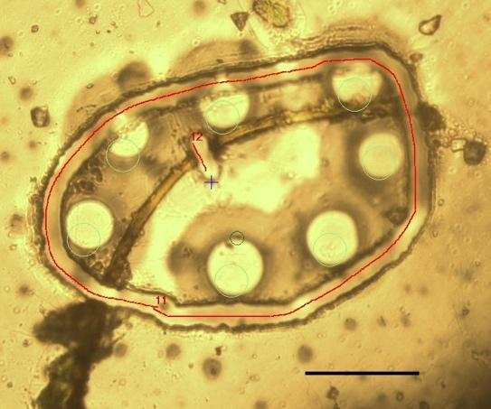
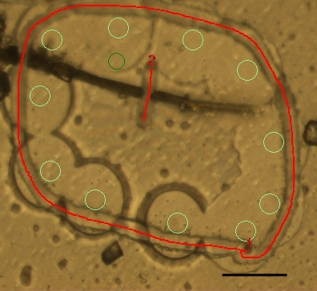
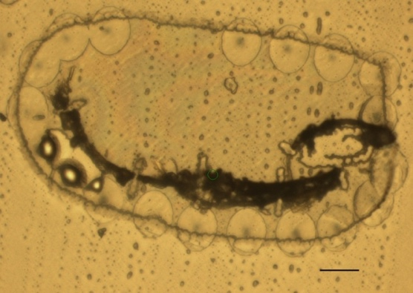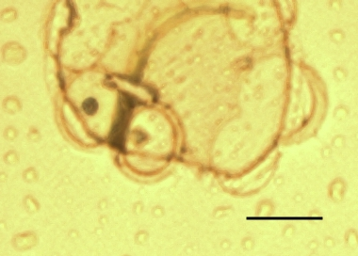

Figure S2: Cyanobacterial cells recovered by single-filament PCR analysis to directly identify the phylotypes comprising cryoconite granules in deeper cryoconite holes. Scale bars represent 50 µm in all images.

Figure S3: Distribution of the major cyanobacterial ASVs among the samples. The heatmap shows the relative abundance (%) of ASV reads within each sample. The effect size, Wilcoxon p-value, and Benjamini-Hochberg (BH)-corrected p-value, calculated using ALDEx2 to assess the differential abundance between the shallower and deeper holes, are also presented. Absolute effect size ≥ 1 or BH-corrected p-value < 0.1 were colored in red.

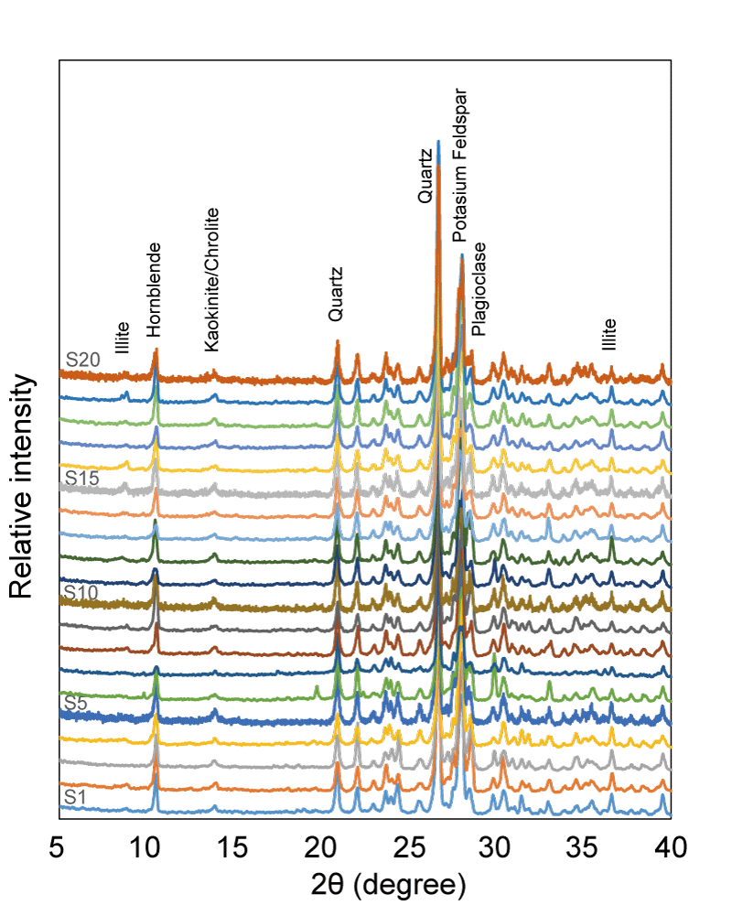

Figure S4: XRD spectra for all samples of cryoconite collected from S1 to S20.

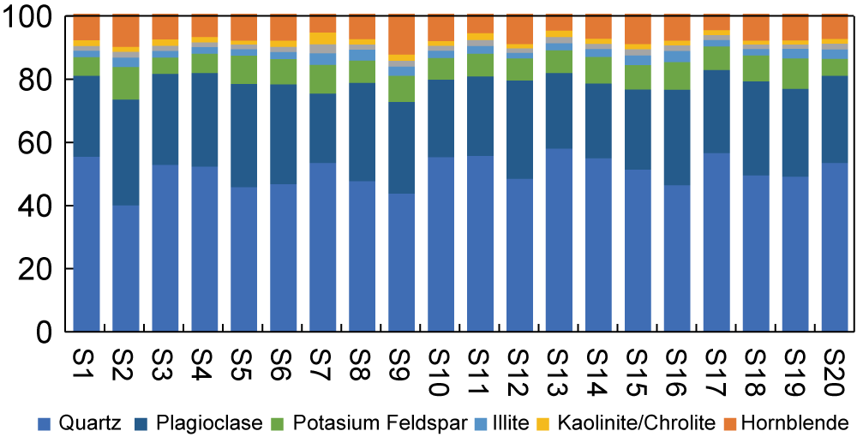

Figure S5: Comparison of the relative peak intensities of the XRD spectra for all samples of cryoconite collected from S1 to S20.

