Supporting Information

Programmable Artificial Glucose-sensing Receptor for Autonomous Single-Cell Closed-loop Glycemic Control

Fang He, ¹ Meixia Wang, ¹ Yiyu Wang, ¹ Yuping Cai, ² Zheng-Jiang Zhu, ² Hong-hui Wang, ¹ Zhou Nie^{*1}

¹State Key Laboratory of Chemo and Biosensing, College of Chemistry and Chemical Engineering, College of Biology, Hunan Provincial Key Laboratory of Biomacromolecular Chemical Biology, Hunan University, Changsha, China.
E-mail: niezhou.hnu@gmail.com (Z. N.)
²Interdisciplinary Research Center on Biology and Chemistry, Shanghai Institute of Organic Chemistry, Chinese Academy of Sciences.

Supplementary Figure 1. The detailed sequences and secondary structures of the cell-wearable glucose-regulating nanodevice (CWGN). R_{G}, the target recognition strand, is a 51 nt glucose binding aptamer sequence. The H_{S} and H_{A} are the receptor-hooking strands containing the sequence of the c-Met binding aptamer. R_{G} has a partial sequence complementary to H_{S}, while B_{S} is entirely complementary to H_{S}, these three components form the sensing-and-decision-making (SD) subunit. Moreover, B_{A} is complementary to H_{A}, making up the actuation (A) subunit. B_{S} and B_{A} both have 16 nt bases. With the binding of glucose to R_{G}, R_{G} will dissociate from the H_{S}/R_{G}/B_{S} complex, exposing the toehold that partially complementary to the 7 nt toeholds in H_{A}. Subsequently, H_{S} will bind to the H_{A} via the toehold-mediated strand displacement reaction. After the binding between H_{S} and H_{A}, the B_{S} and B_{A} will release from H_{S}/B_{S}, H_{A}/B_{A} duplex, respectively. The secondary structures of the SD and A subunit and their associated Gibbs free energies were predicted using NUPACK.

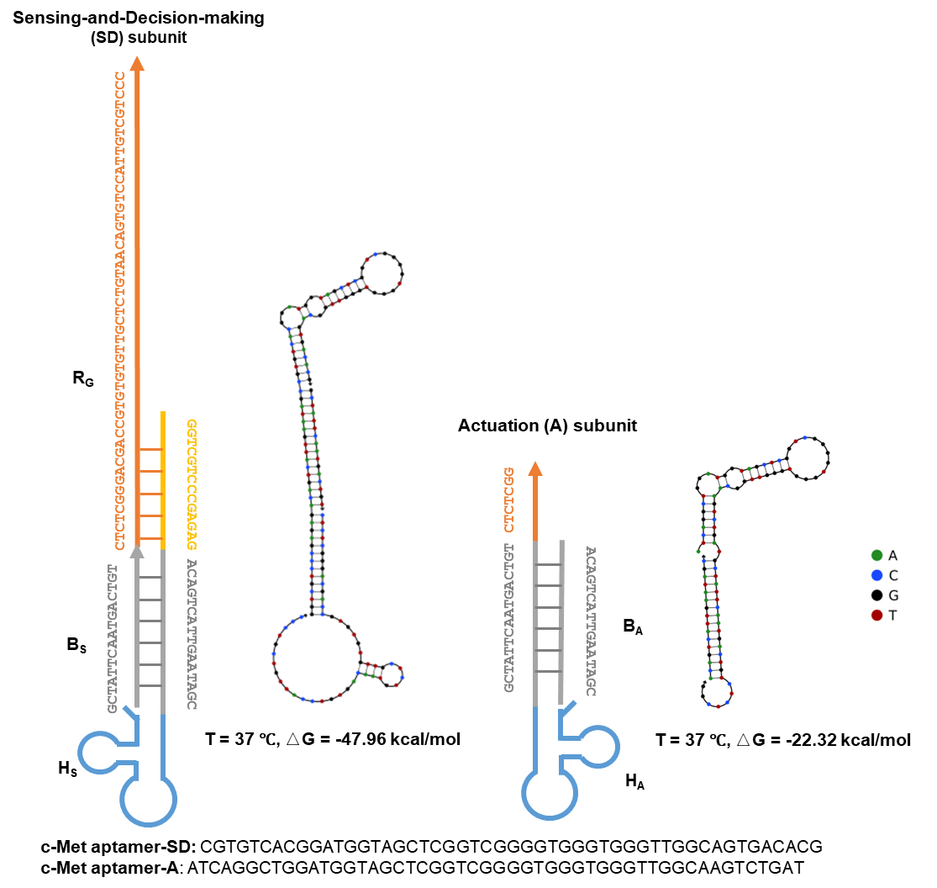

Supplementary Figure 2. GLUT2 translocation in BRL-3A cells treated with aptameric dimer. (a) Schematic representation of GLUT2 translocation in BRL-3A cells following treatment with the aptameric dimer, as assessed by immunofluorescence staining. (b) Immunofluorescence flow cytometry analysis was employed to quantify changes of GLUT2 at the plasma membrane of BRL-3A cells stimulated with aptameric dimer (50 nM) or HGF (1 nM). Serum-starved cells were either treated with aptameric dimer or left untreated, then chilled, stained for externalized GLUT2, and analyzed using flow cytometry.

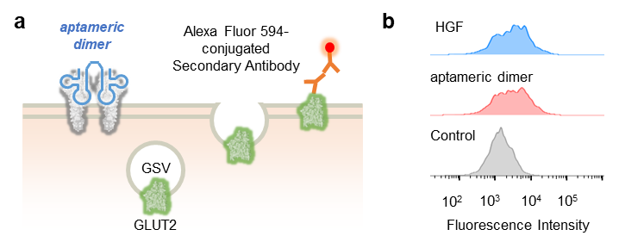

Supplementary Figure 3. Signal transduction activation mediated by the aptameric dimer. (a) Schematic representation of signal transduction mediated by the aptameric dimer. (b) Schematic diagram of in-cell western assay. (c) The BRL-3A cells were treated with the aptameric dimer (50 nM) or HGF (1 nM), respectively. The phosphorylation of Met (Y1234/1235), IRS2 (Ser731), and Akt (Ser473) was investigated using in-cell western assay. The α-tubulin was used as an internal reference. The white dashed circle represents the size of the 96-well plate.

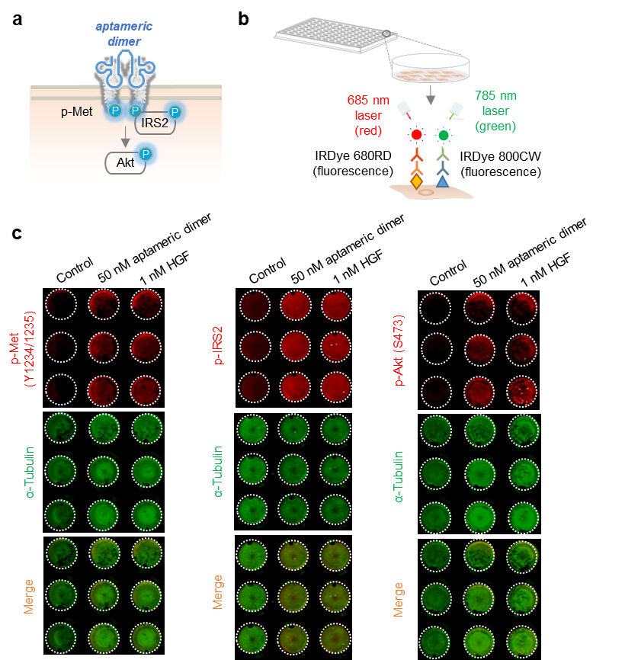

Supplementary Figure 4. Levels of key metabolites in BRL-3A cells treated with aptameric dimer (10 nM) or insulin (10 nM). Data are presented as mean ± S.D. (n = 6). P values were calculated by unpaired two-tailed Student’s t-test.

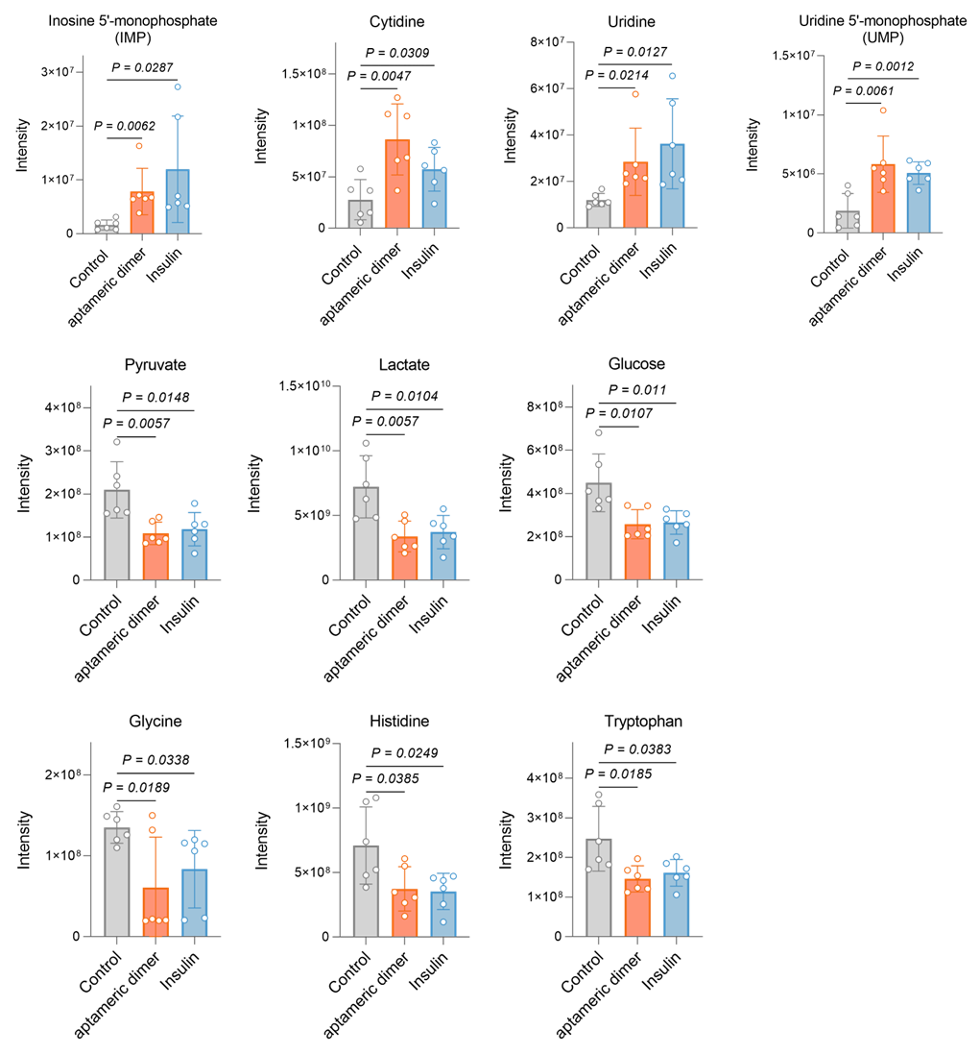

Supplementary Figure 5. Changes in glycogen accumulation in hepatocytes. (a) The glycogen synthesis of BRL-3A cells treated with aptameric dimer, HGF, and insulin was measured using a cell-specific Glycogen PAS staining kit. Nuclear staining is indicated by blue fluorescence, while glycogen deposits are visualized as red fluorescence. (b) Quantification analysis of glycogen expression. Glycogen levels were quantified by determining the ratio of red (glycogen) to blue (nuclear) fluorescence intensity using ImageJ software. Data are presented mean ± S.D. (n = 5). P values were calculated by unpaired two-tailed Student’s t-test.

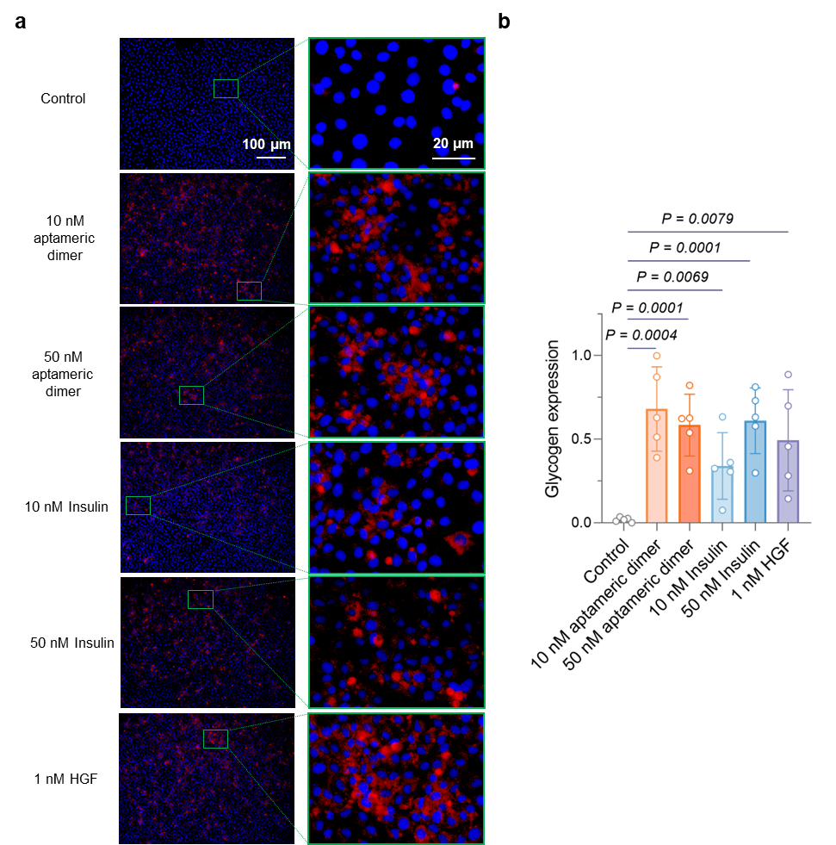

Supplementary Figure 6. Real-time live cell imaging of mCWGN-equipped BRL-3A cells responding to glucose. BRL-3A cells were incubated with mCWGN (100 nM) at 37 °C for 10 minutes. Following the addition of 10 mM glucose, real-time live cell imaging was conducted using a confocal laser scanning microscope (CLSM). Scale bar: 20 μm.

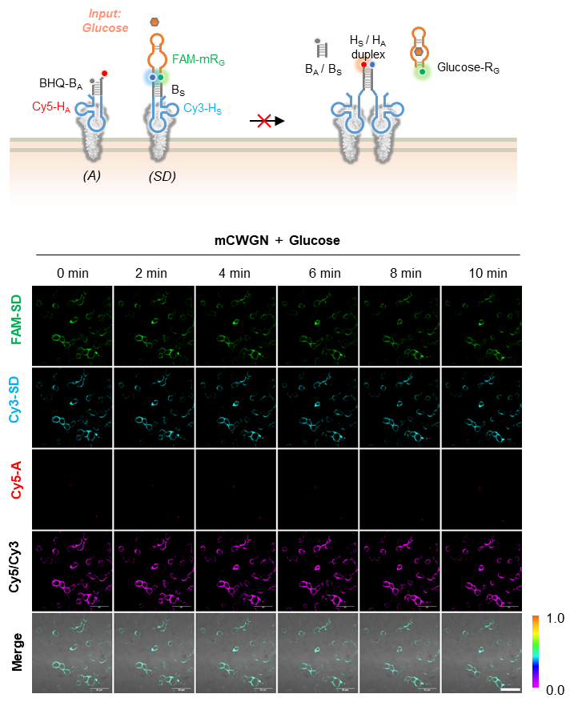

Supplementary Figure 7. (a) Schematic diagram of GLUT4 translocation mediated by AGSR. (b) Real-time image analysis of the AGSR-activation event and GLUT4 translocation of CWGN-equipped HepG2 cells that were transfected with GLUT4-EGFP plasmids for 24 hours. Representative images of TAMRA fluorescence and EGFP-GLUT4 translocation are shown, respectively. Scale bars, 10 µm. (c) The line scan analysis of the EGFP-GLUT4 translocation in (b).

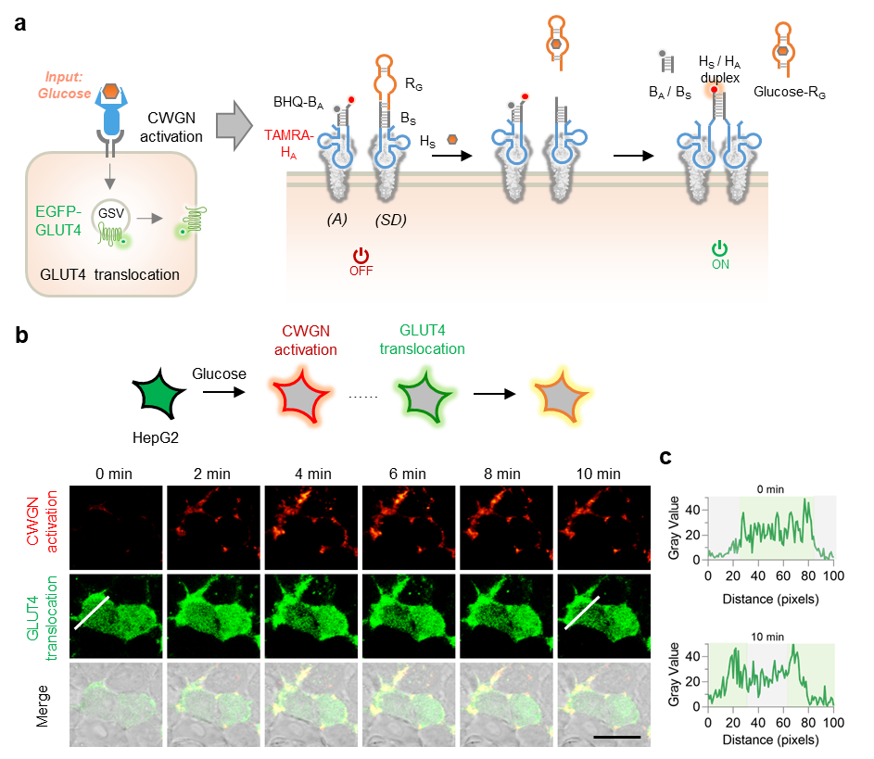

Supplementary Figure 8. (a) Schematic diagram of glucose uptake mediated by AGSR. (b) Time-dependent analysis of glucose uptake on the CWGN- equipped BRL-3A cells with or without treatment of glucose (10 mM). (c) Assessment of glucose uptake capacity in CWGN-equipped hepatocytes. Serum-starved CWGN-equipped-BRL-3A cells were incubated with or without glucose treatment for 30 minutes, followed by three washes with PBS. Glucose uptake was measured using the Glucose Uptake-Glo™ Assay kit (Promega, J1343) according to the manufacturer’s instructions. Data are presented as mean ± S.D. (n = 3). P values were calculated by unpaired two-tailed Student’s t-test.

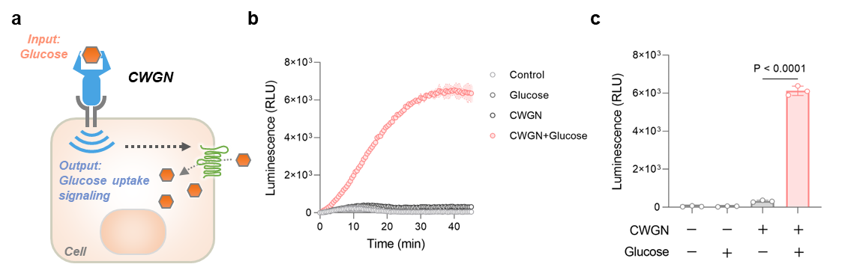

Supplementary Figure 9. Thermodynamic prediction of the secondary structure of SD subunits with different IDs using NUPACK.

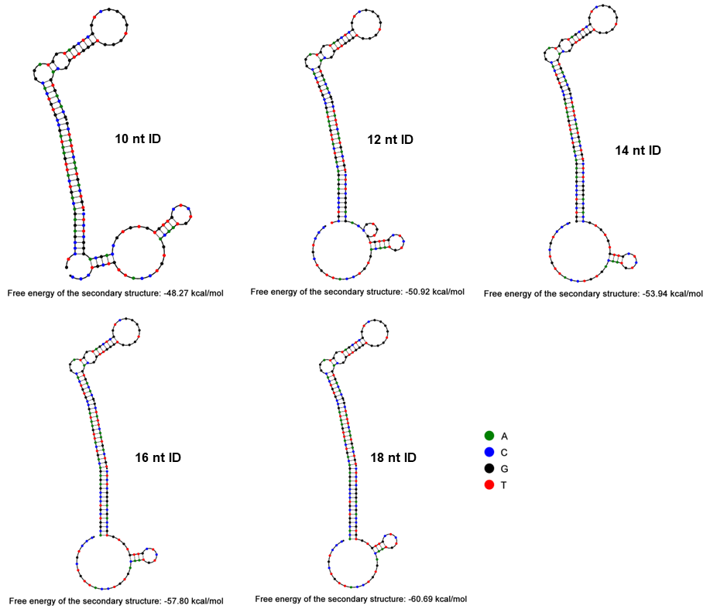

Supplementary Figure 10. The tunable glucose sensitivity of AGSR. BRL-3A cells equipped with CWGN having different IDs, mCWGN, or aptameric dimer were treated with varying concentrations of glucose. The activation of Met was then detected using immunofluorescence flow cytometry.

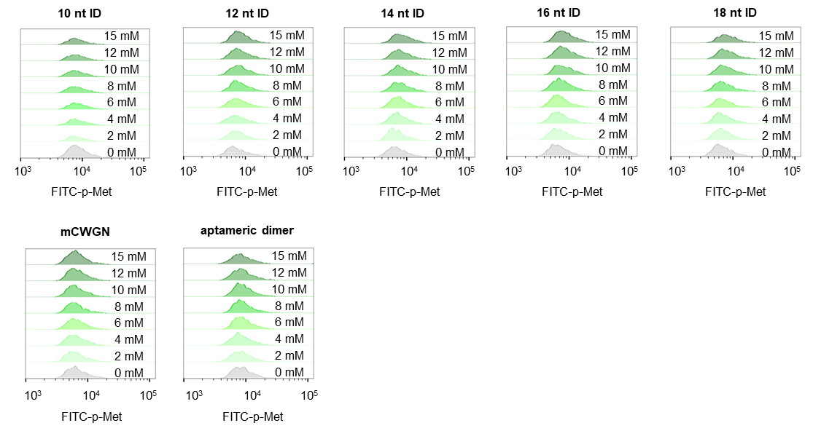

Supplementary Figure 11. Tunable glucose sensitivity of AGSR. BRL-3A cells equipped with CWGN having different IDs, mCWGN, or aptameric dimer were treated with varying glucose concentrations. The activation of Akt was detected using in-cell western assay. Quantification of relative phosphorylation level is shown in the right panel. The α-tubulin was used as an internal reference. The relative phosphorylation level was obtained by normalizing the ratio of p-Akt fluorescence to α-tubulin fluorescence, with an average value of 0 for the mCWGN group and 1 for the aptameric dimer group. The white dashed circle represents the size of the 96 well plate.

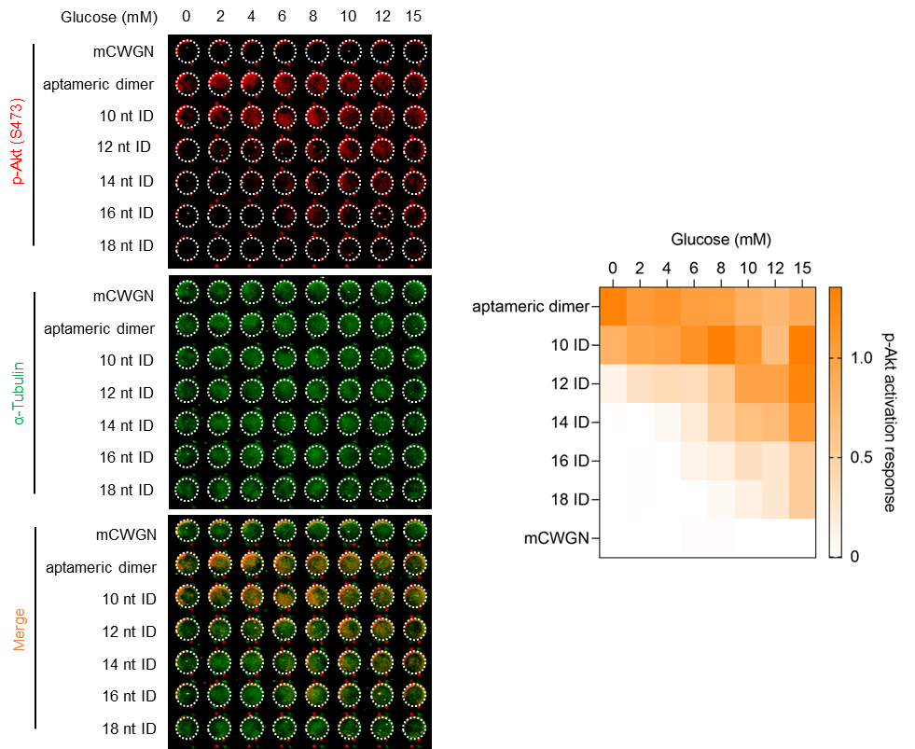

Supplementary Figure 12. AGSR-mediated glucose uptake regulation in myotubes. (a) Schematic diagram of glucose uptake regulation mediated by AGSR in myotubes. (b) Activation of AGSR-mediated signal transduction in myotubes. CWGN-equipped myotubes were treated with glucose (10 mM), and the phosphorylation of Met (Y1234/1235) and Akt (Ser473) was investigated using western blot analysis. (c) Assessment of AGSR-mediated glucose uptake in myotubes using the Glucose Uptake-Glo™ Assay kit (Promega, J1343) following the manufacturer’s instructions. Data are presented as mean ± S.D. (n = 3). P values were calculated by unpaired two-tailed Student’s t-test.

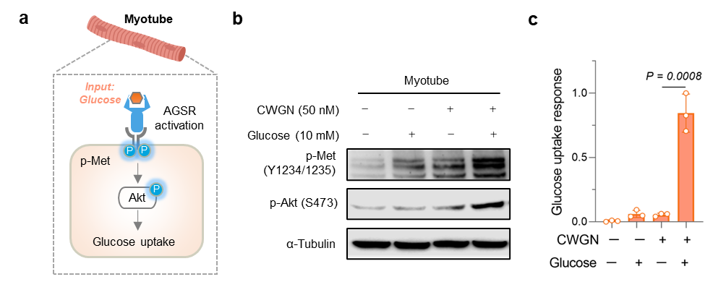

Supplementary Figure 13. Area under the curve (AUC) analysis of the IPGTT data from figure 5c. Data are presented as mean ± S.D. (n = 10). P values were calculated by unpaired two-tailed Student’s t-test.

Supplementary Figure 14. Effects of AGSR on glucose tolerance in type 2 diabetic mice. (a) Intraperitoneal glucose tolerance test (IPGTT) was performed on type 2 diabetic mice 30 minutes after administration of either CWGN or mCWGN. A glucose dose of 2 g/kg was administered to the mice, and blood glucose levels were measured at various time points to assess glucose tolerance. (b) Area under the curve (AUC) analysis of the IPGTT data from (a). Data are presented as mean ± S.D. (n = 5). P values were calculated by unpaired two-tailed Student’s t-test.

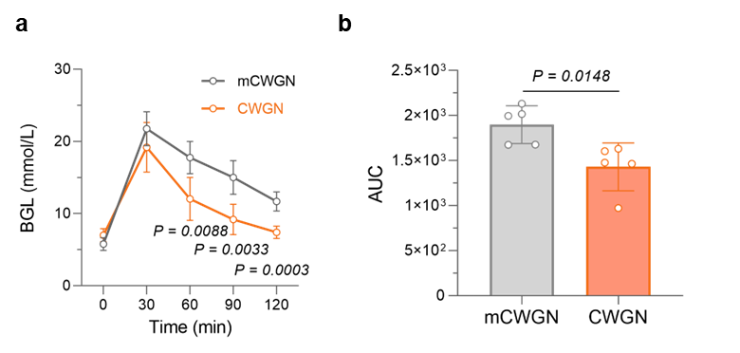

Supplementary Figure 15. Area under the curve (AUC) analysis of the IPGTT data from (Fig. 5k). Data are presented as mean ± S.D. (n = 3). P values were calculated by unpaired two-tailed Student’s t-test.

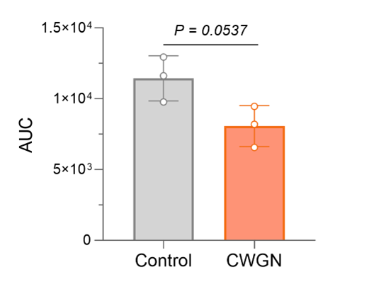

Supplementary Table 1. Oligonucleotide sequences for CWGN.

Name | Sequence (5’---3’)
H_{S-1} | GGTCGTCCCGAGAGACAGTCATTGAATAGCCGTGTCACGGATGGTAGCTCGGTCGGGGTGGGTGGGTTGGCAGTGACACGCTCTCGGTTTTTTT
H_{S-2} | GGTCGTCCCGAGAGACAGTCATTGAATAGCCGTGTCACGGATGGTAGCTCGGTCGGGGTGGGTGGGTTGGCAGTGACACG
H_{S-1}-FAM | GGTCGTCCCGAGAGACAGTCATTGAATAGCCGTGTCACGGATGGTAGCTCGGTCGGGGTGGGTGGGTTGGCAGTGACACGCTCTCGGTTTTTTT (FAM)
H_{A-1} | TTTTTTTGGCTCTCATCAGGCTGGATGGTAGCTCGGTCGGGGTGGGTGGGTTGGCAAGTCTGATGCTATTCAATGACTGTCTCTCGG
H_{A-2} | ATCAGGCTGGATGGTAGCTCGGTCGGGGTGGGTGGGTTGGCAAGTCTGATGCTATTCAATGACTGTCTCTCGG
H_{A-1}-FAM | TTTTTTTGGCTCTCATCAGGCTGGATGGTAGCTCGGTCGGGGTGGGTGGGTTGGCAAGTCTGATGCTATTCAATGACTGTCTCTCGG (FAM)
C_{H-1} | AAAAAAACCGAGAGCGTGTCACTGCCAACCCACCCACCCCGACCGAGCTACCATCCGTGACACGGCTATTCAATGACTGTCTCTCGGGACGACC
C_{H-2} | CCGAGAGACAGTCATTGAATAGCATCAGACTTGCCAACCCACCCACCCCGACCGAGCTACCATCCAGCCTGATGAGAGCCAAAAAAAA
R_{G} | CTCTCGGGACGACCGTGTGTGTTGCTCTGTAACAGTGTCCATTGTCGTCCC
B_{S} | GCTATTCAATGACTGT
B_{A} | ACAGTCATTGAATAGC
mR_{G} | CTCTCGGGACGACCGTCAATCCCGGTTTAGGCCCCAAGTTTGCGTTGTCCC
aptameric dimer | ATCAGGCTGGATGGTAGCTCGGTCGGGGTGGGTGGGTTGGCAAGTCTGATCGTGTCACGGATGGTAGCTCGGTCGGGGTGGGTGGGTTGGCAGTGACACG
Underlines indicated the complementary sequences between H_{S} and H_{A}. Blue bases indicated the aptamer sequences. Orange bases indicated the complementary sequences between H_{S} and R_{G}. Gray bases indicated the complementary sequences between the receptor-hooking strands and the blocking strands.
Supplementary Table 2. Primers for quantitative real-time PCR analysis.

Name | Sequence (5’---3’)
Pck1 forward primer | TGGCTACGTCCCTAAGGAA
Pck1 reverse primer | GGTCCTCCAGATACTTGTCGA
G6pc forward primer | CTACCTTGCGGCTCACTTTC
G6pc reverse primer | ATCCAAGTGCGAAACCAAAC

Supplementary Table 3. Oligonucleotide sequences of CWGN for CLSM imaging.

Name | Sequence (5’---3’)
Cy3-H_{S} | (Cy3) GGTCGTCCCGAGAGACAGTCATTGAATAGCCGTG  TCACGGATGGTAGCTCGGTCGGGGTGGGTGGGTTGGCAGTGACACG
H_{A}-Cy5 | ATCAGGCTGGATGGTAGCTCGGTCGGGGTGGGTGGGTTGGCAAGTCTGATGCTATTCAATGACTGTCTCTCGG (Cy5)
H_{A}-TAMRA | ATCAGGCTGGATGGTAGCTCGGTCGGGGTGGGTGGGTTGGCAAGTCTGATGCTATTCAATGACTGTCTCTCGG (TAMRA)
R_{G}-FAM | CTCTCGGGACGACCGTGTGTGTTGCTCTGTAACAGTGTCCATTGTCGTCCC (FAM)
B_{S} | GCTATTCAATGACTGT
BHQ2-B_{A} | (BHQ2) ACAGTCATTGAATAGC
Underlines indicated the complementary sequences between H_{S} and H_{A}. Blue bases indicated the aptamer sequences. Orange bases indicated the complementary sequences between H_{S} and R_{G}. Gray bases indicated the complementary sequences between the receptor-hooking strands and the blocking strands.

Supplementary Table 4. Oligonucleotide sequences of CWGN for tunable glucose sensitivity.

Name | Sequence (5’---3’)
10 nt ID-H_{S} | GTCCCGAGAGACAGTCATTGAATAGCCGTGTCACGGATGGTAGCTCGGTCGGGGTGGGTGGGTTGGCAGTGACACG
12 nt ID-H_{S} | TCGTCCCGAGAGACAGTCATTGAATAGCCGTGTCACGGATGGTAGCTCGGTCGGGGTGGGTGGGTTGGCAGTGACACG
14 nt ID-H_{S} | GGTCGTCCCGAGAGACAGTCATTGAATAGCCGTGTCACGGATGGTAGCTCGGTCGGGGTGGGTGGGTTGGCAGTGACACG
16 nt ID-H_{S} | ACGGTCGTCCCGAGAGACAGTCATTGAATAGCCGTGTCACGGATGGTAGCTCGGTCGGGGTGGGTGGGTTGGCAGTGACACG
18 nt ID-H_{S} | ACACGGTCGTCCCGAGAGACAGTCATTGAATAGCCGTGTCACGGATGGTAGCTCGGTCGGGGTGGGTGGGTTGGCAGTGACACG
H_{A} | ATCAGGCTGGATGGTAGCTCGGTCGGGGTGGGTGGGTTGGCAAGTCTGATGCTATTCAATGACTGTCTCTCGG
R_{G} | CTCTCGGGACGACCGTGTGTGTTGCTCTGTAACAGTGTCCATTGTCGTCCC
B_{S} | GCTATTCAATGACTGT
B_{A} | ACAGTCATTGAATAGC
Underlines indicated the complementary sequences between H_{S} and H_{A}. Blue bases indicated the aptamer sequences. Orange bases indicated the complementary sequences between H_{S} and R_{G}. Gray bases indicated the complementary sequences between the receptor-hooking strands and the blocking strands.

Supplementary Table 5. Predicted Gibbs free energies, and ensemble pair fraction for SD subunit with different IDs.

Name | -ΔG_{pred}  (kcal/mol) | Ensemble pair fraction
10 nt ID | 48.27 | 15.4%
12 nt ID | 50.92 | 74.9%
14 nt ID | 53.94 | 95.8%
16 nt ID | 57.8 | 99.1%
18 nt ID | 60.69 | 99.9%

Supplementary Table 6. Oligonucleotide sequences for biodistribution experiment.

Name | Sequence (5’---3’)
Cy5-H_{S} | (Cy5) GGTCGTCCCGAGAGACAGTCATTGAATAGCCGTG  TCACGGATGGTAGCTCGGTCGGGGTGGGTGGGTTGGCAGTGACACG
H_{A}-Cy5 | ATCAGGCTGGATGGTAGCTCGGTCGGGGTGGGTGGGTTGGCAAGTCTGATGCTATTCAATGACTGTCTCTCGG (Cy5)
R_{G} | CTCTCGGGACGACCGTGTGTGTTGCTCTGTAACAGTGTCCATTGTCGTCCC
B_{S} | GCTATTCAATGACTGT
B_{A} | ACAGTCATTGAATAGC
Underlines indicated the complementary sequences between H_{S} and H_{A}. Blue bases indicated the aptamer sequences. Orange bases indicated the complementary sequences between H_{S} and R_{G}. Gray bases indicated the complementary sequences between the receptor-hooking strands and the blocking strands.

