Supplementary Material

1. Methods
1.1 Participants:
The following are the inclusion and exclusion criteria for participant recruitment.
Inclusion criteria:
- 6-25 years of age;
- ambulation;
- good physical health;
- ability to give written informed consent (to be interviewed in English);
- intelligence quotient >80;
- normal or corrected-to-normal vision.
Exclusion criteria:
- neurological abnormalities such as seizure disorders;
- history of head injury with a sustained loss of consciousness;
- chronic medical illness or known Mendelian disorder;
- history of substance abuse or dependence;
- use of psychotropic medication during the past month;
- recent weight loss leading to body weight less than 85% than expected for age and height.

1.2 Genotyping
Pediatric clinical samples were collected and extracted in different sites: the samples were collected either at the University of Michigan, Ann Arbor, MI USA; or Wayne State University, Detroit, MI USA; DNA was extracted either at SickKids Hospital in Toronto, ON Canada, or at the University of Calgary. 525 samples out of total 661 were genotyped using the Illumina Multi-Ethnic Global-8 kit (MEG) Array by Delta Genomics (from January 2019 NeoGen) Corporation. Later, 136 samples with matching phenotypes that were genotyped earlier were included. The 136 samples were genotyped using either Illumina Omni 2.5 – 8 kit, PsychChip Illumina microarray, or Human Core Exome kit. All these four genotyping arrays together allowed us to test around 1.7 million unique markers.
1.3 Genome-Wide Association Study
1.3.1 SNP Imputation
SNP imputation was done on the Michigan Imputation Server (MIS). MIS provides imputation via Minimac4 software using 1000 Genome project phase 3v5 as the reference genome [1]. Eagle v2.4 was implemented for phasing. The input data was prepared using BCFtools which handles variant call format (vcf) files [2]. The refence panel 1000 Genomes phase 3v5 consists of 2,504 samples and 49,143,605 markers.
1.3.2 Quality control steps
After obtaining the whole imputed genotyped data, quality control (QC) analysis was conducted using standard methods with PLINK v2.00 [3]. Following are the major QC filters for genetic markers and samples [4] [5]:
- Genotyping call rates: samples were excluded for high missingness rate >3%. This filter is effective as it excludes the variants that are missing in a large number of subjects due to poor DNA quality or technical problems.
- Minor Allele Frequency (MAF): SNPs with MAF <1% were excluded. MAF is the frequency of the least often occurring allele at a specific location. The threshold generally depends on sample size and improper application of this filter will result in genotyping errors.
- Hardy-Weinberg equilibrium (HWE): SNPs that do not pass HWE were excluded from further analysis. We used a HWE threshold of p-value < 10⁻⁶ for quantitative traits. Violation of HWE law indicates that the frequencies are extremely different from expectations.
- Sex discrepancy: this step assures that samples with biological sex inconsistencies are excluded.
- Heterozygosity rate: Samples with extreme high and low heterozygosity rates were excluded.
- Relatedness: an assumption of GWAS is the absence of cryptic relatedness. To check for this, relatedness threshold of second-degree relatives (pihat>0.2) was applied.
- Population stratification: the last step was to check population stratification using a multidimensional scaling approach [6]. The reference HapMap3 genome data was used for this step [7].
1.4 Polygenic Risk Scores (PRS)
1.4.1 PRS Data
Target Data
OCS data in the current study
Target data is the OCS 587 samples with ~6 million genotyped and imputed markers that we ran GWAS using CBCL-OCS as a quantitative trait. Using this target data, we ran six LDpred2 PRS tests [8] using base data from six different disorders; and one PRSice2 PRS [9] test using OCS as base data to train the model.
Base Data
All seven datasets were accessed from PGC Working groups and were run using either LDpred2-auto or PRSice2. All base data meta-analyses show and prove the polygenic architecture of the traits. All six base datasets had heritability of greater than 5% which is a requirement for LDpred2 analysis.
OCD Data by Strom et al. [10]
OCD GWAS meta-analysis was conducted on 53,660 cases and 2,044,417 controls from 28 European-ancestry cohorts including data from 23andMe cohort. This meta-analysis was run on 6,791,632 SNPs and had a SNP heritability (LDSC) of 6.7%. The study identified 30 independent genome-wide variants. As we did not have permission to use 23andMe data, we used GWAS summary statistics from 23,493 cases and 1,114,613 controls from 27 cohorts excluding 23andMe samples.
Anxiety Data by Otowa et al. [11]
Base data for ANX was obtained from the meta-analysis of GWAS of anxiety disorders of 7,016 cases and 13,745 controls. This included data from 7 European-ancestry cohorts. The significant association was observed on variants on locus 3q12.3 (p-value=1,65 x 10⁻⁸). SNP-heritability was 13.8%.
ADHD Data by Demontis et al. [12]
Meta-analysis of GWAS ADHD was carried out on 38,691 cases and 186,843 controls from 12 European-ancestry cohorts. This analysis included 6,774,224 variants and revealed 27 genome-wide significant loci. The SNP-heritability estimate was 14%.
MDD Data by Howard et al. [13]
Meta-analysis of three large MDD GWAS European-ancestry cohorts included 246,363 cases and 561,190 controls. They ran the analysis on 8,098,588 variants and identified 102 independent SNPs. SNP heritability was 9%.
ASD Data by Grove et al. [14]
ASD data was obtained from 10 European-ancestry cohorts of 18,381 cases and 27,969 controls and was ran on 9,112,387 variants. They identified 5 significant loci associated with ASD. SNP heritability was 11.8 %.
TD Data by Yu et al. [15]
GWAS meta-analysis of TS was run on 4,819 cases and 9,488 controls from 5 European-ancestry cohorts consisting of 8,265,319 markers. Only one locus on 13q12.2 (p-value=2.1x10⁻⁸) passed the p-value threshold, top 10 of the suggestive significant loci were identified. SNP heritability was estimated to be 21 %.
OCS Data by Strom et al [16]
GWAS meta-analysis of OCS included 33,943 samples with OC scores from 7 European-ancestry cohorts. 6,232,765 variants were included in the analysis. Z-score estimates from OC score on several questionnaires were utilized as OCS quantitative traits. No genome-significant hits were identified; nevertheless, suggestive significance SNPs were identified for the further analysis. SNP-heritability was 4.1 %.
1.5 Mendelian Randomization (MR)
The MR estimates are considered to show pleiotropic effects under the instrument strength independent of direct effect (InSIDE) assumption[17] [18]. There are different methods to apply MR, such as the Wald ratio estimator, inverse-variance weighted (IVW) method, MR-Egger test, and weighted median estimator. One of the most popular approaches is the IVW. It is a two-sample MR method, meaning that the effect sizes for exposure and outcome cannot be the same. IVW estimates the weighted average of the causal effect of the instrumental variables, i.e. genetic variants [19].
After calculating the MR estimates, the IVs were filtered out using two leave-one-out approaches: 1) Cook’s distance - indicates the measure of leverage and if the datapoint influences the MR estimates, they are removed [20]; 2) MR-PRESSO- evaluates the horizontal pleiotropy, detects the outliers, and removes them [21]. After the analysis MR-PRESSO performs three tests: 1) Global Test - provides a p-value which indicates the existence of horizontal pleiotropy. When the global test is insignificant (p-value > 0.05) it means that MR is valid ; 2) Outlier Test – corrects and removes outliers; 3) Distortion Test – evaluates significant distortion in the causal estimate before and after MR-PRESSO.

2. Results
2.1 Descriptive statistics
Table S1 shows the descriptive statistics of 587 samples that remained after QC steps.
As mentioned before, we collected around 400 cases that are clinically diagnosed with one or more disorders such as OCD, ANX, ADHD, MDD, ASD, TS, and healthy controls free of any mental illness diagnosis. We also ran correlation analysis to see if there is any significant correlation with CBCL-OCS and biological sex, age and diagnosis (Table S2). Table S2 shows that there was no significant correlation between CBCL-OCS scores and age (p=0.7), and CBCL-OCS and biological sex (p=0.2). As expected, there was a significant correlation between CBCL-OCS and binary diagnosis of cases with one or more disorders and controls.
Table S1: Descriptive statistics.
Descriptive statistics of 587 samples post-QC. All 587 samples were included for all the genetic analysis steps.

Descriptive Statistics
Samples Analyzed | 587  397cases/190 controls
CBCL-OCS score | 0-16 range  Mean = 3.2  Mean_{Cases}=5.1 Mean_{Control}=1.01
Age (Min-Max) | 6-25  Mean=14.5, SD=3.75
Gender (M/F) | 258/329

Table S2: Results from correlation analysis between CBCL-OCS and demographics.
CBCL-OCS vs Age was tested using Pearson correlation and it shows there is not significant relationship between CBCL-OCS and age; CBCL-OCS vs Sex and CBCL-OCS vs Diagnosis (*) was run using Student’s t-test. There was a significant correlation between CBCL-OCS and diagnosis.
 | Coefficient | p-value
CBCL-OCS and Age | 0.01 | 0.7
CBCL-OCS and Sex | 0.03 | 0.2
CBCL-OCS and Diagnosis | 0.3 | <0.001*

Table S3: Mental disorders DSM-5 and K-SADS-PL diagnostic characterizations

OCD | Obsessive-compulsive disorder:  OCD cases have current Children’s Yale Brown Obsessive Compulsive Scale (CY-BOCS) score ≥10
ANX | Cases with Anxiety disorders include separation anxiety disorder, specific phobia, social anxiety disorder (social phobia), panic disorder, agoraphobia, and generalized anxiety disorder
MDD | Depressive disorders are specified as major depressive disorder and persistent depressive disorder.
ADHD | Attention-deficit/hyperactivity disorder cases included in the study who routinely discontinue a stimulant medication during school breaks.
ASD | Autism spectrum disorder cases were assessed via 2013 version of K-SADS-PL 2013 which lacks the detail of the ADI/ADOS. Instead, the SCQ was obtained on almost every case and used to identify those with scores over 14.
TD | Tic disorders are specified as Tourette's disorder, persistent motor or vocal tic disorders, and provisional tic disorder.

Table S4 shows that most of the disorders are comorbid and 50% of the participants were diagnosed with more than one mental disorder and 20% of the samples are diagnosed with only one disorders. According to the diagnosis in our samples 1) most comorbid two disorders were: OCD and ANX, OCD and TS, ANX and ADHD, ASD and ADHD, ASD and MDD; 2) most comorbid three disorders were: OCD, ANX and TS; OCD, ANX and ADHD; OCD, ANX and MDD, 3) Most comorbid four disorders are: OCD, ANX, TS and ADHD; OCD, ASD, TS and MDD; ASD, TS, ADHD and MDD.
Table S4: Clinical diagnoses of the 587 samples.
Only small proportion of the “cases” are diagnosed with one disorder. The most comorbid disorder in the sample is OCD, then ANX.
Disorder | Diagnosed | No comorbid diagnosis
OCD | 210 | 85
ANX | 189 | 44
ADHD | 125 | 43
MDD | 63 | 9
ASD | 29 | 5
TS | 48 | 9
Other | 48

2.2 Distribution of CBCL-OCS
As it is reported in Table S2 there is a significant correlation between CBCL-OCS and mental health diagnosis. Figure S1 shows the distribution of CBCL-OCS scores for “healthy controls” and diagnosed “cases”. Figure S2 shows 96% imputation rate per chromosome. Overall, we had 1,751,593 SNPs pre-imputation. After the imputation the number increased to 46,734,388 SNPs. Next QC steps were applied: 1) INFO > 0.3 filter was applied and 14,691,932 SNP remained (Figure S3 A); 2) MAF>1% was applied to and 9,179,840 SNPs remained for further GWAS QC steps (Figure S3 B).
Figure S1: Distribution of CBCL scores.
Distribution of CBCL-OCS scores for diagnosed “cases” and healthy “controls”. The mean for “controls” is equal to 1 and mean for “cases” is 5.1.
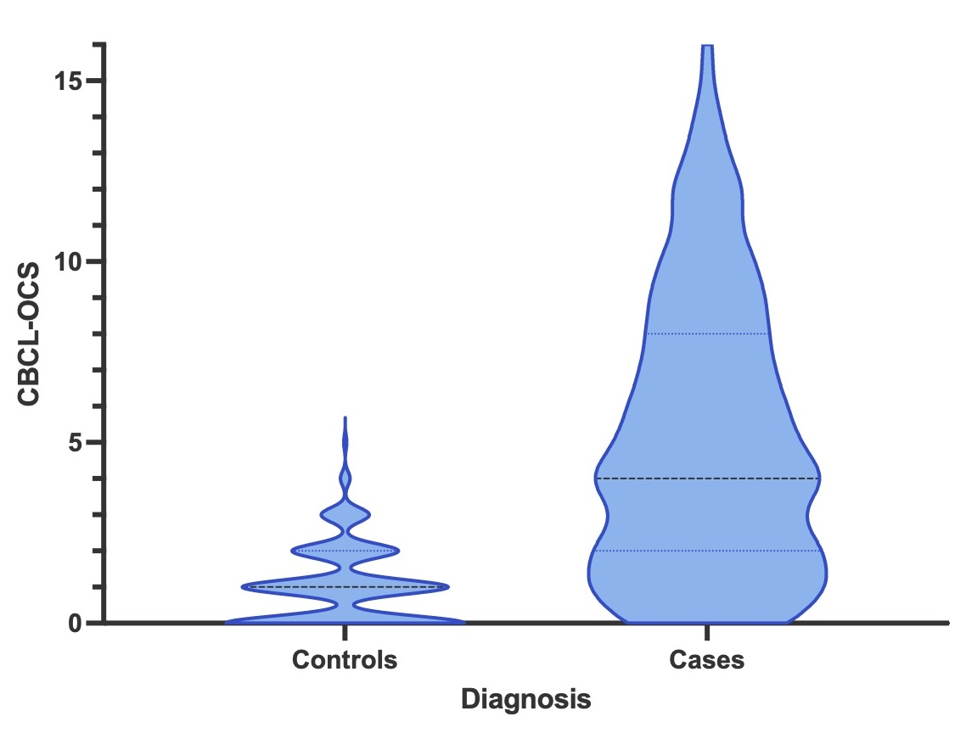

Figure S2: SNP imputation rate per chromosome.
Blue bars are the number of SNPs before the imputations, green bars show the increase of the number of SNPs after the imputation, and consequent QC steps.
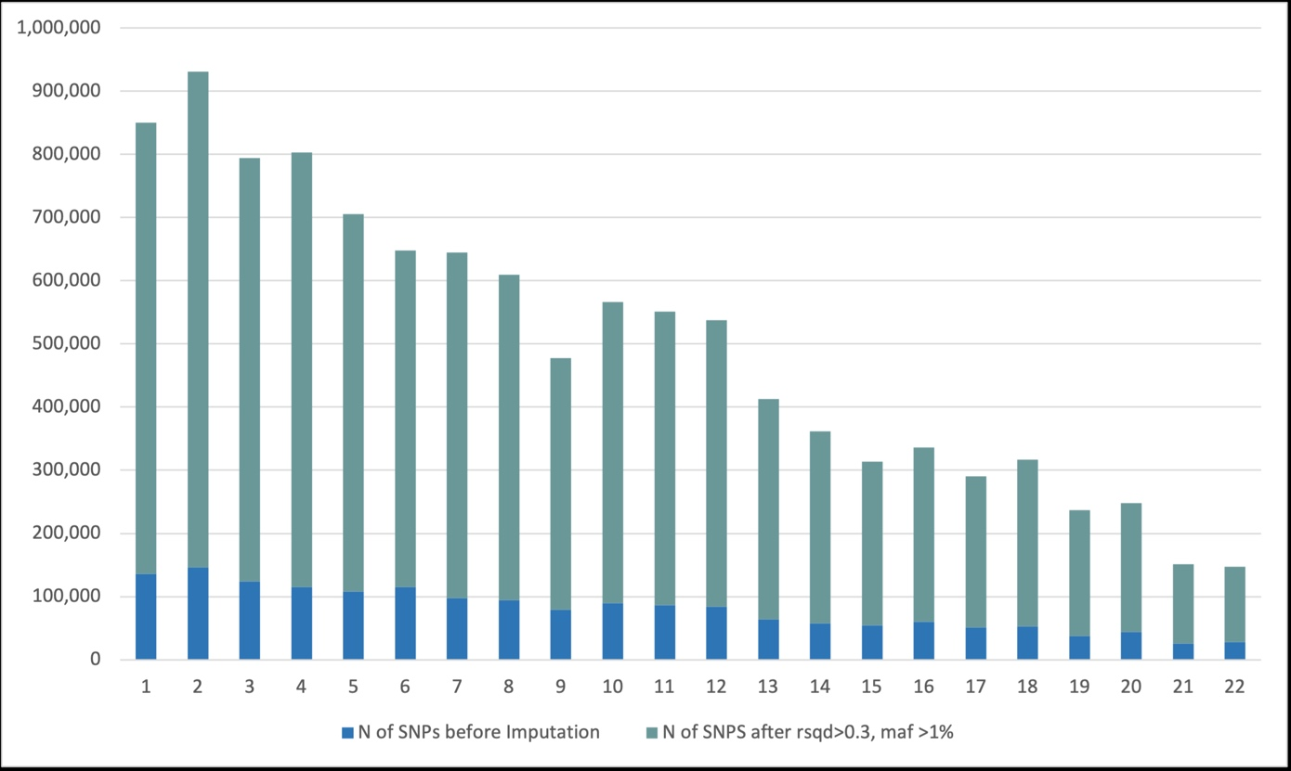
Figure S3: SNP imputation QC filters.
- INFO > 0.3; B) MAF > 1% . 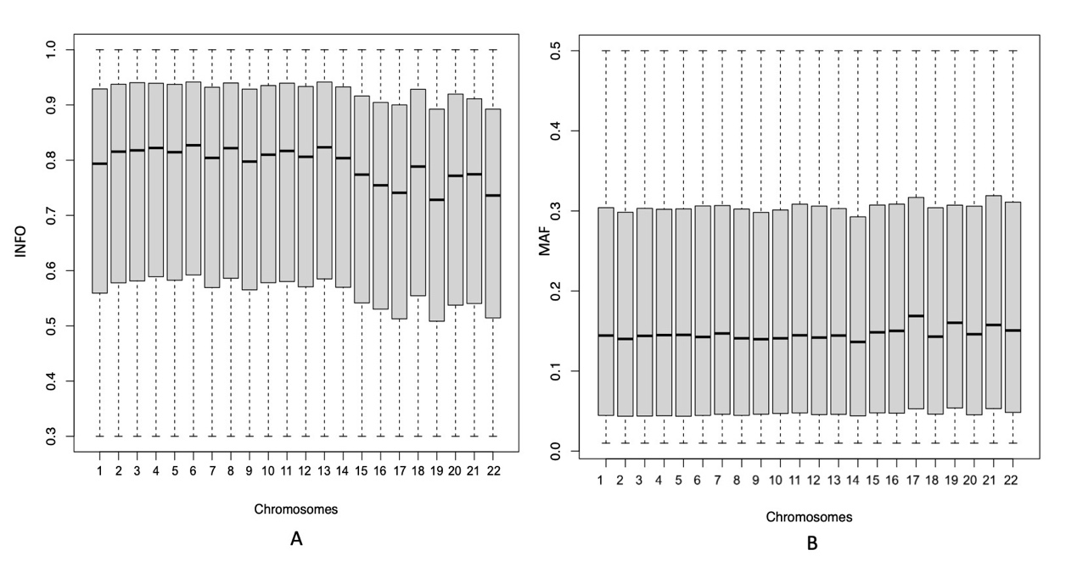
Figure S4: Population stratification plot.
Our samples (+ OWN) are mainly from European (o EUR) and mixed American (o AMR) ancestry. No samples were identified from African (o AFR) or Asian (o ASN) ancestry.
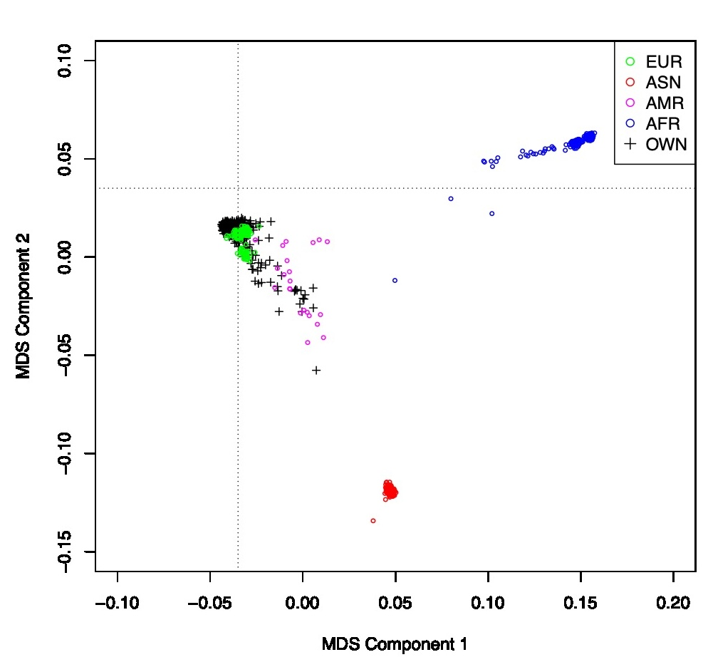
2.3 Genome-Wide Association Study
Quality control
Here are the results after running GWAS QC steps that were introduced above:
- Genotyping call rates: 625 samples passed the genotyping call rates. 98.3% of SNPs passed the missingness rate of 0.03.
- MAF: this was already implemented in the previous post-imputation QC (Figure 3.S3 B).
- HWE Equilibrium: 99.9% of SNPs passed p-value <10⁻⁶ threshold.
- Sex discrepancy was corrected based on X and Y chromosomes.
- Heterozygosity rate: 1 sample with a heterozygosity rate deviating more than 6 SD from the mean was removed.
- Relatedness: none of the samples were related (threshold of second-degree relatives).
- Population Stratification: after filtering, one samples was removed, and 623 samples remain for further analysis (Figure S4)
GWAS Results
A Miami plot of the SNP-based (upper panel) and gene-based (lower panel) association results are shown in Figure 2. No genomic inflation was detected, QQ plots of the SNP-based (λ =0.993) and gene-based (λ =1.03) association results are in Figure S5.
Figure S5: QQ plots of association analysis.
A) SNP-based GWAS λ =0.993; B) gene-based GWAS λ =1.0). No genomic inflation was detected.
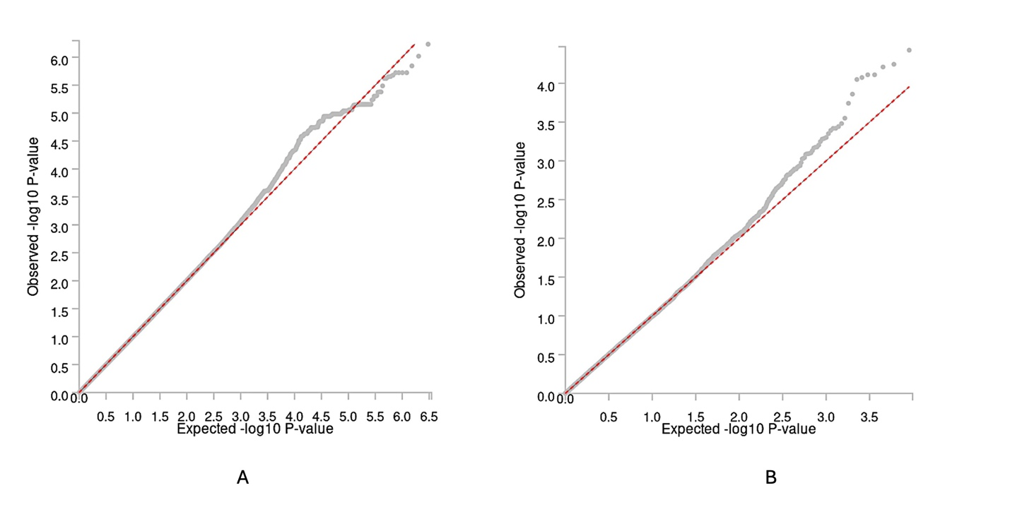

As expected, due to the small sample size no significant variants passed the strict Bonferroni p-value thresholds: SNP-based association p-value < 5x10⁻⁸ (Figure 2 upper panel); gene-based association p-value < 0.05/18 055 =2.8x10⁻⁶ (Figure 2 lower panel). Consequently, we used suggestive significance p-value thresholds of 1x10⁻⁵ for SNP-based (Figure 2 upper panel) and 1x10⁻³ for gene-based tests (Figure 2 lower panel) to identify top associations (Table S5).

Table S5: Top 10 of GWAS variants.
Top 10 of suggestive genome-wide significant variants identified after association analysis of OCS. Nearest genes to the top variants are identified using gene mapping techniques.
Variant | rsID | Alleles | P-Value | Beta | MAF | INFO | Nearest Gene
17:33961713 | rs150013080 | C/T | 6x10⁻⁷ | 3.9 | 0.02 | 0.82 | AP2B1
4:149062985 | rs111805629 | C/T | 1.4x10⁻⁶ | 2.7 | 0.04 | 0.79 | NR3C2
19:18142423 | rs424608 | T/C | 1.9x10⁻⁶ | 1.3 | 0.2 | 0.92 | IL12RB1
5:114926421 | rs419939 | T/C | 2x10⁻⁶ | 1.1 | 0.3 | 0.79 | TICAM2
7:6575582 | rs139834775 | G/A | 2.2x10⁻⁶ | 2.8 | 0.03 | 0.88 | GRID2IP
17:71773592 | rs73343491 | T/C | 2.3x10⁻⁶ | 1.7 | 0.1 | 0.86 | LINC
6:66903215 | rs143062223 | A/G | 2.4x10⁻⁶ | 4.8 | 0.011 | 0.72 | NUFIP1P1
13:44251688 | rs9567245 | C/T | 3.3x10⁻⁶ | 2.3 | 0.05 | 0.7 | ENOX1
9:104072782 | rs77498727 | C/T | 4.2x10⁻⁶ | 4.4 | 0.011 | 0.7 | PLPPR1
22:21395784 | rs6519739 | T/C | 5x10⁻⁶ | 1 | 0.4 | 0.72 | SLC7A4

Table S5 shows top genome-wide significant SNPs along with their alleles, effect sizes, MAF, INFO scores, and genes that are at the nearest distance to them. SNPs from chromosomes 4, 5, 6, 7, 9, 13, 17, 19, and 22 have suggestive significant association with quantitative OCS as measured using the CBCL-OCS (Table S5). rs150013080 is directly mapped to AP2B1 gene, rs111805629 to NR3C2, rs424608 to IL12RB1, rs419939 to TICAM2, rs139834775 to GRID2IP, rs9567245 to ENOX1, rs77498727 to PLPPR1, the remaining three SNPs were in the regions of pseudogenes or lincRNA (Table S5) and current information on these SNPs and genes are very limited. A closer look on the identified loci is visualized in Figure S6.
2.4 Polygenic Risk Scores
For controlling the quality of the variants included in the LDpred2-auto run, SNPs that were matched within LD-reference matrix, summary statistics and the target data were included (Figure S7). Figure S8 shows the paths of LDpred2-auto parameters for six disorder tests. The h2 is the SNP heritability and p is the proportion of the causal variants. Standardized PRS scores across the normal distribution curve for each individual were identified and reported in Figure S9.
2.5 Mendelian Randomization
IVs were 356 SNPs that contributed to the OCS-OCS PRS score. The results were obtained after running PRSice2 where the best model is presented in Figure S10.
Table S7 the global test P-value from MR-PRESSO and Cochran’s Q from MR IVW run. Global test P illustrates the horizontal pleiotropy bias, and the Cochran’s Q detects if there is heterogeneity bias among selected IVs i.e. the genetic variants. There was no horizontal pleiotropy detected for ANX, ADHD, ASD and TS; there was no IV heterogeneity bias detected for ANX, ASD and TS.

Figure S6: Top suggestive significant loci associated with OCS.
Eight SNPs from eight chromosomes were from coding regions and mapped to their nearest genes.
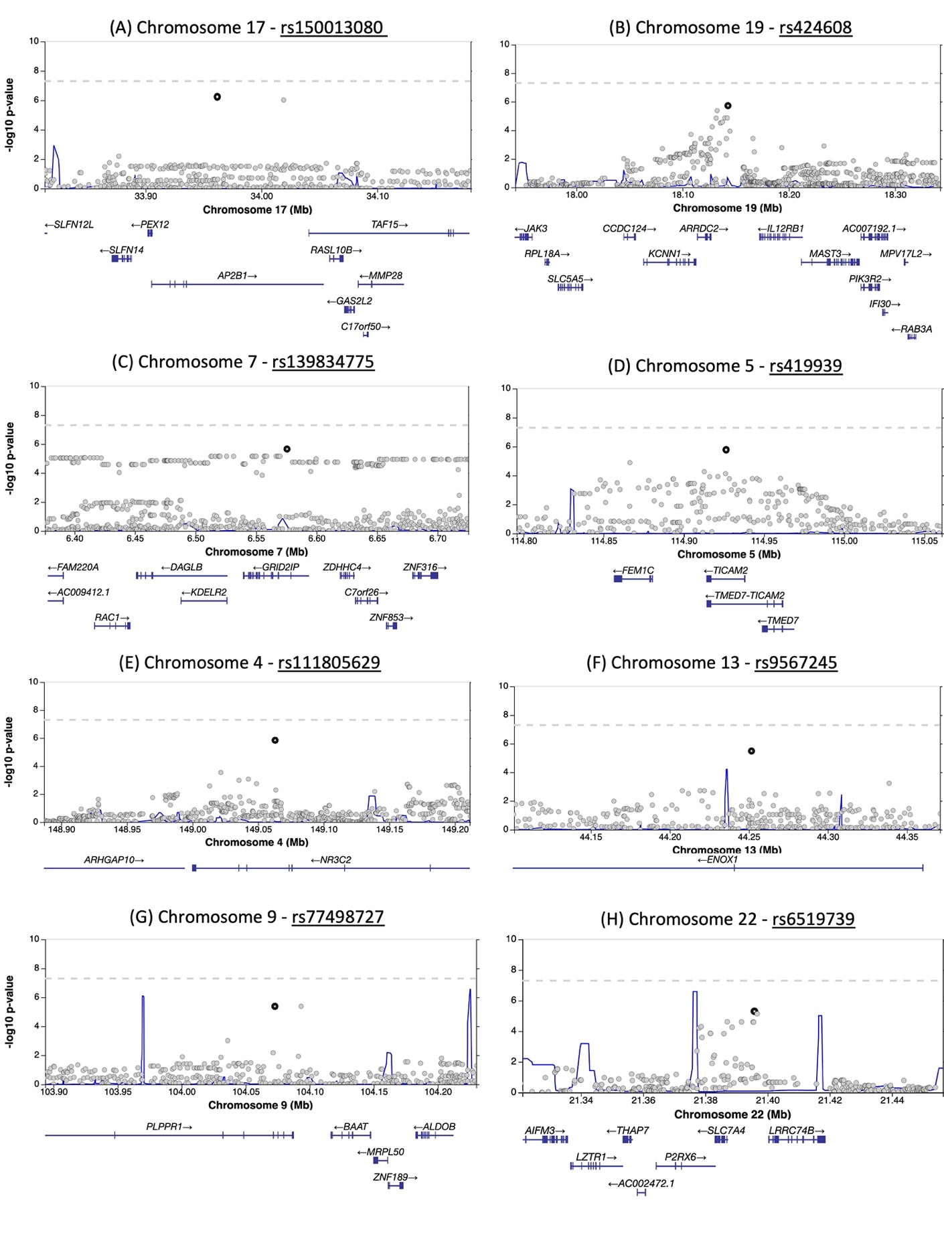
Figure S7: SD derived for six PRS tests.
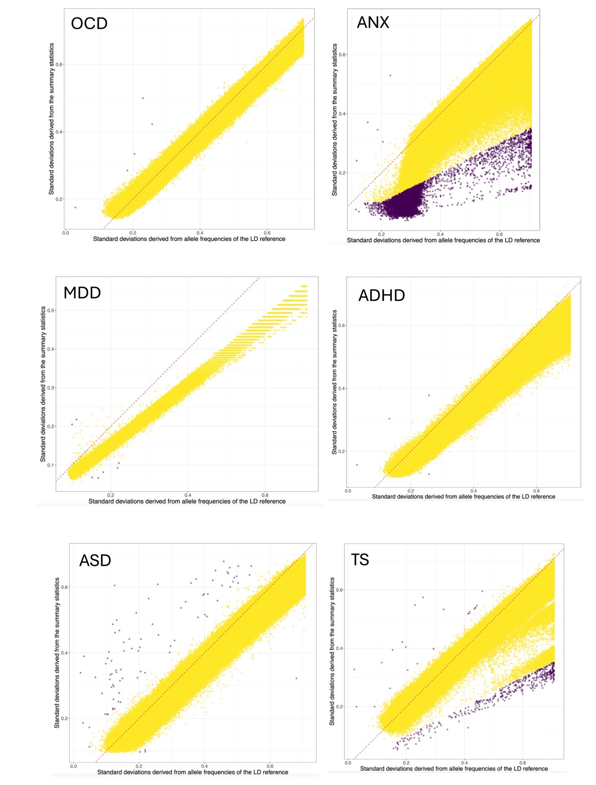
Standard deviation derived from the six summary statistics against the SD of genotypes from HapMap3+ reference data. Every point is a SNP, yellow - passed the QC filters, purple - they were filtered out.
Figure S8: LDpred2-auto parameters.
p - proportion of causal variants (upper panel); h² - the SNP heritability (lower panel) for OCD, ANX, MDD, ADHD, ASD, and TS.
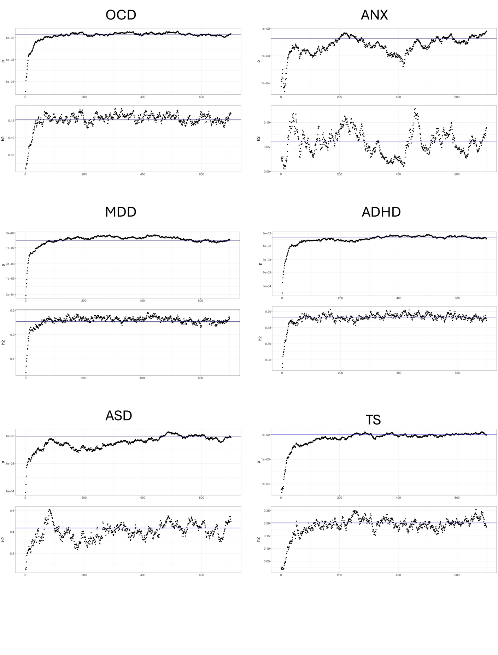

Figure S9: Distribution of standardized PRS scores across 587 participants.
Distribution of standardized PRS scores across 587 participants. The rug on the x axis shows the score for each individual. The individuals on the right edge have a higher risk of developing the phenotype of interest.
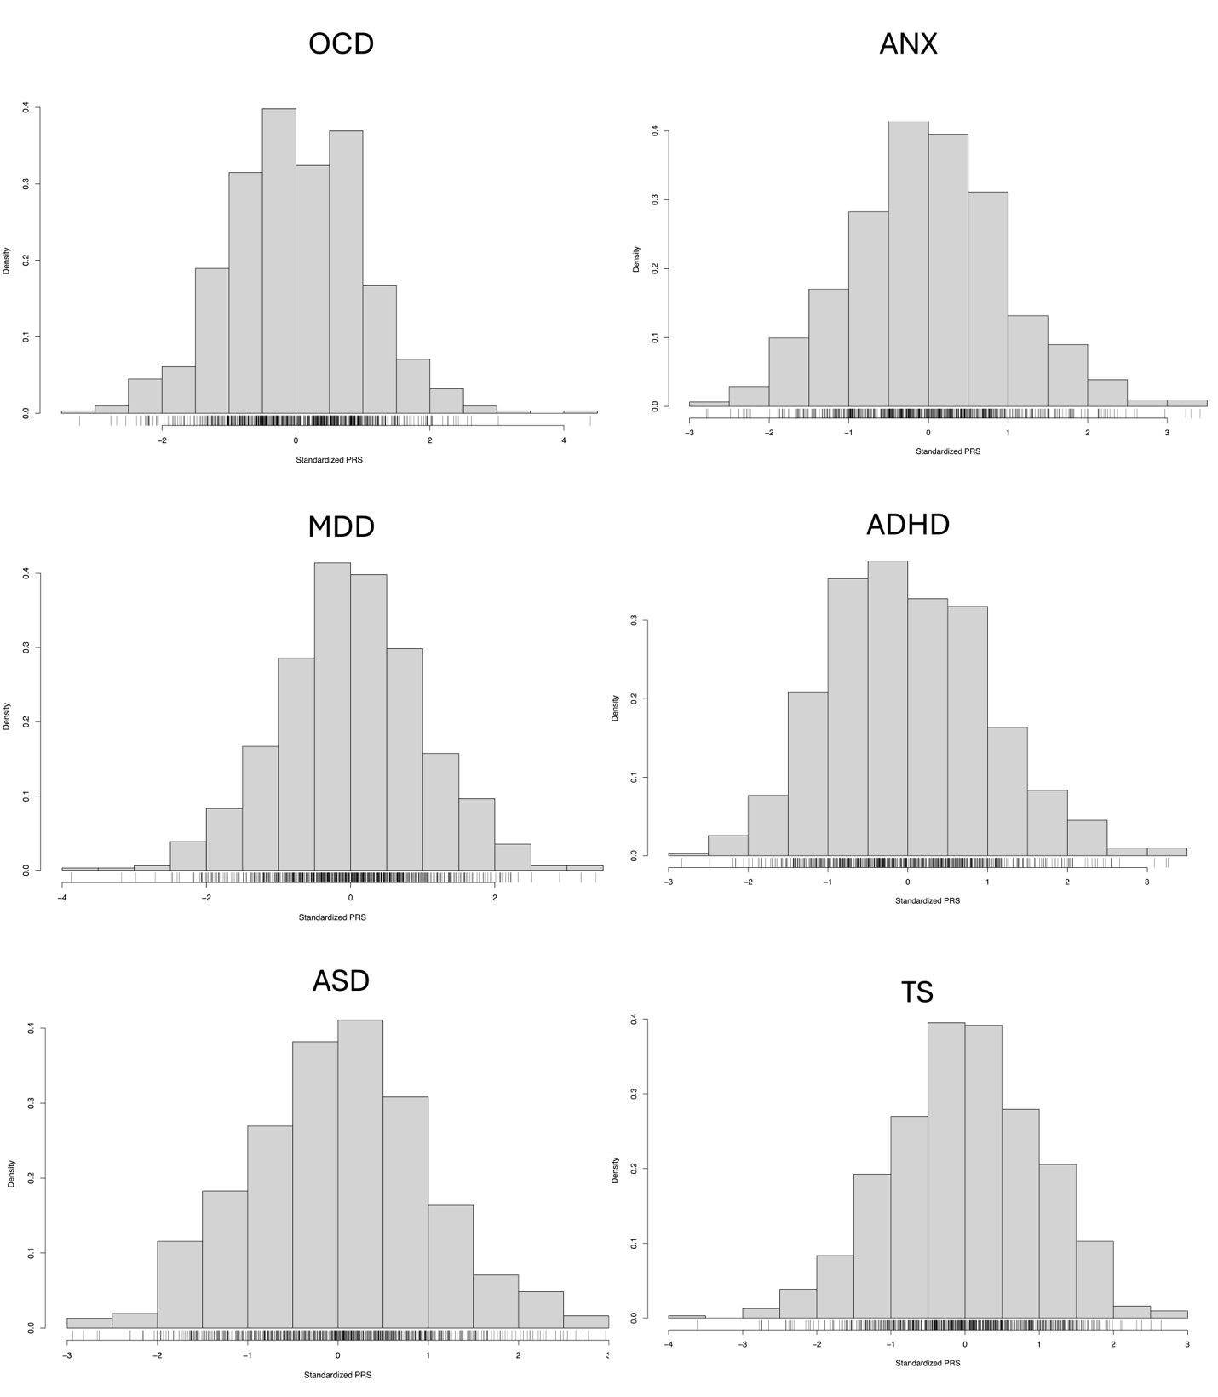
Figure S10: PRSice2 test using our OCS against PGC OCS data.
PRSice2 test using current OCS data as target, and PGC OCS as base data. (A) Bar plot of the models at broad p-value thresholds of C+T predicting OCS severity. “Best fit” model p-value represents the red bar which was 0.059. (B) High resolution plot that presents model fit of PRS at all P thresholds. (C) Quantile plot shows the effect of increasing PRS on predicted risk of OCS.
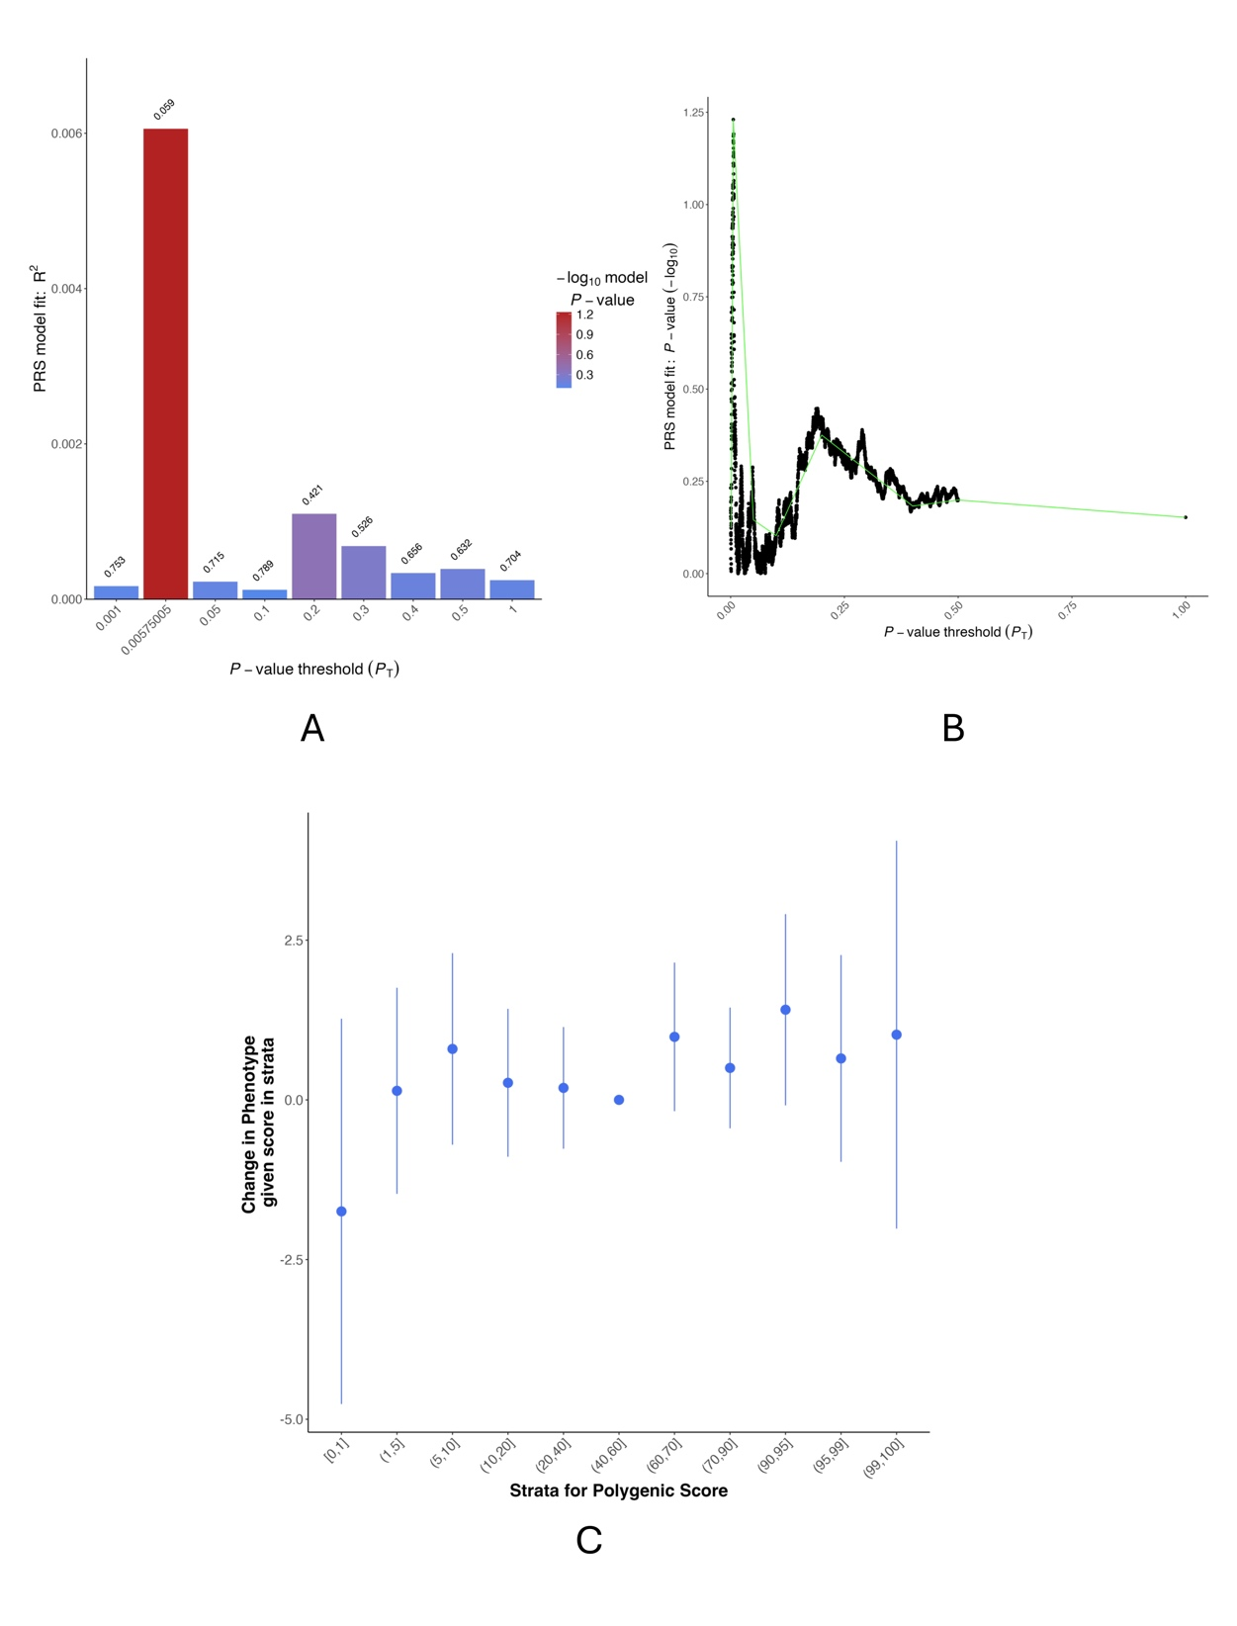
Table S6: Gene-set enrichment analysis based on GWAS results.
GOBP means the sets are from Gene Ontology (GO) biological processes, GOCC means they are from GO Cellular Component, WP means they are from WikiPathways. P is the p-value, P_{bon} is the Bonferroni corrected p-value. No set passed the Bonferroni correction p-value.

Gene Set | N_{genes} | Beta | SE | P | P_{bon}
(GOBP) negative regulation of receptor internalization | 15 | 0.74 | 0.2 | 0.0001 | 1
(GOBP) positive regulation of catecholamine secretion | 12 | 0.9 | 0.24 | 0.0001 | 1
(GOBP) ATP biosynthetic process | 86 | 0.3 | 0.09 | 0.0003 | 1
(GOBP) regulation of ATP biosynthetic process | 17 | 0.7 | 0.2 | 0.0003 | 1
(GOBP) regulation of striated muscle tissue development | 17 | 0.7 | 0.2 | 0.0003 | 1
(WP) hedgehog signaling pathway | 16 | 0.76 | 0.23 | 0.0004 | 1
(GOBP) anterograde dendritic transport | 9 | 0.91 | 0.28 | 0.0005 | 1
(GOCC) NURF complex | 5 | 1.26 | 0.38 | 0.0005 | 1
Response to TZD | 11 | 0.91 | 0.28 | 0.0006 | 1
(GOBP) plasma membrane phospholipid scrambling | 23 | 0.59 | 0.18 | 0.0007 | 1

Table S7: MR tests results.
Significant global test results indicate the presence of horizontal pleiotropy bias. Cochran’s Q show the heterogeneity between IVs: there is no bias if the first number is smaller than the second one. No horizontal pleiotropy was detected for ANX, ADHD, ASD and TS; no IV heterogeneity bias was detected for ANX, ASD and TD.
Outcomes | Global test P | Cochran’s Q  (degrees of freedom)
OCD | <0.001 | 524 on 465
ANX | 0.6 | 275 on 279
ADHD | 0.16 | 478 on 446
ASD | 0.8 | 439 on 464
MDD | 0.006 | 522 on 487
TS | 0.9 | 425 on 459

References
- Das, S., Forer, L., Schönherr, S., Sidore, C., Locke, A. E., Kwong, A., et al. (2016). Next-generation genotype imputation service and methods. Nature Genetics, 48(10), 1284–1287.
- Danecek, P., Bonfield, J. K., Liddle, J., Marshall, J., Ohan, V., Pollard, M. O., et al. (2021). Twelve years of SAMtools and BCFtools. Gigascience, 10(2).
- Purcell, S., Neale, B., Todd-Brown, K., Thomas, L., Ferreira, M.A., Bender, D. et al. (2007). PLINK: A tool set for whole-genome association and population-based linkage analyses. American Journal of Human Genetics, 81(3), 559–575.
- Turner, S., Armstrong, L. L., Bradford, Y., Carlson, C.S., Crawford, D.C., Crenshaw. A.T., et al. (2011). Quality control procedures for genome-wide association studies. Current Protocols in Human Genetics, 68(1), 1-19.
- Marees, A. T., de Kluiver, H., Stringer, S., Vorspan, F., Curis, E., Marie-Claire, C. et al. (2018). A tutorial on conducting genome-wide association studies: Quality control and statistical analysis. International Journal of Methods in Psychiatric Research, 27(2), e1608.
- Price, A. L., Zaitlen, N. A., Reich, D., & Patterson, N. (2010). New approaches to population stratification in genome-wide association studies. Nature Reviews Genetics, 11(7), 459–463.
- Gibbs, R. A., Belmont, J. W., Hardenbol, P., Willis, T. D., Yu, F. L., Yang, H. M., ... International HapMap Consortium. (2003). The International HapMap Project. Nature, 426(6968), 789–796.
- Privé, F., Arbel, J., & Vilhjálmsson, B. J. (2020). LDpred2: Better, faster, stronger. Bioinformatics, 36, 5424–5431.
- Choi, S. W., & O'Reilly, P. F. (2019). PRSice-2: Polygenic risk score software for biobank-scale data. Gigascience, 8(7), giz082.
- Strom, N.I., Gerring, F., Galimberti, M., Yu, D., Halvorsen, M.W., Abdellaoui, A. et al. Genome-wide association study identifies 30 obsessive-compulsive disorder associated loci. Nature Genetics. https://doi.org/10.1038/s41588-025-02189-z (2025)
- Otowa, T., Hek, K., Lee, M., Byrne, E. M., Mirza, S. S., Nivard, M. G., et al. (2016). Erratum: Meta-analysis of genome-wide association studies of anxiety disorders. Molecular Psychiatry, 21(10), 1485–1485.
- Demontis, D., Walters, G. B., Athanasiadis, G., Walters, R., Therrien, K., Nielsen, T. T., et al. (2023). Genome-wide analyses of ADHD identify 27 risk loci, refine the genetic architecture, and implicate several cognitive domains. Nature Genetics, 55(2), 198-208.
- Howard, D. M., Adams, M. J., Clarke, T. K., Hafferty, J. D., Gibson, J., Shirali, M., et al. (2019). Genome-wide meta-analysis of depression identifies 102 independent variants and highlights the importance of the prefrontal brain regions. Nature Neuroscience, 22(3), 343-352.
- Grove, J., Ripke, S., Als, T. D., Mattheisen, M., Walters, R. K., Won, H., et al., (2019). Identification of common genetic risk variants for autism spectrum disorder. Nature Genetics, 51(3), 431-444.
- Yu, D., Sul, J. H., Tsetsos, F., Nawaz, M. S., Huang, A. Y., Zelaya, I., et al. (2019). Interrogating the genetic determinants of Tourette's syndrome and other tic disorders through genome-wide association studies. American Journal of Psychiatry, 176(3), 217-227.
- Strom, N. I., Burton, C. L., Iyegbe, C., Silzer, T., Antonyan, L., Pool, R., et al. (2024). Genome-Wide Association Study of Obsessive-Compulsive Symptoms including 33,943 individuals from the general population. Molecular psychiatry, 1-10.
- Davey Smith, G., & Ebrahim, S. (2003). ‘Mendelian randomization’: Can genetic epidemiology contribute to understanding environmental determinants of disease? International Journal of Epidemiology, 32(1), 1–22.
- Burgess, S., & Thompson, S. G. (2015). Mendelian randomization: methods for using genetic variants in causal estimation. CRC Press.
- Burgess, S., Butterworth, A., & Thompson, S.G. (2013). Mendelian randomization analysis with multiple genetic variants using summarized data. Genetic Epidemiology, 37(7), 658–665.
- Cook, R. D. (1977). Detection of influential observation in linear regression. Technometrics, 19(1), 15–18.
- Verbanck, M., Chen, C. Y., Neale, B., & Do, R. (2018). Detection of widespread horizontal pleiotropy in causal relationships inferred from Mendelian randomization between complex traits and diseases. Nature genetics, 50(5), 693-698.

