Supplementary Information

Functional-Group Compatible Electrooxidation Synthesis of Rifamycin O Key Antibiotic Intermediate

Lihao Liu^{1,#}, Shaoming Zhu^{3,#}, Kai Li^{1,#}, Yuhang Wang¹, Suiqin Li⁴, Jiahui He¹, Pan Hu¹, Chuang Qi¹, Ruixiang Liang¹, Xing Zhong^{1,2,*}, Jianguo Wang^{1,*}

¹State Key Laboratory of Green Chemical Synthesis and Conversion, Zhejiang Key Laboratory of Surface and Interface Science and Engineering for Catalysts, College of Chemical Engineering, Zhejiang University of Technology, Hangzhou 310032, China
²Innovation Research Center for Advanced Environmental Technology, Eco-Industrial Innovation Institute, ZJUT, Rong-Chang East Road, Quzhou 324400, China
³Zhejiang Changhai Pharmaceuticals Co., Ltd., Shaoxing 312000, China
⁴Zhejiang Key Laboratory of Functional ionic membrane Materials and Technology for Hydrogen Production, Shaoxing University, Shaoxing 312000, China

#L. Liu, S. Zhu, K. Li contribute to this work equally.
*Correspondence and requests for materials should be addressed to X. Zhong (email: zhongx@zjut.edu.cn) or J.G.W. (email: jgw@zjut.edu.cn).
.

Table of Contents

Supplementary Fig. 1 3

Supplementary Fig. 2 4

Supplementary Fig. 3 5
Supplementary Fig. 4 6
Supplementary Fig. 5 7

Supplementary Fig. 6 8

Supplementary Fig. 7 9

Supplementary Fig. 8 10

Supplementary Fig. 9 11
Supplementary Fig. 10 12
Supplementary Fig. 11 13

Supplementary Fig. 12 14

Supplementary Fig. 13 15

Supplementary Fig. 14 16

Supplementary Fig. 15 17

Supplementary Fig. 16 18

Supplementary Fig. 17 19
Supplementary Fig. 18 20

Supplementary Figure

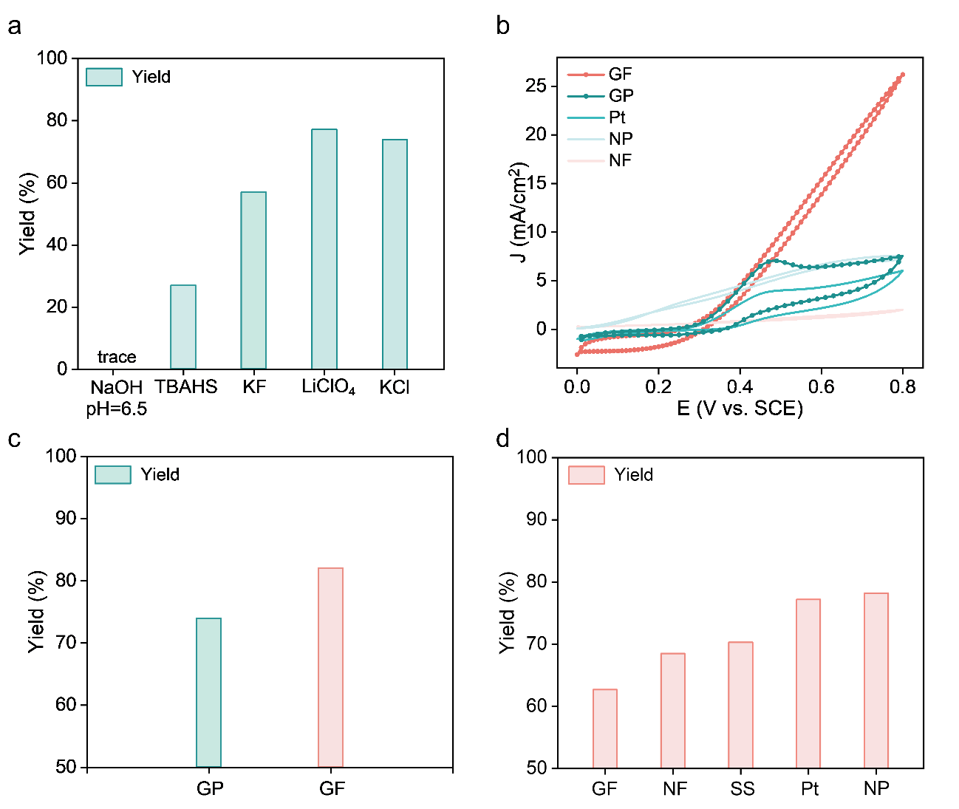
Supplementary Fig. 1. Optimization of reaction conditions. a RO yield in different electrolytes. b CV analysis of different anode electrode. c RO yield for GP or GF as anode electrode. d RO yield in different cathode electrode.

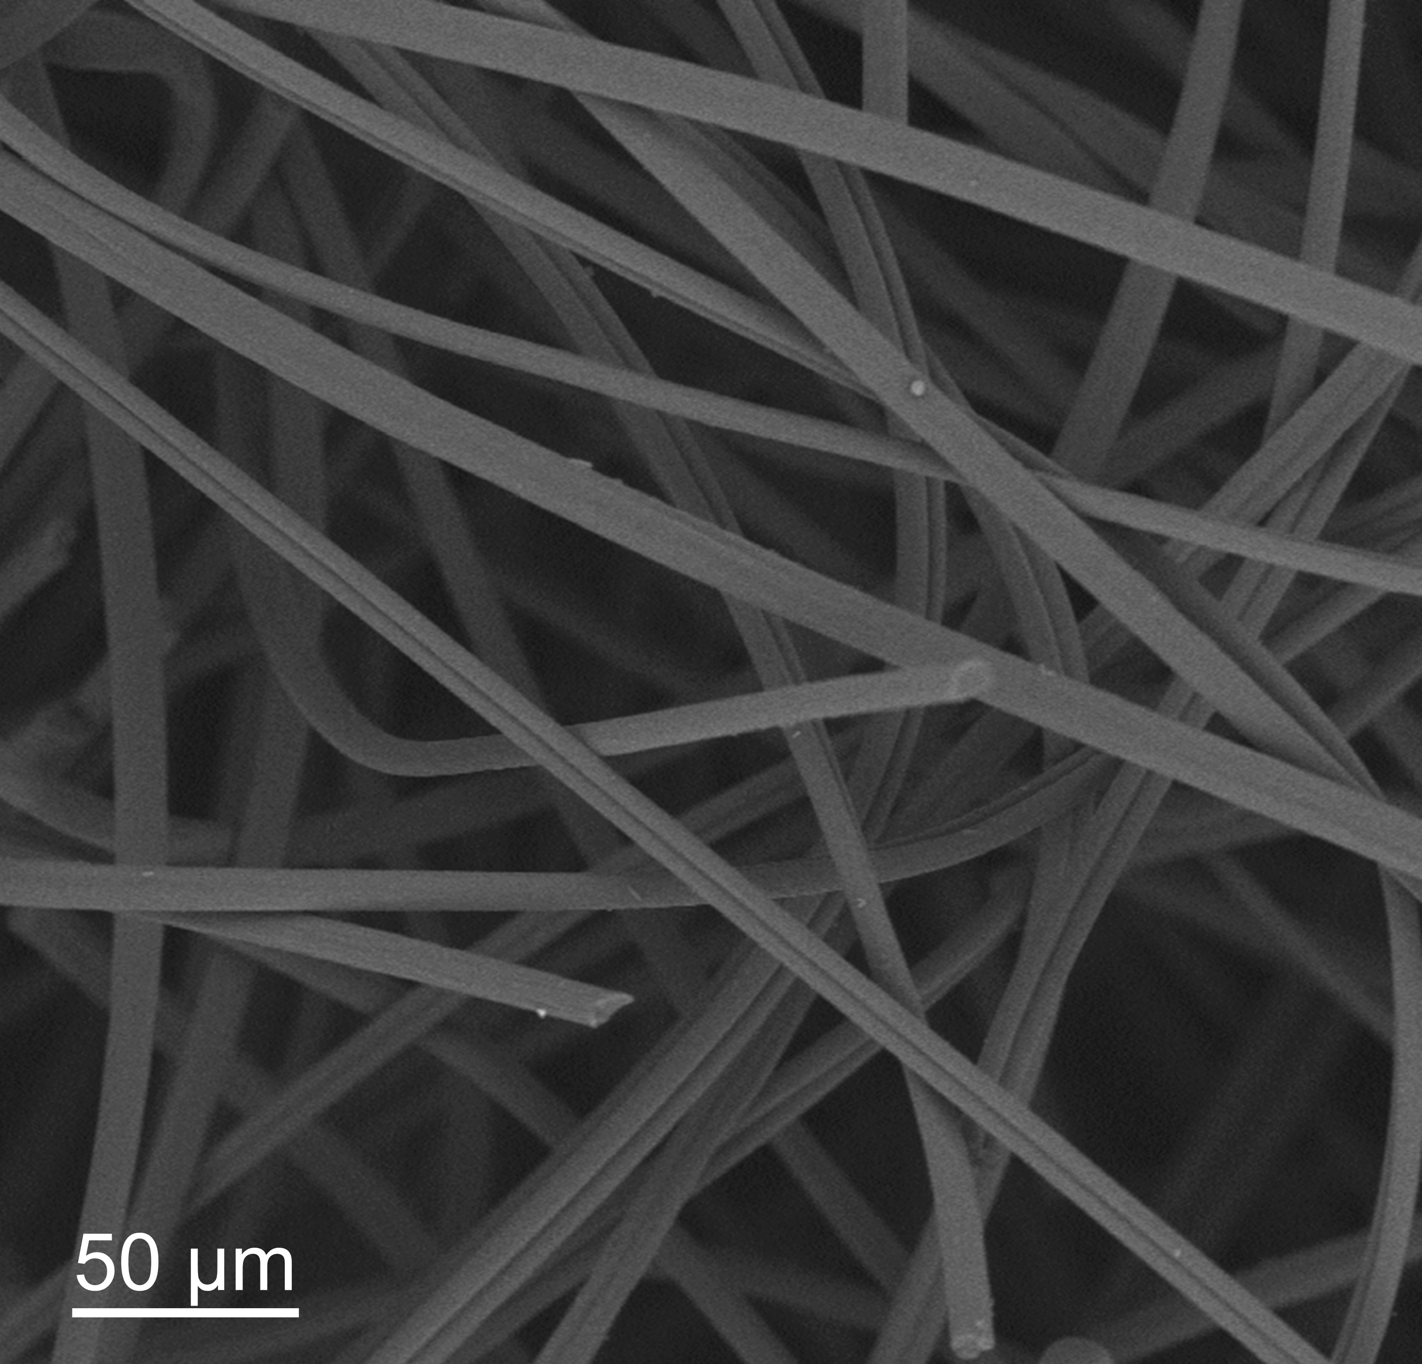

Supplementary Fig. 2. Morphology characterization. SEM image of Graphite form.

Supplementary Fig. 3. Analysis of HPLC chromatogram. HPLC chromatogram at the end of the electrooxidation of RB.

Supplementary Fig. 4. Electrochemical performances. Yield comparison of the electrooxidation of RB (KCl as electrolyte).

Supplementary Fig. 5. Electrochemical performances. Effect of different water quantity on the electrooxidation of RB (LiClO₄ as electrolyte).

Supplementary Fig. 6. Electrochemical performances. Effect of different water quantity on the electrooxidation of RB (KCl as electrolyte).

Supplementary Fig. 7. Electrochemical performances. Conversion in the presence or absence of water.

Supplementary Fig. 8. Tafel plot. Tafel plot for the electrooxidation of RB in the presence or absence of water.

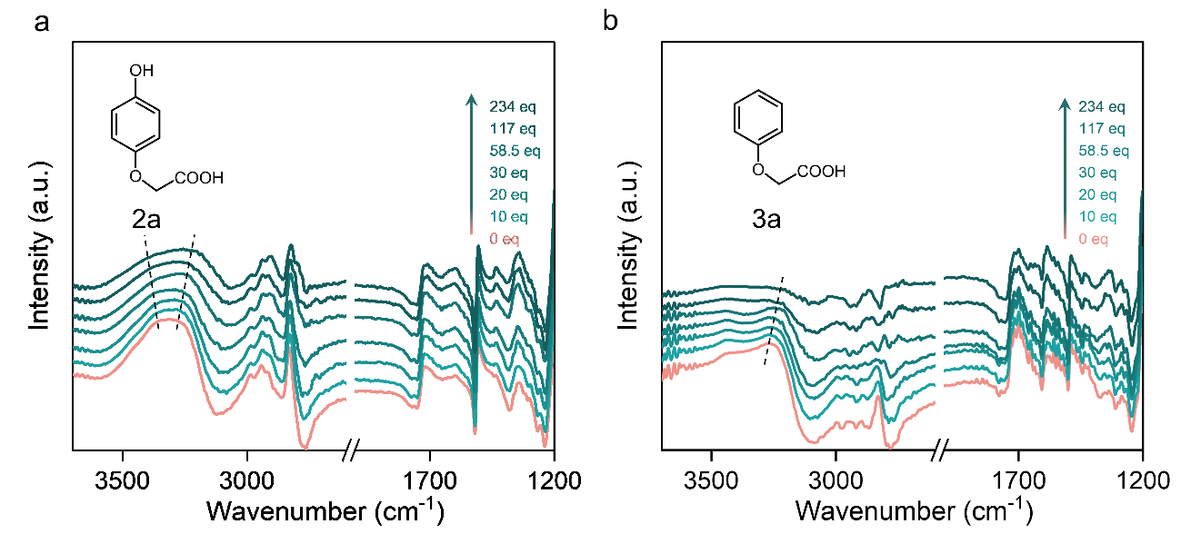
Supplementary Fig. 9. FTIR spectra. FTIR spectra of 2a (a) and 3a (b) in methanol solutions with different water contents.

Supplementary Fig. 10. Conductivity text. Conductivity in different water (LiClO₄ as electrolyte).

Supplementary Fig. 11. Electrochemical performances. CV analysis in the presence or absence of water.

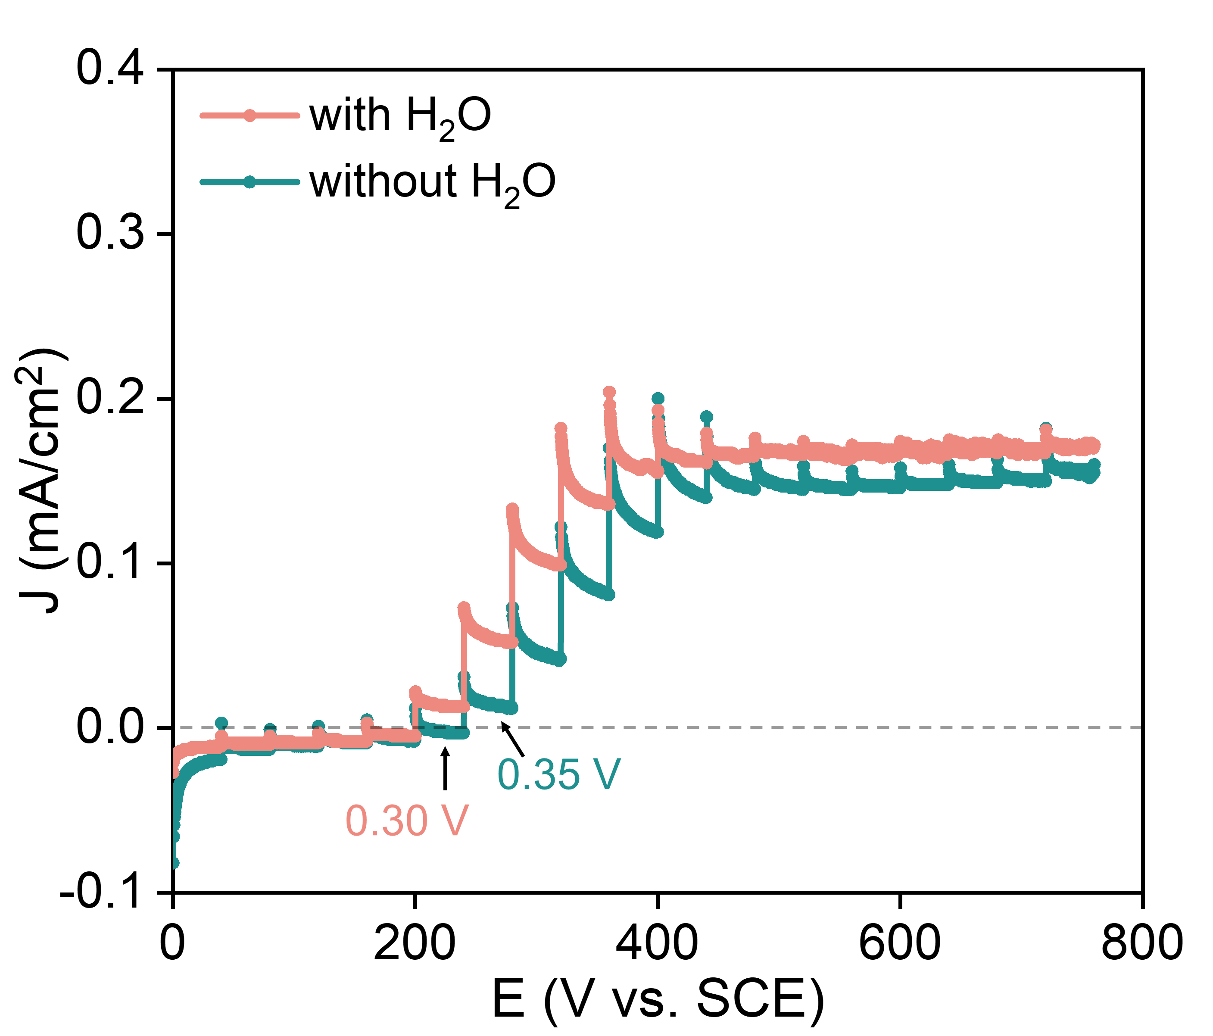
Supplementary Fig. 12. Electrochemical performances. i-E plot of electrooxidation of RB under in-situ IRAS testing conditions.

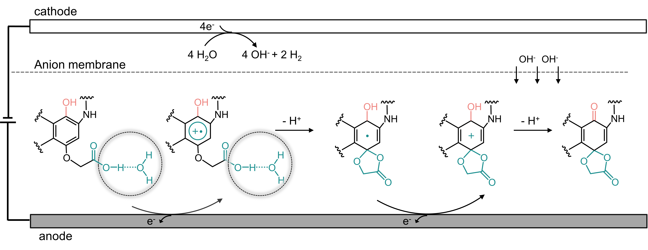
Supplementary Fig. 13. Possible mechanism. Possible electrooxidation mechanism of RB

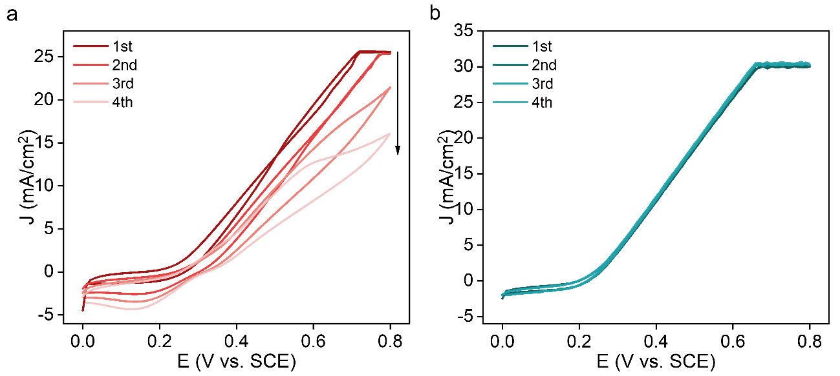
Supplementary Fig. 14. Electrochemical performances. CV analysis for the electrooxidation of RB in the absence a or presence b of stir.

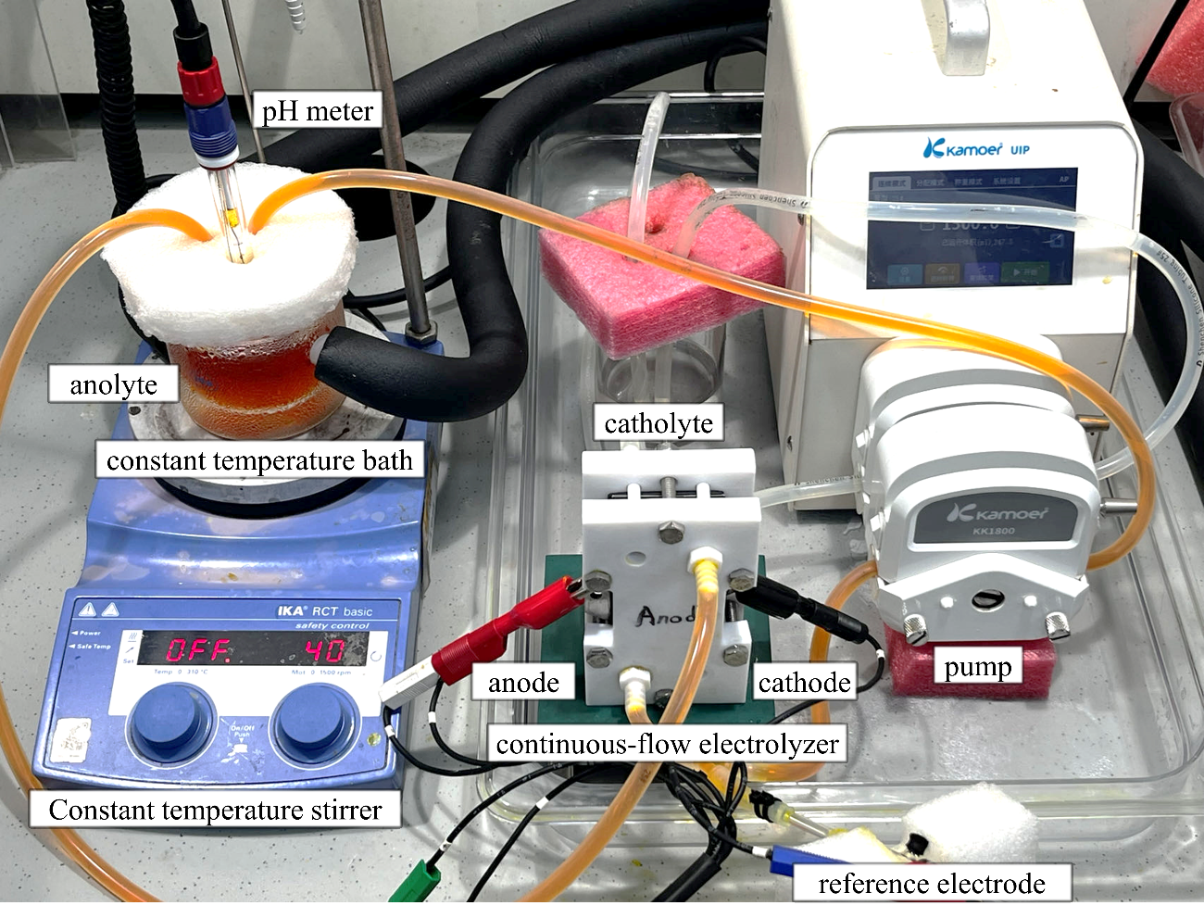
Supplementary Fig. 15. Flow electrolyzer. Electrolysis setup of the electrooxidation of RB in a continuous-flow electrolyzer.

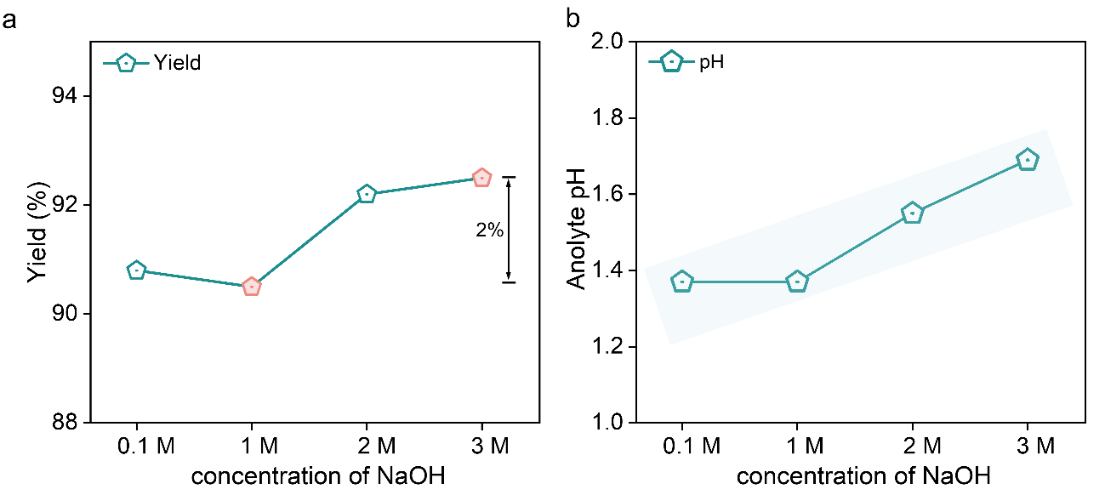
Supplementary Fig. 16. Electrochemical performances. a RO yield in different concentration of NaOH. b Electrolyte pH of the anode side after reaction.

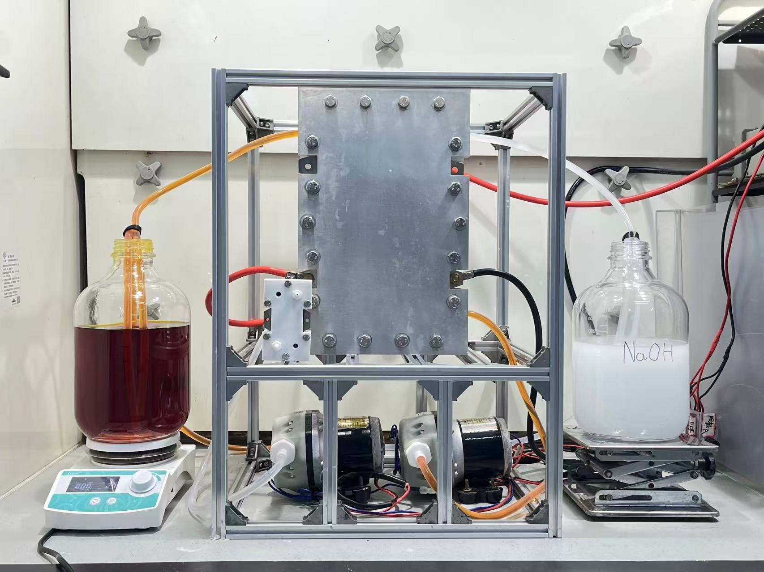
Supplementary Fig. 17. Photograph of the scale-up amplification experiment. Electrooxidation of RB on 50g scale

Supplementary Fig. 18. Mass spectrum. Mass spectrum of RO.

