SEARCH STRATEGY TABLE
Database | Search Strategy | Results
PubMed | ("efbemaLenograstim alfa" OR "F-627" OR "Ryzneuta") AND ("granulocyte colony-stimulating factor" OR "G-CSF" OR "colony-stimulating factor 3" OR "pegfilgrastim" OR "Neulasta" OR "filgrastim" OR "Neupogen" OR "lenograstim" OR "Granocyte") | 6
Google Scholar | "efbemalenograstim alfa" OR "F-627" OR "Ryzneuta" AND "granulocyte colony-stimulating factor" OR "G-CSF" OR "pegfilgrastim" OR "Neulasta" OR "filgrastim" | 105
Cochrane Library | ("efbemalenograstim alfa" OR "F-627" OR "Ryzneuta") AND ("granulocyte colony-stimulating factor" OR "G-CSF" OR "pegfilgrastim" OR "Neulasta" OR "filgrastim") AND ("clinical trial" OR "systematic review" OR "meta-analysis") | 6
Scopus | (TITLE-ABS-KEY("efbemalenograstim alfa" OR "F-627" OR "Ryzneuta")) AND (TITLE-ABS-KEY("granulocyte colony-stimulating factor" OR "G-CSF" OR "colony-stimulating factor 3" OR "pegfilgrastim" OR "Neulasta" OR "filgrastim" OR "Neupogen" OR "lenograstim" OR "Granocyte")) | 9
Embase | ('efbemalenograstim alfa':ti,ab OR 'f 627':ti,ab OR 'ryzneuta':ti,ab) AND ('granulocyte colony stimulating factor'/exp OR 'granulocyte colony stimulating factor':ti,ab OR 'g csf':ti,ab OR 'colony stimulating factor 3':ti,ab OR 'pegfilgrastim'/exp OR 'pegfilgrastim':ti,ab OR 'neulasta':ti,ab OR 'filgrastim'/exp OR 'filgrastim':ti,ab OR 'neupogen':ti,ab OR 'lenograstim'/exp OR 'lenograstim':ti,ab OR 'granocyte':ti,ab) | 17
ClinicalTrials.gov | "F-627" OR "granulocyte colony-stimulating factor" AND "neutropenia" AND Phase 3 AND Recruiting | 31

FUNNEL PLOTS

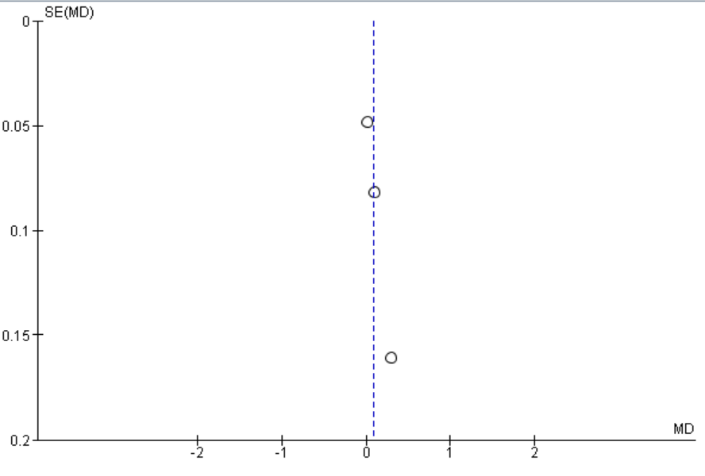
Figure 1 Funnel plot of duration of Severe (Grade 4) Neutropenia (DSN) in cycle 1:

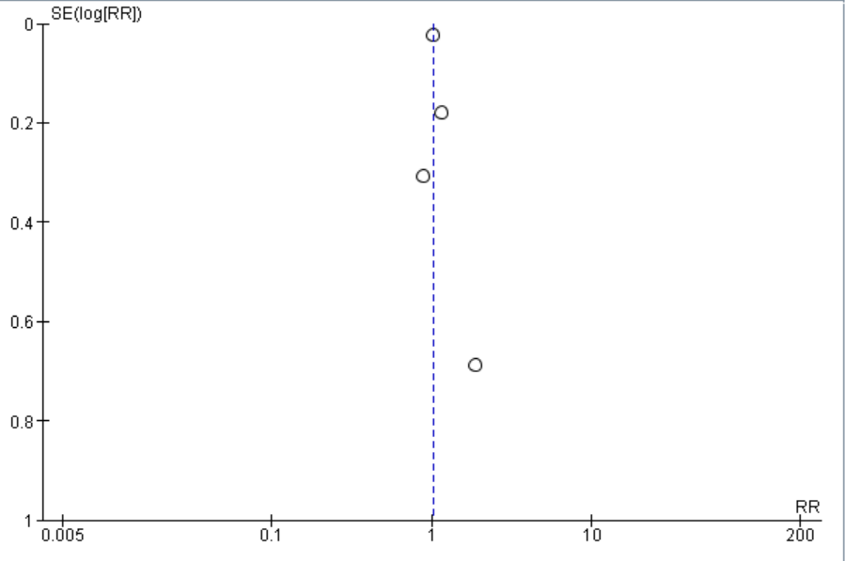
Figure 2 Funnel plot of incidence of Severe neutropenia (Grade 4) in cycle 1
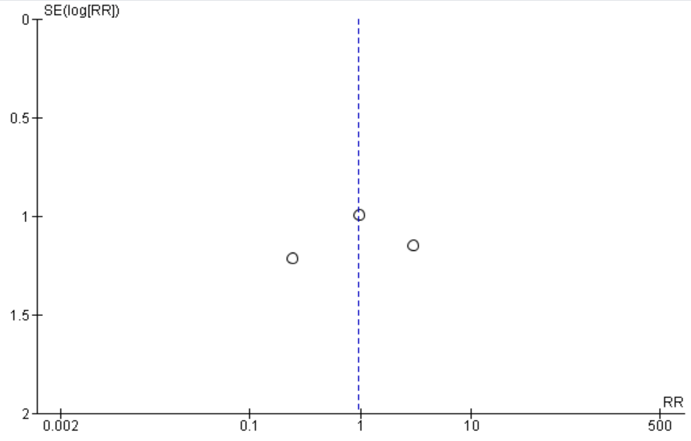
Figure 3 Funnel plot of incidence of febrile neutropenia in cycle 1

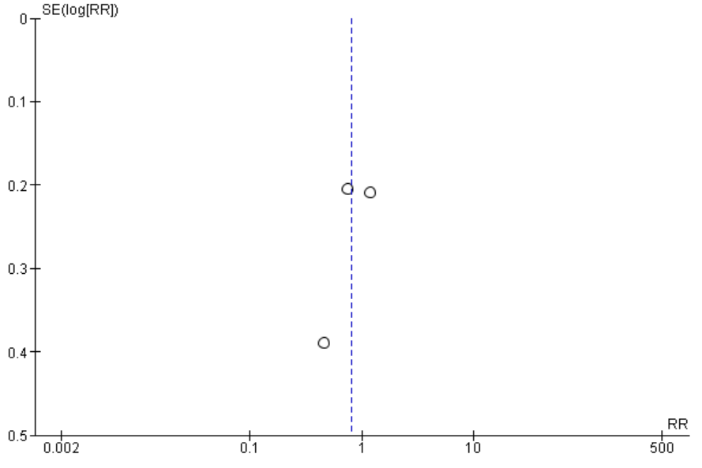
Figure 4 Funnel plot of incidence of febrile neutropenia in cycle 1incidence of bone pain

Outcome Table 1 Statistical Summary
Outcomes | Total sample size (n) | Effect Size MD or RR (95% CI) or P value
 |  | Zhang et al., 2024 | Glaspy et al., 2023 | Glaspy et al., 2024 | Glaspy et al. 2025
The duration in days of grade 3 neutropenia in Cycle-1 |  | 0.00 (0.0, 0.0) | 3.0 (2.2, 3.7) | 0.00 (0.0, 0.0) | NR
The duration in days of grade 3 or 4 (severe) neutropenia in Cycle-2 | 831 | 0.00 (0.0, 0.0) | NR | TAC  240 µg/kg: 0.0 (–0.7, 0.8)  320/kg:  0.3 (–0.5, 1.0)  TC  80µg/kg: 0.3 (0.0, 0.7)  240 µg/kg:  0.1 (–0.2, 0.4)  320 µg/kg:  0.1 (–0.2, 0.5) | -0.0 (-0.10, 0.10)
The duration in days of grade 3 or 4 (severe) neutropenia in Cycle-3 | 831 | 0.0 (0.00, 0.00) | NR | TAC  240 µg/kg: 0.6 (–0.1, 1.4)  320/kg:  0.7 (–0.1, 1.4)  TC  80µg/kg:  0.3 (0.0, 0.5)  240 µg/kg:  0.1 (–0.2, 0.3)  320 µg/kg:  0.0 (–0.3, 0.3) | -0.07 (-0.15, 0.01)
The duration in days of grade 3 or 4 (severe) neutropenia in Cycle-4 | 831 | 0.0 (0.00, 0.00) | NR | TAC  240 µg/kg: 0.8 (–0.2, 1.7)  320/kg:  0.8 (–0.2, 1.7)  TC  80µg/kg:  0.4 (0.1, 0.8)  240 µg/kg:  0.2 (–0.2, 0.6)  320 µg/kg: 0.0 (–0.4, 0.4) | -0.06 (-0.14, 0.02)
Depth of ANC nadir (× 10 (9) /L) in cycle 1 | 973 | 0.3 (0.04, 0.65) | 3.4 (2.0, 5.6) | NR | 0.97 (0.79, 1.19]
Time to ANC recovery (days) in cycle 1 | 731 | NR | 2.0 (1.4, 2.5) | TAC  240 µg/kg: 0.4 (−0.3, 1.1)  320/kg:  0.0 (−0.7, 0.7)  TC  80µg/kg:  0.7 (0.2, 1.1)  240 µg/kg:  0.3 (−0.2, 0.7)  320 µg/kg:  0.2 (−0.3, 0.6) | 0.4 (–0.42, 1.24)
Incidence of Grade 4 (severe) Neutropenia in cycle 2 | 831 | > 0.999ª | NR | TAC  240 µg/kg: 8.1 (0.5279) ª  320/kg:  -7.1 (0.7049) ª | 0.832 ª
Incidence of Grade 4 (severe) Neutropenia in cycle 3 | 831 | 0.048ª | NR | TAC  240 µg/kg:  3.7 (1.0000) ª  320/kg:  6.6 (0.7287) ª | 0. 079 ª
Incidence of Grade 4 (severe) Neutropenia in cycle 4 | 831 | 0.432ª | NR | TAC  240 µg/kg:  -2.2 (1.0000)ª  320/kg:  6.3 (0.7585)ª | 0.05 ª
Leukopenia | 973 | NR | NR | NR | NR
Neutropenia | 973 | NR | NR | NR | NR
Thrombocytopenia | 757 | NR | NR | NR | NR
Anemia | 757 | NR | NR | NR | NR
Incidence of Infection | 757 | NR | 5.3 (− 13.8, 24.1) | NR | NR
TAC: Taxotere® [docetaxel] + doxorubicin + cyclophosphamide TC: Taxotere® [docetaxel] + cyclophosphamide ª P value
NR: Not Reported, RR: Risk Ratio, MD: Mean Difference C.I: Confidence Interval

Outcome Table 2 Numerical Summary
Study – Year |  | Zhang et al., 2024 | Glaspy et al., 2023 | Glaspy et al., 2024 | Glaspy et al. 2025
The duration in days of grade 3 (moderate) neutropenia in Cycle-1 | Intervention  Mean(days)+ SD | 0.68± 1.1 | 2.1± 1.51 | F-627 240 μg/kg = 2.1±1.58  F-627 320 μg/kg = 2.1+1.46 | NR
 | Control  Mean(days)+ SD | 0.71± 0.95 | 5.1± 1.9 | 1.8±1.28 | NR
The duration in days of grade 4 (severe) neutropenia in Cycle-1 | Intervention  Mean(days)+ SD | 0.3±0.69 | 1.3±1.19 | F-627 240 μg/kg = 1.5±1.55  F-627 320 μg/kg = 1.4±1.15 | 0.17±0.51
 | Control  Mean(days)+ SD | 1.3±1.19 | 3.9±1.44 | 1.1±1.01 | 0.15±0.45
The duration in days of grade 3 or 4 (severe) neutropenia in Cycle-2 | Intervention  Mean(days)+ SD | 0.1±0.35 | NR | TAC chemotherapy  F-627 240 μg/kg =0.9±1.21  F-627 320 μg/kg =1.2±1.61  TC chemotherapy  "F-627 240 μg/kg =0.1±0.47  F-627 320 μg/kg = 0.1±0.51 | 0.11±0.5
 | Control  Mean(days)+ SD | 0.1±0.25 | NR | TAC chemotherapy= 0.9±1.31  TC chemotherapy =0.0±0.0 | 0.11±0.51
The duration in days of grade 3 or 4 (severe) neutropenia in Cycle-3 | Intervention  Mean(days)+ SD | 0±0.18 | NR | TAC chemotherapy  F-627 240 μg/kg =1.2±1.67  F-627 320 μg/kg =1.3±1.40  TC chemotherapy  "F-627 240 μg/kg = 0.1±0.48  F-627 320 μg/kg = 0.1±0.37 | 0.05±0.3
 | Control  Mean(days)+ SD | 0.2 ± 0.54 | NR | TAC chemotherapy= 0.6±1.08  TC chemotherapy =0.1±0.34 | 0.12±0.49
The duration in days of grade 3 or 4 (severe) neutropenia in Cycle-4 | Intervention  Mean(days)+ SD | 0.1±0.38 | NR | TAC chemotherapy  F-627 240 μg/kg =1.6±1.73  F-627 320 μg/kg =1.5±1.64  TC chemotherapy  "F-627 240 μg/kg = 0.2±0.84  F-627 320 μg/kg = 0.0±0.00 | 0.04±0.36
 | Control  Mean(days)+ SD | 0.1±0.41 | NR | TAC chemotherapy  =0.8±1.72  TC chemotherapy =0.00±0.00 | 0.1±0.44
Depth of ANC nadir (× 10 (9) /L) in cycle 1 | Intervention  Mean(days)+ SD | 2.059±1.502 | 0.7±1.15 | TAC chemotherapy  F-627 240 μg/kg =0.68±1.064  F-627 320 μg/kg =0.86±1.407  TC chemotherapy  "F-627 240 μg/kg = 2.41±1.856  F-627 320 μg/kg = 3.00±2.608 | 2.7±0,001
 | Control  Mean(days)+ SD | 1.603±1.206 | 0.2±0.57 | TAC chemotherapy= 0.78±1.283  TC chemotherapy =3.05±2.309 | 2.65±0.001
Time to ANC recovery (days) in cycle 1 | Intervention  Mean(days)+ SD | NR | 2.1±1.09 | TAC chemotherapy  F-627 240 μg/kg = 2.4±1.56  F-627 320 μg/kg = 2.0±1.27  TC chemotherapy  "F-627 240 μg/kg = 0.6±0.95  F-627 320 μg/kg = 0.5±0.81 | 4.2±0.001
 | Control  Mean(days)+ SD | NR | 4.1±2.06 | TAC chemotherapy  = 1.9±1.20  TC chemotherapy = 0.4±0.60 | 3.8±0.001
Incidence of Grade 4 (severe) Neutropenia in cycle 1 | Intervention  Means - n(%), Total-n | 17 (14.2), 120 | 58 (69.9), 83 | TAC chemotherapy  F-627 240 μg/kg = 20(66.7), 30  F-627 320 μg/kg = 21(72.4), 29  TC chemotherapy  "F-627 240 μg/kg = 7(18.9), 37  F-627 320 μg/kg = 5(16.1), 31 | 23 (11.7%), 197
 | Control  Means - n(%), Total-n | 19(16.0), 119 | 37 (94.9), 39 | TAC chemotherapy= 19(63.3), 30  TC chemotherapy = 3(8.6), 35 | 23 (11.7%), 196
Incidence of Grade 4 (severe) Neutropenia in cycle 2 | Intervention  Means - n(%), Total-n | 7(6.0), 117 | NR | TAC chemotherapy  F-627 240 μg/kg = 7 (25.9), 27  F-627 320 μg/kg = 3(10.7), 28 | 9 (4.6%), 197
 | Control  Means - n(%), Total-n | 7(6.5), 107 | NR | 5(17.9), 28 | 10 (5.1%), 196
Incidence of Grade 4 (severe) Neutropenia in cycle 3 | Intervention  Means - n(%), Total-n | 4(3.5), 115 | NR | TAC chemotherapy  F-627 240 μg/kg = 5(18.5), 27  F-627 320 μg/kg = 6(21.4), 28 | 5 (2.6%), 197
 | Control  Means - n(%), Total-n | 18(17.5), 103 | NR | 4(14.8), 27 | 12 (6.3%), 196
Incidence of Grade 4 (severe) Neutropenia in cycle 4 | Intervention  Means - n(%), Total-n | 10(8.8), 114 | NR | TAC chemotherapy  F-627 240 μg/kg = 5(20.0), 25  F-627 320 μg/kg =8(28.6), 28 | 3 (1.6%), 197
 | Control  Means - n(%), Total-n | 10(9.9), 101 | NR | 6(22.2), 27 | 10 (5.3%), 196
Any Treatment related Adverse Effect | Intervention - n(%) | 119 (99.2) | 74 (89.2) | F-627 240 μg/kg = 21 (31.3)  F-627 320 μg/kg =24 (36.9) | 178 (90.4%)
 | Control - n(%) | 119 (100) | 36 (92.3) | 24 (36.9) | 169 (86.2%)
Febrile Neutropenia | Intervention - n(%) | 1 (0.8%) | 4 (4.8) | F-627 240 μg/kg = 0  F-627 320 μg/kg = 2 (3.1) | 3 (1.5%)
 | Control - n(%) | 2 (1.7%) | 10 (25.6) | 2 (3.1) | 1 (0.5%)
Leukopenia | Intervention - n(%) | 79 (65.8) | 38 (45.8) | F-627 240 μg/kg = 12 (17.9)  F-627 320 μg/kg = 8 (12.3) | 39 (19.8%)
 | Control - n(%) | 99 (83.2) | 15 (38.5) | 7 (10.8) | 44 (22.4%)
Neutropenia | Intervention - n(%) | 71 (59.2) | 54 (65.1) | F-627 240 μg/kg = 25 (37.3)  F-627 320 μg/kg = 21 (32.3) | 40 (20.3%)
 | Control - n(%) | 99 (83.2) | 25 (64.1) | 17 (26.2) | 50 (25.5%)
Thrombocytopenia | Intervention - n(%) | 56 (46.7) | 10 (12.0) | NR | 20 (10.2%)
 | Control - n(%) | 40 (33.6) | 1 (2.6) | NR | 20 (10.2%)
Anemia | Intervention - n(%) | 81 (67.5) | 12 (14.5) | NR | 47 (23.9%)
 | Control - n(%) | 79 (66.4) | 4 (10.3) | NR | 38 (19.4%)
Bone Pain | Intervention - n(%) | 30 (25.0) | 6 (7.2) | F-627 240 μg/kg = 11 (16.4)  F-627 320 μg/kg = 11 (16.9) | 12 (18.5)
 | Control - n(%) | 40 (33.6) | 4 (10.3) | 41 (20.8%) | 34 (17.3%)
Incidence of Infection | Intervention - n(%) | 14 (11.7) (URI) | 2 (2.4) | NR | 14 (7.1%)
 | Control - n(%) | 16 (13.4)(URI) | 3 (7.7) | NR | 17 (8.7%)
TAC: Taxotere® [docetaxel] + doxorubicin + cyclophosphamide TC: Taxotere® [docetaxel] + cyclophosphamide
NR: Not Reported, RR: Risk Ratio, MD: Mean Difference C.I: Confidence Interval

