An Analytical Study of the Post-Impact of the Training Program on the STEM Curriculum in Mathematics Education: Its Effect on the Performance of Teachers and Students.

Table of Contents
Introduction Introduction: 4
Research methodology and procedures: Methodology 26
-Research Methodology: 26
Research Tools: 27
Research community and sample 27
secondly: Identification of studies: Identify studies 29
A-Research Strategy: Search strategy 29
in- Search vocabulary: Search terms 29
C -Data Mining: Data extraction 30
of -Tuning studies: Synthesis of studies 30
H- The risk of bias: Risk of bias 31
Results: Results 31
Conduct of studies (Study Procedure): Study flow 31
Shape (٣) Flow of identification of studies and determination of admission and exclusion criteria 34
Data Mining: Data extraction 34
Form Information(Codec) For the five studies: 34
Table No. (٦) : Size of the impact of using a strategy STEM As an independent variable in teaching mathematics to learners. 36
Calculation of variance and homogeneity between studies: 37
Table No. (٧): Effect size, weighted average effect size, variance and homogeneity tests of variance between studies 39
Table No. (٨) : Size Impact Using Strategy STEM and confidence period (95%) and homogeneity tests of variance between studies 40
Figure number (٤) Forest shape for average individual impact sizes of research and preliminary studies (N=5 ) 40
Discussion: Discussion 41
Recommendations: 45
The end: 46
Sources and references 46

Introduction :
Knowledge and technical transformations are one of the main pillars that form the standards of modern education curricula. These transformations are characterized by the exponential growth of diverse technical capabilities, including computer processing, data storage, programming, algorithms, and artificial intelligence. This has led to the Fourth Industrial Revolution, which is a continuous revolution characterized by renewed change, affecting the capabilities of individuals, societies and the competitiveness of nations. These transformations call for the need to empower learners with the knowledge, values and skills needed to adapt to changes Rapid assimilation and utilization of information trends, with the need to provide flexibility in building educational curricula to keep pace with these changes (Education and Training Evaluation Commission, 2018).
Since the nineties, the National Science Foundation (NSF) began using the acronym STEM to denote basic disciplines in preparing the next generation of scientifically educated people. The term has become popular in the educational community under the name "STEM education", where it is increasingly used in contexts that recognize the importance of integration between science , technology, engineering mathematics. Although the acronym STEM has spread widely globally, the educational literature indicates that there is no comprehensive consensus around its concept, which has led to the emergence of multiple trends with diverse perceptions of the concept, as pointed out by Sanders (2009). These perceptions take into account the necessity of the essence of the four disciplines, nor the complementarity between them. It is one of the innovative solutions to develop the capabilities of learners in the fields of science, technology, engineering, and mathematics by providing this knowledge in an integrated building through which the student feels the unity of knowledge, and works to solve problems related to his life through exploration and teamwork in a realistic environment, which helps to prepare an enlightened generation that has high abilities in thinking and achieves the requirements of the times (Kware, 2017). STEM-related teaching practices are influenced by teachers' perceptions of the concept, which are also reinforced by specialized organizations. These perceptions form a professional identity that influences the understanding of the role STEM teachers should play, highlighting the urgent need for a clear vision for STEM education, especially in the classroom (Jalal, Shamrani, 2019).
In this context, a number of educators (Zakri, 1997; Sharif, 1993) and psychologists such as Abu Hatab and Sadiq (1991) assert that diverse research practices have resulted in a huge amount of research and studies in the field of education. However, some of these studies have contradictory or sometimes conflicting results, which reduces the chances of employing them and benefiting from them in improving the educational process because there is no way to link and synthesize their results. Therefore, it has become necessary to search for an accurate scientific method. To analyze and organize the results of incremental studies. Hence, the tendency of so-called research synthesis to integrate the results of different studies and reach general conclusions emerged. One type of research synthesis is quantitative meta-analysis, which differs from traditional narrative revision in terms of the statistical methods used (Borenstein et al., 2009). (Zeidan, et al., 2022).
Perhaps one of the first to propose the use of quantitative dimensional analysis to address the shortcomings inherent in the previous methods is the famous statistician Jane Glass (1976, Glass) and this method depends on the statistical analysis of the results of a group of research in a field, with the aim of reaching useful generalizations of data and the results of these researches, and therefore the method of dimensional analysis It is one of the systematic methods that use clear rules to identify research and studies included or excluded from the review, and depends on the use of statistical synthesis of data, which can be considered a transparent, objective and disciplined general framework (Zeidan, et al., 2022).
Decoster2009 indicates that the dimensional analysis is a statistical analysis of the set of results of independent studies, with the aim of creating a synthesis between the results of these studies, and adds ((2009, llic) that dimensional analysis is a statistical analytical method, which synthesizes the results of a large and different number of independent quantitative studies, as it represents a powerful tool for examining these studies, and knowing the impact of treatment in order to resolve the discrepancy between the results of different studies. The method of dimensional analysis is characterized by many characteristics that distinguish it from other methods of reviews used in the analysis of research results, and increase its educational importance, and can identify the benefits of dimensional analysis and its educational importance in identifying gaps in research and previous studies associated with experimental studies, through which it is possible to determine the need for further research in a particular field, and then direct future experimental studies to new directions that are needed, and also helps determine the relationship between Independent and dependent research variables) more accurately, and the results of the post-analysis benefit researchers, practitioners, decision-makers and educational policy makers, by reaching general and more in-depth results that are useful in making educational decisions, and one of the benefits of dimensional analysis is also to increase the statistical strength of comparisons between the results of different studies, as it is used to estimate the total average of the impact sizes; to make a decision about the effectiveness of a particular treatment for a large number of examiners better than calculating the strength of the impact extracted from the study Relying on the results of a number of research and preliminary studies to answer a specific hypothesis is better than relying on the results of one study, and then the possibility of using it to summarize the results of a large number of experimental studies, and the dimensional analysis is characterized by the possibility of updating the dimensional analysis again when new studies appear, and it is characterized by objectivity in the selection of research and preliminary studies, as it represents a review of research in a strict systematic manner that does not allow bias of researchers in the selection process, and does not prejudge Quality of study results (Zeidan, et al., 2022). This research aimed to explore the impact of cognitive and technical transformations on modern educational curricula, with a focus on STEM education and its role in developing learners' capabilities and promoting knowledge integration between the fields of science, technology, engineering, and mathematics. It also seeks to analyse teachers' perceptions about teaching practices, providing valuable information to decision-makers to support the development of effective curricula and learning strategies. The importance of research is evident in keeping pace with the rapid transformations in education and building a generation with multiple skills, which enhances the effectiveness of STEM education in light of the continuous changes. Through the use of quantitative meta-analysis, the research contributes to the organization and synthesis of the results of increasing studies in the field of education, which enhances the opportunities to benefit from them in improving the educational process.
Importance of the study:
The importance of the study is manifested in the following points:
1. Dimensional Analysis Methodology: The study relies on the use of dimensional analysis as a statistical methodology that has increased interest globally, as it provides strong and reliable indicators about the results of certain studies. However, research in this field at the Arab level is still limited, especially in assessing the effectiveness of strategies and approaches to teaching mathematics.
2. A comprehensive picture of research publication: The study provides a comprehensive picture of the development of the research publishing movement on the effectiveness of the STEM approach in achieving mathematics learning outcomes in some Arab countries, which helps researchers in the field of mathematics education to direct their research towards areas that need further research.
3. Providing decision-makers: The study contributes to providing educational decision-makers in educational institutions with accurate results on the effectiveness of the STEM approach, which reinforces the need to adopt these strategies to improve mathematics learning.
4. Comprehensive indicators: The study may provide comprehensive indicators on the effectiveness of the STEM approach in achieving diverse math learning outcomes across different levels of study.
5. Definition of teachers: The study introduces mathematics teachers to the effectiveness of the STEM approach in developing students' knowledge, skills and attitudes, which encourages them to use it in teaching mathematics.
Study terminology:
STEM Integration Approach: It is one of the modern approaches to education based on the integration and integration of four disciplines: science, technology, engineering and mathematics, and employing them in mathematics education by providing realistic practical activities, applications and problems that are interrelated with the rest of the disciplines (Al-Qawas, 2023).
Dimensional analysis: Dimensional analysis is a statistical analysis of a set of results of independent studies with the aim of synthesizing the results of these studies (Decoster, 2009). Zidane, et al., 2022).
Impact size: Educational research and studies differ from each other in many aspects, such as: their design, sample characteristics, objectives, and tools, so it is expected that their results vary, so that it is possible that they do not have the size of one common effect, and in dimensional analysis research, heterogeneity tests are conducted between research and preliminary studies to determine the most appropriate dimensional analysis model with the nature of those research and studies, where there are two models for dimensional analysis, "estimator of the change caused by the independent variable on the dependent independent".
The first is the fixed effect model, in which it is assumed that all studies involved in the dimensional analysis have a real common effect size, which means that all the factors that can affect the value of the effect size are similar in all studies, and then this model is used when there is homogeneity between the results of research and studies subject to dimensional analysis. The other model is the stochastic effects model, which is used when studies derived from indigenous communities differ from each other in size Effect: i.e.: there is no real effect size similar to all studies, but there is a random and different distribution of impact sizes for the studies under analysis, and therefore there is no homogeneity between studies. Ellis, 2010) (Borenstein et al, 2009) (Al-Qawas, 2023).
The first axis: STEM integration approach:
The term (STEM) is an abbreviation for the first four letters of the words of the disciplines of science (Science), technology ( Technology), engineering and mathematics (Mathematics), and there are many names for this entrance, so it is called the integrative entrance, the (STEM) approach, the (STEM) method, and the (STEM) system, The stem curve, but it has the same connotation, which is the integration of science, technology, engineering and mathematics (STEM). It is considered one of the recent approaches that appeared in the United States of America for obtaining a late ranking in students' results in the International Standardized Tests in Mathematics (TIMSS), and this result was attributed to the poor awareness of students of the correlations between what they learn in schools and its practical applications in their daily lives, which led to the need for a multidisciplinary approach (Hassan, 2021; Ola Allah and Mihi, 2019) Al-Qawas, 2023).
The definitions of STEM have gone beyond defining it as the art of planning and implementing educational experiences for educational students about the knowledge, skills, values and trends associated with STEM concepts, taking into account the current concepts of the learner at the same time (Forbes, 2023). The International Centre for Vocational Education and Training of UNESCO (2020, defines STEM as an educational strategy that emphasizes the application of knowledge, skills and values from STEM disciplines in an integrative way to help students solve problems they face in the real world. It is defined as an educational approach based on the principle of teaching scientific concepts in the fields of science, technology, engineering and mathematics through activities, tasks and problems related to the real world using designs and learner-centered teaching strategies and the provision of integrative knowledge through research, inquiry and projects (Cinar, Pirasa & Kocer 2016). Therefore, STEM is an educational approach based on the integration of STEM disciplines and based on real-world problems based on investigation, experimentation and scientific research, and emphasizes the unity of knowledge and concepts and their interdependence across disciplines. Al-Qawas, 2023).
[STEM] entrance characteristics: The STEM entrance has the following characteristics:
Focus on real-world problems. Attract learners to research, inquiry and practical experimentation.
Encourage students to learn with pleasure and desire, which reflects on their future and professional and personal lives. Engage students in learning important topics related to their lives such as health, energy, natural resources, technology, engineering, mathematics and food resources. Use at least two majors simultaneously from the four disciplines. Encourage students to do what they have to do as professionals and citizens.
Enhance the value of taking responsibility in students' education. Focus on twenty-first century skills. Focus on teaching based on real-world problems and projects, Fry ; (Carla, et al., 2023 2018) (Al-Qawas, 2023).
Objectives of the [STEM] approach: Mathematics education through the STEM approach aims to:
Preparing a generation of creators and innovators in various scientific fields. Encourage the learner to investigate and explore to understand the world around him. Providing the learner with various thinking skills such as creative, innovative, critical, and inductive. Improving the level of academic achievement of students in various disciplines. Developing the scientific research skills of learners. Encourage learners to experiment and self-learn independently. Develop the attitudes, values and motivation of learners towards learning. Developing twenty-first century skills such as work and production skills. Assisting teachers with continuous professional development (Hussein and Saadawi, 2021; Efe, et al., 2018) (Al-Qawas, 2023).

Second Theme: Meta-Analysis
The dimensional analysis method has a number of characteristics that distinguish it from other review methods used in analyzing research results, which enhances its importance in the educational field. The benefits of dimensional analysis and its pedagogical importance can be summarized in that it identifies gaps in previous research and studies related to empirical research. Through these gaps, the need for additional research in certain areas can be assessed, directing future empirical studies towards new directions that are needed.
In addition, meta-analysis helps to accurately determine the relationship between research variables (independent and dependent) and provides general and profound results that benefit researchers, practitioners, decision-makers, and educational policymakers. It also enhances the statistical power of comparisons between the results of different studies, as it is used to estimate the total size of the effect, which facilitates decisions about the effectiveness of a particular treatment for a large number of participants, which is more accurate than relying on the results of only one study.
The steps of meta-analysis, as mentioned (Abdelhameed, Decoster, 2004; Ilic, 2009; Hamer & Simpson, 2010) include: identifying the research area of interest, compiling relevant studies, examining and characterizing research according to variables, coding data and results, calculating the impact size in each study, calculating the overall average impact size, and preparing the final report.Conducting the necessary statistical analyses, reaching and interpreting the results. However, some important points that have not been addressed are noted, such as the analysis of subgroups and how to prepare inclusion and exclusion criteria, as well as the quality criteria of the studies accepted in the sample. The issue of publication bias was not discussed, nor did it specify the type of model used in the analysis, which depends on the difference or homogeneity of research and studies. In general, analysis models can be classified into static effect models and random effects models (Al-Qawas, 2023).
The evolution of the concept of meta-analysis: Dimensional analysis arose mainly as a result of dissatisfaction with the traditional non-objective method of theoretical review and review of experimental field studies. The basic assumption of meta-analysis is that each study provides us with a different estimate of the underlying relationship within the sample. By grouping the results across studies, the relationships can be represented more clearly than we get from individual study estimates. The purpose is not just to summarize existing knowledge, but to develop a new understanding of the research problem using logical thinking. The term statistical dimensional analysis was first introduced by Glass (1976) to describe a statistical method for analyzing the results of a set of experimental studies known as "Effect Size". (Al-Zayed, Jawaher, 2020)
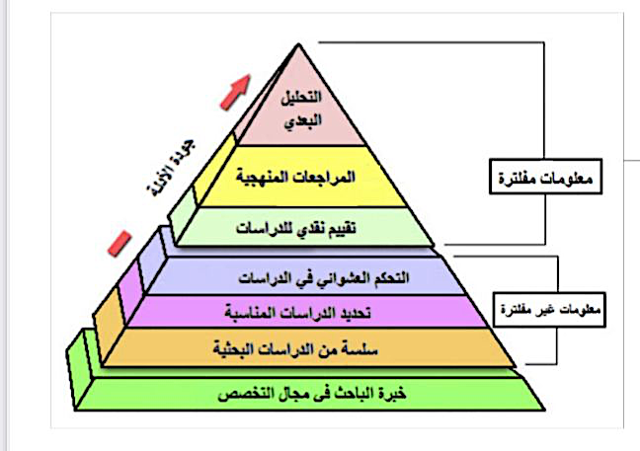

Why Dimensional Analysis: To reduce problems associated with margin of error at the individual academic level.
If we take a sample, say, 100 n = or less, as is usually the case in many researches. Result: very frequent errors of the second type.... How can we solve this problem? By increasing sample size in individual studies (rarely performed) in addition to random error, studies also suffer from methodological problems, such as measuring instruments. Design issues. Sample selection. And anything else makes the results of studies different. Here can meta-analysis correct these problems or at least explain them? (Al-Zayed, Jawaher, 2020)
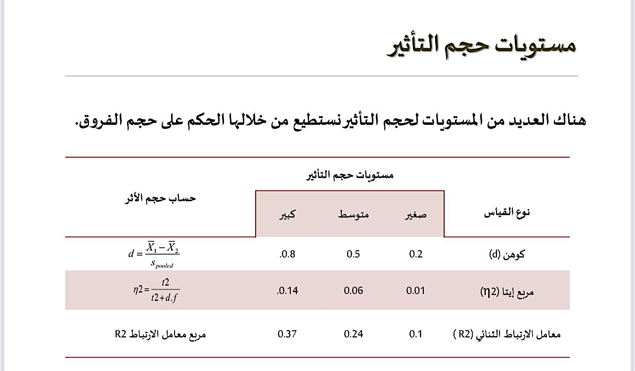
When is dimensional analysis applied? Dimensional analysis applies to experimental - semi-experimental - descriptive research groups... , not a theory. Previous studies should be as comprehensive as possible. Search all studies as much as possible according to a specific indicator (time period, specific sample, specific variable, unpublished studies can be included). Diversity in studies (term: apple and orange) .....The concept of fixed effect and random effect. Present the results in a comparable statistical form (e.g., impact sizes, correlation coefficients, odds ratios,). (Al-Zayed, Jawaher, 2020)
Steps of Dimensional Analysis: Defining the topic and formulating the research question - searching in databases Are the studies eligible for a post-analysis? Accept (yes) or reject (no) - extract data -
Data analysis with statistical programs such as: SPSS, SAS, STATA, R,---
Or by using statistical equations and finding the size of the effect for each study and then finding the average size of the effect (common scale). (Al-Zayed, Jawaher, 2020)

Strengths and weaknesses of meta-analysis:
What does this type of research tell us?
Reviewing the literature and studies in a more objective way can be an effective strategy for identifying gaps in the scientific research literature. Provides a way to review published research on a particular topic over a long period, from a variety of sources. To overcome small sample sizes in individual studies that are probably unrelated to each other. The results can be generalized to more community members. It can increase the statistical strength of effect size and improve accuracy. Generate new hypotheses or highlight research problems for future studies. (Al-Zayed, Jawaher, 2020).
Strengths and weaknesses of dimensional analysis
What this type of research does not tell us about?
A large sample size can yield reliable results, but they are not necessarily suitable for analysis.
The lack of consistency regarding the review of published research papers, for example, the methods used and how the results were measured in a sample of the studies you analyze can make the process more difficult. It may be influenced by sources of bias which may include studies that are not well designed and will therefore give us inaccurate statistics. The process of reviewing and synthesizing multiple studies can be effort- and time-consuming. .(Al-Zayed, Jawaher, 2020)
Points to consider: Dimensional analysis is not as easy as it may seem, but.... A way to change our thinking about research. The most accurate estimates of possible studies parameters (as opposed to individual studies and literature reviews) provides a statistical literature review of the effect size from each study to produce weighted mean. FYI: The natural sciences have variation in study results as in educational and behavioral studies, and most use of forms of dimensional analysis deal with disparate study results.(Al-Zayed, Jawaher, 2020)
Previous studies:
Examples of previous studies related to the effectiveness of the STEM entrance - practical application to previous studies in dimensional analysis on the STEM entrance:
Due to the importance of dimensional analysis, a number of researchers have conducted studies that sought to use it to reveal the effectiveness of the entrance to realistic mathematics, and a number of researchers have conducted studies related to the effectiveness of the STEM approach in achieving various learning outcomes for teaching mathematics using dimensional analysis, the most important of which are: A study (Rosli, et al., 2019) that showed that teaching mathematics using the STEM approach It has a small impact on student achievement through the use of dimensional analysis of 17 studies, and its effectiveness does not vary according to the academic stage. A study (Wang, et al., 2022) according to the dimensional analysis of 36 studies (14 mathematics, 19 science, 3 engineering/technology) found that the average effects of the STEM approach in achieving mathematics and science learning outcomes. A study (Ulum, 2022) showed a small effect of STEM input on primary school students' attitudes towards mathematics using dimensional analysis of 7 studies. The results of the study (Suciana, et al., 2023) revealed significant effects of the STEM entrance on math and science learning outcomes, using dimensional analysis of 21 studies (18 sciences, 3 mathematics), and had a better effect at the undergraduate and secondary levels. While a study (Oztop, 2023) found very large effects of the effectiveness of the STEM approach on academic achievement in science and mathematics through the dimensional analysis of 34 studies that included 38 effect sizes (38 sciences, 6 mathematics), and its effects were better at the secondary level and the field of science. A study (Rahmawati, et al., 2023) showed a great effectiveness of the STEM approach in developing students' mathematical creative thinking abilities using dimensional analysis of 12 studies that included 15 effect sizes, and showed that its effect is better at the secondary stage. (Al-Qawas, 2023).

Research Methodology and Procedures Previous studies:
Research Methodology: To achieve the objectives of the study, the meta-analysis methodology was used, which was designed by the statistician Glass in the late seventies of the last century, which depends on analyzing the results of a number of studies that were concerned with a specific topic quantitatively and qualitatively and qualitatively and synthesizing them to extract indicators about them.
Study population: The study population consisted of all the study that dealt with the approach to the integration of science, technology, engineering and mathematics (STEM) published in Arab scientific periodicals and journals during the period (2013-2023).
Study sample: After applying the inclusion and exclusion criteria adopted in the study, the sample consisted of (27) studies that dealt with the effectiveness of the (STEM) approach in achieving mathematics learning outcomes, including (42) impact size, and the following table shows the distribution of the study sample by variable. Table (1) Distribution of Study Sample
doorway | Variable  minion | Stage |  |  |  | Total | ٪
entrance  STEM | Variable  minion | Primary School | Intermediate | Secondary | University | Total | ٪
entrance  STEM | Gnostic | 1 | 3 | 2 | - | 6 | 14.3
entrance  STEM | Sentimental | 3 | 4 | 2 | 0 | 9 | 21.4
entrance  STEM | mahari | 5 | 17 | 5 | - | 27 | 62.8
entrance  STEM | Total | 9 | 24 | 9 | - | 42 | 100
entrance  STEM | Percentage % | 21.4 | 57.1 | 21.4 | - | 100 | 100

It is clear from Table (1) that the percentage of the size of the impact of STEM studies in focused on skill learning outcomes by (8.62%), followed by emotional outcomes by (4.21%), and the least cognitive by (3.14%), while for the educational stage focused on the intermediate stage by (1.57%), followed by the primary and secondary stage with the same number by (4.21%), and there was no study at the university level.
Study procedure:
The study passed according to the following procedures:
1. Determine the field and subject of study:
The topic of study related to all STEM studies related to the STEM integration approach has been identified.
2. Comprehensive Research and Survey:
A comprehensive research was conducted for all studies related to the STEM approach in Arab databases (such as Dar Al-Manzouma, Shamaa Educational Platform, etc.) using keywords related to the STEM portal such as (STEM entrance, STEM approach) integration of science, technology, engineering, and mathematics.

3. Determine the criteria for inclusion and exclusion of studies:
A set of criteria have been developed to include and exclude studies related to the STEM approach, as these criteria were as follows:

• The study should be published in Arabic in one of the Arab scientific journals and periodicals.
• Exclusion of master's and doctoral theses due to the difficulty of making them available as a full text.
• The study should be published in the period (2013-2023).
• To be applied to a sample of students of the educational stages (primary, intermediate, secondary, university) in the Arab environment.
• Follow the experimental and semi-experimental quantitative approach.
• Addressing the effectiveness of the STEM approach as an experimental variable in teaching mathematics.
• To include mathematics learning outcomes (cognitive, skill, emotional).
• Availability of all qualitative and quantitative data required to calculate the magnitude of the impact and standard error.

4. Determine the sample of dimensional analysis for STEM entrance studies:
• Comprehensive Survey Phase: Search engines and Arab databases for research and studies related to the STEM portal were searched, resulting in (284) studies related to the entrance.
• Examination stage: The studies were examined according to the previous standards, resulting in (56) studies related to the STEM approach in teaching mathematics.
• Selection stage: Experimental studies that dealt with the effectiveness of the STEM approach in teaching mathematics were selected, resulting in (33) studies related to the entrance.
• Inclusion phase: Incomplete studies or containing extreme impact sizes were excluded, resulting in (27) preliminary studies related to the STEM approach as a final sample for dimensional analysis.
Table 2 Heterogeneity Test
doorway | Number | Test Value | Degree of freedom | Significance level | Contrast ratio
STEM | 42 | Q | df | itself | I-squarred (%)
STEM | 42 | 1000.468 | 41 | 0.000 | 95.90

It is clear from Table (2) that the variance ratio reached (95.90), which is a high percentage, which confirms the heterogeneity of the volumes of the effect of the input studies (STEM), and therefore the random effects model was used as a model for dimensional analysis.
Statistical analysis of data: Microsoft Excel was used to encode and unpack data, then a comprehensive dimensional analysis program to calculate the sizes of impact and standard error, and perform statistical treatments for dimensional analysis to answer questions. (Al-Qawas, 2023).
Study results and discussion:
Presentation of the results related to the question What is the effectiveness of the STEM approach in achieving mathematics learning outcomes according to the dimensional analysis of studies published in Arab periodicals in the period (2013-22023)?
To answer this question, the average combined effect size of the impact sizes of STEM studies was calculated, based on the random effects model shown in the following table:
Table (3) Mean Co-effect Size, Standard Error, confidence interval and value 2 for dimensional analysis of studies
doorway | Number | Average size of the combined effect | Error  Normative | Confidence Period (95%) |  | Value(Z) | Significance level | Semantics
STEM | 42 | IS | HERSELF | Upper limit | Bottom line | 13.306 | <0.000 | Statistically significant
STEM | 42 | 3.96 | 0.30 | 4.54 | 3.37 | 13.306 | <0.000 | Statistically significant

It is clear from Table (3) that the average size of the combined effect of the (STEM) entrance studies reached (3096) with a standard error (0.30), and indicates the size of a very large effect, and the average confidence interval The size of the combined effect ranged between (4.54 - 3.37) at a confidence level (95) and these values indicate a very large effect size, and the value of z is statistically significant, which confirms the significance of the average size of the combined effect and this proves the effectiveness of the (STEM) input.In achieving mathematics learning outcomes for students. For more detail, the individual impact sizes, the value of 2 and their statistical significance for STEM entrance studies were calculated through the following forest figure:

Figure (1) Forest Shape for the Distribution of Individual Impact Sizes for STEM Entrance Studies on the Mean Combined Effect Size and its Statistical Significance

It is clear from Figure (1) that the effect sizes for STEM entrance studies ranged from 0.68 to 19.86, with most of the volumes being very large. Study No. (11) by Hassan (2021) recorded the largest effect size of 19.86, while study No. (36) of Hilal (2021) recorded the lowest effect size by 0.68. The value of z was also statistically significant for all effect sizes, confirming the effectiveness of the STEM input in mathematics education.
The distribution of effect volumes around the average was positive, which indicates the positive effects of the input. The results indicate that teaching according to this approach helps students transform their knowledge into reality, facilitating the acquisition of skills. It also promotes learning through experimentation and research, and develops thinking and problem solving. Linking mathematics to everyday life enhances the value of the material in the eyes of students and increases their inclination towards it. These results are consistent with studies by Oztop (2023), Rahmawati et al. (2023), and Suciana et al. (2023) that showed significant positive effects, while they differ with studies of Rosli et al. (2019), Ulum (2022) and Wang et al. (2022) that found small effects. (Al-Qawas, 2023).
Evaluation of the bias of publishing STEM entrance studies:
To ensure the reliability of the results of the dimensional analysis, the publication bias of the studies obtained on the effectiveness of the STEM approach on the outcomes of mathematics learning was evaluated, the following funnel shape scheme was used:
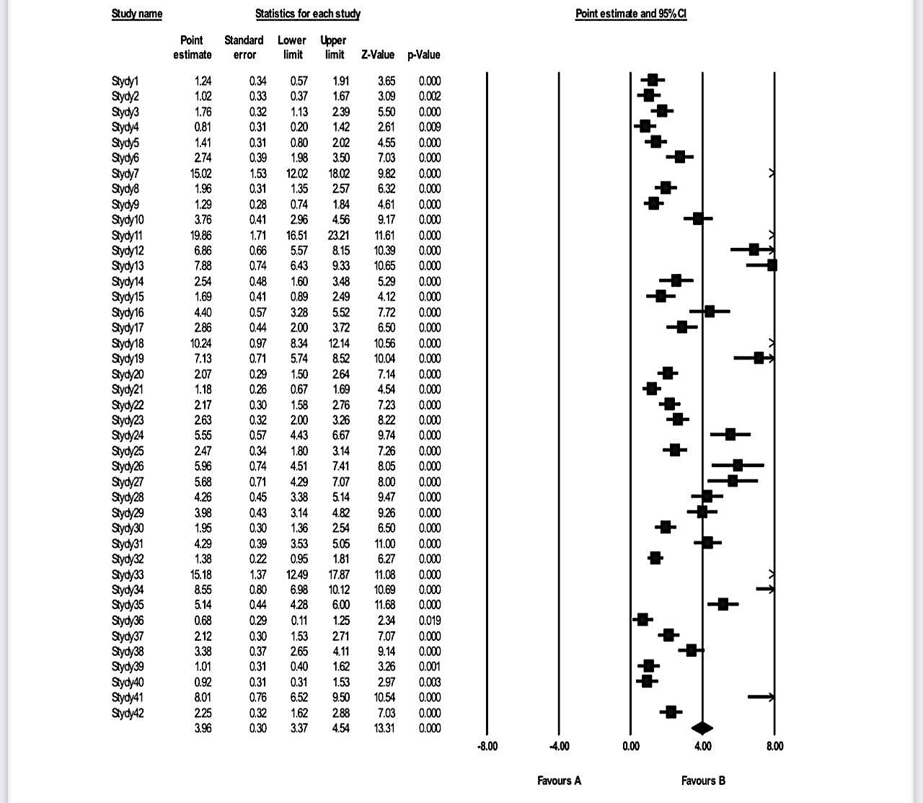

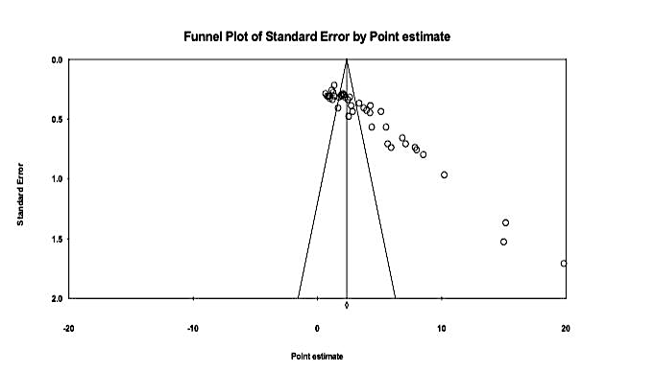

It is noted from Figure (2) that most of the effect sizes were concentrated in the upper part inside the funnel symmetrically around the vertical line, which represents the average size of the effect, but a few have occurred far from the funnel and this indicates a low probability of bias in propagation, and to further confirm the bias of propagation, the classic fail-safe N test was used, which is shown in the following table

Z value for observed studies | 48.10
p-value for observed studies | 0.000
Alpha value | 0.05
Number of observed impact sizes (k ) | 42
Number of trace volumes lost ( N ) | 25251

It is clear from Table (4) that the number of missing effects reached 25251, which must be added in the dimensional analysis to make the effect size non-significant, equivalent to 60,102 missing studies for each study observed to invalidate the size of the effect, which confirms that there is no bias in publication in current studies and that the results of the dimensional analysis are reliable.
Presentation of results related to the question Does the effectiveness of the STEM approach in achieving mathematics learning outcomes according to dimensional analysis differ according to [school stage, dependent variables, sample size]?
To answer this question, the dimensional analysis of the subgroups was used, which is shown in the following table:
Subgroup | Stage | Number | Average impact size  ( EN) | Standard error  (SE ) | With | Itself | Q | df | itself | Significance
Stage of study | Primary School | 9 | 3.57 | 0.47 | 7.65 | <0.000 | 1.04 | 2 | 0.594 | Non-function
Stage of study | Intermediate | 24 | 4.19 | 0.42 | 10.15 | 0.000
Stage of study | Secondary | 9 | 3.85 | 0.78 | 4.93 | 0.000
Dependent variables | Gnostic | 7 | 1.79 | 0.34 | 5.21 | 0.000 | 32.90 | 2 | 0.000 | function
Dependent variables | Sentimental | 9 | 6.15 | 0.81 | 7.60 | 0.000
Dependent variables | mahari | 26 | 3.86 | 0.37 | 10.46 | 0.000
Sample size | ≤30 | 20 | 3.40 | 0.42 | 8.09 | 0.000 | 3.24 | 1 | 0.072 | Non-function
Sample size | >30 | 22 | 4.47 | 0.42 | 10.66 | 0.000

Table (4) Test results to indicate the differences between the mean sizes of the input effect (STEM) according to the subgroup of the academic stage and the dependent variables Sample size
Table (4) showed that the average sizes of the impact of the STEM approach in the academic stages (primary, middle, secondary) were very large and statistically significant, which indicates its great effectiveness in achieving mathematics learning outcomes across all stages. Also, the value of the Q test was not statistically significant, which indicates that there is no difference in the effectiveness of the entrance according to the academic stage, which reflects its compatibility with all students due to the linking of learning content and activities to the reality of their lives and other disciplines.
These findings are consistent with studies by Rosli et al. (2019), Oztop (2023), and Rahmawati et al. (2023), while disagreeing with studies by Suciana et al. (2023) which confirmed that effects are better at high school and university. Also, the average sizes of the impact of the dependent variables (cognitive, emotional, and skill) were very large and statistically significant, which indicates the effectiveness of the input in achieving all mathematics learning outcomes. The value of the Q test also showed statistical significance, suggesting differences in effectiveness in favor of affective outcomes. This is because teaching mathematics via STEM enables students to design and implement projects related to their daily lives, increasing their enjoyment and love of learning.
Finally, there are no differences in the effect of the STEM input depending on the sample size, as this input is suitable for both large and small samples due to its flexibility and ease of procedures. (Al-Qawas, 2023).
Recommendations and suggestions:
Based on the findings, the study recommends:
1. Encouraging mathematics teachers to adopt the STEM approach in teaching mathematics, given its effectiveness in achieving learning outcomes.
2. Providing continuous training programs for mathematics teachers at all educational levels, with the aim of developing their skills in applying the STEM approach, which contributes to enhancing their knowledge, skills and attitudes towards this educational approach. (Al-Qawas, 2023).

The meta-analysis was applied to five previous studies through the research, and these studies aimed to answer key questions related to understanding how cognitive and technical transformations contribute to the development of educational curricula, and the importance of integrating STEM fields in enhancing the capabilities of students and teachers. Studies indicate the need to provide basic skills and knowledge to learners, in order to keep pace with the rapid changes in the education environment and the requirements of the Fourth Industrial Revolution, as the reliance on technology in the educational process is increasing.. In addition, the educational literature indicates that there is no comprehensive agreement on the concept of STEM and the promotion of integration between its disciplines, which calls for the need to build a clear vision for STEM education especially in the classroom. In light of this, the existence of an accurate scientific method to analyze the increasing studies and organize their results has become an urgent necessity to improve the educational process and achieve the desired benefits. By adopting Jane Glass's quantitative meta-analysis method, the research seeks to provide reliable conclusions by analyzing the statistical results of multiple STEM researches, contributing to our understanding of the actual impact of this approach on teacher and student performance. Five studies were conducted in Saudi Arabia on the use of STEM education in teaching mathematics. The study (Salwa and Ishaq, 2023) aimed to determine the degree of use of STEM education in teaching mathematics, in addition to identifying the challenges facing teaching this subject using this approach. The study included (162) participants, including (40) teachers and (122) teachers, and the questionnaire tool was used and followed the descriptive survey approach, which aims to describe the studied phenomenon in terms of its nature and degree of existence.. As for the study (Al-Enezi, 2019), it aimed to identify the reality of teaching according to the STEM approach and its impact on improving the level of academic achievement of mathematics among students of the second and third grades of secondary school. (32) students participated in this study, where they were divided into two groups: (16) students studied according to the STEM entrance and (16) students studied according to the traditional curriculum. Al-Qahtani and Kahlan (2017) examined the obstacles that prevent the application of the STEM curriculum in teaching mathematics at the intermediate stage, from the point of view of teachers and supervisors. The researchers used the questionnaire tool and followed the descriptive approach, where the sample number reached (103) participants who were selected in a simple random way. As for the study (Al-Saidi and Al-Azab, 2021), it aimed to identify the effectiveness of a proposed program to develop the professional and academic performance of science and mathematics teachers in light of the approach to integration between science, technology, engineering, and mathematics. The researchers relied on the descriptive analytical approach, and the number of participants reached (65) teachers, who were randomly selected. The study (Al-Maliki, 2021) aimed to identify the obstacles facing female teachers in using the STEM approach in teaching mathematics for the intermediate stage in the Taif education area. The study used the questionnaire tool and the descriptive analytical method, and the number of participants reached (89) teachers.

Research Methodology and Procedures: Methodology

-Research Methodology:
The current research relied mainly on the dimensional analysis method, which is a statistical analysis of a wide range of results reached by many previous individual studies for the purpose of integration between them, which requires recording the characteristics of the studies and their results quantitatively, and then analyzing those results in order to calculate the average size of the impact caused by the independent variable STEM in the dependent variables, in order to reach results about the results of these studies and extrapolate generalizations from them, and monitor future research trends in this field. (Zeidan; et al., 2022). Includes admission and exclusion criteria. The following: The study should contain the independent variable. STEM, the sample of the participants should be Arabs, the use of the Arabic language in the study. Publication of the study in a refereed journal. Determining the criteria for acceptance and exclusion also includes aspects such as: variables, language, and title, the review excluded studies that used a different independent variable, and a non-descriptive approach. Studies conducted with a sample other than Arabic or outside the Kingdom of Saudi Arabia, and studies not published in a refereed journal as well as in the period (2017-2023) were also excluded.

Research Tools:
First: Admission and Exclusion Criteria
To answer the research questions and achieve its objectives, a table (5) of admission and exclusion criteria has been prepared:
Acceptance Criteria |  | Exclusion criteria
The study included the STEM independent variable  Sample(s) Arab  The curriculum used is descriptive  Language used Arabic  The study used is published in a refereed journal  Publication year is limited to the period (2017-2023) |  | The study did not include the STEM independent variable  Non-Arab sample(s)  Descriptive approach not used  Language used is non-Arabic  The study used is not published in a refereed journal  Publication year not limited to period (2017-2023)

Research community and sample: The concerned studies were selected through the Blackboard system approved at King Saud University, where they moved to the digital library to choose the appropriate databases to obtain sources and references. Rules used include: In Arabic, the "system" database. The study selection process included a general reading of titles and abstracts to exclude duplicate studies, and then a careful reading of the titles and abstracts was performed to verify their conformity with the criteria for admission and exclusion. After that, a list was obtained The studies, as well as the full texts of each study, have been examined in detail to ensure compliance with the specified standards.The reasons for the rejection of some studies were clarified, and the results were presented in the form of an organization chart. The selection process included two main stages: in the first stage, the terminology was checked to remove duplicates, and then the titles and abstracts were checked according to the criteria for admission and exclusion. In the second stage, the full texts of previous studies were obtained and thoroughly examined, in addition to reviewing the bibliographies of the full texts. The standards included studies published over the past two decades to ensure that the information was updated and relevant. Qualitative and quantitative analysis methods were used to summarize the data, which helped to obtain accurate and comprehensive results of the studies. The independent variable used in previous studies was identified and applied to a sample of Arabs, with a focus on sources written in Arabic only. The title of the study was searched through dedicated websites and recorded, with a reference number for each study documented. Studies published only in refereed journals were reviewed to ensure the quality of information, with the screening form applied to the criteria for admission and exclusion to ensure the accuracy of and the comprehensiveness of the data studied.
As for the research sample: Five studies were conducted in the Kingdom of Saudi Arabia on the use of STEM education in teaching mathematics. A study (Salwa and Ishaq, 2023) aimed to determine the degree of use of STEM education in teaching mathematics, in addition to identifying the challenges facing teaching this subject using this approach. The study included (162) participants, including (40) teachers and (122) teachers, and used the questionnaire tool and followed the descriptive survey approach that aims to describe the studied phenomenon In terms of their nature and degree of existence. As for the study (Al-Enezi, 2019), it aimed to identify the reality of teaching according to the STEM approach and its impact on improving the level of academic achievement of mathematics among students of the second and third grades of secondary school. (32) students participated in this study, where they were divided into two groups: (16) students studied according to the STEM entrance and (16) students studied according to the traditional curriculum. Al-Qahtani and Kahlan (2017) examined the obstacles that prevent the application of the STEM curriculum in teaching mathematics at the intermediate stage, from the point of view of teachers and supervisors. The researchers used the questionnaire tool and followed the descriptive approach, where the sample number reached (103) participants who were selected in a simple random way. As for the study (Al-Saidi and Al-Azab, 2021), it aimed to identify the effectiveness of a proposed program to develop the professional and academic performance of science and mathematics teachers in light of the approach to integration between science, technology, engineering, and mathematics. The researchers relied on the descriptive analytical approach, and the number of participants reached (65) teachers, who were randomly selected. The study (Al-Maliki, 2021) aimed to identify the obstacles facing female teachers in using the STEM approach in teaching mathematics for the intermediate stage in the Taif education area. The study used the questionnaire tool and the descriptive analytical method, and the number of participants reached (89) teachers.

Second: Identify studies: Identify studies

A- Search strategy: Search strategy
In April 2025, an electronic search was conducted in the Arabic database "Al-Manzouma". Databases differ in their search methods, but they all share the use of specific search terms. Although each database has a distinct search strategy, accurate keywords have been applied across all parts of the database to ensure accurate and reliable results.

B- Search terms: Search terms
The research used different search terms as follows: STEM education, STEM teaching, STEM approach, STEM application obstacles, integrative science curriculum (STEM), obstacles facing teachers in using STEM, the reality of teaching mathematics, the level of academic achievement of female students, Teaching mathematics at the intermediate stage, developing the professional and academic performance of science and mathematics teachers, teaching mathematics for the intermediate stage.

c. Data extraction: Data extraction
This research aimed to extract data from the Arabic database "Al-Manzouma", where the data is presented in a systematic manner that includes the independent variable STEM and data related to relevant studies. In the first phase, background information was collected related to the included studies, which include the names of the researchers, the name of the journal, the date of the study, the total sample size (number), gender distribution (males and females), age, location of the experiment, nationality, and other relevant factors. The factors focused on the independent variable STEM and its relationship to mathematics education, as well as the analysis of the effect of gender (males and females) on the results. Additional data were also collected including average score, arithmetic mean, standard deviation, level of statistical significance, impact size, and impact strength, where impact strength was classified into three categories: high (0.14), medium (0.06), and low (0.01). This information forms a comprehensive database that contributes to understanding the impact of STEM in different educational contexts.

D. Synthesis of studies: Synthesis of studies
As part of the synthesis process, the steps began with an initial examination, where the titles and abstracts of the available studies were reviewed. The aim of this phase was to determine the extent to which the studies conform to the criteria set for admission and exclusion. Next, we moved on to the second examination, which included a comprehensive assessment of the selected studies. At this stage, we read the full texts of the studies to make sure they are relevant and relevant to the topic we are researching. After the checks were completed, the data mining phase came. Here, we collected information related to the STEM independent variable, focusing on the key results presented by the studies. This data was necessary to understand the impact of STEM more deeply. Finally, meta analysis was performed, where we determined the magnitude and strength of the effect produced by the variables studied. We used descriptive analysis to summarize the main findings of each individual study, giving us a comprehensive view of the magnitude and strength of the impact between different studies. In this way, we were able to build an integrated picture of the impact of STEM in the educational, vocational and academic sectors.

E. Risk of bias: Risk of bias
Research bias suggests that studies published in refereed journals that are included in the post-analysis sample do not accurately reflect the population of studies from which they were extracted. This bias is particularly evident when the studies included in the metaanalysis sample are limited to the time period from 2017 to 2023, limited to studies written in Arabic, which adopted the descriptive approach, and were applied only in Saudi Arabia.

Results: Results

Study flow

Study Procedures: The study went through several methodological stages, where the field of study was initially determined by focusing on the integration of science, technology, engineering and mathematics (STEM), and its impact on education in the Kingdom of Saudi Arabia.
Database search: A thorough search was conducted in Arabic databases such as Dar Al-Manzouma, using keywords associated with the STEM portal.The focus was on studies that dealt with the descriptive approach of this approach within the Kingdom, taking into account its impact on teachers, students and supervisors.
Criteria for selecting studies: Criteria were set to determine the appropriate studies, as these criteria included the following: Publications should be in Arabic. Publications should be in refereed scientific journals. To include studies published between 2017 and 2023.Rely on the descriptive approach.
Address the effectiveness of the STEM input as an independent variable.
Determination of the analysis sample: In terms of determining the analysis sample, the comprehensive survey phase began with a preliminary screening of the studies. This was followed by the screening phase that resulted in the identification of relevant studies dealing with the application of the STEM approach in education. Then there was a selection phase that focused on studies that used the descriptive approach, taking into account the implications for teachers, students and supervisors.
Embedding and Analysis: Finally, in the inclusion phase, studies that fit the set standards were collected, and the data extracted from them were analyzed to assess the impact of the STEM approach in teaching mathematics within the Kingdom. In this way, a reliable sample was prepared to analyze the impact of STEM input in education, which contributes to improving educational practices and developing teaching strategies in Saudi Arabia.
The test for the interpretation of the size of the impact


(Al-Qawas, 2023).
Figure 3 illustrates the electronic and manual search process: The tool used in this research contained five main areas, including the process of distributing studies in databases. Special emphasis has been placed on databases in Arabic, such as the system.
Research steps: Studies extracted from databases: (21) titles and abstracts were retrieved initially. Remove duplicates and unrelated topics: After an initial review, (14) unrelated titles and abstracts were removed.
- Examination No. (1) (Titles and Abstracts): (21) titles and abstracts were examined according to the criteria for acceptance and exclusion. (14) studies were excluded based on titles and abstracts because they are not related to the topic of STEM.
- Examination No. (2) (full studies): (14) complete studies were reviewed, where (8) studies were excluded, because the method used was experimental and not descriptive survey, in addition to excluding one study because it is not related to the subject of STEM, and therefore (5) studies remain for dimensional analysis.
- Examination of the list of references: The list of references was examined, and this resulted in the acceptance of (5) studies for dimensional analysis.
- Summary of results: Acceptable studies in dimensional analysis: N = 5. These steps explain how to conduct electronic and manual research, focusing on the different processes for examining studies and identifying those that are consistent with the STEM topic.

Study flow: Study flow diagram

Figure 3 Flow of identification of studies and determination of admission and exclusion criteria
System

Studies extracted from databases
N= 21
Delete duplicates
N= 14

Exclusion based on headings and summaries as it is not related to a topic by the independent variable
N=٩
Check 1 (headings and abstracts)
N=14

Check No. 2 (full studies)
N=14
Exclusion based on full studies
=8 Not surveyive descriptive studies
1= Not related
N=9

Check the list of references
N=5
Accepted studies in dimensional analysis
N=5

Data extraction: Data extraction

Form information (coding) for the five studies:
Study (1): The reality of teaching mathematics using STEM education at the intermediate stage from the point of view of mathematics teachers in the Jazan Education Department.
Study (2): The reality of teaching according to the (STEM) approach in improving the level of academic achievement among secondary school students.
Study (3): Obstacles to the application of the STEM approach in teaching mathematics at the intermediate stage from the point of view of teachers and supervisors in Asir region
Study 4: A proposed program in light of the requirements of the Integrative Science Curriculum (STEM) to develop the professional and academic performance of secondary science and mathematics teachers.
Study (5): Obstacles facing female teachers in using STEM in teaching mathematics for the intermediate stage in the Taif education area.
–Form (coding) for studies:
Study Number | Methodology used | Accredited Journal Name | year  Publishing  2017-2023 | Sex |  |  | Language  Used | Level of statistical significance | Arithmetic mean | Standard deviation
 |  |  |  | Total number  For subscribers | number  Male | number  Female
Codec | M | S | N | A | K=1 | Th=2 | L | α | X | Q
Study (1) | Descriptive (Clear) | International Journal of Educational and Psychological Studies | 2023 | 162 | 40 | 122 | Arabic Language | 0.01 | 3.81 | 0.807
Study (2) | Descriptive (Clear) | Scientific Journal | 2019 | 32 | 0 | 32 | Arabic Language | 0.01 | 82.50 | -
Study (3) | descriptive | Journal of Educational and Psychological Sciences | 2017 | 103 | 103 | 0 | Arabic Language | 0.01 | 2.985 | 0.895
Study (4) | Descriptive (analytical) | International Journal of Research in Educational Sciences | 2021 | 65 | 0 | 0 | Arabic Language | 0.01 | 9.42 | 1.05
Study (5) | Descriptive (analytical) | Comprehensive multidisciplinary electronic journal | 2021 | 89 | 0 | 89 | Arabic Language | 0.05 | 3.92 | 0.82

To answer the research questions, the effect size can be calculated by converting the calculated value of (t) to the square of ETA (²η), which is given an indication of the size of the effect through the following parameter:
$$ƞ2=\frac{(t)2}{\left(t\right)2+df}$$
Thus, it can be converted to a corresponding value (d), using the following equations (Reda Al-Saeed 2010):
$$d=\frac{2\sqrt{eta}}{\sqrt{1-eta}}$$

Table (6): The size of the impact of using the STEM strategy as an independent variable in teaching mathematics to learners.
Calculated T value | Degrees of freedom | Value ^{2ƞ} | Impact size d | Significance of impact size
4.173 | 4 | 0.81320 | 4.2763 | Very big impact

The size of the effect is the positive effect of the STEM-based program as an independent variable in teaching mathematics to learners by calculating the square of ETA (²η), which is used for related and unrelated samples, and the results were as shown in the previous table (2).
It is clear from the results presented in the previous table that the value of the ETA square is (0.81320) and the value of the effect size resulting from the use of the STEM strategy as an independent variable in teaching mathematics to learners is (4.2763) and by comparing these values with the degrees specified to indicate the size of the effect, we find that the effectiveness of using the STEM strategy as an independent variable in teaching mathematics Learners have a very high impact, as the levels of vulnerability are (0.2 small - 0.5 medium - 0.8 large) (Reda Al-Saeed 2010) and the previous result can be explained that the change that occurred in the understanding and development of learners' abilities for the mathematics curriculum is largely due to the effect of the independent variable, which is the use of the STEM strategy as an independent variable in mathematics teaching.

Calculation of variance and homogeneity between studies:
Using the data of four studies after excluding Study No. 2 because the standard deviation necessary to calculate the effect size was not available. The following metrics were calculated:
- Impact size (Cohen's d)
- Variance within each study
- Weighted average impact size
- Q statistic for homogeneity measurement
- I² indicator to measure the non-random variance ratio
- Estimation of variance between studies (Tau-squared τ²)
1: Calculate the size of the impact (Cohen's d)
The size of the trace for each study is calculated using the formula:
Cohen’s d = Mean / SD
The size of the effect was calculated as follows:
- Study 1: d = 3.81 / 0.807 ≈ 4.72
- Study 3: d = 2.985 / 0.895 ≈ 3.34
- Study 4: d = 9.42 / 1.05 ≈ 8.97
- Study 5: d = 3.92 / 0.82 ≈ 4.78

2: Calculate variance within each study (Vi)
The variance for each study is calculated using the formula:
Wallet = (1/n) + (d² / 2n)
where: n is the number of study participants, d is the size of the effect
The variances were calculated as follows:
- Study 1: Vi = (1/162) + (4.72² / (2×162)) = 0.07491
- Study 3: Vi = (1/103) + (3.34² / (2×103)) = 0.06386
- Study 4: Vi = (1/65) + (8.97² / (2×65)) = 0.63411
- Study 5: Vi = (1/89) + (4.78² / (2×89)) = 0.13951
3: Calculate the weight per study (wi)
The weight for each study is calculated using the formula:
wi = 1 / Vi
Results:
- Study 1: wi ≈ 13.35
- Study 3: wi ≈ 15.66
- Study 4: wi ≈ 1.58
- Study 5: wi ≈ 7.17
4: Weighted Mean:
The weighted average is calculated by the formula:
d̄ = Σ (wi × di) / Σwi
Accounts:
(13.35 + 15.66 + 1.58 + 7.17) / (d̄ = (13.35×4.72 + 15.66×3.34 + 1.58×8.97 + 7.17×4.78
d̄ = (62.99 + 52.32 + 14.17 + 34.26) / 37.76 ≈ 4.34

5: Calculation of homogeneity between studies Q (Cochran's Q)
Q is calculated by the formula:
Q = Σ wi × (di - d) ²
Accounts:
- Study 1: 13.35 × (4.72 - 4.34) ² ≈ 0.28
- Study 3: 15.66 × (3.34 - 4.34) ² = 15.66
- Study 4: 1.58 × (8.97 - 4.34) ² = 33.98
- Study 5: 7.17 × (4.78 - 4.34) ² = 1.38
Q ≈ 51.30
6: Calculating the I² Index (for Nonrandom Variance Ratio)
The non-random variance is calculated from the equation:
I² = ((Q - df) / Q) × 100

I² = ((51.30 - 3) / 51.30) × 100 ≈ 94.15%

7: Estimation of variance between studies (Tau-squared τ²)
The variance between studies is calculated from the equation:
τ² = (Q - df) / (Swi - (Swi² / Swi))
Calculation of values:
Swi = 37.76
Swi² = (13.35² + 15.66² + 1.58² + 7.17²) ≈ 477.4
τ² = (48.30) / (37.76 - (477.4 / 37.76)) = 48.30 / 25.12 ≈ 1.92
Overall final results:
- - Weighted Mean Effect Size d) = 4.34
- - Cochran's Q: Q = 51.30
- Non-random variation between studies: I² = 94.15 % (very high)
- Variance between studies: τ² = 1.92

Table 7: Effect Size, Average Weighted Effect Size, Variance, and Homogeneity Tests for Variance between Studies
Education | Sample size | Average | Standard deviation | Impact size | Average weighted impact size | Contrast | Weight per study | Homogeneity between studies | Non-random variance | Variation between studies
Education | N | Mean | SD | Effect Size | Weighted Effect Mean | You | Wi | Q | I2 | ʈ2
1 | 162 | 3.81 | 0.81 | 4.704 | 762.00 | 0.749 | 13.35 | 0.28 | 94.15  % | 1.92
2 | 32 | 82.5 | --- | --- | --- | --- | --- | --- | 94.15  % | 1.92
3 | 103 | 2.99 | 0.9 | 3.322 | 342.19 | 0.063 | 15.66 | 15.66 | 94.15  % | 1.92
4 | 65 | 9.42 | 1.05 | 8.971 | 583.14 | 0.634 | 1.58 | 33.98 | 94.15  % | 1.92
5 | 89 | 3.92 | 0.82 | 4.780 | 425.46 | 0.139 | 7.17 | 1.38 | 94.15  % | 1.92
sum | 451 |  |  | 4.356 | 2112.795161 |  |  |  | 94.15  % | 1.92
 | Overall Weighted Mean = 4.34 (Average effect size) |  |  |  |  |  |  | 51.30 | 94.15  % | 1.92

- This table presents a quantitative analysis of five studies that examined the use of STEM strategy as an independent variable in mathematics teaching. The effect was calculated using Cohen's equation, and each study was weighed based on its sample size.The average overall weighted mean was 4.34, which is a very high value according to Cohen's classification (greater than 1.3 = very high effect), which indicates a significant effectiveness of the STEM strategy in improving learning outcomes. Study No. 4 achieved the highest effect size (8.971), which indicates an exceptional effect, but this may be explained by reasons including that the study sample is relatively small ( n=65) or may be due to a difference in measured variables or educational context.
- The table also shows that the variation between the studies (ʈ2 = 1.92) indicates that there are actual differences between the studies and not just random variation and therefore not all studies agree completely in their estimate of the size of the effect. It is also noted that the value of non-random variance between studies (I² = 94.15%) means that 94.15% of the variance between studies is non-random variance which is very high and indicates a relatively weak homogeneity between the results of the studies.

Table 8: Size of the impact of using the STEM strategy, confidence interval (95%) and tests of homogeneity of variance between studies
 | Impact size and 95% confidence intervals |  |  |  |  | Hypothesis testing |  | Contrast smoothing
Number of studies | Impact size | Standard error | Contrast | The bare minimum | Upper limit | Z value | P. value | Q | df | P. valu | I2 | ʈ2
4 | 4.34 | 1.44 | 0.317 | 5.78 | 2.90 | 1.31 | 0.001 | 51.30 | 3 | 0.001 | 94.15 % | 1.92

The previous table (8) shows that the variation in the results of the four pooled studies was high, as the value of the homogeneity test was (Q = 51.30) with degrees of freedom (df = 3), which is statistically significant (P = 0.001) and the heterogeneity ratio (I² = 94.15%) confirms that the variation between the studies is not random.
These results indicate that the application of the STEM strategy in teaching mathematics has a very significant impact on the achievement of learners and the development of their abilities, and despite the high average impact size of these studies, the high heterogeneity (I² = 94.15%) requires explanation, and this may be due to the variation of measurement tools, or the difference in ages, or characteristics of samples, or a variation in the design of the study (some descriptive, others analytical) or a difference in the programs or educational interventions applied..

Figure (4) Forest shape for average individual impact sizes for research and preliminary studies (N = 5 )

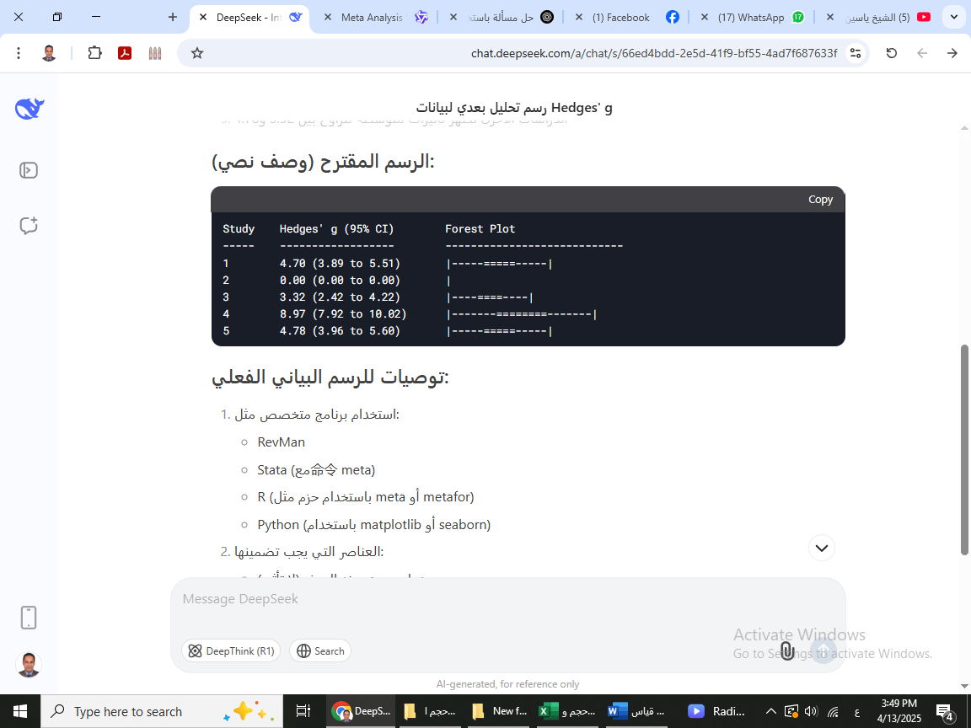

Discussion: Discussion

General discussion of the five studies
The five studies address the obstacles facing female teachers in using the STEM curriculum in teaching mathematics, where a set of factors related to teachers, students, and the school environment were analyzed. Although the contexts and research methods used differ, there are points of convergence and divergence between these studies.
The impact of the STEM-based curriculum training program on mathematics teaching: This study analyzes the impact of the STEM-based curriculum training program on teaching mathematics, with a focus on the magnitude of the impact resulting from the application of this strategy. The results of the statistical analysis showed that the value of the delivery square (²η was 0.81320, which indicates a very significant positive impact of the STEM strategy.as an independent variable in teaching mathematics. This positive effect is in line with what Reda El-Said (2010) pointed out, where values above 0.8 are considered evidence of a significant impact, reflecting the effectiveness of this strategy in enhancing learning. Furthermore, the impact size of the STEM strategy was 4.2763, placing it in the high impact category according to Cohen's criteria. The average weighted weight (d) of 4.34 was also calculated, which enhances the credibility of the results and indicates that the positive impact of the STEM strategyIt goes beyond the traditional boundaries of teaching mathematics. These high values reflect the remarkable positive change in the understanding and development of learners' abilities in the field of mathematics. Study No. 4 achieved the highest effect size of 8,971, indicating an exceptional effect. However, the explanation for this high figure may be attributed to the relatively small sample (N=65) or to a difference in the measured variables or educational context.
Evaluation of homogeneity between studies: In the context of assessing the homogeneity between studies, Cochran's Q test was used, where the value of Q = 51.30 with degrees of freedom (df = 3), indicating a marked variation between the studies analyzed. In addition, the results showed that the non-random variation between the studies was very high, with a value of I² = 94.15%. This percentage means that 94.15% of the variance between studies is non-random, indicating a relatively low homogeneity between the results of the studies. These results suggest that the application of the STEM strategy in mathematics teaching has a very significant impact on learners' achievement and development. However, high heterogeneity (I²=94.15%) is due to several factors, including different measuring instruments, diversity of ages and characteristics of samples, varying design of studies (some descriptive, others analytical), or different educational programs applied.
Study the reality of teaching mathematics using STEM education in the middle stage: The results of the study indicate a great preference among mathematics teachers in the Jazan Education Department to use STEM teaching methods, as the arithmetic mean of their responses was 3.81 with a standard deviation of 0.807. This reflects the efforts of the Ministry of Education in developing curricula and enhancing scientific thinking skills. The results also showed the effectiveness of STEM education in improving students' comprehension of knowledge.
Challenges in teaching mathematics using STEM education: Teachers faced high challenges, with responses ranging from 4.02 to 3.97, with curriculum-related challenges being the highest, followed by student and teacher challenges. These challenges need curriculum development and support to ensure that STEM education is implemented effectively, requiring enhanced efforts in curriculum improvement and training.
The effect of the STEM approach on the achievement of secondary school students: The results showed that there were statistically significant differences in the achievement of secondary school students between the two groups (STEM and normal). The first group achieved an average of 83.125, while the second group got 81.875. In the second grade of secondary school, the first group achieved an average of 84.5 compared to 73.0 for the second group. In contrast, the second group excelled in the third grade of secondary school with an average of 87.2.
Review the final total of students' grades:
- First group (STEM): Third grade of secondary school: Intermediate (82.3) (10 girls) - Second secondary grade: Intermediate (84.5) (6 girls)
- The second group (regular curriculum): Third secondary grade: Intermediate (87.2) (10 girls) Second secondary grade: Intermediate (73.0) (6 girls)
The results indicate a positive effect of STEM teaching in the second grade of secondary school, while it did not appear in the third grade of secondary school.
Evaluation of the effectiveness of the training program for science and mathematics teachers: The training program lasted 26 hours, where the appropriateness of the content and teaching style was assessed using pre- and post-tests. The results showed a difference of D at the level of 0.01 between the two applications, which indicates the improvement of the professional and academic performance of teachers.
Analysis of obstacles in the application of the STEM curriculum: The results of a questionnaire of 89 female teachers showed that the average responses reached 3.92 with a relative weight of 78.41%, which indicates the presence of significant obstacles. These findings indicate the need to address these constraints to ensure that the STEM curriculum is implemented effectively and that the desired educational objectives are achieved. The study provides a comprehensive framework for improving the skills and knowledge of math and science teachers, contributing to improving the quality of education and enhancing students' scientific understanding.

Strengths, weaknesses and recommendations:
Strengths:
Studies have used a variety of methods to collect data, including questionnaires and interviews, enhancing the reliability of the results.
- The studies included large and diverse samples of teachers and students, which further generalized the results.
- Advanced statistical methods were used to analyze the data, which enhances the accuracy of the results.
Studies have provided a clear analysis of a variety of constraints, helping to understand the challenges comprehensively.
- Studies have proposed practical and direct recommendations to improve the application of the STEM curriculum in education.
Weaknesses:
- Some studies did not take into account the impact of cultural and social contexts on the application of the STEM approach.
Some studies have relied heavily on quantitative data, which may limit deep understanding of individual experiences.
- The degree of interest of researchers in each study varied, which affected the depth of the research.
- Teachers' and students' self-reports may affect the accuracy of results due to personal bias.
Some studies did not include comparisons between different schools or districts, limiting the possibility of drawing general conclusions.

Recommendations:
- The need to provide specialized training courses for teachers to enhance their understanding of the STEM curriculum.
- The need for greater administrative support to provide the appropriate environment for the implementation of the STEM curriculum .
- Organizing workshops and events to promote the culture of STEM among students.
- Encourage qualitative studies to understand the experiences of teachers and students more deeply.
- The need to expand the scope of research to include different geographical regions and cultures to obtain more comprehensive results.
Opinions of researchers in each study:
• The first study: stressed the importance of vocational training for female teachers as a key factor to overcome obstacles.
• The second study: indicated the impact of the school environment significantly on the success of the implementation of the STEM curriculum.
• The third study: focused on the importance of enhancing awareness and scientific culture among students.
• The fourth study: discussed the need for administrative and financial support for schools to facilitate the application of the curriculum.
• The fifth study: suggested benefiting from successful international experiences in applying the STEM curriculum as a reference to improve local performance.
This discussion contributes to providing comprehensive insights into the challenges faced by teachers in implementing the STEM curriculum and highlights the importance of collaboration between all stakeholders to achieve success in this educational field.

The end:
The results of the study of the reality of teaching mathematics using STEM education in the middle stage show that there is a positive consensus among teachers on the effectiveness of this curriculum in enhancing students' skills. However, challenges related to curricula, students and teachers emerge as factors influencing the application of this teaching method. The study also showed a remarkable impact of STEM education.on female students' achievement in the second grade of secondary school, while the same effect did not appear in the third grade of secondary school. More efforts are needed to develop curricula and provide the necessary support to teachers and students to ensure better learning outcomes. Addressing these challenges will contribute to enhancing the effectiveness of mathematics teaching and developing students' scientific thinking skills.

Sources and references
Arabic References
Jalal, Muhammad; (2019). Education (STEMA framework for the integration of science, technology, engineering and mathematics. King Saud University Press. Riyadh, p. 10.
Zaid, a jewel. (2020). Dimensional analysis and impact size. Center of Research Excellence in the Development of Science and Mathematics . King Saud University. https://search.app/3nRTknewXktdsX2M9
Zeidan, Abdel Fattah, Hassan, Abdel Moneim, Othman, Al-Saeed. (2022). Dimensional analysis of the effectiveness of using metacognitive strategies in achieving some biological science learning outcomes among general education students. Journal of Education. Al-Azhar University, Faculty of Education, Cairo, pp. 374-376.
Happy, Reza. (2010). "Statistical Methods for Measuring the Scientific Importance of Educational Research Results", Fifteenth Scientific Conference, Curricula of Education and Preparation for Contemporary Life, 21-22 July 2003, Egyptian Association for Curricula and Teaching Methods, Volume II, pp. 645-674.
Al-Saidi, Mansour; (2021). A proposed program in light of the requirements of the Integrated Science Curriculum (STEM) to develop the professional and academic performance of science and mathematics teachers at the secondary level. International Journal of Research in Educational Sciences. My Governorate (Qalyubia, Menoufia), pp. 195-243.
Salwi, Layla, Isaac, Hassan. (2023). The reality of teaching mathematics using STEM education at the intermediate stage from the point of view of mathematics teachers in the Jazan Education Department. International Journal of Educational and Psychological Studies. Jazan Education Department, Saudi Arabia, pp. 765-779.
Al-Anzi, Hanan. (2019). The reality of teaching according to the (STEM) approach in improving the level of academic achievement of secondary school students. Scientific Journal of the Faculty of Education - Assiut University. Riyadh, pp. 127-150.
Al-Qahtani, Hussein; (2017). Obstacles to the application of the STEM approach in teaching mathematics at the intermediate stage from the point of view of teachers and supervisors in Asir region. Journal of Educational and Psychological Sciences. Department of Curriculum and Teaching Methods, College of Education, King Khalid University, pp. 23-42.
Qawas, Muhammad. (2023).The effectiveness of REM & STEM inputs in achieving mathematics learning outcomes according to the dimensional analysis of studies published in Arab periodicals for the period 2013-2023. An Arab research journal in specific education journals. Development and Quality Assurance Center. Ibb University, Yemen. pp. 15-48.
Kwara, Amjad. (2017). The effect of using the STEM curve on developing conceptual comprehension and creative thinking in mathematics among ninth grade students. Retrieved from https://www.mobt3ath.com/uplode/book/book-30697.pdf website
Al-Maliki, Fatima Aidah. (2021). Obstacles facing female teachers in using STEM in teaching mathematics for the intermediate stage in the Taif education area. The comprehensive interdisciplinary electronic journal. Taif.
Education and Training Evaluation Commission. (2018). The National Framework for Public Education Curriculum Standards in the Kingdom of Saudi Arabia. Riyadh, p. 19.

