Supplementary Material

Inhoud
STROBE Statement—checklist of items that should be included in reports of observational studies 2
Supplementary Material Table S1: Quality assessment of the translation high-resolution. 4
Supplementary Material Figure S1: Correlation between total HLA antigen mismatches for HLA-A/-B/-DR and total saAA mismatches 5
Supplementary Material Table S2: Median saAA mismatch scores for transplant outcomes; donor-specific antibodies (DSA), biopsy-proven acute rejection (BPAR) and Death-Censored Graft Failure (DCGF) 6
Supplementary Material Table S3: 7
Supplementary Material Table S4: 8
Supplementary Material Table S5: 9
Supplementary Material Table S6: 11
Supplementary Material Table S7: 11
Supplementary Material Tables S8-11; sensitivity analysis 1 12
Supplementary Material Tables S12-16; sensitivity analysis 2 14
Supplementary Material Tables S17-21; sensitivity analysis 3 16
Supplemental Material Table S22; sensitivity analysis 4 19
Supplementary Material Tables S23-27; sensitivity analysis 4 20

STROBE Statement—checklist of items that should be included in reports of observational studies

 | Item No | Recommendation | Page-number
Title and abstract | 1 | (a) Indicate the study’s design with a commonly used term in the title or the abstract | 1
Title and abstract | 1 | (b) Provide in the abstract an informative and balanced summary of what was done and what was found | 2
Introduction
Background/rationale | 2 | Explain the scientific background and rationale for the investigation being reported | 3
Objectives | 3 | State specific objectives, including any prespecified hypotheses | 3-4
Methods
Study design | 4 | Present key elements of study design early in the paper | 4
Setting | 5 | Describe the setting, locations, and relevant dates, including periods of recruitment, exposure, follow-up, and data collection | 4
Participants | 6 | (a) Cohort study—Give the eligibility criteria, and the sources and methods of selection of participants. Describe methods of follow-up | 4-7
Variables | 7 | Clearly define all outcomes, exposures, predictors, potential confounders, and effect modifiers. Give diagnostic criteria, if applicable | 5-7
Data sources/ measurement | 8* | For each variable of interest, give sources of data and details of methods of assessment (measurement). Describe comparability of assessment methods if there is more than one group | 4-7
Bias | 9 | Describe any efforts to address potential sources of bias | 7-8
Study size | 10 | Explain how the study size was arrived at | 4
Quantitative variables | 11 | Explain how quantitative variables were handled in the analyses. If applicable, describe which groupings were chosen and why | 7-8
Statistical methods | 12 | (a) Describe all statistical methods, including those used to control for confounding | 7-8
Statistical methods | 12 | (b) Describe any methods used to examine subgroups and interactions | 7-8
Statistical methods | 12 | (c) Explain how missing data were addressed | 7-8
Statistical methods | 12 | (d) Cohort study—If applicable, explain how loss to follow-up was addressed | 7-8
Statistical methods | 12 | (e) Describe any sensitivity analyses | 8

Results |  |  | Page Number
Participants | 13* | (a) Report numbers of individuals at each stage of study—eg numbers potentially eligible, examined for eligibility, confirmed eligible, included in the study, completing follow-up, and analysed | 8-9
Participants | 13* | (b) Give reasons for non-participation at each stage | 8
Participants | 13* | (c) Consider use of a flow diagram | NA
Descriptive data | 14* | (a) Give characteristics of study participants (eg demographic, clinical, social) and information on exposures and potential confounders | 8-9
Descriptive data | 14* | (b) Indicate number of participants with missing data for each variable of interest | 8-9
Descriptive data | 14* | (c) Cohort study—Summarise follow-up time (eg, average and total amount) | 8-9
Outcome data | 15* | Cohort study—Report numbers of outcome events or summary measures over time | 8-9
Main results | 16 | (a) Give unadjusted estimates and, if applicable, confounder-adjusted estimates and their precision (eg, 95% confidence interval). Make clear which confounders were adjusted for and why they were included | 11-13
Main results | 16 | (b) Report category boundaries when continuous variables were categorized
Main results | 16 | (c) If relevant, consider translating estimates of relative risk into absolute risk for a meaningful time period
Other analyses | 17 | Report other analyses done—eg analyses of subgroups and interactions, and sensitivity analyses | 11-13
Discussion
Key results | 18 | Summarise key results with reference to study objectives | 13-14
Limitations | 19 | Discuss limitations of the study, taking into account sources of potential bias or imprecision. Discuss both direction and magnitude of any potential bias | 17
Interpretation | 20 | Give a cautious overall interpretation of results considering objectives, limitations, multiplicity of analyses, results from similar studies, and other relevant evidence | 13-17
Generalisability | 21 | Discuss the generalisability (external validity) of the study results | 13-17
Other information
Funding | 22 | Give the source of funding and the role of the funders for the present study and, if applicable, for the original study on which the present article is based | 2

Supplementary Material Table S1: Quality assessment of the translation high-resolution.

Important note: the quality assessment was performed on the alleles and not individual kidney transplant recipients.

High-resolution imputation was performed for kidney transplant recipients in the Leiden cohort. High-resolution NGS typing were available for 22.907 alleles (46%), while the remaining 54% were imputed.

Supplementary Material Figure S1: Correlation between total HLA antigen mismatches for HLA-A/-B/-DR and total saAA mismatches

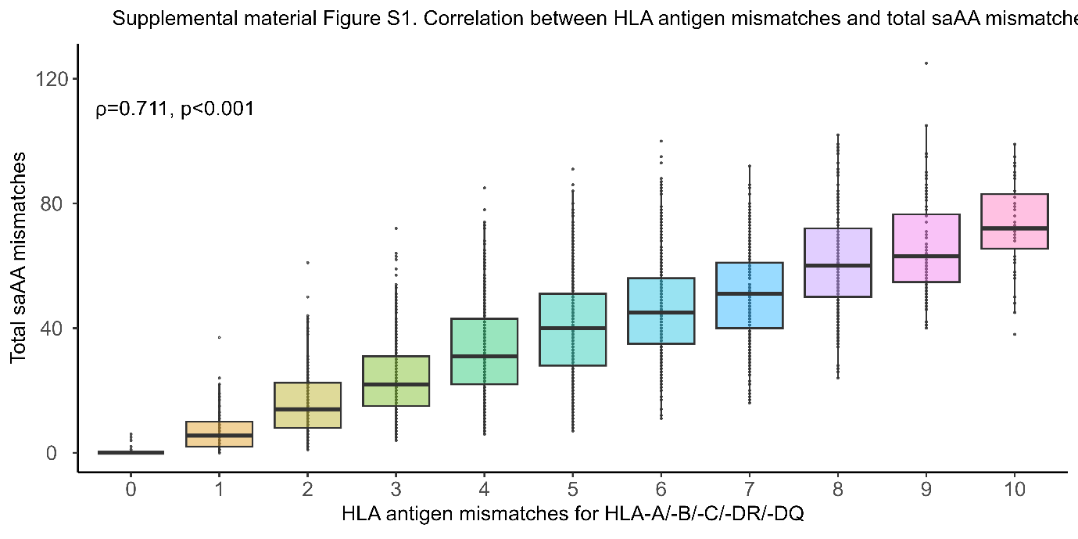

Supplementary Material Table S2: Median saAA mismatch scores for transplant outcomes; donor-specific antibodies (DSA), biopsy-proven acute rejection (BPAR) and Death-Censored Graft Failure (DCGF)

Supplementary Material Table S3:

Multivariable analysis including both total class I and total class II solvent-accessible amino acid mismatches simultaneously on hierarchical composite endpoint of death-censored graft failure, biopsy-proven acute rejection, and de novo donor-specific antibody development

Supplementary Material Table S4:

Multivariable analysis including both total class I and total class II solvent-accessible amino acid mismatches simultaneously on DCGF

Supplementary Material Table S5:
Multivariable analysis including both total class I and total class II solvent-accessible amino acid mismatches simultaneously on BPAR

Supplementary Material Table S6:

Multivariable analysis including both total class I and total class II solvent-accessible amino acid mismatches simultaneously on dnDSA development

Supplementary Material Table S7:

Multivariable analysis in which the impact of locus specific saAA mismatches on locus-specific dnDSA formation was investigated within the context of one or two antigen mismatches

Supplementary Material Tables S8-11; sensitivity analysis 1

Sensitivity analysis was performed by restricting our analysis to KTRs with only NGS HLA data for both primary and secondary endpoints. For secondary endpoint analyses, we limited the assessment to Total, Class I and Class II saAA mismatches to maintain methodological rigor and power, and prevent uninterpretable, excessively broad confidence intervals.

Supplementary Material Tables S12-16; sensitivity analysis 2

To facilitate the comparison of hazard ratios (HRs) for the hierarchical composite endpoint, and individual outcomes of dnDSA, BPAR, and DCGF across individual HLA loci, we included the "median increase" for each HLA locus to account for differences in their distributions (Supplementary Material Tables S12-S16)

Supplementary Material Tables S17-21; sensitivity analysis 3

Sensitivity analysis in subgroup of patients without pre-transplant donor-specific antibodies for all primary and secondary endpoints.

Supplemental Material Table S22; sensitivity analysis 4

Sensitivity analysis by excluding BPARs diagnosed on protocol biopsies, thereby focusing solely on for-cause biopsies for the primary and secondary endpoints

Supplementary Material Tables S23-27; sensitivity analysis 4

Sensitivity analysis was performed in a subgroup where HLA-identical familial kidney donors were excluded. The analysis was done for both the primary and secondary endpoints.

