Supplementary Information for
Examining the Relationship between Residential and Workplace Segregation and Environmental Exposures
Priyanka deSouza^{1,2,^}, Shin Bin Tan^{3,*}, Zoe Haskell-Craig⁴, Kirk Hohsfield⁵, James Crooks⁵, Jing Li⁶, Jacqueline Klopp⁷, Carrie Makarewicz¹, Ellen M. Considine^{8,9}, Prashant Kumar^{10,11}, Patrick L. Kinney¹², Jonathan I. Levy¹², Kevin Josey¹³, Jenny Jyoung Lee^{13,}^

1: Department of Urban and Regional Planning, University of Colorado Denver
2: CU Population Center, University of Colorado Boulder
3: Lee Kuan Yew School of Public Policy, National University of Singapore
4: Department of Biostatistics, New York University School of Global Public Health, New York, NY
5: Department of Epidemiology, Colorado School of Public Health, University of Colorado - Anschutz Medical Campus, Aurora, CO, USA
6: Department of Geography and the Environment, University of Denver, Denver, CO 80210, USA
7: Center for Sustainable Urban Development, Earth Institute, Columbia University, United States
8: Cooperative Institute for Research in Environmental Sciences, University of Colorado Boulder
9: Department of Geography, University of Colorado Boulder
10: Global Centre for Clean Air Research (GCARE), School of Engineering, Civil and Environmental Engineering, Faculty of Engineering and Physical Sciences, University of Surrey, Guildford GU2 7XH, United Kingdom
11: Institute for Sustainability, University of Surrey, Guildford GU2 7XH, Surrey, United Kingdom
12: Department of Environmental Health, Boston University School of Public Health, Boston, MA
13: Department of Biostatistics & Informatics, Colorado School of Public Health, Aurora, CO
14: Department of Data Science, Ewha Womans University, Seoul 03760, Republic of Korea
*: Contributed Equally
^: Corresponding authors (priyanka.desouza@ucdenver.edu, jj_lee@ewha.ac.kr)

S1 Summary of Evidence Linking Segregation with Exposure to Pollution, Disparities in Pollution, and Health Risks from Pollution
Lopez (2002) estimated the exposure to air toxics in 44 metropolitan statistical areas (MSAs) in 1990 and found that more than half of the variation in pollution exposure between Black and white residents could be attributed to racial segregation levels, the Black-white poverty ratio, and the percentage of the population engaged in manufacturing.¹ Woo et al. (2018) also noted that racial/ethnic disparities in exposure to NO₂, PM_{2.5}, and PM₁₀ were higher in MSA areas with high segregation.² Jones et al. (2014) reported higher PM_{2.5} and NO₂ levels in more segregated neighborhoods.³ Kodros et al. (2022) reported that Americans living in white-Black segregated communities were exposed to fine particulate matter with over three times higher mass proportions of known toxic and carcinogenic metals. Liang et al. (2025) found that residential segregation was associated with higher PM_{2.5} and NO₂ concentrations, which in turn were linked to variability in hippocampal features among a cohort of recent trauma survivors.⁵ Zewdie et al. (2025) also reported that multi-race residential segregation was associated with higher PM_{2.5} and NO₂ levels based on the experience of individuals in eight large US-based cohorts.⁶ Ash et al. (2013) observed higher air toxics exposure in more segregated urban areas.⁷

Morello-Frosch and Lopez (2006) found significant associations between segregation and cancer-weighted and non-cancer-weighted air toxics.⁸ Morello-Frosch and Jesdale (2006) found that estimated cancer risks associated with air toxics and disparities between racial/ethnic groups were highest in census tracts located in highly-segregated MSAs, after controlling for poverty, material deprivation, population density, and MSA population size, and that the risks were highest for Hispanics.⁹ Poulson, Uvin, and Kenzik (2024) observed that lung cancer incidence was higher in more racially segregated census tracts and that air pollution was a mediating factor of lung cancer incidence in more segregated counties.¹⁰ Ard (2016) reported significant associations between segregation and the health risks from air toxics for 331 MSAs, and noted that the associations were robust to the segregation measure used.¹¹ Yitshak-Sade (2020) reported that the association between PM_{2.5} and cardiovascular disease (CVD) in Massachusetts was higher in more segregated neighborhoods.¹²

S2 Maps of Supplementary Segregation Indices
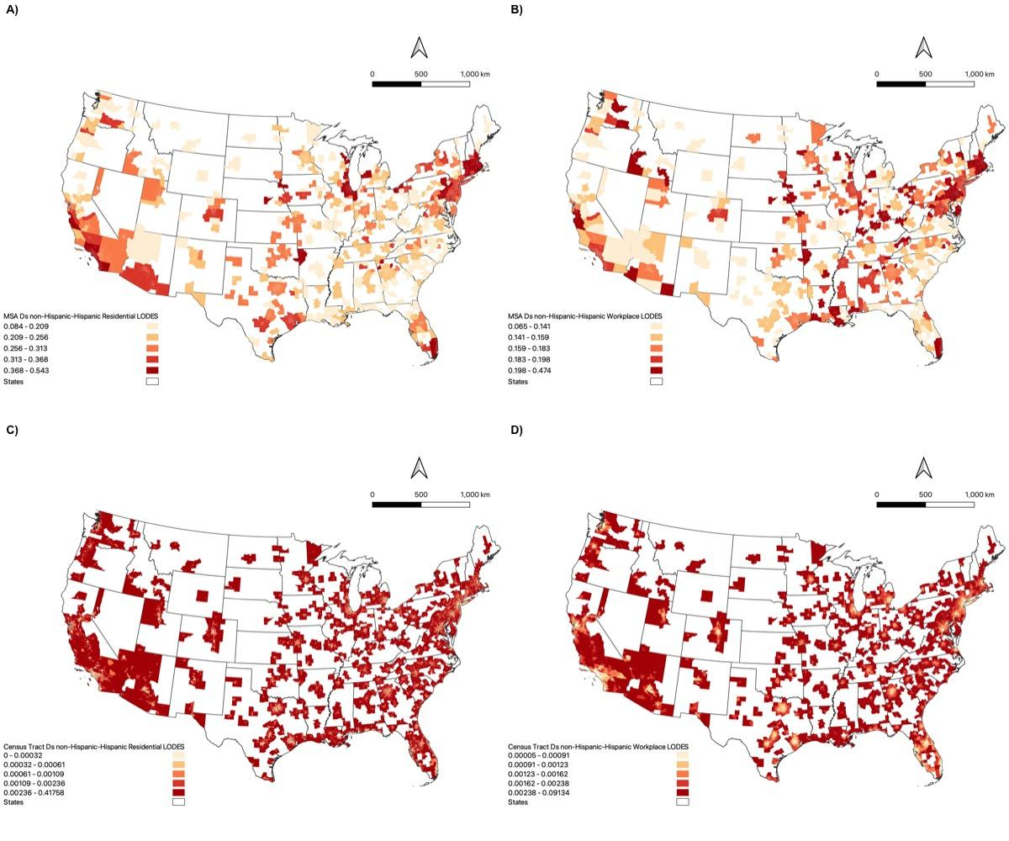
Figure S2.1: Maps of A) MSA-level Residential non-Hispanic and Hispanic segregation, B) MSA-level Workplace non-Hispanic and Hispanic segregation, C) Census tract-level Residential non-Hispanic and Hispanic segregation, D) Census tract-level Workplace non-Hispanic and Hispanic segregation categorized in quantiles

Figure S2.2: Maps of A) MSA-level Residential College and Less than High School-educated segregation, B) MSA-level Workplace College and Less than High School-educated segregation, C) Census tract-level Residential College and Less than High School-educated segregation, and D) Census tract-level Workplace College and Less than High School-educated segregation categorized in quantiles.

S2.1 Supplementary Segregation Indices Based on ACS Data
Residential segregation calculated based on ACS data is higher than that from the LODES data because the ACS includes a larger population (including children and non-workers). Unlike the LODES data, ACS displays very little differentiation between segregation in central cities and surrounding suburbs (Figure S2.1.1), likely because tract level-segregation measures from the ACS were derived from blockgroup (the most granular spatial unit- instead of block-level information as in the case of the LODES dataset, which is more coarse and thus more similar to the overall tract-level dataset. As in previous research,¹³ we use segregation metrics derived from the LODES data as the main measures in this analysis, and ACS data in supplementary analyses.

Correlations between the LODES-based estimates and ACS-based estimates were moderate to high, ranging from 0.53, 0.65, and 0.79 for white-Black, not-Hispanic-Hispanic segregation, and College - Less than High School-educated segregation at the MSA-level, respectively. No correlation was observed between the LODES and ACS-based estimates, and they were 0.06, 0.08, and -0.02 for white-Black, not-Hispanic-Hispanic segregation, and College-Less than High School-educated segregation at the census tract-level, respectively, due to differences in the fundamental building block of census tract-level residential segregation (block for the LODES data set and blockgroup for the ACS dataset), as well as differences in the population in the LODES and ACS datasets (Figure 2).
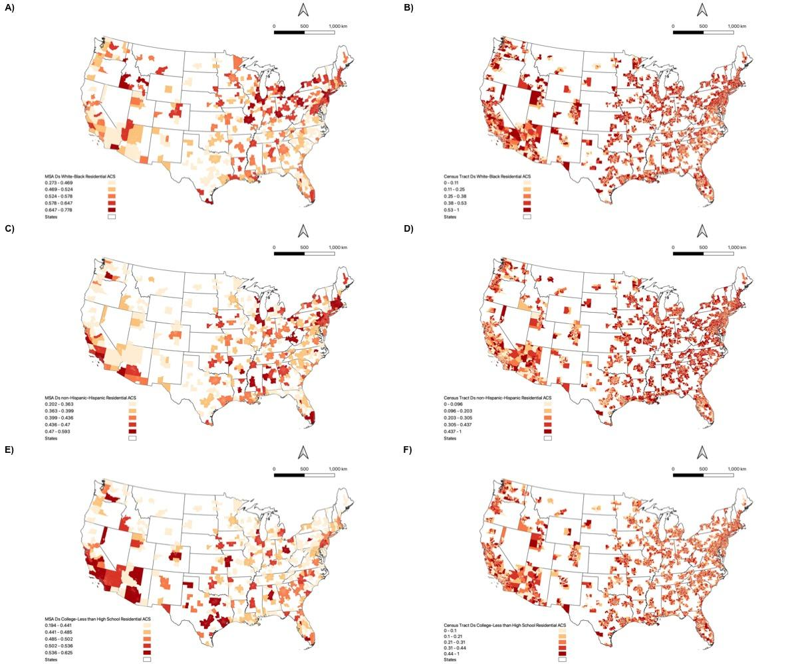
Figure S2.1.1: Maps derived from ACS data of A) MSA-level Residential White-Black segregation, B) Census tract-level Residential White-Black segregation, C) MSA-level Residential non-Hispanic and Hispanic segregation, D) Census tract-level Residential non-Hispanic and Hispanic segregation, E) MSA-level Residential College and Less than High School-educated segregation, F) Census tract-level Residential College and Less than High School-educated segregation categorized in quantiles.

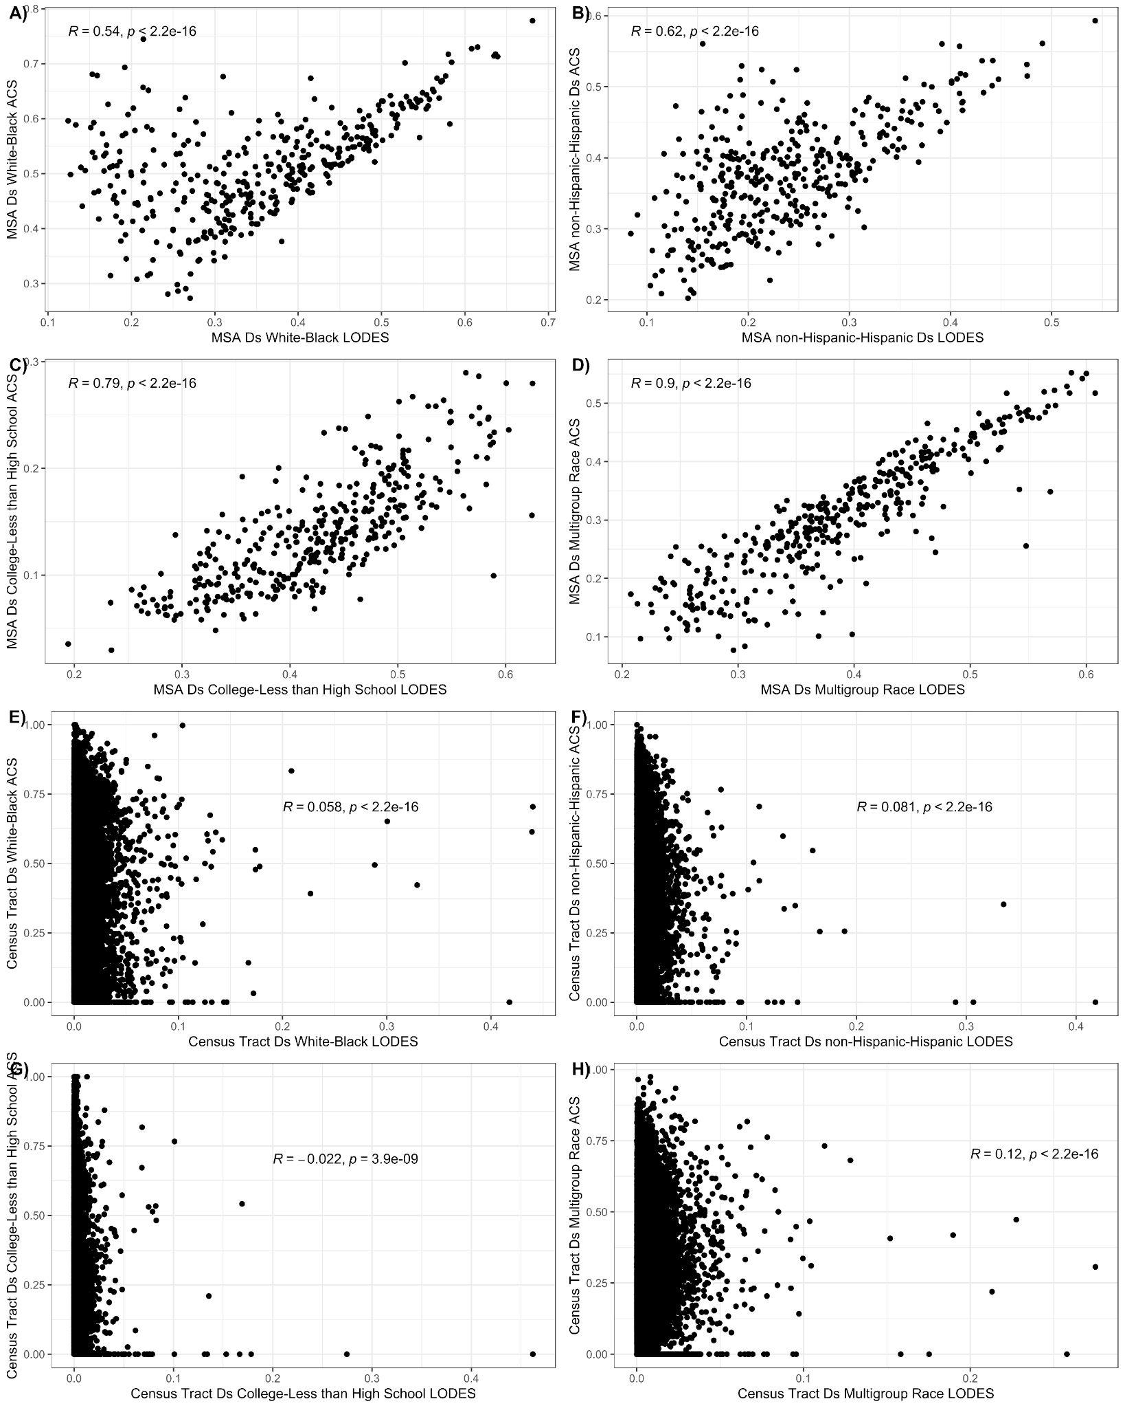
Figure S2.1.2: Scatterplots between segregation measures derived from the LODES and ACS datasets A) White-Black at the MSA level, B) Non-Hispanic - Hispanic at the MSA level, C) College - Less than High School-educated at the MSA level, D) Multigroup Race (White, Black, Asian, Others) at the MSA level, E) White-Black at the census tract level, F) non-Hispanic - Hispanic at the census tract level, G) College - Less than High School-educated at the census tract level, H) Multigroup Race at the census tract level.

Table 2.1.1: Descriptive statistics of segregation exposures, covariates, and environmental pollution concentrations considered in this study
 | 1st quartile | Median | Mean (sd) | 3rd quartile
Residential Segregation
ACS
MSA-level
Ds of White - Black | 0.47 | 0.53 | 0.53  (0.09) | 0.59
Ds of Non-Hispanic - Hispanic | 0.32 | 0.38 | 0.38  (0.07) | 0.42
Ds of College - Less than High School-educated | 0.37 | 0.43 | 0.43  (0.08) | 0.48
Census tract-level
Ds of White - Black | 0.15 | 0.32 | 0.33  (0.22) | 0.49
Ds of Non-Hispanic - Hispanic | 0.13 | 0.25 | 0.27  (0.19) | 0.40
Ds of College - Less than High School-educated | 0.13 | 0.26 | 0.28  (0.19) | 0.40

S3 Maps of Covariates
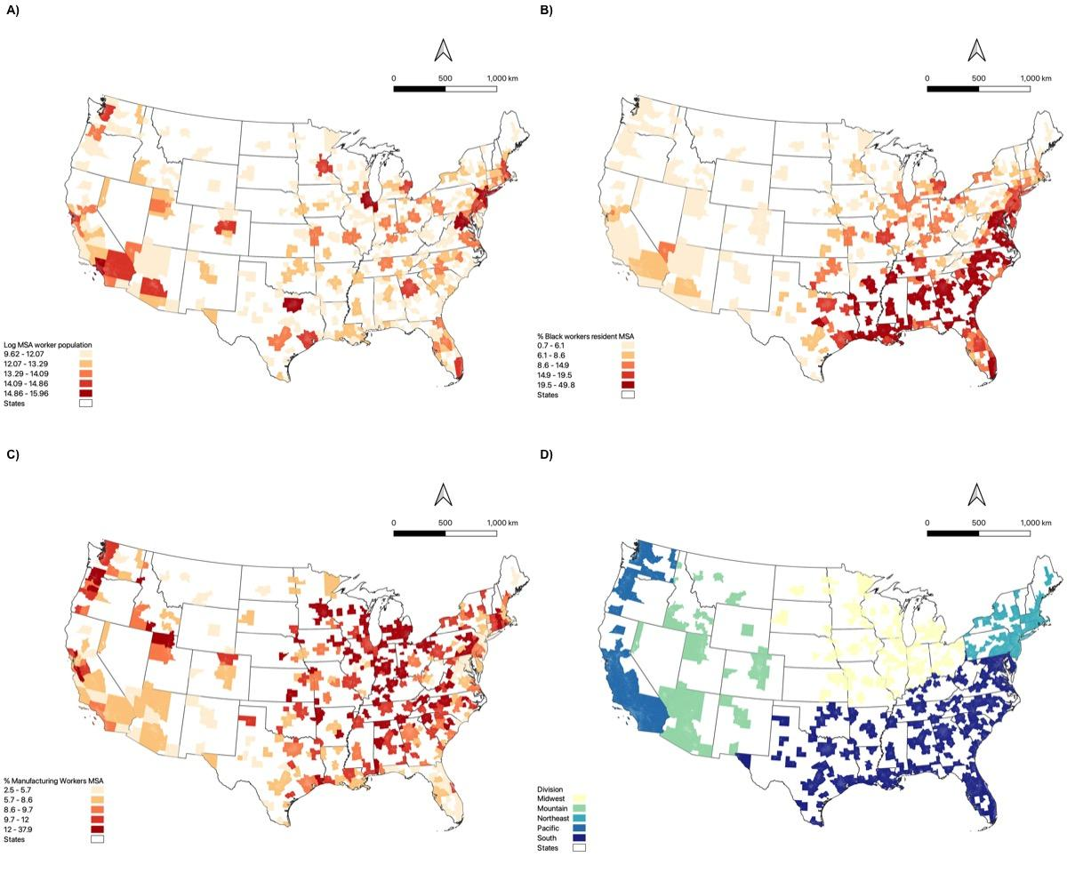
Figure S3.1: MSA level covariates: A) Log MSA worker population, B) % Black Workers MSA level, C) % Manufacturing Workers, and D) Census Divisions.
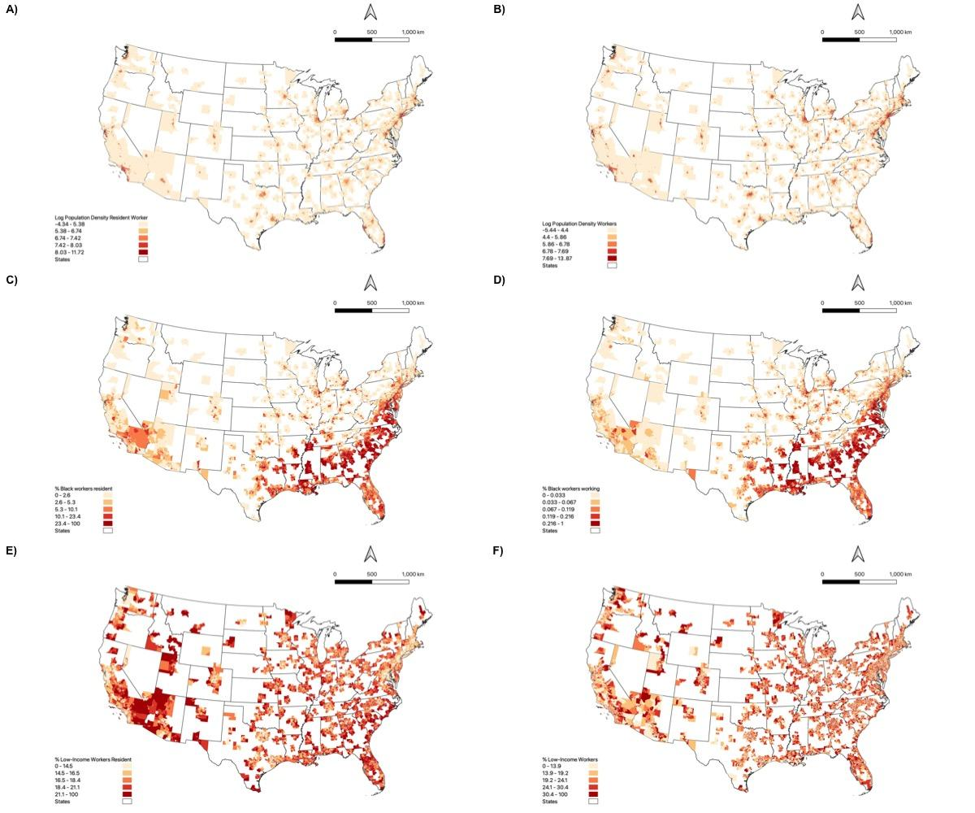
Figure S3.2: Census tract-level covariates: A) Log Resident Worker Population Density, B) Log Worker Population Density, C) % Black workers resident, D) % Black workers, E) % Low-income workers resident, F) % Low-income workers, categorized into quantiles for all 380 MSAs in the contiguous United States.

S4 Main Forest Plots

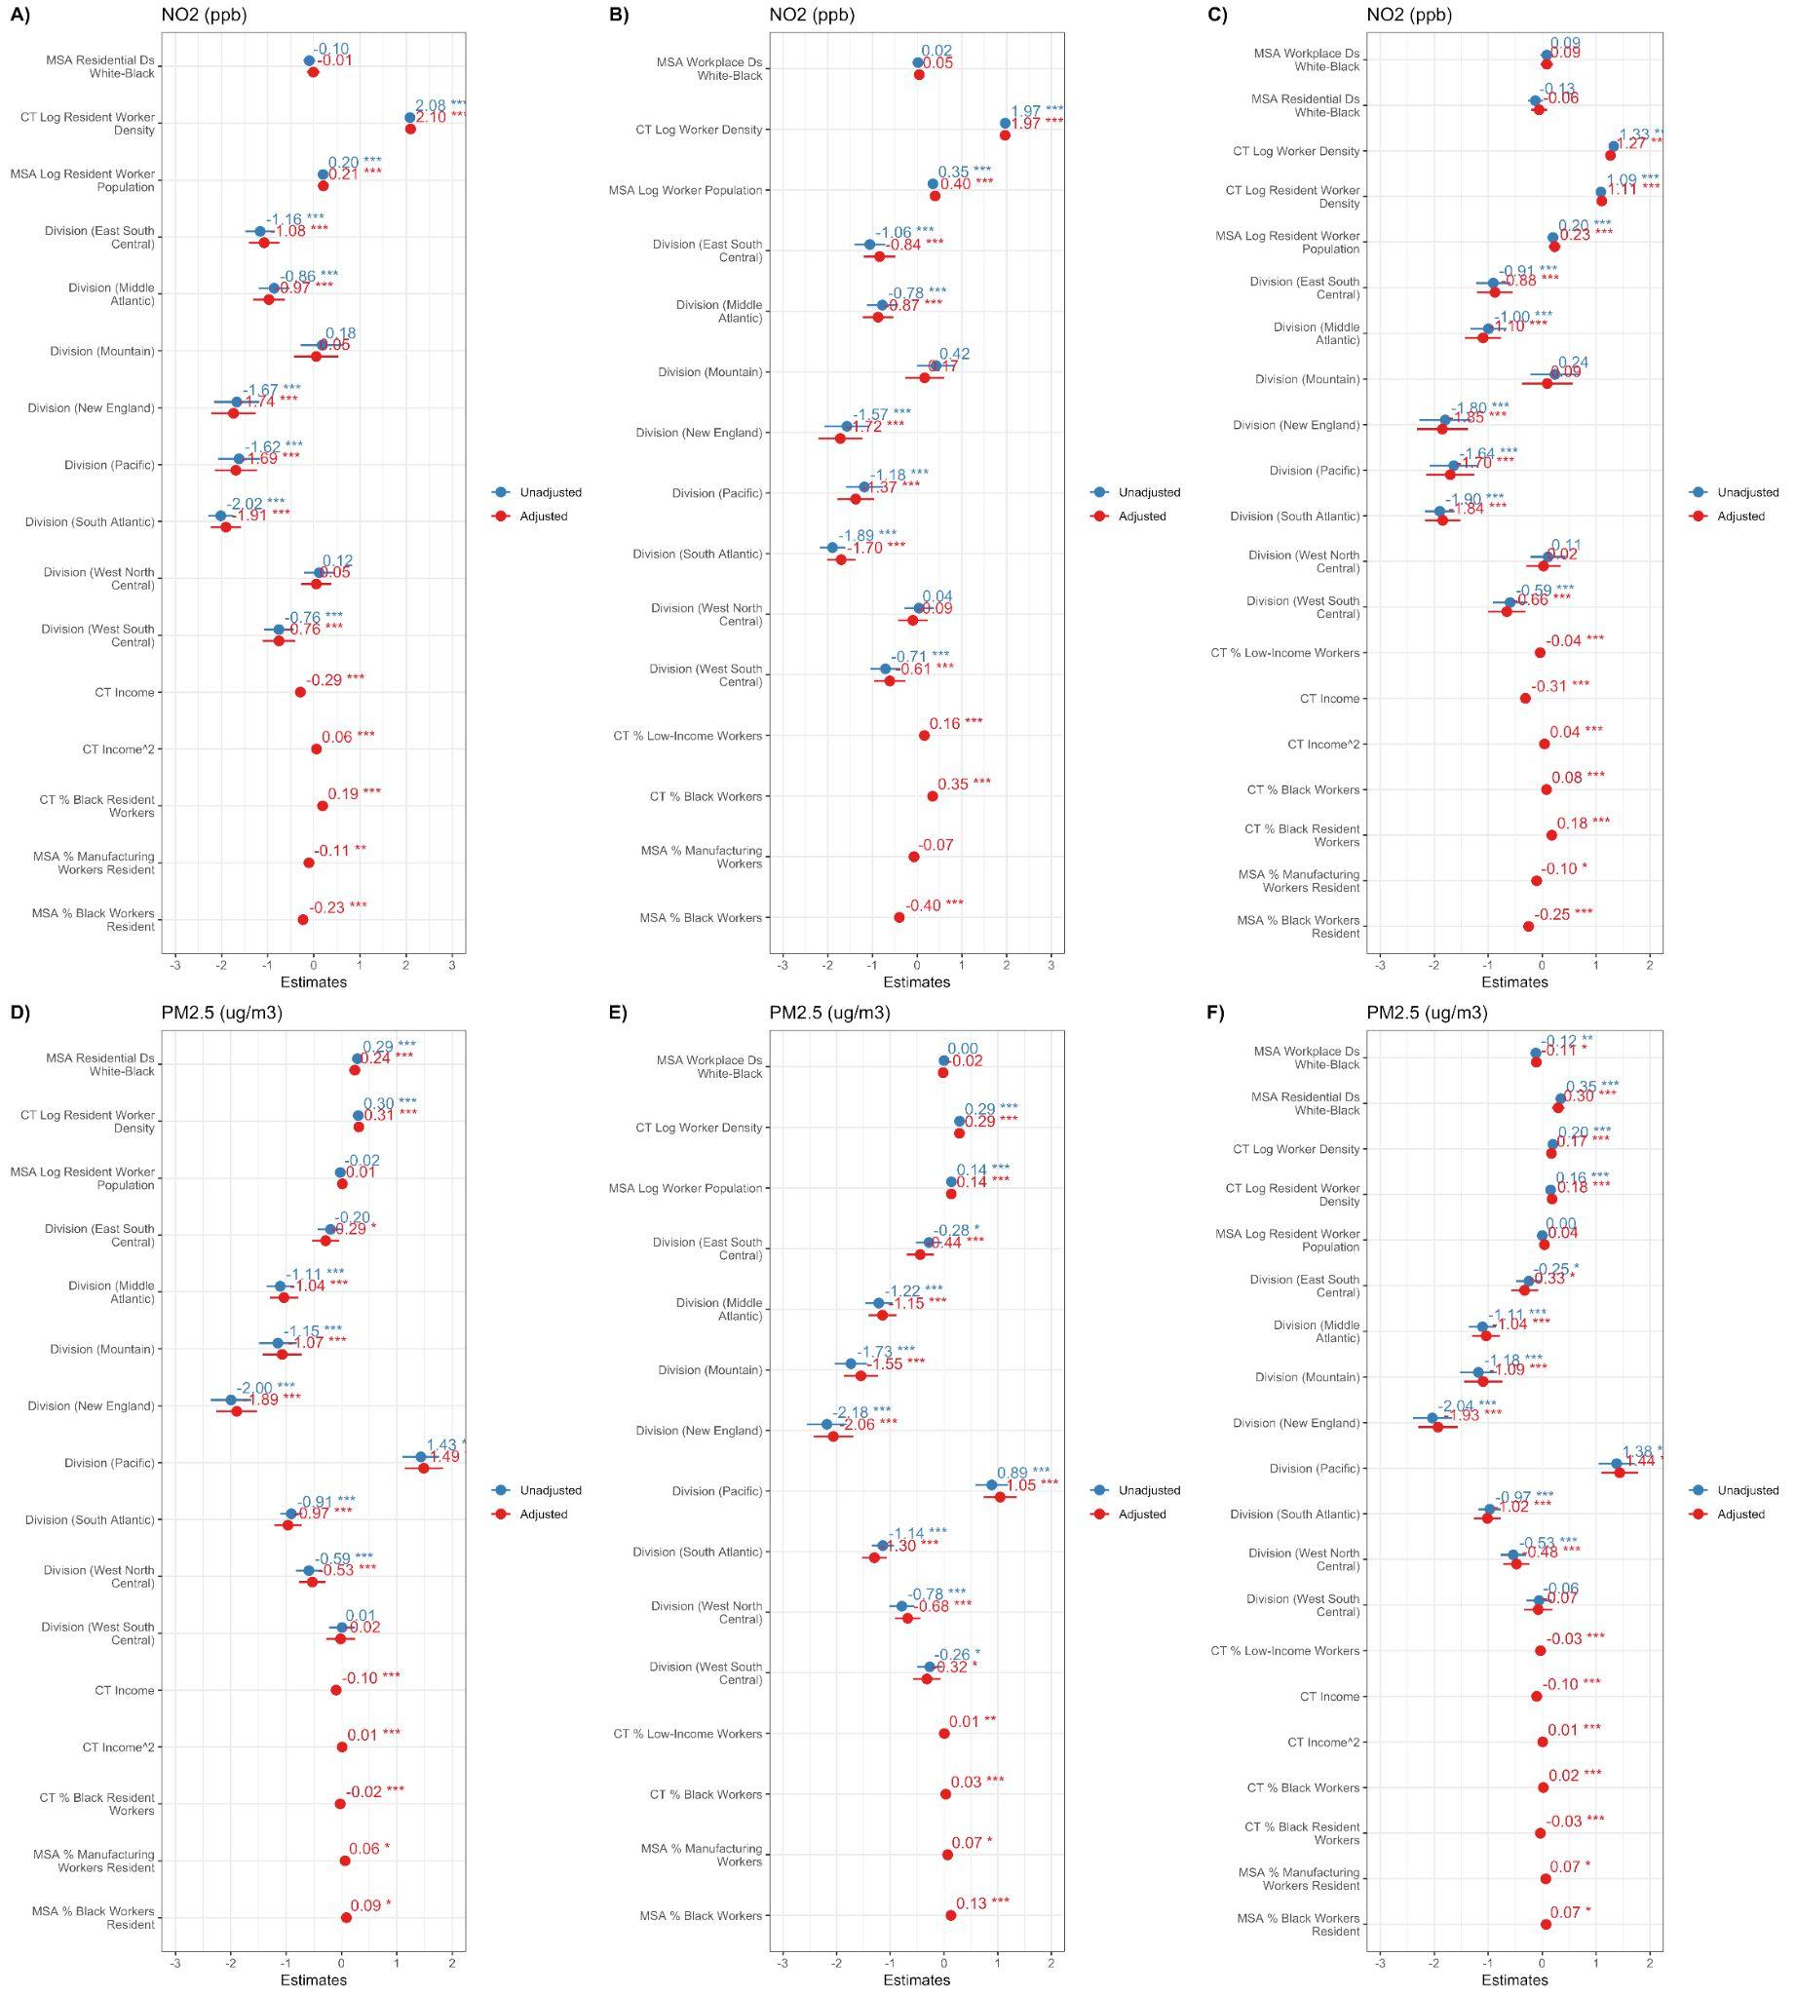
Figure S4.1: Associations between MSA-level White-Black residential segregation metrics and A) NO₂ exposure (ppb), and D) PM_{2.5} exposure (μg/m³) of a given census tract after controlling for different residential covariates. Associations between MSA-level White-Black workplace-based segregation metrics and B) NO₂ exposure (ppb), and E) PM_{2.5} exposure (μg/m³) of a given census tract, and after controlling for different workplace-based covariates. Associations between MSA-level White-Black residential and workplace-based segregation metrics and C) NO₂ exposure (ppb), and F) PM_{2.5} exposure (μg/m³) of a given census tract after controlling for different residential and workplace-based covariates. All associations were derived from multilevel models with random effects at the census tract, county, and MSA levels.

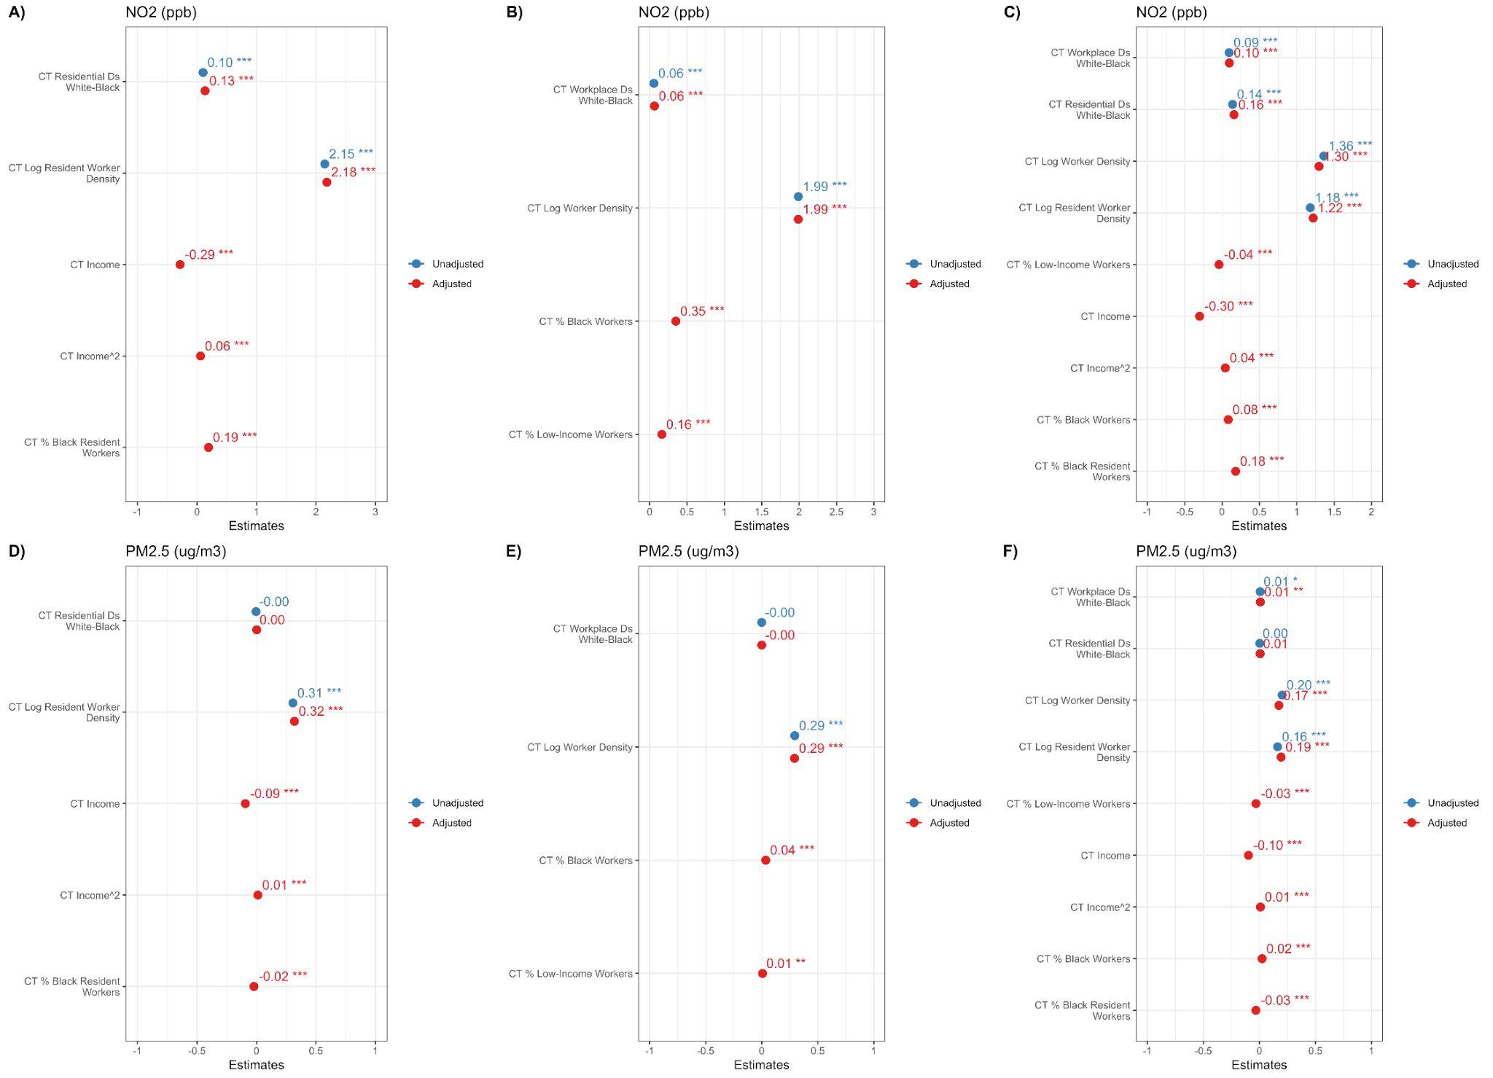

Figure S4.2: Associations between census tract-level White-Black residential segregation metrics and A) NO₂ exposure (ppb), and D) PM_{2.5} exposure (μg/m³) of a given census tract after controlling for different residential covariates. Associations between census tract-level White-Black workplace-based segregation metrics and B) NO₂ exposure (ppb), and E) PM_{2.5} exposure (μg/m³) of a given census tract, and after controlling for different workplace-based covariates. Associations between census tract-level White-Black residential and workplace-based segregation metrics and C) NO₂ exposure (ppb), and F) PM_{2.5} exposure (μg/m³) of a given census tract after controlling for different residential and workplace-based covariates. All associations were derived from multilevel models with random effects at the census tract and county levels and fixed effects at the MSA level.
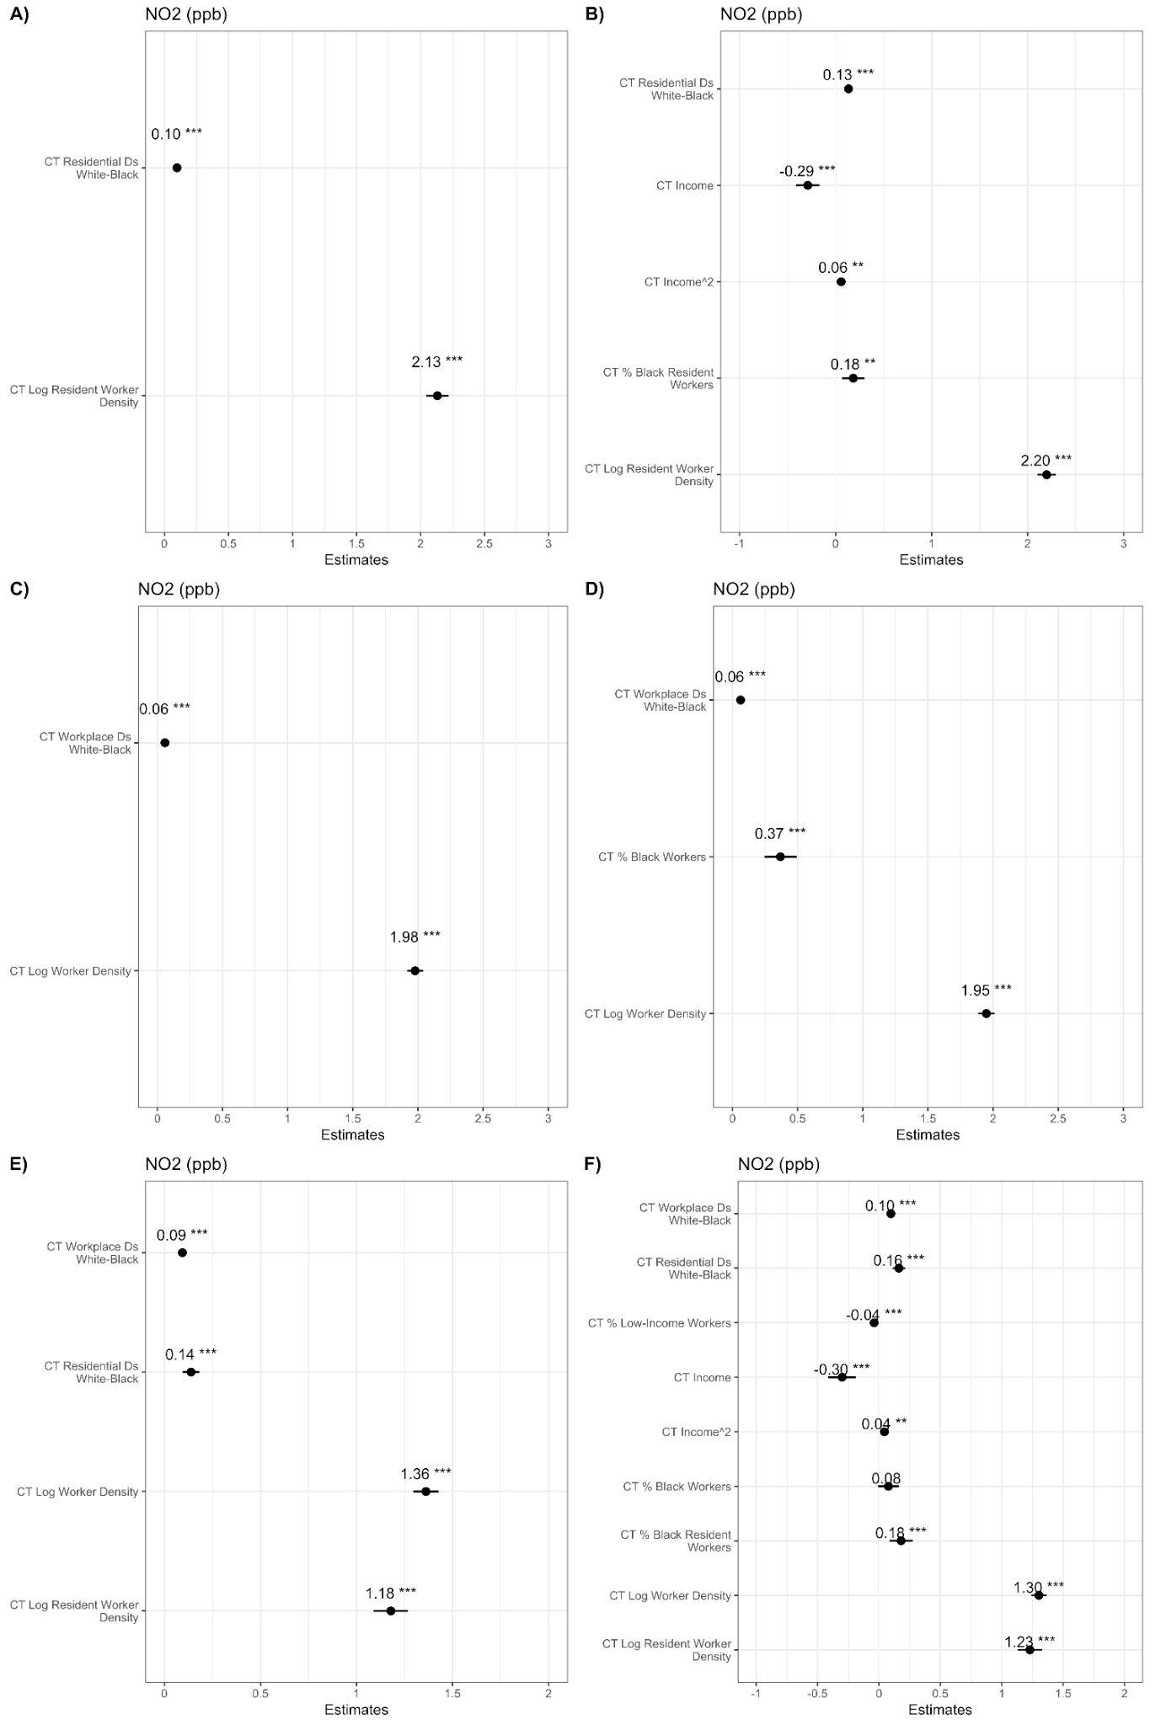
Figure S4.3: Associations between census tract-level White-Black residential segregation metrics and NO₂ exposure (ppb) of a given census tract after controlling for different residential covariates in A) partially adjusted and B) fully-adjusted models. Associations between census tract-level White-Black workplace-based segregation metrics and NO₂ exposure (ppb) of a given census tract in C) partially adjusted and D) fully-adjusted models. Associations between census tract-level White-Black residential and workplace-based segregation metrics and NO₂ exposure (ppb) of a given census-tract in E) partially adjusted and F) fully-adjusted models. All associations were derived from linear regression models with fixed effects at the county-level.
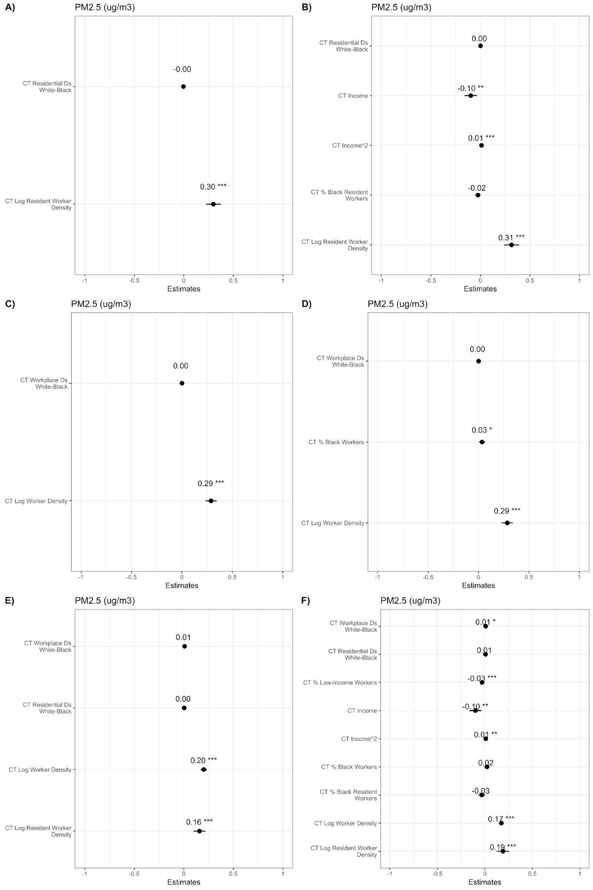
Figure S4.4: Associations between census tract-level White-Black residential segregation metrics and NO₂ exposure (ppb) of a given census tract after controlling for different residential covariates in A) partially adjusted and B) fully-adjusted models. Associations between census tract-level White-Black workplace-based segregation metrics and NO₂ exposure (ppb) of a given census tract in C) partially adjusted and D) fully-adjusted models. Associations between census tract-level White-Black residential and workplace-based segregation metrics and NO₂ exposure (ppb) of a given census tract in E) partially adjusted and F) fully-adjusted models. All associations were derived from linear regression models with fixed effects at the county level.

S5 Supplementary Segregation Measures
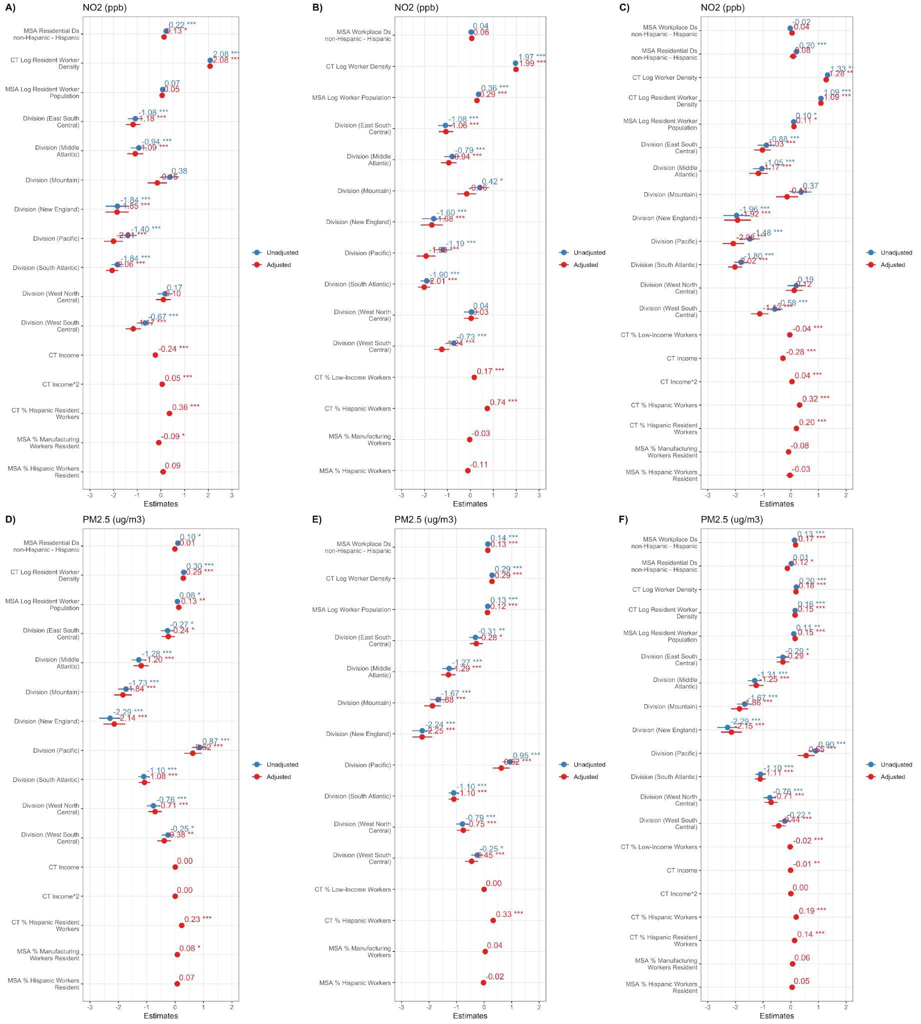
Figure S5.1: Associations between MSA-level non-Hispanic-Hispanic residential segregation metrics and A) NO₂ exposure (ppb), and D) PM_{2.5} exposure (μg/m³) of a given census tract after controlling for different residential covariates. Associations between MSA-level non-Hispanic-Hispanic workplace-based segregation metrics and B) NO₂ exposure (ppb), and E) PM_{2.5} exposure (μg/m³) of a given census tract, and after controlling for different workplace-based covariates. Associations between MSA-level non-Hispanic-Hispanic residential and workplace-based segregation metrics and C) NO₂ exposure (ppb), and F) PM_{2.5} exposure (μg/m³) of a given census tract after controlling for different residential and workplace-based covariates. All associations were derived from multilevel models with random effects at the county- and MSA-level.
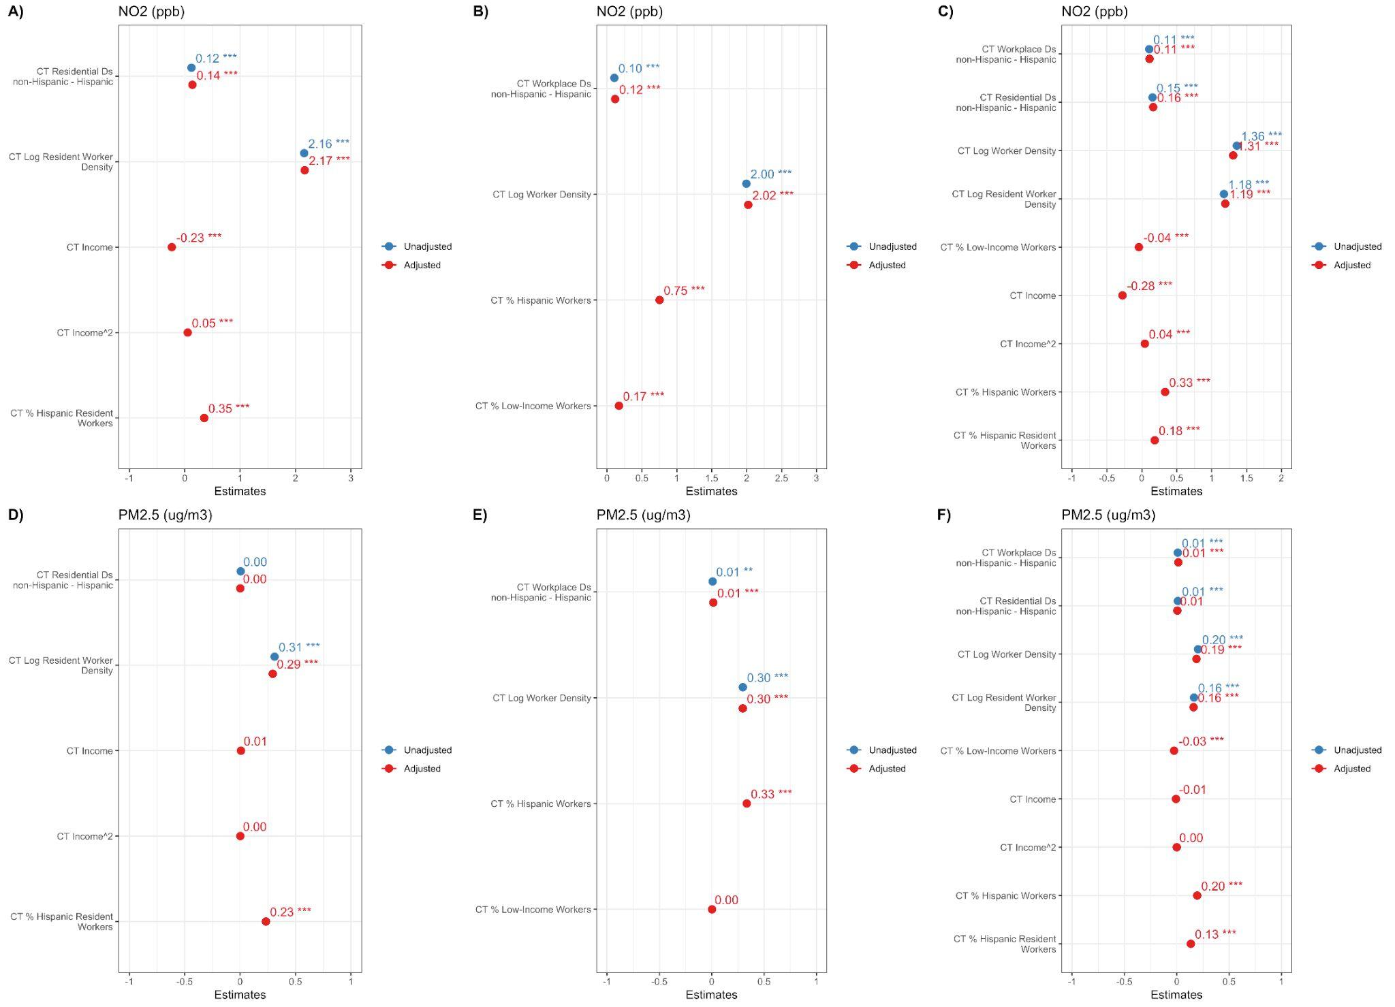
Figure S5.2: Associations between census tract-level non-Hispanic-Hispanic residential segregation metrics and A) NO₂ exposure (ppb), and D) PM_{2.5} exposure (μg/m³) of a given census tract after controlling for different residential covariates. Associations between census tract-level non-Hispanic-Hispanic workplace-based segregation metrics and B) NO₂ exposure (ppb), and E) PM_{2.5} exposure (μg/m³) of a given census tract, and after controlling for different workplace-based covariates. Associations between census tract-level non-Hispanic-Hispanic residential and workplace-based segregation metrics and C) NO₂ exposure (ppb), and F) PM_{2.5} exposure (μg/m³) of a given census tract after controlling for different residential and workplace-based covariates. All associations were derived from multilevel models with random effects at the census tract and county levels and fixed effects at the MSA level.

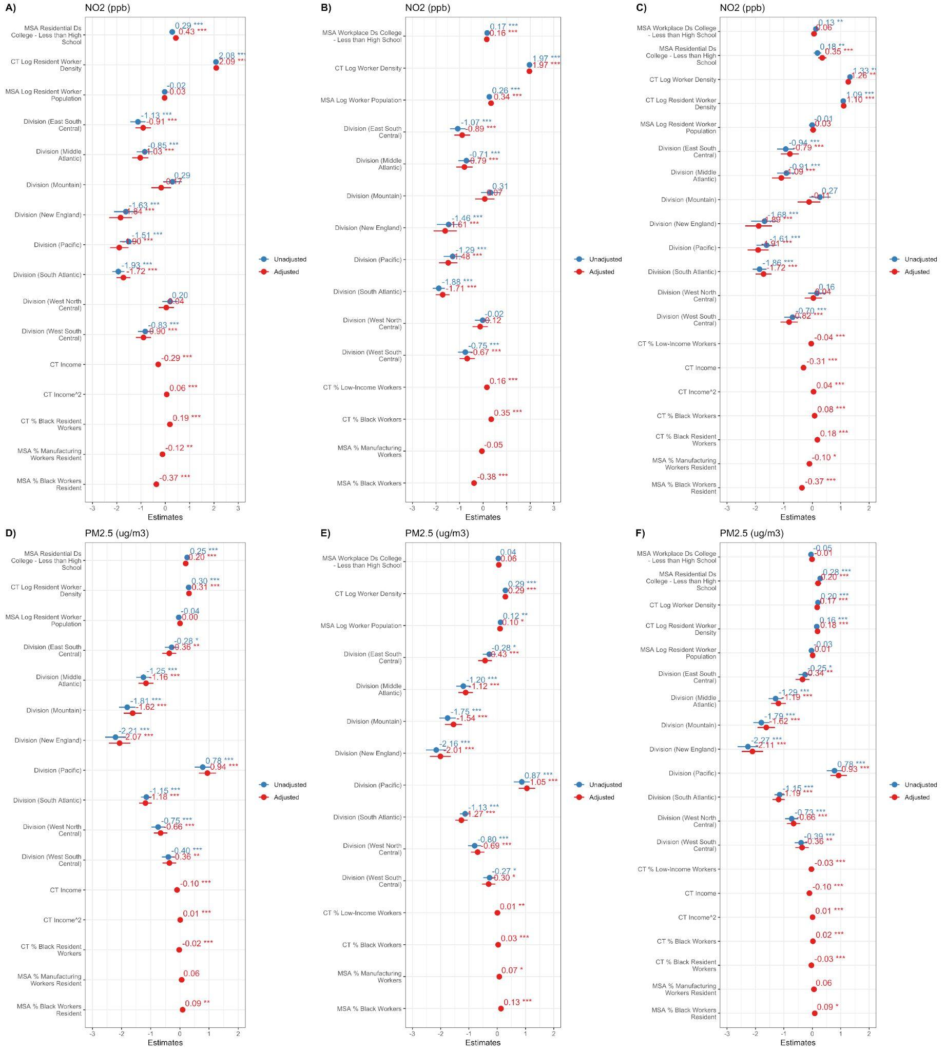

Figure S5.3: Associations between MSA-level College - Less than High School-educated residential segregation metrics and A) NO₂ exposure (ppb), and D) PM_{2.5} exposure (μg/m³) of a given census tract after controlling for different residential covariates. Associations between MSA-level College - Less than High School-educated workplace-based segregation metrics and B) NO₂ exposure (ppb), and E) PM_{2.5} exposure (μg/m³) of a given census tract, and after controlling for different workplace-based covariates. Associations between MSA-level College - Less than High School-educated residential and workplace-based segregation metrics and C) NO₂ exposure (ppb), and F) PM_{2.5} exposure (μg/m³) of a given census tract after controlling for different residential and workplace-based covariates. All associations were derived from multilevel models with random effects at the census tract, county, and MSA levels.
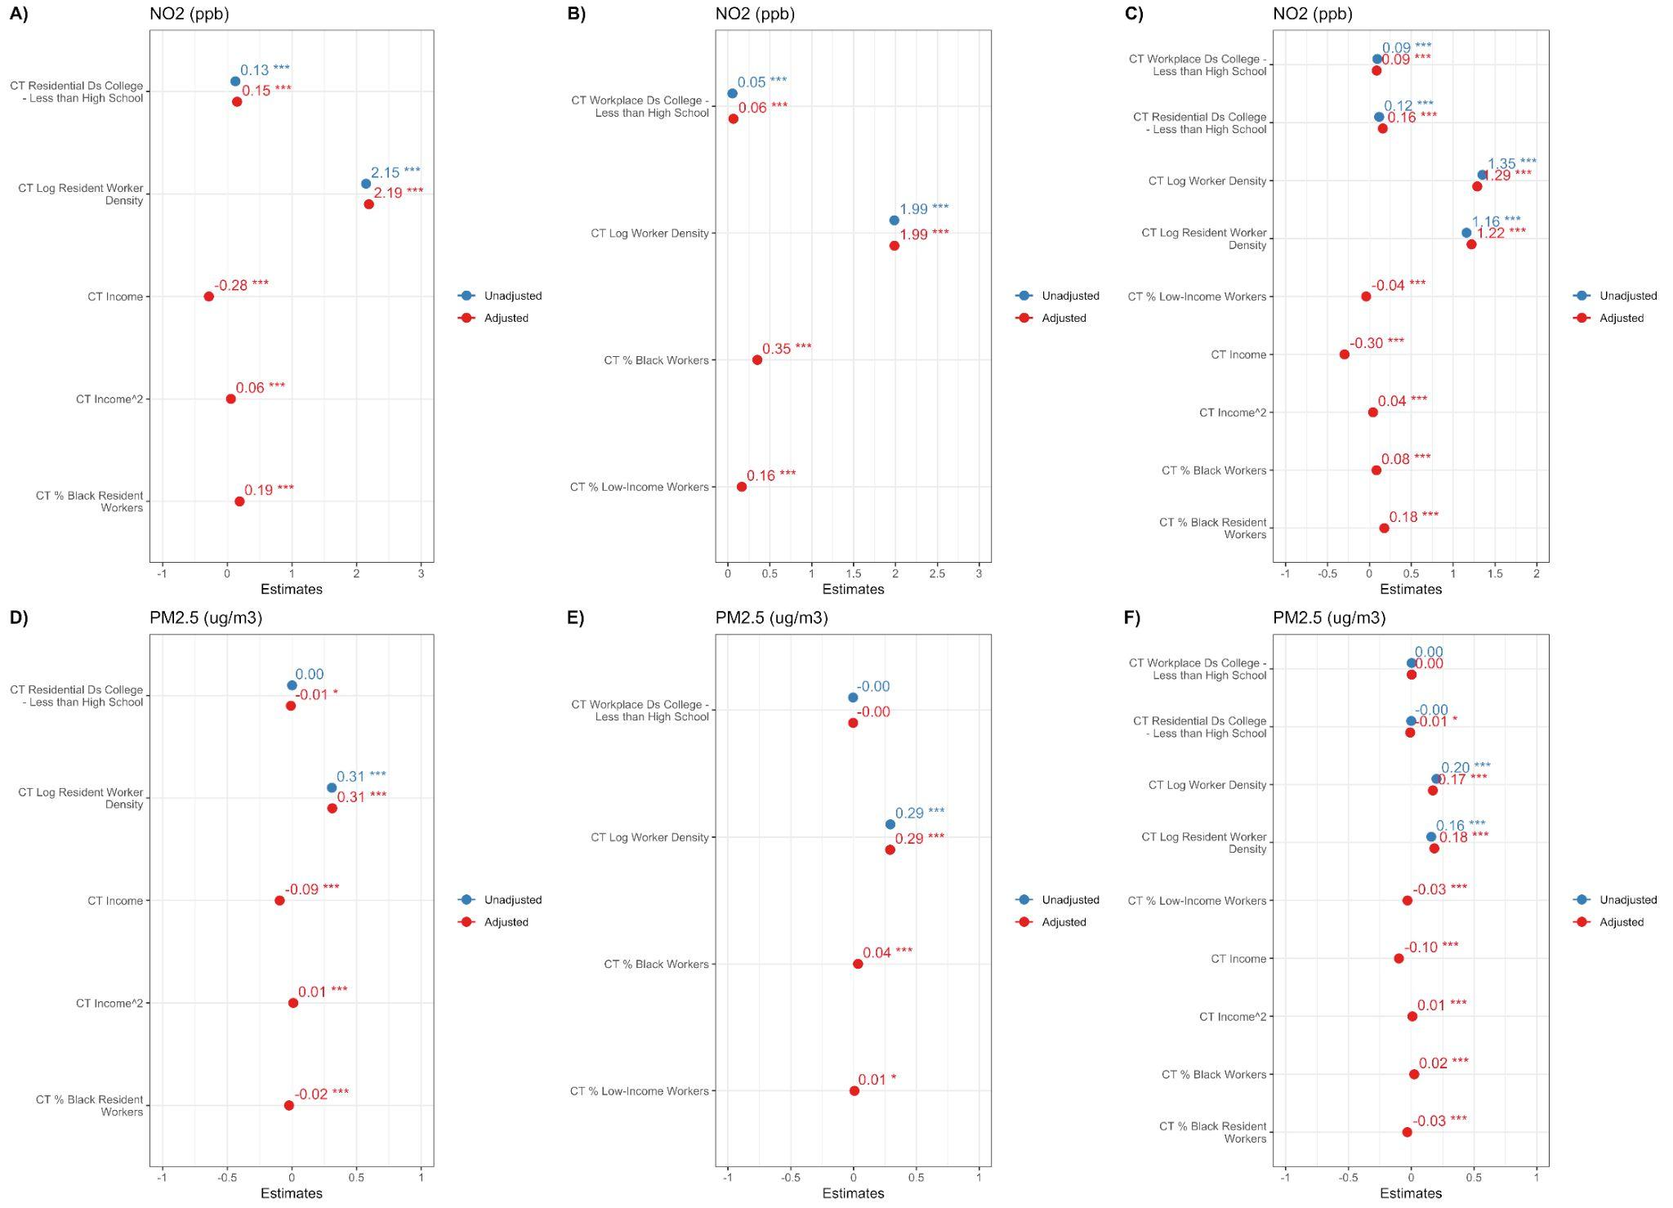
Figure S5.4: Associations between census tract (CT)-level College - Less than High School-educated residential segregation metrics and A) NO₂ exposure (ppb), and D) PM_{2.5} exposure (μg/m³) of a given census tract, and after controlling for different residential covariates. Associations between census tract (CT)-level College - Less than High School-educated workplace-based segregation metrics and B) NO₂ exposure (ppb), and E) PM_{2.5} exposure (μg/m³) of a given census tract, and after controlling for different workplace-based covariates. Associations between C) NO₂ exposure (ppb), and F) PM_{2.5} exposure (μg/m³) of a given census-tract and census tract (CT)-level College - Less than High School-educated residential and workplace-based segregation metrics after controlling for different residential and workplace-based covariates using multilevel models with random effects at the census tract and county-level and fixed effects at the MSA level.

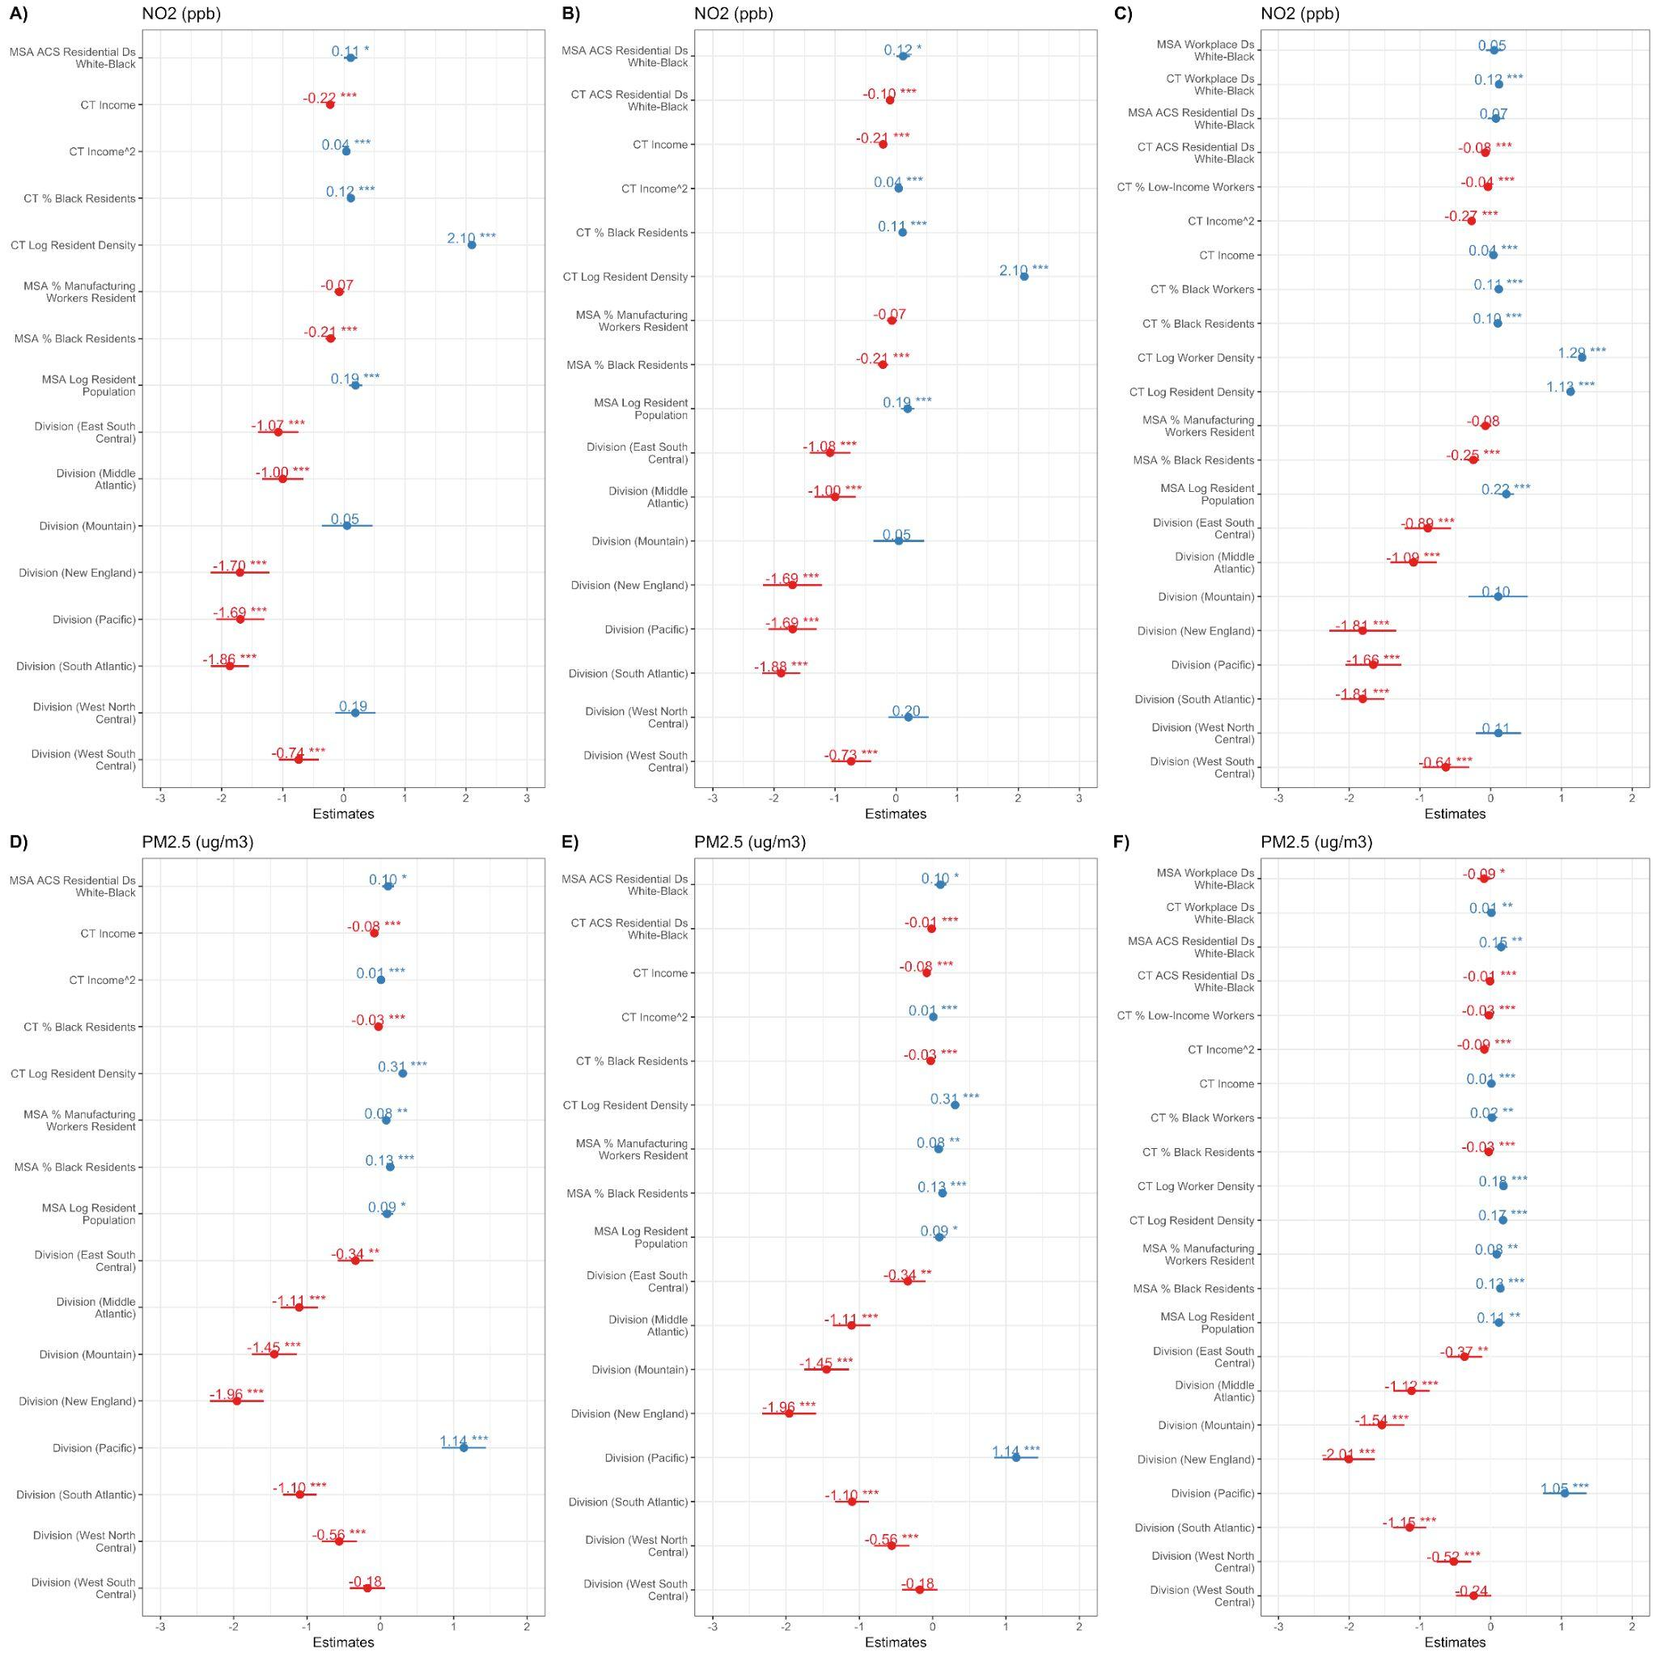
Figure S5.4: Associations between MSA-level White-Black residential segregation metrics derived from ACS data and A) NO₂ exposure (ppb), and D) PM_{2.5} exposure (μg/m³) of a given census tract, and after controlling for different residential covariates. Associations between MSA-level and census-tract level White-Black residential segregation metrics derived from ACS data and B) NO₂ exposure (ppb), and E) PM_{2.5} exposure (μg/m³) of a given census-tract and after controlling for different residential covariates. Associations between C) NO₂ exposure (ppb), and F) PM_{2.5} exposure (μg/m³) of a given census-tract and MSA- and census tract (CT)-level White-Black residential and workplace-based segregation metrics after controlling different residential and workplace-based covariates using multilevel models with random effects at the census tract, county, and MSA-levels.

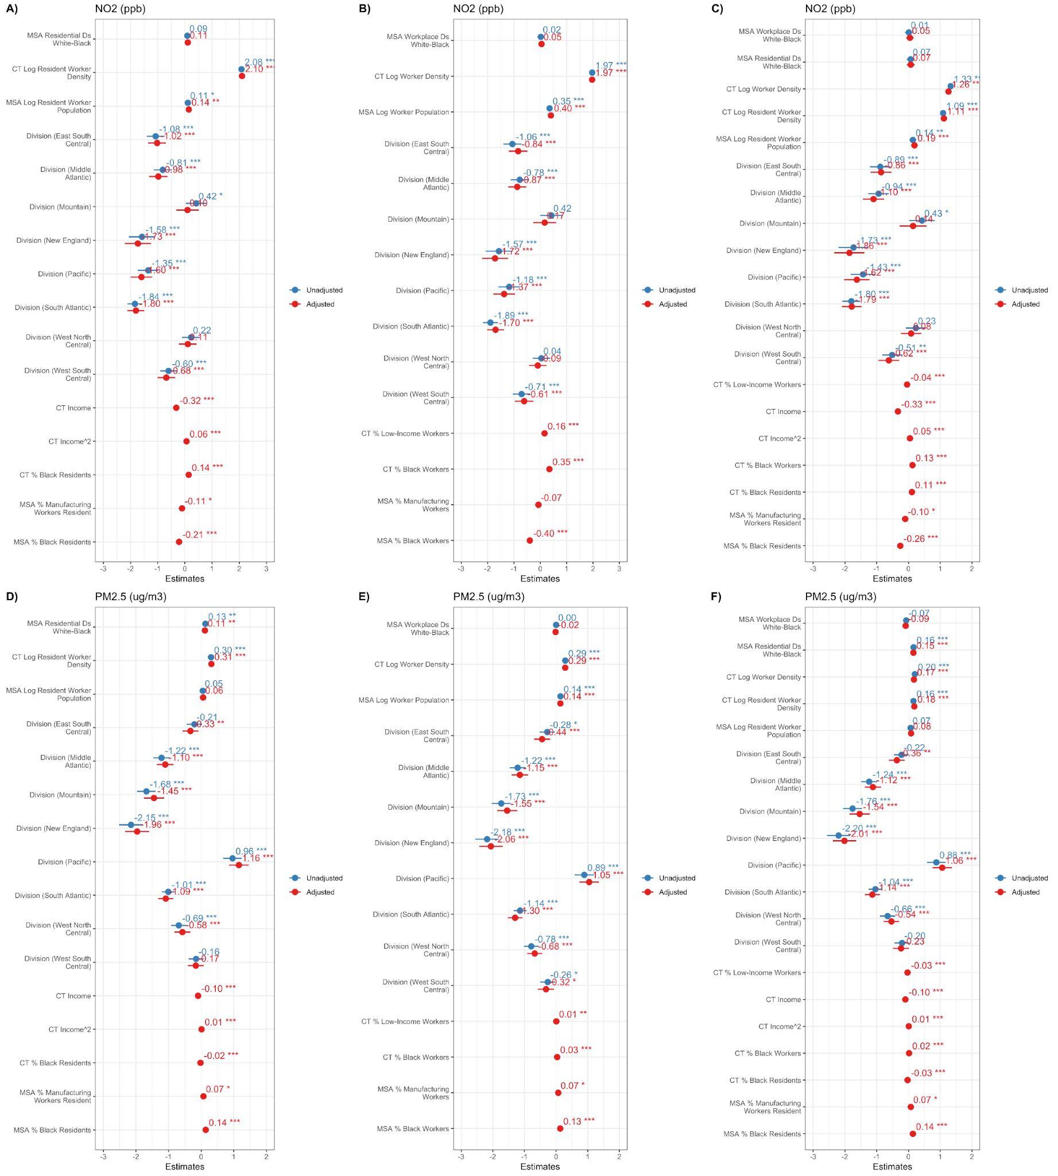
Figure S5.5: Associations between MSA-level White-Black residential segregation metrics derived from ACS data and A) NO₂ exposure (ppb), and D) PM_{2.5} exposure (μg/m³) of a given census tract after controlling for different residential covariates. Associations between MSA-level White-Black workplace-based segregation metrics derived from LODES data and B) NO₂ exposure (ppb), and E) PM_{2.5} exposure (μg/m³) of a given census tract, and after controlling for different workplace-based covariates. Associations between MSA-level White-Black residential segregation derived from ACS data and workplace-based segregation derived from LODES data and C) NO₂ exposure (ppb), and F) PM_{2.5} exposure (μg/m³) of a given census tract after controlling for different residential and workplace-based covariates. All associations were derived from multilevel models with random effects at the census tract, county, and MSA levels.
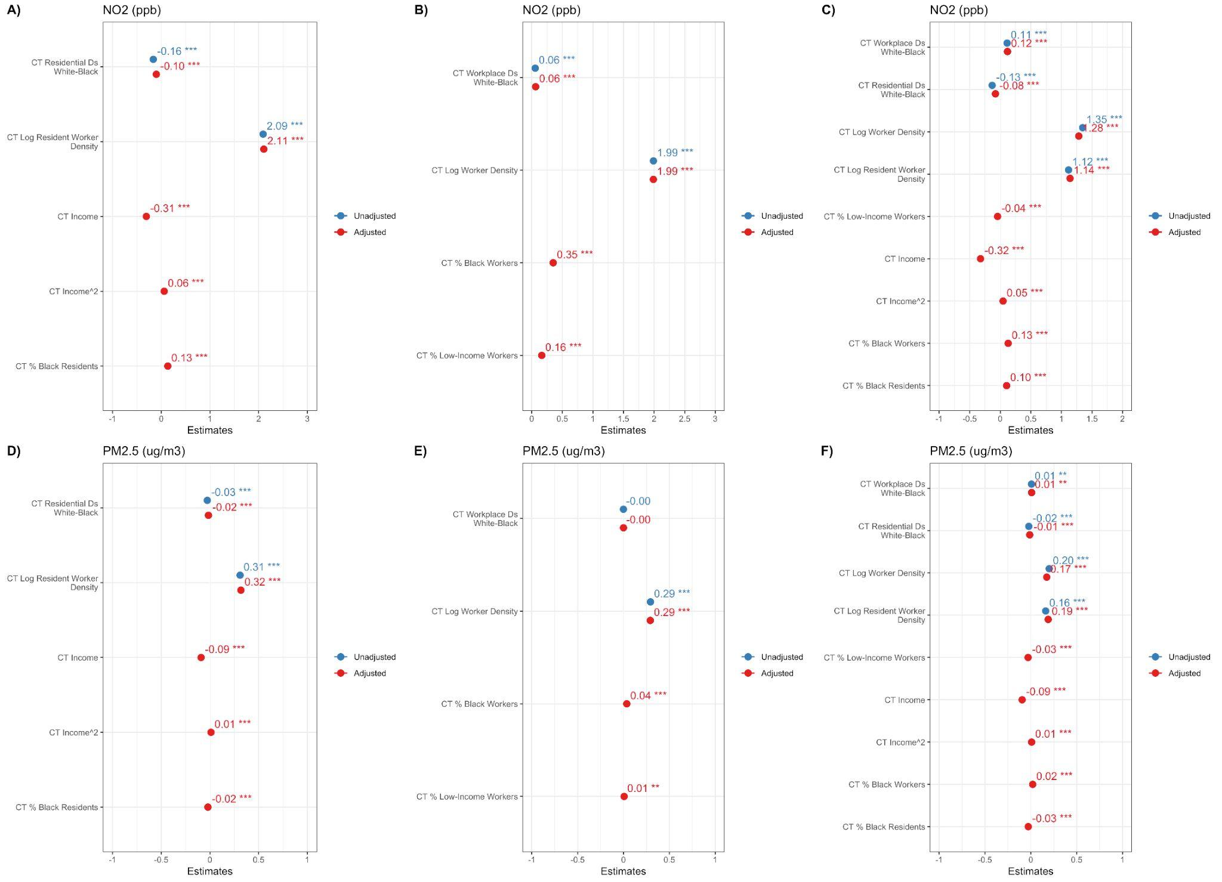
Figure S5.6: Associations between census tract-level White-Black residential segregation metrics derived from ACS and A) NO₂ exposure (ppb), and D) PM_{2.5} exposure (μg/m³) of a given census tract after controlling for different residential covariates. Associations between census tract-level White-Black workplace-based segregation metrics and B) NO₂ exposure (ppb), and E) PM_{2.5} exposure (μg/m³) of a given census tract, and after controlling for different workplace-based covariates. Associations between census tract-level White-Black residential segregation derived from ACS data and workplace-based segregation and C) NO₂ exposure (ppb), and F) PM_{2.5} exposure (μg/m³) of a given census tract after controlling for different residential and workplace-based covariates. All associations were derived from multilevel models with random effects at the census tract and county levels and fixed effects at the MSA level.

S6 Sensitivity Analyses
We explored associations between environmental exposures and segregation measures using linear mixed models that controlled for covariates and included nested random effects at the census tract, county, and MSA levels to account for similarities between census tracts within the same county and MSA.

Evaluating Associations between Residential Segregation and Environmental Exposures
We used Equation S6.1 to evaluate the associations between residential segregation and the various environmental exposures considered in this study, following the approach employed in other research.

$$CT Exposure_{j}={β_{0}+β_{1}×}_{}CT Residential {Ds}_{j}+{β_{2}×}_{}MSA Residential {Ds}_{l} {+β}_{covariate}×Covariates_{}+u_{j:k:l}+v_{k:l}+f_{l}$$
(S6.1)

Where CT Exposure_{j}= Census tract level exposure to PM_{2.5}, and NO₂ in tract j. $β_{0}$ is the constant. CT Residential Ds_{j} = Census tract level residential segregation experienced by residents in tract j, MSA Residential Ds_{l} = Residential segregation estimated at the MSA-level experienced by residents in MSA l. $β_{1}$ , and $β_{2}$ represents the association between the environmental exposure and the census tract-level and MSA-level segregation metrics, respectively. Covariates = Census tract-level percentage of Black residents, log population density of Black worker residents, Income, Income²; MSA-level percentage of resident workers in manufacturing, percentage of Black worker residents, log resident worker population, and Division. $β_{covariate}$represents associations between each covariate and the environmental exposure. $u_{j:k:l}$, $v_{k:l}$, and $f_{l}$ are the residuals at the census tract (j), county (k), and MSA (l) levels.

Evaluating Associations between Workplace Segregation and Environmental Exposures
We next used Equation S6.2 to evaluate associations between workplace segregation and the different environmental exposures considered experienced at the workplace.

$$CT Exposure_{j}={β_{0}+β_{1}×}_{}CT Workplace {Ds}_{j}+{β_{2}×}_{}MSA Workplace {Ds}_{l} {+β}_{covariate}×Covariates_{}+u_{jkl}+v_{kl}+f_{l}$$
(S6.2)
Where CT Exposure_{j}= Census tract level exposure to PM_{2.5}, and NO₂ in tract j. $β_{0}$ is the constant. CT Workplace Ds_{j} = Census tract level workplace segregation experienced by workers working in tract j, MSA Workplace Ds_{l} = Workplace segregation estimated at the MSA-level experienced by workers in MSA l. $β_{1}$ , and $β_{2}$ represents the association between the environmental exposure and the census tract-level and MSA-level segregation metrics, respectively. Covariates_{j} = Census tract-level % of Low-income workers, % Black workers, log of worker density, MSA-level % of Black workers, log worker population, and Division. $β_{covariate}$represents associations between each covariate and the environmental exposure. $u_{j:kLl}$, $v_{k:l}$, and $f_{l}$ are the residuals at the census tract (j), county (k), and MSA (l) levels.

Evaluating Associations between Workplace Segregation and Environmental Exposures after Controlling for Residential Segregation
We then ran a model with CT Exposure_{j} as the dependent variable, and all independent variables in Equations S6.1 and S6.2, to assess if workplace segregation at the census tract and MSA levels mattered after controlling for residential segregation.

S6.1 Results
We first present results from conducting a conventional assessment evaluating associations between residential segregation and pollution exposures. Associations between environmental exposures: NO₂, and PM_{2.5,} and standardized residential segregation metrics as well as covariates, derived from multilevel linear regression models depicted in Equation S6.1
are displayed in Figure S6.1A and S6.1D, respectively. Associations can be interpreted as a unit change in environmental exposures for every increase in the independent variable under consideration by one standard deviation.

MSA-level White-Black residential segregation was significantly associated with census tract-level PM_{2.5} concentrations: 0.24 (95% CI: 0.14, 0.34), but not NO₂ concentrations: -0.02 (95% CI: -0.16, 0.12). Census tract-level residential segregation, on the other hand, was significantly associated with census tract-level NO₂ concentrations: 0.13 (95% CI: 0.12, 0.15), but not PM_{2.5} concentrations: 0.00 (95% CI: -0.01, 0.01).

Next, we treat each census tract as a workhood. Associations between environmental exposures: NO₂ and PM_{2.5}, and standardized workplace-based segregation metrics and covariates are displayed in Figures S6.1B and S6.1E, respectively. MSA-level workplace-based segregation was not significantly associated with NO₂: 0.04 (95% CI: -0.07, 0.16), or PM_{2.5}: -0.02 (-0.10, 0.07). However, census-tract level workplace segregation was significantly associated with NO₂: 0.06 (95% CI: 0.05, 0.08), but not PM_{2.5}: 0.00 (-0.01, 0.01).

We now present results from our analysis, where we evaluated associations between workplace segregation and the environmental exposures after controlling for residential segregation and residential-based characteristics (Figures S6.1C and S6.1F). For NO_{2,} the coefficients observed remained similar to those observed in the previous residential segregation and workplace segregation-only analyses. Specifically, MSA-level residential and workplace segregation were not significantly associated with NO₂ concentrations: -0.05 (95% CI: -0.20, 0.09) and 0.06 (95% CI: -0.05, 0.18), respectively. Census-tract level residential and workplace segregation, however, were both significantly associated with NO₂ concentrations: 0.16 (95% CI: 0.14, 0.17) and 0.10 (95% CI: 0.09, 0.11), respectively.

However, for PM_{2.5}, unlike in the previous analyses, MSA-level workplace segregation was significantly negatively associated with PM_{2.5} concentrations: -0.11 (95% CI: -0.20, -0.02). MSA-level residential segregation was still significantly associated with PM_{2.5} concentrations: 0.30 (95% CI: 0.19, 0.41), and more strongly than in Figure S6.1D. Census tract-level workplace segregation was also significantly positively associated with PM_{2.5} concentrations: 0.01 (95% CI: 0.00, 0.01), although the magnitude of the association did not change very much. Census-tract level residential segregation continued to not be significantly associated with PM_{2.5} concentrations: 0.01 (95% CI: -0.00, 0.01).

Like our main analyses displayed in Table 1, our results imply that for census tracts with similar levels of residential segregation, an increase in MSA-level workplace White-Black segregation is associated with a decrease in PM_{2.5} concentrations, while an increase in census-tract level workplace White-Black segregation is associated with an increase in both NO₂ and PM_{2.5} concentrations.
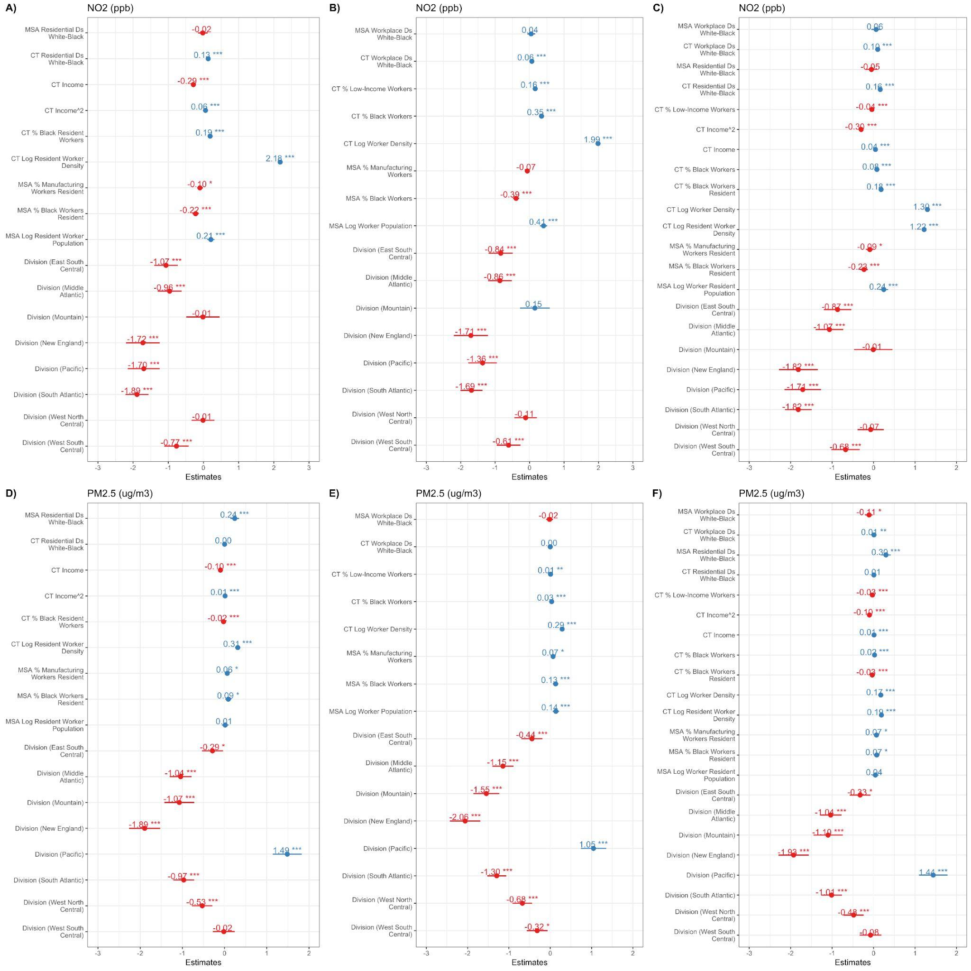
Figure S6.1: Associations between MSA- and census tract (CT)-level White-Black residential segregation metrics and A) NO₂ exposure (ppb), and D) PM_{2.5} exposure (μg/m³) of a given census tract, and after controlling for different residential covariates. Associations between MSA- and census tract (CT)-level White-Black workplace-based segregation metrics and B) NO₂ exposure (ppb), and E) PM_{2.5} exposure (μg/m³) of a given census tract, and after controlling for different workplace-based covariates. Associations between C) NO₂ exposure (ppb), and F) PM_{2.5} exposure (μg/m³) of a given census-tract and MSA-level White-Black residential and workplace-based segregation metrics after controlling for different residential and workplace-based covariates using multilevel models with random effects at the county- and MSA-level.

S7 Sensitivity Analyses: Bayesian Analysis
There are two main approaches to incorporating a spatial component into a model: a “lag” and/or an “error” term. To ensure the interpretability of the coefficients in the model, we opted to model the data structure using a spatial error term. Specifically, we employed a Bayesian modeling technique that utilizes the Integrated Nested Laplace Approximation (INLA) to incorporate a spatial model component, in addition to nested random intercepts, into a multilevel model. INLA is a computationally efficient alternative to Markov Chain Monte Carlo (MCMC) approximations, which has been widely used in epidemiologic studies. We implemented the model in R using the INLA package.

In line with previous work, we modeled the county and MSA-level nested random effects as independent and identically distributed (i.i.d.), and the spatial error term according to the Besag model. Similar to the main multilevel model, we assumed linear associations between workplace segregation and the different covariates and county and MSA-level random effects, with an additional error term composed of a spatially structured and spatially unstructured component. The specification of the BYM model is provided in the Appendix of Haskell-Craig et al.¹⁴

Table S7.1: Associations derived from multilevel models between MSA-level White-Black segregation measures based on A) residential location, alone, B) workplace location alone, and C) residential and workplace location and census tract-level NO₂ and PM_{2.5} after controlling for different covariates and including random intercepts at the county and MSA level.
Associations between census-tract-level White-Black segregation measures based on D) residential location, alone, E) workplace location alone, and F) residential and workplace location and census tract-level NO₂ and PM_{2.5} after controlling for different covariates with fixed effects at the MSA-level with county-level random intercepts.
 | MSA-level Segregation Analyses |  |  |  |  |  | Census Tract-Level Segregation Analyses
 | A) Residential |  | B) Workplace |  | C) Residential and Workplace |  | D) Residential |  | E) Workplace |  | F) Residential and Workplace
 | NO₂ | PM_{2.5} | NO₂ | PM_{2.5} | NO₂ | PM_{2.5} | NO₂ | PM_{2.5} | NO₂ | PM_{2.5} | NO₂ | PM_{2.5}
Residential White-Black | 0.21*  (0.18, 0.24) | 0.27*  (0.25, 0.29) | - | - | -0.02  (-0.04, 0.01) | 0.30*  (0.28, 0.32) | 0.23*  (0.21, 0.25) | -0.01  (-0.02, -0.00) | - | - | 0.08*  (0.07, 0.05) | -0.00  (-0.01, 0.01)
Workplace White-Black | - |  | 0.03*  (0.02, 0.05) | 0.06*  (0.04, 0.07) | 0.02  (-0.00, 0.04) | -0.06*  (-0.08, -0.04) | - | - | 0.02*  (0.01, 0.03) | -0.01  (-0.01, -0.00) | 0.04*  (0.04, 0.05) | 0.00  (-0.01, 0.01)

References
1. Lopez, R. Segregation and black/white differences in exposure to air toxics in 1990. Environ. Health Perspect. 110, 289–295 (2002).
2. Woo, B. et al. Residential Segregation and Racial/Ethnic Disparities in Ambient Air Pollution. Race Soc. Probl. 11, 60–67 (2019).
3. Jones, M. R. et al. Race/Ethnicity, Residential Segregation, and Exposure to Ambient Air Pollution: The Multi-Ethnic Study of Atherosclerosis (MESA). Am. J. Public Health 104, 2130–2137 (2014).
4. Kodros, J. K. et al. Unequal airborne exposure to toxic metals associated with race, ethnicity, and segregation in the USA. Nat. Commun. 13, 6329 (2022).
5. Liang, S. S. et al. Associations between residential segregation, ambient air pollution, and hippocampal features in recent trauma survivors. medRxiv 2025.02.18.25322464 (2025) doi:10.1101/2025.02.18.25322464.
6. Zewdie, H. Y. et al. Racial residential segregation is associated with ambient air pollution exposure after adjustment for multilevel sociodemographic factors: Evidence from eight US-based cohorts. Environ. Epidemiol. 9, e367 (2025).
7. Ash, M., Boyce, J. K., Chang, G. & Scharber, H. Is Environmental Justice Good for White Folks? Industrial Air Toxics Exposure in Urban America. Soc. Sci. Q. 94, 616–636 (2013).
8. Morello-Frosch, R. & Lopez, R. The riskscape and the color line: Examining the role of segregation in environmental health disparities. Environ. Res. 102, 181–196 (2006).
9. Morello-Frosch, R. & Jesdale, B. M. Separate and Unequal: Residential Segregation and Estimated Cancer Risks Associated with Ambient Air Toxics in U.S. Metropolitan Areas. Environ. Health Perspect. 114, 386–393 (2006).
10. Poulson, M. R., Uvin, A. Z. & Kenzik, K. M. Environmental pollution, racial segregation, and lung cancer incidence. Air Qual. Atmosphere Health 17, 2569–2577 (2024).
11. Ard, K. By all measures: an examination of the relationship between segregation and health risk from air pollution. Popul. Environ. 38, 1–20 (2016).
12. Yitshak-Sade, M. et al. Race or racial segregation? Modification of the PM(2.5)and cardiovascular mortality association. PLOS ONE vol. 15 (2020).
13. Hall, M., Iceland, J. & Yi, Y. Racial Separation at Home and Work: Segregation in Residential and Workplace Settings. Popul. Res. Policy Rev. 38, 671–694 (2019).
14. Haskell-Craig, Z., Josey, K. P., Kinney, P. L. & deSouza, P. Equity in the Distribution of Regulatory PM2.5 Monitors. Preprint at https://doi.org/10.48550/arXiv.2410.18692 (2024).

