Supplementary Figures
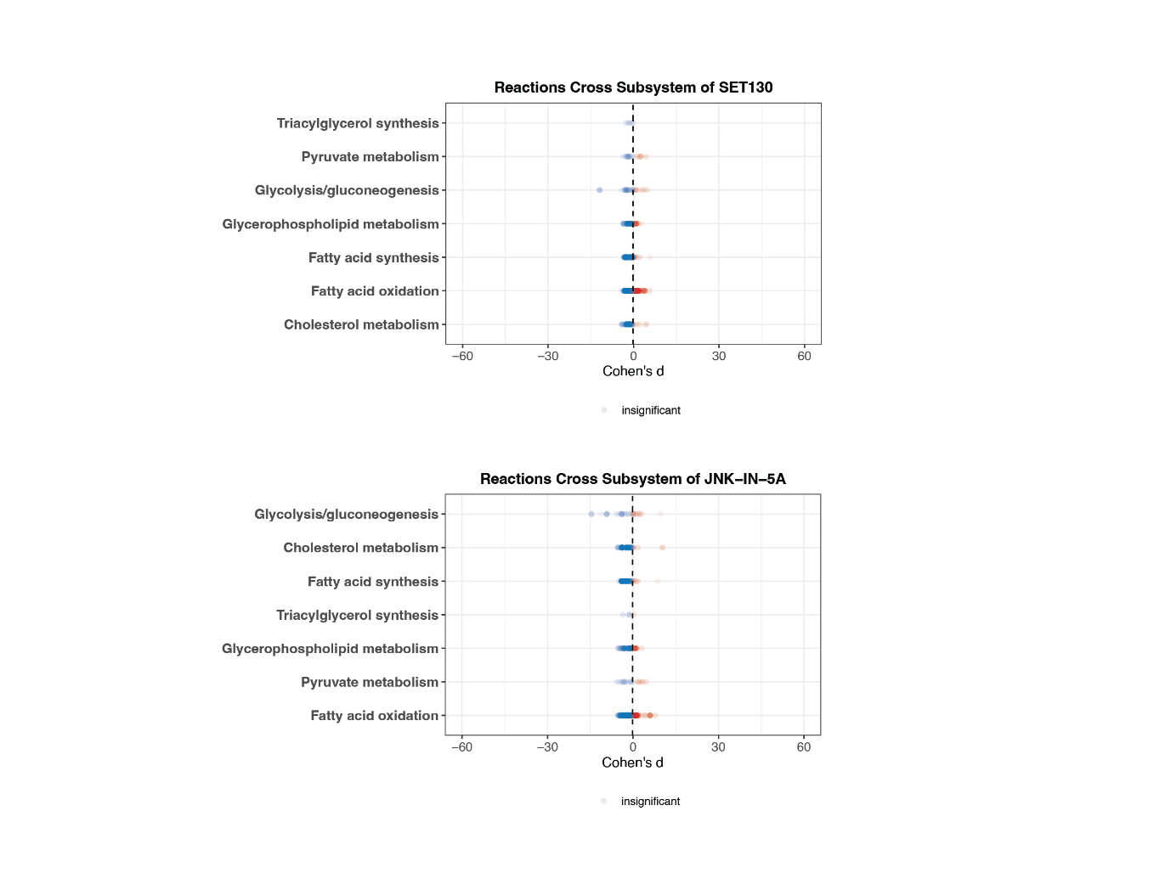
Supplementary Figure 1
Compass-score differential activity test between SET130 and the Control group, JNK-IN-5A and the Control group, respectively.

Supplementary Figure 2
- Predicted mechanism of action for drugs regulating chREBP. Penalty scores and gene expression significance are shown by the bar plot.
- Predicted mechanism of action for drugs regulating SREBP-C. Confidence scores and gene expression significance are shown by the bar plot.

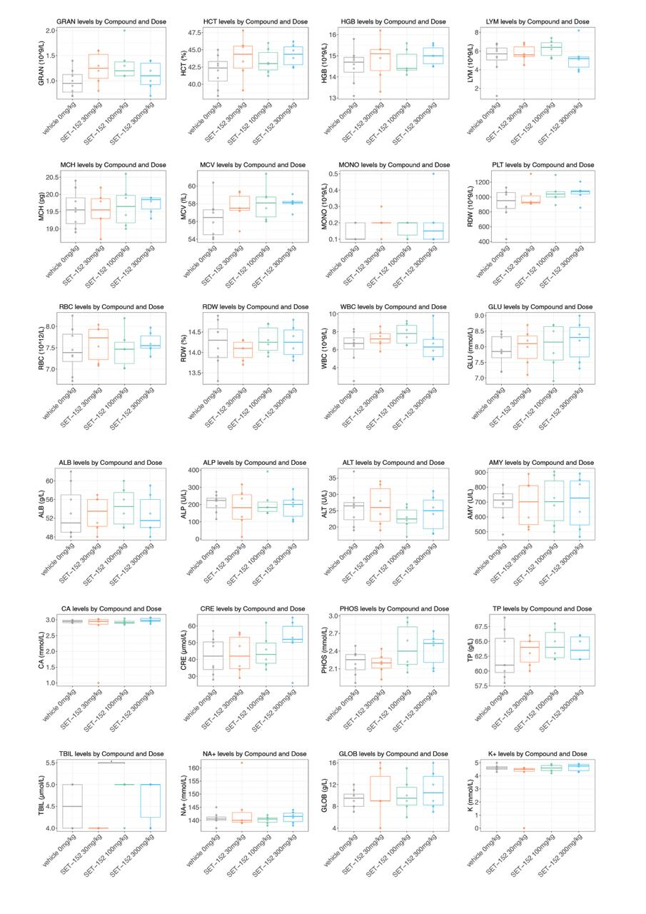
Supplementary Figure 3

Hematology and plasma chemistry parameters remained within normal ranges, supporting the overall safety profile of the compound.

