S1: Temporal distribution of observed and historical CMIP6 data for precipitation, minimum and maximum temperature in lowland (a1-a3), midland (b1-b2), and highland (c1-c2) from (1995-2014).

S2. Spatial distribution of annual extreme indices under SSP1-2.6 scenario in UBNB.
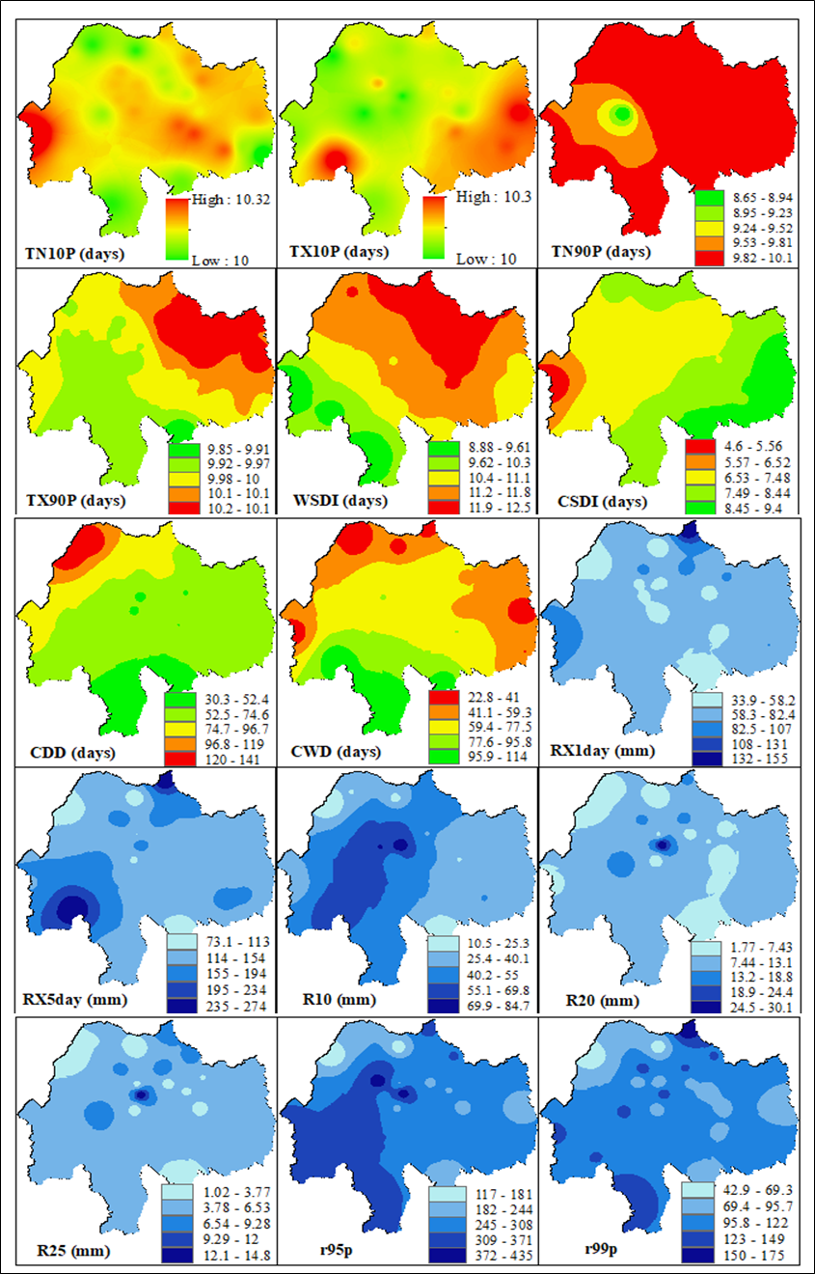
S3. Spatial distribution of annual extreme indices under SSP2-4.5 scenario in UBNB.
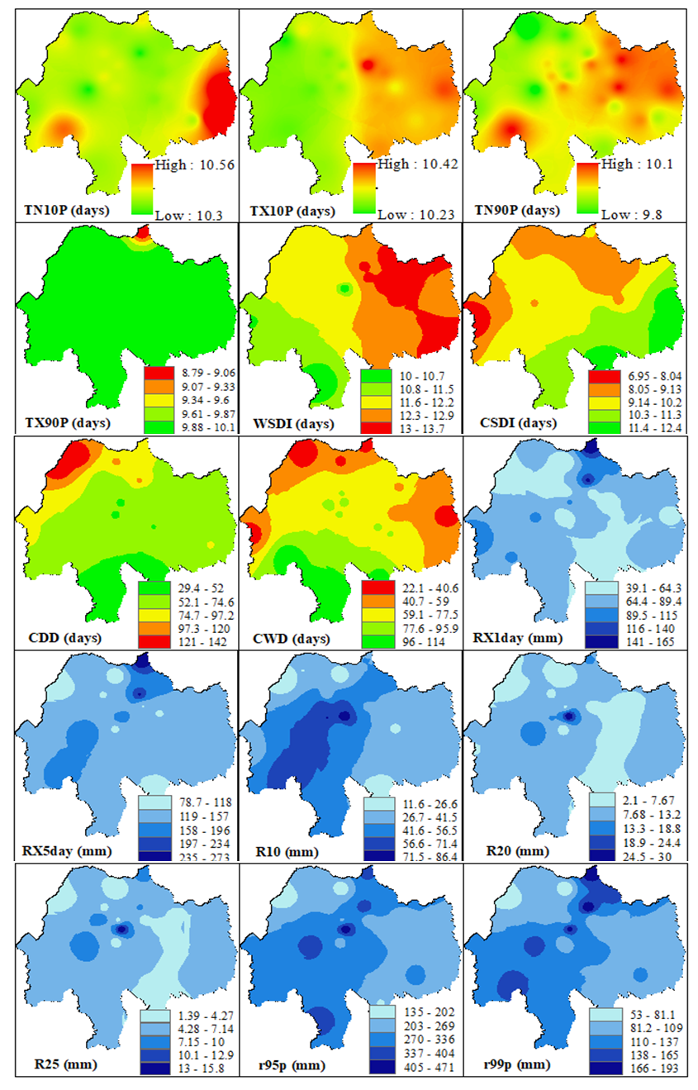
S4. Spatial distribution of annual extreme indices under SSP5-8.5 scenario in UBNB.
