Supplementary Material

Section A: Protocol for optimizing personalized TI stimulation electrode montage (Main article - Section 2.3 continued)
This study utilized SimNIBS to segment the T1-weighted MRI images of the participants [1]. Dividing their heads into six tissue types and assigning corresponding conductivities: scalp (0.465 S/m), skull (0.01 S/m), cerebrospinal fluid (1.65 S/m), white matter (0.126 S/m), gray matter (0.276 S/m), and cavity (2.5e-14 S/m). After segmentation, we registered the 10-10 EEG electrode system onto the participants' scalp.
Next, using the Gmsh, we generated tetrahedral finite element meshes of the participants' heads. After obtaining the meshes, we employed the finite element solver to compute the electric field intensity in the participants' brains. The electric field intensity was calculated separately for each of the two electrode pairs. Let E1 represent the magnitude of the electric field at each element of the grid (head model) due to a 5-mA current passing through one pair of electrodes, and E2 represent the electric field magnitude for the other pair of electrodes. The maximum amplitude modulation of the interference pattern is given by the following equation [2]:
$${TI}_{max}=\left\{\begin{aligned} 2E_{2}, if E_{2}<E_{1}cos⁡(a) \\ {(2\left|\vec{E_{2}}×(\vec{E_{1}}- \vec{E_{2}})\right|)}/{\left|\vec{E_{1}}- \vec{E_{2}}\right|}, &otherwise\end{aligned}\right.$$
Here, E2<E1 and a < 90 degrees, and note that the TI field amplitude is limited to the weaker of the two fields E1 and E2. From this we can get the electric field strength of each TI simulation.
Based on the electric field strength simulation calculations from prior stimulation studies targeting the striatum, the computed electric field strength was approximately 0.22 V/m [3]. Considering that this study employs a dual-channel 4-electrode stimulation paradigm with a current intensity of 5 mA for each electrode, we estimate that the electric field strength at the stimulation site will reach at least 2.2 V/m. Through simulation studies of multiple electrode placement configurations and applying the following method of exclusion, we determined the most suitable electrode placement scheme for each participant：
a) The ratio of the envelope electric field amplitude of the target brain region to the envelope electric field amplitude of the entire brain.
b) Maintain safe current densities, typically less than 2 mA/cm²
c) The number of voxels in the target region that have a TI > 0.2 V/m expressed as the percentage of the average number of the voxels in the non-target regions that have a TI > 0.2 V/m.
d) The magnitude of the electric field in the target area is at least 2.2 V/m
Through the above method screening, we obtained the optimal electrode placement position for each subject (Fig S1).

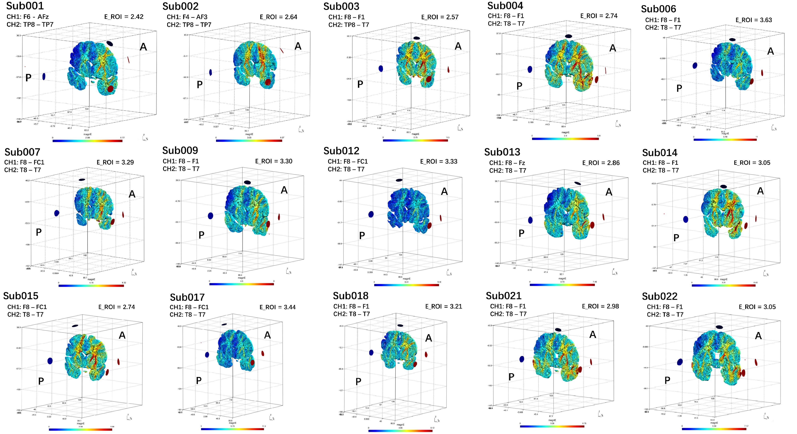

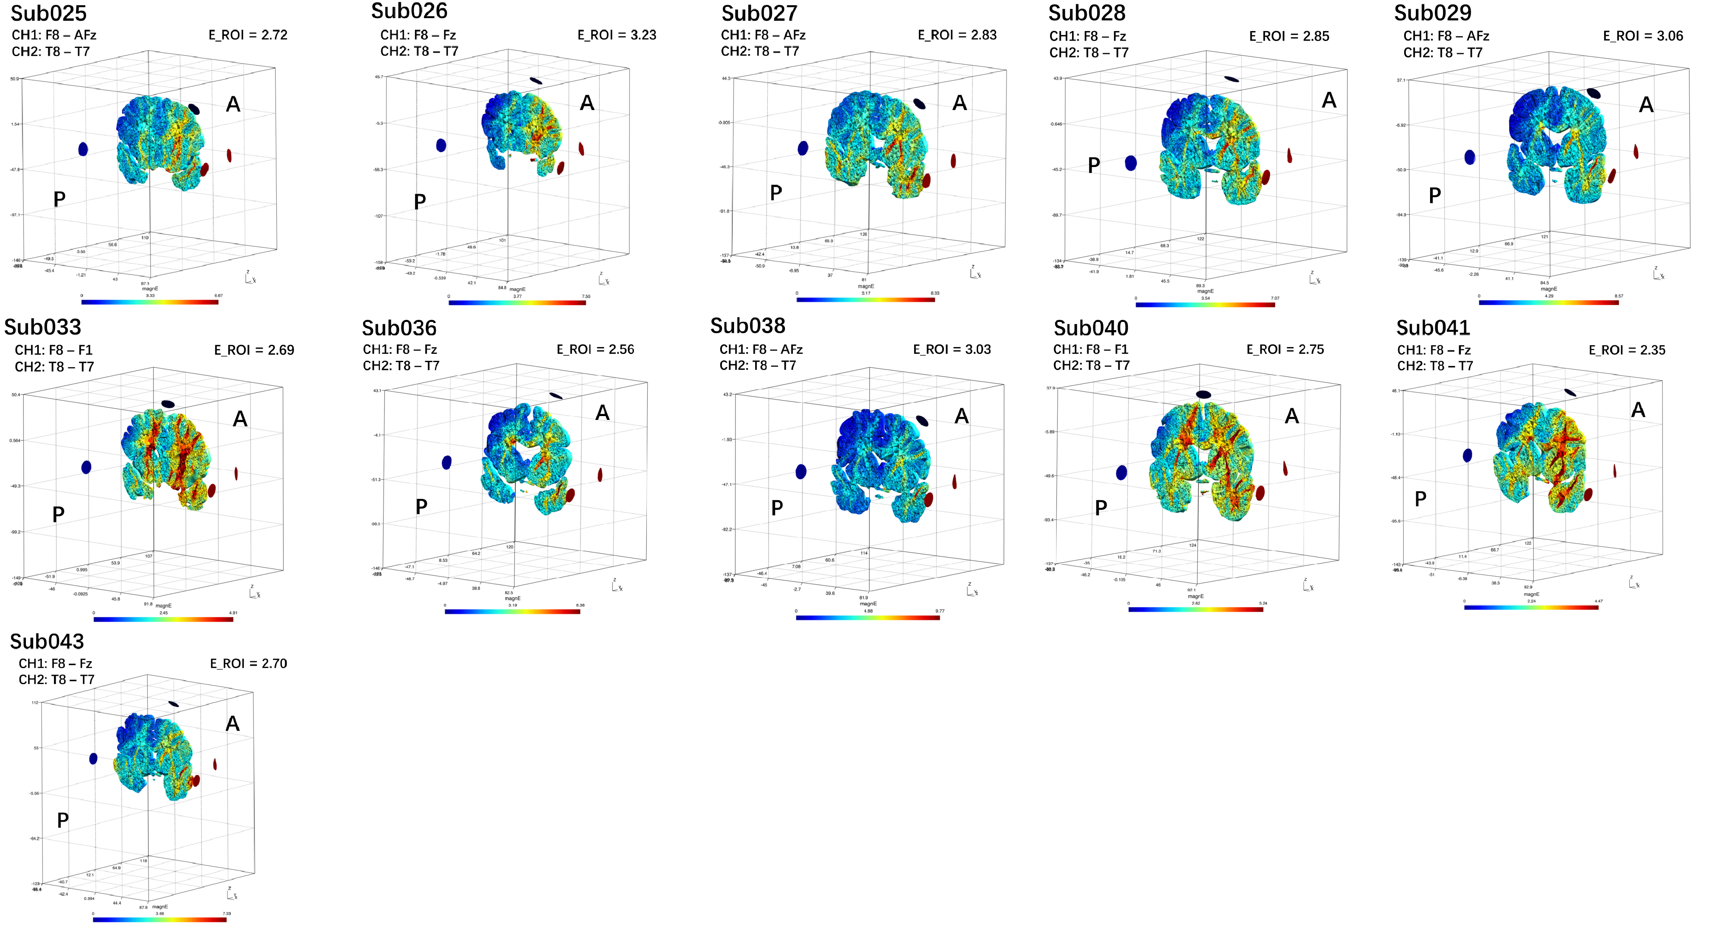
Fig. S1. Electric field intensity for participants. The modeling process included brain tissue segmentation, electrode placement (10-10 EEG system), finite element meshing, and TI electric field solution. A, Anterior; P, Posterior; E_ROI, Electric field intensity in the ROI area.

Section B: Extended analysis of main results
Fig. S2. Changes in nodal topological metrics in functional networks following stimulation in Sham group. (A) Cingulo-opercular network. (B) Sensorimotor network. Note: Red dots indicate brain regions showing significantly increased nodal topological metrics post-stimulation compared to baseline.

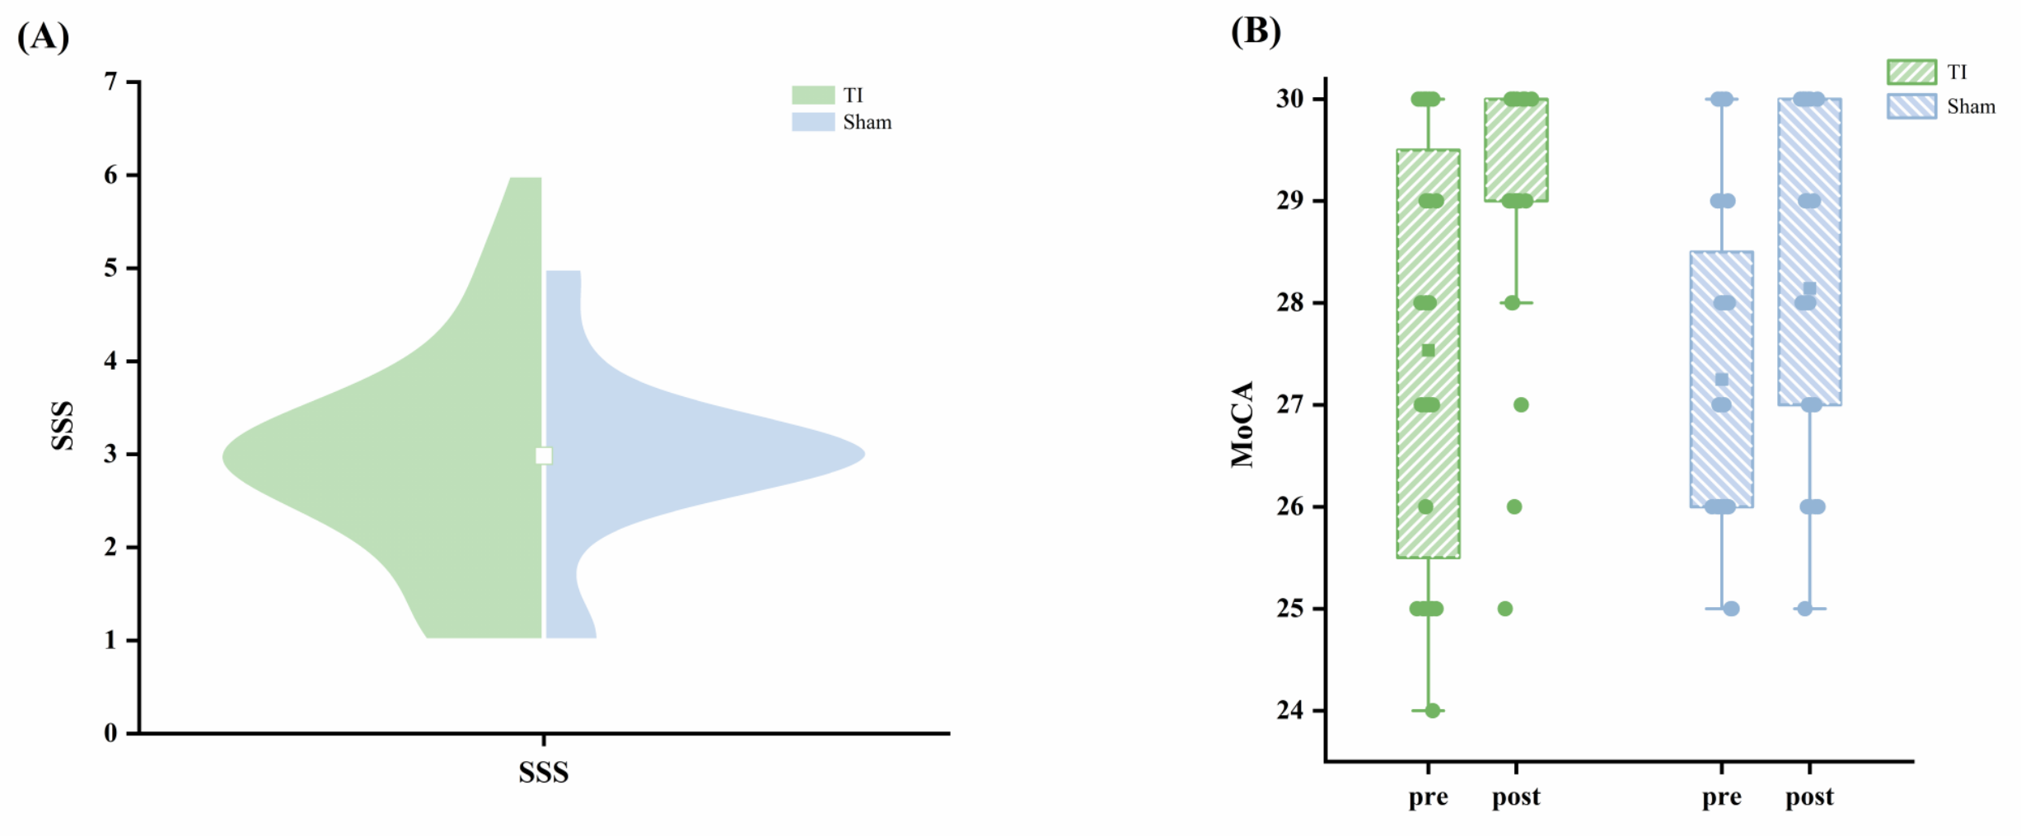Fig. S3. Questionnaire responses about sleepiness and cognitive
Subjects were required to complete the questionnaire before and after the experiment to account for subject wakefulness and cognitive status (n=28). (A) Subjects’ level of attention and fatigue before the experiment, quantified with the Stanford Sleepiness Scale, ranging from 0 to 8. Comparison of pre-stimulation sleepiness in the TI and Sham groups. No significant difference was found (Pearson's chi-square test: χ² = 4.275, P = 0.513). (B) Both groups of subjects completed the Montreal Cognitive Assessment Scale before and after the experiment. The results of the questionnaire data were compared for differences by Generalized Estimating Equations (GEE). The results showed that there was no significant difference between the two groups on the time x group interaction effect (Wald χ² = 1.295, P = 0.255), and the group main effects analysis did not reveal differences (Wald χ² = 2.655, P = 0.103). Time main effects analysis showed that post-experiment cognition was significantly higher than pre-experiment (Wald χ² = 22.040, P < 0.001). TI, temporal interference stimulation; Sham, sham stimulation; Pre, before the experiment; Post, after the experiment; SSS, Stanford Sleepiness Scale; MoCA, Montreal Cognitive Assessment Scale. Boxes show median and interquartile range (IQR); whiskers extend to data within 1.5×IQR; points beyond are outliers.

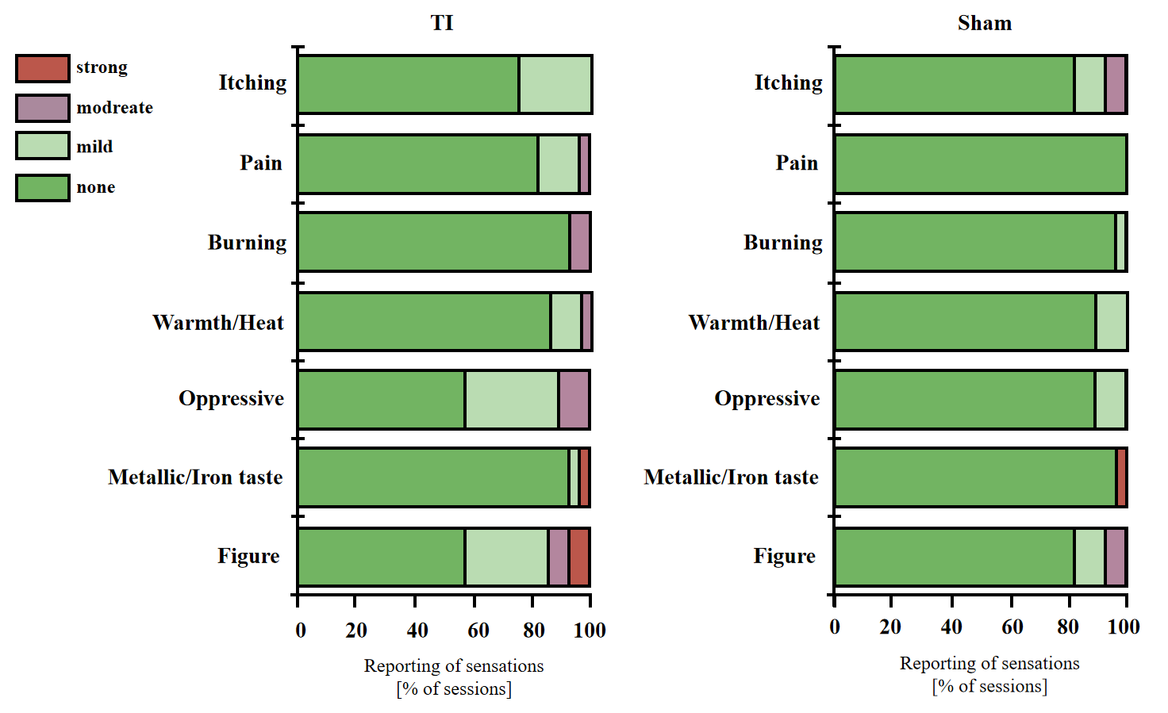
Fig. S4. Reported side effects of TI stimulation and sham stimulation
Subjects from both groups were asked to complete the Adverse Effects Questionnaires at the end of the experiment. The scale categorizes adverse reactions into 4 scales. The results of the questionnaire were analyzed using Pearson's chi-square test to determine the variability in the scores of the items between the two groups. The results showed that there was no significant difference between the two groups in terms of the total score of adverse reactions (χ² = 10.864, P = 0.285). TI, temporal interference stimulation; Sham, sham stimulation.

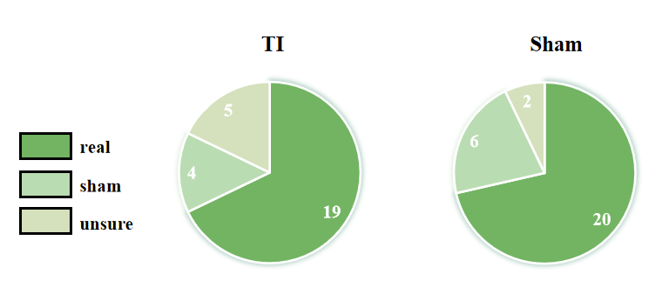
Fig. S5. Blinding Efficacy of TI and Sham Stimulation.
At the end of the experiment, subjects were asked to complete a blind school test questionnaire. The results of the questionnaire were tested by Pearson's chi-square and showed that without difference in the blinded test of stimuli across groups (χ2 = 1.711, P = 0.425).

Reference
[1] Thielscher A, Antunes A, Saturnino GB. Field modeling for transcranial magnetic stimulation: A useful tool to understand the physiological effects of TMS? Annu Int Conf IEEE Eng Med Biol Soc 2015;2015:222-5.
[2] Grossman N, Bono D, Dedic N, Kodandaramaiah SB, Rudenko A, Suk HJ, et al. Noninvasive Deep Brain Stimulation via Temporally Interfering Electric Fields. Cell 2017;169(6):1029-41.e16.
[3] Wessel MJ, Beanato E, Popa T, Windel F, Vassiliadis P, Menoud P, et al. Noninvasive theta-burst stimulation of the human striatum enhances striatal activity and motor skill learning. Nat Neurosci 2023;26(11):2005-16.

