Supporting information

S1 Table. Cancer Group Classification Based on ICD-10 Codes.
Cancer group | ICD - 10 codes | Description
Colorectal | C18, C19, C20 | Colon, rectosigmoid junction, rectum
Head and neck | C00–C06, C07–C08, C09–C10, C12–C14 | Lip, oral cavity, salivary glands, pharynx
Hepatobiliary | C22, C23, C24 | Liver and biliary system
Female genital | C51–C57 | Vulva, vagina, cervix, corpus uteri, ovary, etc.
Urinary system | C64–C68 | Kidney, renal pelvis, ureter, bladder, etc.
Secondary_metastatic | C77, C78, C79 | Lymph node, respiratory and digestive metastasis
Non Hodgkin lymphoma | C82, C83, C84, C85 | Different types of non-Hodgkin lymphoma
Hematologic malignancy | C88, C90–C96 | Blood malignancies (multiple myeloma, leukemia, etc.)
Lung | C34 | Lung cancer
Stomach | C16 | Gastric cancer
Esophagus | C15 | Esophageal cancer
Breast | C50 | Breast cancer
Prostate | C61 | Prostate cancer
Nasopharynx | C11 | Nasopharyngeal cancer
Pancreas | C25 | Pancreatic cancer
Brain | C71 | Brain tumors
Thyroid | C73 | Thyroid carcinoma
Other | Other codes outside above categories | Other malignancies or unspecified sites

S2 Table. Multivariate linear regression analysis of factors associated with CK-MB/CK ratio in colorectal and lung cancer patients.
Variable | Colorectal |  |  | Lung
Variable | Estimate | Std. Error | P-value | Estimate | Std. Error | P-value
Intercept | 1.490 | 0.188 | <0.001 | 1.198 | 0.157 | <0.001
Age | -0.002 | 0.002 | 0.132 | 0.000 | 0.002 | 0.944
Sex (male vs female) | 0.025 | 0.040 | 0.536 | 0.013 | 0.036 | 0.714
Stage III (vs Stage II) | -0.053 | 0.173 | 0.760 | 0.094 | 0.127 | 0.459
Stage IV (vs Stage II) | 0.094 | 0.161 | 0.562 | 0.110 | 0.118 | 0.351
Treatment (Yes vs No) | 0.042 | 0.040 | 0.294 | -0.048 | 0.031 | 0.125
Notes: Stage II was set as the reference category for tumor stage comparison. Treatment status refers to whether the patient received any form of adjuvant therapy (e.g., chemotherapy, radiotherapy, targeted therapy, or immunotherapy). Statistical methods: Multivariate linear regression analysis was performed to evaluate the associations between clinical variables and CK-MB/CK ratio. The independent variables included age, sex, tumor stage (stage II as reference group), and treatment status (yes vs no). The regression coefficients (Estimate), standard errors (Std. Error), and P-values were reported. A P-value < 0.05 was considered statistically significant. Abbreviations: CK-MB, creatine kinase-MB isoenzyme; CK, creatine kinase.

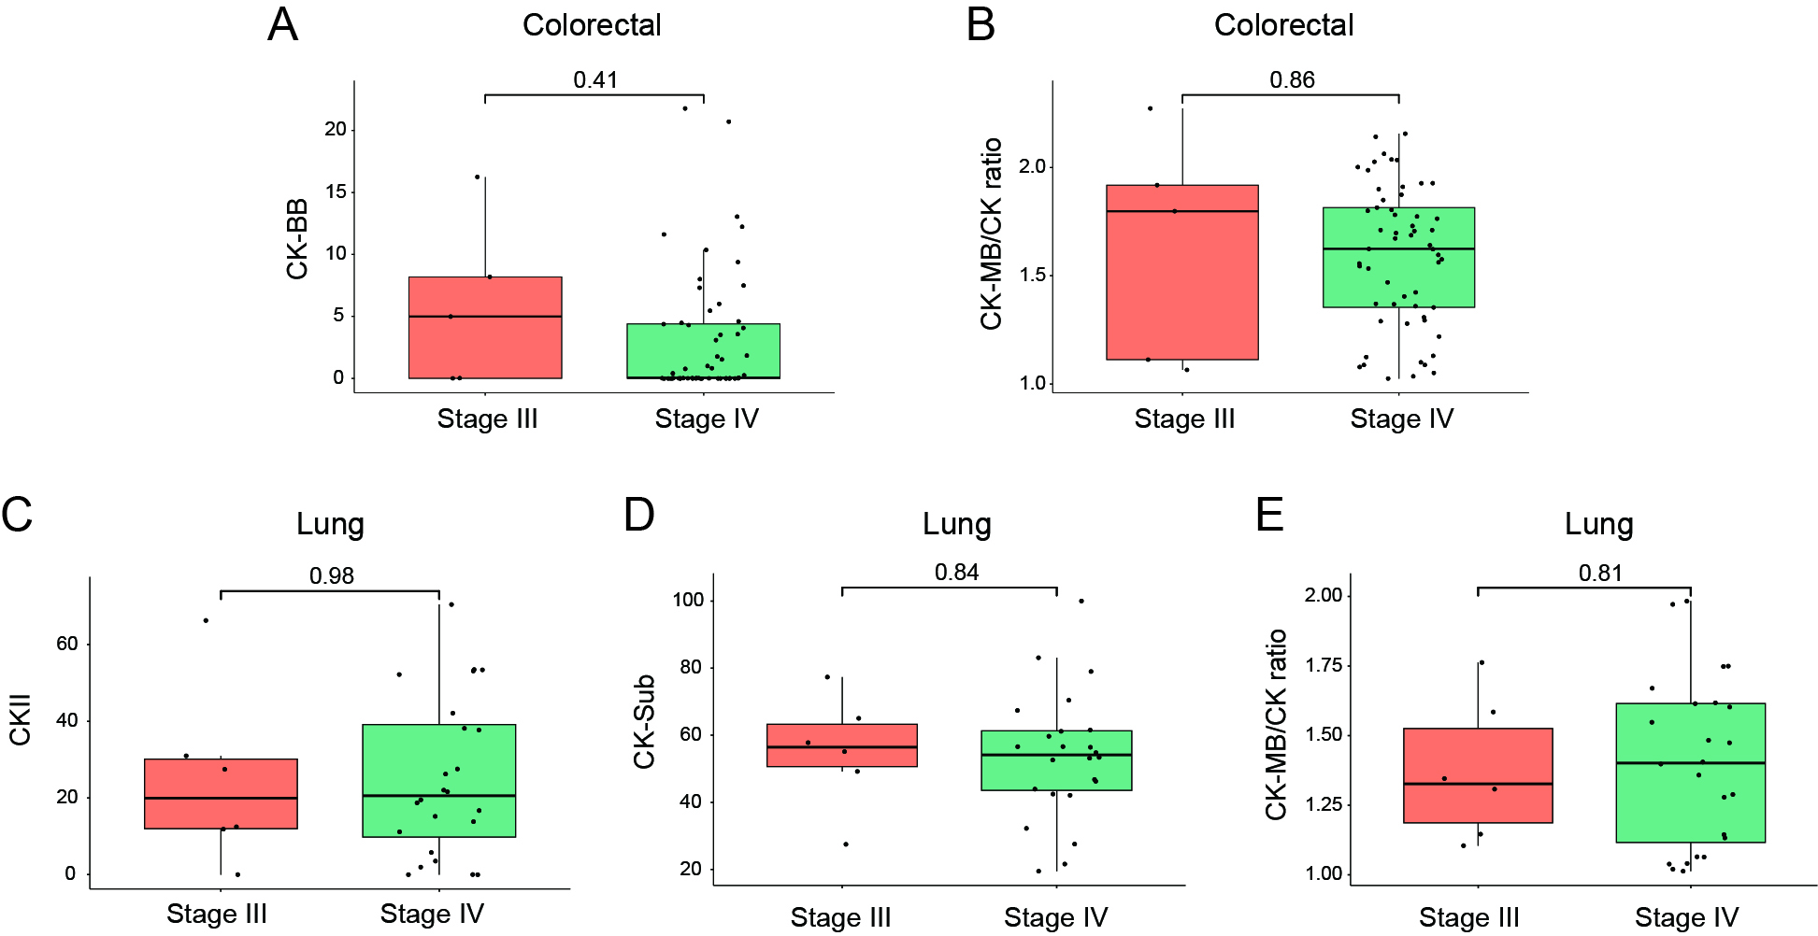
S1 Fig. Expression of serum CK isoenzymes in different disease stages. (A–B) Comparison of CK-BB, CK-MB/CK ratio between stage III and stage IV colorectal cancer patients. (C–E) Comparison of CKII, CK-Sub, and CK-MB/CK ratio between stage III and stage IV lung cancer patients. Statistical methods: Group comparisons were performed using the Wilcoxon rank-sum test. Abbreviations: CK-MB, creatine kinase-MB isoenzyme; CK, creatine kinase; CKII, mitochondrial creatine kinase isoenzyme II; CK-BB, creatine kinase brain-type isoenzyme; CK-Sub, total CK isoenzyme activity (CK-BB + CKII + CKI).

