Supplementary Information
Machine-learning potential reveals the origin of hydrogen embrittlement at general grain boundaries in α-Fe
Kazuma Ito ^{a,}*, Takashi Otakiª, Tatsuya Yokoi ^{b}, Katsutoshi Hyodo ^{c}, Hideki Mori ^{d}

ª Advanced Technology Research Laboratories, Nippon Steel Corporation, 20-1, Shintomi, Futtsu city, Chiba 293-8511, Japan
^{b} Department of Materials Physics, Nagoya University, Nagoya 464-8603, Japan
^{c} Steel Research Laboratories, Nippon Steel Corporation, 20-1, Shintomi, Futtsu city, Chiba 293-8511, Japan
^{d} Department of Mechanical Engineering, College of Industrial Technology, 1-27-1 Nishikoya, Amagasaki, Hyogo 661-0047, Japan

* Corresponding author.
E-mail address: ito.nn3.kazuma@jp.nipponsteel.com (K. Ito)

Supplementary Note 1. Computational Performance of the MLIP
In this study, we not only used the Beller-Parinello neural network potential (BNNP) framework shown in the main article but also tested a deep potential (DP) framework that includes a three-body embedding network. In the DP, we used the same hyperparameters as those used in a previous study on the Fe-H binary system ¹. Specifically, A hybrid descriptor of se_e2_a and se_e3 types was employed with the following configuration: cutoff radius 6.5 Å, configuration of embedding net (30, 60, 120), and number of axis neurons 32 for se_e2_a type descriptor, as well as the cutoff radius 5.0 Å, and configuration of embedding net (10, 20) for se_e3 type descriptor. We adopted the hybrid descriptor consisting of the descriptor se_e2_a with a large cutoff radius of 6.5 Å and the descriptor se_e3 with a small cutoff radius of 5.0 Å. The following fitting net of deep neural network model in the training stage was used: the configuration of fitting net (320, 320, 320), initial learning rate 10⁻³, final learning rage 2.2 × 10⁻⁸, and training steps 2 × 10⁶. The deep neural network architecture contains three hidden layers, each containing 320 neurons. The activation function was set in hyperbolic tangent form for each hidden layer. Due to the same size of each hidden layer, a “skip” connection was also built.
The root mean square errors (RMSEs) of the DP for energy (normalized by the number of atoms) and atomic force in the entire training dataset were 12.46 meV/atom and 92.62 meV/Å, respectively. The fitting accuracy for the atomic forces was similar to that of BNNP (Table 1); however, BNNP was more accurate in terms of energy. This trend was similar to that observed in previous studies ¹.
We also tested BNP with a cutoff radius of 6.5 Å. The RMSEs of energy and atomic force for the entire training dataset were 4.33 meV/atom and 110.04 meV/Å, respectively. which were very similar to those obtained with the BNP with a cutoff radius of 6.0 Å shown in the main article.
Table S1 lists the performances of the constructed MLIP. It shows the performance of BNNP with a cutoff radius of 6.0 Å used in the main article and BNNP with a cutoff radius of 6.5 Å. The results for the DP and MTP prototypes developed in this study are also presented. The results of BNNP (cutoff radius of 6.5 Å) and EAM constructed in previous studies are also shown. The performance was evaluated using a 10 × 10 × 10 supercell of α-Fe consisting of 2048 atoms. The tests were performed on two computing nodes of the supercomputer Fugaku. Each node was equipped with a 48-core A64FX processor, and internode communication was facilitated via a Tofu Interconnect D. Owing to memory constraints, we utilized two nodes to ensure sufficient computational resources.
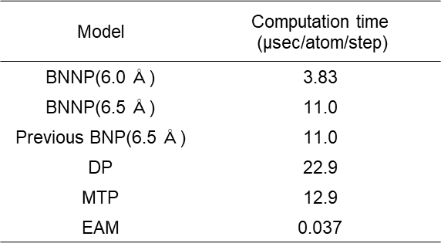
The calculation speed of the DP can be improved using a GPU. However, in this study, it was executed within the CPU-based supercomputer Fugaku Project. Therefore, in the main article, we used a BNNP with a cutoff radius of 6.0 Å, which exhibited excellent fitting accuracy and performance. The calculation cost of BNNP is approximately 100 times that of EAM, which is relatively fast compared to MLIP.
Table S1. Performance of the constructed machine learning potentials. The performance of BNNP with a cutoff radius of 6.0 Å used in the main article and BNNP with a cutoff radius of 6.5 Å are listed. The results of DP and MTP prototypes developed in this study are listed. The results of BNNP (cutoff radius of 6.5 Å) and EAM constructed in previous studies are also shown. The performance was evaluated using a 10 × 10 × 10 supercell of α-Fe consisting of 2048 atoms. The tests were performed on two compute nodes of the supercomputer Fugaku. Each node was equipped with a 48-core A64FX processor, and inter-node communication was facilitated via the Tofu Interconnect D.

Supplementary Note 2. Calculation accuracy of the constructed Fe-H binary MLIP
To evaluate the calculation accuracy of the obtained MLIP, we calculated the physical properties of α-Fe, the formation energy of lattice defects using MLIP, and compared the results with those obtained from DFT (see the “METHODS” section for the calculation conditions). For comparison, we used the Fe-H binary BNNP from a previous study ². Furthermore, we compared the results with the EAM potential ^{3, 4}, which is the most widely used potential in hydrogen embrittlement studies. Hereafter, we refer to the BNNP simply as MLIP.
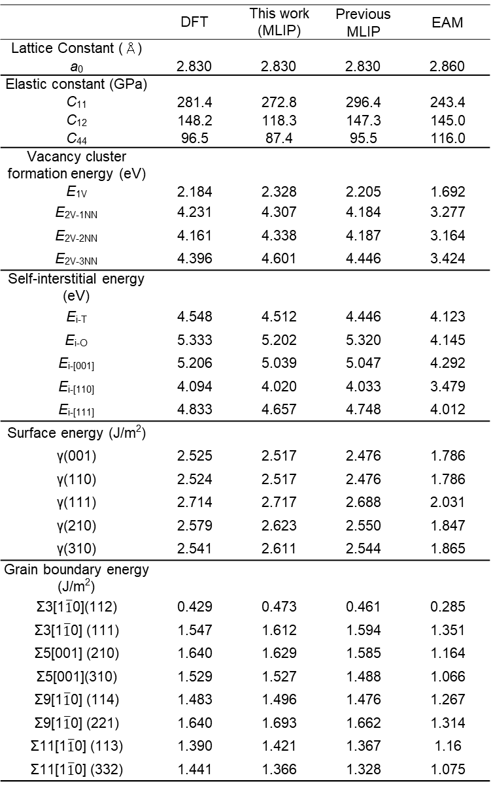
The accuracy of the physical properties of α-Fe and the formation energy of lattice defects in the constructed MLIP are shown in Table S2. The obtained MLIP reproduced the DFT calculations with an accuracy comparable to that reported in previous studies. In addition, The developed MLIP reproduces the generalized stacking fault energies (Fig. S1a and b) and the energy of the screw-dislocation core structure (Fig. S1c and d), which are critical to the plastic deformation behavior of α-Fe, with an accuracy comparable to that of previous MLIPs in reproducing DFT results⁵. In contrast, the EAM significantly underestimated the grain boundary energy and failed to reproduce the qualitative energy trend of the srew dislocation core structure.
Table S2. Calculation accuracy of the machine learning interatomic potential for physical properties of α-Fe and defect formation energies in α-Fe. The values calculated using the EAM are also presented for comparison. The self-interstitial energy represents the formation energies of crowdion<111>, dumbbell<110>, dumbbell<100>, tetrahedral, and octahedral configurations, in order of top to bottom. In vacancy formation energy E_{mV-nNN}, m is the number of vacancies, and n indicates that the vacancies are in the n-th nearest neighbor configuration. For comparison, values calculated using DFT and values calculated using MLIP and EAM constructed in previous studies are also shown.
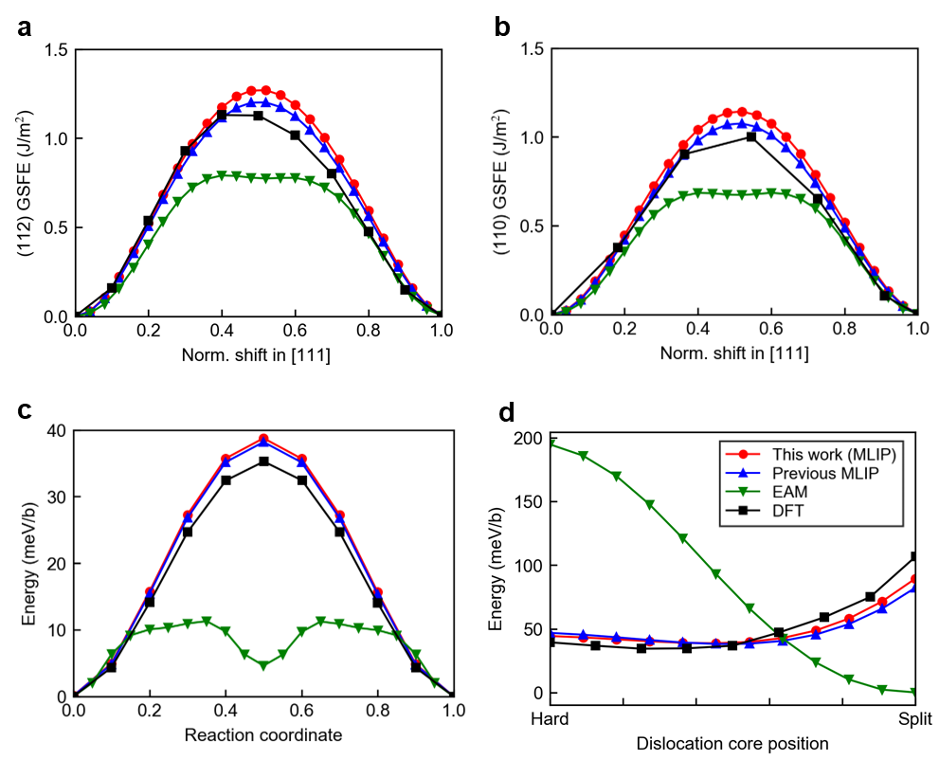
Fig. S1. Calculation accuracy of the MTP for generalized stacking fault energy (GSFE) and Peierls potential. a GSFE for the (110) plane, b GSFE for the (112) plane, c Peierls potential for the srew dislocation, showing the slip barrier of ½ screw dislocation from easy core to easy core determined by NEB, and d 2D Peierls potential for the srew dislocation, showing the slip barrier of ½ screw dislocation from hard core to split core. For comparison, values calculated using DFT and values calculated using MLIP and EAM constructed in previous studies are also shown. The DFT results in c and d are values calculated in previous studies.
Supplementary Note 3. Method for evaluating calculation accuracy of grain boundary segregation energy of hydrogen
First, we describe a method for calculating the hydrogen segregation energy at symmetric tilt grain boundaries. The most stable grain boundary structure was determined using DFT for symmetrically tilted grain boundaries that did not contain hydrogen. Several initial structures were created by shifting a single-crystal grain in a direction parallel to the grain boundary, and the cell size and atomic positions were relaxed. Using the most stable atomic structure as the initial structure, the initial position of hydrogen was determined using the method proposed by Ito et al.³². That is, we performed a Voronoi division on the Fe atoms and found the vertices of the Voronoi polyhedra. This is the initial configuration corresponding to the tetrahedral sites. In addition, we determined the midpoints between a given Fe atom and its second-nearest Fe atom. This was the initial configuration corresponding to the octahedral sites. Among these tetrahedral and octahedral sites, we set all sites within 2.5 Å of the grain boundary center as the initial configuration of hydrogen. The atomic positions of the grain boundaries where hydrogen was positioned were relaxed using DFT, and the hydrogen segregation energy was calculated. At this time, one of the pairs with a close segregation energy and coordinates of hydrogen after relaxation was deleted. After relaxation, the grain boundaries containing hydrogen and those without hydrogen obtained from DFT were used as the initial structures, and the hydrogen segregation energy was calculated using each interatomic potential.
The calculation accuracy of the MLIP for general grain boundaries was evaluated using grain boundaries in a nanopolycrystal with random orientations obtained by Voronoi tessellation and relaxation of the interatomic potential. Relaxation of the nanopolycrystal was created using Fe MTP⁵⁶, which reproduces general grain boundaries with DFT accuracy. The average grain boundary energy of the nanopolycrystal obtained in this manner reproduces the experimental value of ⁶⁵. From the grain boundaries (misorientation of 15° or more) contained in the nano-polycrystal, we extracted calculation cells of 15Å×15Å×15Å (containing approximately 250 atoms) for which DFT calculations could be performed. Periodic boundary conditions were imposed and atoms that were too close to each other near the edges of the calculation cell were removed. Grain boundaries are formed at the cell edges owing to periodic boundary conditions, but their effect on atoms near the cell center is negligible⁵⁶. The atomic positions were relaxed by DFT with the 2.5 Å region at the edges of the calculation cell fixed. In addition, using the same method as for symmetric tilt grain boundaries, we determined the initial position of hydrogen in the region 1.5 Å from the cell center and 2.5 Å from the grain boundary center, where the effects of the extraction and periodic boundary conditions are negligible. After placing hydrogen in the initial position and fixing the 2.5 Å region at the end of the calculation cell, the atomic positions were relaxed using DFT, and the hydrogen segregation energy was calculated. The hydrogen-free cutout cell, which serves as a reference for the hydrogen segregation energy, was also fixed at the 2.5 Å region at the end of the calculation cell, and the atomic coordinates were relaxed to calculate the energy. Using the relaxed structures of the grain boundaries with and without hydrogen obtained from DFT as the initial structures, the hydrogen segregation energy was calculated for each interatomic potential. Five grain boundaries were selected and the segregation energy was evaluated for the initial configuration of 16 sites on average for each grain boundary.
Supplementary Note 4. Validity of bicrystal model including general grain boundaries
In this study, a bicrystalline grain boundary model containing six general grain boundaries is used. The main article states that the grain boundaries contained in these grain boundary models have properties similar to those contained in nanopolycrystal models with random orientations obtained using Voronoi tessellation and structural relaxation using MLIP.
Fig. S2a shows the relationship between the grain boundary energy and misorientation of the grain boundaries in the nano-polycrystals. The relationships among the general grain boundaries included in the six bicrystal models are also shown. For grain boundaries in nanopolycrystals, there was no correlation between the grain boundary energy and misorientation for grain boundaries with a misorientation of 15° or more. The misorientation of grain boundaries in the six bicrystal models ranges from 25.4 to 47.91°, and the grain boundary energy ranges from 1.65 to 1.87 J/m2, which is similar to the grain boundary energy of grain boundaries in nano-polycrystals. As shown in Fig. S2b, no specific periodic structure is observed at any of the six grain boundaries. These results indicate that a bicrystalline model containing general grain boundaries comparable to those in polycrystals was obtained.
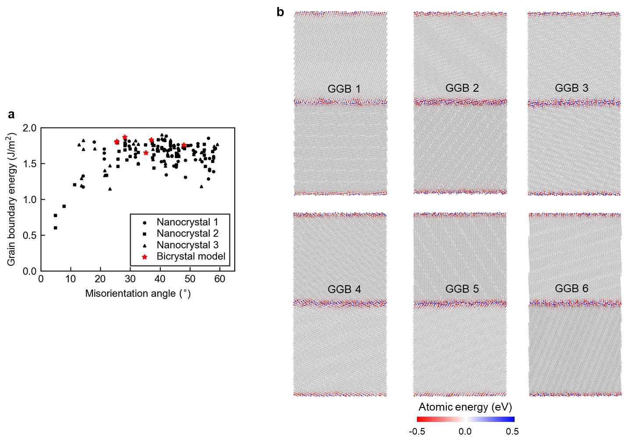
Fig. S2. Validity of the bicrystal grain boundary model including general grain boundaries. a Relationship between crystal misorientation and grain boundary energy included in the nano-polycrystal model and bicrystal model. b Atomic structure and color map of the energy of each atom in bicrystal grain boundary models. The energy reference is the energy of Fe atoms in a perfect crystal.

References
1. Zhang S, Meng F, Fu R, Ogata S. Highly efficient and transferable interatomic potentials for α-iron and α-iron/hydrogen binary systems using deep neural networks. Comput Mater Sci 235, 112843 (2024).

2. Meng F-S, et al. General-purpose neural network interatomic potential for the α-iron and hydrogen binary system: Toward atomic-scale understanding of hydrogen embrittlement. Phys Rev Mater 5, 113606 (2021).

3. Ramasubramaniam A, Itakura M, Carter EA. Interatomic potentials for hydrogen in α-iron based on density functional theory. Phys Rev B 79, 174101 (2009).

4. Song J, Curtin WA. Atomic mechanism and prediction of hydrogen embrittlement in iron. Nat Mate 12, 145-151 (2013).

5. Itakura M, Kaburaki H, Yamaguchi M. First-principles study on the mobility of screw dislocations in bcc iron. Acta Mater 60, 3698-3710 (2012).

