Supplement Materials
A Meta Learning Approach to Enhance Resolution in Uncertainty Space of Hydro-Climatic Artificial Intelligence Models
*Corresponding Author: Mina Sayyah-Fard

S1. PaD Method
In this method, the partial derivative of the output is calculated with respect to each input variable, while keeping all other variables constant. The magnitude of this derivative indicates how sensitive the output is to small changes in that specific input variable. It is utilized in engineering, climatology, and ML for the preliminary assessment of inputs (Nourani and Sayyah-Fard, 2012). The magnitude of the derivatives is often measured using the Sum of Squared Derivatives (SSD). This SSD-based sensitivity analysis, derived from the nonlinear ANN model, offers valuable insight into the nonlinear influence of input variables and can be utilized to identify the most influential variables under a nonlinear regression framework. If the model is $y=f\left(x_{1}, x_{2},…,x_{n}\right)$ , then the partial derivatives $\frac{∂y}{∂xi}$ are calculated on the $x_{i}$ , i^{th} input variable, domain accordingly. The SSD number is ultimately derived by averaging the squared values of these partial derivatives as:
(S1-1)
where, the total count of input variables and sampels are represented by ni and n, respectivly, N represents the output signal of the neuron, while o denotes the output node, and $X_{p}$ represents the p^{th} input to the model. Inputs associated with larger SSD values exert a more significant influence on the network's output. In ANN-based model, the Jacobian matrix, which contains the first-order partial derivatives of the outputs with respect to the inputs, is commonly used for conducting PaD values (Dimopoulos, et al. 1995, Gevrey et al., 2003).
S2. Some parameter settings for SA algorithm
The optimization process in AI/ML models was carried out using the SA algorithm, based on previous studies (e.g., Khosravi et al., 2011) and empirical adjustments through trial and error. Some parameter settings for each model are presented in Table S1.
TABLE S1 Summary of SA algorithm hyperparameter settings
Parameters | Numerical value
Geometric cooling schedule
Initial temperature (T0) | $$5≤T0≤7$$
Stopping temperature | $$0.2≤Tend≤1$$
Maximum number of tries within one temperature | 30

S3. Visualization of PIs
Figs. S1 to S2 illustrate the best uncertainty bounds estimated by individual models and ensemble methods. As shown, the refined bounds produced by INI aggregation approach yield the highest resolution among PIs.

Fig. S1 Visual comparison of PIs produced by individual and hybrid models for various targets at Tabriz station: (a) Et, (b) SPI-6, (c) SPI-12, (d) SPEI-6, (e) SPEI-12.

Fig. S1 (Continued)

Fig. S2 Visual comparison of PIs produced by individual and hybrid models for various targets at Ahvaz station: (a) Et, (b) SPI-6, (c) SPI-12, (d) SPEI-6, (e) SPEI-12

Fig. S2 (Continued)

S4. Statistical characteristics of uncertainty classes
Table S2 and Fig. S3 present the statistical characteristics of the uncertainty classes generated by Fig. 5 in the main text. These statistics provide insights into the distribution and variability within each uncertainty class, supporting the interpretation of the uncertainty analysis results.
Variable | Class Label (UQ) | Tabriz station |  |  |  |  |  | Ahvaz station
Variable | Class Label (UQ) | Q1 | Q2 | Q3 | Min | Max | Class Data (%) | Q1 | Q2 | Q3 | Min | Max | Class Data (%)
Et | ● | 5.90 | 8.80 | 12 | 0.60 | 21 | 60.91 | 7.80 | 10.0 | 14.0 | 0.9 | 22.90 | 60.36
Et | ● | 2.20000000000000 | 3.05296100000000 | 3.59724400000000 | 0.500000000000000 | 5.30 | 2.77 | 3.50 | 4.60000000000000 | 5.35000000000000 | 0.90 | 8.50 | 4.87
Et | ● | 2.5617052500000 | 2.95590000000000 | 3.26055850000000 | 1.60 | 4.0 | 3.71 | 2.65 | 3.80000000000000 | 4.82500000000000 | 0.30 | 7.50 | 5.09
Et | ● | 0.245100000000000 | 1.09020400000000 | 1.94935600000000 | -0.05 | 4.50 | 32.62 | 1.60 | 2.40000000000000 | 3.20000000000000 | 0 | 5.6 | 29.68
SPI-6 | ● | -1/77 | -0/75 | 1/94 | -2.91 | 3/17 | 9/70 | 0/27 | 0/88 | 1.26 | -0.61 | 2/5 | 6/03
SPI-6 | ● | -1/03 | -0/33 | 1/05 | -2.41 | 2/51 | 15/81 | -0/35 | 0/45 | 1.12 | -2/44 | 2/29 | 18/73
SPI-6 | ● | -0/62 | -0/16 | 0/84 | -2.3 | 1/91 | 28/26 | -0/755 | 0/27 | 0.75 | -2/17 | 2/32 | 30/76
SPI-6 | ● | -0/17 | 0/21 | 0/62 | -1.29 | 1/54 | 46/23 | -0/66 | -0.03 | 0.44 | -2/04 | 1.65 | 44/50
SPI-12 | ● | 1/02 | 1/56 | 2/19 | 0.02 | 3/24 | 11/57 | -1/68 | -1/31 | -0/31 | -3/01 | 1/22 | 14/04
SPI-12 | ● | -1/09 | 0/71 | 1/013 | -2/46 | 1/59 | 6/87 | -0/89 | -0/17 | 1/04 | -2/42 | 2/25 | 20/53
SPI-12 | ● | -0/72 | 0/39 | 0/76 | -2/82 | 1/99 | 36/02 | -0/83 | -0/01 | 1/05 | -2/09 | 2/16 | 27/81
SPI-12 | ● | -0/64 | -0/26 | 0/14 | -1/58 | 1/31 | 45/54 | 0/19 | 0/44 | 0/78 | -0/69 | 1/58 | 37/62
SPEI-6 | ● | -1/47 | -0/56 | -0/23 | -2/90 | 0/73 | 20/94 | -1/32 | -0/72 | -0/25 | -2/85 | 0/54 | 51/69
SPEI-6 | ● | -1/21 | -0/65 | 0/18 | -2/64 | 1/37 | 40/15 | 0/28 | 0/44 | 0/61 | -0/20 | 1/01 | 14/21
SPEI-6 | ● | 0/55 | 0/61 | 0/67 | 0.51 | 0.71 | 7/51 | 0/62 | 0/72 | 0/83 | 0/33 | 1/02 | 9/74
SPEI-6 | ● | 0/79 | 0/89 | 0/99 | 0.55 | 1/19 | 31/40 | 0/82 | 0/93 | 0/98 | 0/66 | 1/07 | 24/36
SPEI-12 | ● | -2/42 | -2/16 | -1/62 | -2/82 | -0/65 | 3/97 | -2/50 | -2/11 | -1/81 | -3/29 | -1/11 | 6/96
SPEI-12 | ● | -1/87 | -1/56 | -1/29 | -2/65 | -0.78 | 5/33 | -1/16 | -0/86 | -0/58 | -2/01 | -0.03 | 22/24
SPEI-12 | ● | -0/34 | 0/18 | 1/00 | -1/91 | 1/80 | 34/49 | -0/27 | 0/26 | 0/63 | -0/96 | 1/40 | 32/74
SPEI-12 | ● | -0/54 | 0/22 | 0/72 | -2/04 | 1/33 | 56/20 | 0/03 | 0/33 | 0/89 | -0/64 | 1/21 | 38/06
● Very High, ● High, ● Low, ● Very low
Table S2. Statistical characteristics of the uncertainty

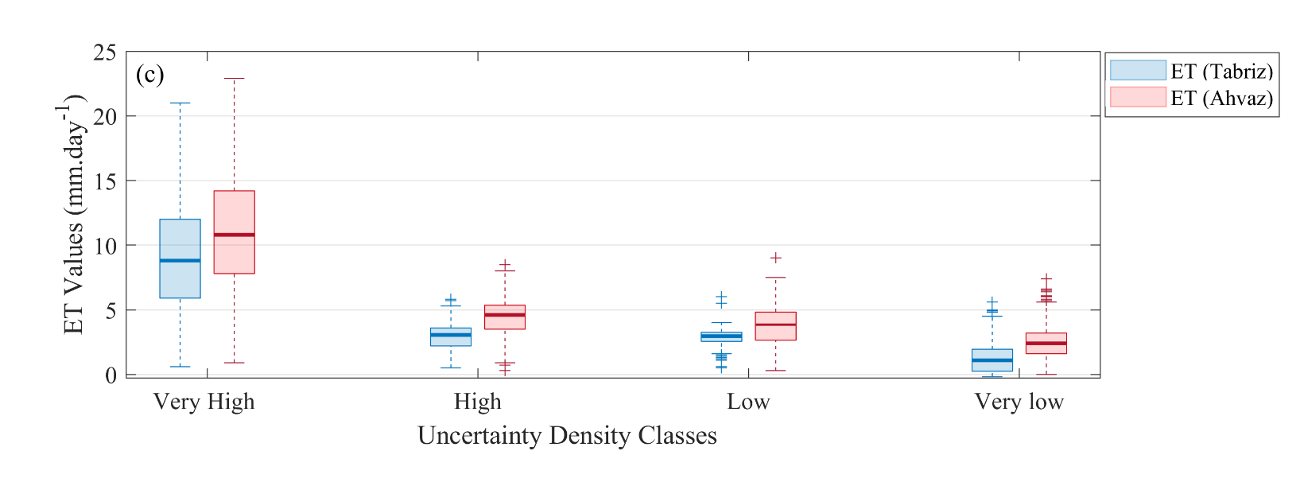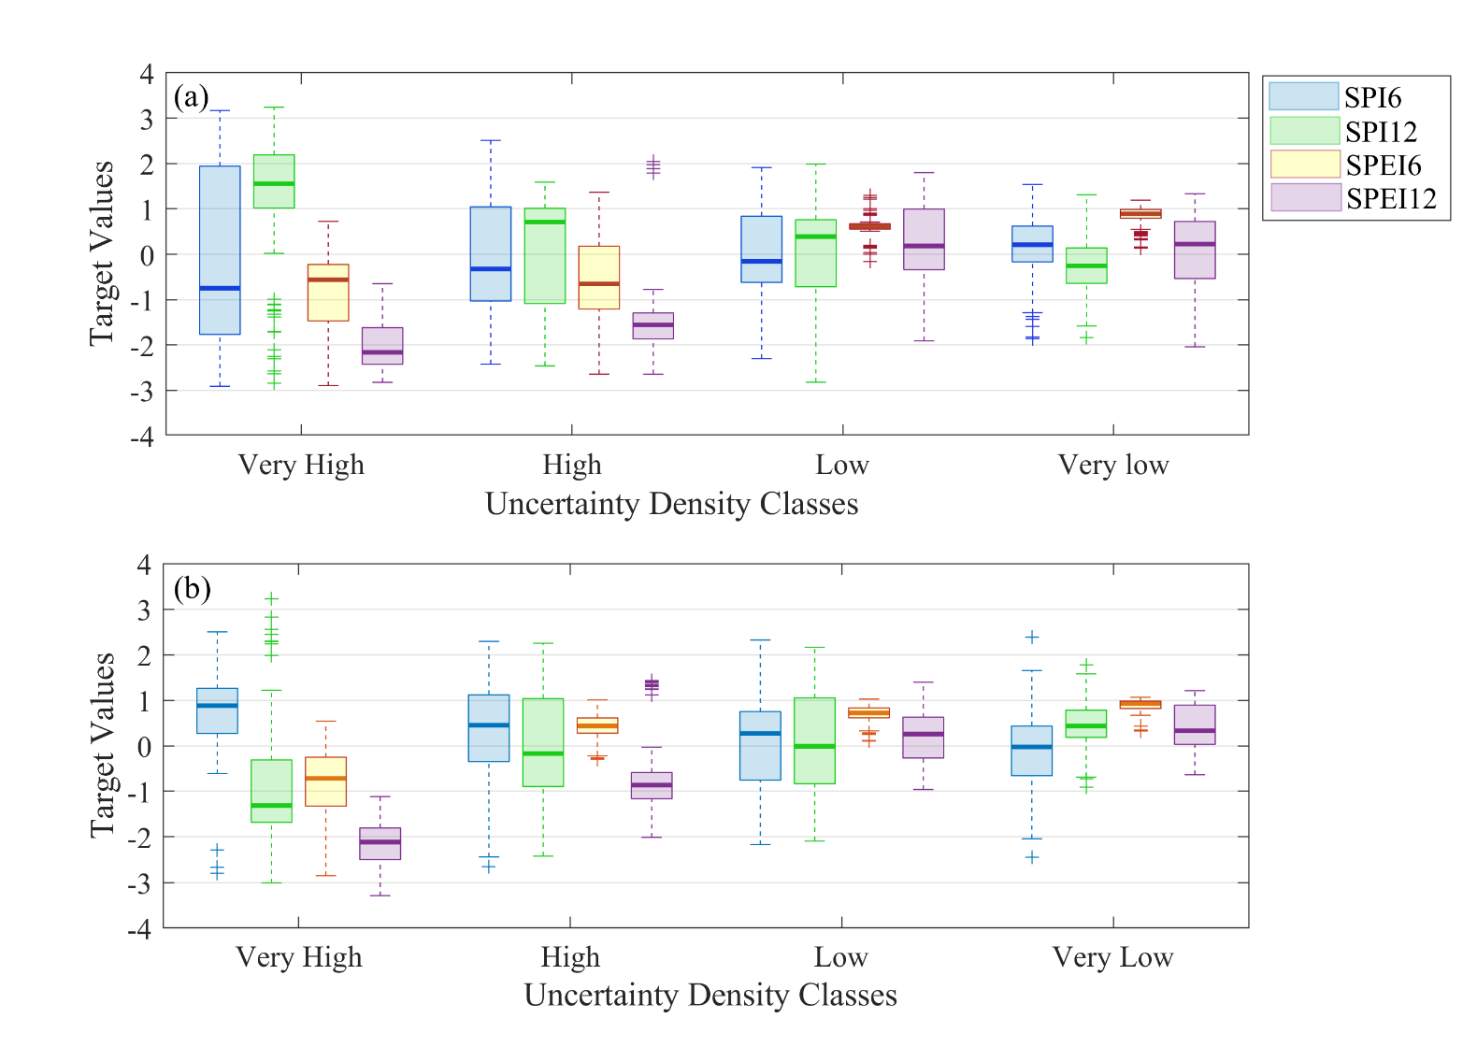

Fig. S3. Boxplots of data classes based on uncertainty content within PIANN AGG: (a) Tabriz station (for drought indexes), (b) Ahvaz station (for drought indexes), and (c) for Et at each station.

References
Dimopoulos, Y., Bourret, P., Lek, S. 1995. Use of some sensitivity criteria for choosing networks with good generalization ability. Neural Process. Lett, 2(1), 1–4. https://doi.org/10.1007/BF02309007
Gevrey, M., Dimopoulos, I., Lek, S. 2003. Review and comparison of methods to study the contribution of variables in artificial neural network models. Ecol. Modell., 160, 249–264, https://doi.org/10.1016/S0304-3800(02)00257-0
Khosravi, A., Nahavandi, S., Creighton, D., Atiya, A. F. 2011. Lower upper bound estimation method for construction of neural network-based prediction intervals. IEEE Trans. Neural Netw., 22, 337–346, DOI: 10.1109/TNN.2010.2096824
Nourani, V., and M. Sayyah-Fard, 2012. Sensitivity analysis of the artificial neural network outputs in simulation of the evaporation process at different climatologic regimes. Adv. Eng. Software, 47, 127–146.

