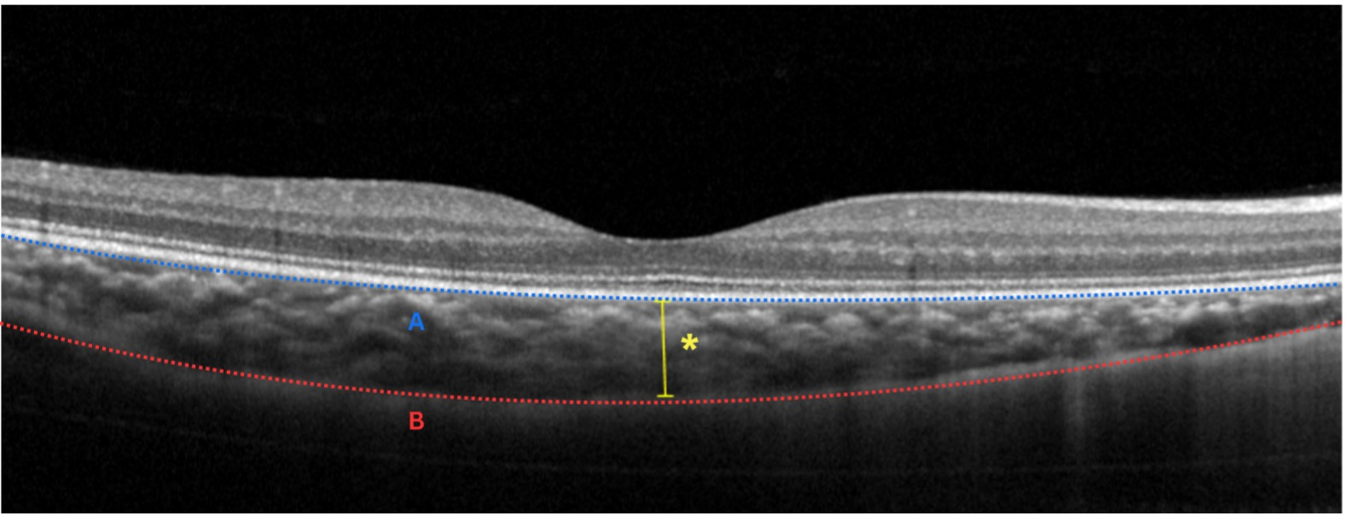
Supplemental Figure 2. Subfoveal choroidal thickness (SFCT) measurement. The vertical distance from the outer border of the retinal pigment epithelium (RPE) (A) to the choroidoscleral interface (B) was manually measured using the built-in caliper tool of the imaging software.

