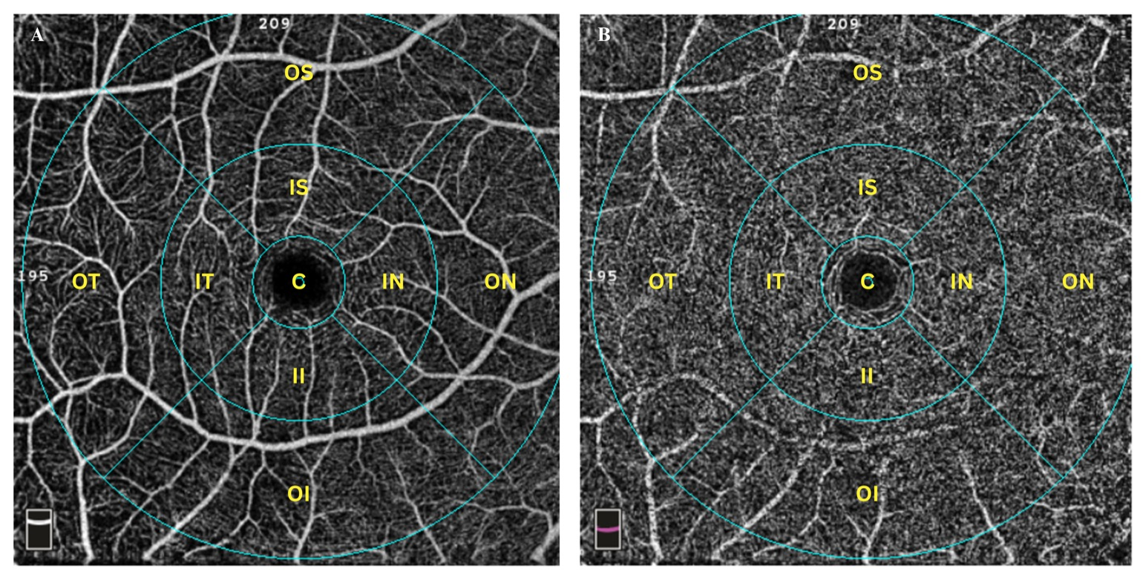
Supplemental Figure 2. Standard ETDRS grid overlay on macular OCTA images (A) Superficial vascular plexus and (B) deep vascular plexus. The grid consists of three concentric circles: a central 1-mm foveal zone [C], an inner ring with a 1–3 mm radius representing the parafoveal region (including the inner superior [IS], inner nasal [IN], inner inferior [II], and inner temporal [IT] subfields), and an outer ring with a 3–6 mm radius representing the perifoveal region (outer superior [OS], outer nasal [ON], outer inferior [OI], and outer temporal [OT] subfields).

