Supplementary materials
The Interaction of Five Coordinated Iron Containing Adsorption Centers of Fe₂₄O₃₆ with Perfluorooctanoic (PFOA) and Perfluorooctanesulphonic (PFOS) Acids: A Density Functional Theory Study
Leonid Gorb^{1,2}, Anita Sosnowska^{2,3}, Danuta Leszczynska⁴, Tomasz Puzyn^{2,3} and Jerzy Leszczynski⁵
¹Institute of Molecular Biology and Genetics, NAS of Ukraine, 150 Zabolotny Str., Kyiv, 03143, Ukraine
²University of Gdansk, Faculty of Chemistry, Department of Environmental Chemistry and Radiochemistry, Laboratory of Environmental Chemoinformatics, Jana Bażyńskiego 8, 80-309 Gdańsk
³QSAR Lab Ltd. Gdańsk, Poland
⁴Department of Civil and Environmental Engineering, Jackson State University, Jackson, Mississippi, 39217, USA
⁵Department of Chemistry, Physics & Atmospheric Sciences, Jackson State University, Jackson, Mississippi, 39217, USA

Table 1S
Change coordination numbers of Fe and O atoms before and after the optimization of the geometry Fe₂₄O₃₆

Coordination  number | Fe |  | O
Coordination  number | srart | optim | start | optim
1 | 2 |  | 6 | 1
2 | 4 | 1 | 12 | 11
3 | 4 | 3 | 12 | 14
4 | 4 | 7 | 6 | 8
5 | 8 | 11 |  | 2
6 | 2 | 2

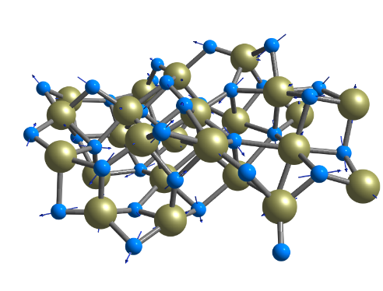
A

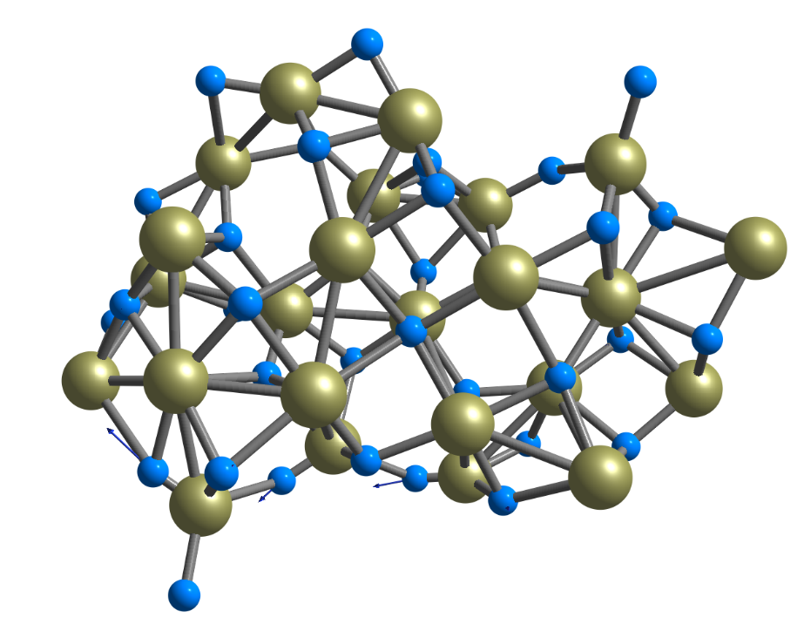

B

Figure 1S. Directions of displacement vectors of the 749.3 cm⁻¹ vibraion of Fe₂₄O₃₆ (see Fig. 3). A – Simple visualization by Chemcraf program; B – application of the option “scaling vibrations vectors”

Cartesian Coordinates

Fe₂₄O₃₆
26 -1.299735000 2.203962000 0.895004000
8 -3.182299000 1.343202000 0.752066000
26 -3.847348000 3.171002000 1.121107000
26 1.437542000 1.580919000 1.644045000
26 3.959617000 1.334339000 1.427189000
26 2.358609000 0.014294000 -1.015574000
26 -0.456437000 0.241752000 -0.920932000
26 6.177800000 1.521334000 -0.250143000
26 -3.429087000 1.683829000 -1.100874000
26 -6.230136000 1.692709000 -0.675226000
26 3.625353000 3.820053000 0.771724000
26 -1.624525000 3.593036000 -1.377463000
26 1.268374000 2.825816000 -0.858353000
8 -2.181200000 3.882161000 0.242030000
8 -2.939501000 3.067315000 -2.301566000
8 2.557700000 -0.070812000 2.152178000
8 2.626152000 3.811735000 -0.805008000
8 2.594281000 1.364799000 0.029312000
8 0.949399000 -1.043316000 -0.522385000
8 0.971372000 1.172788000 -1.659859000
8 -0.327941000 0.457297000 0.952095000
8 -4.744956000 2.872292000 -0.497166000
8 -4.771666000 0.762811000 -1.589917000
8 -6.001222000 0.542684000 0.799207000
8 5.068462000 2.749554000 0.622795000
8 3.898959000 5.319419000 1.162071000
8 2.896932000 2.833713000 2.087830000
8 0.488945000 2.953491000 0.670047000
8 -1.474675000 1.760243000 -1.002725000
8 0.020288000 3.850367000 -1.750451000
26 -2.060383000 -0.539554000 1.450675000
8 -3.784207000 -1.411328000 1.589954000
26 -4.309257000 -0.197560000 0.112152000
26 0.918846000 -1.039645000 1.528049000
26 3.988198000 -1.233508000 1.563334000
26 2.014558000 -4.162768000 0.467928000
26 -0.322024000 -3.445486000 1.216317000
26 3.701548000 -3.129038000 -1.145752000
26 -4.276299000 -2.776362000 0.563358000
26 -6.872216000 -1.105204000 0.821253000
26 5.054939000 -0.684230000 -1.111759000
26 -1.951811000 -2.262849000 -1.545764000
26 0.499407000 -2.499231000 -1.741371000
8 -2.215035000 -0.733436000 -0.487774000
8 -3.346025000 -2.940707000 -1.062909000
8 3.602764000 -4.453984000 0.382536000
8 3.623366000 -0.003342000 -2.103468000
8 3.395129000 -1.452694000 -0.239345000
8 0.483729000 -4.986667000 1.076991000
8 1.731310000 -3.602264000 -1.219063000
8 1.450109000 -2.898568000 1.535139000
8 -5.513864000 -1.842744000 -0.272191000
8 -0.804857000 -2.040046000 2.023826000
8 -4.566383000 -4.147416000 1.275187000
8 5.412312000 -2.312674000 -1.383547000
8 6.332986000 0.348239000 -1.690166000
8 5.231628000 -0.012623000 0.587063000
8 -0.645706000 -0.968413000 -2.184495000
8 -0.673082000 -2.995775000 -0.418815000
8 -0.721188000 -3.150040000 -2.725985000

Fe₂₄O₃₆H⁺…. CF₃(CF₂)₆COO⁻
26 -0.922034 2.285638 -1.740075
8 0.762679 3.136657 -0.879039
26 0.647542 4.460933 -2.356049
26 -2.310707 -0.265140 -2.076635
26 -4.276815 -1.986557 -1.937153
26 -3.667838 -0.475046 0.856479
26 -1.633880 1.473539 0.854808
26 -6.891655 -2.428559 -1.055933
26 -0.158450 4.373839 0.228370
26 2.128600 6.043144 0.162534
26 -5.355091 0.008231 -3.186024
26 -2.460229 4.387913 -1.067478
26 -3.985782 1.770253 -1.138824
8 -1.335782 4.141339 -2.369729
8 -1.742328 5.408140 0.067109
8 -2.279157 -2.319139 -1.338733
8 -5.409970 1.388563 -1.937787
8 -3.857414 -0.418170 -0.852407
8 -1.923660 -0.397723 1.378317
8 -3.471199 1.409920 0.599187
8 -0.871010 0.605808 -0.632389
8 0.606512 5.650239 -0.907571
8 0.977908 4.980671 1.338167
8 3.201964 4.524332 -0.121326
8 -6.082076 -1.470225 -2.456605
8 -5.978621 0.519848 -4.531731
8 -3.723594 -0.756871 -3.348877
8 -2.685929 1.604774 -2.256920
8 -1.583725 3.058027 -0.066812
8 -3.974894 3.596757 -1.128820
26 1.108266 0.982433 -0.139789
8 2.825957 1.574246 0.517201
26 1.924594 3.315964 0.755213
26 -0.763740 -1.329370 -0.104997
26 -3.245564 -3.646444 -0.150586
26 -0.942249 -3.287463 2.743802
26 0.939087 -1.765924 1.993304
26 -3.501148 -3.043411 3.046489
26 3.216350 1.612962 2.253155
26 4.585912 4.139256 1.067185
26 -5.536678 -2.515518 1.202538
26 0.194888 1.358357 3.195269
26 -1.629443 -0.283532 3.321518
8 0.300281 1.882845 1.378904
8 1.759940 1.723992 3.439248
8 -2.066714 -4.453604 2.833489
8 -5.180875 -0.718461 1.512091
8 -3.486686 -2.372790 1.235348
8 0.767275 -3.007531 3.253669
8 -1.862616 -1.983634 3.584487
8 -0.365949 -2.778442 1.156680
8 3.343171 3.370632 2.274928
8 1.040121 -0.797355 0.626900
8 4.349648 0.645301 2.751644
8 -5.274933 -3.541577 2.513420
8 -7.217801 -2.413261 0.783939
8 -5.116354 -3.117779 -0.487056
8 -1.624934 1.539916 2.608122
8 0.162792 -0.463202 2.940299
8 -0.997604 0.656371 4.578827
9 11.543575 -2.373544 0.287500
9 11.007638 -1.669848 -1.685605
6 10.589757 -1.795514 -0.432216
9 10.334428 -0.588912 0.069395
9 9.516863 -3.754165 -1.131831
9 9.114828 -3.027317 0.897001
6 9.316165 -2.661091 -0.376102
6 8.060283 -1.921205 -0.882163
9 8.386138 -1.206367 -1.971806
9 7.638085 -1.089958 0.085603
9 6.858699 -3.869081 -0.336819
9 7.173424 -3.415775 -2.459677
6 6.912820 -2.888279 -1.252432
6 5.540447 -2.179093 -1.300558
9 5.101749 -2.020578 -0.038780
9 5.701609 -0.972366 -1.869787
9 4.629399 -4.282736 -1.834617
9 4.719031 -2.767828 -3.418355
6 3.046480 -2.536713 -1.775637
9 3.060366 -1.199154 -1.629084
9 2.702737 -3.115983 -0.607258
9 2.294469 -4.177721 -3.266300
6 2.003674 -2.932872 -2.840514
9 2.127774 -2.082283 -3.884749
8 -0.201089 -3.793041 -2.424126
8 0.374252 -1.740039 -1.688095
6 0.570246 -2.846527 -2.265728
1 -1.689285 -2.884924 -1.880883
6 4.488282 -2.975336 -2.111210

Fe₂₄O₃₆…. CF₃(CF₂)₆COO⁻
26 0.243231 -1.496913 1.417699
8 -0.842338 -3.167754 0.869343
26 0.436969 -4.167976 2.002217
26 1.002029 1.125851 0.425908
26 1.265052 3.650169 0.387033
26 -1.668329 2.737095 0.907148
26 -2.151469 -0.051994 1.133581
26 0.675467 6.062044 1.664808
26 -2.044305 -3.129141 2.339543
26 -2.382924 -5.927165 2.089493
26 2.325511 3.060287 2.674969
26 -0.613154 -1.617468 3.962194
26 -0.054390 1.218539 3.008376
8 0.626246 -2.495083 3.117085
8 -1.944914 -2.642640 4.174060
8 0.491562 2.384133 -1.114755
8 0.939435 2.376794 3.722377
8 -0.020142 2.548369 1.365937
8 -2.375740 1.427693 -0.106202
8 -1.761673 1.322305 2.288661
8 -0.625387 -0.302914 0.059594
8 -1.148867 -4.695155 2.851828
8 -3.307435 -4.214285 1.977506
8 -1.959778 -5.791309 0.258049
8 1.880077 4.656103 1.965882
8 3.639259 3.028340 3.542279
8 2.482778 2.277517 1.057878
8 0.979513 0.172639 2.109213
8 -1.466063 -1.259393 2.333311
8 -0.338824 0.010993 4.382219
26 -1.284285 -1.904819 -1.017808
8 -2.151933 -3.503735 -1.741783
26 -2.562336 -3.913990 0.144338
26 -0.875995 0.898676 -1.518307
26 -0.296128 4.067220 -1.607542
26 -3.410383 2.771414 -3.022062
26 -3.043602 0.256693 -3.110452
26 -3.596147 4.568740 -1.183386
26 -3.890915 -3.553657 -2.077680
26 -3.175791 -6.376281 -1.027501
26 -1.663223 5.445333 0.630370
26 -4.579764 -1.031495 -0.306558
26 -4.327685 1.414985 -0.348408
8 -2.890145 -1.725556 0.128580
8 -5.004581 -2.376770 -1.115221
8 -3.310523 4.384779 -3.178666
8 -2.241856 4.068690 1.762135
8 -1.902008 3.853561 -0.605891
8 -3.987655 1.431877 -4.062878
8 -4.359525 2.720002 -1.496000
8 -1.970213 1.767070 -2.890674
8 -4.176297 -4.784495 -0.844580
8 -1.839719 -0.753259 -2.589029
8 -4.310719 -3.708116 -3.587816
8 -2.846163 6.127943 -0.360555
8 -1.105827 6.584093 1.824871
8 0.045465 5.240690 -0.028098
8 -3.896430 0.152212 1.068465
8 -3.986113 0.132546 -1.613210
8 -5.748559 0.514445 -0.162445
9 11.931208 -1.147548 0.448225
9 11.496606 -0.600029 -1.597791
6 11.040793 -0.573414 -0.351613
9 10.865317 0.691087 0.025791
9 9.845743 -2.512934 -0.884733
9 9.441505 -1.549970 1.043273
6 9.705172 -1.335047 -0.252865
6 8.521945 -0.566819 -0.877548
9 8.928536 0.000148 -2.025363
9 8.135980 0.391943 -0.019427
9 7.165565 -2.354498 -0.170376
9 7.568695 -2.156896 -2.316951
6 7.316305 -1.484486 -1.182141
6 6.000988 -0.689684 -1.352272
9 5.536061 -0.370382 -0.132080
9 6.261602 0.434329 -2.039697
9 4.946684 -2.765753 -1.676259
9 5.208587 -1.462894 -3.421210
6 3.501434 -0.923808 -1.891481
9 3.574991 0.420294 -1.896448
9 3.074715 -1.330529 -0.676530
9 2.687912 -2.686483 -3.193858
6 2.476653 -1.376121 -2.953493
9 2.712640 -0.685826 -4.084829
8 0.487321 -2.109762 -1.916567
8 0.681367 0.071011 -2.539680
6 1.046821 -1.119020 -2.435459
6 4.919360 -1.494106 -2.110571

Fe₂₄O₃₆…. CF₃(CF₂)₇SO₃⁻

26 -1.198105 -1.374128 2.021490
8 -2.319761 -2.847461 1.178867
26 -1.970696 -3.909128 2.799484
26 0.620272 0.762229 1.261352
26 1.527053 3.146742 1.191811
26 -1.461885 2.959058 0.381892
26 -2.732874 0.420589 0.559918
26 1.101388 5.807364 1.920029
26 -3.986436 -2.334370 1.960816
26 -4.822456 -5.025155 1.622912
26 1.356583 2.746814 3.736677
26 -3.012299 -0.868855 3.906842
26 -1.350442 1.563966 3.088402
8 -1.818775 -2.124043 3.768729
8 -4.523826 -1.578402 3.605323
8 1.147331 1.856510 -0.412302
8 -0.474444 2.587546 4.095993
8 -0.287657 2.527727 1.569374
8 -2.029423 1.669879 -0.752164
8 -2.507231 1.863517 1.656035
8 -1.027657 -0.325446 0.315122
8 -3.846190 -3.963131 2.876728
8 -5.181704 -3.173229 1.075428
8 -3.481495 -5.201054 0.306886
8 1.676548 4.261724 2.811925
8 2.122993 2.587944 5.103926
8 1.960127 1.683460 2.415952
8 -0.364203 0.175685 2.825780
8 -3.020916 -0.644370 2.036228
8 -2.499161 0.709662 4.270657
26 -1.539686 -1.967943 -0.779731
8 -2.393511 -3.508330 -1.719955
26 -3.672617 -3.311727 -0.196018
26 -0.263454 0.675097 -1.280203
26 1.136400 3.545896 -1.334776
26 -1.368834 2.668808 -3.896741
26 -1.633878 0.151763 -3.588152
26 -1.806262 4.761433 -2.453134
26 -3.786941 -3.103545 -2.849578
26 -3.212454 -5.384750 -1.540423
26 -0.652207 5.517277 -0.026060
26 -4.501935 -0.266710 -1.747024
26 -3.631513 2.024086 -1.831819
8 -3.355833 -1.216168 -0.586778
8 -4.914580 -1.648901 -2.503038
8 -0.807177 4.170708 -4.121230
8 -1.994981 4.499032 0.798105
8 -0.745356 3.818918 -1.146286
8 -1.802770 1.266250 -4.954462
8 -2.841438 3.086892 -2.947821
8 -0.405708 1.458286 -3.058116
8 -4.715648 -4.185719 -1.837320
8 -1.073202 -0.874197 -2.385890
8 -3.532026 -3.337838 -4.373841
8 -1.080019 6.246610 -1.487669
8 -0.379015 6.700145 1.220927
8 1.049202 4.850975 0.185997
8 -4.175858 0.944794 -0.297677
8 -3.161947 0.503592 -2.755965
8 -5.186197 1.473423 -2.233220
9 13.022505 -1.734191 -0.014898
9 12.089150 -1.326746 -1.922480
6 11.948455 -1.226024 -0.606636
9 11.832383 0.057773 -0.273834
9 10.705466 -3.205382 -0.731455
9 10.770882 -2.149001 1.188574
6 10.698855 -1.998209 -0.140854
6 9.379865 -1.275284 -0.484804
9 9.474306 -0.761911 -1.722354
9 9.197913 -0.279125 0.397483
9 8.282657 -3.044664 0.614784
9 8.135256 -2.942327 -1.569964
6 8.157979 -2.220734 -0.438225
6 6.823962 -1.448821 -0.299873
9 6.684468 -1.072206 0.978708
9 6.868445 -0.356638 -1.081018
9 5.757328 -3.560105 -0.284429
9 5.599416 -2.313889 -2.084467
6 4.260391 -1.765742 -0.223405
9 4.151347 -0.478960 -0.600321
9 4.256680 -1.848572 1.113899
9 2.958747 -3.710280 -0.061757
6 3.033651 -2.561179 -0.735135
9 3.119024 -2.810400 -2.043442
8 0.416455 -2.686551 -0.598584
8 1.426915 -0.622217 -1.545058
16 1.460023 -1.635931 -0.474368
6 5.610610 -2.305103 -0.744087
8 1.579207 -1.070475 0.896108

