Supplementary Information
Decoupled Activation-Selectivity Control in a Filament-Catalyst Reactor for CH₄ Upgrading
Ji Yang Tan^{1, †}, Sikai Wang^{1, †}, Abhinandan Nabera^{2,3}, Keshia Saradima Indriadi¹, Sie Shing Wong¹, Gonzalo Guillén-Gosálbez^{2,3}, Javier Pérez-Ramírez^{2,3}, Ning Yan^{1,4}*

¹Department of Chemical and Biomolecular Engineering, National University of Singapore, Singapore 117585, Singapore
²Institute for Chemical and Bioengineering, Department of Chemistry and Applied Biosciences, ETH Zürich, Vladimir-Prelog-Weg 1, Zürich 8093, Switzerland
³NCCR Catalysis, Zürich 8093, Switzerland
⁴Centre for Hydrogen Innovations, National University of Singapore, Singapore 117580
†Both authors contributed equally.
*Corresponding author: ning.yan@nus.edu.sg (N. Yan)

Table of Contents
Supplementary Fig. 1 5
Supplementary Fig. 2 6
Supplementary Fig. 3 7
Supplementary Fig. 4 8
Supplementary Fig. 5 9
Supplementary Fig. 6 10
Supplementary Fig. 7 11
Supplementary Fig. 8 12
Supplementary Fig. 9 13
Supplementary Fig. 10 14
Supplementary Fig. 11 15
Supplementary Fig. 12 16
Supplementary Fig. 13 17
Supplementary Fig. 14 18
Supplementary Fig. 15 19
Supplementary Fig. 16 20
Supplementary Fig. 17 21
Supplementary Fig. 18 22
Supplementary Fig. 19 23
Supplementary Fig. 20 24
Supplementary Fig. 21 25
Supplementary Fig. 22 26
Supplementary Fig. 232 27
Supplementary Fig. 24 28
Supplementary Table 1 29
Supplementary Table 2 31
Supplementary Table 3 32
Supplementary Table 4 33
Supplementary Table 5 34
Supplementary Note 1 35
Supplementary Note 2 37
Supplementary Note 3 38
Supplementary Note 4 39
Supplementary Note 5 40
References 42

Supplementary Figures
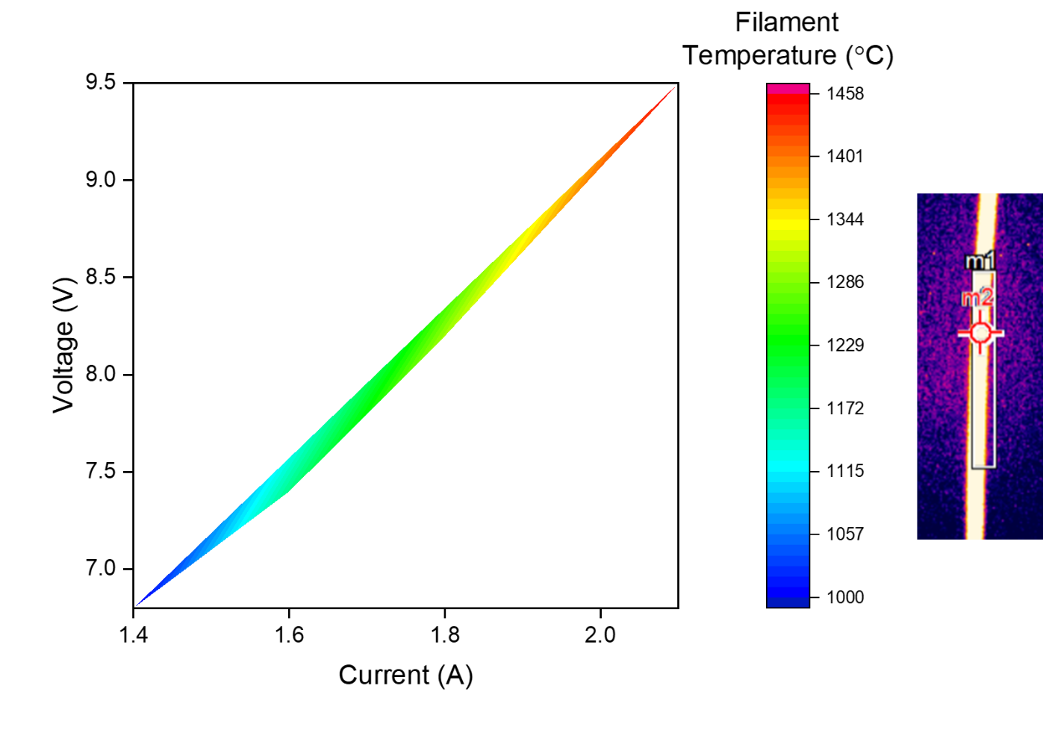
Supplementary Fig. 1 | Relationship between the applied current and voltage of the filament and its temperature. The filament temperature was measured using a short-wavelength infrared thermometer, and the infrared image of the filament from the thermometer is provided on the right, where m1 and m2 give region and point measurements of temperature.
Supplementary Fig. 2 | Relationship of applied current and temperature of the filament with catalyst temperature.

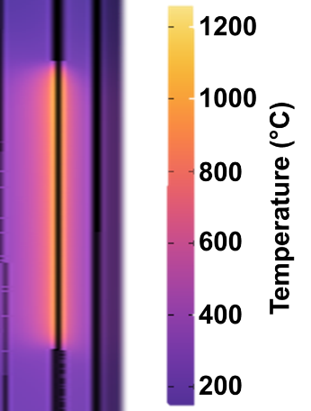
Supplementary Fig. 3 | Temperature profile of our FCR system from computational fluid dynamics simulation. The simulated and measured temperature gradient matches well with each other.

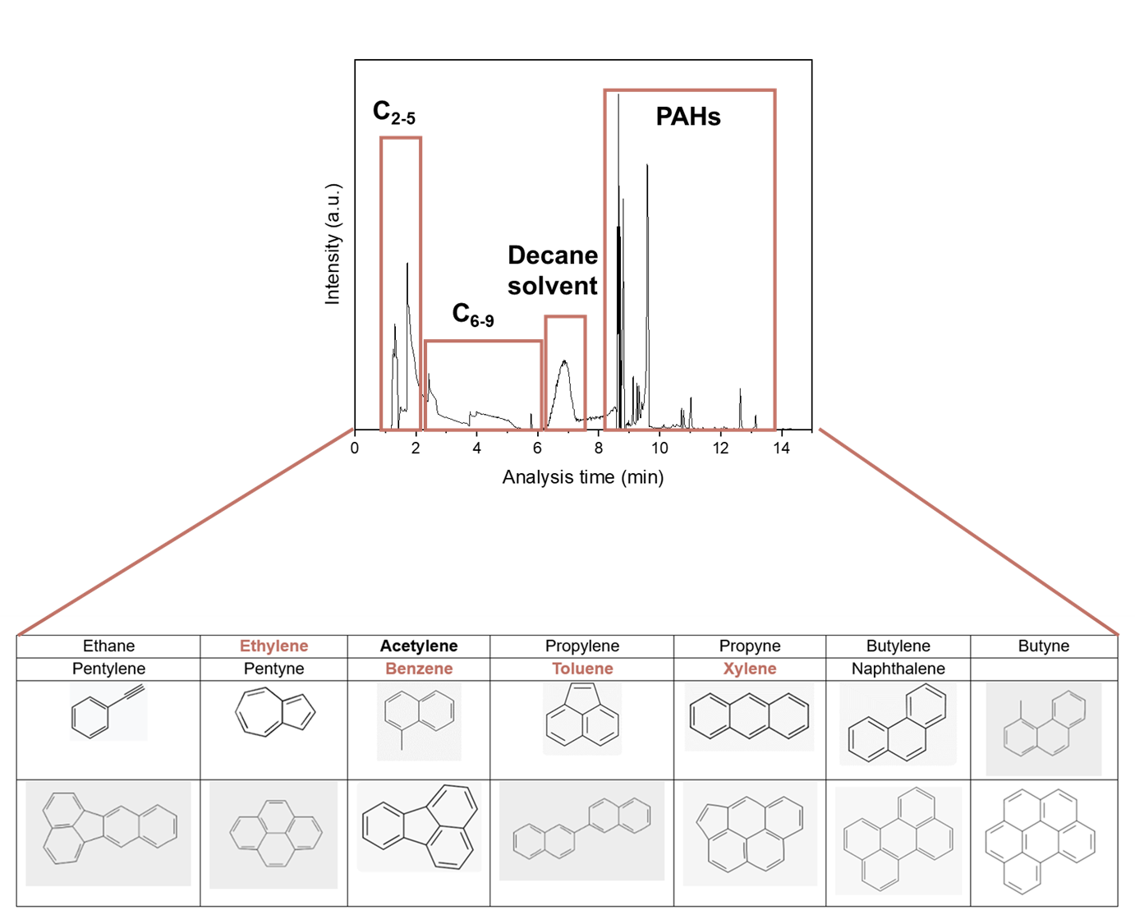
Supplementary Fig. 4 | GC-MS analysis for filament system, where all gaseous and oily products were dissolved in decane. The products range across various aliphatic and aromatic hydrocarbons.

Supplementary Fig. 5 | Reaction order study for filament-induced methane pyrolysis at applied temperature of 1457 °C. The label indicates the CH₄ reaction order as derived from the best-fit line.

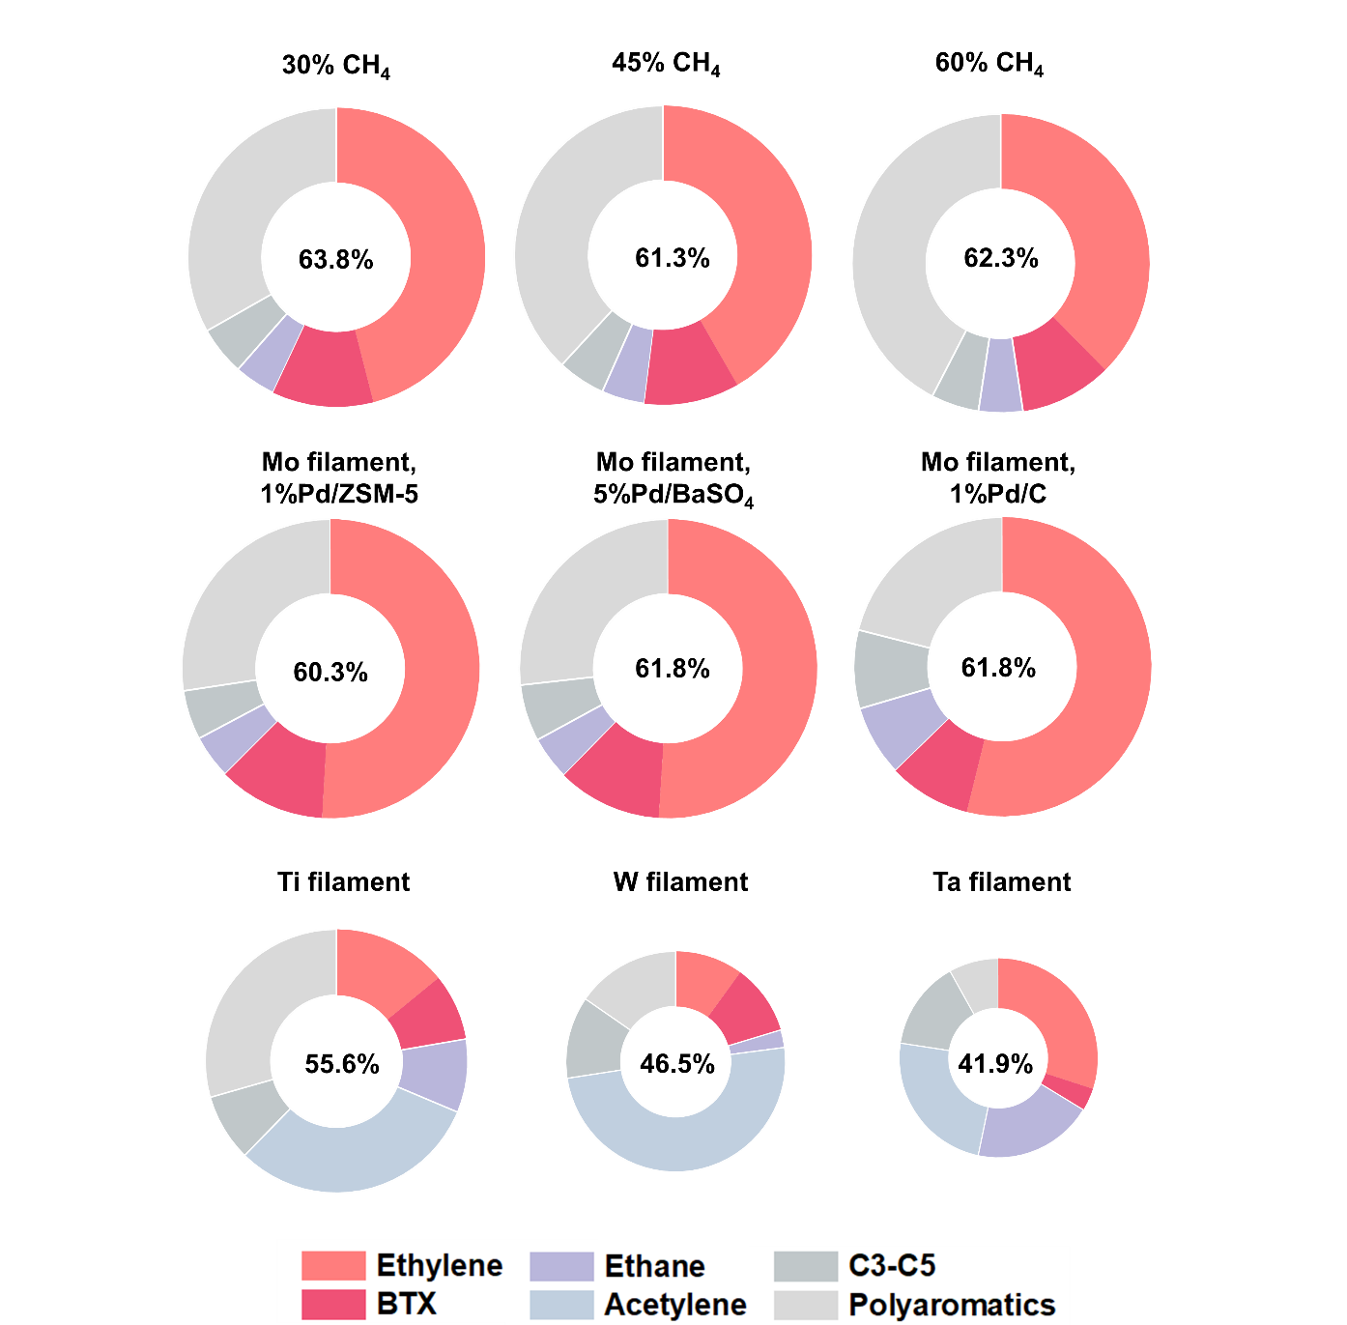
Supplementary Fig. 6 | Methane conversion and product distributions at filament temperature of 1457 °C for various CH₄ concentrations (top row; using Mo filament and Pd/Al₂O₃ catalyst), low-loading Pd catalysts (middle row; using Mo filament and Pd/ZSM-5, Pd/BaSO₄ or Pd/C catalyst) and filaments (bottom row; using Ti, W or Ta filament without catalyst). The size of each pie chart is proportional to the individual product yield.

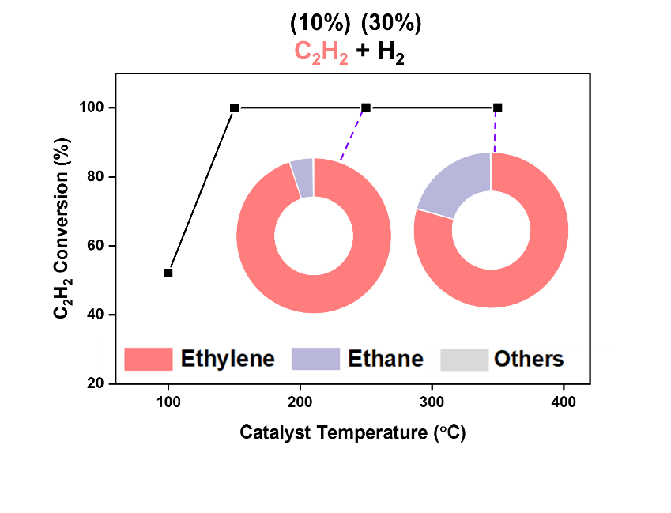
Supplementary Fig. 7 | Acetylene semi-hydrogenation performance over Pd/Al₂O₃ catalyst packed bed at relevant temperatures.

Supplementary Fig. 8 | Supplementary in-situ DRIFTS for acetylene/propylene cyclic oligomerization, where a sequential change of gas flow was employed: (1) 10% acetylene flow, (2) 5% propylene flow, and (3) argon purge. In step (1), acetylene adsorption but negligible aromatic C–H peaks were observed. In step (2), immediate appearance of C=C and aromatic C–H peaks was observed when the flowing gas was switched to propylene. Peaks remain after argon purge in step (3).

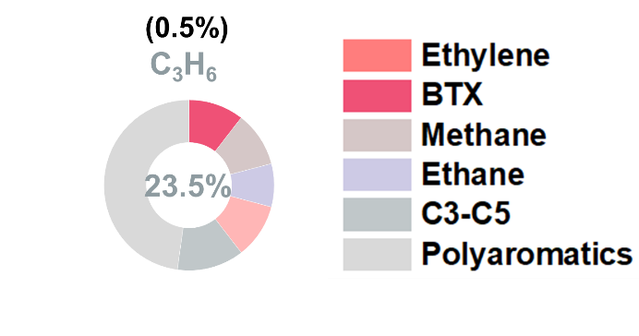
Supplementary Fig. 9 | Propylene oligomerization performance over Pd/Al₂O₃ catalyst packed bed at 250 °C.

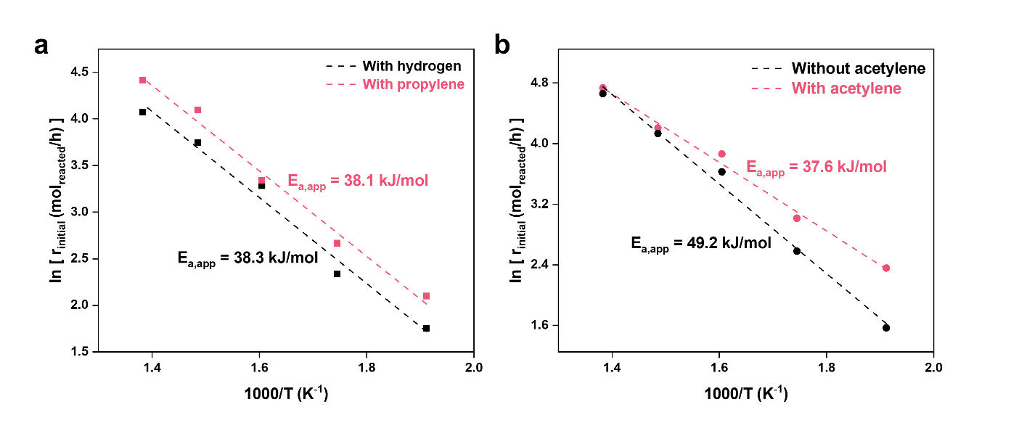
Supplementary Fig. 10 | Arrhenius plots for acetylene hydrogenation and propylene/acetylene oligomerization over a packed Pd/Al₂O₃ catalyst bed at 350 °C. a For acetylene. b For propylene. The apparent activation energies derived from the best-fit lines are provided.

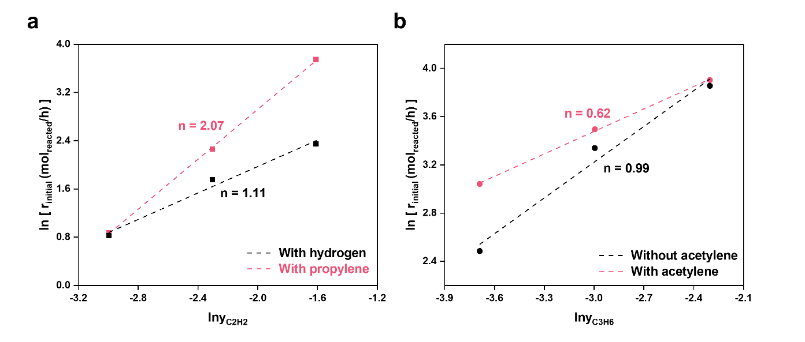
Supplementary Fig. 11 | Reaction order study for acetylene hydrogenation and propylene/acetylene oligomerization over a packed Pd/Al₂O₃ catalyst bed at 350 °C. a Acetylene reaction orders. b Propylene reaction orders. The labels indicate the respective reaction orders as derived from the best-fit lines.

Supplementary Fig. 12 | XRD of Pd/Al₂O₃ catalyst before reaction (Fresh), after 120-minute reaction in our FCR system (FC, reacted), and after 75-minute reaction at 1050 °C in a furnace-heated packed bed configuration (1050 °C, reacted).

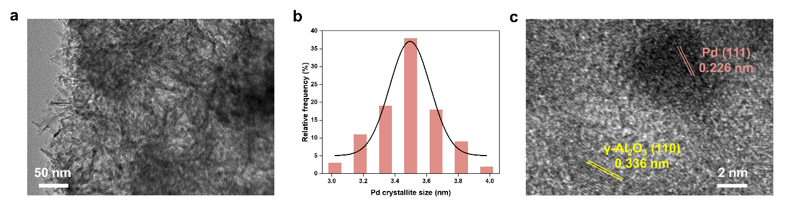
Supplementary Fig. 13 | TEM images for Pd/Al₂O₃ catalyst after reaction in our FCR system at 1457 / 350 °C (a), with crystallite size distribution (b) and lattice fringes (c).

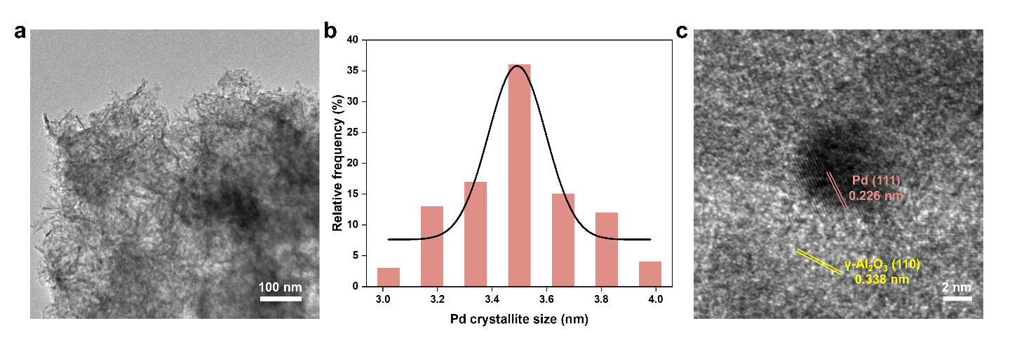
Supplementary Fig. 14 | TEM images for Pd/Al₂O₃ catalyst before reaction (a), with crystallite size distribution (b) and lattice fringes (c).

Supplementary Fig. 15 | Pd 3d XPS spectra for Pd/Al₂O₃ catalyst before reaction (Fresh), after 120-minute reaction in our FCR system (FC, reacted), after 500-minute filament regeneration study in FCR system (Regen, 500 minutes), and after 75-minute reaction at 1050 °C in a furnace-heated packed bed configuration (1050 °C, reacted).

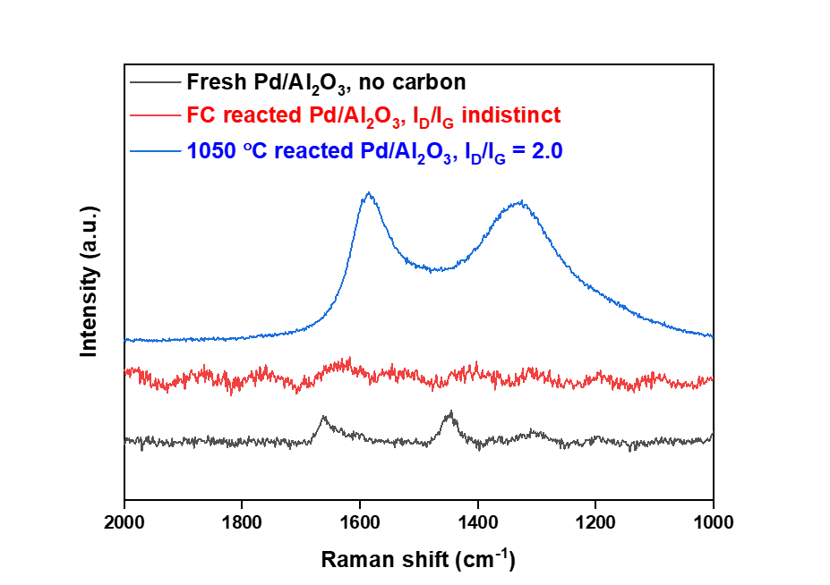
Supplementary Fig. 16 | Raman spectroscopy of fresh, FC reacted and 1050 °C (furnace) reacted Pd/Al₂O₃ catalyst.

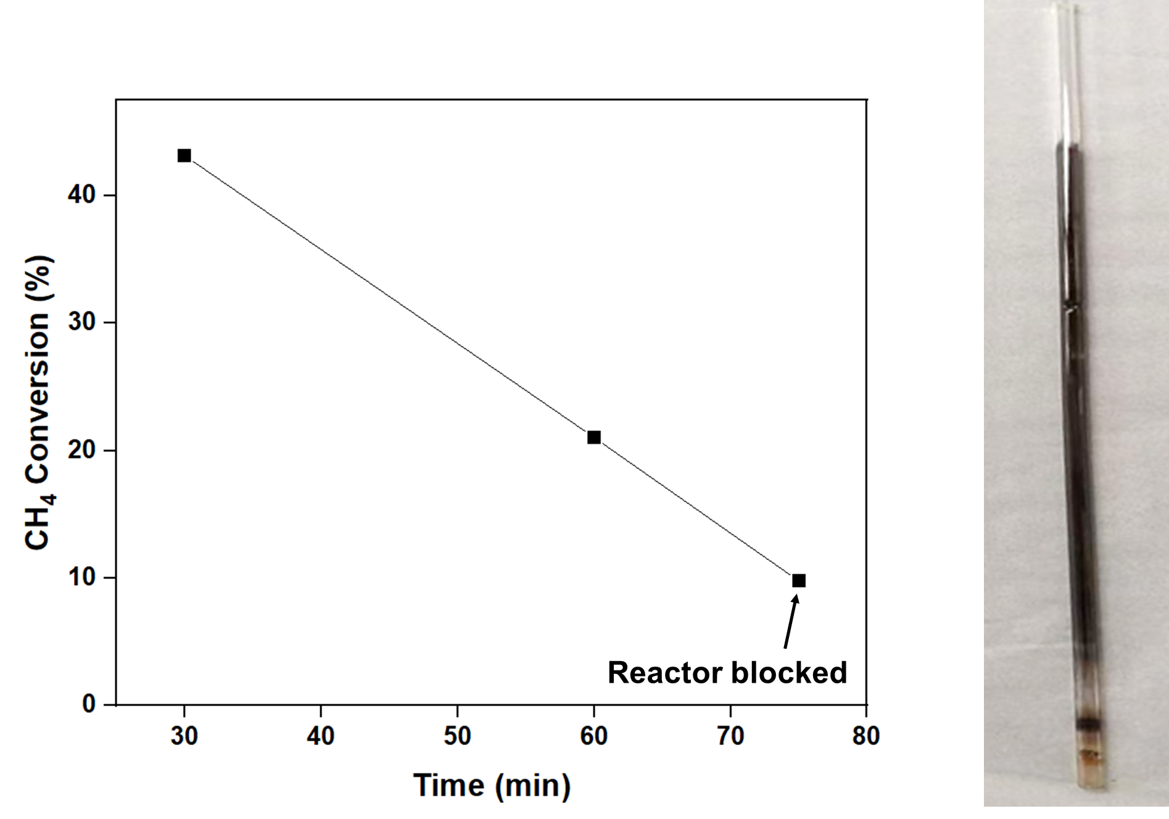
Supplementary Fig. 17 | Methane conversion with time on stream for the furnace-heated packed bed configuration at 1050 °C. The reactor blocked in 75 minutes due to the generation of excessive coke, and an image of the blocked reactor tube is provided on the right.

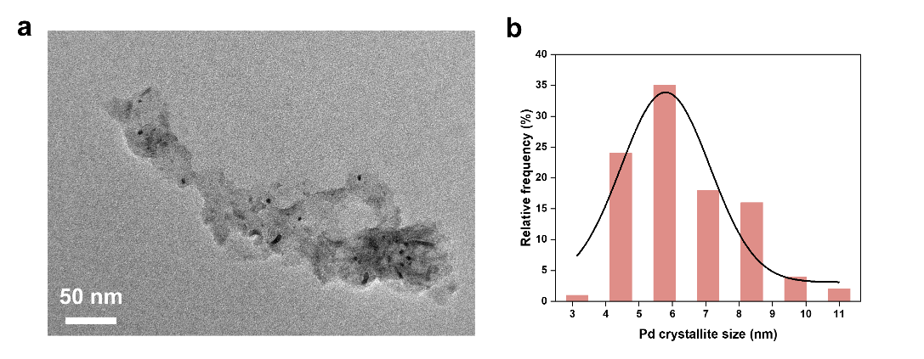
Supplementary Fig. 18 | TEM image for Pd/Al₂O₃ catalyst after reaction in furnace-heated packed bed configuration at 1050 °C (a), with crystallite size distribution (b).

Supplementary Fig. 19 | Raman spectra for Mo filament before regeneration at 75th minute of reaction, after 30-second CO₂ regeneration and after 1-minute CO₂ regeneration.

Supplementary Fig. 20 | Mo 3d XPS for Mo filament after 120-minute reaction at applied temperature of 1457 °C.

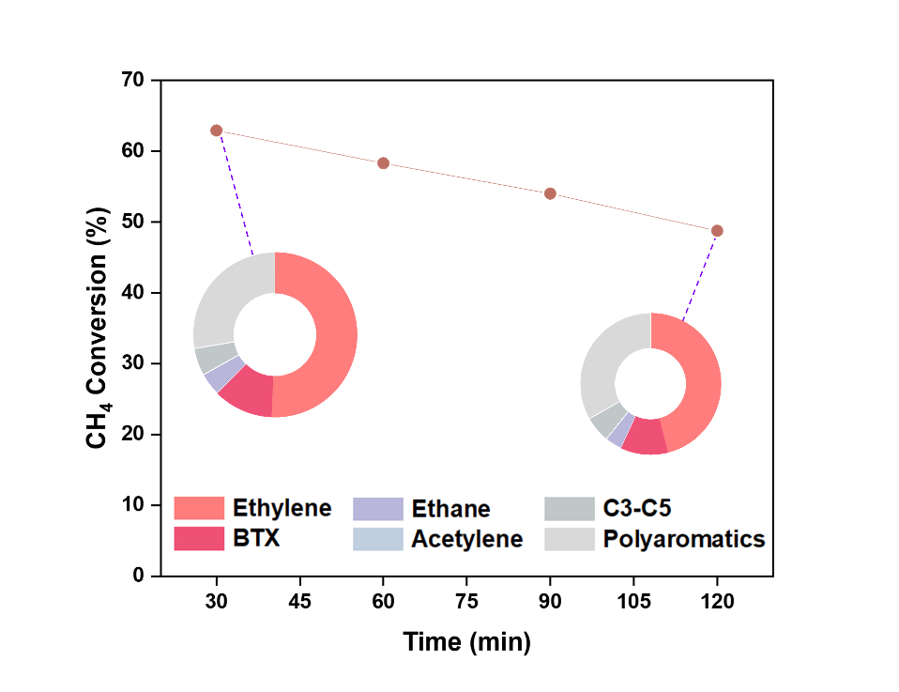
Supplementary Fig. 21 | Methane conversion performance with time on stream for the FCR system.

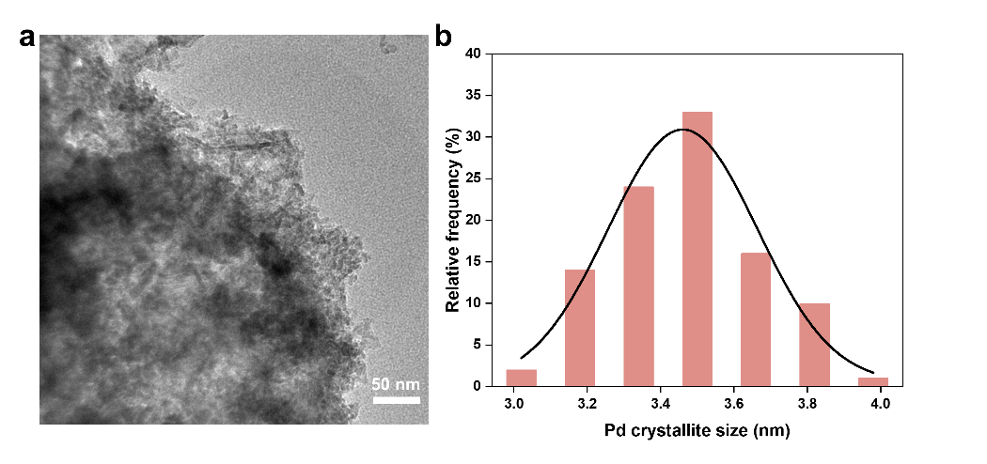
Supplementary Fig. 22 | TEM image for Pd/Al₂O₃ catalyst after 500-minute filament regeneration study in FCR system (a), with crystallite size distribution (b).

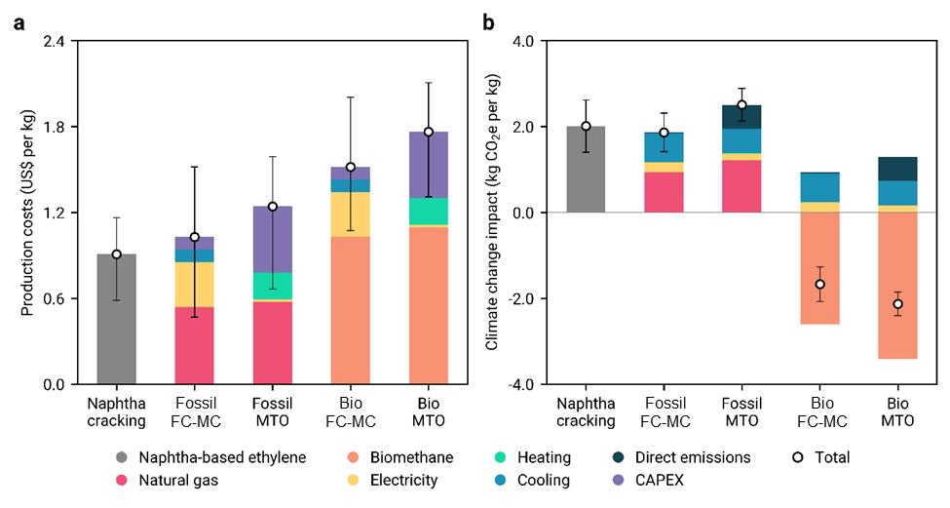
Supplementary Fig. 23 | a Production costs per kg of ethylene for naphtha cracking, fossil or biomethane-based NOCM in FCR and MTO. b Climate change impact for naphtha cracking, fossil or biomethane-based NOCM in FCR and MTO. Onshore wind electricity is utilized across all pathways to power the reactor, compressors, and pumps. See Supplementary Notes for more details.

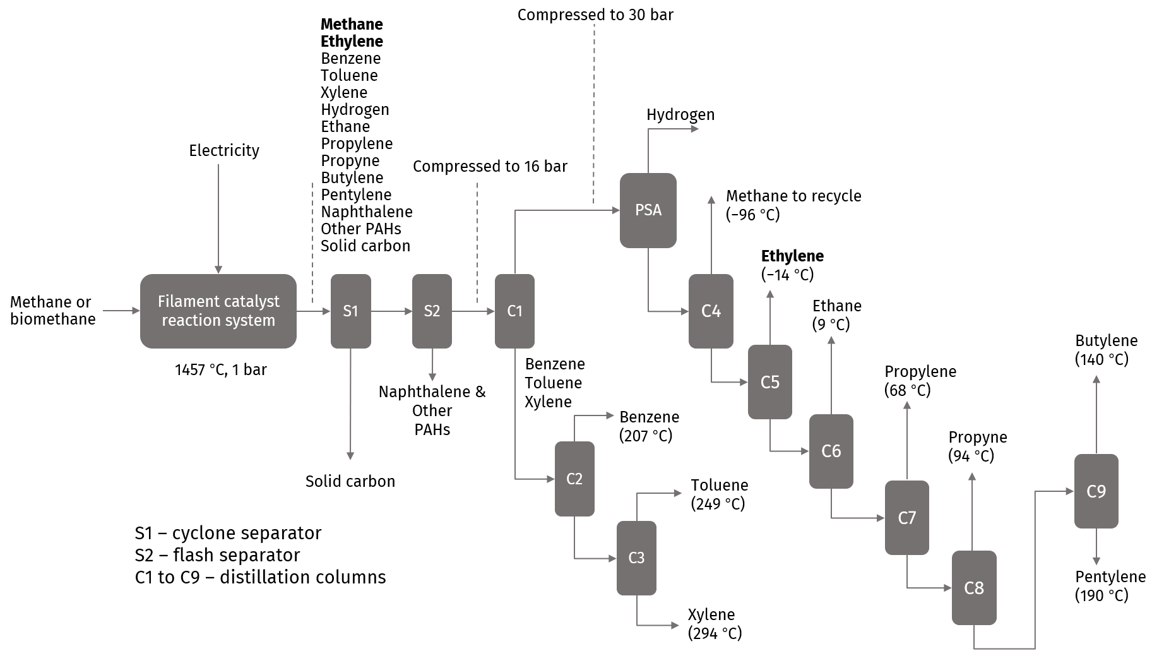
Supplementary Fig. 24 | Process block diagram for production of ethylene via the NOCM in FCR route. An annual production of 130 kt of ethylene was considered. All process models were simulated using Aspen Plus v12.1, employing the Peng-Robinson fluid package. For simplicity, compressors, pumps, valves, heaters, and coolers are omitted from the process block diagram. The separation system includes a cyclone separator modelled as a component splitter (S1), a flash unit (S2), a PSA unit for separating hydrogen, and nine distillation columns (C1 to C9) to separate ethylene and all by-products. Unreacted methane from column C4 is recycled to the reactor. Heat integration was performed using the Aspen Energy Analyzer v12.1. The condensers of columns C4 to C6 operate under cryogenic conditions. Cooling energy requirements for these condensers were obtained from the simulation and translated into the corresponding power demand and cost, following Luyben.¹ An economic-based allocation system, as adopted in previous studies, is used in this work.² In this approach, all inputs to the NOCM in FCR ethylene production process (feedstock and utilities) are normalized based on the proportion of ethylene's economic value relative to the total economic value of all products. The allocation ratio for ethylene is calculated to be approximately 54% (normalization percentage).

Supplementary Tables
Supplementary Table 1 | Overall product distributions for filament-only and FCR systems under tested filament temperatures. All carbon balances were >90% after accounting the non-gaseous products on the filament, catalyst and reactor wall. *Hydrogen yield was calculated based on its ratio to the maximum theoretical hydrogen production from the (weighted) average degree of dehydrogenation of the measured product distributions, while all other yields were calculated on a carbon number basis.
Filament temperature (°C) | Filament-only |  | FCR
1000 | Hydrogen*  Ethane  Ethylene  Acetylene  Propylene  Propyne  Butylene  Pentylene  Benzene  Toluene  Xylene  Naphthalene  Other polyaromatics | Yield / %  33.9  0.6  13.0  8.8  0.5  0.1  0.3  0.1  0.0  0.0  0.0  0.0  5.5 | Hydrogen*  Ethane  Ethylene  Acetylene  Propylene  Propyne  Butylene  Pentylene  Benzene  Toluene  Xylene  Naphthalene  Other polyaromatics | Yield / %  31.1  0.7  26.2  0.0  0.6  0.2  0.3  0.1  0.0  0.0  0.0  0.0  6.5
1175 | Hydrogen*  Ethane  Ethylene  Acetylene  Propylene  Propyne  Butylene  Pentylene  Benzene  Toluene  Xylene  Naphthalene  Other polyaromatics | Yield / %  45.2  1.0  7.0  18.9  1.9  0.3  0.9  0.4  4.4  2.0  0.3  1.4  14.3 | Hydrogen*  Ethane  Ethylene  Acetylene  Propylene  Propyne  Butylene  Pentylene  Benzene  Toluene  Xylene  Naphthalene  Other polyaromatics | Yield / %  39.9  2.7  26.6  0.0  1.4  0.4  0.9  0.5  5.2  2.6  0.3  1.2  12.3
1457 | Hydrogen*  Ethane  Ethylene  Acetylene  Propylene  Propyne  Butylene  Pentylene  Benzene  Toluene  Xylene  Naphthalene  Other polyaromatics | Yield / %  75.5  0.5  2.7  31.0  1.9  0.3  0.9  0.4  3.0  1.4  0.2  1.7  16.3 | Hydrogen*  Ethane  Ethylene  Acetylene  Propylene  Propyne  Butylene  Pentylene  Benzene  Toluene  Xylene  Naphthalene  Other polyaromatics | Yield / %  61.8  2.8  32.0  0.0  1.5  0.4  1.0  0.5  4.9  2.3  0.3  1.4  14.3

Supplementary Table 2 | References and reaction conditions for literature comparison of combined ethylene and BTX selectivity with methane conversion. The reactions were non-oxidative at applied (or average) temperatures ≤1700 °C.
Reference | Material | Temperature / °C | CH₄ Conversion / % | C₂H₄ + BTX Selectivity / % | C₂H₄ + BTX Yield / %
This work | Mo filament / Pd/Al₂O₃ catalyst | 1457 / 350 | 63.0 | 62.5 | 39.4
3 | Fe©SiO₂ catalyst | 1090 | 48.0 | 74 | 35.5
4 | W filament | 1700 | 50.0 | 66 | 33.0
5 | Mo/ZSM-5 catalyst | 700 | 34.0 | 55 | 18.7
6 | Mo plate (Joule-heated) | 1350 | 60.0 | 30 | 18.0
7 | Carbon paper (dynamically Joule-heated) | 542 (average) | 21.0 | 81 | 17.0
8 | Fe©SiO₂ catalyst / Sr-Ce-Zr-Eu membrane | 1050 | 23.5 | 55 | 12.9
9 | Mo/ZSM-5 catalyst | 720 | 14.0 | 86 | 12.0
10 | Pt/C filament | 1300 | 20.0 | 57 | 11.4
11 | Pt@CeO₂ catalyst | 975 | 12.0 | 85 | 10.2
12 | Mo-Re/ZSM-5 catalyst | 750 | 14.8 | 56 | 8.3
13 | Mo/MCM-22 catalyst | 700 | 9.0 | 75 | 6.8
14 | K-Pt-Sn/ZSM-5 catalyst | 600 | 7.4 | 85 | 6.3
15 | Fe©SiO₂ catalyst | 1020 | 12.2 | 33 | 4.0

Supplementary Table 3 | Inputs and outputs of the NOCM in FCR and MTO routes per kg of ethylene produced. For the NOCM in FCR route, these values were extracted from the Aspen Plus v12.1 simulation (Supplementary Fig. 23). For the MTO route, the inputs and outputs were derived from Ioannou et al.² The methanol required for the MTO route was modelled based on Nabera et al.,¹⁶ pertaining to methanol production from natural gas or biomethane reforming.
Stream | NOCM in FCR | MTO
Feedstock
Natural gas or biomethane / kg | 1.21 | 1.28
Utilities
Electricity / kWh | 6.22 | 0.33
Cooling water / MJ | 1.47 | 5⋅10^{–3}
Refrigeration to –25 °C / MJ | 1.08 | -
Refrigeration to –75 °C / MJ | 0.48 | -
Refrigeration to –125 °C / MJ | 0.54 | -
Heating – natural gas / MJ | 0.12 | 0.38
Steam / kg | - | 0.02
Emissions to air
Carbon dioxide / kg | - | 0.121
Water / m³ | - | 2⋅10^{–5}
Methane / kg | 7⋅10^{–4} | -
Ethylene / kg | 3⋅10^{–6} | -
Hydrogen / kg | 5⋅10^{–7} | -

Supplementary Table 4 | Inventories used in the life cycle assessment (LCA) to calculate the climate change impact of all ethylene production technologies.
Flow | Activity | Source
Naphtha-based ethylene | unsaturated hydrocarbons production, steam cracking operation, average | Ecoinvent v3.10
Natural gas | market group for natural gas, high pressure | Ecoinvent v3.10
Biomethane | market for biomethane with carbon capture and storage | Istrate et al.¹⁷
Grid electricity | market group for electricity, high voltage | Ecoinvent v3.10
Wind electricity | electricity production, wind, >3MW turbine, onshore | Ecoinvent v3.10
Cooling water | cooling water | Ioannou et al.²
Refrigeration –25 °C | refrigeration –25 °C | Luyben¹
Refrigeration –75 °C | refrigeration –75 °C | Luyben¹
Refrigeration –125 °C | refrigeration –125 °C | Luyben¹
Heating – natural gas | heat production, natural gas, at boiler condensing modulating >100kW | Ecoinvent v3.10
Steam | market for steam, in chemical industry | Ecoinvent v3.10

Supplementary Table 5 | Cost parameters used to calculate the unitary production cost of ethylene, with all costs reported using 2023 as the reference year.
Flow | Average | Low | High | Source
Naphtha-based ethylene / USD kg^{–1} | 0.908 | 0.585 | 1.164 | 18
Natural gas / USD kg^{–1} | 0.447 | 0.113 | 0.643 | 19
Biomethane / USD kg^{–1} | 0.853 | 0.615 | 1.046 | 20
Heating – natural gas / USD MJ^{–1} | 0.009 | 0.002 | 0.014 | 19
Steam / USD kg^{–1} | 0.016 | - | - | 2
Cooling water / USD MJ^{–1} | 0.024 | - | - | 2
Grid electricity / USD kWh^{–1} | 0.086 | 0.037 | 0.159 | 21
Wind electricity / USD kWh^{–1} | 0.050 | 0.025 | 0.091 | 22
Refrigeration to –25 °C / USD MJ^{–1} | 0.019 | - | - | 1
Refrigeration to –75 °C / USD MJ^{–1} | 0.042 | - | - | 1
Refrigeration to –125 °C / USD MJ^{–1} | 0.086 | - | - | 1
Direct air carbon capture and storage / USD kg^{–1} | 0.362 | 0.269 | 0.623 | 23

Supplementary Notes
Supplementary Note 1 | Supplementary analysis of reaction order and kinetics.
The reactions involving acetylene will include hydrogenation (r₁), C–C coupling (r₂), and formation (e.g. from hydrocracking of polyaromatics, r₃). Therefore, the rate of acetylene consumption may be expressed as:
$$-\frac{d\left[C_{2}H_{2}\right]}{dt}=k_{1}\left[C_{2}H_{2}\right]{\left[H_{2}\right]}^{n}+k_{2}{\left[C_{2}H_{2}\right]}^{m}-k_{3}{\left[C_{2}H_{2}\right]}^{l}$$
, where n is 1 or 2 depending on the extent of hydrogenation, m is ≥2 depending on the extent of C–C coupling, and l is negative, likely –1.
Expected first-order kinetics was observed for acetylene hydrogenation where an acetylene molecule reacted with one or two hydrogen. The observed second-order kinetics for acetylene/propylene oligomerization can be explained by a balance between the three terms of acetylene consumption rate where the first term (C₂H₂ order = 1) and last term (C₂H₂ order = –1) cancel out, leaving us with the second term (C₂H₂ order = 2) which represents
C–C coupling. Thus, a shift from hydrogenation with hydrogen to coupling with propylene was observed in our reaction order experiments, and it highlights that hydrogenation and cyclization are in competition. Furthermore, the similar acetylene activation energy pinpoints the rate-limiting step in both cases is the activation of acetylene, which is corroborated by a lower propylene activation energy, and the known capability of Pd in activating hydrogen.
For propylene, its reactions will include hydrogenation (r₄), C–C coupling (r₅), C–C cleavage forming reactive intermediates which subsequently form BTX (r₆), and formation (e.g. from hydrocracking of polyaromatics, r₇). Hence, the propylene consumption rate may be expressed as:
$$-\frac{d\left[C_{3}H_{6}\right]}{dt}=k_{4}\left[C_{3}H_{6}\right]{\left[H_{2}\right]}^{N}+k_{5}{\left[C_{3}H_{6}\right]}^{M}+k_{6}{\left[C_{3}H_{6}\right]}^{L}-k_{7}{\left[C_{3}H_{6}\right]}^{J}$$
, where N is 1 or 2 depending on the extent of hydrogenation, M is ≥2 depending on the extent of C–C coupling, L is between 0 and 1, and J is negative, most possibly –1.
When acetylene was introduced to propylene flow, the apparent propylene activation decreased by 11.6 kJ/mol to 37.6 kJ/mol while its order changed from first-order to 0.6-order. The reaction order for the cyclic oligomerization of propylene with and without acetylene may be explained by a balance between C–C coupling, cleavage and propylene formation, resulting in an average order of 0.62 and 1 respectively. The observed decrease in propylene order is possibly due to C–C cleavage dominating over C–C coupling in the presence of acetylene. The apparent propylene activation energy also decreased, indicating that the co-interaction of propylene and acetylene plays a role in accelerating the cyclic conversion of propylene to BTX. Thus, the co-interaction between acetylene and propylene may facilitate the activation, C–C coupling and cyclization of acetylene and propylene, forming more BTX in our FCR system.

Supplementary Note 2 | Supplementary analysis of characterization results.
In the high-resolution TEM images at nanometer range (Supplementary Figs. 13 and 14), a Pd lattice spacing of 0.226 nm corresponding to the (111) facet of metallic Pd was observed for both fresh and reacted catalysts in FCR.²⁴ Pd 3d XPS revealed a single 3d_{5/2} peak at 335.4 eV characteristic of Pd⁰ for both fresh and reacted catalysts (Supplementary Fig. 15). These observations indicate Pd⁰ was maintained in FCR. As mentioned for post-reaction Pd/Al₂O₃ in FCR, polyaromatics accumulated on the surface causing TGA weight loss of 13.6% starting from 50 °C (Fig. 4a), evidenced from elemental analysis where a H:C ratio of 0.71 was recorded, corresponding to an average of 3 fused benzene rings (e.g. anthracene has a chemical formula of C₁₄H₁₀ and hence a similar H:C ratio). Indistinct Raman peaks were observed (Supplementary Fig. 16) since the adsorbed polyaromatics, though in low quantities (<0.1 mol%), cover the surface.
For the furnace-heated packed catalyst bed at 1050 °C, TGA showed a weight loss of 54.2% starting at 500 °C, corresponding to 1.18 g/g_{cat} of deposited carbon. XPS and Raman spectra confirmed the presence of highly disordered carbon covering the catalyst surface (Supplementary Figs. 15 and 16).²⁵ No surface Pd peaks were observed from XPS (Supplementary Fig. 15), attributable to surface carbon formation as confirmed by TGA, Raman and elemental analysis. Disordered (D) and graphitic (G) carbon Raman bands were observed at ca. 1340 and 1580 cm^{–1}, with the original peaks from Pd/Al₂O₃ being covered (Supplementary Fig. 16). The D:G intensity ratio (I_{D}/I_{G}) of 2.0 indicates high extent of disorder in the deposited carbon, measuring only ~2 nm in the direction of the graphitic plane (a-direction) based on Tuinstra et al.’s relation.²⁵ From elemental analysis, this carbon is pyrolytic coke (H:C ≈ 0). Additionally, significant sintering occurred for the packed Pd/Al₂O₃ catalyst at 1050 °C, with mean Pd size increasing to 5.8 nm (Supplementary Fig. 18).
For the reacted Mo filament, Mo 3d XPS with the carbon layer polished away (Supplementary Fig. 20) showed the formation of Mo₂C, exhibiting the 3d_{5/2} peak at 228.6 eV, while the MoO₃ peak at 233.0 eV was likely due to carbide oxidation during ex-situ transfer in open air.²⁶ In filament-regeneration studies, Raman analysis (Supplementary Fig. 19) presented an increasing I_{D}/I_{G} with regeneration time (1.2 to 1.6 to 2.7), signaling that CO₂ reacted with carbon and created defects or gaps in the carbon lattice, perhaps due to Mo catalyzing the reverse Boudouard reaction of proximal carbon with CO₂.²⁷ From Tuinstra et al.’s correlation, residual carbon after 1-minute regeneration measured 1.6 nm in the a-direction, compared to 3.5 and 2.6 nm before CO₂ regeneration and after 30-second regeneration.²⁵ Our filament-regeneration protocol did not affect the catalyst structure, as illustrated by TEM and XPS where mean Pd crystallite size of ca. 3.5 nm and Pd⁰ XPS peaks remained intact (Supplementary Fig. 22 and 15).

Supplementary Note 3 | Comparison of advantages and disadvantages of the various ethylene and BTX formation pathways (especially from methane).
All values were obtained from literature,^{3-15, 28-34} measured in this work, or from the process models of this work (Fig. 2, Supplementary Fig. 23 and 24). Conversion and ethylene and BTX yield for Pathways I–IV were averaged based on commonly reported values for naphtha cracking, steam methane reforming, methanol synthesis, methanol-to-olefins, oxidative and non-oxidative methane coupling, and methane dehydroaromatization. For stability, the typical time of each regeneration cycle was considered. For energy demand, an inverse scale was used where lower energy consumption gives higher value.

Supplementary Note 4 | Computational fluid dynamics (CFD) simulation methodology.
The CFD model mirrors our experimental reactor set-up, with a 0.1 mm diameter molybdenum wire held in place by two 0.8 mm diameter copper rods in a 9.0 mm diameter quartz tube with a 1.0 mm thick outer wall. The gas flow at our applied flow rates was modeled using turbulent flow at low Re, which applies the Navier-Stokes equation at low Re k-ε. The electric current was related to applied voltage using Ohm’s law with a temperature-dependent linearized resistivity model. Conductive heat transfer was calculated via Fourier’s law of heat conduction, where the heat source is our Joule-heated molybdenum filament, with thermoelastic damping effects of the molybdenum and copper and additional work done by pressure change and viscous dissipation in the gas phase taken into consideration. Convective heat transfer was modeled with Multiphysics consisting of turbulent flow and conductive heat transfer, where forced convection occurs in the flowing gas while natural convection occurs outside the reactor walls. For radiative heat transfer, Stefan-Boltzmann law was applied, where methane was defined as participating media.
The simulation matches well with our experiments, with a highly similar temperature profile where the molybdenum filament is >1000 °C and reactor inner wall where the catalyst will be coated is <400 °C (Fig. 1c and 2d). As for the mass flux, the model displayed radial flow along the temperature gradient where the flux near the reactor wall (r = 4.45 cm) was 8.56 × 10^{–4} g/(cm² s) which was 27.6% higher than the average flux of 6.71 × 10^{–4} g/(cm² s), attributed to differences in density between the high- and low-temperature regions. This radial flow may explain the higher selectivity observed for one-stage FCR, by allowing higher mass flow and greater contact near the catalyst layer coated on the reactor wall for better selectivity control, compared to F-CR in which the second isothermal stage demonstrated regular, laminar flow with a constant flux of 6.71 × 10^{–4} g/(cm² s).

Supplementary Note 5 | Techno-economic and life cycle assessment methodology.
The process flowsheet for the NOCM in FCR technology (Supplementary Fig. 24) was developed using standard process models in Aspen Plus v12.1. Simulation results, including input-output data for the mass and energy flows and process unit sizes, were utilized for the techno-economic and life cycle assessments (LCA). Supplementary Table 3 presents the mass balance in the process simulation. The economic assessment considers operational and capital expenditures (OPEX and CAPEX, respectively) for the reference year 2023. For naphtha-based ethylene production process, the production costs were extracted from literature.¹⁸ Similarly, for the MTO process, the mass and energy flows used to calculate the OPEX and the CAPEX were extracted from Ioannou et al.² The data for methanol produced from natural gas or biomethane, required in the MTO pathway, is derived from Nabera et al.¹⁶ For the NOCM in FCR route, the OPEX was calculated following Ioannou et al.,² while the CAPEX was estimated using correlations from Sinnott and Towler,³⁵ accounting for installation factors of each equipment unit, and the annual capital charge ratio was used to annualize the CAPEX. Supplementary Table 5 provides feedstock and utility prices used in the OPEX calculations for both the MTO and NOCM in FCR routes. Notably, the NOCM in FCR ethylene production process yields various valuable by-products. Therefore, we applied an economic allocation system to normalize the production cost, as recommended in the literature.³⁶
For the LCA, the global average climate change impacts are quantified using an attributional LCA in accordance with ISO 14044/14040 standards.³⁷ We consider 1 kg of ethylene produced as the functional unit, following a cradle-to-gate approach that encompasses all activities from raw material acquisition to ethylene production. We assume that the end-use phase remains consistent across all cases, regardless of the production route. The mass and energy flows for the ethylene production routes were obtained from the simulation (Supplementary Fig. 24) for the NOCM in FCR route and derived from Ioannou et al.² for the MTO route. This data allows us to model the foreground system (ethylene production), while data for the background system (activities supplying inputs to the production facility) were primarily sourced from the ecoinvent v3.10 database.³⁸ The 100-year average global warming potentials (GWPs) as outlined by IPCC in 2021 were used to calculate the climate change impacts. The inventories used to calculate the climate change impacts for all ethylene production technologies are presented in Supplementary Table 4. Additionally, we perform an uncertainty assessment for all ethylene production scenarios using Monte Carlo sampling with 500 iterations, generated from the ecoinvent pedigree matrix, which provides uncertainty levels for the life cycle inventory parameters. A normalization was similarly performed for NOCM in FCR route. Moreover, uncertainties affecting economic performance were modelled using minimum and maximum values from the literature, as detailed in Supplementary Table 5.
For the net-zero scenario, net-zero was achieved for naphtha cracking by offsetting its residual emissions using direct-air carbon capture and storage technology, while net-zero was achieved for NOCM in FCR by utilizing a 47:53 natural gas-biomethane mixture as feedstock and for MTO by reforming an initial feedstock of 45:55 natural gas-biomethane.

References
1. Luyben, W. L., Estimating refrigeration costs at cryogenic temperatures. Comput. Chem. Eng. 2017, 103, 144-150.
2. Ioannou, I.; D'Angelo, S. C.; Martín, A. J.; Pérez‐Ramírez, J.; Guillén‐Gosálbez, G., Hybridization of Fossil‐and CO2‐Based Routes for Ethylene Production using Renewable Energy. ChemSusChem 2020, 13 (23), 6370-6380.
3. Guo, X.; Fang, G.; Li, G.; Ma, H.; Fan, H.; Yu, L.; Ma, C.; Wu, X.; Deng, D.; Wei, M.; Bao, X., Direct, nonoxidative conversion of methane to ethylene, aromatics, and hydrogen. Science 2014, 344 (6184), 616-619.
4. Porsin, A.; Kulikov, A.; Amosov, Y. I.; Rogozhnikov, V.; Noskov, A., Acetylene synthesis by methane pyrolysis on a tungsten wire. Theor. Found. Chem. Eng. 2014, 48, 397-403.
5. Kosinov, N.; Uslamin, E. A.; Meng, L.; Parastaev, A.; Liu, Y.; Hensen, E. J., Reversible nature of coke formation on Mo/ZSM‐5 methane dehydroaromatization catalysts. Angew. Chem. 2019, 131 (21), 7142-7146.
6. Homichenko, V.; Sigaeva, S.; Cyrul’nikov, a. P., CH4/H2 ratio effect on methane pyrolysis on resistive molybdenum catalyst. Procedia Eng. 2015, 113, 138-143.
7. Dong, Q.; Yao, Y.; Cheng, S.; Alexopoulos, K.; Gao, J.; Srinivas, S.; Wang, Y.; Pei, Y.; Zheng, C.; Brozena, A. H.; Vlachos, D. G.; Liu, D.; Hu, L., Programmable heating and quenching for efficient thermochemical synthesis. Nature 2022, 605 (7910), 470-476.
8. Sakbodin, M.; Wu, Y.; Oh, S. C.; Wachsman, E. D.; Liu, D., Hydrogen‐permeable tubular membrane reactor: Promoting conversion and product selectivity for non‐oxidative activation of methane over an Fe© SiO2 catalyst. Angew. Chem. 2016, 128 (52), 16383-16386.
9. Matus, E. V.; Ismagilov, I. Z.; Sukhova, O. B.; Zaikovskii, V. I.; Tsikoza, L. T.; Ismagilov, Z. R.; Moulijn, J. A., Study of methane dehydroaromatization on impregnated Mo/ZSM-5 catalysts and characterization of nanostructured molybdenum phases and carbonaceous deposits. Ind. Eng. Chem. Res. 2007, 46 (12), 4063-4074.
10. Sun, Q.; Tang, Y.; Gavalas, G. R., Methane pyrolysis in a hot filament reactor. Energy Fuels 2000, 14 (2), 490-494.
11. Xie, P.; Pu, T.; Nie, A.; Hwang, S.; Purdy, S. C.; Yu, W.; Su, D.; Miller, J. T.; Wang, C., Nanoceria-supported single-atom platinum catalysts for direct methane conversion. ACS Catal. 2018, 8 (5), 4044-4048.
12. Stepanov, A.; Zaikovskii, V.; Korobitsyna, L.; Vosmerikov, A., Nonoxidative conversion of methane to aromatic hydrocarbons in the presence of ZSM-5 zeolites modified with molybdenum and rhenium. Pet. Chem. 2019, 59, 91-98.
13. Julian, I.; Hueso, J. L.; Lara, N.; Solé-Daurá, A.; Poblet, J. M.; Mitchell, S. G.; Mallada, R.; Santamaría, J., Polyoxometalates as alternative Mo precursors for methane dehydroaromatization on Mo/ZSM-5 and Mo/MCM-22 catalysts. Catal. Sci. Technol. 2019, 9 (21), 5927-5942.
14. Liu, B.; Wang, F.; Dou, X.; Li, P.; Xiang, H.; Yang, Y.; He, P., Co-aromatization of methane and hexane over Pt encapsulated in ZSM-5 zeolite and the electronic effect of K promoters. Sci. China Chem. 2024, 67 (3), 1017-1027.
15. Kim, S. K.; Kim, H. W.; Han, S. J.; Lee, S. W.; Shin, J.; Kim, Y. T., Mechanistic and microkinetic study of non-oxidative methane coupling on a single-atom iron catalyst. Commun. Chem. 2020, 3 (1), 58.
16. Nabera, A.; Istrate, I.-R.; Martín, A. J.; Pérez-Ramírez, J.; Guillén-Gosálbez, G., Energy crisis in Europe enhances the sustainability of green chemicals. Green Chem. 2023, 25 (17), 6603-6611.
17. Istrate, R.; Nabera, A.; Pérez-Ramírez, J.; Guillén-Gosálbez, G., One-tenth of the EU’s sustainable biomethane coupled with carbon capture and storage can enable net-zero ammonia production. One Earth 2024, 7 (12), 2235-2249.
18. Business Analytiq Ethylene price index. https://businessanalytiq.com/procurementanalytics/index/ethylene-price-index/.
19. World Bank Group Commodity markets. https://www.worldbank.org/en/research/commodity-markets.
20. International Energy Agency Outlook for biogas and biomethane: Prospects for organic growth. https://www.iea.org/reports/outlook-for-biogas-and-biomethane-prospects-for-organic-growth.
21. International Energy Agency Electricity 2025. https://www.iea.org/reports/electricity-2025.
22. International Renewable Energy Agency Renewable power generation costs in 2023. https://www.irena.org/Publications/2024/Sep/Renewable-Power-Generation-Costs-in-2023.
23. Young, J.; McQueen, N.; Charalambous, C.; Foteinis, S.; Hawrot, O.; Ojeda, M.; Pilorgé, H.; Andresen, J.; Psarras, P.; Renforth, P., The cost of direct air capture and storage can be reduced via strategic deployment but is unlikely to fall below stated cost targets. One Earth 2023, 6 (7), 899-917.
24. Lim, B.; Jiang, M.; Camargo, P. H.; Cho, E. C.; Tao, J.; Lu, X.; Zhu, Y.; Xia, Y., Pd-Pt bimetallic nanodendrites with high activity for oxygen reduction. Science 2009, 324 (5932), 1302-1305.
25. Tuinstra, F.; Koenig, J. L., Raman spectrum of graphite. J. Chem. Phys. 1970, 53 (3), 1126-1130.
26. Wan, C.; Regmi, Y. N.; Leonard, B. M., Multiple phases of molybdenum carbide as electrocatalysts for the hydrogen evolution reaction. Angew. Chem. 2014, 126 (25), 6525-6528.
27. Pereira, S. C.; Ribeiro, M. F.; Batalha, N.; Pereira, M. M., Catalyst regeneration using CO2 as reactant through reverse‐Boudouard reaction with coke. Greenh. Gases: Sci. Technol. 2017, 7 (5), 843-851.
28. Akhtar, M. N.; Aitani, A. M.; Ummer, A. C.; Alasiri, H. S., Review on the catalytic conversion of naphtha to aromatics: advances and outlook. Energy Fuels 2023, 37 (4), 2586-2607.
29. Cruchade, H.; Medeiros-Costa, I. C.; Nesterenko, N.; Gilson, J.-P.; Pinard, L.; Beuque, A.; Mintova, S., Catalytic routes for direct methane conversion to hydrocarbons and hydrogen: current state and opportunities. ACS Catal. 2022, 12 (23), 14533-14558.
30. Dimian, A. C.; Bildea, C. S., Energy efficient methanol-to-olefins process. Chem. Eng. Res. Des. 2018, 131, 41-54.
31. Kosinov, N.; Hensen, E. J., Reactivity, selectivity, and stability of zeolite‐based catalysts for methane dehydroaromatization. Adv. Mater. 2020, 32 (44), 2002565.
32. Kumar, A.; Baldea, M.; Edgar, T. F., A physics-based model for industrial steam-methane reformer optimization with non-uniform temperature field. Comput. Chem. Eng. 2017, 105, 224-236.
33. Son, H.; Kim, M.; Kim, J.-K., Sustainable process integration of electrification technologies with industrial energy systems. Energy 2022, 239, 122060.
34. Wismann, S. T.; Engbæk, J. S.; Vendelbo, S. B.; Bendixen, F. B.; Eriksen, W. L.; Aasberg-Petersen, K.; Frandsen, C.; Chorkendorff, I.; Mortensen, P. M., Electrified methane reforming: A compact approach to greener industrial hydrogen production. Science 2019, 364 (6442), 756-759.
35. Towler, G.; Sinnott, R., Chemical engineering design: principles, practice and economics of plant and process design. Butterworth-Heinemann: 2021.
36. Von der Assen, N.; Jung, J.; Bardow, A., Life-cycle assessment of carbon dioxide capture and utilization: avoiding the pitfalls. Energy Environ. Sci. 2013, 6 (9), 2721-2734.
37. International Standards Organization, Environmental management-Life cycle assessment-Requirements and guidelines. London: ISO 2006, (14040:2006).
38. Wernet, G.; Bauer, C.; Steubing, B.; Reinhard, J.; Moreno-Ruiz, E.; Weidema, B., The ecoinvent database version 3 (part I): overview and methodology. Int. J. Life Cycle Assess. 2016, 21, 1218-1230.

