Appendix
The appendix of this study contains two parts, results of parallel trend test, and results of Sobel test.

1. Results of parallel trend test

1.1. Parallel trend testing of different functional areas
This section corresponds to Table 2 (Benchmark regression results for comparing different functional areas.)

1.1.1. CUA & UDA
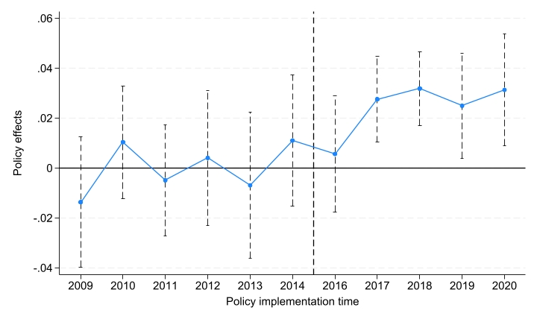

1.1.2. CUA & ECA
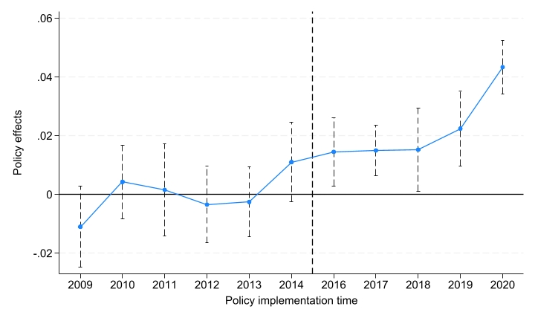

1.1.3. UDA & ECA
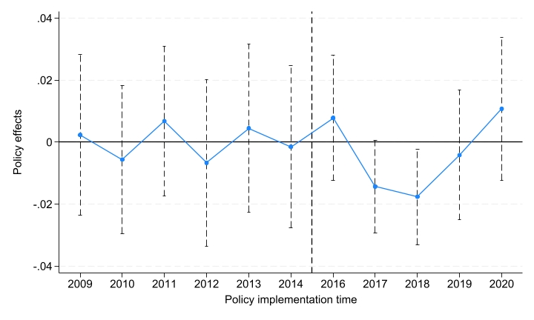

1.2. Parallel trend test in different administrative regions
This section corresponds to Table 3 (Benchmark regression results are based on different districts.)

1.2.1. Xicheng
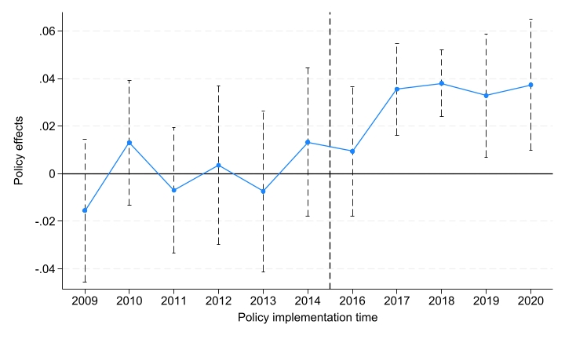

1.2.2. Shijingshan
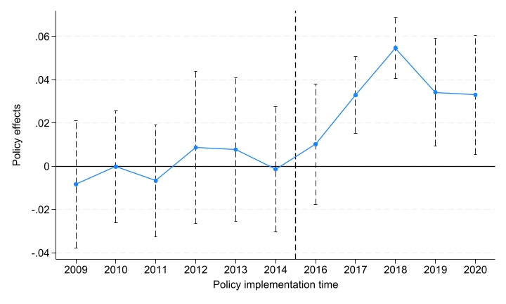

1.2.3. Fengtai
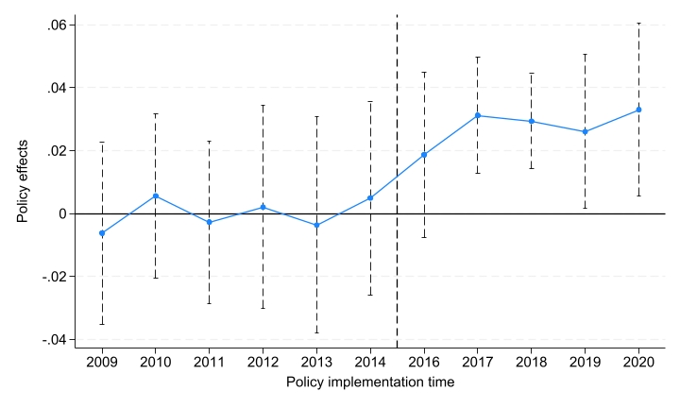

1.2.4. Haidian
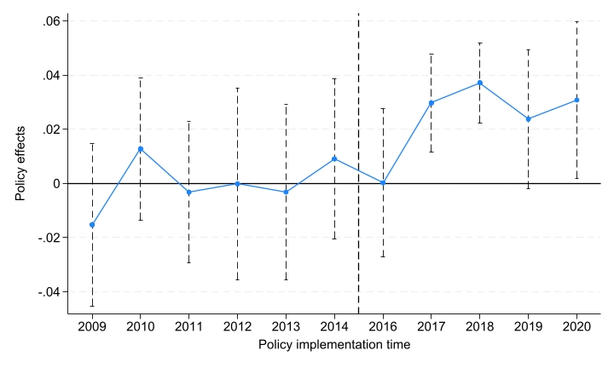

1.2.5. Chaoyang
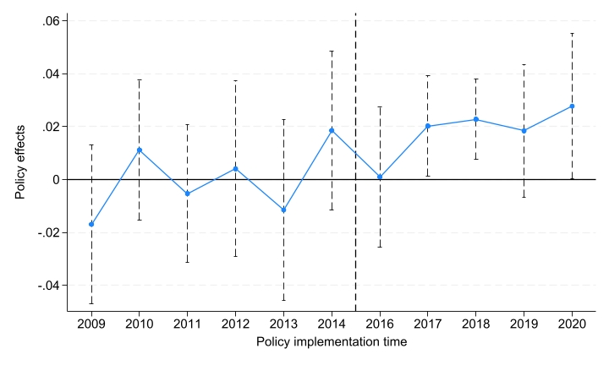

1.2.6. Dongcheng
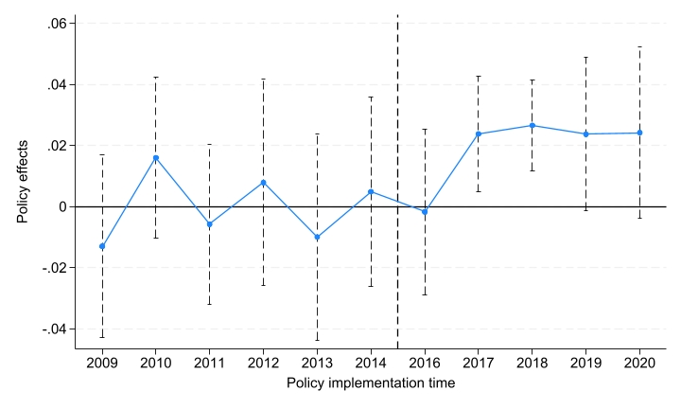

1.2.7. Changping
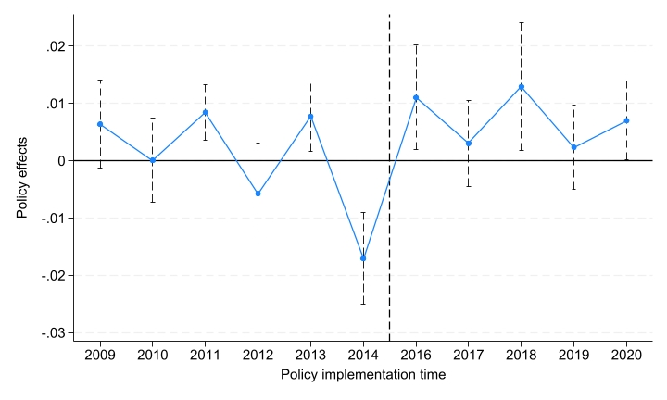

1.2.8. Daxing
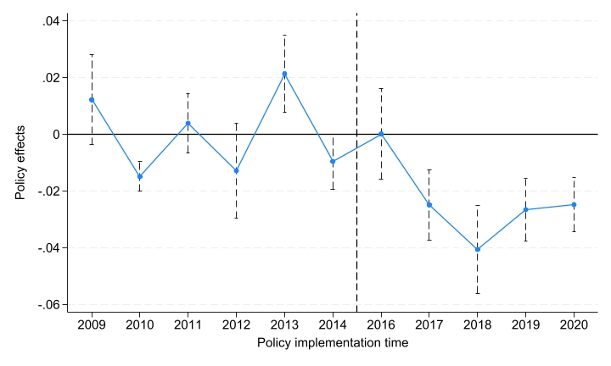

1.2.9. Fangshan
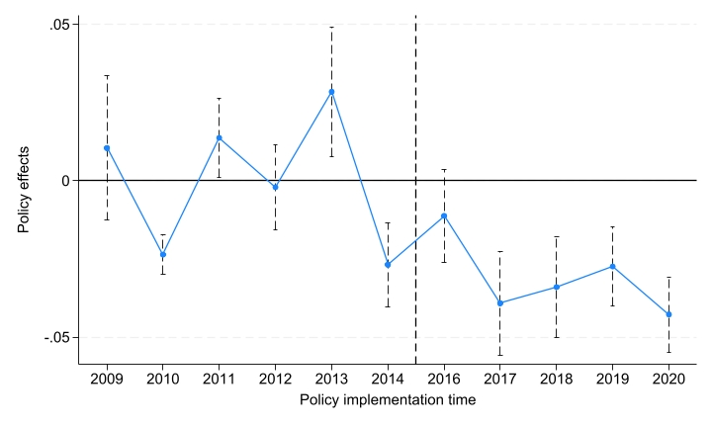

1.2.10. Tongzhou
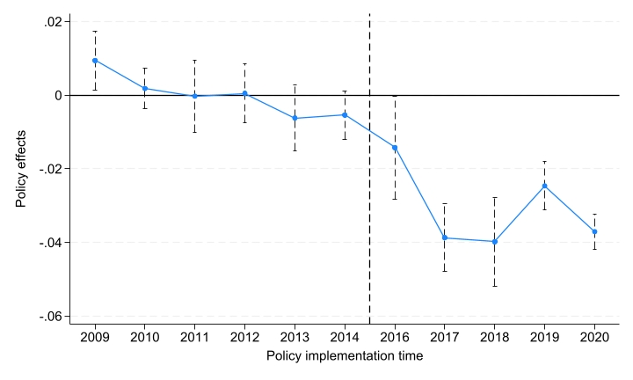

1.2.11. Shunyi
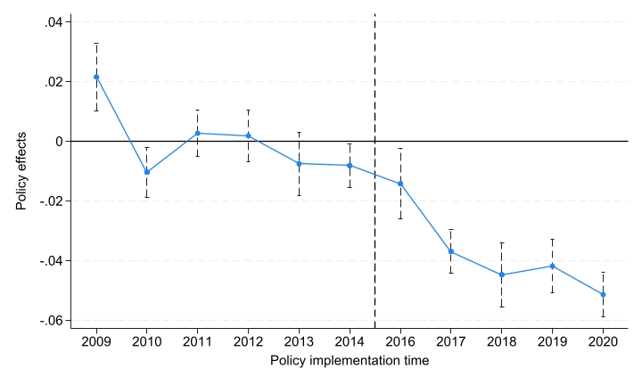

1.3. Parallel trend test of streets with different population densities
This section corresponds to Table 4 (Benchmark regression results are based on subdistricts with different population densities.)

1.3.1. HDS in CUA
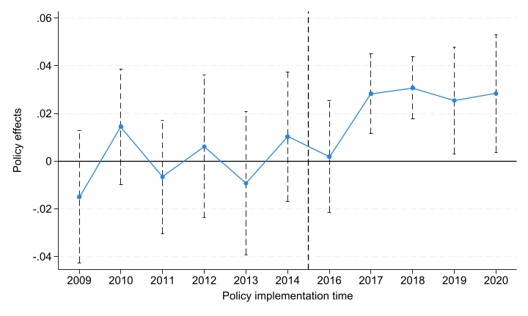

1.3.2. MDS in CUA
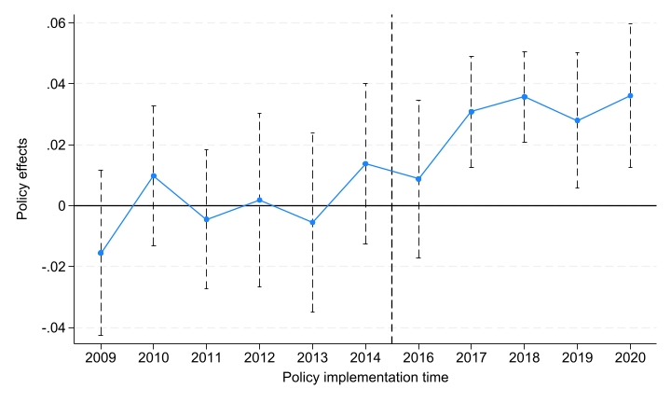

1.3.3. LDS in CUA
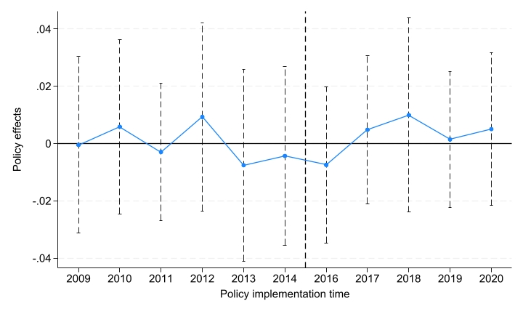

1.3.4. MDS in UDA
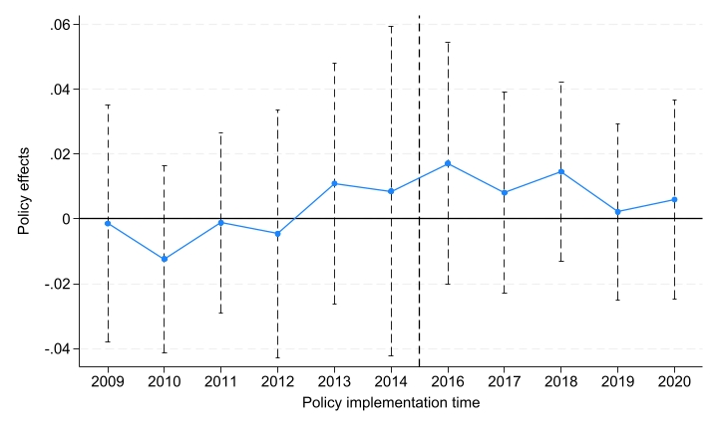

1.3.5. LDS in UDA
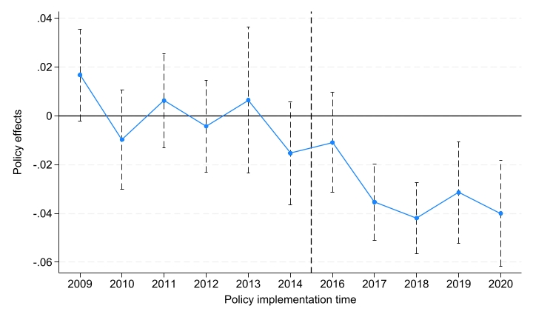

2. Sobel test results

2.1. Sobel test in different administrative regions
This section corresponds to Table 5 (Proportion of mediating effects of mechanism variables in different districts in the central urban area.)

2.1.1. Xicheng
Xicheng gdp

Sobel-Goodman Mediation Tests

| Est Std_err z P>|z|
---------------------+-----------------------------------------------
Sobel | 0.018 0.002 8.829 0.000
Aroian | 0.018 0.002 8.816 0.000
Goodman | 0.018 0.002 8.842 0.000

Indirect, Direct, and Total Effects

| Est Std_err z P>|z|
---------------------+-----------------------------------------------
a_coefficient | 3.811 0.349 10.912 0.000
b_coefficient | 0.005 0.000 15.025 0.000
Indirect_effect_aXb | 0.018 0.002 8.829 0.000
Direct_effect_c' | 0.015 0.004 4.008 0.000
Total_effect_c | 0.032 0.004 8.504 0.000

Proportion of total effect that is mediated: 0.549
Ratio of indirect to direct effect: 1.219
Ratio of total to direct effect: 2.219

Xicheng imp

Sobel-Goodman Mediation Tests

| Est Std_err z P>|z|
---------------------+-----------------------------------------------
Sobel | 0.016 0.002 8.311 0.000
Aroian | 0.016 0.002 8.298 0.000
Goodman | 0.016 0.002 8.323 0.000

Indirect, Direct, and Total Effects

| Est Std_err z P>|z|
---------------------+-----------------------------------------------
a_coefficient | -0.045 0.003 -15.202 0.000
b_coefficient | -0.354 0.036 -9.925 0.000
Indirect_effect_aXb | 0.016 0.002 8.311 0.000
Direct_effect_c' | 0.017 0.004 4.429 0.000
Total_effect_c | 0.033 0.004 9.013 0.000

Proportion of total effect that is mediated: 0.482
Ratio of indirect to direct effect: 0.931
Ratio of total to direct effect: 1.931

Xicheng ntl

Sobel-Goodman Mediation Tests

| Est Std_err z P>|z|
---------------------+-----------------------------------------------
Sobel | -0.008 0.002 -4.513 0.000
Aroian | -0.008 0.002 -4.504 0.000
Goodman | -0.008 0.002 -4.522 0.000

Indirect, Direct, and Total Effects

| Est Std_err z P>|z|
---------------------+-----------------------------------------------
a_coefficient | 49.455 3.281 15.072 0.000
b_coefficient | -0.000 0.000 -4.730 0.000
Indirect_effect_aXb | -0.008 0.002 -4.513 0.000
Direct_effect_c' | 0.041 0.004 10.241 0.000
Total_effect_c | 0.033 0.004 9.013 0.000

Proportion of total effect that is mediated: -0.235
Ratio of indirect to direct effect: -0.191
Ratio of total to direct effect: 0.809

Xicheng pop

Sobel-Goodman Mediation Tests

| Est Std_err z P>|z|
---------------------+-----------------------------------------------
Sobel | 0.002 0.002 1.412 0.158
Aroian | 0.002 0.002 1.409 0.159
Goodman | 0.002 0.002 1.415 0.157

Indirect, Direct, and Total Effects

| Est Std_err z P>|z|
---------------------+-----------------------------------------------
a_coefficient | 1946.699 125.963 15.454 0.000
b_coefficient | 0.000 0.000 1.418 0.156
Indirect_effect_aXb | 0.002 0.002 1.412 0.158
Direct_effect_c' | 0.030 0.004 7.582 0.000
Total_effect_c | 0.033 0.004 9.013 0.000

Proportion of total effect that is mediated: 0.073
Ratio of indirect to direct effect: 0.079
Ratio of total to direct effect: 1.079

Xicheng vgdp

Sobel-Goodman Mediation Tests

| Est Std_err z P>|z|
---------------------+-----------------------------------------------
Sobel | 0.005 0.001 4.098 0.000
Aroian | 0.005 0.001 4.075 0.000
Goodman | 0.005 0.001 4.121 0.000

Indirect, Direct, and Total Effects

| Est Std_err z P>|z|
---------------------+-----------------------------------------------
a_coefficient | -0.293 0.062 -4.715 0.000
b_coefficient | -0.015 0.002 -8.285 0.000
Indirect_effect_aXb | 0.005 0.001 4.098 0.000
Direct_effect_c' | 0.028 0.004 7.472 0.000
Total_effect_c | 0.032 0.004 8.504 0.000

Proportion of total effect that is mediated: 0.140
Ratio of indirect to direct effect: 0.163
Ratio of total to direct effect: 1.163

Xicheng vimp

Sobel-Goodman Mediation Tests

| Est Std_err z P>|z|
---------------------+-----------------------------------------------
Sobel | 0.003 0.001 2.829 0.005
Aroian | 0.003 0.001 2.813 0.005
Goodman | 0.003 0.001 2.845 0.004

Indirect, Direct, and Total Effects

| Est Std_err z P>|z|
---------------------+-----------------------------------------------
a_coefficient | 0.017 0.002 8.862 0.000
b_coefficient | 0.175 0.058 2.985 0.003
Indirect_effect_aXb | 0.003 0.001 2.829 0.005
Direct_effect_c' | 0.030 0.004 7.973 0.000
Total_effect_c | 0.033 0.004 9.013 0.000

Proportion of total effect that is mediated: 0.088
Ratio of indirect to direct effect: 0.096
Ratio of total to direct effect: 1.096

Xicheng vntl

Sobel-Goodman Mediation Tests

| Est Std_err z P>|z|
---------------------+-----------------------------------------------
Sobel | -0.005 0.001 -4.754 0.000
Aroian | -0.005 0.001 -4.731 0.000
Goodman | -0.005 0.001 -4.779 0.000

Indirect, Direct, and Total Effects

| Est Std_err z P>|z|
---------------------+-----------------------------------------------
a_coefficient | -13.339 1.665 -8.012 0.000
b_coefficient | 0.000 0.000 5.907 0.000
Indirect_effect_aXb | -0.005 0.001 -4.754 0.000
Direct_effect_c' | 0.038 0.004 10.278 0.000
Total_effect_c | 0.033 0.004 9.013 0.000

Proportion of total effect that is mediated: -0.155
Ratio of indirect to direct effect: -0.134
Ratio of total to direct effect: 0.866

Xicheng vpop

Sobel-Goodman Mediation Tests

| Est Std_err z P>|z|
---------------------+-----------------------------------------------
Sobel | 0.004 0.001 3.423 0.001
Aroian | 0.004 0.001 3.408 0.001
Goodman | 0.004 0.001 3.438 0.001

Indirect, Direct, and Total Effects

| Est Std_err z P>|z|
---------------------+-----------------------------------------------
a_coefficient | -810.077 81.579 -9.930 0.000
b_coefficient | -0.000 0.000 -3.646 0.000
Indirect_effect_aXb | 0.004 0.001 3.423 0.001
Direct_effect_c' | 0.029 0.004 7.643 0.000
Total_effect_c | 0.033 0.004 9.013 0.000

Proportion of total effect that is mediated: 0.120
Ratio of indirect to direct effect: 0.136
Ratio of total to direct effect: 1.136

2.1.2. Shijingshan
Shijingshan gdp

Sobel-Goodman Mediation Tests

| Est Std_err z P>|z|
---------------------+-----------------------------------------------
Sobel | 0.014 0.002 6.207 0.000
Aroian | 0.014 0.002 6.196 0.000
Goodman | 0.014 0.002 6.219 0.000

Indirect, Direct, and Total Effects

| Est Std_err z P>|z|
---------------------+-----------------------------------------------
a_coefficient | 3.046 0.445 6.848 0.000
b_coefficient | 0.005 0.000 14.697 0.000
Indirect_effect_aXb | 0.014 0.002 6.207 0.000
Direct_effect_c' | 0.019 0.004 4.178 0.000
Total_effect_c | 0.033 0.005 6.816 0.000

Proportion of total effect that is mediated: 0.433
Ratio of indirect to direct effect: 0.764
Ratio of total to direct effect: 1.764

Shijingshan imp

Sobel-Goodman Mediation Tests

| Est Std_err z P>|z|
---------------------+-----------------------------------------------
Sobel | 0.014 0.002 7.105 0.000
Aroian | 0.014 0.002 7.088 0.000
Goodman | 0.014 0.002 7.123 0.000

Indirect, Direct, and Total Effects

| Est Std_err z P>|z|
---------------------+-----------------------------------------------
a_coefficient | -0.038 0.004 -10.191 0.000
b_coefficient | -0.368 0.037 -9.912 0.000
Indirect_effect_aXb | 0.014 0.002 7.105 0.000
Direct_effect_c' | 0.019 0.005 4.020 0.000
Total_effect_c | 0.033 0.005 7.025 0.000

Proportion of total effect that is mediated: 0.426
Ratio of indirect to direct effect: 0.742
Ratio of total to direct effect: 1.742

Shijingshan ntl

Sobel-Goodman Mediation Tests

| Est Std_err z P>|z|
---------------------+-----------------------------------------------
Sobel | -0.001 0.001 -1.130 0.259
Aroian | -0.001 0.001 -1.110 0.267
Goodman | -0.001 0.001 -1.151 0.250

Indirect, Direct, and Total Effects

| Est Std_err z P>|z|
---------------------+-----------------------------------------------
a_coefficient | 4.527 3.908 1.158 0.247
b_coefficient | -0.000 0.000 -5.129 0.000
Indirect_effect_aXb | -0.001 0.001 -1.130 0.259
Direct_effect_c' | 0.034 0.005 7.289 0.000
Total_effect_c | 0.033 0.005 7.025 0.000

Proportion of total effect that is mediated: -0.026
Ratio of indirect to direct effect: -0.025
Ratio of total to direct effect: 0.975

Shijingshan pop

Sobel-Goodman Mediation Tests

| Est Std_err z P>|z|
---------------------+-----------------------------------------------
Sobel | 0.004 0.001 3.417 0.001
Aroian | 0.004 0.001 3.395 0.001
Goodman | 0.004 0.001 3.440 0.001

Indirect, Direct, and Total Effects

| Est Std_err z P>|z|
---------------------+-----------------------------------------------
a_coefficient | 698.414 89.437 7.809 0.000
b_coefficient | 0.000 0.000 3.801 0.000
Indirect_effect_aXb | 0.004 0.001 3.417 0.001
Direct_effect_c' | 0.028 0.005 5.978 0.000
Total_effect_c | 0.033 0.005 7.025 0.000

Proportion of total effect that is mediated: 0.130
Ratio of indirect to direct effect: 0.149
Ratio of total to direct effect: 1.149

Shijingshan vgdp

Sobel-Goodman Mediation Tests

| Est Std_err z P>|z|
---------------------+-----------------------------------------------
Sobel | 0.002 0.001 1.772 0.076
Aroian | 0.002 0.001 1.760 0.078
Goodman | 0.002 0.001 1.785 0.074

Indirect, Direct, and Total Effects

| Est Std_err z P>|z|
---------------------+-----------------------------------------------
a_coefficient | -0.143 0.079 -1.815 0.069
b_coefficient | -0.016 0.002 -8.173 0.000
Indirect_effect_aXb | 0.002 0.001 1.772 0.076
Direct_effect_c' | 0.031 0.005 6.555 0.000
Total_effect_c | 0.033 0.005 6.816 0.000

Proportion of total effect that is mediated: 0.068
Ratio of indirect to direct effect: 0.073
Ratio of total to direct effect: 1.073

Shijingshan vimp

Sobel-Goodman Mediation Tests

| Est Std_err z P>|z|
---------------------+-----------------------------------------------
Sobel | 0.003 0.001 2.395 0.017
Aroian | 0.003 0.001 2.373 0.018
Goodman | 0.003 0.001 2.418 0.016

Indirect, Direct, and Total Effects

| Est Std_err z P>|z|
---------------------+-----------------------------------------------
a_coefficient | 0.016 0.002 6.861 0.000
b_coefficient | 0.154 0.060 2.556 0.011
Indirect_effect_aXb | 0.003 0.001 2.395 0.017
Direct_effect_c' | 0.030 0.005 6.358 0.000
Total_effect_c | 0.033 0.005 7.025 0.000

Proportion of total effect that is mediated: 0.077
Ratio of indirect to direct effect: 0.084
Ratio of total to direct effect: 1.084

Shijingshan vntl

Sobel-Goodman Mediation Tests

| Est Std_err z P>|z|
---------------------+-----------------------------------------------
Sobel | 0.002 0.001 2.212 0.027
Aroian | 0.002 0.001 2.180 0.029
Goodman | 0.002 0.001 2.246 0.025

Indirect, Direct, and Total Effects

| Est Std_err z P>|z|
---------------------+-----------------------------------------------
a_coefficient | 4.595 1.881 2.442 0.015
b_coefficient | 0.000 0.000 5.222 0.000
Indirect_effect_aXb | 0.002 0.001 2.212 0.027
Direct_effect_c' | 0.031 0.005 6.698 0.000
Total_effect_c | 0.033 0.005 7.025 0.000

Proportion of total effect that is mediated: 0.056
Ratio of indirect to direct effect: 0.059
Ratio of total to direct effect: 1.059

Shijingshan vpop

Sobel-Goodman Mediation Tests

| Est Std_err z P>|z|
---------------------+-----------------------------------------------
Sobel | 0.003 0.001 3.165 0.002
Aroian | 0.003 0.001 3.131 0.002
Goodman | 0.003 0.001 3.200 0.001

Indirect, Direct, and Total Effects

| Est Std_err z P>|z|
---------------------+-----------------------------------------------
a_coefficient | -241.588 62.891 -3.841 0.000
b_coefficient | -0.000 0.000 -5.585 0.000
Indirect_effect_aXb | 0.003 0.001 3.165 0.002
Direct_effect_c' | 0.030 0.005 6.416 0.000
Total_effect_c | 0.033 0.005 7.025 0.000

Proportion of total effect that is mediated: 0.093
Ratio of indirect to direct effect: 0.103
Ratio of total to direct effect: 1.103

2.1.3. Fengtai
Fengtai gdp

Sobel-Goodman Mediation Tests

| Est Std_err z P>|z|
---------------------+-----------------------------------------------
Sobel | 0.015 0.002 8.824 0.000
Aroian | 0.015 0.002 8.811 0.000
Goodman | 0.015 0.002 8.836 0.000

Indirect, Direct, and Total Effects

| Est Std_err z P>|z|
---------------------+-----------------------------------------------
a_coefficient | 3.201 0.297 10.778 0.000
b_coefficient | 0.005 0.000 15.367 0.000
Indirect_effect_aXb | 0.015 0.002 8.824 0.000
Direct_effect_c' | 0.012 0.003 4.042 0.000
Total_effect_c | 0.027 0.003 8.443 0.000

Proportion of total effect that is mediated: 0.544
Ratio of indirect to direct effect: 1.191
Ratio of total to direct effect: 2.191

Fengtai imp

Sobel-Goodman Mediation Tests

| Est Std_err z P>|z|
---------------------+-----------------------------------------------
Sobel | 0.013 0.002 8.252 0.000
Aroian | 0.013 0.002 8.239 0.000
Goodman | 0.013 0.002 8.265 0.000

Indirect, Direct, and Total Effects

| Est Std_err z P>|z|
---------------------+-----------------------------------------------
a_coefficient | -0.038 0.003 -14.797 0.000
b_coefficient | -0.345 0.035 -9.941 0.000
Indirect_effect_aXb | 0.013 0.002 8.252 0.000
Direct_effect_c' | 0.015 0.003 4.605 0.000
Total_effect_c | 0.028 0.003 8.944 0.000

Proportion of total effect that is mediated: 0.461
Ratio of indirect to direct effect: 0.856
Ratio of total to direct effect: 1.856

Fengtai ntl

Sobel-Goodman Mediation Tests

| Est Std_err z P>|z|
---------------------+-----------------------------------------------
Sobel | -0.002 0.001 -2.732 0.006
Aroian | -0.002 0.001 -2.706 0.007
Goodman | -0.002 0.001 -2.759 0.006

Indirect, Direct, and Total Effects

| Est Std_err z P>|z|
---------------------+-----------------------------------------------
a_coefficient | 18.698 2.870 6.514 0.000
b_coefficient | -0.000 0.000 -3.010 0.003
Indirect_effect_aXb | -0.002 0.001 -2.732 0.006
Direct_effect_c' | 0.030 0.003 9.378 0.000
Total_effect_c | 0.028 0.003 8.944 0.000

Proportion of total effect that is mediated: -0.064
Ratio of indirect to direct effect: -0.060
Ratio of total to direct effect: 0.940

Fengtai pop

Sobel-Goodman Mediation Tests

| Est Std_err z P>|z|
---------------------+-----------------------------------------------
Sobel | 0.001 0.000 1.613 0.107
Aroian | 0.001 0.000 1.550 0.121
Goodman | 0.001 0.000 1.683 0.092

Indirect, Direct, and Total Effects

| Est Std_err z P>|z|
---------------------+-----------------------------------------------
a_coefficient | 216.948 74.542 2.910 0.004
b_coefficient | 0.000 0.000 1.937 0.053
Indirect_effect_aXb | 0.001 0.000 1.613 0.107
Direct_effect_c' | 0.028 0.003 8.758 0.000
Total_effect_c | 0.028 0.003 8.944 0.000

Proportion of total effect that is mediated: 0.018
Ratio of indirect to direct effect: 0.019
Ratio of total to direct effect: 1.019

Fengtai vgdp

Sobel-Goodman Mediation Tests

| Est Std_err z P>|z|
---------------------+-----------------------------------------------
Sobel | 0.003 0.001 3.248 0.001
Aroian | 0.003 0.001 3.228 0.001
Goodman | 0.003 0.001 3.269 0.001

Indirect, Direct, and Total Effects

| Est Std_err z P>|z|
---------------------+-----------------------------------------------
a_coefficient | -0.191 0.054 -3.547 0.000
b_coefficient | -0.014 0.002 -8.086 0.000
Indirect_effect_aXb | 0.003 0.001 3.248 0.001
Direct_effect_c' | 0.025 0.003 7.770 0.000
Total_effect_c | 0.027 0.003 8.443 0.000

Proportion of total effect that is mediated: 0.101
Ratio of indirect to direct effect: 0.112
Ratio of total to direct effect: 1.112

Fengtai vimp

Sobel-Goodman Mediation Tests

| Est Std_err z P>|z|
---------------------+-----------------------------------------------
Sobel | 0.003 0.001 3.068 0.002
Aroian | 0.003 0.001 3.052 0.002
Goodman | 0.003 0.001 3.085 0.002

Indirect, Direct, and Total Effects

| Est Std_err z P>|z|
---------------------+-----------------------------------------------
a_coefficient | 0.015 0.002 9.119 0.000
b_coefficient | 0.185 0.057 3.258 0.001
Indirect_effect_aXb | 0.003 0.001 3.068 0.002
Direct_effect_c' | 0.025 0.003 7.840 0.000
Total_effect_c | 0.028 0.003 8.944 0.000

Proportion of total effect that is mediated: 0.097
Ratio of indirect to direct effect: 0.107
Ratio of total to direct effect: 1.107

Fengtai vntl

Sobel-Goodman Mediation Tests

| Est Std_err z P>|z|
---------------------+-----------------------------------------------
Sobel | -0.001 0.001 -2.514 0.012
Aroian | -0.001 0.001 -2.475 0.013
Goodman | -0.001 0.000 -2.555 0.011

Indirect, Direct, and Total Effects

| Est Std_err z P>|z|
---------------------+-----------------------------------------------
a_coefficient | -3.937 1.329 -2.963 0.003
b_coefficient | 0.000 0.000 4.751 0.000
Indirect_effect_aXb | -0.001 0.001 -2.514 0.012
Direct_effect_c' | 0.029 0.003 9.401 0.000
Total_effect_c | 0.028 0.003 8.944 0.000

Proportion of total effect that is mediated: -0.046
Ratio of indirect to direct effect: -0.044
Ratio of total to direct effect: 0.956

Fengtai vpop

Sobel-Goodman Mediation Tests

| Est Std_err z P>|z|
---------------------+-----------------------------------------------
Sobel | 0.002 0.001 3.415 0.001
Aroian | 0.002 0.001 3.379 0.001
Goodman | 0.002 0.001 3.452 0.001

Indirect, Direct, and Total Effects

| Est Std_err z P>|z|
---------------------+-----------------------------------------------
a_coefficient | -246.987 53.217 -4.641 0.000
b_coefficient | -0.000 0.000 -5.043 0.000
Indirect_effect_aXb | 0.002 0.001 3.415 0.001
Direct_effect_c' | 0.026 0.003 8.277 0.000
Total_effect_c | 0.028 0.003 8.944 0.000

Proportion of total effect that is mediated: 0.076
Ratio of indirect to direct effect: 0.082
Ratio of total to direct effect: 1.082

2.1.4. Haidian
Haidian gdp

Sobel-Goodman Mediation Tests

| Est Std_err z P>|z|
---------------------+-----------------------------------------------
Sobel | 0.014 0.002 9.490 0.000
Aroian | 0.014 0.002 9.478 0.000
Goodman | 0.014 0.002 9.502 0.000

Indirect, Direct, and Total Effects

| Est Std_err z P>|z|
---------------------+-----------------------------------------------
a_coefficient | 3.146 0.262 12.011 0.000
b_coefficient | 0.005 0.000 15.483 0.000
Indirect_effect_aXb | 0.014 0.002 9.490 0.000
Direct_effect_c' | 0.012 0.003 4.386 0.000
Total_effect_c | 0.027 0.003 9.229 0.000

Proportion of total effect that is mediated: 0.541
Ratio of indirect to direct effect: 1.180
Ratio of total to direct effect: 2.180

Haidian imp

Sobel-Goodman Mediation Tests

| Est Std_err z P>|z|
---------------------+-----------------------------------------------
Sobel | 0.012 0.001 8.956 0.000
Aroian | 0.012 0.001 8.943 0.000
Goodman | 0.012 0.001 8.969 0.000

Indirect, Direct, and Total Effects

| Est Std_err z P>|z|
---------------------+-----------------------------------------------
a_coefficient | -0.033 0.002 -14.361 0.000
b_coefficient | -0.379 0.033 -11.456 0.000
Indirect_effect_aXb | 0.012 0.001 8.956 0.000
Direct_effect_c' | 0.015 0.003 5.181 0.000
Total_effect_c | 0.027 0.003 9.730 0.000

Proportion of total effect that is mediated: 0.453
Ratio of indirect to direct effect: 0.829
Ratio of total to direct effect: 1.829

Haidian ntl

Sobel-Goodman Mediation Tests

| Est Std_err z P>|z|
---------------------+-----------------------------------------------
Sobel | -0.003 0.001 -3.088 0.002
Aroian | -0.003 0.001 -3.076 0.002
Goodman | -0.003 0.001 -3.101 0.002

Indirect, Direct, and Total Effects

| Est Std_err z P>|z|
---------------------+-----------------------------------------------
a_coefficient | 26.457 2.450 10.797 0.000
b_coefficient | -0.000 0.000 -3.223 0.001
Indirect_effect_aXb | -0.003 0.001 -3.088 0.002
Direct_effect_c' | 0.030 0.003 10.281 0.000
Total_effect_c | 0.027 0.003 9.730 0.000

Proportion of total effect that is mediated: -0.100
Ratio of indirect to direct effect: -0.091
Ratio of total to direct effect: 0.909

Haidian pop

Sobel-Goodman Mediation Tests

| Est Std_err z P>|z|
---------------------+-----------------------------------------------
Sobel | 0.002 0.001 3.280 0.001
Aroian | 0.002 0.001 3.261 0.001
Goodman | 0.002 0.001 3.300 0.001

Indirect, Direct, and Total Effects

| Est Std_err z P>|z|
---------------------+-----------------------------------------------
a_coefficient | 614.594 72.359 8.494 0.000
b_coefficient | 0.000 0.000 3.556 0.000
Indirect_effect_aXb | 0.002 0.001 3.280 0.001
Direct_effect_c' | 0.025 0.003 8.680 0.000
Total_effect_c | 0.027 0.003 9.730 0.000

Proportion of total effect that is mediated: 0.087
Ratio of indirect to direct effect: 0.095
Ratio of total to direct effect: 1.095

Haidian vgdp

Sobel-Goodman Mediation Tests

| Est Std_err z P>|z|
---------------------+-----------------------------------------------
Sobel | 0.003 0.001 3.839 0.000
Aroian | 0.003 0.001 3.816 0.000
Goodman | 0.003 0.001 3.863 0.000

Indirect, Direct, and Total Effects

| Est Std_err z P>|z|
---------------------+-----------------------------------------------
a_coefficient | -0.206 0.047 -4.393 0.000
b_coefficient | -0.014 0.002 -7.899 0.000
Indirect_effect_aXb | 0.003 0.001 3.839 0.000
Direct_effect_c' | 0.024 0.003 8.379 0.000
Total_effect_c | 0.027 0.003 9.229 0.000

Proportion of total effect that is mediated: 0.108
Ratio of indirect to direct effect: 0.121
Ratio of total to direct effect: 1.121

Haidian vimp

Sobel-Goodman Mediation Tests

| Est Std_err z P>|z|
---------------------+-----------------------------------------------
Sobel | 0.002 0.001 3.135 0.002
Aroian | 0.002 0.001 3.113 0.002
Goodman | 0.002 0.001 3.157 0.002

Indirect, Direct, and Total Effects

| Est Std_err z P>|z|
---------------------+-----------------------------------------------
a_coefficient | 0.011 0.001 7.690 0.000
b_coefficient | 0.189 0.055 3.433 0.001
Indirect_effect_aXb | 0.002 0.001 3.135 0.002
Direct_effect_c' | 0.025 0.003 8.824 0.000
Total_effect_c | 0.027 0.003 9.730 0.000

Proportion of total effect that is mediated: 0.076
Ratio of indirect to direct effect: 0.082
Ratio of total to direct effect: 1.082

Haidian vntl

Sobel-Goodman Mediation Tests

| Est Std_err z P>|z|
---------------------+-----------------------------------------------
Sobel | -0.001 0.001 -2.448 0.014
Aroian | -0.001 0.001 -2.419 0.016
Goodman | -0.001 0.000 -2.477 0.013

Indirect, Direct, and Total Effects

| Est Std_err z P>|z|
---------------------+-----------------------------------------------
a_coefficient | -3.210 1.194 -2.689 0.007
b_coefficient | 0.000 0.000 5.916 0.000
Indirect_effect_aXb | -0.001 0.001 -2.448 0.014
Direct_effect_c' | 0.028 0.003 10.278 0.000
Total_effect_c | 0.027 0.003 9.730 0.000

Proportion of total effect that is mediated: -0.045
Ratio of indirect to direct effect: -0.043
Ratio of total to direct effect: 0.957

Haidian vpop

Sobel-Goodman Mediation Tests

| Est Std_err z P>|z|
---------------------+-----------------------------------------------
Sobel | 0.002 0.001 3.766 0.000
Aroian | 0.002 0.001 3.737 0.000
Goodman | 0.002 0.001 3.796 0.000

Indirect, Direct, and Total Effects

| Est Std_err z P>|z|
---------------------+-----------------------------------------------
a_coefficient | -312.399 47.838 -6.530 0.000
b_coefficient | -0.000 0.000 -4.610 0.000
Indirect_effect_aXb | 0.002 0.001 3.766 0.000
Direct_effect_c' | 0.025 0.003 8.813 0.000
Total_effect_c | 0.027 0.003 9.730 0.000

Proportion of total effect that is mediated: 0.086
Ratio of indirect to direct effect: 0.095
Ratio of total to direct effect: 1.095

2.1.5. Chaoyang
Chaoyang gdp

Sobel-Goodman Mediation Tests

| Est Std_err z P>|z|
---------------------+-----------------------------------------------
Sobel | 0.015 0.001 10.831 0.000
Aroian | 0.015 0.001 10.820 0.000
Goodman | 0.015 0.001 10.843 0.000

Indirect, Direct, and Total Effects

| Est Std_err z P>|z|
---------------------+-----------------------------------------------
a_coefficient | 3.267 0.212 15.412 0.000
b_coefficient | 0.005 0.000 15.225 0.000
Indirect_effect_aXb | 0.015 0.001 10.831 0.000
Direct_effect_c' | 0.005 0.003 2.059 0.040
Total_effect_c | 0.020 0.003 8.086 0.000

Proportion of total effect that is mediated: 0.745
Ratio of indirect to direct effect: 2.919
Ratio of total to direct effect: 3.919

Chaoyang imp

Sobel-Goodman Mediation Tests

| Est Std_err z P>|z|
---------------------+-----------------------------------------------
Sobel | 0.011 0.001 9.158 0.000
Aroian | 0.011 0.001 9.145 0.000
Goodman | 0.011 0.001 9.170 0.000

Indirect, Direct, and Total Effects

| Est Std_err z P>|z|
---------------------+-----------------------------------------------
a_coefficient | -0.030 0.002 -14.928 0.000
b_coefficient | -0.358 0.031 -11.596 0.000
Indirect_effect_aXb | 0.011 0.001 9.158 0.000
Direct_effect_c' | 0.011 0.002 4.308 0.000
Total_effect_c | 0.021 0.002 8.828 0.000

Proportion of total effect that is mediated: 0.498
Ratio of indirect to direct effect: 0.993
Ratio of total to direct effect: 1.993

Chaoyang ntl

Sobel-Goodman Mediation Tests

| Est Std_err z P>|z|
---------------------+-----------------------------------------------
Sobel | -0.001 0.001 -1.358 0.174
Aroian | -0.001 0.001 -1.355 0.175
Goodman | -0.001 0.001 -1.360 0.174

Indirect, Direct, and Total Effects

| Est Std_err z P>|z|
---------------------+-----------------------------------------------
a_coefficient | 43.808 2.691 16.279 0.000
b_coefficient | -0.000 0.000 -1.363 0.173
Indirect_effect_aXb | -0.001 0.001 -1.358 0.174
Direct_effect_c' | 0.023 0.003 8.646 0.000
Total_effect_c | 0.021 0.002 8.828 0.000

Proportion of total effect that is mediated: -0.067
Ratio of indirect to direct effect: -0.063
Ratio of total to direct effect: 0.937

Chaoyang pop

Sobel-Goodman Mediation Tests

| Est Std_err z P>|z|
---------------------+-----------------------------------------------
Sobel | 0.002 0.001 3.290 0.001
Aroian | 0.002 0.001 3.277 0.001
Goodman | 0.002 0.001 3.303 0.001

Indirect, Direct, and Total Effects

| Est Std_err z P>|z|
---------------------+-----------------------------------------------
a_coefficient | 1029.311 98.063 10.496 0.000
b_coefficient | 0.000 0.000 3.464 0.001
Indirect_effect_aXb | 0.002 0.001 3.290 0.001
Direct_effect_c' | 0.019 0.002 7.606 0.000
Total_effect_c | 0.021 0.002 8.828 0.000

Proportion of total effect that is mediated: 0.109
Ratio of indirect to direct effect: 0.122
Ratio of total to direct effect: 1.122

Chaoyang vgdp

Sobel-Goodman Mediation Tests

| Est Std_err z P>|z|
---------------------+-----------------------------------------------
Sobel | 0.003 0.001 4.792 0.000
Aroian | 0.003 0.001 4.769 0.000
Goodman | 0.003 0.001 4.816 0.000

Indirect, Direct, and Total Effects

| Est Std_err z P>|z|
---------------------+-----------------------------------------------
a_coefficient | -0.223 0.038 -5.856 0.000
b_coefficient | -0.015 0.002 -8.337 0.000
Indirect_effect_aXb | 0.003 0.001 4.792 0.000
Direct_effect_c' | 0.017 0.002 6.847 0.000
Total_effect_c | 0.020 0.003 8.086 0.000

Proportion of total effect that is mediated: 0.164
Ratio of indirect to direct effect: 0.196
Ratio of total to direct effect: 1.196

Chaoyang vimp

Sobel-Goodman Mediation Tests

| Est Std_err z P>|z|
---------------------+-----------------------------------------------
Sobel | 0.002 0.001 3.507 0.000
Aroian | 0.002 0.001 3.490 0.000
Goodman | 0.002 0.001 3.525 0.000

Indirect, Direct, and Total Effects

| Est Std_err z P>|z|
---------------------+-----------------------------------------------
a_coefficient | 0.011 0.001 9.197 0.000
b_coefficient | 0.199 0.052 3.794 0.000
Indirect_effect_aXb | 0.002 0.001 3.507 0.000
Direct_effect_c' | 0.019 0.002 7.715 0.000
Total_effect_c | 0.021 0.002 8.828 0.000

Proportion of total effect that is mediated: 0.105
Ratio of indirect to direct effect: 0.117
Ratio of total to direct effect: 1.117

Chaoyang vntl

Sobel-Goodman Mediation Tests

| Est Std_err z P>|z|
---------------------+-----------------------------------------------
Sobel | -0.003 0.001 -4.150 0.000
Aroian | -0.003 0.001 -4.130 0.000
Goodman | -0.003 0.001 -4.170 0.000

Indirect, Direct, and Total Effects

| Est Std_err z P>|z|
---------------------+-----------------------------------------------
a_coefficient | -11.233 1.248 -9.002 0.000
b_coefficient | 0.000 0.000 4.676 0.000
Indirect_effect_aXb | -0.003 0.001 -4.150 0.000
Direct_effect_c' | 0.024 0.002 9.737 0.000
Total_effect_c | 0.021 0.002 8.828 0.000

Proportion of total effect that is mediated: -0.126
Ratio of indirect to direct effect: -0.112
Ratio of total to direct effect: 0.888

Chaoyang vpop

Sobel-Goodman Mediation Tests

| Est Std_err z P>|z|
---------------------+-----------------------------------------------
Sobel | 0.001 0.000 1.838 0.066
Aroian | 0.001 0.000 1.802 0.072
Goodman | 0.001 0.000 1.876 0.061

Indirect, Direct, and Total Effects

| Est Std_err z P>|z|
---------------------+-----------------------------------------------
a_coefficient | -326.383 71.527 -4.563 0.000
b_coefficient | -0.000 0.000 -2.008 0.045
Indirect_effect_aXb | 0.001 0.000 1.838 0.066
Direct_effect_c' | 0.021 0.002 8.532 0.000
Total_effect_c | 0.021 0.002 8.828 0.000

Proportion of total effect that is mediated: 0.028
Ratio of indirect to direct effect: 0.028
Ratio of total to direct effect: 1.028

2.1.6. Dongcheng
Dongcheng gdp

Sobel-Goodman Mediation Tests

| Est Std_err z P>|z|
---------------------+-----------------------------------------------
Sobel | 0.017 0.002 8.907 0.000
Aroian | 0.017 0.002 8.895 0.000
Goodman | 0.017 0.002 8.921 0.000

Indirect, Direct, and Total Effects

| Est Std_err z P>|z|
---------------------+-----------------------------------------------
a_coefficient | 3.666 0.328 11.175 0.000
b_coefficient | 0.005 0.000 14.751 0.000
Indirect_effect_aXb | 0.017 0.002 8.907 0.000
Direct_effect_c' | 0.003 0.003 0.970 0.332
Total_effect_c | 0.020 0.004 5.608 0.000

Proportion of total effect that is mediated: 0.834
Ratio of indirect to direct effect: 5.008
Ratio of total to direct effect: 6.008

Dongcheng imp

Sobel-Goodman Mediation Tests

| Est Std_err z P>|z|
---------------------+-----------------------------------------------
Sobel | 0.015 0.002 8.271 0.000
Aroian | 0.015 0.002 8.259 0.000
Goodman | 0.015 0.002 8.283 0.000

Indirect, Direct, and Total Effects

| Est Std_err z P>|z|
---------------------+-----------------------------------------------
a_coefficient | -0.045 0.003 -16.060 0.000
b_coefficient | -0.340 0.035 -9.649 0.000
Indirect_effect_aXb | 0.015 0.002 8.271 0.000
Direct_effect_c' | 0.005 0.004 1.433 0.152
Total_effect_c | 0.020 0.003 5.960 0.000

Proportion of total effect that is mediated: 0.744
Ratio of indirect to direct effect: 2.903
Ratio of total to direct effect: 3.903

Dongcheng ntl

Sobel-Goodman Mediation Tests

| Est Std_err z P>|z|
---------------------+-----------------------------------------------
Sobel | -0.008 0.002 -4.102 0.000
Aroian | -0.008 0.002 -4.096 0.000
Goodman | -0.008 0.002 -4.108 0.000

Indirect, Direct, and Total Effects

| Est Std_err z P>|z|
---------------------+-----------------------------------------------
a_coefficient | 63.138 3.419 18.469 0.000
b_coefficient | -0.000 0.000 -4.207 0.000
Indirect_effect_aXb | -0.008 0.002 -4.102 0.000
Direct_effect_c' | 0.028 0.004 7.288 0.000
Total_effect_c | 0.020 0.003 5.960 0.000

Proportion of total effect that is mediated: -0.385
Ratio of indirect to direct effect: -0.278
Ratio of total to direct effect: 0.722

Dongcheng pop

Sobel-Goodman Mediation Tests

| Est Std_err z P>|z|
---------------------+-----------------------------------------------
Sobel | 0.008 0.003 3.210 0.001
Aroian | 0.008 0.003 3.208 0.001
Goodman | 0.008 0.003 3.213 0.001

Indirect, Direct, and Total Effects

| Est Std_err z P>|z|
---------------------+-----------------------------------------------
a_coefficient | 2509.671 98.622 25.447 0.000
b_coefficient | 0.000 0.000 3.236 0.001
Indirect_effect_aXb | 0.008 0.003 3.210 0.001
Direct_effect_c' | 0.012 0.004 2.818 0.005
Total_effect_c | 0.020 0.003 5.960 0.000

Proportion of total effect that is mediated: 0.409
Ratio of indirect to direct effect: 0.693
Ratio of total to direct effect: 1.693

Dongcheng vgdp

Sobel-Goodman Mediation Tests

| Est Std_err z P>|z|
---------------------+-----------------------------------------------
Sobel | 0.004 0.001 4.193 0.000
Aroian | 0.004 0.001 4.171 0.000
Goodman | 0.004 0.001 4.215 0.000

Indirect, Direct, and Total Effects

| Est Std_err z P>|z|
---------------------+-----------------------------------------------
a_coefficient | -0.281 0.058 -4.812 0.000
b_coefficient | -0.016 0.002 -8.541 0.000
Indirect_effect_aXb | 0.004 0.001 4.193 0.000
Direct_effect_c' | 0.016 0.003 4.468 0.000
Total_effect_c | 0.020 0.004 5.608 0.000

Proportion of total effect that is mediated: 0.221
Ratio of indirect to direct effect: 0.284
Ratio of total to direct effect: 1.284

Dongcheng vimp

Sobel-Goodman Mediation Tests

| Est Std_err z P>|z|
---------------------+-----------------------------------------------
Sobel | 0.003 0.001 2.738 0.006
Aroian | 0.003 0.001 2.723 0.006
Goodman | 0.003 0.001 2.753 0.006

Indirect, Direct, and Total Effects

| Est Std_err z P>|z|
---------------------+-----------------------------------------------
a_coefficient | 0.016 0.002 9.234 0.000
b_coefficient | 0.166 0.058 2.867 0.004
Indirect_effect_aXb | 0.003 0.001 2.738 0.006
Direct_effect_c' | 0.018 0.004 5.006 0.000
Total_effect_c | 0.020 0.003 5.960 0.000

Proportion of total effect that is mediated: 0.132
Ratio of indirect to direct effect: 0.152
Ratio of total to direct effect: 1.152

Dongcheng vntl

Sobel-Goodman Mediation Tests

| Est Std_err z P>|z|
---------------------+-----------------------------------------------
Sobel | -0.006 0.001 -4.520 0.000
Aroian | -0.006 0.001 -4.504 0.000
Goodman | -0.006 0.001 -4.535 0.000

Indirect, Direct, and Total Effects

| Est Std_err z P>|z|
---------------------+-----------------------------------------------
a_coefficient | -18.597 1.689 -11.010 0.000
b_coefficient | 0.000 0.000 4.957 0.000
Indirect_effect_aXb | -0.006 0.001 -4.520 0.000
Direct_effect_c' | 0.026 0.004 7.265 0.000
Total_effect_c | 0.020 0.003 5.960 0.000

Proportion of total effect that is mediated: -0.270
Ratio of indirect to direct effect: -0.212
Ratio of total to direct effect: 0.788

Dongcheng vpop

Sobel-Goodman Mediation Tests

| Est Std_err z P>|z|
---------------------+-----------------------------------------------
Sobel | 0.001 0.000 2.048 0.041
Aroian | 0.001 0.000 1.990 0.047
Goodman | 0.001 0.000 2.112 0.035

Indirect, Direct, and Total Effects

| Est Std_err z P>|z|
---------------------+-----------------------------------------------
a_coefficient | -190.244 66.302 -2.869 0.004
b_coefficient | -0.000 0.000 -2.925 0.003
Indirect_effect_aXb | 0.001 0.000 2.048 0.041
Direct_effect_c' | 0.020 0.003 5.709 0.000
Total_effect_c | 0.020 0.003 5.960 0.000

Proportion of total effect that is mediated: 0.042
Ratio of indirect to direct effect: 0.044
Ratio of total to direct effect: 1.044

2.1.7. Daxing
Daxing gdp

Sobel-Goodman Mediation Tests

| Est Std_err z P>|z|
---------------------+-----------------------------------------------
Sobel | -0.018 0.002 -10.514 0.000
Aroian | -0.018 0.002 -10.508 0.000
Goodman | -0.018 0.002 -10.521 0.000

Indirect, Direct, and Total Effects

| Est Std_err z P>|z|
---------------------+-----------------------------------------------
a_coefficient | -4.362 0.164 -26.630 0.000
b_coefficient | 0.004 0.000 11.444 0.000
Indirect_effect_aXb | -0.018 0.002 -10.514 0.000
Direct_effect_c' | -0.011 0.003 -3.791 0.000
Total_effect_c | -0.029 0.002 -11.839 0.000

Proportion of total effect that is mediated: 0.629
Ratio of indirect to direct effect: 1.693
Ratio of total to direct effect: 2.693

Daxing imp

Sobel-Goodman Mediation Tests

| Est Std_err z P>|z|
---------------------+-----------------------------------------------
Sobel | -0.016 0.001 -10.753 0.000
Aroian | -0.016 0.001 -10.745 0.000
Goodman | -0.016 0.001 -10.760 0.000

Indirect, Direct, and Total Effects

| Est Std_err z P>|z|
---------------------+-----------------------------------------------
a_coefficient | 0.050 0.002 24.223 0.000
b_coefficient | -0.324 0.027 -12.000 0.000
Indirect_effect_aXb | -0.016 0.001 -10.753 0.000
Direct_effect_c' | -0.011 0.003 -4.341 0.000
Total_effect_c | -0.028 0.002 -11.601 0.000

Proportion of total effect that is mediated: 0.583
Ratio of indirect to direct effect: 1.400
Ratio of total to direct effect: 2.400

Daxing ntl

Sobel-Goodman Mediation Tests

| Est Std_err z P>|z|
---------------------+-----------------------------------------------
Sobel | -0.001 0.001 -2.526 0.012
Aroian | -0.001 0.001 -2.513 0.012
Goodman | -0.001 0.001 -2.538 0.011

Indirect, Direct, and Total Effects

| Est Std_err z P>|z|
---------------------+-----------------------------------------------
a_coefficient | -33.263 3.395 -9.798 0.000
b_coefficient | 0.000 0.000 2.614 0.009
Indirect_effect_aXb | -0.001 0.001 -2.526 0.012
Direct_effect_c' | -0.026 0.002 -10.703 0.000
Total_effect_c | -0.028 0.002 -11.601 0.000

Proportion of total effect that is mediated: 0.053
Ratio of indirect to direct effect: 0.056
Ratio of total to direct effect: 1.056

Daxing pop

Sobel-Goodman Mediation Tests

| Est Std_err z P>|z|
---------------------+-----------------------------------------------
Sobel | 0.000 0.000 0.842 0.400
Aroian | 0.000 0.000 0.835 0.404
Goodman | 0.000 0.000 0.849 0.396

Indirect, Direct, and Total Effects

| Est Std_err z P>|z|
---------------------+-----------------------------------------------
a_coefficient | -1165.514 153.418 -7.597 0.000
b_coefficient | -0.000 0.000 -0.847 0.397
Indirect_effect_aXb | 0.000 0.000 0.842 0.400
Direct_effect_c' | -0.028 0.002 -11.562 0.000
Total_effect_c | -0.028 0.002 -11.601 0.000

Proportion of total effect that is mediated: -0.013
Ratio of indirect to direct effect: -0.013
Ratio of total to direct effect: 0.987

Daxing vgdp

Sobel-Goodman Mediation Tests

| Est Std_err z P>|z|
---------------------+-----------------------------------------------
Sobel | -0.008 0.001 -7.857 0.000
Aroian | -0.008 0.001 -7.842 0.000
Goodman | -0.008 0.001 -7.871 0.000

Indirect, Direct, and Total Effects

| Est Std_err z P>|z|
---------------------+-----------------------------------------------
a_coefficient | 0.384 0.029 13.360 0.000
b_coefficient | -0.020 0.002 -9.714 0.000
Indirect_effect_aXb | -0.008 0.001 -7.857 0.000
Direct_effect_c' | -0.021 0.002 -8.419 0.000
Total_effect_c | -0.029 0.002 -11.839 0.000

Proportion of total effect that is mediated: 0.271
Ratio of indirect to direct effect: 0.371
Ratio of total to direct effect: 1.371

Daxing vimp

Sobel-Goodman Mediation Tests

| Est Std_err z P>|z|
---------------------+-----------------------------------------------
Sobel | -0.004 0.001 -4.564 0.000
Aroian | -0.004 0.001 -4.552 0.000
Goodman | -0.004 0.001 -4.576 0.000

Indirect, Direct, and Total Effects

| Est Std_err z P>|z|
---------------------+-----------------------------------------------
a_coefficient | -0.015 0.001 -12.975 0.000
b_coefficient | 0.243 0.050 4.876 0.000
Indirect_effect_aXb | -0.004 0.001 -4.564 0.000
Direct_effect_c' | -0.024 0.002 -9.678 0.000
Total_effect_c | -0.028 0.002 -11.601 0.000

Proportion of total effect that is mediated: 0.131
Ratio of indirect to direct effect: 0.151
Ratio of total to direct effect: 1.151

Daxing vntl

Sobel-Goodman Mediation Tests

| Est Std_err z P>|z|
---------------------+-----------------------------------------------
Sobel | 0.000 0.000 1.239 0.215
Aroian | 0.000 0.000 1.201 0.230
Goodman | 0.000 0.000 1.281 0.200

Indirect, Direct, and Total Effects

| Est Std_err z P>|z|
---------------------+-----------------------------------------------
a_coefficient | 5.706 1.534 3.720 0.000
b_coefficient | 0.000 0.000 1.314 0.189
Indirect_effect_aXb | 0.000 0.000 1.239 0.215
Direct_effect_c' | -0.028 0.002 -11.675 0.000
Total_effect_c | -0.028 0.002 -11.601 0.000

Proportion of total effect that is mediated: -0.010
Ratio of indirect to direct effect: -0.010
Ratio of total to direct effect: 0.990

Daxing vpop

Sobel-Goodman Mediation Tests

| Est Std_err z P>|z|
---------------------+-----------------------------------------------
Sobel | -0.000 0.000 -1.181 0.238
Aroian | -0.000 0.000 -1.134 0.257
Goodman | -0.000 0.000 -1.234 0.217

Indirect, Direct, and Total Effects

| Est Std_err z P>|z|
---------------------+-----------------------------------------------
a_coefficient | 325.052 101.748 3.195 0.001
b_coefficient | -0.000 0.000 -1.271 0.204
Indirect_effect_aXb | -0.000 0.000 -1.181 0.238
Direct_effect_c' | -0.027 0.002 -11.471 0.000
Total_effect_c | -0.028 0.002 -11.601 0.000

Proportion of total effect that is mediated: 0.008
Ratio of indirect to direct effect: 0.009
Ratio of total to direct effect: 1.009

2.2.8. Fangshan
Fangshan gdp

Sobel-Goodman Mediation Tests

| Est Std_err z P>|z|
---------------------+-----------------------------------------------
Sobel | -0.024 0.002 -10.713 0.000
Aroian | -0.024 0.002 -10.707 0.000
Goodman | -0.024 0.002 -10.719 0.000

Indirect, Direct, and Total Effects

| Est Std_err z P>|z|
---------------------+-----------------------------------------------
a_coefficient | -4.583 0.162 -28.288 0.000
b_coefficient | 0.005 0.000 11.575 0.000
Indirect_effect_aXb | -0.024 0.002 -10.713 0.000
Direct_effect_c' | -0.005 0.004 -1.386 0.166
Total_effect_c | -0.029 0.003 -9.890 0.000

Proportion of total effect that is mediated: 0.833
Ratio of indirect to direct effect: 4.985
Ratio of total to direct effect: 5.985

Fangshan imp

Sobel-Goodman Mediation Tests

| Est Std_err z P>|z|
---------------------+-----------------------------------------------
Sobel | -0.010 0.001 -8.379 0.000
Aroian | -0.010 0.001 -8.364 0.000
Goodman | -0.010 0.001 -8.394 0.000

Indirect, Direct, and Total Effects

| Est Std_err z P>|z|
---------------------+-----------------------------------------------
a_coefficient | 0.024 0.002 11.605 0.000
b_coefficient | -0.389 0.032 -12.109 0.000
Indirect_effect_aXb | -0.010 0.001 -8.379 0.000
Direct_effect_c' | -0.022 0.003 -7.832 0.000
Total_effect_c | -0.032 0.003 -11.178 0.000

Proportion of total effect that is mediated: 0.302
Ratio of indirect to direct effect: 0.432
Ratio of total to direct effect: 1.432

Fangshan ntl

Sobel-Goodman Mediation Tests

| Est Std_err z P>|z|
---------------------+-----------------------------------------------
Sobel | -0.003 0.001 -3.935 0.000
Aroian | -0.003 0.001 -3.920 0.000
Goodman | -0.003 0.001 -3.951 0.000

Indirect, Direct, and Total Effects

| Est Std_err z P>|z|
---------------------+-----------------------------------------------
a_coefficient | -48.086 4.582 -10.495 0.000
b_coefficient | 0.000 0.000 4.245 0.000
Indirect_effect_aXb | -0.003 0.001 -3.935 0.000
Direct_effect_c' | -0.028 0.003 -9.788 0.000
Total_effect_c | -0.032 0.003 -11.178 0.000

Proportion of total effect that is mediated: 0.099
Ratio of indirect to direct effect: 0.110
Ratio of total to direct effect: 1.110

Fangshan pop

Sobel-Goodman Mediation Tests

| Est Std_err z P>|z|
---------------------+-----------------------------------------------
Sobel | 0.000 0.000 0.774 0.439
Aroian | 0.000 0.000 0.762 0.446
Goodman | 0.000 0.000 0.786 0.432

Indirect, Direct, and Total Effects

| Est Std_err z P>|z|
---------------------+-----------------------------------------------
a_coefficient | -1161.138 208.728 -5.563 0.000
b_coefficient | -0.000 0.000 -0.781 0.435
Indirect_effect_aXb | 0.000 0.000 0.774 0.439
Direct_effect_c' | -0.032 0.003 -11.178 0.000
Total_effect_c | -0.032 0.003 -11.178 0.000

Proportion of total effect that is mediated: -0.010
Ratio of indirect to direct effect: -0.010
Ratio of total to direct effect: 0.990

Fangshan vgdp

Sobel-Goodman Mediation Tests

| Est Std_err z P>|z|
---------------------+-----------------------------------------------
Sobel | -0.003 0.001 -3.925 0.000
Aroian | -0.003 0.001 -3.905 0.000
Goodman | -0.003 0.001 -3.945 0.000

Indirect, Direct, and Total Effects

| Est Std_err z P>|z|
---------------------+-----------------------------------------------
a_coefficient | 0.320 0.036 8.862 0.000
b_coefficient | -0.009 0.002 -4.378 0.000
Indirect_effect_aXb | -0.003 0.001 -3.925 0.000
Direct_effect_c' | -0.026 0.003 -8.699 0.000
Total_effect_c | -0.029 0.003 -9.890 0.000

Proportion of total effect that is mediated: 0.102
Ratio of indirect to direct effect: 0.114
Ratio of total to direct effect: 1.114

Fangshan vimp

Sobel-Goodman Mediation Tests

| Est Std_err z P>|z|
---------------------+-----------------------------------------------
Sobel | -0.003 0.001 -4.733 0.000
Aroian | -0.003 0.001 -4.707 0.000
Goodman | -0.003 0.001 -4.760 0.000

Indirect, Direct, and Total Effects

| Est Std_err z P>|z|
---------------------+-----------------------------------------------
a_coefficient | -0.007 0.001 -6.710 0.000
b_coefficient | 0.425 0.064 6.679 0.000
Indirect_effect_aXb | -0.003 0.001 -4.733 0.000
Direct_effect_c' | -0.028 0.003 -10.066 0.000
Total_effect_c | -0.032 0.003 -11.178 0.000

Proportion of total effect that is mediated: 0.099
Ratio of indirect to direct effect: 0.110
Ratio of total to direct effect: 1.110

Fangshan vntl

Sobel-Goodman Mediation Tests

| Est Std_err z P>|z|
---------------------+-----------------------------------------------
Sobel | 0.000 0.000 1.073 0.283
Aroian | 0.000 0.000 0.974 0.330
Goodman | 0.000 0.000 1.210 0.226

Indirect, Direct, and Total Effects

| Est Std_err z P>|z|
---------------------+-----------------------------------------------
a_coefficient | 3.341 2.055 1.626 0.104
b_coefficient | 0.000 0.000 1.427 0.153
Indirect_effect_aXb | 0.000 0.000 1.073 0.283
Direct_effect_c' | -0.032 0.003 -11.231 0.000
Total_effect_c | -0.032 0.003 -11.178 0.000

Proportion of total effect that is mediated: -0.005
Ratio of indirect to direct effect: -0.005
Ratio of total to direct effect: 0.995

Fangshan vpop

Sobel-Goodman Mediation Tests

| Est Std_err z P>|z|
---------------------+-----------------------------------------------
Sobel | -0.000 0.000 -1.551 0.121
Aroian | -0.000 0.000 -1.491 0.136
Goodman | -0.000 0.000 -1.618 0.106

Indirect, Direct, and Total Effects

| Est Std_err z P>|z|
---------------------+-----------------------------------------------
a_coefficient | 412.915 138.049 2.991 0.003
b_coefficient | -0.000 0.000 -1.813 0.070
Indirect_effect_aXb | -0.000 0.000 -1.551 0.121
Direct_effect_c' | -0.031 0.003 -11.020 0.000
Total_effect_c | -0.032 0.003 -11.178 0.000

Proportion of total effect that is mediated: 0.012
Ratio of indirect to direct effect: 0.012
Ratio of total to direct effect: 1.012

2.1.9. Tongzhou
Tongzhou gdp

Sobel-Goodman Mediation Tests

| Est Std_err z P>|z|
---------------------+-----------------------------------------------
Sobel | -0.014 0.002 -9.183 0.000
Aroian | -0.014 0.002 -9.175 0.000
Goodman | -0.014 0.002 -9.191 0.000

Indirect, Direct, and Total Effects

| Est Std_err z P>|z|
---------------------+-----------------------------------------------
a_coefficient | -3.062 0.142 -21.523 0.000
b_coefficient | 0.005 0.000 10.154 0.000
Indirect_effect_aXb | -0.014 0.002 -9.183 0.000
Direct_effect_c' | -0.022 0.003 -7.626 0.000
Total_effect_c | -0.036 0.003 -13.953 0.000

Proportion of total effect that is mediated: 0.394
Ratio of indirect to direct effect: 0.651
Ratio of total to direct effect: 1.651

Tongzhou imp

Sobel-Goodman Mediation Tests

| Est Std_err z P>|z|
---------------------+-----------------------------------------------
Sobel | -0.013 0.001 -10.493 0.000
Aroian | -0.013 0.001 -10.482 0.000
Goodman | -0.013 0.001 -10.503 0.000

Indirect, Direct, and Total Effects

| Est Std_err z P>|z|
---------------------+-----------------------------------------------
a_coefficient | 0.035 0.002 17.711 0.000
b_coefficient | -0.385 0.030 -13.024 0.000
Indirect_effect_aXb | -0.013 0.001 -10.493 0.000
Direct_effect_c' | -0.023 0.003 -8.928 0.000
Total_effect_c | -0.036 0.002 -14.728 0.000

Proportion of total effect that is mediated: 0.370
Ratio of indirect to direct effect: 0.587
Ratio of total to direct effect: 1.587

Tongzhou ntl

Sobel-Goodman Mediation Tests

| Est Std_err z P>|z|
---------------------+-----------------------------------------------
Sobel | -0.002 0.000 -3.941 0.000
Aroian | -0.002 0.000 -3.912 0.000
Goodman | -0.002 0.000 -3.971 0.000

Indirect, Direct, and Total Effects

| Est Std_err z P>|z|
---------------------+-----------------------------------------------
a_coefficient | -20.321 4.104 -4.952 0.000
b_coefficient | 0.000 0.000 6.509 0.000
Indirect_effect_aXb | -0.002 0.000 -3.941 0.000
Direct_effect_c' | -0.034 0.002 -14.010 0.000
Total_effect_c | -0.036 0.002 -14.728 0.000

Proportion of total effect that is mediated: 0.054
Ratio of indirect to direct effect: 0.057
Ratio of total to direct effect: 1.057

Tongzhou pop

Sobel-Goodman Mediation Tests

| Est Std_err z P>|z|
---------------------+-----------------------------------------------
Sobel | 0.000 0.000 0.363 0.716
Aroian | 0.000 0.000 0.356 0.722
Goodman | 0.000 0.000 0.371 0.711

Indirect, Direct, and Total Effects

| Est Std_err z P>|z|
---------------------+-----------------------------------------------
a_coefficient | -922.259 188.025 -4.905 0.000
b_coefficient | -0.000 0.000 -0.364 0.716
Indirect_effect_aXb | 0.000 0.000 0.363 0.716
Direct_effect_c' | -0.036 0.002 -14.660 0.000
Total_effect_c | -0.036 0.002 -14.728 0.000

Proportion of total effect that is mediated: -0.003
Ratio of indirect to direct effect: -0.003
Ratio of total to direct effect: 0.997

Tongzhou vgdp

Sobel-Goodman Mediation Tests

| Est Std_err z P>|z|
---------------------+-----------------------------------------------
Sobel | -0.001 0.000 -1.865 0.062
Aroian | -0.001 0.001 -1.848 0.065
Goodman | -0.001 0.000 -1.882 0.060

Indirect, Direct, and Total Effects

| Est Std_err z P>|z|
---------------------+-----------------------------------------------
a_coefficient | 0.218 0.030 7.169 0.000
b_coefficient | -0.004 0.002 -1.931 0.053
Indirect_effect_aXb | -0.001 0.000 -1.865 0.062
Direct_effect_c' | -0.035 0.003 -13.375 0.000
Total_effect_c | -0.036 0.003 -13.953 0.000

Proportion of total effect that is mediated: 0.026
Ratio of indirect to direct effect: 0.026
Ratio of total to direct effect: 1.026

Tongzhou vimp

Sobel-Goodman Mediation Tests

| Est Std_err z P>|z|
---------------------+-----------------------------------------------
Sobel | -0.003 0.001 -4.038 0.000
Aroian | -0.003 0.001 -4.025 0.000
Goodman | -0.003 0.001 -4.051 0.000

Indirect, Direct, and Total Effects

| Est Std_err z P>|z|
---------------------+-----------------------------------------------
a_coefficient | -0.012 0.001 -11.675 0.000
b_coefficient | 0.246 0.057 4.303 0.000
Indirect_effect_aXb | -0.003 0.001 -4.038 0.000
Direct_effect_c' | -0.033 0.003 -13.026 0.000
Total_effect_c | -0.036 0.002 -14.728 0.000

Proportion of total effect that is mediated: 0.084
Ratio of indirect to direct effect: 0.092
Ratio of total to direct effect: 1.092

Tongzhou vntl

Sobel-Goodman Mediation Tests

| Est Std_err z P>|z|
---------------------+-----------------------------------------------
Sobel | 0.000 0.000 1.776 0.076
Aroian | 0.000 0.000 1.734 0.083
Goodman | 0.000 0.000 1.821 0.069

Indirect, Direct, and Total Effects

| Est Std_err z P>|z|
---------------------+-----------------------------------------------
a_coefficient | 7.282 1.788 4.073 0.000
b_coefficient | 0.000 0.000 1.973 0.048
Indirect_effect_aXb | 0.000 0.000 1.776 0.076
Direct_effect_c' | -0.037 0.002 -14.865 0.000
Total_effect_c | -0.036 0.002 -14.728 0.000

Proportion of total effect that is mediated: -0.014
Ratio of indirect to direct effect: -0.013
Ratio of total to direct effect: 0.987

Tongzhou vpop

Sobel-Goodman Mediation Tests

| Est Std_err z P>|z|
---------------------+-----------------------------------------------
Sobel | -0.000 0.000 -1.582 0.114
Aroian | -0.000 0.000 -1.513 0.130
Goodman | -0.000 0.000 -1.662 0.096

Indirect, Direct, and Total Effects

| Est Std_err z P>|z|
---------------------+-----------------------------------------------
a_coefficient | 318.912 124.136 2.569 0.010
b_coefficient | -0.000 0.000 -2.008 0.045
Indirect_effect_aXb | -0.000 0.000 -1.582 0.114
Direct_effect_c' | -0.036 0.002 -14.584 0.000
Total_effect_c | -0.036 0.002 -14.728 0.000

Proportion of total effect that is mediated: 0.009
Ratio of indirect to direct effect: 0.009
Ratio of total to direct effect: 1.009

2.1.10. Shunyi
Shunyi gdp

Sobel-Goodman Mediation Tests

| Est Std_err z P>|z|
---------------------+-----------------------------------------------
Sobel | -0.013 0.001 -10.067 0.000
Aroian | -0.013 0.001 -10.058 0.000
Goodman | -0.013 0.001 -10.075 0.000

Indirect, Direct, and Total Effects

| Est Std_err z P>|z|
---------------------+-----------------------------------------------
a_coefficient | -3.318 0.153 -21.690 0.000
b_coefficient | 0.004 0.000 11.365 0.000
Indirect_effect_aXb | -0.013 0.001 -10.067 0.000
Direct_effect_c' | -0.021 0.002 -8.982 0.000
Total_effect_c | -0.034 0.002 -15.812 0.000

Proportion of total effect that is mediated: 0.378
Ratio of indirect to direct effect: 0.607
Ratio of total to direct effect: 1.607

Shunyi imp

Sobel-Goodman Mediation Tests

| Est Std_err z P>|z|
---------------------+-----------------------------------------------
Sobel | -0.012 0.001 -10.636 0.000
Aroian | -0.012 0.001 -10.626 0.000
Goodman | -0.012 0.001 -10.645 0.000

Indirect, Direct, and Total Effects

| Est Std_err z P>|z|
---------------------+-----------------------------------------------
a_coefficient | 0.033 0.002 19.984 0.000
b_coefficient | -0.366 0.029 -12.563 0.000
Indirect_effect_aXb | -0.012 0.001 -10.636 0.000
Direct_effect_c' | -0.025 0.002 -11.236 0.000
Total_effect_c | -0.037 0.002 -17.707 0.000

Proportion of total effect that is mediated: 0.326
Ratio of indirect to direct effect: 0.484
Ratio of total to direct effect: 1.484

Shunyi ntl

Sobel-Goodman Mediation Tests

| Est Std_err z P>|z|
---------------------+-----------------------------------------------
Sobel | -0.002 0.000 -4.735 0.000
Aroian | -0.002 0.000 -4.711 0.000
Goodman | -0.002 0.000 -4.760 0.000

Indirect, Direct, and Total Effects

| Est Std_err z P>|z|
---------------------+-----------------------------------------------
a_coefficient | -27.107 3.449 -7.859 0.000
b_coefficient | 0.000 0.000 5.933 0.000
Indirect_effect_aXb | -0.002 0.000 -4.735 0.000
Direct_effect_c' | -0.034 0.002 -16.470 0.000
Total_effect_c | -0.037 0.002 -17.707 0.000

Proportion of total effect that is mediated: 0.063
Ratio of indirect to direct effect: 0.067
Ratio of total to direct effect: 1.067

Shunyi pop

Sobel-Goodman Mediation Tests

| Est Std_err z P>|z|
---------------------+-----------------------------------------------
Sobel | 0.000 0.000 0.216 0.829
Aroian | 0.000 0.000 0.215 0.830
Goodman | 0.000 0.000 0.218 0.827

Indirect, Direct, and Total Effects

| Est Std_err z P>|z|
---------------------+-----------------------------------------------
a_coefficient | -1127.405 151.751 -7.429 0.000
b_coefficient | -0.000 0.000 -0.217 0.829
Indirect_effect_aXb | 0.000 0.000 0.216 0.829
Direct_effect_c' | -0.037 0.002 -17.465 0.000
Total_effect_c | -0.037 0.002 -17.707 0.000

Proportion of total effect that is mediated: -0.002
Ratio of indirect to direct effect: -0.002
Ratio of total to direct effect: 0.998

Shunyi vgdp

Sobel-Goodman Mediation Tests

| Est Std_err z P>|z|
---------------------+-----------------------------------------------
Sobel | 0.000 0.000 0.556 0.578
Aroian | 0.000 0.000 0.552 0.581
Goodman | 0.000 0.000 0.560 0.576

Indirect, Direct, and Total Effects

| Est Std_err z P>|z|
---------------------+-----------------------------------------------
a_coefficient | 0.267 0.030 8.812 0.000
b_coefficient | 0.001 0.002 0.557 0.577
Indirect_effect_aXb | 0.000 0.000 0.556 0.578
Direct_effect_c' | -0.034 0.002 -15.554 0.000
Total_effect_c | -0.034 0.002 -15.812 0.000

Proportion of total effect that is mediated: -0.008
Ratio of indirect to direct effect: -0.008
Ratio of total to direct effect: 0.992

Shunyi vimp

Sobel-Goodman Mediation Tests

| Est Std_err z P>|z|
---------------------+-----------------------------------------------
Sobel | -0.006 0.001 -6.533 0.000
Aroian | -0.006 0.001 -6.525 0.000
Goodman | -0.006 0.001 -6.542 0.000

Indirect, Direct, and Total Effects

| Est Std_err z P>|z|
---------------------+-----------------------------------------------
a_coefficient | -0.017 0.001 -18.443 0.000
b_coefficient | 0.368 0.053 6.986 0.000
Indirect_effect_aXb | -0.006 0.001 -6.533 0.000
Direct_effect_c' | -0.030 0.002 -13.584 0.000
Total_effect_c | -0.037 0.002 -17.707 0.000

Proportion of total effect that is mediated: 0.172
Ratio of indirect to direct effect: 0.208
Ratio of total to direct effect: 1.208

Shunyi vntl

Sobel-Goodman Mediation Tests

| Est Std_err z P>|z|
---------------------+-----------------------------------------------
Sobel | 0.001 0.000 3.063 0.002
Aroian | 0.001 0.000 3.037 0.002
Goodman | 0.001 0.000 3.090 0.002

Indirect, Direct, and Total Effects

| Est Std_err z P>|z|
---------------------+-----------------------------------------------
a_coefficient | 10.235 1.520 6.734 0.000
b_coefficient | 0.000 0.000 3.440 0.001
Indirect_effect_aXb | 0.001 0.000 3.063 0.002
Direct_effect_c' | -0.038 0.002 -18.083 0.000
Total_effect_c | -0.037 0.002 -17.707 0.000

Proportion of total effect that is mediated: -0.031
Ratio of indirect to direct effect: -0.030
Ratio of total to direct effect: 0.970

Shunyi vpop

Sobel-Goodman Mediation Tests

| Est Std_err z P>|z|
---------------------+-----------------------------------------------
Sobel | -0.000 0.000 -1.998 0.046
Aroian | -0.000 0.000 -1.947 0.052
Goodman | -0.000 0.000 -2.053 0.040

Indirect, Direct, and Total Effects

| Est Std_err z P>|z|
---------------------+-----------------------------------------------
a_coefficient | 363.758 100.215 3.630 0.000
b_coefficient | -0.000 0.000 -2.393 0.017
Indirect_effect_aXb | -0.000 0.000 -1.998 0.046
Direct_effect_c' | -0.036 0.002 -17.456 0.000
Total_effect_c | -0.037 0.002 -17.707 0.000

Proportion of total effect that is mediated: 0.012
Ratio of indirect to direct effect: 0.012
Ratio of total to direct effect: 1.012

2.2 Sobel test for streets with different population densities
This section corresponds to Table 6 (The proportion of mediating effects of mechanism variables in subdistricts with different population densities in the central urban area.)

2.2.1. HDS in CUA
HDS in CUA gdp

Sobel-Goodman Mediation Tests

| Est Std_err z P>|z|
---------------------+-----------------------------------------------
Sobel | 0.017 0.002 11.032 0.000
Aroian | 0.017 0.002 11.020 0.000
Goodman | 0.017 0.002 11.043 0.000

Indirect, Direct, and Total Effects

| Est Std_err z P>|z|
---------------------+-----------------------------------------------
a_coefficient | 3.699 0.237 15.612 0.000
b_coefficient | 0.005 0.000 15.591 0.000
Indirect_effect_aXb | 0.017 0.002 11.032 0.000
Direct_effect_c' | 0.008 0.003 3.115 0.002
Total_effect_c | 0.025 0.003 9.533 0.000

Proportion of total effect that is mediated: 0.673
Ratio of indirect to direct effect: 2.059
Ratio of total to direct effect: 3.059

HDS in CUA imp

Sobel-Goodman Mediation Tests

| Est Std_err z P>|z|
---------------------+-----------------------------------------------
Sobel | 0.015 0.002 9.290 0.000
Aroian | 0.015 0.002 9.282 0.000
Goodman | 0.015 0.002 9.298 0.000

Indirect, Direct, and Total Effects

| Est Std_err z P>|z|
---------------------+-----------------------------------------------
a_coefficient | -0.045 0.002 -21.944 0.000
b_coefficient | -0.335 0.033 -10.255 0.000
Indirect_effect_aXb | 0.015 0.002 9.290 0.000
Direct_effect_c' | 0.010 0.003 3.627 0.000
Total_effect_c | 0.025 0.003 10.050 0.000

Proportion of total effect that is mediated: 0.594
Ratio of indirect to direct effect: 1.463
Ratio of total to direct effect: 2.463

HDS in CUA ntl

Sobel-Goodman Mediation Tests

| Est Std_err z P>|z|
---------------------+-----------------------------------------------
Sobel | -0.005 0.002 -3.322 0.001
Aroian | -0.005 0.002 -3.318 0.001
Goodman | -0.005 0.002 -3.325 0.001

Indirect, Direct, and Total Effects

| Est Std_err z P>|z|
---------------------+-----------------------------------------------
a_coefficient | 56.657 2.605 21.753 0.000
b_coefficient | -0.000 0.000 -3.361 0.001
Indirect_effect_aXb | -0.005 0.002 -3.322 0.001
Direct_effect_c' | 0.030 0.003 10.381 0.000
Total_effect_c | 0.025 0.003 10.050 0.000

Proportion of total effect that is mediated: -0.200
Ratio of indirect to direct effect: -0.166
Ratio of total to direct effect: 0.834

HDS in CUA pop

Sobel-Goodman Mediation Tests

| Est Std_err z P>|z|
---------------------+-----------------------------------------------
Sobel | 0.002 0.001 1.679 0.093
Aroian | 0.002 0.001 1.677 0.094
Goodman | 0.002 0.001 1.681 0.093

Indirect, Direct, and Total Effects

| Est Std_err z P>|z|
---------------------+-----------------------------------------------
a_coefficient | 2438.552 113.766 21.435 0.000
b_coefficient | 0.000 0.000 1.684 0.092
Indirect_effect_aXb | 0.002 0.001 1.679 0.093
Direct_effect_c' | 0.023 0.003 7.803 0.000
Total_effect_c | 0.025 0.003 10.050 0.000

Proportion of total effect that is mediated: 0.099
Ratio of indirect to direct effect: 0.110
Ratio of total to direct effect: 1.110

HDS in CUA vgdp

Sobel-Goodman Mediation Tests

| Est Std_err z P>|z|
---------------------+-----------------------------------------------
Sobel | 0.005 0.001 5.442 0.000
Aroian | 0.005 0.001 5.421 0.000
Goodman | 0.005 0.001 5.464 0.000

Indirect, Direct, and Total Effects

| Est Std_err z P>|z|
---------------------+-----------------------------------------------
a_coefficient | -0.289 0.042 -6.830 0.000
b_coefficient | -0.016 0.002 -9.007 0.000
Indirect_effect_aXb | 0.005 0.001 5.442 0.000
Direct_effect_c' | 0.020 0.003 7.916 0.000
Total_effect_c | 0.025 0.003 9.533 0.000

Proportion of total effect that is mediated: 0.181
Ratio of indirect to direct effect: 0.220
Ratio of total to direct effect: 1.220

HDS in CUA vimp

Sobel-Goodman Mediation Tests

| Est Std_err z P>|z|
---------------------+-----------------------------------------------
Sobel | 0.003 0.001 3.180 0.001
Aroian | 0.003 0.001 3.171 0.002
Goodman | 0.003 0.001 3.190 0.001

Indirect, Direct, and Total Effects

| Est Std_err z P>|z|
---------------------+-----------------------------------------------
a_coefficient | 0.016 0.001 12.727 0.000
b_coefficient | 0.178 0.054 3.284 0.001
Indirect_effect_aXb | 0.003 0.001 3.180 0.001
Direct_effect_c' | 0.022 0.003 8.432 0.000
Total_effect_c | 0.025 0.003 10.050 0.000

Proportion of total effect that is mediated: 0.114
Ratio of indirect to direct effect: 0.129
Ratio of total to direct effect: 1.129

HDS in CUA vntl

Sobel-Goodman Mediation Tests

| Est Std_err z P>|z|
---------------------+-----------------------------------------------
Sobel | -0.005 0.001 -5.403 0.000
Aroian | -0.005 0.001 -5.388 0.000
Goodman | -0.005 0.001 -5.418 0.000

Indirect, Direct, and Total Effects

| Est Std_err z P>|z|
---------------------+-----------------------------------------------
a_coefficient | -16.005 1.326 -12.068 0.000
b_coefficient | 0.000 0.000 6.042 0.000
Indirect_effect_aXb | -0.005 0.001 -5.403 0.000
Direct_effect_c' | 0.030 0.003 11.571 0.000
Total_effect_c | 0.025 0.003 10.050 0.000

Proportion of total effect that is mediated: -0.197
Ratio of indirect to direct effect: -0.165
Ratio of total to direct effect: 0.835

HDS in CUA vpop

Sobel-Goodman Mediation Tests

| Est Std_err z P>|z|
---------------------+-----------------------------------------------
Sobel | 0.001 0.001 1.610 0.107
Aroian | 0.001 0.001 1.600 0.110
Goodman | 0.001 0.001 1.621 0.105

Indirect, Direct, and Total Effects

| Est Std_err z P>|z|
---------------------+-----------------------------------------------
a_coefficient | -706.213 83.169 -8.491 0.000
b_coefficient | -0.000 0.000 -1.640 0.101
Indirect_effect_aXb | 0.001 0.001 1.610 0.107
Direct_effect_c' | 0.024 0.003 9.418 0.000
Total_effect_c | 0.025 0.003 10.050 0.000

Proportion of total effect that is mediated: 0.038
Ratio of indirect to direct effect: 0.040
Ratio of total to direct effect: 1.040

2.2.2. MDS in CUA
MDS in CUA gdp

Sobel-Goodman Mediation Tests

| Est Std_err z P>|z|
---------------------+-----------------------------------------------
Sobel | 0.016 0.001 13.562 0.000
Aroian | 0.016 0.001 13.553 0.000
Goodman | 0.016 0.001 13.570 0.000

Indirect, Direct, and Total Effects

| Est Std_err z P>|z|
---------------------+-----------------------------------------------
a_coefficient | 3.488 0.155 22.544 0.000
b_coefficient | 0.005 0.000 16.977 0.000
Indirect_effect_aXb | 0.016 0.001 13.562 0.000
Direct_effect_c' | 0.013 0.002 6.427 0.000
Total_effect_c | 0.029 0.002 15.344 0.000

Proportion of total effect that is mediated: 0.559
Ratio of indirect to direct effect: 1.265
Ratio of total to direct effect: 2.265

MDS in CUA imp

Sobel-Goodman Mediation Tests

| Est Std_err z P>|z|
---------------------+-----------------------------------------------
Sobel | 0.013 0.001 10.918 0.000
Aroian | 0.013 0.001 10.912 0.000
Goodman | 0.013 0.001 10.924 0.000

Indirect, Direct, and Total Effects

| Est Std_err z P>|z|
---------------------+-----------------------------------------------
a_coefficient | -0.038 0.001 -27.251 0.000
b_coefficient | -0.343 0.029 -11.916 0.000
Indirect_effect_aXb | 0.013 0.001 10.918 0.000
Direct_effect_c' | 0.017 0.002 8.046 0.000
Total_effect_c | 0.030 0.002 16.394 0.000

Proportion of total effect that is mediated: 0.441
Ratio of indirect to direct effect: 0.788
Ratio of total to direct effect: 1.788

MDS in CUA ntl

Sobel-Goodman Mediation Tests

| Est Std_err z P>|z|
---------------------+-----------------------------------------------
Sobel | -0.001 0.001 -1.427 0.153
Aroian | -0.001 0.001 -1.425 0.154
Goodman | -0.001 0.001 -1.430 0.153

Indirect, Direct, and Total Effects

| Est Std_err z P>|z|
---------------------+-----------------------------------------------
a_coefficient | 35.699 2.000 17.848 0.000
b_coefficient | -0.000 0.000 -1.432 0.152
Indirect_effect_aXb | -0.001 0.001 -1.427 0.153
Direct_effect_c' | 0.031 0.002 15.708 0.000
Total_effect_c | 0.030 0.002 16.394 0.000

Proportion of total effect that is mediated: -0.036
Ratio of indirect to direct effect: -0.035
Ratio of total to direct effect: 0.965

MDS in CUA pop

Sobel-Goodman Mediation Tests

| Est Std_err z P>|z|
---------------------+-----------------------------------------------
Sobel | 0.001 0.000 1.480 0.139
Aroian | 0.001 0.000 1.473 0.141
Goodman | 0.001 0.000 1.488 0.137

Indirect, Direct, and Total Effects

| Est Std_err z P>|z|
---------------------+-----------------------------------------------
a_coefficient | 686.514 71.563 9.593 0.000
b_coefficient | 0.000 0.000 1.498 0.134
Indirect_effect_aXb | 0.001 0.000 1.480 0.139
Direct_effect_c' | 0.029 0.002 15.688 0.000
Total_effect_c | 0.030 0.002 16.394 0.000

Proportion of total effect that is mediated: 0.020
Ratio of indirect to direct effect: 0.021
Ratio of total to direct effect: 1.021

MDS in CUA vgdp

Sobel-Goodman Mediation Tests

| Est Std_err z P>|z|
---------------------+-----------------------------------------------
Sobel | 0.003 0.001 5.966 0.000
Aroian | 0.003 0.001 5.946 0.000
Goodman | 0.003 0.001 5.986 0.000

Indirect, Direct, and Total Effects

| Est Std_err z P>|z|
---------------------+-----------------------------------------------
a_coefficient | -0.215 0.028 -7.699 0.000
b_coefficient | -0.015 0.002 -9.438 0.000
Indirect_effect_aXb | 0.003 0.001 5.966 0.000
Direct_effect_c' | 0.026 0.002 13.740 0.000
Total_effect_c | 0.029 0.002 15.344 0.000

Proportion of total effect that is mediated: 0.112
Ratio of indirect to direct effect: 0.126
Ratio of total to direct effect: 1.126

MDS in CUA vimp

Sobel-Goodman Mediation Tests

| Est Std_err z P>|z|
---------------------+-----------------------------------------------
Sobel | 0.003 0.001 3.660 0.000
Aroian | 0.003 0.001 3.654 0.000
Goodman | 0.003 0.001 3.667 0.000

Indirect, Direct, and Total Effects

| Est Std_err z P>|z|
---------------------+-----------------------------------------------
a_coefficient | 0.014 0.001 16.412 0.000
b_coefficient | 0.181 0.048 3.755 0.000
Indirect_effect_aXb | 0.003 0.001 3.660 0.000
Direct_effect_c' | 0.027 0.002 14.055 0.000
Total_effect_c | 0.030 0.002 16.394 0.000

Proportion of total effect that is mediated: 0.086
Ratio of indirect to direct effect: 0.095
Ratio of total to direct effect: 1.095

MDS in CUA vntl

Sobel-Goodman Mediation Tests

| Est Std_err z P>|z|
---------------------+-----------------------------------------------
Sobel | -0.001 0.000 -4.100 0.000
Aroian | -0.001 0.000 -4.073 0.000
Goodman | -0.001 0.000 -4.127 0.000

Indirect, Direct, and Total Effects

| Est Std_err z P>|z|
---------------------+-----------------------------------------------
a_coefficient | -6.919 0.964 -7.178 0.000
b_coefficient | 0.000 0.000 4.995 0.000
Indirect_effect_aXb | -0.001 0.000 -4.100 0.000
Direct_effect_c' | 0.031 0.002 17.092 0.000
Total_effect_c | 0.030 0.002 16.394 0.000

Proportion of total effect that is mediated: -0.050
Ratio of indirect to direct effect: -0.048
Ratio of total to direct effect: 0.952

MDS in CUA vpop

Sobel-Goodman Mediation Tests

| Est Std_err z P>|z|
---------------------+-----------------------------------------------
Sobel | 0.001 0.000 2.670 0.008
Aroian | 0.001 0.000 2.644 0.008
Goodman | 0.001 0.000 2.697 0.007

Indirect, Direct, and Total Effects

| Est Std_err z P>|z|
---------------------+-----------------------------------------------
a_coefficient | -300.643 46.099 -6.522 0.000
b_coefficient | -0.000 0.000 -2.927 0.003
Indirect_effect_aXb | 0.001 0.000 2.670 0.008
Direct_effect_c' | 0.029 0.002 15.808 0.000
Total_effect_c | 0.030 0.002 16.394 0.000

Proportion of total effect that is mediated: 0.027
Ratio of indirect to direct effect: 0.028
Ratio of total to direct effect: 1.028

2.2.3. LDS in UDA
LDS in UDA gdp

Sobel-Goodman Mediation Tests

| Est Std_err z P>|z|
---------------------+-----------------------------------------------
Sobel | -0.016 0.001 -13.201 0.000
Aroian | -0.016 0.001 -13.196 0.000
Goodman | -0.016 0.001 -13.207 0.000

Indirect, Direct, and Total Effects

| Est Std_err z P>|z|
---------------------+-----------------------------------------------
a_coefficient | -4.083 0.134 -30.461 0.000
b_coefficient | 0.004 0.000 14.648 0.000
Indirect_effect_aXb | -0.016 0.001 -13.201 0.000
Direct_effect_c' | -0.017 0.002 -8.971 0.000
Total_effect_c | -0.033 0.002 -19.677 0.000

Proportion of total effect that is mediated: 0.477
Ratio of indirect to direct effect: 0.912
Ratio of total to direct effect: 1.912

LDS in UDA imp

Sobel-Goodman Mediation Tests

| Est Std_err z P>|z|
---------------------+-----------------------------------------------
Sobel | -0.012 0.001 -11.207 0.000
Aroian | -0.012 0.001 -11.202 0.000
Goodman | -0.012 0.001 -11.213 0.000

Indirect, Direct, and Total Effects

| Est Std_err z P>|z|
---------------------+-----------------------------------------------
a_coefficient | 0.040 0.001 29.939 0.000
b_coefficient | -0.294 0.024 -12.086 0.000
Indirect_effect_aXb | -0.012 0.001 -11.207 0.000
Direct_effect_c' | -0.022 0.002 -11.898 0.000
Total_effect_c | -0.034 0.002 -21.026 0.000

Proportion of total effect that is mediated: 0.351
Ratio of indirect to direct effect: 0.542
Ratio of total to direct effect: 1.542

LDS in UDA ntl

Sobel-Goodman Mediation Tests

| Est Std_err z P>|z|
---------------------+-----------------------------------------------
Sobel | -0.001 0.001 -2.275 0.023
Aroian | -0.001 0.001 -2.272 0.023
Goodman | -0.001 0.001 -2.279 0.023

Indirect, Direct, and Total Effects

| Est Std_err z P>|z|
---------------------+-----------------------------------------------
a_coefficient | -36.996 2.143 -17.265 0.000
b_coefficient | 0.000 0.000 2.295 0.022
Indirect_effect_aXb | -0.001 0.001 -2.275 0.023
Direct_effect_c' | -0.032 0.002 -18.993 0.000
Total_effect_c | -0.034 0.002 -21.026 0.000

Proportion of total effect that is mediated: 0.040
Ratio of indirect to direct effect: 0.041
Ratio of total to direct effect: 1.041

LDS in UDA pop

Sobel-Goodman Mediation Tests

| Est Std_err z P>|z|
---------------------+-----------------------------------------------
Sobel | -0.000 0.000 -0.988 0.323
Aroian | -0.000 0.000 -0.985 0.325
Goodman | -0.000 0.000 -0.991 0.322

Indirect, Direct, and Total Effects

| Est Std_err z P>|z|
---------------------+-----------------------------------------------
a_coefficient | -1098.017 89.807 -12.226 0.000
b_coefficient | 0.000 0.000 0.991 0.322
Indirect_effect_aXb | -0.000 0.000 -0.988 0.323
Direct_effect_c' | -0.033 0.002 -20.114 0.000
Total_effect_c | -0.034 0.002 -21.026 0.000

Proportion of total effect that is mediated: 0.012
Ratio of indirect to direct effect: 0.012
Ratio of total to direct effect: 1.012

LDS in UDA vgdp

Sobel-Goodman Mediation Tests

| Est Std_err z P>|z|
---------------------+-----------------------------------------------
Sobel | -0.003 0.000 -6.527 0.000
Aroian | -0.003 0.000 -6.509 0.000
Goodman | -0.003 0.000 -6.545 0.000

Indirect, Direct, and Total Effects

| Est Std_err z P>|z|
---------------------+-----------------------------------------------
a_coefficient | 0.279 0.026 10.694 0.000
b_coefficient | -0.011 0.001 -8.239 0.000
Indirect_effect_aXb | -0.003 0.000 -6.527 0.000
Direct_effect_c' | -0.030 0.002 -17.564 0.000
Total_effect_c | -0.033 0.002 -19.677 0.000

Proportion of total effect that is mediated: 0.097
Ratio of indirect to direct effect: 0.108
Ratio of total to direct effect: 1.108

LDS in UDA vimp

Sobel-Goodman Mediation Tests

| Est Std_err z P>|z|
---------------------+-----------------------------------------------
Sobel | -0.002 0.001 -3.700 0.000
Aroian | -0.002 0.001 -3.695 0.000
Goodman | -0.002 0.001 -3.705 0.000

Indirect, Direct, and Total Effects

| Est Std_err z P>|z|
---------------------+-----------------------------------------------
a_coefficient | -0.016 0.001 -19.316 0.000
b_coefficient | 0.158 0.042 3.770 0.000
Indirect_effect_aXb | -0.002 0.001 -3.700 0.000
Direct_effect_c' | -0.031 0.002 -18.110 0.000
Total_effect_c | -0.034 0.002 -21.026 0.000

Proportion of total effect that is mediated: 0.073
Ratio of indirect to direct effect: 0.078
Ratio of total to direct effect: 1.078

LDS in UDA vntl

Sobel-Goodman Mediation Tests

| Est Std_err z P>|z|
---------------------+-----------------------------------------------
Sobel | 0.001 0.000 3.820 0.000
Aroian | 0.001 0.000 3.792 0.000
Goodman | 0.001 0.000 3.848 0.000

Indirect, Direct, and Total Effects

| Est Std_err z P>|z|
---------------------+-----------------------------------------------
a_coefficient | 6.915 1.008 6.862 0.000
b_coefficient | 0.000 0.000 4.598 0.000
Indirect_effect_aXb | 0.001 0.000 3.820 0.000
Direct_effect_c' | -0.035 0.002 -21.561 0.000
Total_effect_c | -0.034 0.002 -21.026 0.000

Proportion of total effect that is mediated: -0.031
Ratio of indirect to direct effect: -0.031
Ratio of total to direct effect: 0.969

LDS in UDA vpop

Sobel-Goodman Mediation Tests

| Est Std_err z P>|z|
---------------------+-----------------------------------------------
Sobel | -0.000 0.000 -1.353 0.176
Aroian | -0.000 0.000 -1.341 0.180
Goodman | -0.000 0.000 -1.365 0.172

Indirect, Direct, and Total Effects

| Est Std_err z P>|z|
---------------------+-----------------------------------------------
a_coefficient | 436.397 59.113 7.382 0.000
b_coefficient | -0.000 0.000 -1.377 0.169
Indirect_effect_aXb | -0.000 0.000 -1.353 0.176
Direct_effect_c' | -0.033 0.002 -20.569 0.000
Total_effect_c | -0.034 0.002 -21.026 0.000

Proportion of total effect that is mediated: 0.010
Ratio of indirect to direct effect: 0.010
Ratio of total to direct effect: 1.010

