Supplementary Figure 3
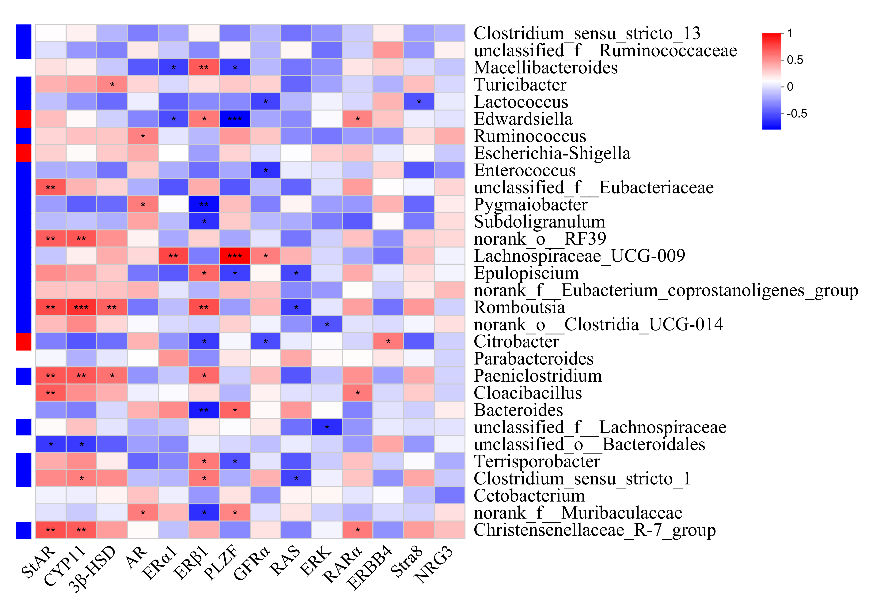
Figure S3: Correlation analysis between intestinal flora and spermatogenesis genes. The right side of the figure is intestinal flora, and the bottom is the name of genes related to spermatogenesis, with red representing a positive correlation and blue representing a negative correlation. *P < 0.05, **P < 0.01, ***P < 0.001.

