Supplementary Figure 2
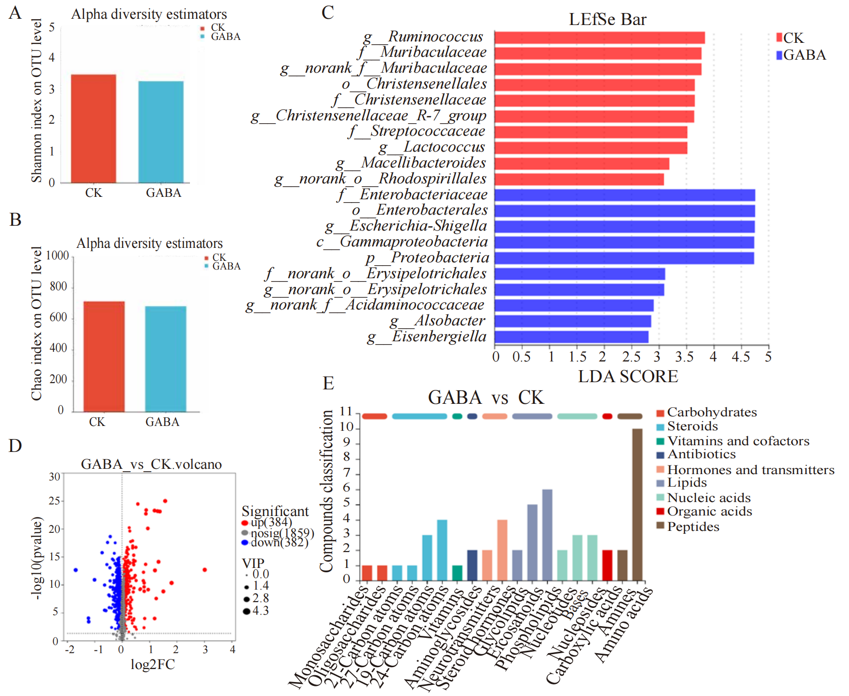
Figure S2: Effects of GABA supplementation on the intestinal microbiota and metabolites of T. s. elegans.
A: Shannon Index. B: Chao index. C: LEfSe Difference Analysis. D: Volcano map of the metabolites differences between the GABA and CK groups. E: Classification of KEGG compounds of differential metabolites between the GABA group and the CK group.

