Supplementary Figure 1
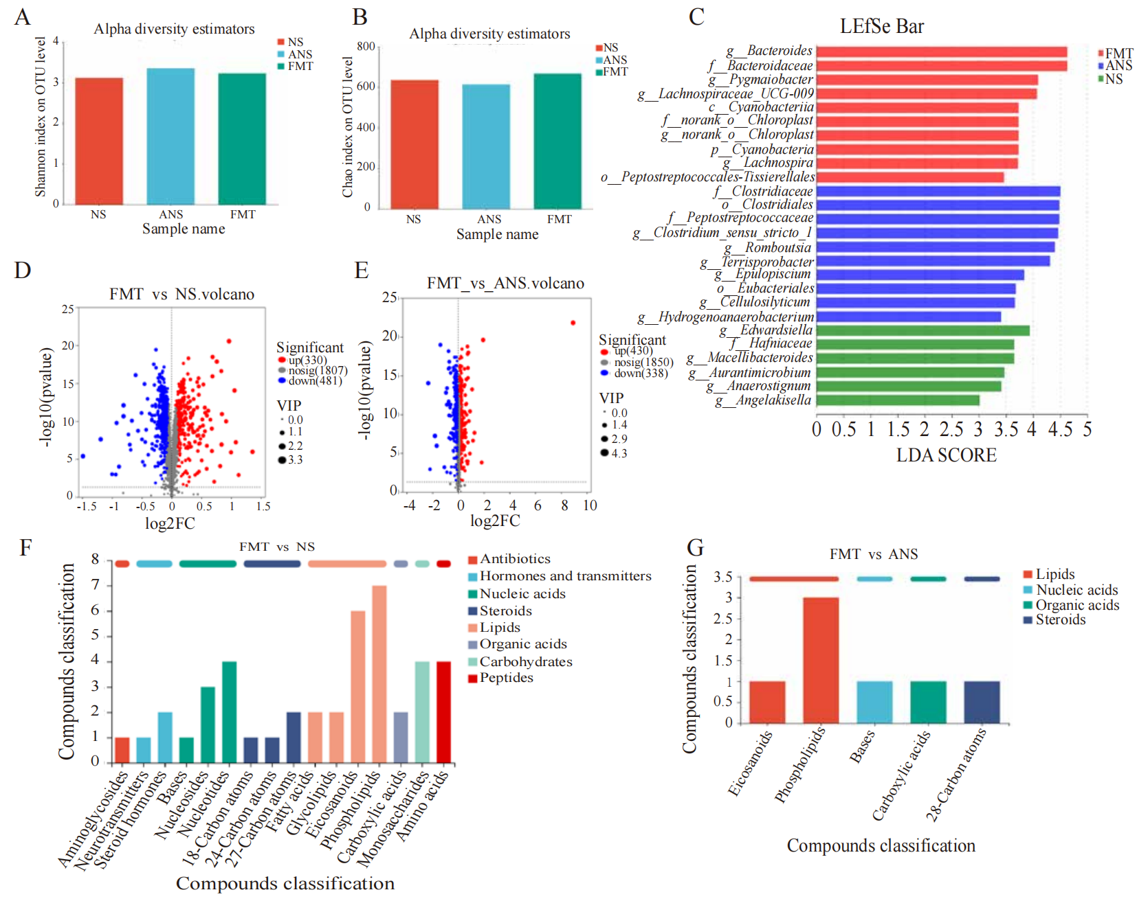
Figure S1: Effect of FMT on the intestinal microbiota and metabolites of T. s. elegans.
A: Shannon Index. B: Chao index. C: LEfSe Difference Analysis. D: Volcano map of the differences between the FMT group and the NS group. E: Volcano map of the differences between the FMT and ANS groups. F: Classification of KEGG compounds of differential metabolites between the FMT group and the NS group. G: Classification of KEGG compounds of differential metabolites between the FMT group and the ANS group.

