Supplementary Information
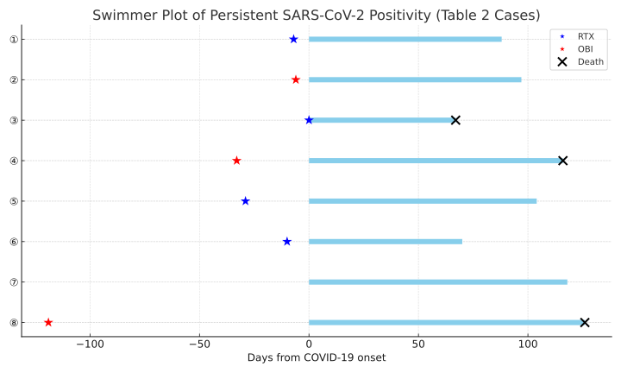
Additional file 1.PNG: Swimmer plot of patients with persistent SARS-CoV-2 NAAT positivity (Table 2 cases).
Each bar represents the duration of NAAT positivity, starting from the day of COVID-19 onset (day 0). Red stars indicate obinutuzumab (OBI) administration, and blue stars indicate rituximab (RTX) administration prior to infection. Black crosses mark the date of death.

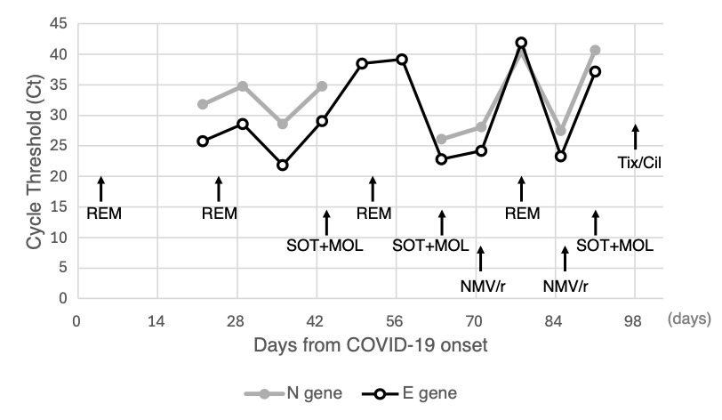
Additional file 2.PNG: A case of SARS-CoV-2 PCR cycle threshold (Ct) value changes during treatment.
Changes in Ct values over time and in response to antiviral treatment are shown for Patient No. 5, who remained NAAT-positive for 91 days (Table 2). Abbreviations: PCR, polymerase chain reaction; NAAT, nucleic acid amplification test; REM, Remdesivir; SOT, Sotrovimab; MOL, Molnupiravir; NMV/r, Nirmatrelvir/Ritonavir; Tix-Cil, tixagevimab-cilgavimab.

