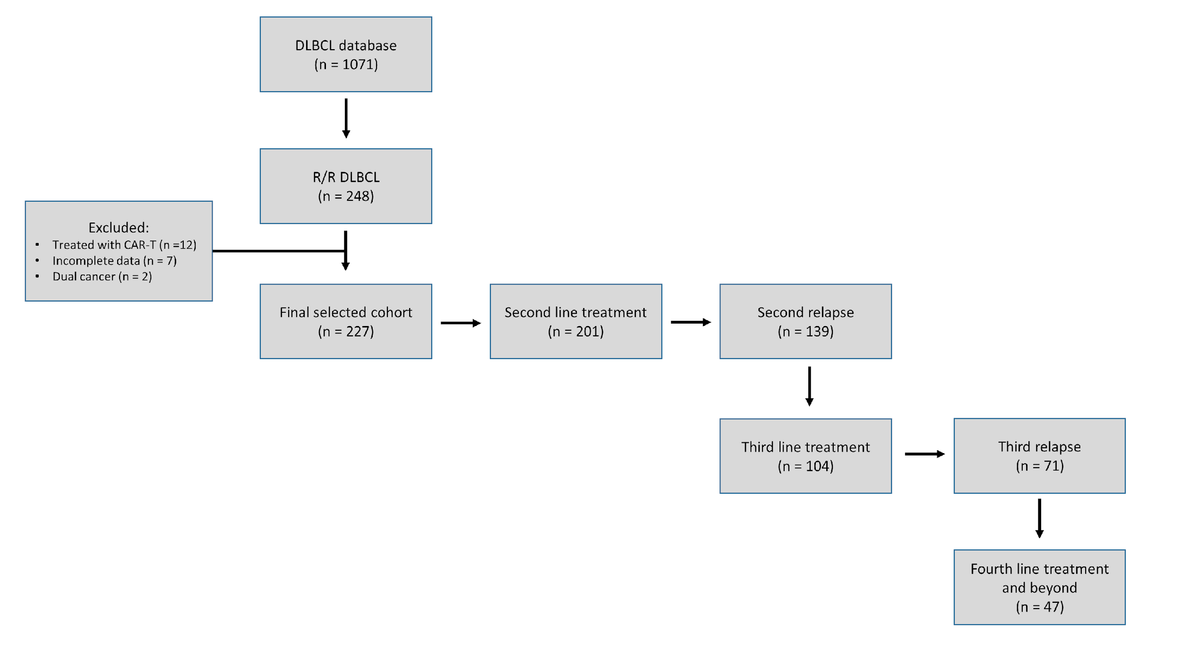
Supplementary Figure 1. Patient inclusion and treatment overview in the study cohort.

Supplementary Figure 2. Time to relapse and survival outcomes. (A-B) Earlier relapse within 24 months confers worse OS and PFS outcomes as compared with later relapses beyond 24 months.

Supplementary Figure 3. Kaplan-Meier plots of overall survival (OS) and progression-free survival (PFS) of relapsed/refractory (R/R) DLBCL from each relapse, stratified by treatment strategy. (A-B) First relapse. (C-D) Second relapse. (E-F) Third relapse.
Supplementary Figure 4. Time to next treatment from 2nd to 4th lines. Median time to next treatment at 15.0 months (2nd to 3rd line), 16.4 months (3rd to 4th line), and 6.0 months (4th to 5th line).

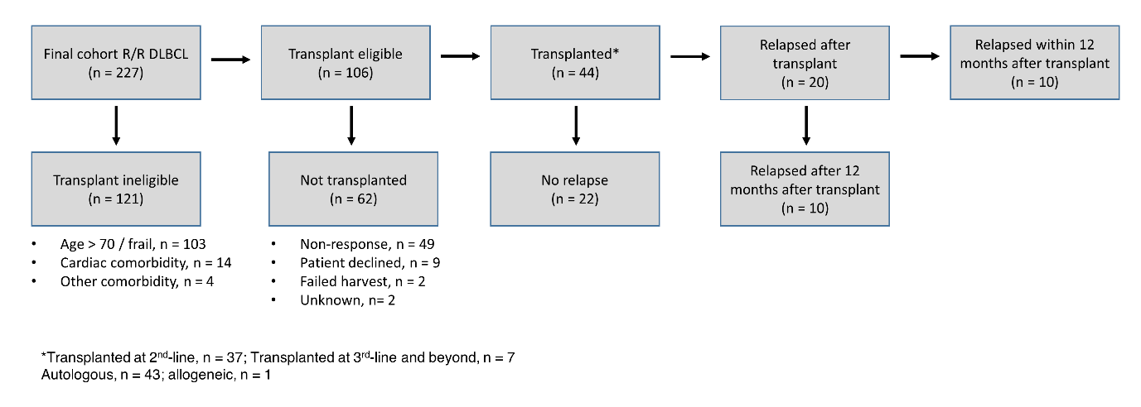
Supplementary Figure 5. Overview of transplant eligibility status and relapse outcomes in the study cohort.

Supplementary Figure 6. Survival outcomes in patients who did or did not undergo stem cell transplantation. (A) Patients who successfully underwent stem cell transplantation had a median PFS of 34.4 months as compared to 3.5 months for those who did not. (B) Similarly, median OS was significantly higher at 114.1 months and 8.5 months, respectively.

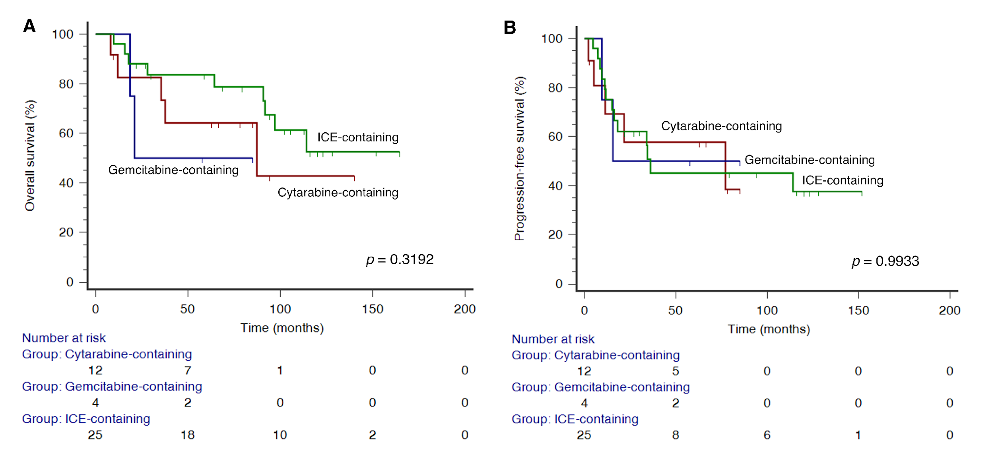
Supplementary Figure 7. Salvage regimens pre-transplant and survival outcomes. (A) Overall survival. (B) Progression-free survival.

Supplementary Figure 8. Outcomes of patients treated with GEMOX regimen. (A) Twenty-nine patients received GEMOX in the second line (n = 17), third line (n = 10), and fourth-line and beyond (n = 2). The majority received GEMOX with rituximab (R-GEMOX) (n = 27). (B) Partial response (27.6%) and complete response (27.6%) rates. (C) Median PFS was 4.8 months. (D) Median OS was 18.4 months. (E) TTNT was 1.9 months.

Supplementary Figure 9. Outcomes of refractory DLBCL as per SCHOLAR-1 criteria, from time of initial relapse. Shown are survival outcomes with or without initiation of salvage therapy.

Supplementary Figure 10. Outcomes of refractory DLBCL as per SCHOLAR-1 criteria, from commencement of salvage therapy. (A) OS outcomes subgrouped by age at relapse. (B) Subgroup by stage at initial diagnosis. (C) Subgroup by IPI scores at initial diagnosis.

Supplementary Table 1. Clinical characteristics of patients treated with GEMOX
Characteristic | n (%)
Total number of patients | 29 (100%)
Sex
Male | 21 (72.4%)
Female | 8 (27.6%)
Age at diagnosis (years)
Median (range) | 71.2 (19.9 to 87.2)
Age at first relapse (years)
Median (range) | 74.0 (20.3 to 88.0)
Primary refractory disease
Yes | 9 (31.0%)
No | 20 (69.0%)
ECOG performance status
0 to 1 | 28 (96.6%)
2 to 4 | 1 (3.4%)
Ann Arbor stage
I-II | 10 (34.5%)
III-IV | 19 (65.5%)
B-symptoms
Present | 12 (41.4%)
Absent | 17 (58.6%)
Serum LDH
Raised (above upper limit of normal) | 20 (69.0%)
Not raised | 9 (31.0%)
Extranodal sites
> 1 | 7 (24.1%)
≤ 1 | 22 (75.9%)
IPI score
Low (0 to 1) | 4 (13.8%)
Low-Intermediate (2) | 11 (37.9%)
High-intermediate (3) | 10 (34.5%)
High (4 to 5) | 4 (13.8%)
Cell of origin
Germinal center | 6 (24.0%)
Non-germinal center | 19 (76.0%)
MYC rearrangement
Present* | 0 (0.0%)
Absent | 11 (100.0%)
Anti-CD20 agent
Rituximab (R-GEMOX) | 27 (93.1%)
Obinutuzumab | 1 (3.4%)
None | 1 (3.4%)
Dosing frequency
Two-weekly | 19 (65.6%)
Three-weekly | 7 (24.1%)
Only single cycle administered | 3 (10.3%)
Line of therapy
Second-line | 17 (58.6%)
Third-line | 10 (34.5%)
Fourth-line and beyond | 2 (6.9%)
Missing data: Cell-of-origin, n = 4; MYC rearrangement status, n = 18

