Supplementary figures

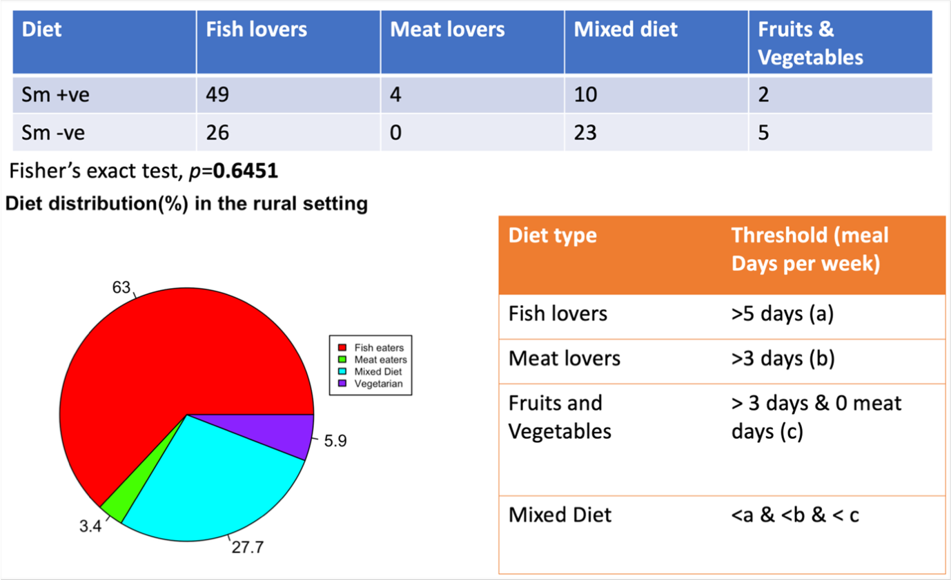
Supplementary figure 1: (A) Summary table indicating the number of Schistosoma mansoni-positive and -negative individuals within each dominant dietary category—fish-heavy, meat-heavy, mixed, and fruit/vegetable-rich diets.
(B) Pie chart illustrating the proportional representation of dietary patterns across the rural cohort, expressed as percentage of participants.
(C) Overview of the decision framework applied to assign dietary categories, based on participant-reported weekly intake frequency of major food groups.

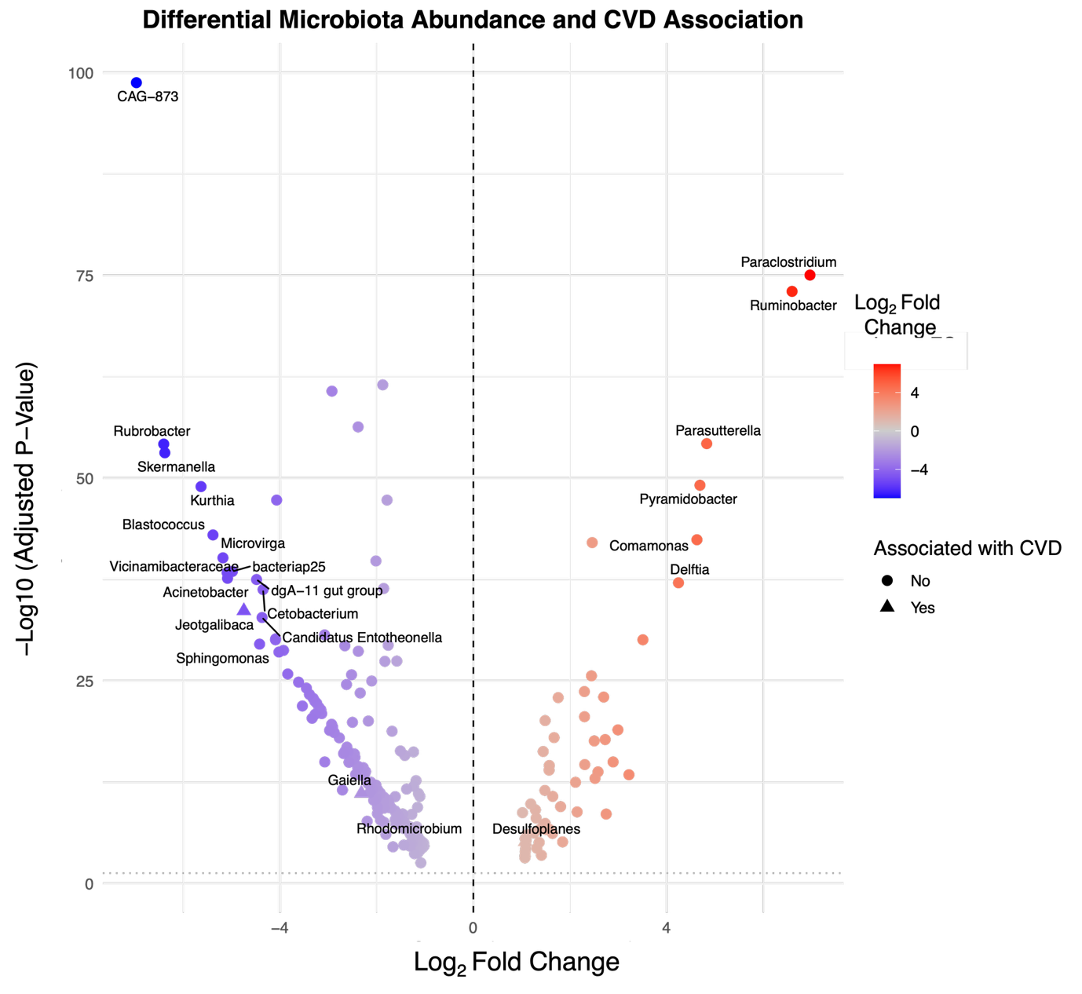
Supplementary figure 2. Volcano plot showing the log₂ fold change in abundance (x-axis) versus the –log₁₀ adjusted p-value (y-axis) for microbial taxa that are differentially abundant between rural and urban individuals. Each point represents a microbial taxon. Taxa to the right of the vertical dashed line are enriched in urban participants, while those to the left are enriched in rural participants. Points are colored by their log₂ fold change, with red indicating higher abundance in rural individuals and blue indicating higher abundance in urban individuals. Labels highlight taxa with statistically significant differences (FDR-adjusted p < 0.05). Triangular points represent taxa that are not only significantly different between rural and urban populations but are also associated with cardiovascular disease (CVD) risk. Circular points denote taxa that are significantly different between settings but are not associated with CVD risk.

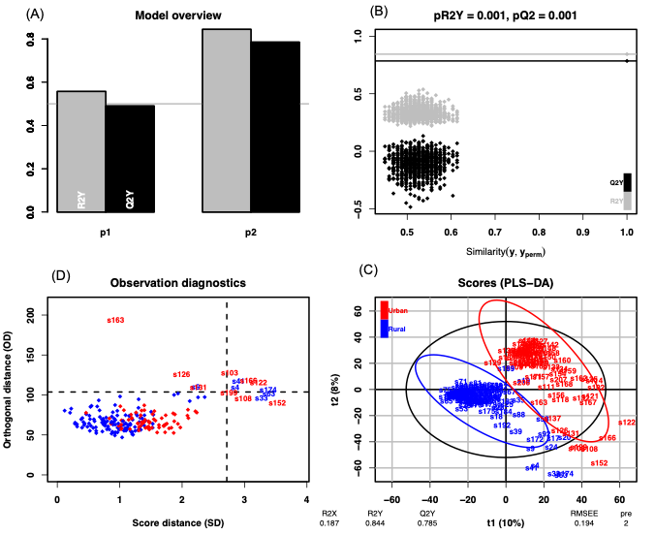
Supplementary Figure 3. Partial Least Squares Discriminant Analysis (PLS-DA) of metabolomic profiles in rural vs. urban participants. (a) Score plot from PLS-DA showing separation between rural (blue) and urban (red) participants along the first two latent components (t1 = 10%, t2 = 8%).
(b) Model quality metrics: R²X = 0.187, R²Y = 0.844, Q²Y = 0.785, indicating strong model fit and predictive performance.
(c) Permutation testing revealed the model’s R²Y and Q²Y were significantly better than random (p < 0.01), supporting the robustness of group separation.
(d) Observation diagnostics plot of score distance (SD) vs. orthogonal distance (OD) identified potential outliers for further inspection.
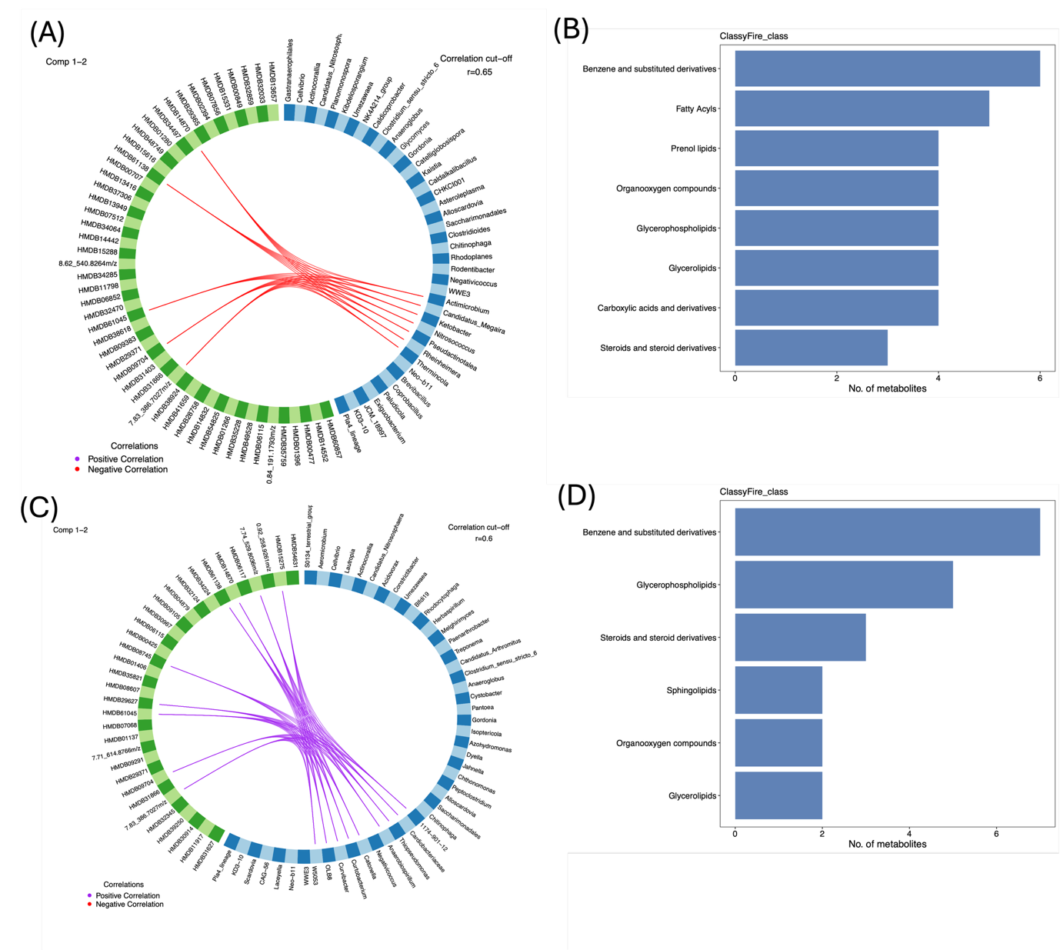
Supplementary figure 4: A Circos plot illustrating the strongest correlations between microbial taxa (blue blocks) and metabolites (green blocks) that were significantly associated with insulin levels, based on linear regression models adjusting for age, sex, BMI, and S. mansoni infection, with environmental setting included as an interaction term (as described in Figure 4B). Only correlations with Spearman’s r ≥ 0.65 are shown.
B Classification of metabolites associated with insulin levels into chemical classes using the ClassyFire algorithm (via the RaMP package in R). The y-axis indicates metabolite classes, while the x-axis shows the number of metabolites per class (represented by blue horizontal bars).
C Circos plot showing microbe–metabolite correlations associated with glucose levels, using the same filtering and visualization strategy as in panel A.
D Classification of glucose-associated metabolites using the same annotation approach as in panel B .

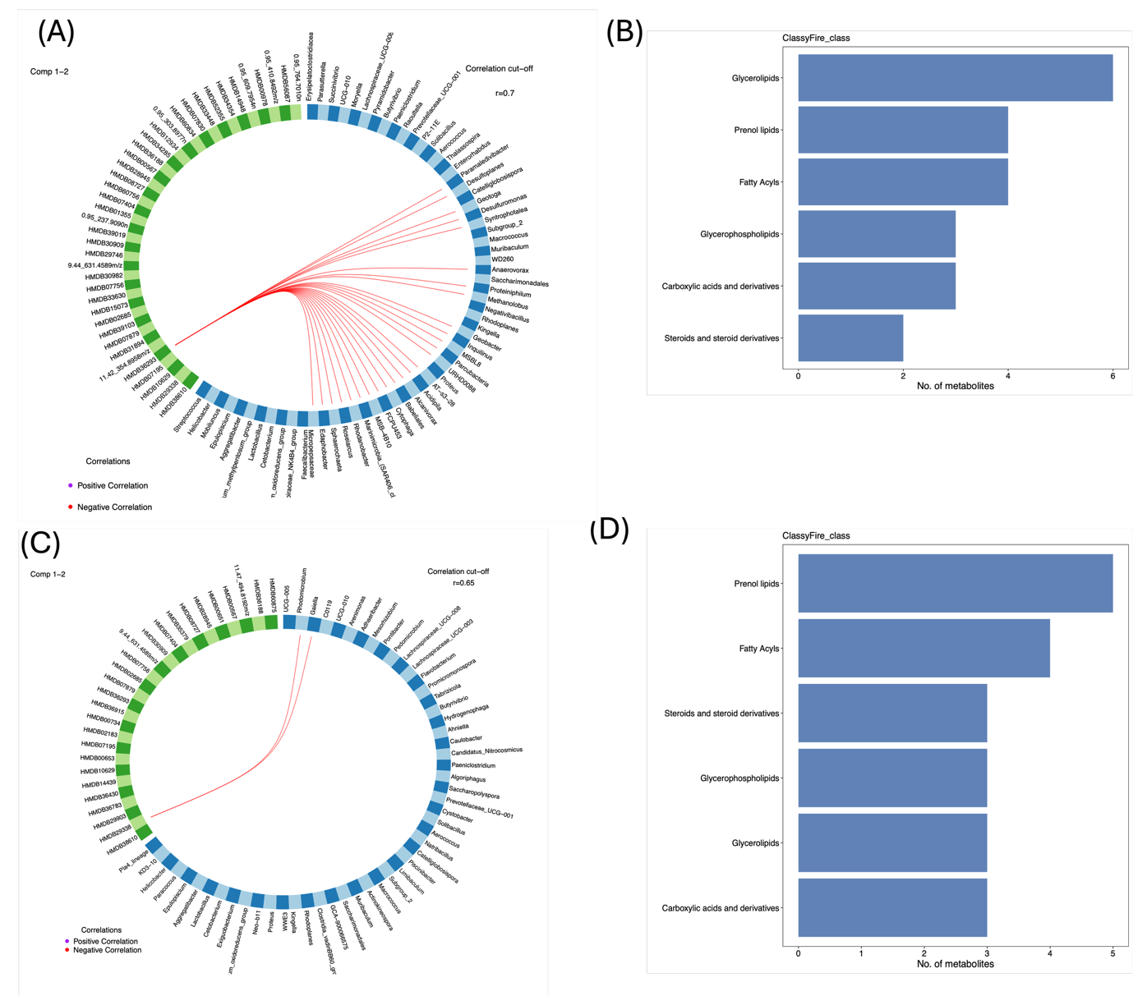
Supplementary figure 5: A Circos plot illustrating the strongest correlations between microbial taxa (blue blocks) and metabolites (green blocks) that were significantly associated with total cholesterol levels, based on linear regression models adjusting for age, sex, BMI, and S. mansoni infection, with environmental setting included as an interaction term (as described in Figure 4B). Only correlations with Spearman’s r ≥ 0.65 are shown.
B Classification of metabolites associated with total cholesterol into chemical classes using the ClassyFire algorithm (via the RaMP package in R). The y-axis indicates metabolite classes, and the x-axis shows the number of metabolites per class (represented by blue horizontal bars).
C Circos plot showing microbe–metabolite correlations associated with LDL cholesterol levels, using the same filtering and visualization strategy as in panel A.
D Classification of LDL cholesterol-associated metabolites using the same annotation approach as in panel B

log2FoldChange | Adjusted p-value | Setting | taxa | metabolite | correlation | Absolute correlation |  | CVD risk factor
-1.5585 | 2.82E-09 | Rural | Rhodomicrobium | HMDB29338 | -0.6671 | 0.6671 |  | LDL Cholesterol
-2.3166 | 7.18E-12 | Rural | Gaiella | HMDB29338 | -0.6647 | 0.6647 |  | LDL Cholesterol
1.0731 | 6.92E-06 | Urban | Desulfoplanes | HMDB36293 | -0.7183 | 0.7183 |  | Total Cholesterol
-4.7479 | 2.26E-34 | Rural | Jeotgalibaca | HMDB42648 | -0.7022 | 0.7022 |  | Diastolic BP
-4.7479 | 2.26E-34 | Rural | Jeotgalibaca | HMDB50197 | -0.7005 | 0.7005 |  | Diastolic BP
-4.7479 | 2.26E-34 | Rural | Jeotgalibaca | HMDB34644 | -0.7090 | 0.7090 |  | Diastolic BP
-4.7479 | 2.26E-34 | Rural | Jeotgalibaca | 0.95_135.9755n | -0.7032 | 0.7032 |  | Systolic BP
-4.7479 | 2.26E-34 | Rural | Jeotgalibaca | HMDB01553 | -0.7381 | 0.7381 |  | Systolic BP
-4.7479 | 2.26E-34 | Rural | Jeotgalibaca | 0.95_271.9515n | -0.7711 | 0.7711 |  | Systolic BP
-4.7479 | 2.26E-34 | Rural | Jeotgalibaca | 0.95_380.9005m/z | -0.7645 | 0.7645 |  | Systolic BP
-4.7479 | 2.26E-34 | Rural | Jeotgalibaca | 0.95_430.9152m/z | -0.7376 | 0.7376 |  | Systolic BP
-4.7479 | 2.26E-34 | Rural | Jeotgalibaca | HMDB10408 | -0.7801 | 0.7801 |  | Systolic BP
-4.7479 | 2.26E-34 | Rural | Jeotgalibaca | HMDB43260 | -0.7675 | 0.7675 |  | Systolic BP
-4.7479 | 2.26E-34 | Rural | Jeotgalibaca | HMDB13327 | -0.7184 | 0.7184 |  | Systolic BP
-4.7479 | 2.26E-34 | Rural | Jeotgalibaca | 0.95_611.8881n | -0.7649 | 0.7649 |  | Systolic BP
-4.7479 | 2.26E-34 | Rural | Jeotgalibaca | 0.95_695.8497n | -0.7867 | 0.7867 |  | Systolic BP
-4.7479 | 2.26E-34 | Rural | Jeotgalibaca | 0.95_763.8375n | -0.7837 | 0.7837 |  | Systolic BP
-4.7479 | 2.26E-34 | Rural | Jeotgalibaca | HMDB13228 | -0.7499 | 0.7499 |  | Systolic BP
-4.7479 | 2.26E-34 | Rural | Jeotgalibaca | HMDB30077 | -0.7540 | 0.7540 |  | Systolic BP
-4.7479 | 2.26E-34 | Rural | Jeotgalibaca | HMDB43165 | -0.7837 | 0.7837 |  | Systolic BP
-4.7479 | 2.26E-34 | Rural | Jeotgalibaca | HMDB04948 | -0.7856 | 0.7856 |  | Systolic BP
-4.7479 | 2.26E-34 | Rural | Jeotgalibaca | 0.95_860.7565m/z | -0.7604 | 0.7604 |  | Systolic BP
-4.7479 | 2.26E-34 | Rural | Jeotgalibaca | HMDB15207 | -0.7703 | 0.7703 |  | Systolic BP
-4.7479 | 2.26E-34 | Rural | Jeotgalibaca | HMDB42596 | -0.7461 | 0.7461 |  | Systolic BP
-4.7479 | 2.26E-34 | Rural | Jeotgalibaca | HMDB48984 | -0.7864 | 0.7864 |  | Systolic BP
-4.7479 | 2.26E-34 | Rural | Jeotgalibaca | HMDB43454 | -0.7756 | 0.7756 |  | Systolic BP
-4.7479 | 2.26E-34 | Rural | Jeotgalibaca | HMDB47975 | -0.7161 | 0.7161 |  | Systolic BP
-4.7479 | 2.26E-34 | Rural | Jeotgalibaca | HMDB48496 | -0.7844 | 0.7844 |  | Systolic BP
-4.7479 | 2.26E-34 | Rural | Jeotgalibaca | HMDB44985 | -0.7626 | 0.7626 |  | Systolic BP
-4.7479 | 2.26E-34 | Rural | Jeotgalibaca | HMDB53370 | -0.7388 | 0.7388 |  | Systolic BP
-4.7479 | 2.26E-34 | Rural | Jeotgalibaca | HMDB43249 | -0.7004 | 0.7004 |  | Systolic BP
-4.7479 | 2.26E-34 | Rural | Jeotgalibaca | HMDB42648 | -0.7784 | 0.7784 |  | Systolic BP
-4.7479 | 2.26E-34 | Rural | Jeotgalibaca | HMDB45328 | -0.7410 | 0.7410 |  | Systolic BP
-4.7479 | 2.26E-34 | Rural | Jeotgalibaca | HMDB31392 | -0.7198 | 0.7198 |  | Systolic BP
-4.7479 | 2.26E-34 | Rural | Jeotgalibaca | HMDB43537 | -0.7141 | 0.7141 |  | Systolic BP
-4.7479 | 2.26E-34 | Rural | Jeotgalibaca | HMDB53376 | -0.7843 | 0.7843 |  | Systolic BP
-4.7479 | 2.26E-34 | Rural | Jeotgalibaca | HMDB33727 | -0.7020 | 0.7020 |  | Systolic BP
-4.7479 | 2.26E-34 | Rural | Jeotgalibaca | HMDB50197 | -0.7788 | 0.7788 |  | Systolic BP
-4.7479 | 2.26E-34 | Rural | Jeotgalibaca | HMDB49027 | -0.7612 | 0.7612 |  | Systolic BP
-4.7479 | 2.26E-34 | Rural | Jeotgalibaca | HMDB34644 | -0.7971 | 0.7971 |  | Systolic BP
-4.7479 | 2.26E-34 | Rural | Jeotgalibaca | HMDB54231 | -0.7124 | 0.7124 |  | Systolic BP
-4.7479 | 2.26E-34 | Rural | Jeotgalibaca | HMDB56291 | -0.7688 | 0.7688 |  | Systolic BP
-4.7479 | 2.26E-34 | Rural | Jeotgalibaca | HMDB53513 | -0.7130 | 0.7130 |  | Systolic BP
-4.7479 | 2.26E-34 | Rural | Jeotgalibaca | HMDB15424 | -0.7586 | 0.7586 |  | Systolic BP
-4.7479 | 2.26E-34 | Rural | Jeotgalibaca | 0.95_988.7020m/z | -0.7582 | 0.7582 |  | Systolic BP
-4.7479 | 2.26E-34 | Rural | Jeotgalibaca | HMDB11595 | -0.7450 | 0.7450 |  | Systolic BP
Supplementary table 2: Differentially abundant gut microbiota by setting (rural vs urban) and their correlations with CVD-associated metabolites. This table presents microbial taxa that were significantly enriched in either rural or urban populations, based on differential abundance analysis (log₂ fold change and adjusted p-value). For each taxon, the table lists its corresponding metabolite and associated cardiovascular disease (CVD) risk factor, as depicted in the network shown in Figure 7. Microbiota–metabolite correlations are reported as Pearson correlation coefficients, where negative values indicate a potential inverse relationship between microbial abundance and metabolite concentration. CVD risk factors include diastolic blood pressure, total cholesterol, and LDL cholesterol.

