Supplementary online materials

Statistical analyses of tomato landraces and hybrids vegetative and generative parameters, significant p values are green marked in tables.
Table S1. Plants height parameters statistically analyses

Table S2. Leaf number parameters statistically analyses

Table S3. Number of flowers parameters statistically analyses

Table S4. Flower-set parameters statistically analyses

Table S5. Fruit width parameters statistically analyses

Table S6. Fruit length parameters statistically analyses

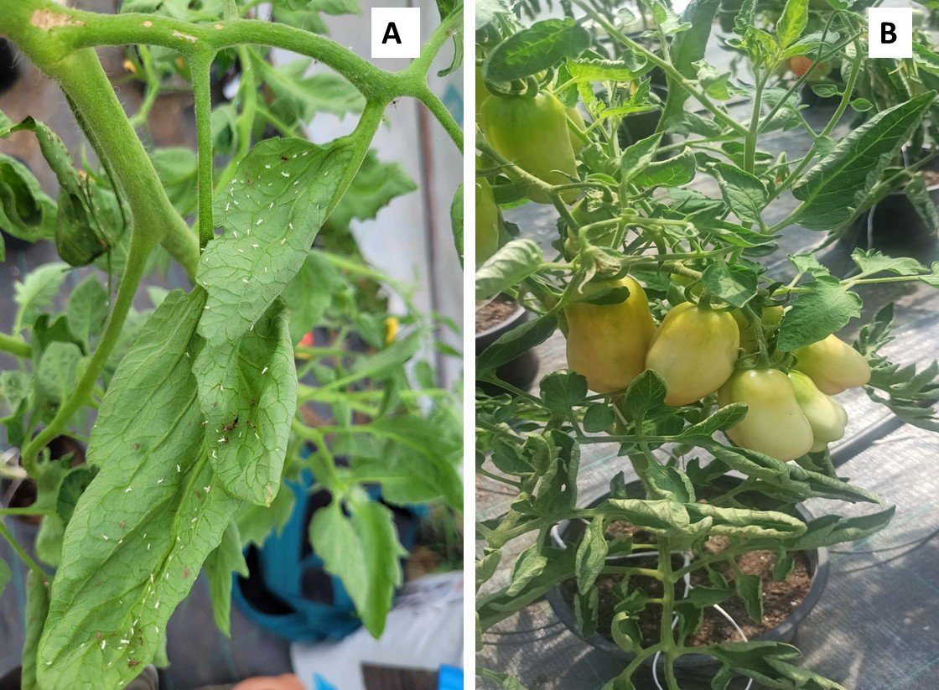
Figure S1. Glasshouse whitefly (Trialeurodes vaporariorum) exuvia on Hybrid (A), and landrace without pests and diseases (B).

