THE ASSOCIATION BETWEEN THE ERROR-RELATED NEGATIVITY AND SELF-CONTROL IS MODERATED BY IMPULSIVITY AND COMPULSIVITY
SUPPLEMENT

Supplement 1: Sample characteristics 2
Supplement 2: The effects of impulsivity and compulsivity on desire enactment 6
Supplement 3: The effects of impulsivity and compulsivity on the association between the ERN and desire enactment 8
Supplement 4: Additional analyses regarding the correct-related negativity and behavioral parameters 16
References 17

Supplement 1: Sample characteristics
See Tab. S1 for psychopathological symptoms and personality traits sample characteristics, Fig. S1 for correlations between these measures, and Tab. S2 for measures of performance monitoring and task performance and Fig. S2 for a depiction of the error-related negativity (ERN) and the correct-related negativity (CRN). Psychopathological symptoms and personality traits potentially related to goal-directed control assessed in the laboratory. Impulsivity was assessed using the 11th version of the Barratt Impulsiveness Scale (BIS-11) [1,2] which is conceptualized in terms of attentional, motor and non-planning impulsivity facets. The total score yields good internal consistency (α = .83)[2]. Compulsivity was assessed using the Obsessive-Compulsive Inventory-Revised (OCI-R) [3,4]. The total score determines the severity of obsessive-compulsive symptoms (including washing, checking, doubting, ordering, obsessing, hoarding, and neutralizing) and yields good internal consistency (α = .85) [4]. Additional impulsivity facets were assessed using the Urgency, Premeditation (lack of), Perseverance (lack of), Sensation Seeking, Impulsive Behavior Scale [5-7]. Depression, anxiety and worry were measured using the Depression Anxiety Stress Scales [8], the State-Trait Inventory for Cognitive and Somatic Anxiety [9], and the Penn State Worry Questionnaire [10]. Habitual propensity was operationalized using the Creature of Habit Scale [11,12]. Behavioral inhibition and activation were measured using the BIS/BAS scales [13,14].
Table S1. Sample characteristics derived from questionnaire data
 | Mean | SD | Range
Impulsivity | 60.57 | 8.95 | 38 - 96
Compulsivity | 12.74 | 9.33 | 0 - 46
Urgency | 26.31 | 5.86 | 14 - 43
Lack of premeditation | 22.38 | 4.36 | 13 - 38
Lack of perseverance | 19.38 | 4.29 | 10 - 31
Sensation  seeking | 33.05 | 7.04 | 14 - 46
Depression  (DASS-21) | 2.76 | 2.94 | 0 - 19
Anxiety  (DASS-21) | 1.89 | 2.57 | 0 - 20
Somatic anxiety | 14.40 | 2.84 | 11 - 26
Cognitive anxiety | 15.81 | 3.98 | 10 - 32
Worry | 43.22 | 11.39 | 22 - 74
Automaticity | 29.80 | 7.79 | 11 - 51
Routine | 51.23 | 9.24 | 27 - 75
Behavioral  inhibition | 20.29 | 3.68 | 10 - 28
Behavioral  activation | 40.39 | 4.56 | 26 - 52
Impulsivity and compulsivity: Barratt Impulsiveness Scale, revised [1]; Obsessive-Compulsive Inventory-Revised [3,4]; additional impulsivity facets: Urgency, Lack of premeditation, Lack of perseverance, Sensation seeking, Impulsive Behavior Scale [5-7]; Depression (DASS-21) and Anxiety (DASS-21): Depression Anxiety Stress Scales [8]; Somatic and Cognitive anxiety: State-Trait Inventory for Cognitive and Somatic Anxiety [9]; Rumination: Penn State Worry Questionnaire [10]; Automaticity and Routine: subscales of habitual propensity measure Creature of Habit Scale [11,12]; Behavioral inhibition and activation: BIS/BAS scales [13,14].

Fig. S1: Correlations between sample questionnaire scores.
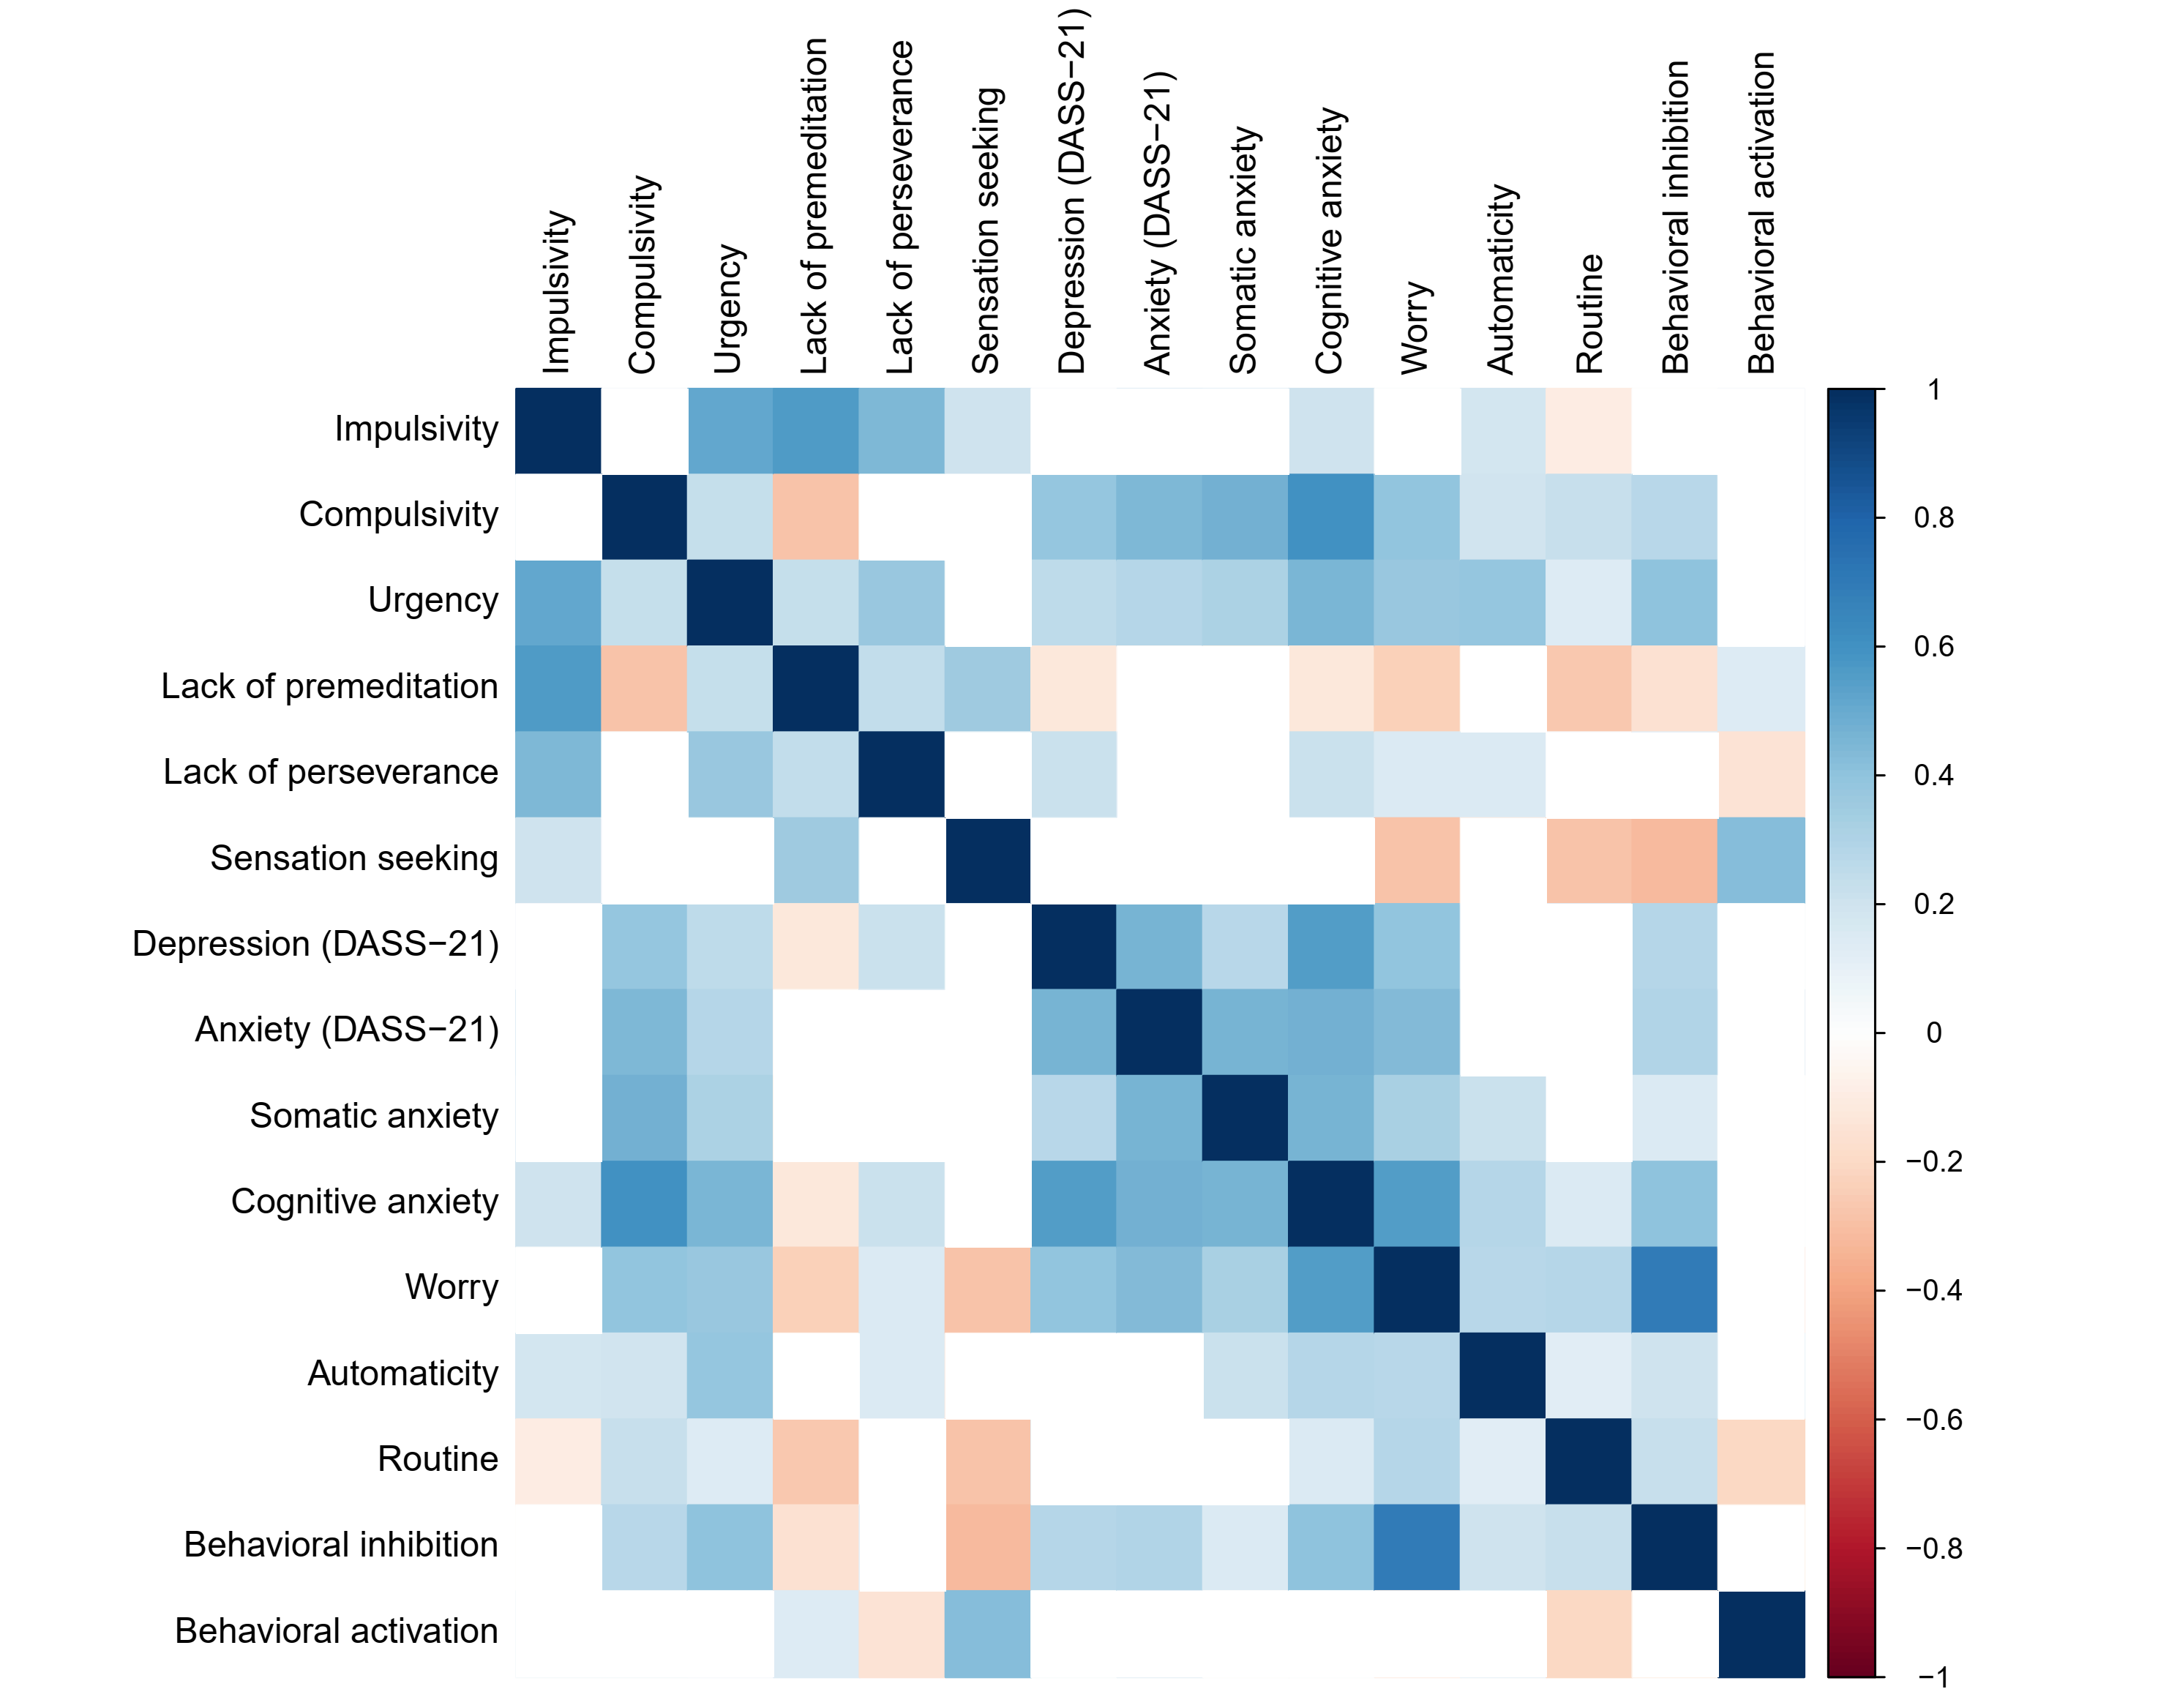
Heat map depicting all correlation coefficients (Spearman’s correlations, two-tailed), p-values were corrected using the Bonferroni method (p < 0.0004), and white squares denote non-significant correlations. Impulsivity and compulsivity: Barratt Impulsiveness Scale, revised [1]; Obsessive-Compulsive Inventory-Revised [3,4]; additional impulsivity facets: Urgency, Lack of premeditation, Lack of perseverance, Sensation seeking, Impulsive Behavior Scale [5-7]; Depression (DASS-21) and Anxiety (DASS-21): Depression Anxiety Stress Scales [8]; Somatic and Cognitive anxiety: State-Trait Inventory for Cognitive and Somatic Anxiety [9]; Worry: Penn State Worry Questionnaire [10]; Automaticity and Routine: subscales of habitual propensity measure Creature of Habit Scale [11,12]; Behavioral inhibition and activation: BIS/BAS scales [13,14].

Table S2. Sample characteristics derived from the monetary incentive Flanker task: Measures of performance monitoring and task performance
 | Mean | SD | Range
EEG (μV)
ERN | -4.48 | 2.89 | -15.29 – 2.64
ERN gain | -4.43 | 3.01 | -15.44 – 2.89
ERN loss | -4.56 | 2.89 | -15.17 – 2.36
CRN gain | -0.32 | 2.87 | -13.91 – 8.13
CRN loss | -0.53 | 2.81 | -8.39 – 8.30
Accuracy (%)
Error rate | 17.76 | 7.94 | 5.31 – 39.01
PEA | 75.72 | 15.38 | 33.78 – 97.92
Reaction times (ms)
PES | -1.90 | 14.93 | -93.35 – 33.06
RT error | 253.60 | 24.12 | 193.25 – 374.21
RT correct | 375.35 | 31.74 | 286.00 – 510.29
ERN, error-related negativity; CRN, correct-related negativity; Error rate, percentage of errors; PEA, Post-error accuracy; RT, reaction time; PES, post-error slowing; Error reaction times refer to all incongruent error trials; Correct reaction times refer to incongruent correct trials.

Fig. S2: Depiction of the error-related negativity and the correct-related negativity.
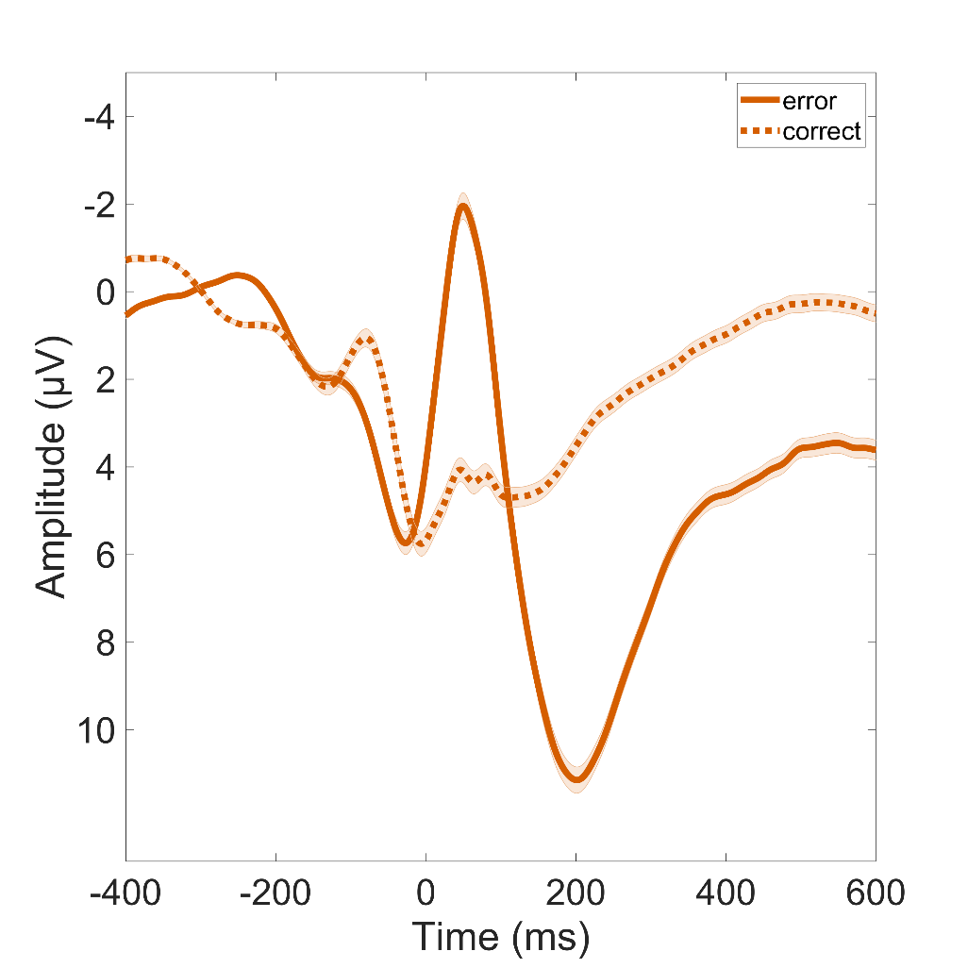
Time course of mean response-locked incongruent error and correct trials for the complete sample at Fz, FCz and Cz. Shades indicate the standard error of the mean (SEM).

Supplement 2: The effects of impulsivity and compulsivity on desire enactment
Predicting enactment. We fitted a logistic mixed-effects model to predict desire enactment with desire strength, conflict strength, impulsivity and compulsivity; and desire and conflict strength as random effects. Within this model, desire strength had a significant positive effect on enactment (β = 5.75, 95% CI [5.27, 6.24], p < .001; β_{standardized} = 3.38, 95% CI [3.18, 3.58]), conflict strength had a significant negative effect (β = -1.83, 95% CI [-2.08, -1.57], p < .001; β_{standardized} = -1.33, 95% CI [-1.46, -1.19]), impulsivity was not significant (β = -0.03, 95% CI [-0.77, 0.71], p = 0.938; β_{standardized} = -0.02, 95% CI [-0.13, 0.09]) and compulsivity showed a significant positive effect (β = 0.31, 95% CI [0.06, 0.56], p = 0.016; β_{standardized} = 0.11, 95% CI [0.01, 0.21]). Both interaction effects were significant (impulsivity and compulsivity with desire strength: β = -0.67, 95% CI [-1.12, -0.23], p = 0.003; β_{standardized} = 0.03, 95% CI [-0.13, 0.18]; impulsivity and compulsivity with conflict strength: β = 0.41, 95% CI [0.18, 0.65], p < .001; β_{standardized} = 0.02, 95% CI [-0.09, 0.13]). The model's total explanatory power was substantial (conditional R² = 0.78) and the part related to the fixed effects alone (marginal R²) was 0.66. The model's intercept, corresponding to desire strength = 0, conflict strength = 0, impulsivity = 0, and compulsivity = 0, was at -3.49 (95% CI [-4.29, -2.68], p < .001).
Table S3. Statistics for the full model analyzing the effect of impulsivity and compulsivity on desire enactment
 | Enactment
Predictors | Odds Ratios | CI | p
(Intercept) | 0.03 | 0.01 – 0.07 | <0.001
Desire strength | 314.85 | 193.86 – 511.36 | <0.001
Conflict strength | 0.16 | 0.12 – 0.21 | <0.001
Impulsivity | 0.97 | 0.46 – 2.04 | 0.938
Compulsivity | 1.36 | 1.06 – 1.75 | 0.016
Desire strength:Impulsivity:Compulsivity | 0.51 | 0.32 – 0.80 | 0.003
Conflict strength:Impulsivity:Compulsivity | 1.51 | 1.19 – 1.91 | 0.001
Random Effects
σ² | 3.29
τ₀₀ _{Participant} | 0.29
τ₁₁ _{Participant.Desire strength} | 2.66
τ₁₁ _{Participant.Conflict strength} | 0.73
ρ₀₁ | -0.59
 | 0.35
ICC | 0.35
N _{Participant} | 221
Observations | 12353
Marginal R² / Conditional R² | 0.660 / 0.778

Impulsivity and compulsivity also significantly interacted with desire strength and conflict strength: in high impulsivity, high compulsivity led to an even weaker influence of desire and conflict strength on enactment. This was investigated using a simple slopes analysis.
For desire strength, the analysis revealed that, at low levels of impulsivity, the slope of desire strength was positive and significant across all levels of compulsivity (low compulsivity: β = 5.63, SE = 0.22, 95% CI [5.21, 6.05]; moderate compulsivity: β = 5.29, SE = 0.16, 95% CI [4.99, 5.60]; high compulsivity: β = 4.96, SE = 0.17, 95% CI [4.63, 5.29]). As impulsivity increased to moderate levels, the strength of the relationship between desire strength and enactment slightly weakened but remained significant, particularly at higher levels of compulsivity (low compulsivity: β = 5.61, SE = 0.21, 95% CI [5.19, 6.02]; moderate compulsivity: β = 5.22, SE = 0.15, 95% CI [4.92, 5.52]; high compulsivity: β = 4.82, SE = 0.20, 95% CI [4.44, 5.21]). At high levels of impulsivity, the strength of the relationship continued to weaken across all levels of compulsivity (low compulsivity: β = 5.59, SE = 0.206, 95% CI [5.18, 5.99]; moderate compulsivity: β = 5.14, SE = 0.153, 95% CI [4.84, 5.44]; high compulsivity: β = 4.69, SE = 0.227, 95% CI [4.24, 5.13]), but remained significant. These results suggest that desire strength is a stronger predictor of enactment when individuals score lower on impulsivity and compulsivity. For conflict strength, the analysis revealed that, at low levels of impulsivity, the association between conflict strength and enactment was negative and significant across all levels of compulsivity, with decreasing magnitude as compulsivity increases (low compulsivity: β = -1.75, SE = 0.1128, 95% CI [-1.97, -1.53]; moderate compulsivity: β = -1.55, SE = 0.0813, 95% CI [-1.71, -1.39]; high compulsivity: β = -1.35, SE = 0.0868, 95% CI [-1.52, -1.18]). At moderate levels of impulsivity, the strength of the negative relationship between conflict strength and enactment decreased slightly but remained significant (low compulsivity: β = -1.74, SE = 0.1101, 95% CI [-1.96, -1.52]; moderate compulsivity: β = -1.50, SE = 0.0787, 95% CI [-1.66, -1.35]; high compulsivity: β = -1.26, SE = 0.0997, 95% CI [-1.46, -1.07]). At high levels of impulsivity, the negative association remained significant but weakened slightly (low compulsivity: β = -1.73, SE = 0.1075, 95% CI [-1.94, -1.52]; moderate compulsivity: β = -1.45, SE = 0.0785, 95% CI [-1.61, -1.30]; high compulsivity: β = -1.18, SE = 0.1163, 95% CI [-1.41, -0.95]). Slopes decreased in magnitude with increasing compulsivity. Therefore, there is evidence that both impulsivity and compulsivity lead to a weaker association between desire strength and enactment, as well as conflict strength and enactment.
Multiple regression for consistency with previous analyses. To establish consistency with previous analyses from our group [15] we additionally used an operationalization of self-control failures where the enactment of conflict-laden desires was divided by the number of questionnaires participants had responded to. Compulsivity also significantly predicted the proportion of enacted conflict-laden desires in all reported situations (β = 0.04, p < 0.001), while impulsivity did not (β = 0.07, p = 0.164). The regression model was significant (adjusted R² = 0.05, F(2, 218) = 7.36, p < 0.001) and an interaction between impulsivity and compulsivity yielded no additional explanatory effect. Our analyses therefore revealed evidence for high compulsivity leading to more self-control failures, confirming our initial hypothesis, while high impulsivity does not, against our expectations.
Predicting desire and conflict. We also fitted generalized linear models to predict desire occurrence, reported conflict and conflict strength with impulsivity and compulsivity. Compulsivity predicted desire occurrence (β = 0.07, p = 0.003) and both conflict reporting (β = 0.05, p = 0.004) and conflict strength (β = 0.22, p = 0.002). There were no effects of impulsivity (desire: β = -0.05, p = 0.597; conflict: β = 0.07, p = 0.342; conflict strength: β = 0.14, p = 0.626) and no additional explanatory effect of an interaction between impulsivity and compulsivity. All regression models were statistically significant (desire: adjusted R² = 0.03, F(2, 218) = 4.59, p = 0.011; conflict: adjusted R² = 0.03, F(2, 218) = 4.58, p = 0.011; conflict strength: adjusted R² = 0.04, F(2, 218) = 5.20, p = 0.006). Thus, none of our hypotheses were confirmed: high compulsivity was associated with reporting more desires, conflict reporting and conflict strength, while impulsivity was not.

Supplement 3: The effects of impulsivity and compulsivity on the association between the ERN and desire enactment
As there is evidence for a connection between error-related brain activity and self-control [15,16] but also evidence for altered performance monitoring in disorders characterized by impulsivity and compulsivity, we wanted to investigate the moderating effect of these two traits on the association between the ERN and self-control. We fitted logistic mixed-effects models to predict desire enactment with desire strength, conflict strength, the ERN, impulsivity and compulsivity. The models included desire and conflict strength as random effects. Within the base model, the effect of desire strength was statistically significant and positive (β = 5.22, 95% CI [4.91, 5.52], p < .001; β_{standardized} = 3.38, 95% CI [3.18, 3.58]). The effect of conflict strength was statistically significant and negative (β = -1.49, 95% CI [-1.65, -1.33], p < .001; β_{standardized} = -1.32, 95% CI [-1.46, -1.18]). The effect of the ERN was statistically non-significant and positive (β = 0.11, 95% CI [-0.08, 0.31], p = 0.258; β_{standardized} = 0.06, 95% CI [-0.05, 0.17]). The model’s total explanatory power was substantial (conditional R² = 0.78) and the part related to the fixed effects alone (marginal R²) was of 0.66. The model’s intercept, corresponding to desire strength = 0, conflict strength = 0, and ERN = 0, was at -3.18 (95% CI [-3.41, -2.95], p < .001).
Table S4. Statistics for the base model analyzing the effect of impulsivity and compulsivity on the association between the ERN and enactment
 | Enactment
Predictors | Odds Ratios | CI | p
(Intercept) | 0.04 | 0.03 – 0.05 | <0.001
Desire strength | 184.77 | 136.30 – 250.48 | <0.001
Conflict strength | 0.22 | 0.19 – 0.26 | <0.001
ERN | 1.12 | 0.92 – 1.37 | 0.258
Random Effects
σ² | 3.29
τ₀₀ _{Participant} | 0.32
τ₁₁ _{Participant.Desire_strength} | 2.80
τ₁₁ _{Participant.Conflict_strength} | 0.79
ρ₀₁ | -0.62
 | 0.40
ICC | 0.36
N _{Participant} | 221
Observations | 12353
Marginal R² / Conditional R² | 0.656 / 0.779

Within the full model including an interaction term with impulsivity and compulsivity, the effect of desire strength was statistically significant and positive (β = 5.22, 95% CI [4.91, 5.52], p < .001; β_{standardized} = 3.38, 95% CI [3.18, 3.58]). The effect of conflict strength was statistically significant and negative (β = -1.50, 95% CI [-1.65, -1.34], p < .001; β_{standardized} = -1.32, 95% CI [-1.46, -1.18]). Interestingly, the effect of the ERN was statistically significant and positive (β = 0.26, 95% CI [0.02, 0.51], p = 0.033; β_{standardized} = 0.06, 95% CI [-0.05, 0.17]). Finally, the interaction effect of the ERN with impulsivity and compulsivity was statistically significant and negative (β = -0.20, 95% CI [-0.38, -0.01], p = 0.034; β_{standardized} = 0.01, 95% CI [-0.12, 0.12]). The model’s total explanatory power was substantial (conditional R² = 0.78) and the part related to the fixed effects alone (marginal R²) was of 0.66. The model’s intercept, corresponding to desire strength = 0, conflict strength = 0, ERN = 0, impulsivity = 0 and compulsivity = 0, was at -3.18 (95% CI [-3.41, -2.95], p < .001).

Table S5. Statistics for the full model analyzing the effect of impulsivity and compulsivity on the association between the ERN and enactment
 | Enactment
Predictors | Odds Ratios | CI | p
(Intercept) | 0.04 | 0.03 – 0.05 | <0.001
Desire strength | 184.30 | 135.84 – 250.06 | <0.001
Conflict strength | 0.22 | 0.19 – 0.26 | <0.001
ERN | 1.30 | 1.02 – 1.66 | 0.033
ERN:Impulsivity:Compulsivity | 0.82 | 0.68 – 0.99 | 0.034
Random Effects
σ² | 3.29
τ₀₀ _{Participant} | 0.29
τ₁₁ _{Participant.Desire strength} | 2.83
τ₁₁ _{Participant.Conflict strength} | 0.79
ρ₀₁ | -0.61
 | 0.37
ICC | 0.36
N _{Participant} | 221
Observations | 12353
Marginal R² / Conditional R² | 0.657 / 0.780

A simple slopes analysis was conducted to investigate the three-way interaction between the ERN, impulsivity and compulsivity. The results suggest that when both compulsivity and impulsivity are low, higher ERN amplitudes significantly predict lower probability of enactment. However, at higher levels of either impulsivity or compulsivity, the relationship between the ERN and enactment becomes non-significant.
The effect of impulsivity at different levels of compulsivity. Slopes for the effect of the ERN on enactment were calculated at low (-1 SD below the mean), moderate (mean), and high (+1 SD above the mean) levels of impulsivity. At low levels of compulsivity and low levels of impulsivity, the slope of the ERN was positive and significant, β = 0.23, SE = 0.11, 95% CI [0.01, 0.45], indicating that as the ERN decreased (indicated by more positive values), the amount of enactments significantly increased. The slope remained positive but marginally non-significant at low compulsivity and moderate levels of impulsivity, β = 0.22, SE = 0.11, 95% CI [−0.01, 0.44], and at low compulsivity and high levels of impulsivity, β = 0.21, SE = 0.11, 95% CI [−0.01, 0.43]. At moderate levels of compulsivity, the slopes of the ERN were non-significant across all levels of impulsivity: At low impulsivity, the slope was β = 0.13, SE = 0.10, 95% CI [−0.07, 0.33]; at moderate impulsivity, β = 0.10, SE = 0.10, 95% CI [−0.09, 0.30]; and at high impulsivity, β = 0.08, SE = 0.10, 95% CI [−0.12, 0.28]. This was also true at high levels of compulsivity: At low impulsivity, the slope was β = 0.03, SE = 0.11, 95% CI [−0.18, 0.24]; at moderate impulsivity, β = −0.01, SE = 0.12, 95% CI [−0.24, 0.22]; and at high impulsivity, β = −0.05, SE = 0.13, 95% CI [−0.30, 0.20].
The effect of compulsivity at different levels of impulsivity. Slopes for the effect of the ERN on enactment were calculated at low (-1 SD below the mean), moderate (mean), and high (+1 SD above the mean) levels of compulsivity. At low levels of impulsivity and low levels of compulsivity, the slope of the ERN was positive and significant, β = 0.23, SE = 0.11, 95% CI [0.01, 0.45], indicating that as the ERN decreased (indicated by more positive values), the amount of enactments significantly increased. The slope was non-significant at moderate (β = 0.13, SE = 0.10, 95% CI [−0.07, 0.33]) and high levels of compulsivity (β = 0.03, SE = 0.11, 95% CI [−0.18, 0.24]). At moderate levels of impulsivity, the slopes of the ERN were non-significant across all levels of compulsivity: At low compulsivity, the slope was β = 0.22, SE = 0.11, 95% CI [−0.01, 0.44]; at moderate compulsivity, β = 0.10, SE = 0.10, 95% CI [−0.09, 0.30]; and at high levels, β = −0.01, SE = 0.12, 95% CI [−0.24, 0.22]. At high levels of impulsivity, this was also true: all slopes were non-significant: At low compulsivity, β = 0.21, SE = 0.11, 95% CI [−0.01, 0.43]; at moderate compulsivity, β = 0.08, SE = 0.10, 95% CI [−0.12, 0.28]; at high compulsivity β = −0.05, SE = 0.13, 95% CI [−0.30, 0.20].
No difference between motivational contexts. Results did not differ between gain and loss contexts. To analyze the gain context, we fitted a logistic mixed model (estimated using ML and BOBYQA optimizer) to predict enactment with desire strength, conflict strength, ERN gain, Impulsivity and Compulsivity (formula: enactment ~ desire strength + conflict strength + ERN gain + ERN gain:impulsivity:compulsivity). The model included desire and conflict strength as random effects (formula: ~1 + desire strength + conflict strength | participant). The model's total explanatory power was substantial (conditional R² = 0.78) and the part related to the fixed effects alone (marginal R²) was of 0.66. The model's intercept, corresponding to desire strength = 0, conflict strength = 0, ERN gain = 0, impulsivity = 0 and compulsivity = 0, is at -3.20 (95% CI [-3.43, -2.97], p < .001). Within this model, the effect of desire strength was statistically significant and positive (β = 5.22, 95% CI [4.91, 5.52], p < .001; β_{standardized} = 3.38, 95% CI [3.18, 3.58]); the effect of conflict strength was statistically significant and negative (β = -1.50, 95% CI [-1.65, -1.34], p < .001; β_{standardized} = -1.32, 95% CI [-1.46, -1.18]); the effect of ERN gain was statistically non-significant and positive (β = 0.23, 95% CI [-6.98e-03, 0.47], p = 0.057; β_{standardized} = 0.05, 95% CI [-0.06, 0.16]); the interaction effect of ERN gain with impulsivity and compulsivity was statistically significant and negative (β = -0.19, 95% CI [-0.38, -4.58e-03], p = 0.045; β_{standardized} = 0.02, 95% CI [-0.11, 0.14]). Standardized parameters were obtained by fitting the model on a standardized version of the dataset. 95% Confidence Intervals (CIs) and p-values were computed using a Wald z-distribution approximation.

Table S6. Statistics for the full model analyzing the effect of impulsivity and compulsivity on the association between the ERN in the gain context and enactment
 | Enactment
Predictors | Odds Ratios | CI | p
(Intercept) | 0.04 | 0.03 – 0.05 | <0.001
Desire strength | 184.42 | 135.93 – 250.22 | <0.001
Conflict strength | 0.22 | 0.19 – 0.26 | <0.001
ERN gain | 1.26 | 0.99 – 1.60 | 0.057
ERN gain:Impulsivity:Compulsivity | 0.82 | 0.68 – 1.00 | 0.045
Random Effects
σ² | 3.29
τ₀₀ _{Participant} | 0.29
τ₁₁ _{Participant.Desire strength} | 2.83
τ₁₁ _{Participant.Conflict strength} | 0.79
ρ₀₁ | -0.61
 | 0.37
ICC | 0.36
N _{Participant} | 221
Observations | 12353
Marginal R² / Conditional R² | 0.657 / 0.780

To analyze the loss context, we fitted a logistic mixed model (estimated using ML and nlminbwrap optimizer) to predict enactment with desire strength, conflict strength, ERN gain, Impulsivity and Compulsivity (formula: enactment ~ desire strength + conflict strength + ERN loss + ERN loss:impulsivity:compulsivity). The model included desire and conflict strength as random effects (formula: ~1 + desire strength + conflict strength | participant). The model's total explanatory power was substantial (conditional R² = 0.78) and the part related to the fixed effects alone (marginal R²) was of 0.66. The model's intercept, corresponding to desire strength = 0, conflict strength = 0, ERN gain = 0, impulsivity = 0 and compulsivity = 0, was at -3.17 (95% CI [-3.40, -2.94], p < .001). Within this model, the effect of desire strength was statistically significant and positive (β = 5.22, 95% CI [4.91, 5.52], p < .001; β_{standardized} = 3.38, 95% CI [3.18, 3.58]); the effect of conflict strength was statistically significant and negative (β = -1.50, 95% CI [-1.65, -1.34], p < .001; β_{standardized} = -1.32, 95% CI [-1.46, -1.18]); the effect of ERN loss is statistically significant and positive (β = 0.27, 95% CI [0.03, 0.52], p = 0.027; β_{standardized} = 0.06, 95% CI [-0.05, 0.17]); the interaction effect of ERN loss with impulsivity and compulsivity was statistically significant and negative (β = -0.20, 95% CI [-0.38, -0.02], p = 0.030; β_{standardized} = -0.02, 95% CI [-0.13, 0.10]). Standardized parameters were obtained by fitting the model on a standardized version of the dataset. 95% Confidence Intervals (CIs) and p-values were computed using a Wald z-distribution approximation.
Table S7. Statistics for the full model analyzing the effect of impulsivity and compulsivity on the association between the ERN in the loss context and enactment
 | Enactment
Predictors | Odds Ratios | CI | p
(Intercept) | 0.04 | 0.03 – 0.05 | <0.001
Desire strength | 184.18 | 135.76 – 249.89 | <0.001
Conflict strength | 0.22 | 0.19 – 0.26 | <0.001
ERN loss | 1.32 | 1.03 – 1.68 | 0.027
ERN loss:Impulsivity:Compulsivity | 0.82 | 0.68 – 0.98 | 0.030
Random Effects
σ² | 3.29
τ₀₀ _{Participant} | 0.29
τ₁₁ _{Participant.Desire strength} | 2.82
τ₁₁ _{Participant.Conflict strength} | 0.79
ρ₀₁ | -0.61
 | 0.37
ICC | 0.36
N _{Participant} | 221
Observations | 12353
Marginal R² / Conditional R² | 0.657 / 0.780
Both high impulsivity and compulsivity are therefore associated with a diminished association between self-control failures and the ERN, independent of motivational context (hypotheses partly confirmed). They also interact in moderating the association between ERN and self-control failures, and this association is attenuated when impulsivity and compulsivity are high.

Multiple regression for consistency with previous analyses. The results were similar when investigating the association between ERN and the proportion of enacted conflict-laden desires in all reported situations. In the base model (self-control failures ~ ERN), the effect of the ERN was not significant (β = 0.02, p = 0.092; the regression model was not significant with an adjusted R² = 0.01, F(1, 219) = 2.87, p = 0.09). The ERN significantly predicted self-control in daily life (β = 0.06, p = 0.001) only when including an interaction with impulsivity and compulsivity (β = -0.05, p < 0.001). The regression model (self-control failures ~ ERN + ERN:impulsivity:compulsivity) was significant (adjusted R² = 0.08, F(2, 218) = 9.93, p < 0.001). Simple slopes analyses were performed to investigate this further. The slopes of the ERN were examined at three levels of compulsivity (low, mean, high) across three levels of Imp (low: -1 SD below the mean, moderate: mean, and high: +1 SD above the mean). When impulsivity was low, the relationship between the ERN and enactment varied across levels of compulsivity: at low compulsivity, there was a significant positive slope for the ERN predicting self-control failures, β = 0.05, SE = 0.02, t(218) = 3.45, p = .001; at mean compulsivity, the slope was positive and significant, β = 0.03, SE = 0.01, t(218) = 1.99, p = .048.; at high compulsivity, the slope was small and not significant, β = 0.01, SE = 0.01, t(218) = 0.08, p = .934. When impulsivity was moderate, the slopes of the ERN also varied: at low compulsivity), the slope was positive and significant, β = 0.05, SE = 0.01, t(218) = 3.39, p = .001; at mean compulsivity, the slope was not significant, β = 0.02, SE = 0.01, t(218) = 1.54, p = .123; at high compulsivity, the slope was near zero and not significant, β = -0.01, SE = 0.02, t(218) = -0.60, p = .550. When impulsivity was high, the relationship between the ERN and enactment weakened further: at low compulsivity, the slope was positive and significant, β = 0.05, SE = 0.01, t(218) = 3.32, p = .001.; at mean compulsivity the slope was small and not significant, β = 0.01, SE = 0.01, t(218) = 1.08, p = .28; at high compulsivity the slope was negative and not significant, β = -0.02, SE = 0.02, t(218) = -1.16, p = .27. The analysis revealed that the relationship between the ERN and enactment is moderated by both impulsivity and compulsivity. At low levels of impulsivity, there is a significant positive association between the ERN and enactment when compulsivity is low, suggesting that the ERN may have more influence on self-control failures. However, as impulsivity increases, the strength of this relationship diminishes, particularly at higher levels of compulsivity, where the slopes become non-significant or close to zero. This indicates that the combined effect of high impulsivity and compulsivity may reduce the impact of ERN on self-control in daily life.

Fig. S3: The moderating effects of impulsivity and compulsivity on the association of ERN and self-control failures
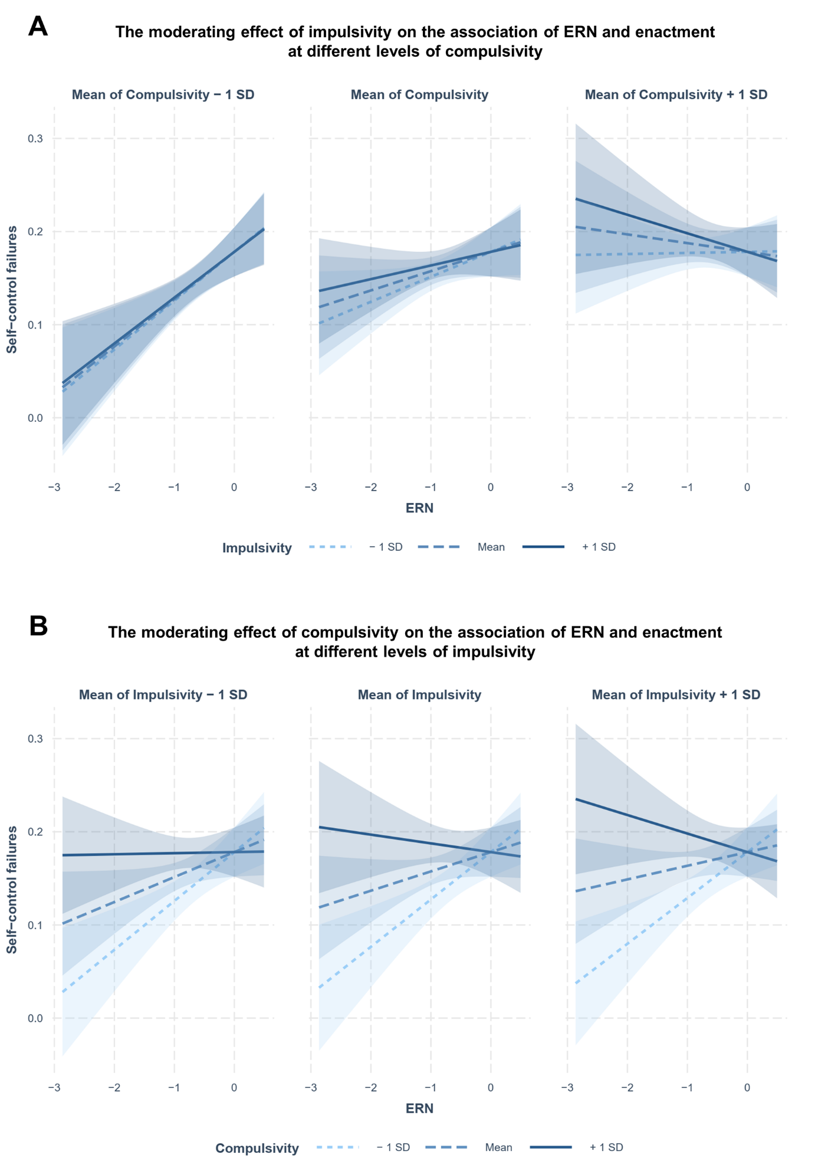
Visualization of the moderating effects of impulsivity and compulsivity on the association between the ERN amplitude and self-control failures. This association was attenuated with higher impulsivity and compulsivity. A Simple slopes for the moderating effect of impulsivity on the association between the ERN and desire enactment at different levels of compulsivity. First panel, simple slopes for the association between ERN amplitude and self-control failures for low (-1 SD below the mean), moderate (mean), and high (+1 SD above the mean) levels of impulsivity, in low (-1 SD below the mean) compulsivity. Second panel, simple slopes for the association between ERN amplitude and self-control failures for low (-1 SD below the mean), moderate (mean), and high (+1 SD above the mean) levels of impulsivity, in moderate (mean) compulsivity. Third panel, simple slopes for the association between ERN amplitude and self-control failures for low (-1 SD below the mean), moderate (mean), and high (+1 SD above the mean) levels of impulsivity, in high (+1 SD above the mean) compulsivity. B Simple slopes for the moderating effect of compulsivity on the association between the ERN and self-control failures at different levels of impulsivity. First panel, simple slopes for the association between ERN amplitude and self-control failures for low (-1 SD below the mean), moderate (mean), and high (+1 SD above the mean) levels of compulsivity, in low (-1 SD below the mean) impulsivity. Second panel, simple slopes for the association between ERN amplitude and self-control failures for low (-1 SD below the mean), moderate (mean), and high (+1 SD above the mean) levels of compulsivity, in moderate (mean) impulsivity. Third panel, simple slopes for the association between ERN amplitude and self-control failures for low (-1 SD below the mean), moderate (mean), and high (+1 SD above the mean) levels of compulsivity, in high (+1 SD above the mean) impulsivity.

Supplement 4: Additional analyses regarding the correct-related negativity and behavioral parameters
The CRN was neither significantly associated with self-control in the gain context (β = 0.01, p = 0.423; model: adjusted R² = -0.00, F(1, 219) = 0.64, p = 0.423), nor the loss context (β = 0.00, p = 0. 729; model: adjusted R² = -0.00, F(1, 219) = 0.12, p = 0.729). Post-error slowing, the reaction time (RT) on correct incongruent and the RT on erroneous incongruent trials showed no significant association with self-control (all p > 0.1). However, higher error rate was associated with lower self-control (β = 0.06, p = 0.001; model: adjusted R² = 0.04, F(1, 219) = 10.49, p = 0.001), and higher post-error accuracy predicted higher self-control in daily life (β = -0.14, p < 0.001; model: adjusted R² = 0.06, F(1, 219) = 14.12, p < 0.001).

References

1 Patton, J. H., Stanford, M. S. & Barratt, E. S. Factor structure of the Barratt impulsiveness scale. Journal of clinical psychology 51, 768-774, doi:10.1002/1097-4679(199511)51:6<768::AID-JCLP2270510607>3.0.CO;2-1 (1995).
2 Stanford, M. S. et al. Fifty years of the Barratt Impulsiveness Scale: An update and review. Personality and individual differences 47, 385-395, doi:10.1016/j.paid.2009.04.008 (2009).
3 Foa, E. B. et al. The Obsessive-Compulsive Inventory: development and validation of a short version. Psychological assessment 14, 485, doi:10.1037/1040-3590.14.4.485 (2002).
4 Gönner, S., Leonhart, R. & Ecker, W. The German version of the obsessive-compulsive inventory-revised: a brief self-report measure for the multidimensional assessment of obsessive-compulsive symptoms. Psychotherapie, Psychosomatik, Medizinische Psychologie 57, 395-404, doi:10.1055/s-2007-970894 (2007).
5 Schmidt, R. E., Gay, P., d’Acremont, M. & Van der Linden, M. A German Adaptation of the UPPS Impulsive Behavior Scale: Psychometric Properties and Factor Structure. Swiss Journal of Psychology 67, 107-112, doi:10.1024/1421-0185.67.2.107 (2008).
6 Whiteside, S. P. & Lynam, D. R. The five factor model and impulsivity: Using a structural model of personality to understand impulsivity. Personality and individual differences 30, 669-689, doi:10.1016/S0191-8869(00)00064-7 (2001).
7 Whiteside, S. P., Lynam, D. R., Miller, J. D. & Reynolds, S. K. Validation of the UPPS impulsive behaviour scale: a four‐factor model of impulsivity. European Journal of personality 19, 559-574, doi:10.1002/per.556 (2005).
8 Henry, J. D. & Crawford, J. R. The short‐form version of the Depression Anxiety Stress Scales (DASS‐21): Construct validity and normative data in a large non‐clinical sample. British journal of clinical psychology 44, 227-239, doi:10.1348/014466505X29657 (2005).
9 Ree, M. J., French, D., MacLeod, C. & Locke, V. Distinguishing cognitive and somatic dimensions of state and trait anxiety: Development and validation of the State-Trait Inventory for Cognitive and Somatic Anxiety (STICSA). Behavioural and Cognitive Psychotherapy 36, 313-332, doi:10.1017/S1352465808004232 (2008).
10 Stöber, J. Besorgnis: ein vergleich dreier inventare zur erfassung allgemeiner sorgen. Zeitschrift für differentielle und diagnostische Psychologie 16, 50-63 (1995).
11 Ersche, K. D., Lim, T.-V., Ward, L. H., Robbins, T. W. & Stochl, J. Creature of Habit: A self-report measure of habitual routines and automatic tendencies in everyday life. Personality and Individual Differences 116, 73-85, doi:10.1016/j.paid.2017.04.024 (2017).
12 Overmeyer, R., Fürtjes, S., Ersche, K. D., Ehrlich, S. & Endrass, T. Self-regulation is negatively associated with habit tendencies: A validation of the German Creature of Habit Scale. Personality and Individual Differences 163, 110029, doi:10.1016/j.paid.2020.110029 (2020).
13 Strobel, A., Beauducel, A., Debener, S. & Brocke, B. Eine deutschsprachige version des BIS/BAS-Fragebogens von carver und white. Zeitschrift für Differentielle und diagnostische Psychologie, doi:10.1024/0170-1789.22.3.216 (2001).
14 Carver, C. S. & White, T. L. Behavioral inhibition, behavioral activation, and affective responses to impending reward and punishment: the BIS/BAS scales. Journal of personality and social psychology 67, 319, doi:10.1037/0022-3514.67.2.319 (1994).
15 Overmeyer, R. et al. The error-related negativity predicts self-control failures in daily life. Frontiers in Human Neuroscience 14, 614979, doi:10.3389/fnhum.2020.614979 (2021).
16 Krönke, K.-M. et al. Monitor yourself! Deficient error-related brain activity predicts real-life self-control failures. Cognitive, Affective, & Behavioral Neuroscience 18, 622-637, doi:10.3758/s13415-018-0593-5 (2018).

