Figure S1. Flowchart of experimental design.
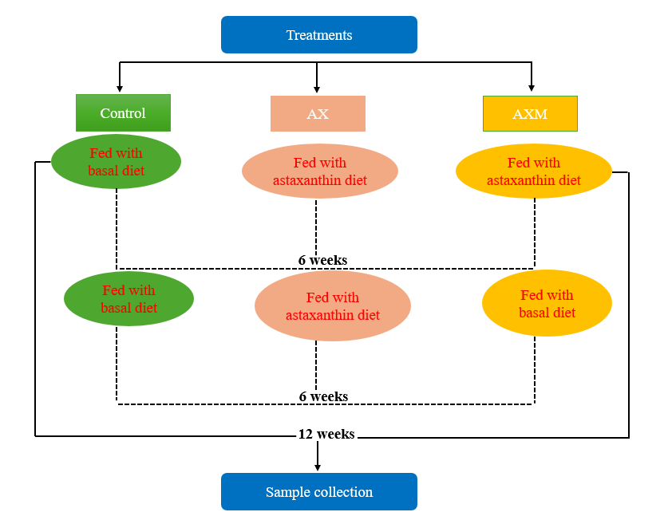

Figure S2. Corresponding permutation test of Wk6CvsWk0C2, Wk12CvsWk6C, Wk6AXvsWk0C, Wk6AXvsWk6C, Wk12AXvsWk12C, Wk12AXvsWk6AX, Wk12AXMvsWk12C, and Wk12AXMvsWk12AX following negative mode (A) and positive mode (B). Where C is control, AX is coloration, and AXM is decoloration.
(A)
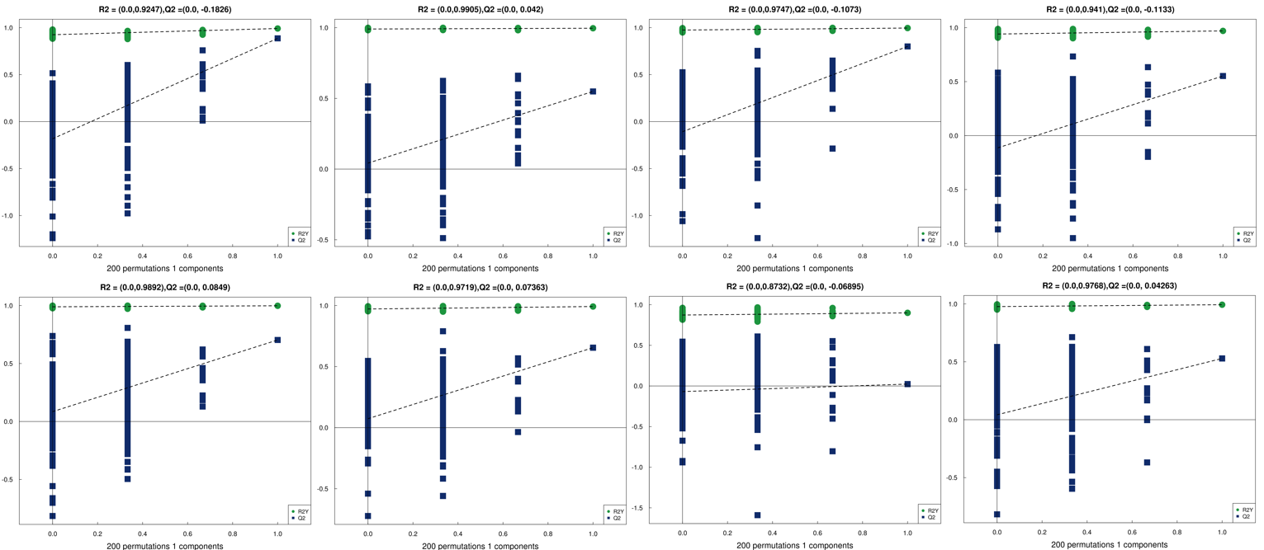
(B)
