Supplementary data
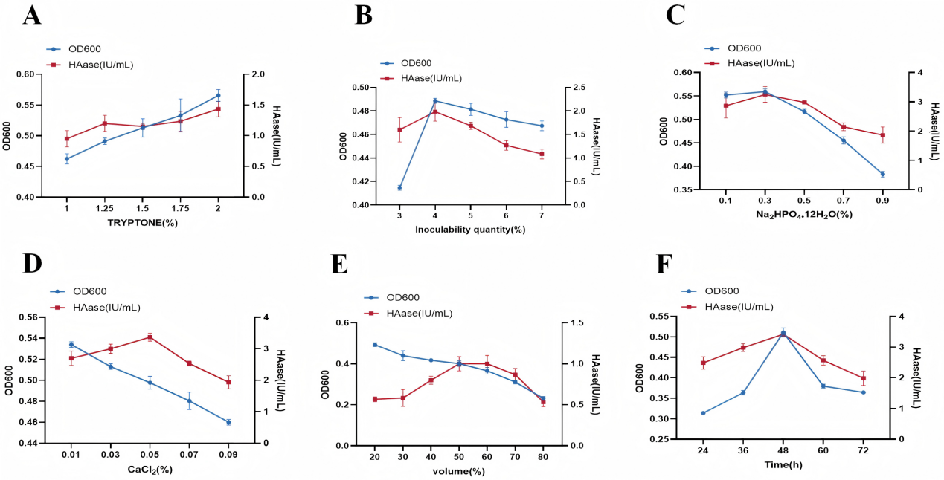
Figure 1. Fermentation optimisation for HAase production by Flavobacterium heparinum
Peptone;(B)Inoculum dose;(C) Disodium hydrogen phosphate dodecahydrate; (D) Calcium chloride; (E) Liquid volume; (F) Time;

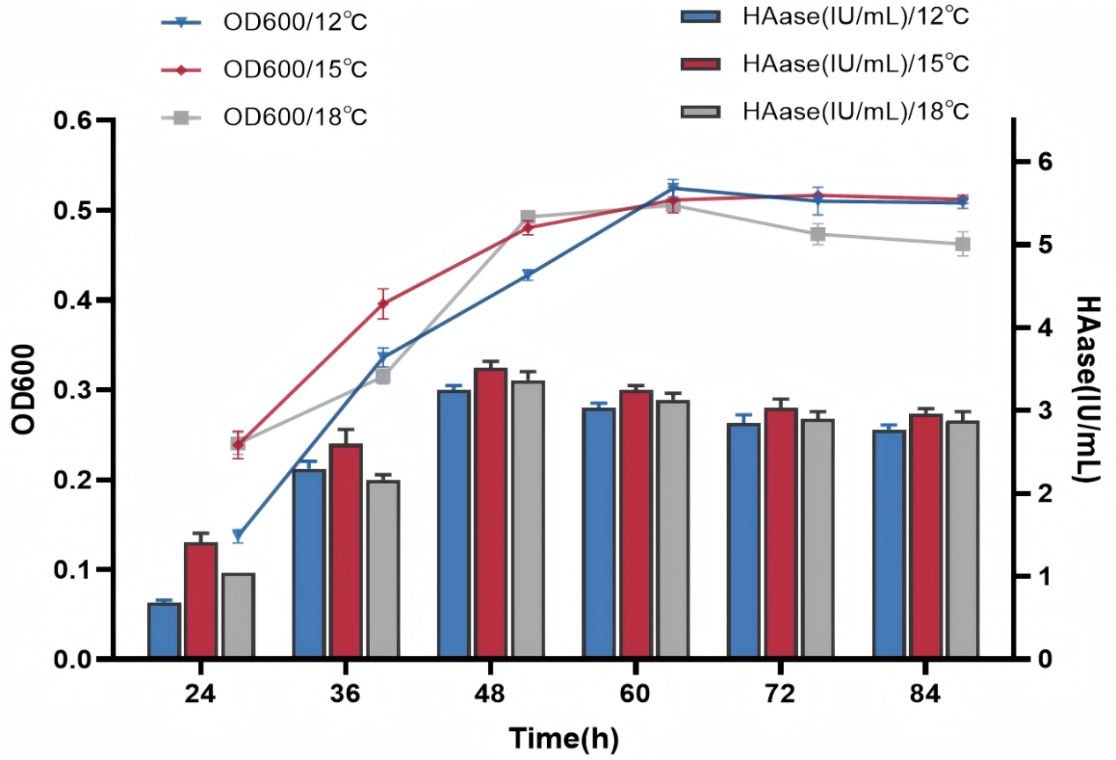

Figure 2. Effect of different fermentation times on F. heparinum-HAase at 3 temperatures

Table 1. Orthogonal experiment factor level table
 | considerations
level (of achievement etc) | Liquid content % | % of inoculations | Time h | Temp℃
level (of achievement etc) | A | B | C | D
1 | 50 | 3 | 44 | 15
2 | 60 | 4 | 48 | 18
3 | 70 | 5 | 52 | 21

Table 2. Orthogonal experimental design and results
Serial number | Considerations |  |  |  | Enzyme viability (IU/mL)
Serial number | Liquid volume % A | Inoculum % B | Time (h) C | Temperature (°C) D
1 | 1 | 1 | 1 | 1 | 3.4 | 3.15 | 3.25
2 | 1 | 2 | 3 | 2 | 2.45 | 2.3 | 2.35
3 | 1 | 3 | 2 | 3 | 2.8 | 2.65 | 2.85
4 | 2 | 1 | 3 | 3 | 2.1 | 2.2 | 2.3
5 | 2 | 2 | 2 | 1 | 3.55 | 3.5 | 3.4
6 | 2 | 3 | 1 | 2 | 3 | 2.95 | 2.8
7 | 3 | 1 | 2 | 2 | 2.4 | 2.5 | 2.55
8 | 3 | 2 | 1 | 3 | 2.45 | 2.5 | 2.4
9 | 3 | 3 | 3 | 1 | 2.9 | 3.05 | 3.1
K1 | 25.200 | 23.850 | 25.900 | 29.300
K2 | 25.800 | 24.900 | 26.200 | 23.300
K3 | 23.850 | 26.100 | 22.750 | 22.250
k1 | 2.800 | 2.650 | 2.878 | 3.256
k2 | 2.867 | 2.767 | 2.911 | 2.589
k3 | 2.650 | 2.900 | 2.528 | 2.472
R | 0.217 | 0.250 | 0.383 | 0.783

Table 3. ANOVA
Source of variance | Sum of squared deviations | Degrees of Freedom | Mean square | F-value | P-value
A | 0.221666667 | 2 | 0.110833333 | 12.73404255 | 0.000358029
B | 0.281666667 | 2 | 0.140833333 | 16.18085106 | 0.000095181
C | 0.811666667 | 2 | 0.405833333 | 46.62765957 | 0.000000076
D | 3.215 | 2 | 1.6075 | 184.6914894 | 0.000000000
Inaccuracies | 0.156666667 | 18 | 0.009
Total |  | 26

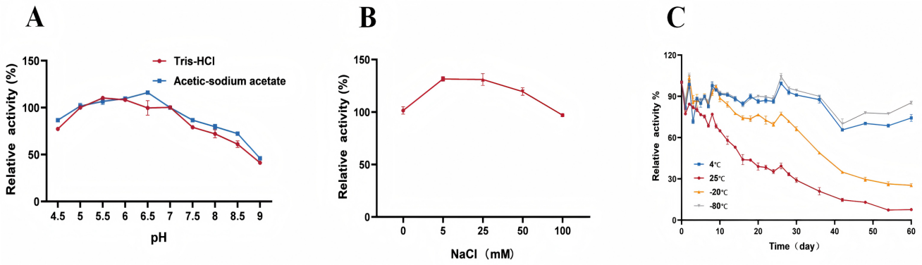
Figure 3. Effect of temperature and pH on HAase activity and stability. (A) Optimum reaction pH at different buffers; (B)Effect of different concentrations of NaCl on HAase; (C) Storage stability of HAase at four temperatures;
Table 4. Kinetic parameters of hydrolysis of different substrates by F. heparinum-HAase
Substrate | HA | CS | DS
Km (mg/ml) | 0.057 | 0.098 | 0.112
Vmax(A232/min) | 0.128 | 0.114 | 0.033
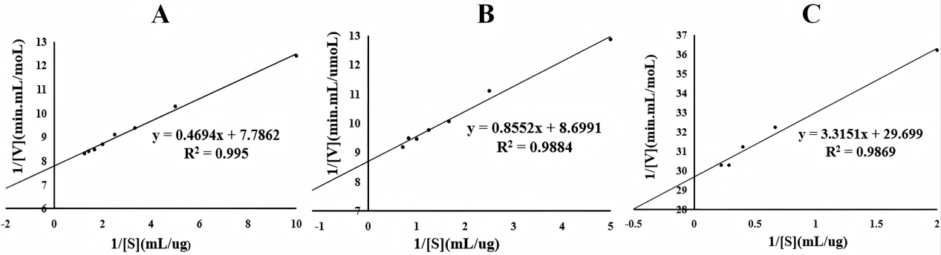
Figure 4. Michaelis-Menten of F. heparinum-HAase for different substrates. (A) HA; (B) CS; (C) DS

