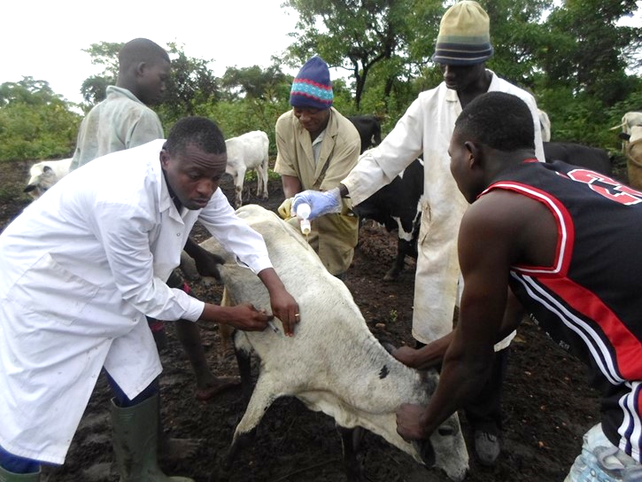
Illustration of α-cypermethrin pour-on application and diminazen aceturate for the treatment of trypanosome-related diseases caused by tsetse flies in cattle in Mô (Togo)

