SUPPLEMENTAL FIGURES
Initial sample (n=26079 people)
European Americans (n=120991 variants; 22043 people)
African Americans (n=264814 variants; 4036 people)

Divide files for analysis. Include MESA in train set
 | train | test
European Americans | 10204 | 11839
African Americans | 1980 | 2018

Replicate train results in test file (reporting file)

Exclude missing on
T2DM (n= 811 )
Covariates (n=1 )
Extreme level of total caloric intake <1%>1 (males: n =53; females: n=48)

European Americans (n= 8283)
African Americans (n=1205)

Supplemental Figure 1. Flowchart of patient selection into the study.
European Americans | African Americans
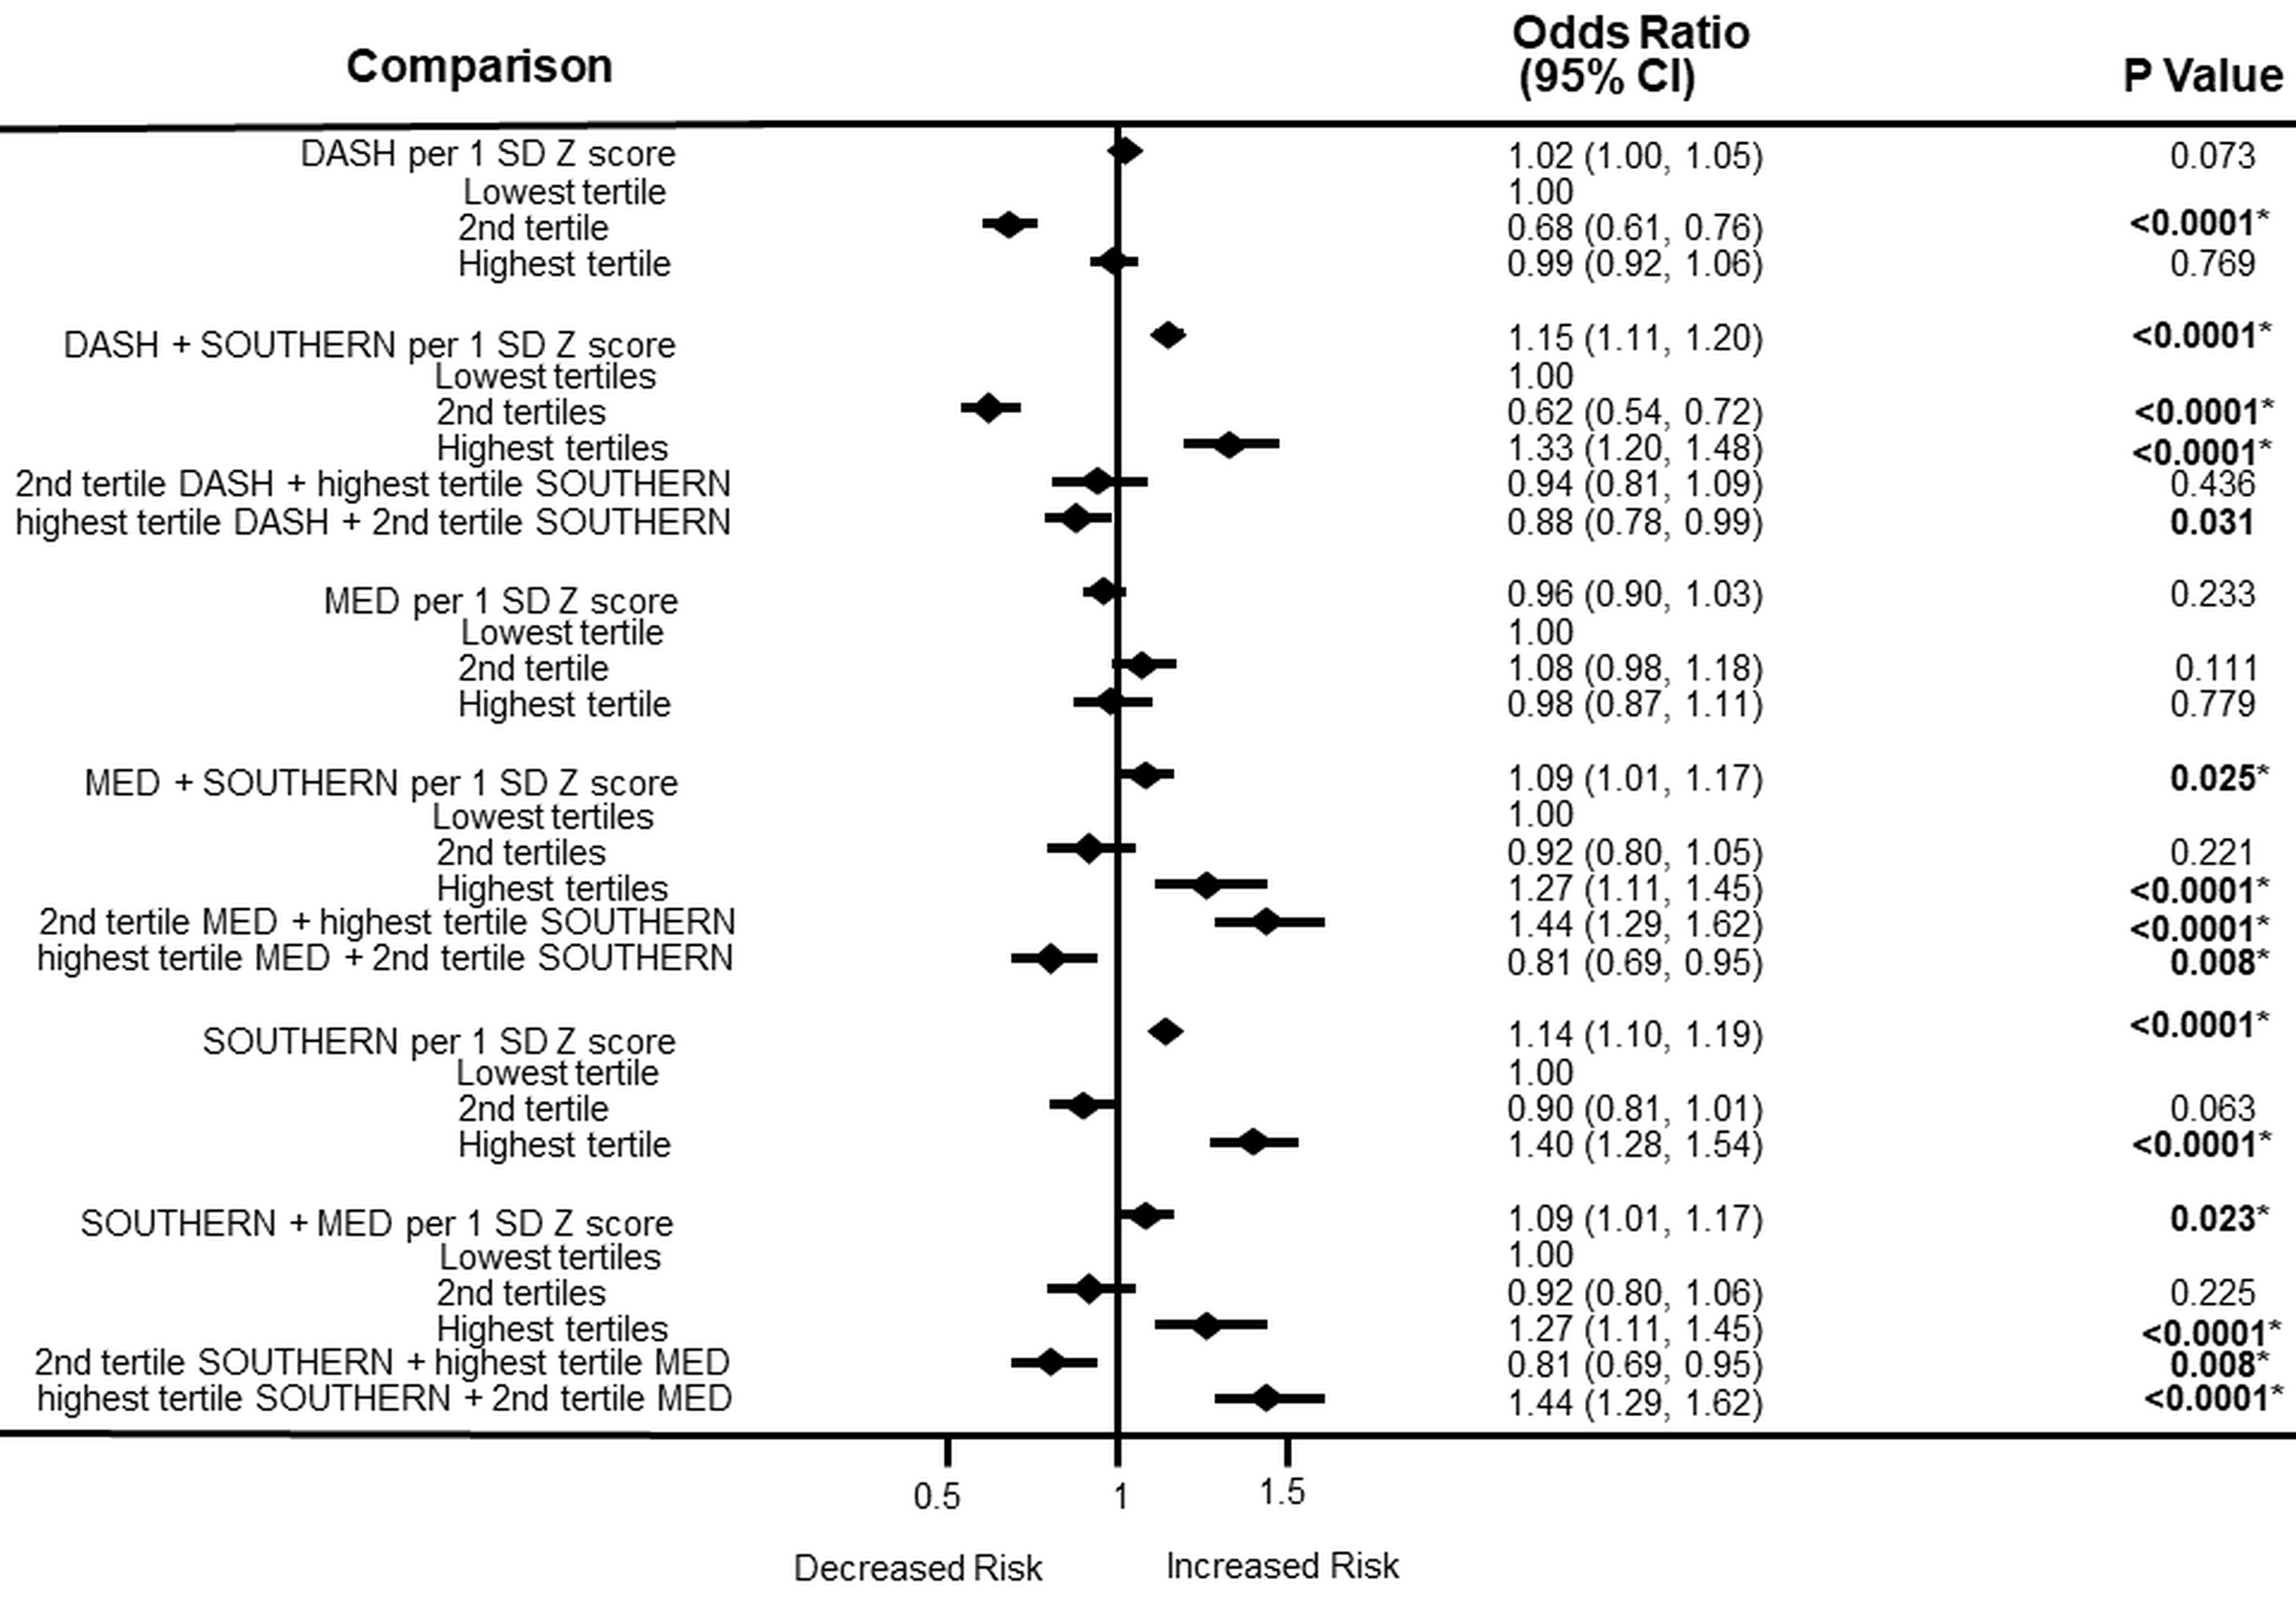 | 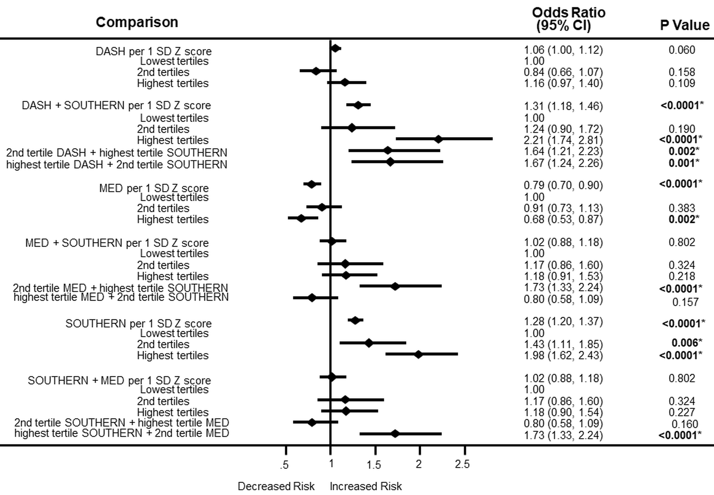
Supplemental Figure 2. Association between dietary patterns and incident type 2 diabetes.
Abbreviations: DASH diet, Dietary Approaches to Stop High Blood Pressure diet; MED, Mediterranean diet.
Bold indicates p values that were statistically significant at p < 0.05.
*Bonferroni adjustment for multiple testing (p < 0.05/2= < 0.025).
Type 2 diabetes status was regressed against each diet, adjusting for a covariate summary score composed of age, sex, current cigarette smoking status, current drinking status, educational level, physical activity, and 10 genetic principal components for stratification.

Dietary pattern scores were computed as a measure of food quality using values that were assigned to foods, scaled to an individual’s caloric intake. The foods were then adjusted using the residual energy adjustment method, then the selected foods were added up to form the dietary patterns, which were converted to Z scores for analysis.

European Americans | African Americans
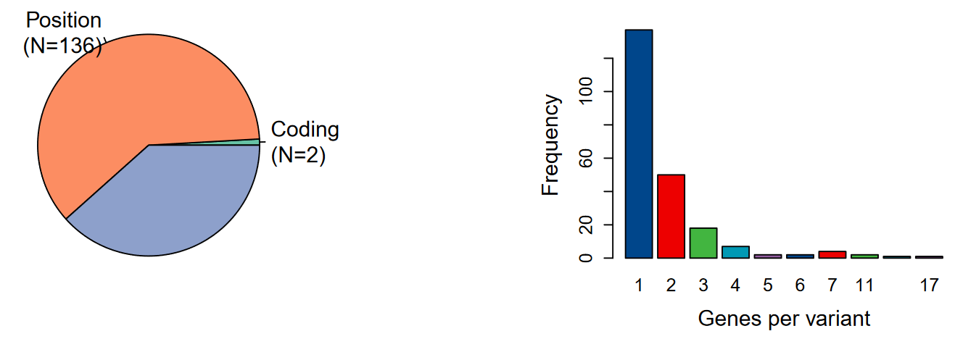 | 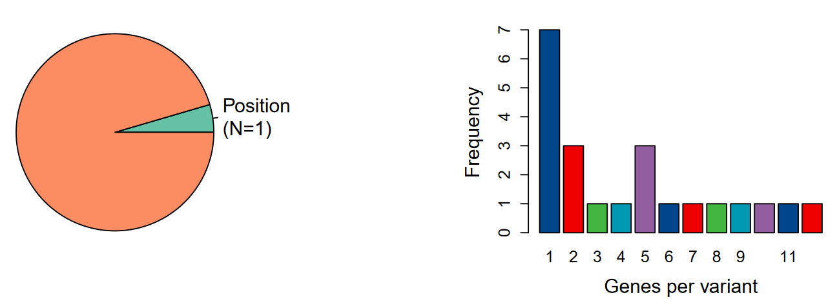
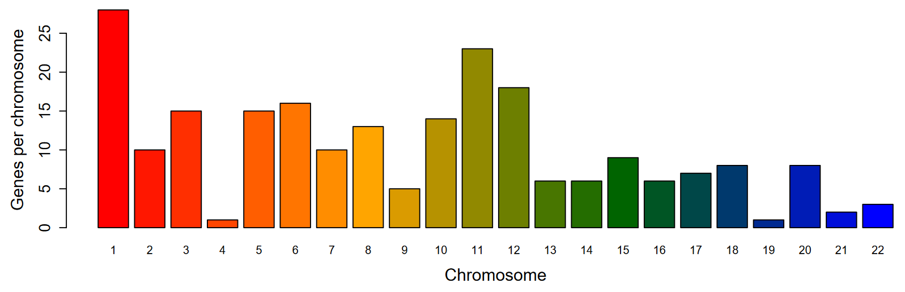 | 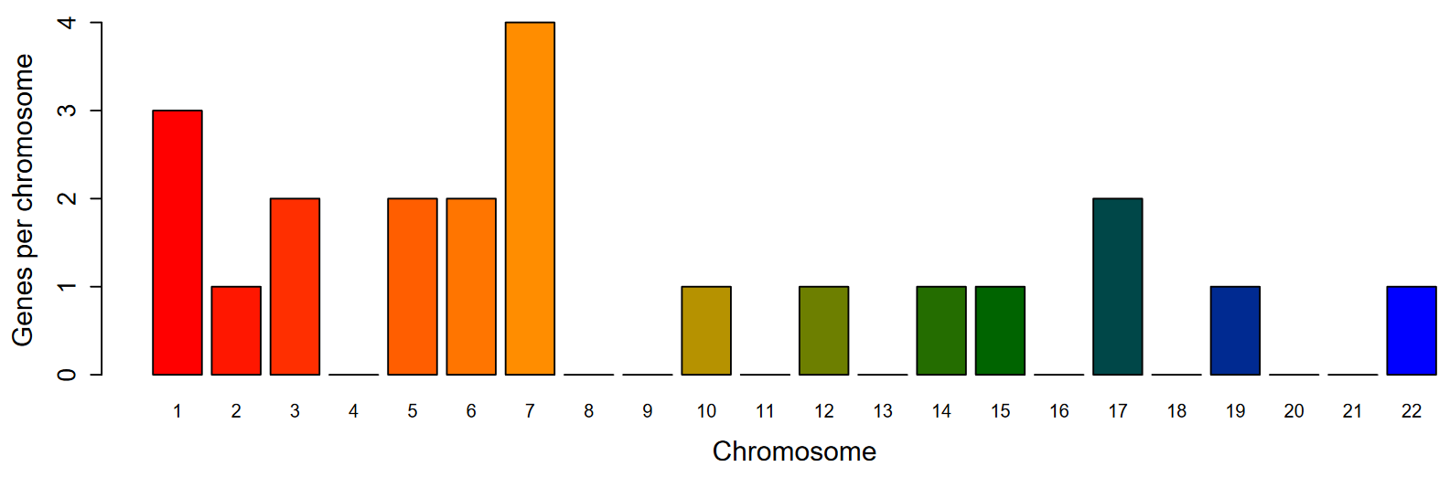
Gene Overlap | Gene Overlap
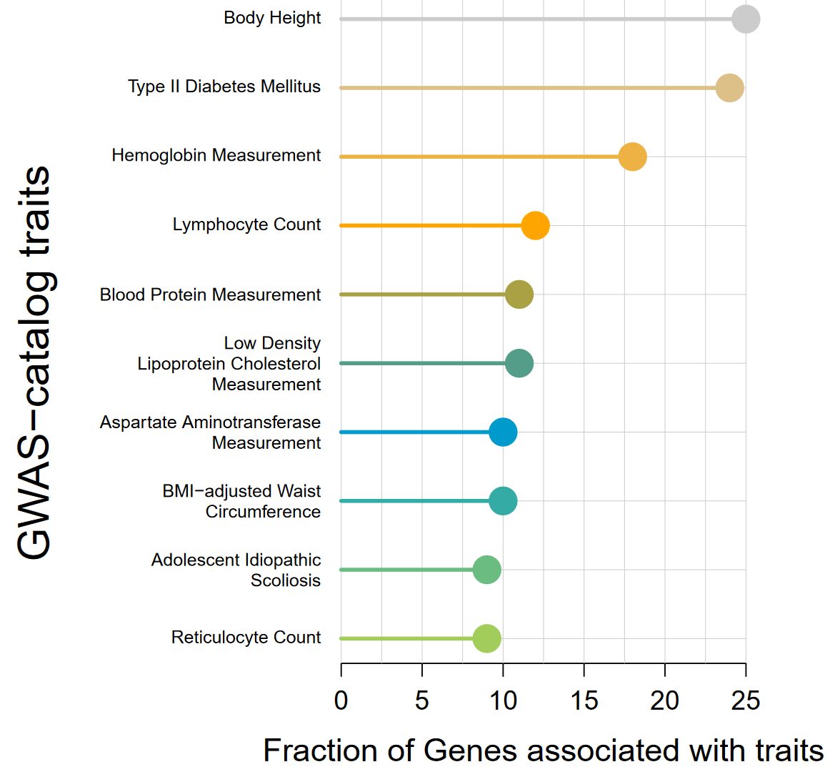 | 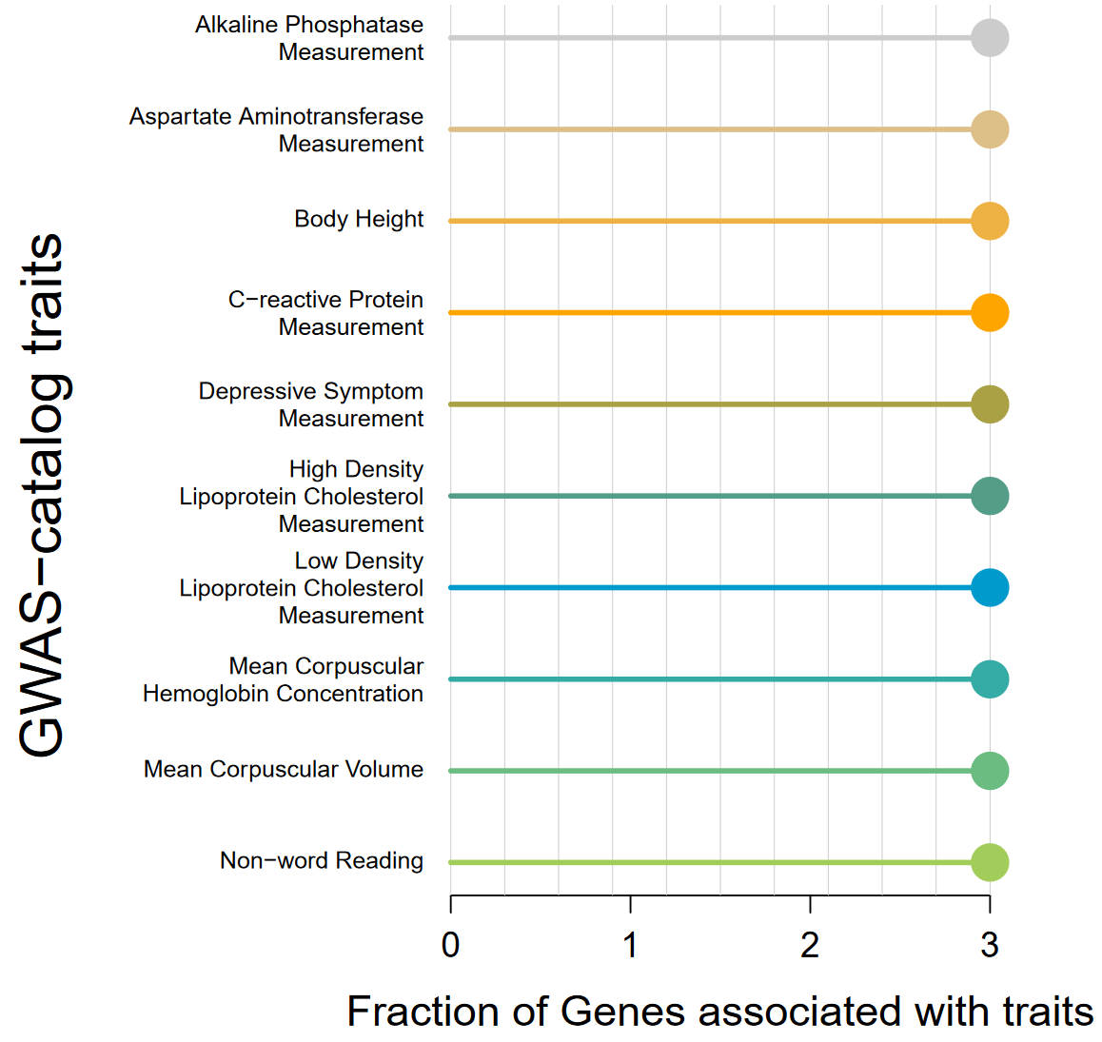
Supplemental Figure 3. Characteristics of the annotation of the variants and differences by ancestry.
Characteristics of the genes by ancestry for functional SNP annotation analysis variant-gene mapping were performed in SnpXplorer.
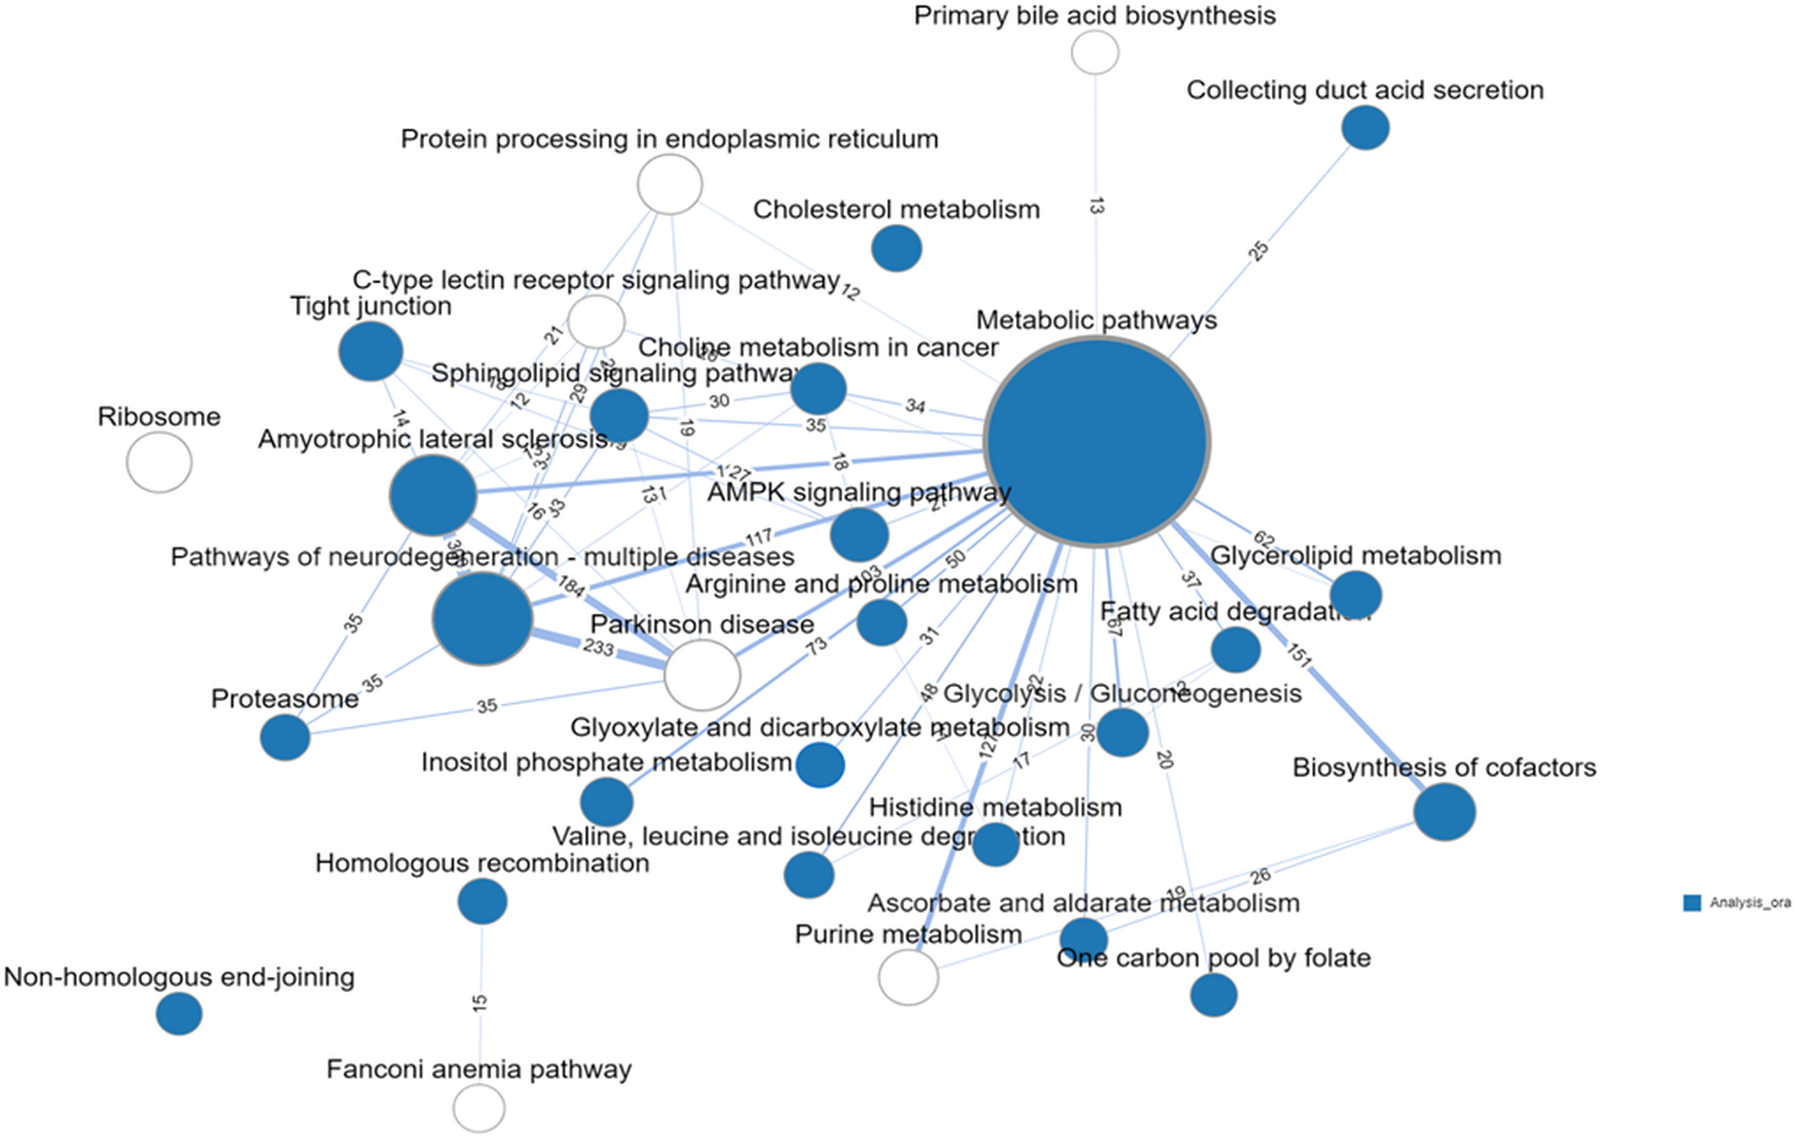

Supplemental Figure 4. Overrepresentation Enrichment Analysis pathway-pathway connectivity graph using rank regression for pathways common to ancestries.
Overrepresentation Enrichment Analysis for molecular pathway analysis and visualization in 30 top pathways using the Consensus pathway Analysis platform. In this pathway-pathway connectivity, nodes represent pathways and edges represent common genes between pathways. Colored blue circles correspond to significant pathways for adjusted p values using Kegg pathway-pathway connectivity in rank regression.

