Supplementary Text for “Insights into Li mobilisation during metapelite melting”
Costa, E.O.^{1*}, Alt, I.², Argles T.W.¹, Hoogendoorn, S.¹, Kriegsman L.M.^{3,4}, Kunz B.E.¹, Riel N.^{5,6}, and Warren C.J.¹

¹School of Environment, Earth and Ecosystem Sciences, The Open University, Walton Hall, Milton Keynes, MK7 6AA, United Kingdom, ²Department of Earth Sciences, Faculty of Science, Vrije Universiteit Amsterdam, De Boelelaan 1085, 1081 HV, Amsterdam, Netherlands, ³Department of Research & Education, Naturalis Biodiversity Center, Darwinweg 2, 2333 CR, Leiden, Netherlands, ⁴Department of Earth Sciences, University of Utrecht, Princetonlaan 8A, 3584 CB, Utrecht, Netherlands, ⁵Institute of Geosciences, Johannes Gutenberg-University, Mainz, Germany, ⁶Terrestrial Magmatic Systems (TeMaS) Research Center, Johannes Gutenberg-University, Mainz, Germany.

* Corresponding author email: elisa.oliveira.da.costa@gmail.com

______________________________________________________

Contents
1. Details about novel datasets 1
1.1 Geological setting 1
1.2 In situ mineral major analysis 3
1.3 In situ mineral trace element analysis 3
1.4 P-T estimates 3
1.5 Sample coordinates, description and P-T estimates 4
2. References 10

_________________________________________________________________________________________

Details about novel datasets

Geological setting
Novel data from seven samples were acquired. These samples are from different areas affected by the Paleozoic Variscan Orogeny (Europe), which assembled Laurussia (Avalonia, East European Craton or Baltica, and North American Craton or Laurentia), Gondwana, and several microcontinents that separated from the northern margin of Gondwana (Franke et al., 2021). Partial melting of the continental crust featured biotite dehydration melting at different pressures throughout the orogeny due to extension-related metamorphism, as documented by migmatite complexes and granitoids in the Late Carboniferous and Permian (e.g., Finger et al., 1997; Finger & Clemens, 1995).
Brittany is located in the southern segment of the Armorican Massif in western France, and comprises the high-temperature and low-pressure Vilaine group and Southern Brittany migmatite belt (associated with extension after peak metamorphism of the Variscan orogen); and the low-temperature high-pressure Belle Ile group (associated with subduction and exhumation during the onset of the Variscan orogen – (Johnson & Brown, 2004; and references therein). The studied samples come from the migmatite belt, in which garnet-sillimanite-biotite-feldspars-quartz pelitic assemblages record peak conditions of ~8 kbar and 800 °C at ca. 325–320 Ma (Johnson & Brown, 2004; EPMA U-Th/Pb in monazite – Augier et al., 2015), while assemblages with cordierite are associated with later near-isothermal exhumation to ~6-4 kbar. Water-fluxed melting of muscovite was followed by muscovite-dehydration and biotite-dehydration melting (producing peritectic garnet, then peritectic cordierite as decompression occurred). Exhumation of the migmatite belt is related to extensional shear zones and interpreted to be followed by leucogranitic intrusions from ca. 320 Ma (EPMA U-Th/Pb in monazite – Augier et al., 2015).
The Agly Massif, located in the easternmost massif of the Northern Pyrenean Zone, consists of a Paleozoic sedimentary cover sequence overlying an older gneissic core (Fonteilles, 1976; and references therein). Studied samples are from the high-grade gneissic core, which is composed mostly of pelitic and metagreywacke migmatites interlayered with calc-silicates, marbles and orthogneisses (Fontailles, 1976; and references therein). The pelitic migmatites are composed of garnet, sillimanite, biotite, quartz, alkali-feldspar, plagioclase and locally cordierite, and record peak metamorphic conditions of 4.9–6.5 kbar and 730–800 °C at c. 305 Ma (thermodynamic modelling, and monazite U-Th-Pb – LA-ICP-MS – Siron et al., 2020). Partial melting ages are close to the emplacement of different magmas between c. 304–309 Ma (Siron et al., 2020). Moreover, different studies dating samples within extensional mylonitic shear zones in the gneissic core show that the massif deformed extensionally shortly after melting (e.g., ca. 296–300 Ma, monazite U-Th-Pb – Siron et al., 2020), and was later reactivated due to Cretaceous rifting (e.g., c. 90-130 Ma, Ar-Ar in biotite and muscovite – Hoogendoorn, 2024).
The Moldanubian Unit, located in the Bohemian Massif, is composed of cordierite-bearing pelitic migmatites (Monotonous Series), metasedimentary complexes with amphibolite, marble, and quartzite lenses (Variegated Series) and high-pressure and high-temperature orthogneisses and granulite facies rocks (Faryad et al., 2010; Žák et al., 2011; and references therein). Recently, the term Pelhřimov Complex was proposed to differentiate pelitic migmatites with melting ages between 330-340 Ma of the Monotonous Series from pelitic migmatites in the Pelhřimov area (~329 Ma – monazite U-Th-Pb – Žák et al., 2011). The studied sample comes from the Pelhřimov Complex. Phase equilibria modelling in a garnet-bearing migmatite indicated this area reached peak metamorphic conditions of 6 kbar and 730 °C followed by isothermal decompression to 2 kbar (based on the formation of cordierite). Modelling and petrography indicate biotite dehydration melting reactions are responsible for migmatite formation (Žák et al., 2011). Peak metamorphism and associated partial melting were contemporary to, or shortly followed by, the intrusion of voluminous crustally-derived granitoids around 330-300 Ma (e.g., Gerdes et al., 2003; references therein).
The Mindelo Migmatitic Complex is in the westernmost part of the Porto-Viseu Metamorphic Belt in the Central Iberian Zone, Portugal (dos Santos et al., 2021; Silva, 2014). The complex consists of pelitic, metagreywacke, and calc-silicate migmatites with varying melt volumes, as well as syn- to late-tectonic granitoids that released K-rich, B-rich, and silicate-rich fluids in the region (Silva, 2014). Nearby schists indicate the area experienced pressures >4.9 kbar and temperatures of 560-600 °C due to burial and heating, followed by decompression and partial melting around 309 ±3 Ma to 319 ±11 Ma (zircon, U-Th-Pb SHRIMP – Silva, 2014). Pelitic metatexites and diatexites composed of biotite, cordierite, sillimanite, quartz, plagioclase, alkali-feldspar and, rarely, garnet are interpreted to have formed by water-present melting followed by biotite dehydration melting with peritectic cordierite at shallower structural levels (P<3.5 kbar), and muscovite water-present and muscovite-dehydration followed by biotite-dehydration melting with mostly peritectic cordierite (rare garnet) in deeper structural levels (P>3.5 kbar - Silva, 2014). Moreover, syn- to late-tectonic granites in the area are interpreted as the source of three fluid pulses: (1) K-rich fluids evidenced by plagioclase alteration and wide variation of K content in the granitoids; (2) B-rich fluids, which led to replacement of biotite by tourmaline and symplectic intergrowths of tourmaline, quartz and K-feldspar; and (3) later silicate-rich aqueous fluids as inferred from retrograde reactions and discordant quartz-veins (Silva, 2014).

In situ mineral major analysis
In situ major element analyses of cordierite, pinite, biotite, chlorite, muscovite, and feldspars were conducted at the Open University, England, using either a Tescan Clara Energy-Dispersive Spectroscopy Scanning Electron Microscope (EDS-SEM) operating at 20 keV and 3 nA, or a Cameca SX100 electron microprobe (EPMA) equipped using an unfocused beam at 20 keV and 20 nA. Analytical precision was assessed via repeated measurements of a natural almandine standard from the GEO MkII block (P&H Developments Ltd), which was analysed at the beginning and end of each session and remained within 7% of the preferred values. On the EPMA, element acquisition utilised the following crystals: PET for Ca and Ti, LPET for Cl, K, and Cr, LLIF for Fe and Mn, TAP for Si and Mg, and LTAP for F, Na, and Al. Rutile and ilmenite were analysed at the University of Utrecht, Netherlands, using a JEOL JXA-8530F EPMA (5-spectrometer) with a 2 μm beam, 50 keV accelerating voltage, and 20 nA beam current. Elements were measured using LIFH for Fe, Mn, and Ta; PETL for Cr, Nb, and Ti; PETH for Ca, K, and Zr; TAP for Si and Al; and TAPH for Mg and Na. Analytical quality for these sessions was ensured through analysis of the R10 standard (Luvizotto et al., 2009) at both the beginning and end of the run. Relative standard deviations ranged from 0.9–2.5% for Ti, Cr, Fe, Nb, and Zr, and reached 13% for Ta.

In situ mineral trace element analysis
In situ mineral trace element concentrations were determined using a Photon Machines Analyte G2 193 nm excimer laser system, and a HelEX II laser ablation cell coupled to an Agilent 8800 Triple Quadrupole ICP-MS (LA-ICP-MS) at the Open University, England. Prior to analysis, the instrument was calibrated using SRM-NIST 612 glass to maximise ICP-MS sensitivity and minimise oxide production to below 0.1%. Analytical settings for biotite, muscovite, chlorite, feldspars, cordierite, and pinite included a laser fluence of 3.63 J/cm², a 10 Hz repetition rate, a spot size of either 50 or 30 μm, a 30 s gas blank, 30 s ablation time, and a 40 s gas washout. For ilmenite and rutile, the conditions were adjusted to a 3.63 J/cm² fluence, 5 Hz repetition rate, 20 μm spot size, 30 s gas blank, 30 s ablation, and 50 s gas washout. SRM-NIST 612 glass served as the primary standard and BCR-2G as the secondary standard for silicate measurements. For Ti oxides, SRM-NIST 610 glass was used as the primary standard and R10 rutile (Luvizotto et al., 2009) as the secondary standard. Both primary and secondary standards were analysed at the beginning and end of each run, as well as between every 20–30 unknowns. Data reduction was performed using Iolite v3.71 (Paton et al., 2011), employing ²⁹Si as the internal standard for silicates and ⁴⁹Ti for ilmenite and rutile, based on SEM and/or EPMA data. The accuracy of the analyses was assessed using BCR-2G and R10, which generally yielded results within 10% of their preferred values.

P-T estimates
Metamorphic conditions were estimated with the Na in cordierite geothermometer and/or phase equilibria modelling. The Na-in-Crd geothermometer was experimentally calibrated by Tropper et al., (2018) using two pelite starting compositions, which fitted different calibration equations. However, the application of only one of these equations (T [°C] = [Na - 0.4052]/-0.000487) is advised regardless of the starting bulk composition because (1) the cordierites produced in this experiment were less disordered, which indicates thermodynamic equilibrium was achieved, and (2) this equation better reproduces temperatures independently constrained in high-grade pelites and migmatites. Phase equilibria modelling was carried out using the software package Perple_X, version 6.8.7 (Connolly, 2005, 2009) and GeoPS (Xiang & Connolly, 2022) with the thermodynamic dataset hp622ver.dat (Holland & Powell, 2011; as used in Jennings & Holland, 2015). Solution models for staurolite, garnet, white mica, biotite, ilmenite, chloritoid, cordierite, chlorite and melt are from White et al. (2014), while the model of Fuhrman & Lindsley (1988) was used for feldspar.

Sample coordinates, description and P-T estimates
Sample PT03B (Mindelo – Portugal) is a metatexite with lepidoblastic melanosome of up to 2 cm thick, composed mainly of biotite (usually around 1 mm) and leucosome composed of nearly equal abundances of plagioclase, alkali-feldspar, and quartz (up to 3 mm), while cordierite with fibrolite/sillimanite inclusions occurs in both the leucosome and melanosome. Biotite crystals (X_{Fe} = 0.52–0.59) commonly have graphite inclusions and show intergrowth with quartz in contact with the leucosome. Apatite is a common accessory phase. Cordierite (X_{Fe} = 0.35–-0.37) shows moderate degrees of pinitization and high abundances of sillimanite/fibrolite inclusions, which made in situ major and trace element analysis difficult. The development of small amounts of randomly oriented muscovite is restricted to the leucosome. Euhedral to subhedral plagioclase crystals (X_{An} = 0.16–0.22) are often enclosed by anhedral alkali-feldspar (X_{Or} = 0.73–0.93). Phase equilibria modelling indicates conditions of 3.3-4.5 kbar and 680-740°C (Figure 1), similar conditions to estimates of Silva (2014) in nearby granitoids (4-5 kbar and 720-840°C). This pressure and temperature interval intersects the stability field of garnet, which is not observed in thin section; however, the calculated garnet volumes are smaller than 2 vol.%.

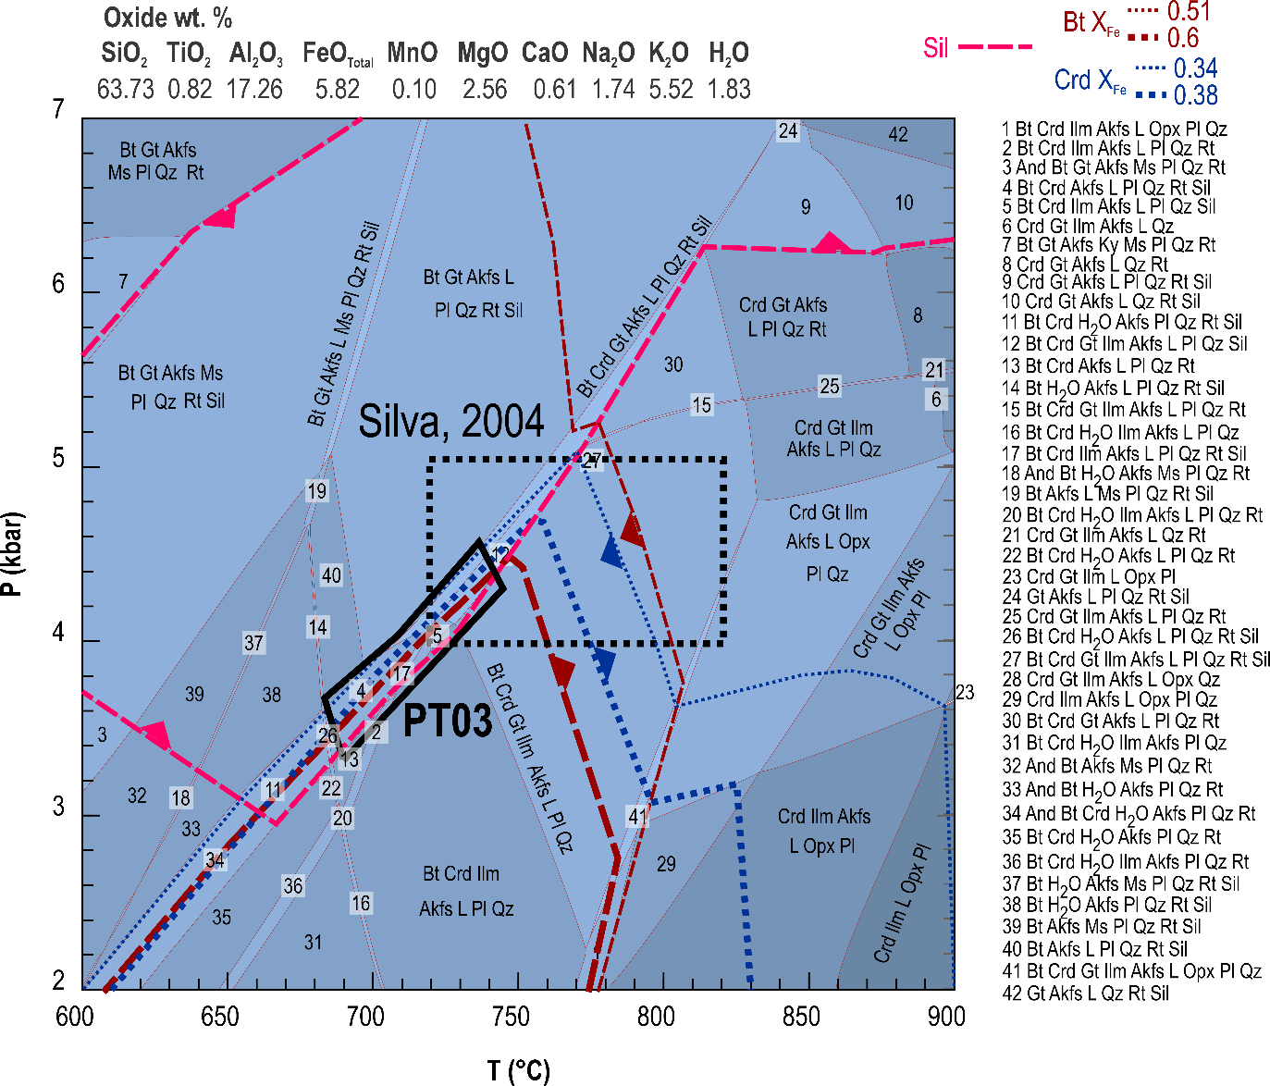
Figure 1. Pseudosection for sample PT03C showing the PT conditions estimated in this study and literature, as well as selected isopleths for the stability field of sillimanite, and X_{Fe} of biotite and cordierite.

Sample CZ03 (Moldanubiam, Czech Republic) is a metatexite with melanocratic bands composed mainly of lepidoblastic biotite (X_{Fe} = 0.54–0.59) and elongated cordierite of up to 0.5 mm (X_{Fe} = 0.40–0.42) commonly with sillimanite inclusions, and leucocratic bands composed of granoblastic plagioclase (X_{An} = 0.21–0.24), alkali-feldspar (X_{Or} = 0.75–0.9), and quartz and cordierite also with sillimanite inclusions. Accessory ilmenite, graphite and apatite are common. Muscovite is rare and restricted to the leucosome, where it is a late phase that partly replaces feldspars. Melanocratic bands are thin and often discontinuous, appearing intertwined with leucocratic bands with finer-grained (up to 1 mm) crystals. In contrast, thicker leucocratic bands have quartz and feldspars of varying grain size (up to 4 mm) and smaller anhedral biotite crystals. Phase equilibria modelling indicates CZ03 records 740–770 °C and 3.7–4.5 kbar (Figure 2). These conditions are slightly outside the stability field of sillimanite and within the stability field of garnet, However, these conditions are preferred over lower temperatures since (1) temperatures match the Ti apfu compositional isopleths of biotite and the Na in cordierite estimates for the sample; (2) sillimanite only occurs as inclusions in sample CZ03, hence, sillimanite was likely no longer stable in the matrix assemblage; (3) volumes of garnet predicted in these conditions are lower than 2 vol.% and could have been missed in the thin section. This sample P-T estimates indicate the sample is from a different structural level than samples from previous studies where garnet is the peritectic phase (Žák et al., 2011 – 6 kbar, 730°C).
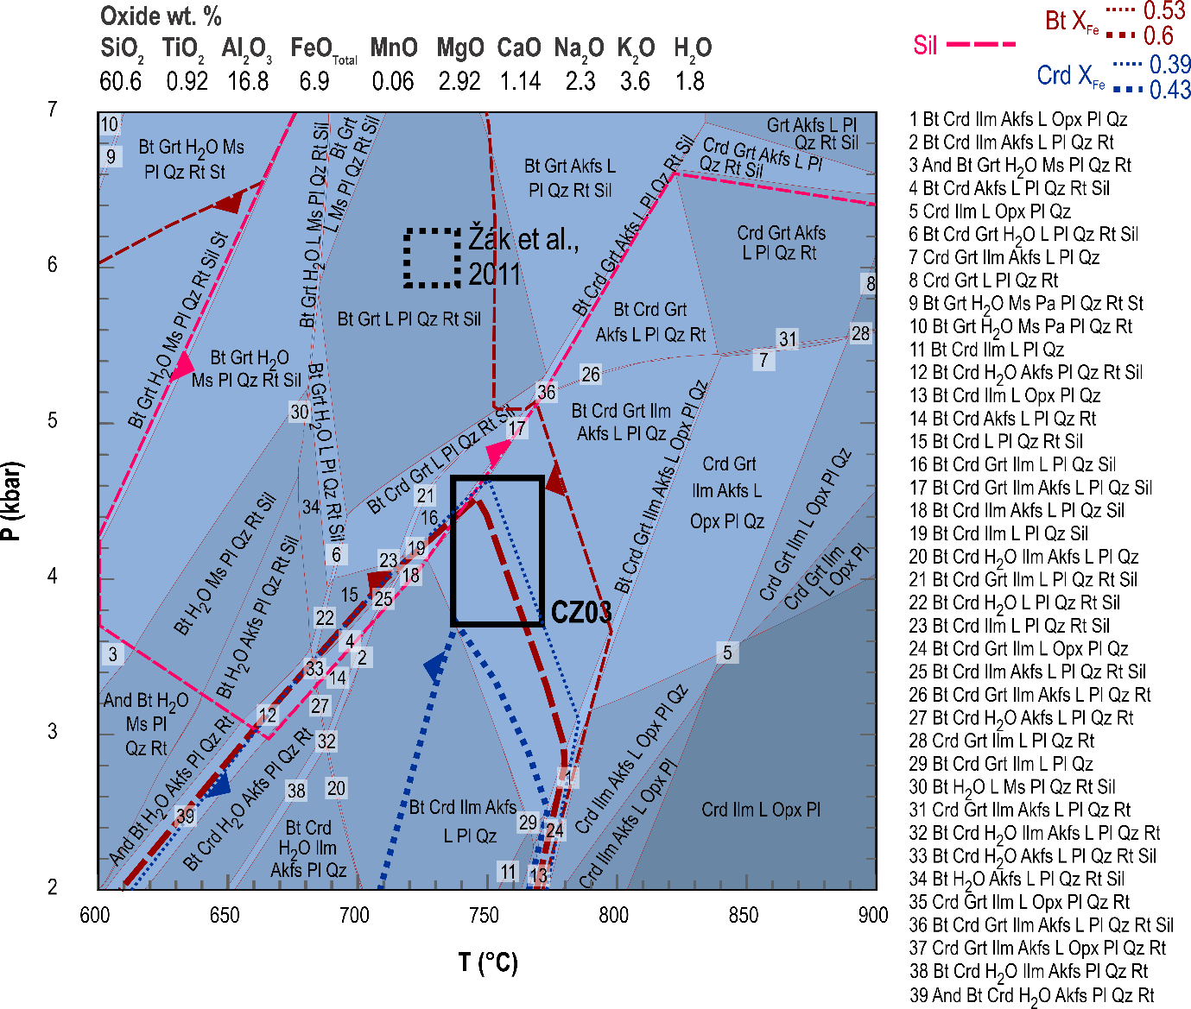
Figure 2. Pseudosection for sample CZ03 showing the PT conditions estimated in this study and literature, as well as selected isopleths for the stability field of sillimanite, and X_{Fe} of biotite and cordierite.

Sample L14C (Agly, France) has one leucosome layer composed of quartz, plagioclase (X_{An} = 0.39–0.41), and garnet (X_{Alm} = 0.73–0.78; X_{Prp} = 0.11-0.19; X_{Sps} = 0.03–0.05; X_{Grs} = 0.05–0.06), and melanosome composed mainly of biotite (X_{Fe} = 0.53–0.58) and minor quartz, plagioclase, and alkali-feldspar (X_{Or} = 0.97-1.00). Intense deformation is attested to by quartz crystals with dynamic recrystallisation textures (bulging and grain boundary migration), and fractured garnet crystals filled by chlorite. Phase equilibria modelling indicates conditions of 750–770 °C and 4.6–5.4 kbar (Figure 3).
Sample L14G (Agly, France) is a diatexite with no clear melanosome, and it is composed of biotite (X_{Fe} = 0.46-0.55), garnet, cordierite (X_{Fe} = 0.34-0.4), sillimanite, spinel (X_{Hc} ≈ 0.6, X_{Ghn} ≈ 0.3, X_{Spl} ≈ 0.1), hercynite, quartz, plagioclase (X_{An} ≈ 0.3), and alkali-feldspar (X_{Or} ≈ 0.9). Poikiloblastic garnet crystals (Grt₁ – up to 2 cm diameter) contain several sillimanite inclusions as well as quartz and rutile in the core and clear rims and show a slight increase in X_{Alm} from core to rim (X_{Alm} = 0.79 near the core, and X_{Alm} = 0.80–0.84 in the rims; X_{Prp} = 0.12–0.17; X_{Sps} = 0.00–0.01; X_{Grs} ≈ 0.03) Smaller garnet crystals (Grt₂ – up to 200 µm) have the same X_{Alm} as Grt₁ rims. Fractured and elongated Grt₂, quartz dynamic recrystallisation textures (sub-grain rotation and chessboard extinction), and overall sheared habit of biotite indicate deformation. Phase equilibria modelling indicates conditions of 770–800 °C and 4.5–5.3 kbar. Garnet rim isopleths and spinel stability field indicate final cooling (Figure 3).

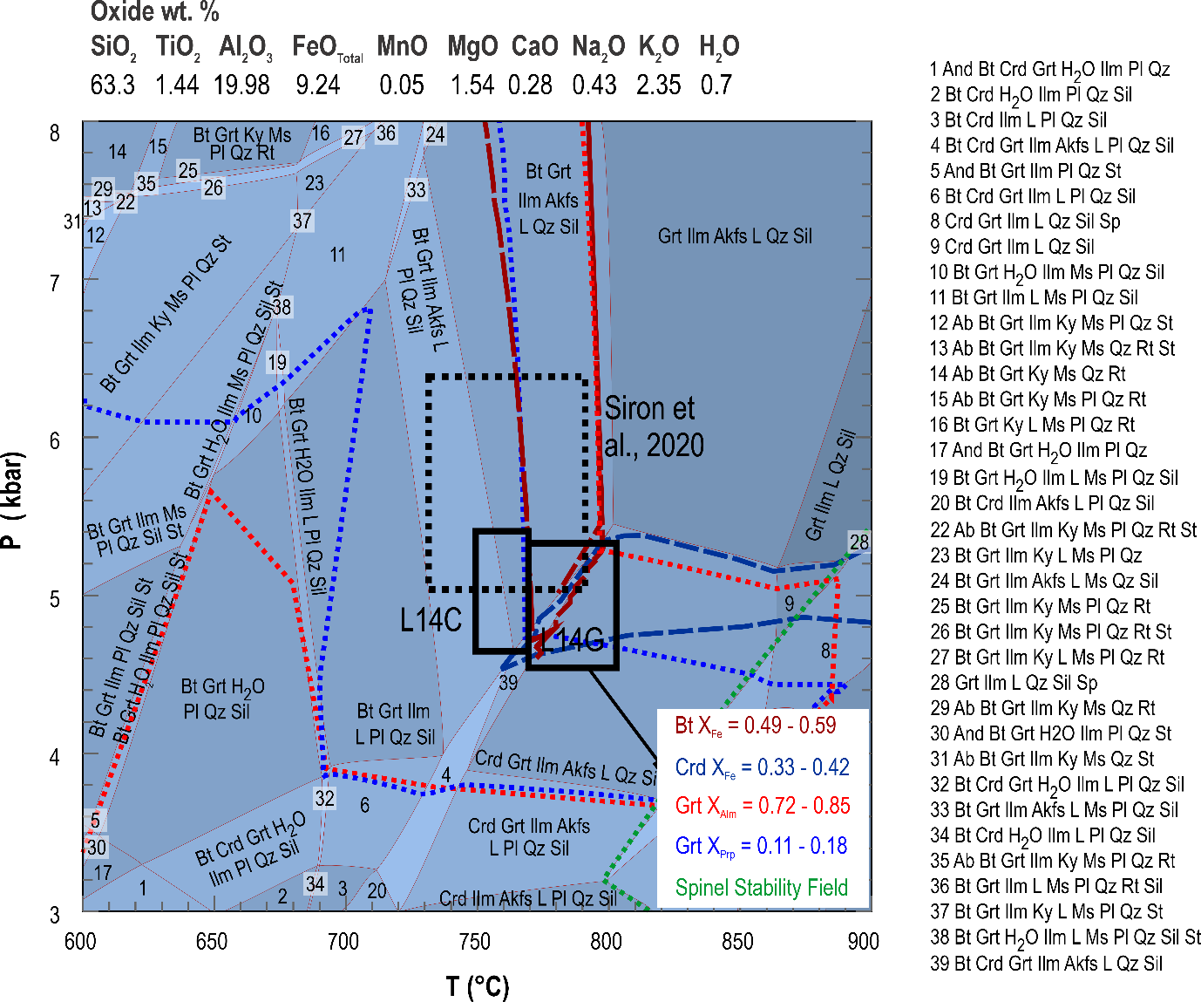
Figure 3. Pseudosection for samples L14C and L14G showing the PT conditions estimated in this study and literature, as well as selected isopleths for X_{Fe} of biotite and cordierite, X_{Alm} and X_{Prp} of garnet, and spinel stability field.

Sample L44 (Agly, France) melanocratic bands are mainly composed of garnet (X_{Alm} = 0.70–0.75; X_{Prp} = 0.21–0.26; X_{Sps} ≈ 0.01; X_{Grs} = 0.02–0.03) and cordierite (X_{Fe} = 0.24–0.29), as well as sillimanite, hercynite and plagioclase, while leucocratic bands are composed of quartz, plagioclase (X_{An} = 0.27–0.29) and alkali-feldspar (X_{Or} = 0.82–0.89). Biotite is absent except for rare, very small relics with alkali-feldspar. Agly sample L44 yielded higher temperature estimates (at least 820°C based Na-in-cordierite geothermometer) than previous studies; however, these were expected since the sample comes from the southern boundary of the Agly, which exposes the deepest parts of the crustal section (Siron et al., 2020) associated with the highest temperatures (evidenced also by the lack of biotite).
Samples K5533 (Brittany, France) is a diatexite composed of biotite (X_{Fe} = 0.5–0.57), garnet, cordierite, sillimanite, plagioclase (X_{An} = 0.19–0.27), quartz, and accessory monazite, apatite, zircon, ilmenite, and rutile. Some garnet cores show different compositions (X_{Alm} ≈ 0.65, X_{Prp} = 0.28; X_{Sps} ≈ 0.01; X_{Grs} ≈ 0.06); however, most cores and rims have similar compositions X_{Alm} = 0.7–0.75, X_{Prp} = 0.11–0.21; X_{Sps} = 0.02–0.11; X_{Grs} = 0.05-0.06). Garnets have rutile, ilmenite, monazite, and quartz inclusions. Two generations of cordierite occur: (1) fine-grained cordierite of up to 0.2 mm located around garnet crystals (Crd₁ – X_{Fe} = 0.40–0.42); and (2) up to 1 mm cordierite in the leucosome (Crd₂ – X_{Fe} = 0.35–0.38). Sillimanite is localised near the contact between leucosome and melanosome, where it is partially enclosed by cordierite. Muscovite and chlorite are formed due to the retrogression of biotite. Phase equilibria modelling and garnet core composition isopleths (X_{Alm} and X_{Prp}) indicate peak metamorphic conditions of 750–790 °C and 8.4–8.8 kbar, while garnet rims, biotite, and cordierite in the leucosome (Crd₂) compositions indicate 710–760 °C and 4.2–4.8 kbar. On the other hand, Crd₁ is not predicted by the model results. Based on the petrographic position, we interpret that Crd₁ is a product of garnet breakdown during exhumation; hence, its composition was likely controlled by the reaction effective composition, instead of the system composition. The determined metamorphic conditions are similar to previously estimated peak metamorphic conditions around 8 kbar and 800°C followed by near isothermal exhumation to 4-6 kbar (Johnson & Brown, 2004).
Sample K5534 is a diatexite composed of biotite (X_{Fe} = 0.54–0.57), cordierite (X_{Fe} = 0.39–0.42), sillimanite, plagioclase (X_{An} = 0.21–0.25), quartz, apatite, ilmenite, and rutile. The melanosome comprises around 2 mm round schlieren composed mainly of biotite and cordierite of up to 2 mm. Cordierite often contains sillimanite inclusions. Near the contact with the leucosome, biotite is often chloritized and contains rutile needles. The leucosome is mainly composed of quartz of up to 3 mm and plagioclase of up to 1 cm, commonly containing quartz inclusions. Temperature estimates indicate 754°C (Na-in-Crd), likely related to the exhumation.

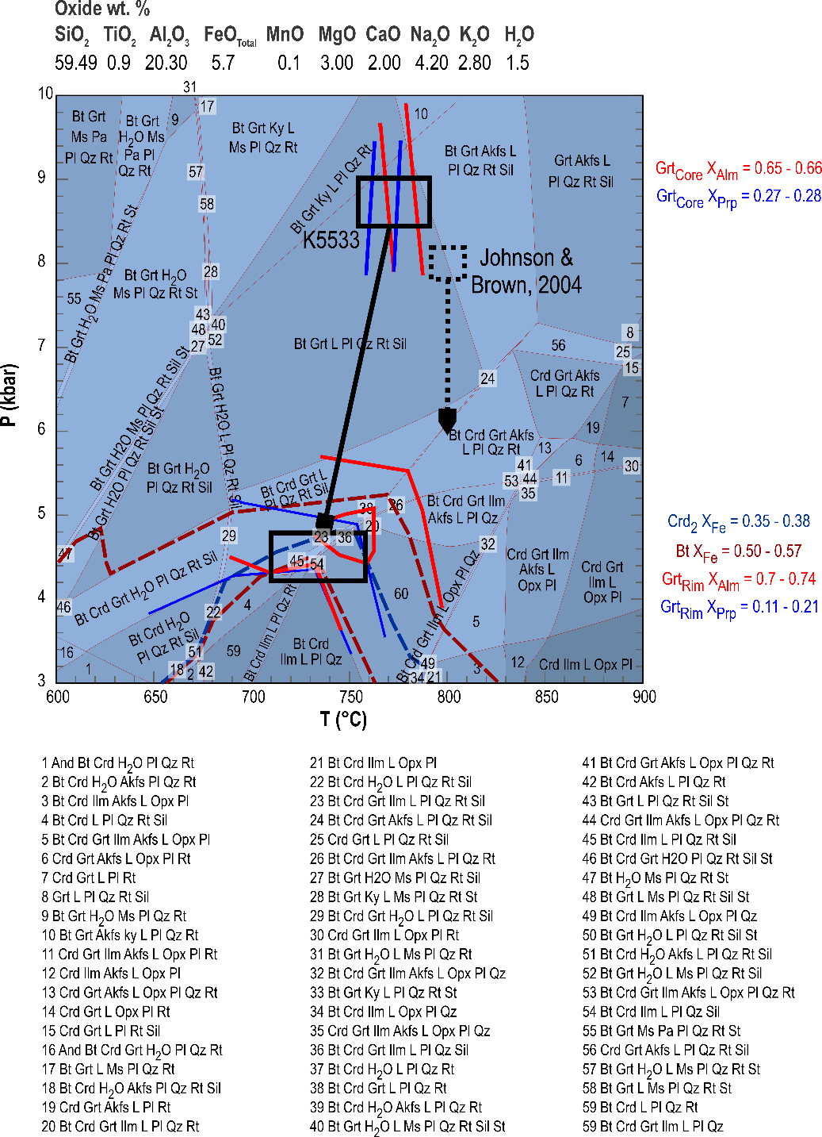
Figure 4. Pseudosection for sample K5533 showing the PT conditions estimated in this study and literature, as well as selected isopleths for X_{Fe} of biotite and cordierite and X_{Alm} and X_{Prp} of garnet.

Table 1. Summary of studied samples: area, primary mineral assemblage, coordinates and PT estimates.
Area | Sample | Primary Mineral Assemblage | Coordinates |  | Na-in-Crd | Thermodynamic modelling
Area | Sample | Primary Mineral Assemblage | X | Y | Na-in-Crd | Thermodynamic modelling
Mindelo | PT03 | Crd-Sil-Bt-Pl-Akfs-Qz-Ap-Gr | 41°17'54.5"N | 8°44'15.1"E | 663-756°C (699°C) | 3.3-4.5 kbar, 680-740°C
Moldanubian | CZ03 | Crd-Sil-Bt-Pl-Akfs-Qz-Ap-Gr | 49°23'25.7"N | 15°16'30.3"E | 697-785°C (752°C) | 3.7-4.5 kbar, 740-770°C
Agly | L14C | Grt-Bt-Pl-Akfs-Qz-Ap-Ilm | 42°43'13.89"N | 2°36'48.14"E | - | 4.6-5.4 kbar, 750-770°C
Agly | L14G | Grt-Crd-Sil-Bt-Pl-Qz-Ilm-Hc | 42°43'14.10"N | 2°36'47.72"E | 743-807°C (791°C) | 4.5-5.3 kbar, 770-800°C
Agly | L44 | Grt-Crd-Sil-Pl-Afs-Qz-Ilm-Hc | 42°43'38.22"N | 2°34'32.41"E | 817-832°C (826°C) | -
Brittany | K5533 | Grt-Crd-Sil-Bt-Pl-Akfs-Qz-Ap-Mnz | Near Port du Crouesty* |  | 630-773°C (720°C) | Peak: 8.4-8.8 kbar, 750-790°C Exhumation: 710-760°C, 4.2-4.8 kbar
Brittany | K5534 | Crd-Bt-Pl-Qz-Ap-Rt-Ilm | Le Petit Mont* |  | 673-779°C (754°C) | -
*Approximate location available only (Brown, 1991)

2. References
Augier, R., Choulet, F., Faure, M., & Turrillot, P. (2015). A turning-point in the evolution of the Variscan orogen: The ca. 325 Ma regional partial-melting event of the coastal South Armorican domain (South Brittany and Vendée, France). Bulletin de La Société Géologique de France, 186(2–3), 63–91. https://doi.org/10.2113/GSSGFBULL.186.2-3.63
dos Santos, T. B., Rodrigues, J. F., Castro, P., Cotrim, B., Pereira, I., Ferreira, J. A., Meireles, C., Ferreira, N., Ferreira, P., Ribeiro, A., & Guimarães, F. (2021). Exhumation of an anatectic complex by channel flow and extrusion tectonics: Structural and metamorphic evidence from the Porto–Viseu Metamorphic Belt, Central-Iberian Zone. International Journal of Earth Sciences, 110(6), 2179–2201. https://doi.org/10.1007/S00531-021-02067-Z/FIGURES/11
Faryad, S. W., Nahodilová, R., & Dolejš, D. (2010). Incipient eclogite facies metamorphism in the Moldanubian granulites revealed by mineral inclusions in garnet. Lithos, 114(1–2), 54–69. https://doi.org/10.1016/J.LITHOS.2009.07.014
Finger, F., & Clemens, J. D. (1995). Migmatization and “secondary” granitic magmas: Effects of emplacement and crystallization of “primary” granitoids in Southern Bohemia, Austria. Contributions to Mineralogy and Petrology 1995 120:3, 120(3), 311–326. https://doi.org/10.1007/BF00306510
Finger, F., Roberts, M. P., Haunschmid, B., Schermaier, A., & Steyrer, H. P. (1997). Variscan granitoids of central Europe: Their typology, potential sources and tectonothermal relations. Mineralogy and Petrology, 61(1–4), 67–96. https://doi.org/10.1007/BF01172478
Fonteilles, M. (1976). Essai d’interpretation des compositions chimiques des roches d’origines metamorphique et magmatique du massif hercynien de l’agly (pyrenees orientales).
Franke, W., Ballèvre, M., Cocks, L. R. M., Torsvik, T. H., & Żelaźniewicz, A. (2021). Variscan Orogeny. In Encyclopedia of Geology (Second Edition) (pp. 338–349). Academic Press. https://doi.org/10.1016/B978-0-08-102908-4.00022-9
Gerdes, A., Friedl, G., Parrish, R., & Finger, F. (2003). High-resolution geochronology of Variscan granite emplacement—The South Bohemian Batholith. Journal of the Czech Geological Society, 48, 53–54.
Hoogendoorn, S. B. (2024). Argon Mobility in the Mid-Lower Continental Crust: Insights from the Agly Massif and El Hoyazo.
Johnson, T., & Brown, M. (2004). Quantitative Constraints on Metamorphism in the Variscides of Southern Brittany—A Complementary Pseudosection Approach. Journal of Petrology, 45(6), 1237–1259. https://doi.org/10.1093/PETROLOGY/EGH012
Luvizotto, G. L., Zack, T., Meyer, H. P., Ludwig, T., Triebold, S., Kronz, A., Münker, C., Stockli, D. F., Prowatke, S., Klemme, S., Jacob, D. E., & von Eynatten, H. (2009). Rutile crystals as potential trace element and isotope mineral standards for microanalysis. Chemical Geology, 261(3–4), 346–369. https://doi.org/10.1016/J.CHEMGEO.2008.04.012
Paton, C., Hellstrom, J., Paul, B., Woodhead, J., & Hergt, J. (2011). Iolite: Freeware for the visualisation and processing of mass spectrometric data. Journal of Analytical Atomic Spectrometry, 26(12), 2508–2518. https://doi.org/10.1039/C1JA10172B
Silva, M. A. (2014). Petrogenesis of a variscan migmatite complex (NW Portugal): Petrography, geochemistry and fluids. https://www.proquest.com/docview/1914879078?pq-origsite=gscholar&fromopenview=true
Siron, G., Goncalves, P., Marquer, D., Pierre, T., Paquette, J.-L., & Vanardois, J. (2020). Contribution of magmatism, partial melting buffering and localized crustal thinning on the late Variscan thermal structure of the Agly massif (French Pyrenees). Journal of Metamorphic Geology, 38(8), 799–829. https://doi.org/10.1111/JMG.12549
Žák, J., Verner, K., Finger, F., Faryad, S. W., Chlupácová, M., & Veselovskỳ, F. (2011). The generation of voluminous S-type granites in the Moldanubian unit, Bohemian Massif, by rapid isothermal exhumation of the metapelitic middle crust. Lithos, 121(1–4), 25–40. https://doi.org/10.1016/J.LITHOS.2010.10.002

