Supplementary Figure 1
Southern blotting of genomic DNA from 4 individuals with confirmed biallelic expansions (41, 41-2, 41-3, 50), three failed (54, 58, 61), and one confirmed negative (65)

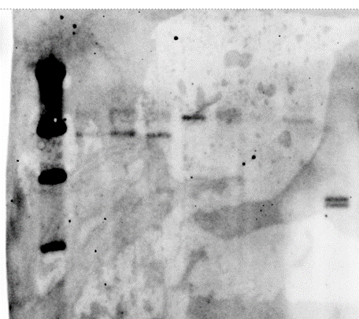
41
41-2
41-3
50
54
58
61
65

