Characterization of Mo- and Fe-Nitrogenases expression in the Plant Growth-Promoting Endophyte Kosakonia radicincitans UYSO10

Submitted to Plant and Soil

Authors: ^{1*}Cecilia Taulé, ²Raúl Platero, ³Analía Lima, ⁴Máximo González, ³Rosario Durán, ⁵Alexandra Stoll, and ¹Federico Battistoni

*corresponding author: Cecilia Taulé: ¹Laboratorio de Interacción Planta Microorganismos, Departamento de Bioquímica y Genómica Microbiana. Centro de Investigaciones en Ciencias Ambientales, Instituto de Investigaciones Biológicas Clemente Estable. Avenida Italia 3318. Montevideo 11600, Uruguay. ctaule@iibce.edu.uy

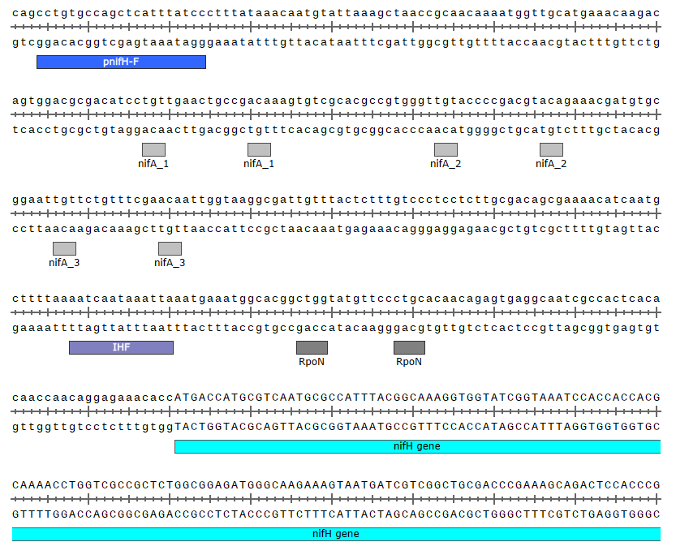
Fig. S1 Regulatory elements identified in the nifH promoter region used in the construction of the reporter fusion in this study. The DNA sequence includes three NifA-binding sites, the RpoN-binding site, and an IHF-binding site. The PCR primer used to amplify the promoter region is marked in blue, and the coding sequence for the nifH gene is indicated in sky blue. The image was generated using SnapGene Viewer v7.2.

A)
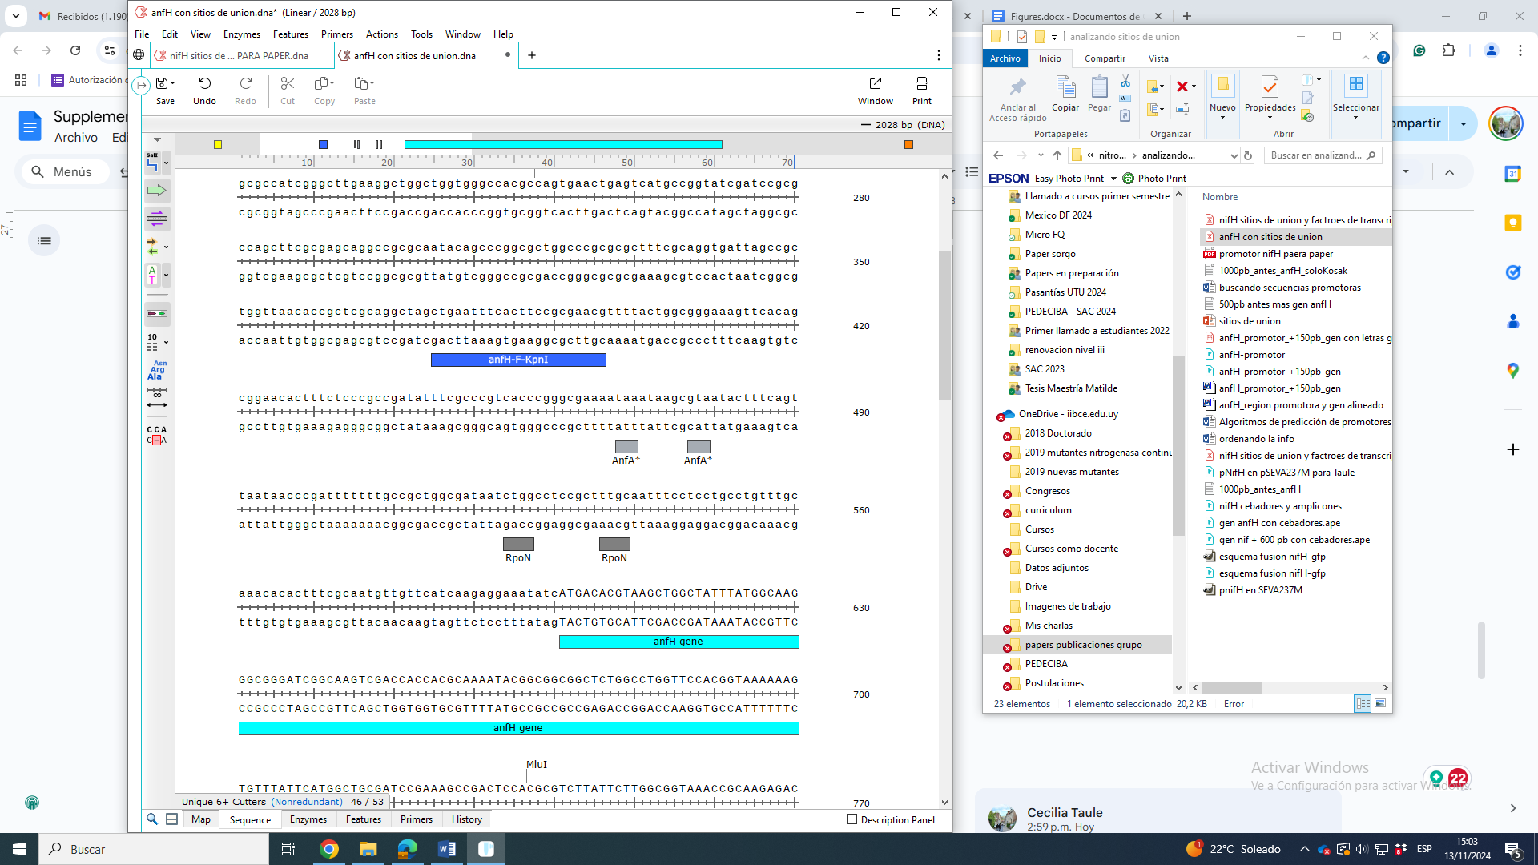
B)
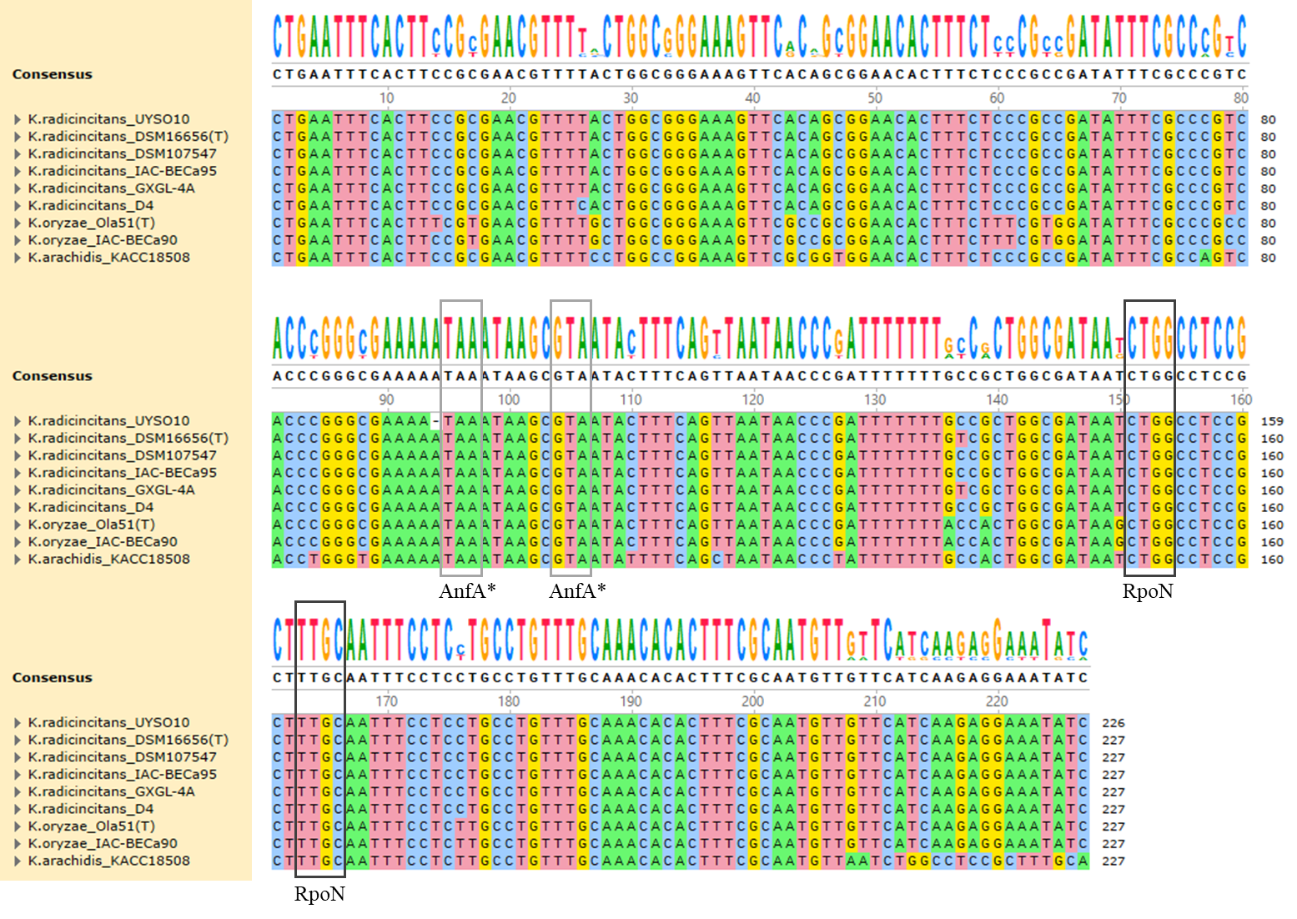
Fig. S2 Regulatory elements identified in the anfH promoter region used in constructing the reporter fusion in this study. A) The DNA sequence includes an RpoN-binding site and a possible AnfA-binding site. The PCR primer used to amplify the promoter region is marked in blue, and the coding sequence for the nifH gene is highlighted in sky blue. B) Comparison of the promoter region of the anfH gene from strains of K. radicincitans, K. oryzae, and K. arachidis. The conserved nucleotides proposed as RpoN-binding sites and the potential AnfA-binding sites are indicated by grey squares. The image was generated using SnapGene Viewer v7.2.

-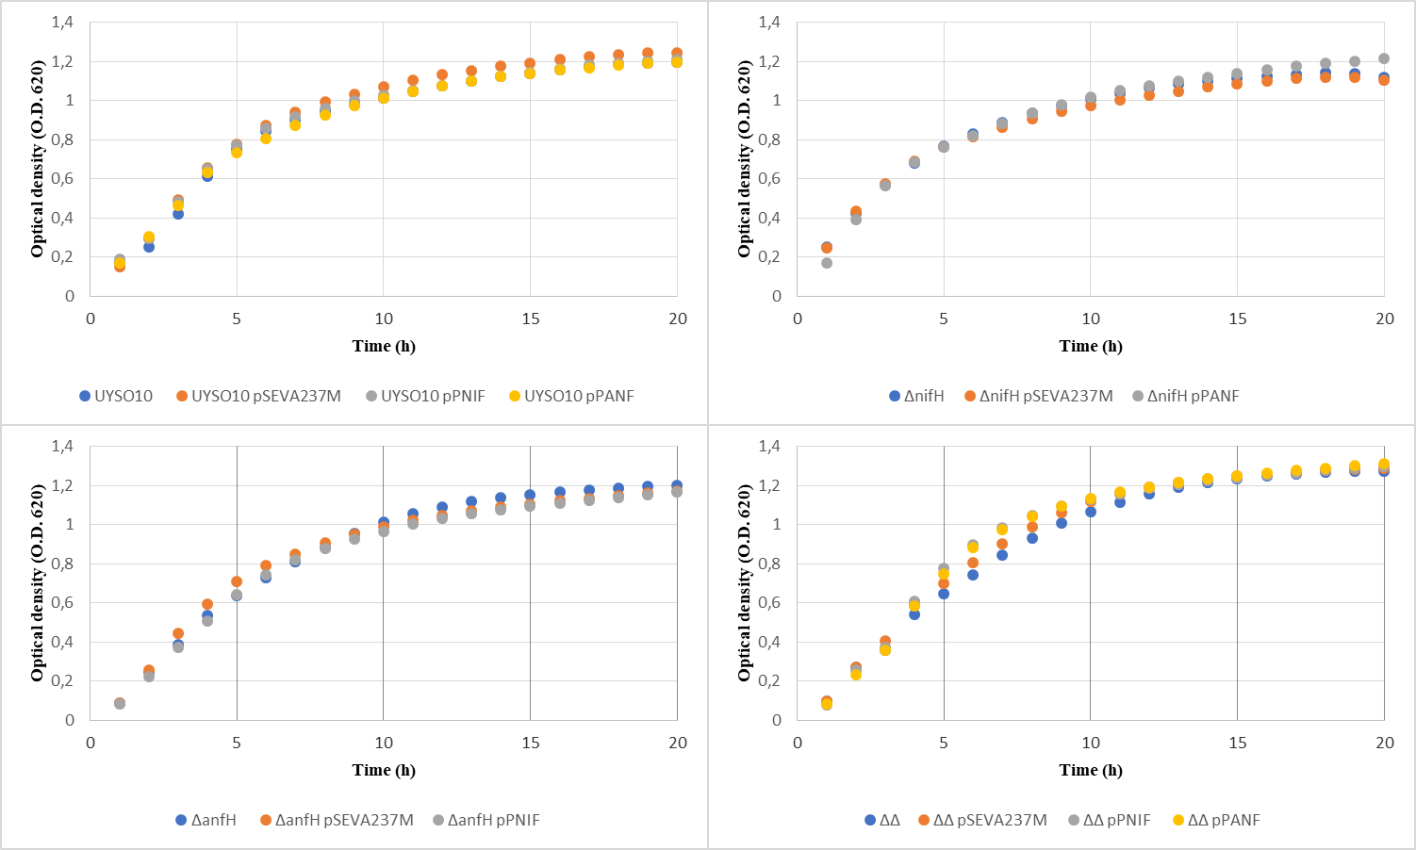Fig. S3 Growth capacity of K. radicincitans UYSO10 wild-type, nitrogenase mutant strains, and strains harboring pSEVA237M, pPNIF, and pPANF, in 96-well microtiter plates containing LB growth medium.

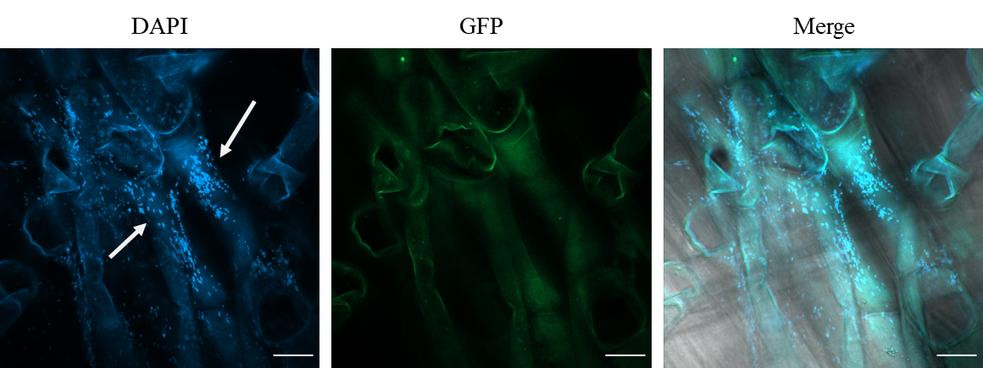
Fig. S4 Laser confocal microscopy showing the colonization of K. radicincitans UYSO10 strain on sugarcane var. LCP roots, 7 days post-inoculation. The micrographs in the DAPI column identify bacterial and plant cells. The GFP column micrographs show no GFP signal, indicating the absence of promoter activation for msfGFP in the UYSO10 strain. The last column provides a merge of the previous micrographs. The bacterial cells are indicated with white arrows. White bars represent 20 µm.

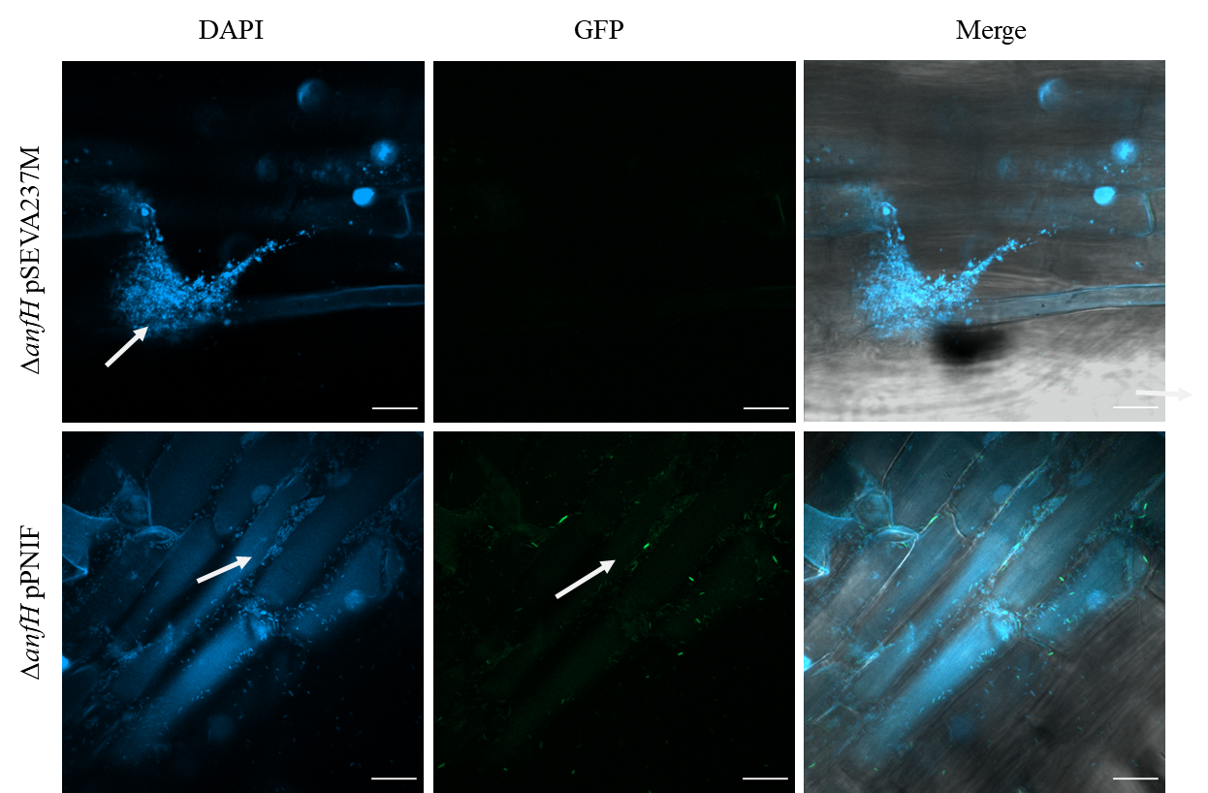
Fig. S5 Laser confocal microscopy showing the colonization of strains ΔanfH pSEVA237M and ΔanfH pPNIF on sugarcane var. LCP roots, 7 days post-inoculation. The micrograph in the DAPI column allows identification of bacterial and plant cells, while the micrographs under the GFP column show GFP signal detected from constructions using the nifH gene promoter. The strain ΔanfH pSEVA237M, containing a promoter-less msfGFP gene, was used as a negative control. In the final column, a merged image of the previous micrographs is shown. Bacteria are indicated with white arrows. Scale bars represent 20 µm.

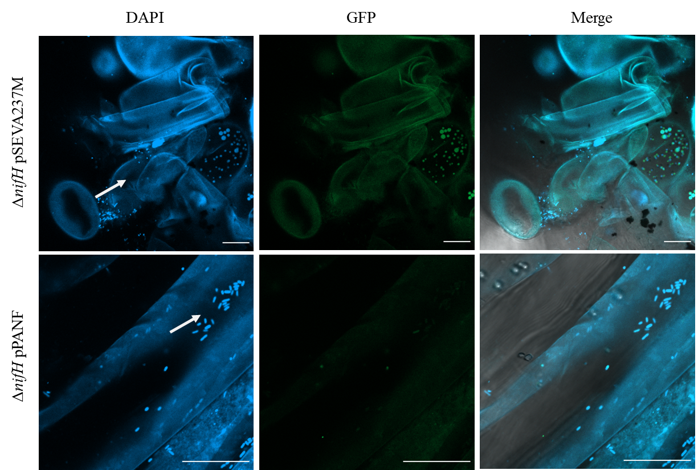
Fig. S6 Laser confocal microscopy showing the colonization of strains ΔnifH pSEVA237M and ΔnifH pPANF on sugarcane var. LCP roots, 7 days post-inoculation. The micrograph in the DAPI column allows identification of bacterial and plant cells. Micrographs in the GFP column show GFP signals detected from constructs using the anfH gene promoter. The strain ΔnifH pSEVA237M, which contains the msfGFP gene without any promoters, was used as a negative control. In the final column, a merged image of the previous micrographs is shown. Bacteria are indicated with white arrows. Scale bars represent 20 µm.

Table S1 Identification of unique peptide sequences of nitrogenase enzymes in Kosakonia radicincitans UYSO10 grown as free-living cells in co-culture with sugarcane plants
Peptide sequence | Spectrum count | # replicates
UYSO10_3119
CAESGGPEPGVGCAGR | 60 | 4
CNQANEYR | 15 | 3
LGGLICNSR | 40 | 3
LGTQM_{ox}IHFVPR | 5 | 3
MoxTVIEYDPK | 5 | 2
MTVIEYDPK | 20 | 3
QTDREDELIMoxALAEK | 10 | 3
QTDREDELIMALAEK | 17 | 4
RMTVIEYDPK | 6 | 2
STTTQNLVAALAEMGK | 18 | 3
VMoxIVGCDPK | 4 | 2
VMIVGCDPK | 5 | 2
UYSO10_3118
AINKPVIPVR | 2 | 1
DIVFGGDK | 8 | 4
DIVFGGDKK | 3 | 1
DMoxDMoxTINNPAWGQLTAPWLK | 11 | 4
DMDMTINNPAWGQLTAPWLK | 2 | 1
EGKPFEAGPYDVAIIGDYNIGGDAWASR | 5 | 2
GISIQSECPVGLIGDDIEAVANASR | 56 | 4
GVSQSLGHHIANDVIR | 14 | 4
GVSQSLGHHIANDVIRDWVLDNR | 1 | 1
HGIPWMoxEYNFFGPTK | 1 | 1
HVIGAYEDLGMoxEIIAAGYEFAHNDDYDR | 1 | 1
IADMoxFDDTIR | 20 | 4
IADMFDDTIR | 6 | 3
ILLEEMoxGLR | 16 | 3
ILLEEMGLR | 46 | 4
KAINKPVIPVR | 3 | 1
KIADMoxFDDTIR | 2 | 2
LIEEMoxETLFPLTK | 7 | 3
LIEEMETLFPLTK | 13 | 3
LNLVHCYR | 5 | 2
NLEIIQEVLEIFPEK | 35 | 3
NYYTGVSGVDSFGTLNFTSDFQER | 31 | 4
QMHSWDYSGPYHGYDGFAIFAR | 2 | 1
RNYYTGVSGVDSFGTLNFTSDFQER | 1 | 1
SMoxNYISR | 4 | 2
SMNYISR | 3 | 2
SQPGVMoxTVR | 2 | 1
SQPGVMTVR | 1 | 1
VVAQWSGDGTLVEMoxENTPFVK | 3 | 2
VVAQWSGDGTLVEMENTPFVK | 1 | 1
YQAQNDAIIAK | 7 | 2
TLPDLKEGTLLFDDASSYELEAFVK | 1 | 1
UYSO10_3117
ACQPLGAVLCSLGFANTLPYVHGSQGCVAYFR | 4 | 2
AIPDSLALER | 9 | 4
DTLAKGEQFEVPLIR | 2 | 1
EAPDAIDTLLLQPWQLAK | 68 | 4
EALTIDPAK | 19 | 4
ESEVFINCDLWHFR | 8 | 4
FGLFGDPDFVMoxGLTR | 11 | 4
FGLFGDPDFVMGLTR | 31 | 4
FLLELGCEPTVILCHNGSK | 5 | 2
GEQFEVPLIR | 41 | 4
INLVSGFETYLGNFR | 87 | 4
KFGLFGDPDFVMoxGLTR | 2 | 2
LGFPLFDR | 43 | 4
MLEASPYGK | 4 | 1
PEIIAVSTTCMAEVIGDDLQAFIANAKK | 1 | 1
QLEEAHDPAR | 12 | 3
QPDFMoxIGNSYAK | 3 | 2
QTTWGYEGAMoxSILTTLVNAVLEK | 18 | 4
QTTWGYEGAMSILTTLVNAVLEK | 8 | 4
SLMFTR | 5 | 3
TDYSFDLIR | 57 | 4
TFTADYSGQPGK | 25 | 4
TFTADYSGQPGKLPR | 4 | 2
VQEVFQWTTTAEYEALNFQR | 47 | 4

Table S2 Identification of unique peptide sequences of nitrogenase enzymes in Kosakonia fradicincitans UYSO10 adhered to the sugarcane root.
Peptide sequence | Spectrum count | # replicates
UYSO10_3119
CAESGGPEPGVGCAGR | 38 | 3
LGGLICNSR | 30 | 3
MTVIEYDPK | 6 | 2
QTDREDELIMALAEK | 4 | 2
UYSO10_3118
GISIQSECPVGLIGDDIEAVANASR | 4 | 2
GVSQSLGHHIANDVIR | 6 | 2
ILLEEMoxGLR | 16 | 3
ILLEEMGLR | 30 | 3
KVLLYMoxGGLR | 1 | 1
KVLLYMGGLR | 7 | 2
LEGRKVLLYMoxGGLR | 1 | 1
NLEIIQEVLEIFPEK | 1 | 1
NYYTGVSGVDSFGTLNFTSDFQER | 6 | 2
PDLIGSGIK | 6 | 2
PDLIGSGIKEK | 1 | 1
VLLYMGGLR | 1 | 1
UYSO10_3117
EALTIDPAK | 2 | 2
EAPDAIDTLLLQPWQLAK | 6 | 2
FGLFGDPDFVMoxGLTR | 1 | 1
FGLFGDPDFVMGLTR | 11 | 2
GEQFEVPLIR | 5 | 2
INLVSGFETYLGNFR | 45 | 3
LGFPLFDR | 24 | 3
SLMoxFTR | 1 | 1
TDYSFDLIR | 9 | 2
TFTADYSGQPGK | 3 | 2
TFTADYSGQPGKLPR | 1 | 1
VQEVFQWTTTAEYEALNFQR | 14 | 2
QLEEAHDPAR | 5 | 2

