Supplementary Information

S1. Mesh Independence Study
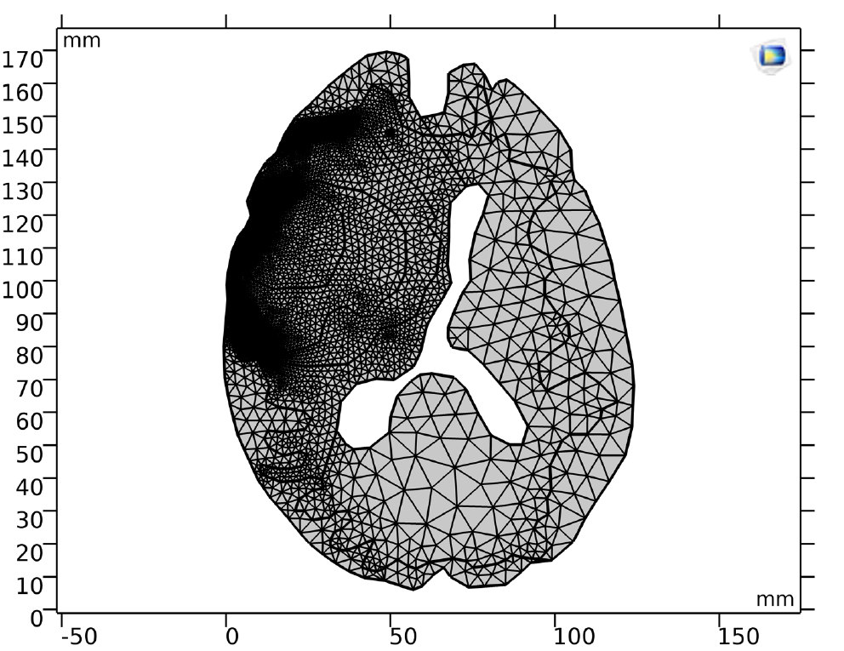
The computational domain for each patient model was discretized using the integrated meshing tools within COMSOL Multiphysics. A free triangular mesh was generated, employing three-node elements with one degree of freedom per node. To ensure the numerical results were not dependent on the mesh resolution, a mesh independence study was performed for each patient-specific model. This analysis confirmed that a solution independent of mesh density was achieved when the Average Element Quality (AEQ) exceeded 0.82. Beyond this quality threshold, further increases in the number of elements did not significantly alter the simulation outcomes. An adaptive meshing strategy was employed to optimize computational cost, as illustrated in Figure 6. The mesh was generated with a higher element density (i.e., finer mesh) in and near the tumor regions, while a coarser mesh was used in regions farther from the area of interest. This approach maintains high accuracy where it is most needed while reducing the overall simulation time.
Figure S1 Mesh used for a simulation model. The areas with sharp curves and high importance were meshed finer compared to those areas which were further or smoother.

S2. Per-Patient Data and Derived Parameters
The following table (Table S1) provides a comprehensive summary of the demographic, clinical, pathological, and key model-derived data for each of the 10 patients included in the final analysis.
Table S1: Summary of Per-Patient Clinical, Pathological, and Model-Derived Data
Patient ID | Age | Sex | Tumor Type | GFAP Status | IDH-1 Status | Ki-67 Positive | T1Gd Area (mm²) | T2 Area (mm²) | T1Gd Velocity (mm²/year) | Diffusivity (D) (mm²/year) | Proliferation (ρ) (1/year)
Case 1 | 32 | M | Mutant | + | + | - | 345.5 | 1570.8 | 53.86 | 42.75 | 17
Case 2 | 59 | F | Wild-type | + | - | + | 382.2 | 506 | 118.1 | 33.43 | 104.25
Case 3 | 36 | M | Mutant | + | + | + | 1665 | 2214 | 49.1 | 208 | 2.9
Case 4 | 66 | F | Wild-type | + | - | + | 826.1 | 2092.3 | 31.6 | 24.72 | 10.1
Case 5 | 60 | F | Mutant | + | + | + | 2172.9 | 3670 | 102.1 | 77 | 33
Case 6 | 57 | F | Mutant | + | + | - | 1289 | 2398 | 125.4 | 95 | 41.4
Case 7 | 66 | F | Mutant | + | + | - | 1070 | 1918 | 22.8 | 13.3 | 9.8
Case 8 | 61 | M | Wild-type | + | - | - | 622 | 2324 | 17.7 | 4.6 | 0.256
Case 9 | 63 | M | Wild-type | + | - | - | 836.5 | 2128 | 59.5 | 42 | 21
Case 10 | 52 | F | Mutant | + | + | - | 1360 | 2432.3 | 70.8 | 41.8 | 52.6

S3. Methodology for Parameter Calculation

S3.1. Calculation of Patient-Specific Diffusion (D) and Proliferation (ρ) Coefficients
The patient-specific diffusion and proliferation rate coefficients were extracted from the T1Gd and T2-weighted MR images. The calculation for each patient involved solving a system of two equations with two unknowns (D and ρ). First, the ratio of proliferation to diffusion (ρ/D), which represents the tumor's relative invasiveness, was calculated using the volumes of the T1Gd and T2 regions. The tumor volume for each region was determined by calculating the delineated area in each MRI slice and multiplying it by the slice thickness (which varied from 5 to 7 mm). Second, assuming linear tumor growth between two sequential MRI scans, the Fisher-Kolmogorov approximation for tumor front velocity was used to establish the relationship $V=2×\sqrt{ρD}$ By solving these two equations simultaneously, unique patient-specific values for both the diffusion coefficient (D) and the net proliferation rate (ρ) were determined. A sample calculation for patient 8 is detailed in Table S1.
Table S2. Sample Calculation of the Pathological Coefficient ($ρ_{path}$) via Iterative Error Minimization
Patient 8 | Wild-Type | 63 | M
T1Gd area(mm²) | - | - | 201 | 435 | 622 | 54 | - | - | -
T2 area(mm²) | 659 | 1195 | 2062 | 1978 | 2324 | 2339 | 1794 | 1127 | 147
Volume T1Gd (mm³) | 7699.25
Volume T2 (mm³) | 85943
Velocity ($\frac{mm}{year}$) | 17.71

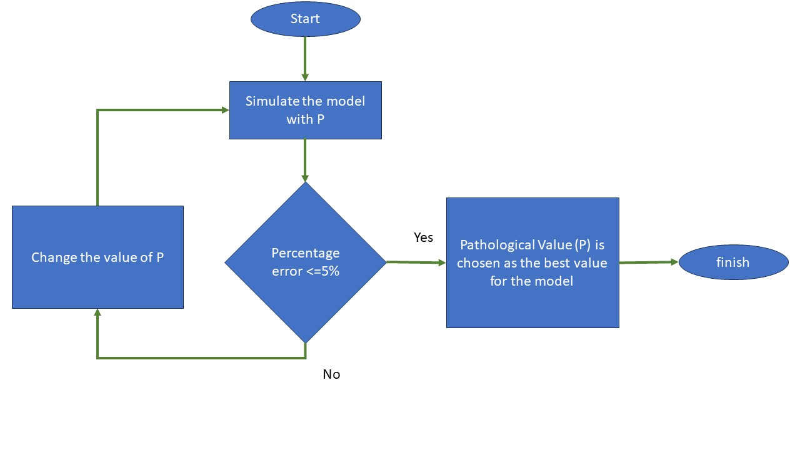
S4. Determination of the Pathological Coefficient ($ρ_{path}$​)
Figure S2 Flowchart of calculating the value of P. the initial value of P is arbitrary and the change of P depends on the difference between the area of the actual MR image and the model.
Following the calculation of the baseline patient-specific parameters, the Pathological Coefficient ($ρ_{path}$​, referred to as P in the original draft's figures and tables) was determined. This process used an iterative parameter sweeping method, as illustrated in the flowchart in
For each patient, the simulation (Equation 2 from the main text) was initialized with $ρ_{path}$​=0. The resulting simulated tumor area was compared to the actual tumor area observed in the follow-up MR image. If the percentage error between the simulated and actual area was greater than 5% (±0.5), the value of $ρ_{path}$ was incrementally increased, and the simulation was run again. This loop was repeated until the error dropped below the 5% (±0.5) threshold. The final $ρ_{path}$​ was chosen as the value that best fit the observed data while satisfying this condition. A sample calculation is shown in Table S2.
Table S3 the range of $ρ_{path}$ for a patient with
$ρ_{path}$ | Actual area (mm²) | Simulation area (mm²) | Percentage error %
0 | 2452 | 2226 | 9%
1 | 2452 | 2237 | 8.76%
5 | 2452 | 2253 | 8%
20 | 2452 | 2323 | 5.26%
40 | 2452 | 2459 | 0.3%
70 | 2452 | 2560 | 4.4%
To develop a generalized model, the leave-one-out method was employed to determine a single, representative $ρ_{path}$​ value for each GBM subtype (wild-type and mutant).

