Supplementary Material

Adding Time-Domain ¹⁶¹Dy Mössbauer to the Mix: a Multitechnique Investigation of Magnetic Transitions in a {Co^{III}₃Dy^{III}₃} Cluster with a Toroidal Moment
Yan Peng,*^{1,2} Jonas Braun,^{1,3,4} Lena Scherthan,⁵ Hendrik Auerbach,⁶ Juliusz A. Wolny,⁵ Michael Schulze,⁷ E. Ercan Alp,⁸ Jiyong Zhao,⁸ Wenli Bi,⁹ Lorenzo Tesi,^{10,11} Christopher E. Anson,¹ Jani O. Moilanen,¹² Dennis. E. Brown,¹³ Liviu F. Chibotaru,¹⁴ Wolfgang Wernsdorfer,^{4,6} Mauro Perfetti,⁸ Roberta Sessoli,*⁸ Volker Schünemann,*⁵ Annie K. Powell,*^{1,3,4}

1) Institute of Inorganic Chemistry (AOC), Karlsruhe Institute of Technology (KIT), Kaiserstr. 12, 76131 Karlsruhe, Germany.
2) School of Chemistry and Chemical Engineering, Jiangxi Provincial Key Laboratory of Functional Crystalline Materials Chemistry, Jiangxi University of Science and Technology, Ganzhou 341000, Jiangxi Province, P. R. China.
3) Institute of Nanotechnology (INT), Karlsruhe Institute of Technology (KIT), Kaiserstr. 12, 76131 Karlsruhe, Germany.
4) Institute for Quantum Materials and Technologies (IQMT), Karlsruhe Institute of Technology (KIT), Kaiserstr. 12, 76131 Karlsruhe, Germany.
5) Department of Physics, University of Kaiserlautern-Landau, Erwin-Schrödinger-Str. 46, 67663 Kaiserslautern, Germany.
6) Department of Radiotherapy and Radiation Oncology, Saarland University Medical Centre, Kirrberger Str. 100, 66421, Homburg, Saar, Germany.
7) Institute of Physics (PHI), Karlsruhe Institute of Technology (KIT), Kaiserstr. 12, 76131 Karlsruhe, Germany.
8) Advanced Photon Source, Argonne National Laboratory, Argonne, Illinois 60439, USA.
9) SmartState Center for Experimental Nanoscale Physics, Department of Physics and Astronomy, University of South Carolina, Columbia, South Carolina 29208, USA.
10) Department of Chemistry “U. Schiff”, University of Florence, Via della Lastruccia 3-13, Sesto Fiorentino, Italy.
11) Institute of Physical Chemistry and Center for Integrated Quantum Science and Technology, University of Stuttgart, D-70569 Stuttgart, Germany
12) University of Jyväskylä, Department of Chemistry, Nanoscience Centre, P.O. Box 35, FI-40014 University of Jyväskylä, Finland.
13) Department of Physics, Northern Illinois University, DeKalb, Illinois 60115 USA.
14) Theory of Nanomaterials Group, Katholieke Universiteit Leuven, Celesijnenlaan, 200F, Heverlee, B-3001, Belgium.

Corresponding authors:
annie.powell@kit.edu
yan.peng@jxust.edu.cn
roberta.sessoli@unifi.it
schuene@rptu.de

Synthesis of [Co^{III}₃Dy^{III}₃(OH)₄(O₂C-C₆H₄-p-Me)₆(pmide)₃(H₂O)₃]Cl₂·10MeCN (1)
H₂pmide (100 mg, 0.5 mmol) in MeCN (5 ml) was added to a solution of CoCl₃·6H₂O (66 mg, 0.25 mmol), DyCl₃·6H₂O (94 mg, 0.25 mmol) and 4-methylbenzoic acid (136 mg, 1 mmol) in a mixture of MeCN (15 ml) and MeOH (5 ml). After stirring for 10 minutes, NEt₃ (0.56 ml, 4 mmol) was added and the solution was stirred for a further 30 minutes. The solution was then filtered and left undisturbed. After three days purple single crystals in the form of hexagonal plates were collected by filtration. Anal. Calcd for C₉₈H₁₂₄Cl₂Co₃Dy₃N₁₆O₂₅: C 44.23; H 4.70; N 8.42. Found: C 44.14; H 4.57; N 8.52. Selected IR data (KBr, cm⁻¹) for 1: 3493 (br), 3062 (w), 2978 (w), 2856 (m), 1595 (s), 1542 (s), 1097 (s), 908 (s), 719 (s), 673 (s), 593 (s).

Magnetic Measurements: The magnetic susceptibility measurements were obtained using a Quantum Design SQUID magnetometer MPMS-XL in the temperature range 1.8-300 K. Measurements were performed on a polycrystalline sample restrained with eicosane in a polyethylene bag. Magnetization isotherms were collected at 2, 3 and 5 K between 0 and 7 T. Alternating current (ac) susceptibility measurements were performed with an oscillating field of 3 Oe and ac frequencies ranging from 1 to 1500 Hz. The magnetic data were corrected for the sample holder and the diamagnetic contribution.

X-ray analysis: X-ray crystallographic data were collected at 180(2) K on a Stoe IPDS II diffractometer using graphite-monochromated Mo-Ka radiation. The structure was solved by dual-space direct methods (SHELXT)¹ and refined by full-matrix least-squares against F_{o}² (SHELXL-2016)² within the Olex2 platform.³ Anisotropic displacement parameters were used for all ordered non-hydrogen atoms. O-H distances were restrained to 0.88(4) Å, and organic hydrogen atoms were placed in calculated positions. One chloride counterion and six lattice MeCN per cluster could be refined anisotropically; the second chloride and four further MeCN were mutually disordered, and these were refined using partial-occupancy isotropic atoms. Full crystallographic data and details of the structural determinations for the structures in this paper have been deposited with the Cambridge Crystallographic Data Centre as supplementary publication nos. CCDC 1560928. Copies of the data can be obtained, free of charge, from https://www.ccdc.cam.ac.uk/structures/

Table S1. Crystallographic Data and Structural Refinement for 1.
Compound | 1
Formula | C₉₈H₁₂₄Cl₂Co₃Dy₃N₁₆O₂₅
Mr [g mol⁻¹] | 2661.31
Colour | Purple
Crystal System | Trigonal
Space Group | $P\overline{3}c1$
T [K] | 180(2)
a [Å] | 18.8802(6)
c [Å] | 35.8782(15)
V [Å] | 11075.8(8)
Z | 4
D_{calc} [g·cm⁻³] | 1.596
µ(Mo-Kα) [mm⁻¹] | 2.561
F(000) | 5348
Reflns collected | 43578
Unique data | 7016
Rint | 0.0875
Data with I > 2σ(I) | 4049
Parameters / restraints | 459 / 16
S on F² | 0.825
R₁ [I > 2σ(I)] | 0.0367
wR₂ (all data) | 0.0797
Largest diff peak/hole [e Å⁻³] | +0.88 / -1.42
CCDC No. | 1560928

Table S2. Selected bond lengths and angles for compound 1.
Dy1-O1 | 2.3650 (17) | Co1-N1 | 1.914 (5)
Dy1-O2 | 2.460 (3) | Co1-N2 | 1.929 (4)
Dy1-O2^{i} | 2.396 (3) | Co1-O2 | 1.906 (3)
Dy1-O3 | 2.300 (3) | Co1-O3 | 1.883 (3)
Dy1-O4^{i} | 2.321 (3) | Co1-O4 | 1.859 (3)
Dy1-O6 | 2.351 (3) | Co1-O5 | 1.925 (4)
Dy1-O7 | 2.316 (3) | Dy1-O1-Dy1 | 108.98 (12)
Dy1-O9 | 2.482 (4) | Co1-O2-Dy1^{i} | 102.23 (14)
Dy1∙∙∙Co1 | 3.3036 (7) | Co1-O2-Dy1 | 97.50 (13)
Dy1∙∙∙Co1^{i} | 3.3636 (8) | Dy1-O2-Dy1i | 104.88 (11)
Dy1∙∙∙Dy1^{i} | 3.8502 (5) | Co1-O3-Dy1 | 103.87 (14)
Co1∙∙∙Co1^{i} | 6.2764 (2) | Co1-O4-Dy1^{i} | 106.65 (14)
Symmetry operation: i 1-y, 1+x-y, z
SQUID Magnetometry
Fig S1. Plots of χ’ (a) and χ’’ (b) vs temperature under 0 Oe dc fields for 1 at indicates frequencies.

Fig S2. Plots of χ’ (a) and χ’’ (b) vs frequency under 0 Oe dc fields for 1 at indicates temperatures.
Fig S3. Plots of χ’ (a) and χ’’ (b) vs frequency under different dc magnetic fields for 1 at 2 K.

Fig S4. Plots of χ’ (a) and χ’’ (b) vs temperature under 3000 Oe dc fields for 1 at indicates frequencies.
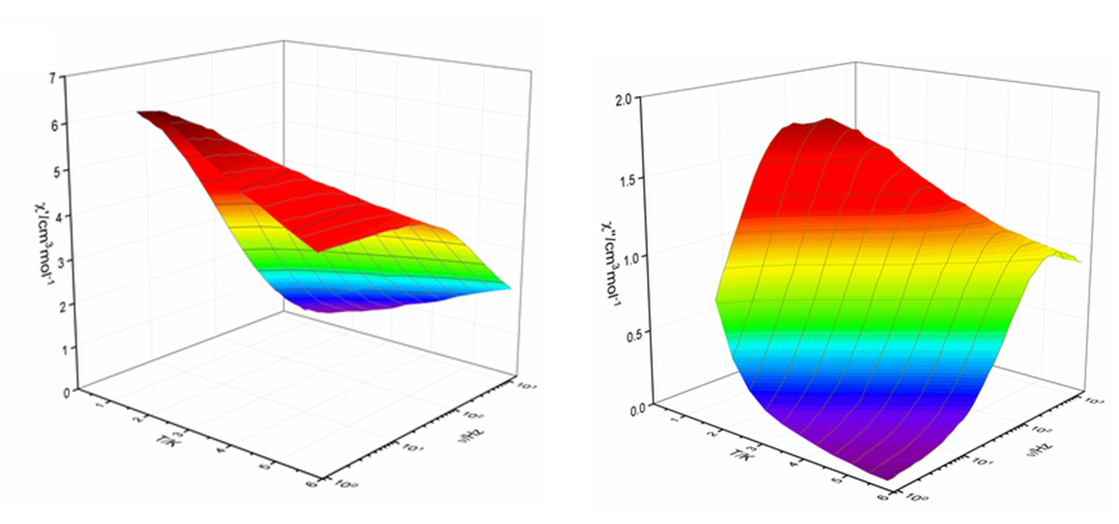
Fig S5. Plots of χ’ (left) χ’’ for 1 and (right) vs frequency under 3000 Oe dc fields at indicated temperatures (solid lines for guiding the eyes).

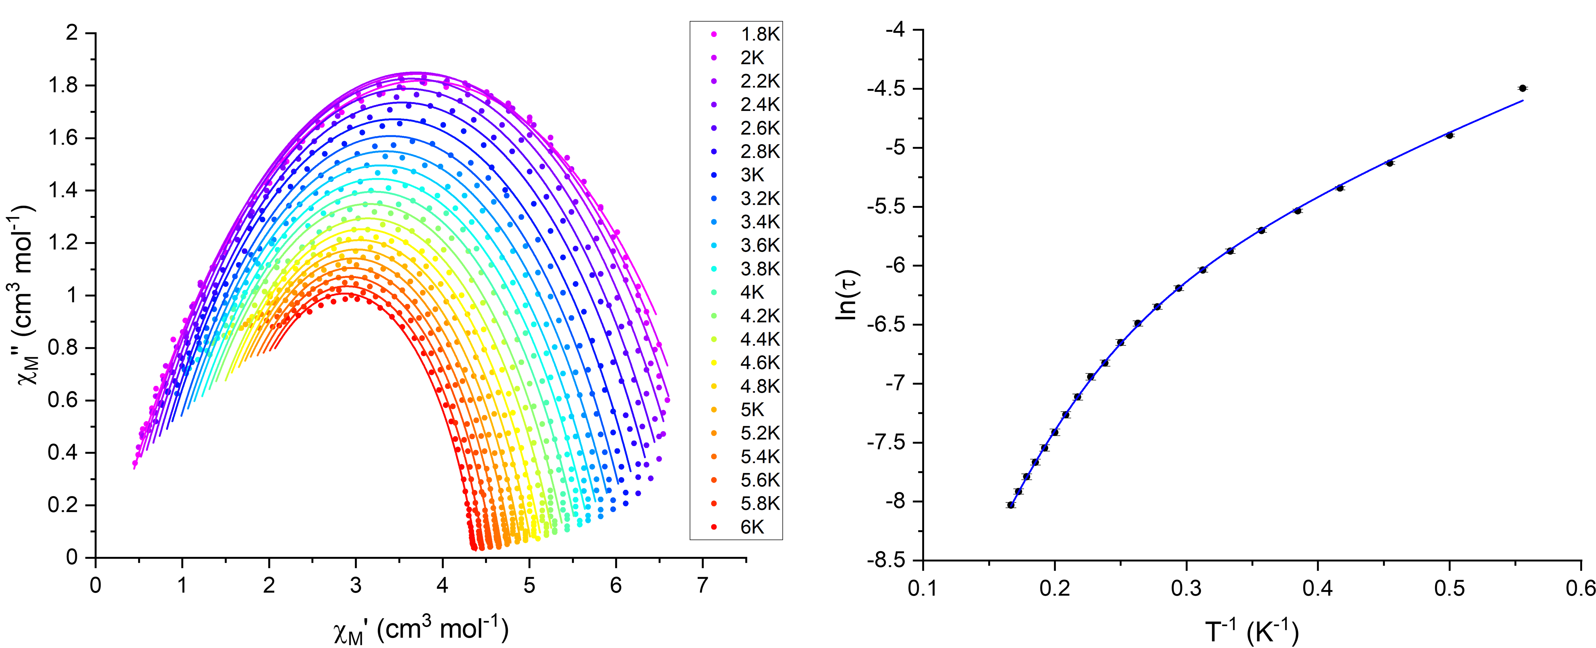
Fig S6. Cole-Cole plots (left); solid lines are best fit to a single generalised Debye model. Temperature dependence of relaxation times (right); solid blue line corresponds to the best fit using the multicomponent equation (1) as shown in the main text.

Experimental ¹⁶¹Dy time-domain SMS Setup:
Time-domain SMS experiments were carried out at the Advanced Photon Source (APS) at Argonne, Illinois operating in the standard operating mode (top-up) (bunch separation of 153 ns).
The monochromatization of the desired nuclear resonant transition energy of 25.65 keV was achieved using the suitable monochromator setup as described in reference⁴.⁵ In analogy to our recent experiments,⁶ the beam size was about 0.5mm (horizontal) and 0.3 mm (vertical) at the sample position, with a flux of about 1.5 ·10⁸ phs/s. The polycrystalline compound 1 was pressed into a hole of a copper sample holder with a diameter of 1.5 mm and thickness of 1.5 mm. The elastic coherent signal was measured in forward geometry with a detector system consisting of Avalanche Photo Diodes and electronic amplification.^{5,7}

¹⁶¹Dy time-domain SMS Analysis:⁸ The analysis of the experimental time-domain SMS data was performed by the theoretical calculation of the nuclear forward scattered amplitude implemented in the software CONUSS.⁸ The conversion of the raw time-domain SMS data into time scale is done with a conversion factor of 0.0489 ns per channel and with a binning of three channels. The time zero point is given by the maximum of the prompt signal.⁷ This conversion process influences slightly the determination of the magnetic hyperfine field, leading to a maximal error of ΔB_{eff} = 0.5 T.
The huge magnetic hyperfine field of ¹⁶¹Dy leads to a hyperfine splitting in the range of about ±1200 Γ or ±22 cm/s.^{9,10} As outlined in detail in ref⁶, the related fast beating period of 2πћ/ΔE = 0.11 ns can, however, not be resolved due to the limited detector resolution of about 1 ns.
The texture coefficient reflects the fraction of randomly oriented hyperfine fields in units of percent. Here, 100 % represents a single crystal or a perfect alignment of the magnetic hyperfine field along the same direction, while 0 % means no preferred orientation in sample. The orientation of the hyperfine field given by the polar angle θ and azimuthal angle φ with respect to the reference system determined by the synchrotron radiation (beam direction and polarization) has to be seen as an averaged angle if the texture coefficient is not 100 %. The effective thickness t_{eff} is a dimensionless parameter, depending on the absorption cross section, the number density of resonant nuclei, Lamb Mössbauer factor and the thickness of the sample.¹¹ This value influences the time scale of the exponential decay.^{7,8}

Table S3. Parameters used for the analysis of the time-domain SMS spectra with effective angle θ=0° and ϕ=0°. An effective thickness t_{eff}=26(1) was used for the simulation.

B_{ext} (T) | B_{eff} (T) | σ (T) | texture coefficient (%)
0 | 558.5(5) | 2.0(2) | 0(5)
0.4 | 558.6(5) | 1.8(2) | 0(5)
0.5 | 558.4(5) | 1.9(2) | 0(8)
0.6 | 558.7(5) | 1.9(2) | 0(10)
0.8 | 558.4(5) | 1.6(2) | 25(10)
1 | 559.0(5) | 1.6(1) | 37(5)
2 | 559.7(5) | 0.8(1) | 62(4)
4 | 560.8(5) | 0.5(1) | 72(3)

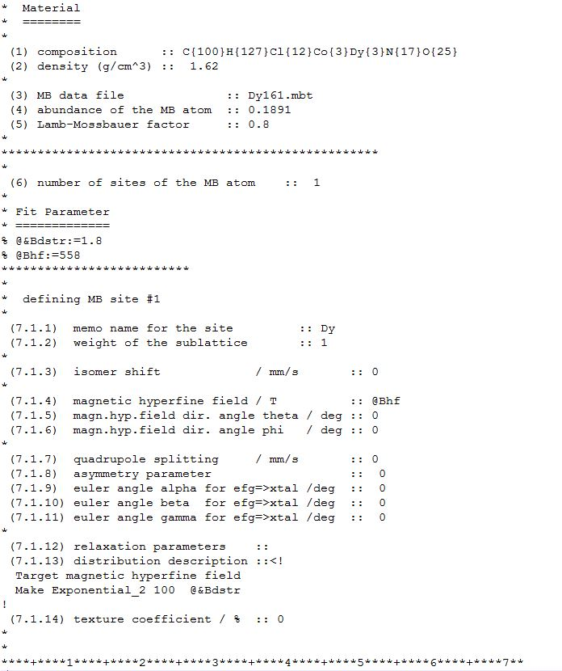
Fig S7. Schematic presentation of the results of a theoretical simulation of the experimental time-domain SMS zero-field spectrum resulting by the analysis with CONUSS with its preinstalled nuclear parameters and the used hyperfine parameters.⁸

Cantilever Torque Magnetometry
Torque magnetometry experiments were performed by using a homemade two-legged CuBe cantilever separated by 0.1 mm from a gold plate.¹² The cantilever was inserted into an Oxford Instruments MAGLAB2000 platform with automated rotation of the cantilever chip in a vertical magnet. The capacitance of the cantilever was detected with an Andeen-Hegerling 2500. An Ultra Precision Capacitance Bridge.

Table S4. Components the rotation axis (Y) and of the direction of the magnetic field (B) expressed in the orthogonal ab’c reference frame.
 | Y | B
Rot1 | (-0.5, -0.866, 0) | (-0.866, 0.5, 0)
Rot2 | (0, 0, 1) | (0.5, -0.866, 0)

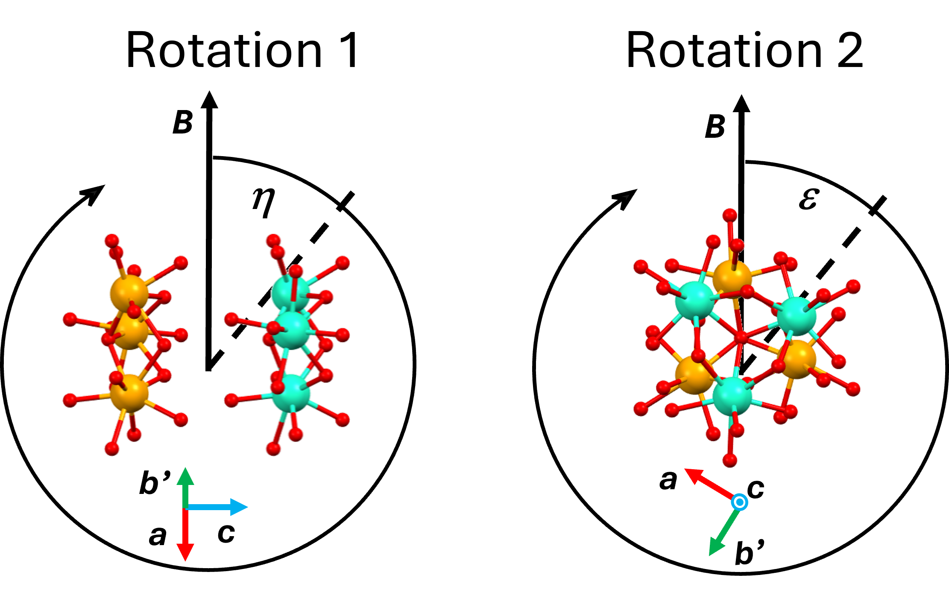
Fig S8. Sample reference frame and rotation angle definition of the torque measurements.
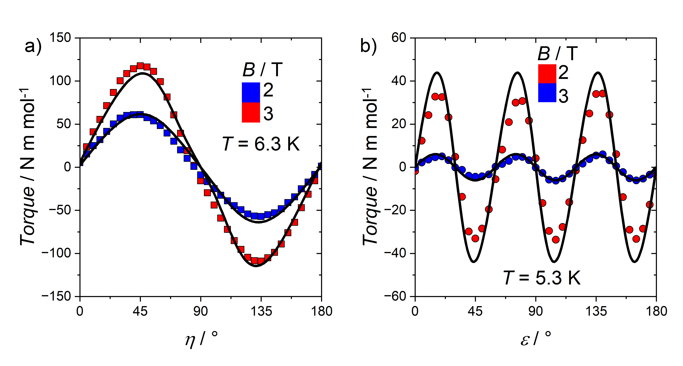
Fig S9. Torque signal of Rot 1 (a) and Rot 2 (b). The black line is the best fit (see text).
Micro-SQUID Magnetometry
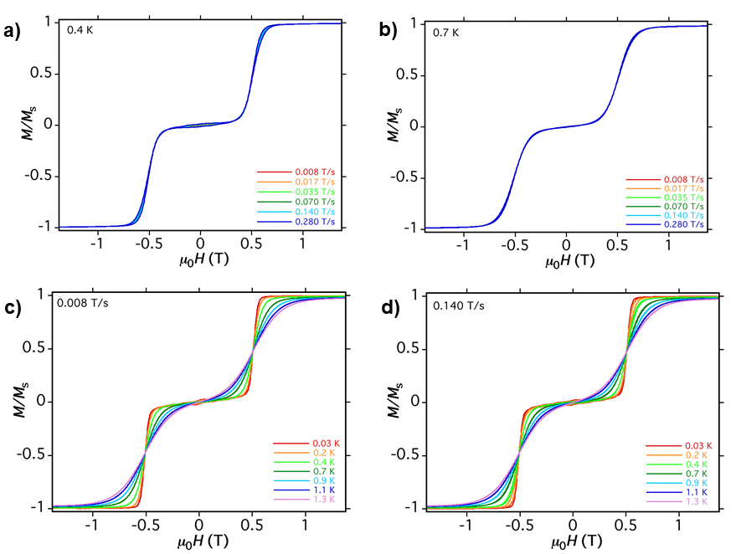
Fig S10. Field dependence of the magnetization at T = 0.4 K (a) and 0.7 K (b) with the field applied parallel to the ab-plane of the crystal, Field dependence of the magnetization at indicated temperatures with the field applied parallel to ab-plane of the crystal in scan rates of 0.008 T/s (c) and 0.014 T/s (d). Field dependence of the magnetization at indicated temperatures with the field applied parallel to ab-plane of the crystal with scan rates of 64 mT/s (e) and first derivative of the magnetization of micro-SQUID loops at different temperatures with scan rate of 64 mT/s (f).

Computational details
To investigate the magnetic properties of 1 computationally, the CASSCF/SO-RASSI calculations were carried out for the three model systems, namely [Dy₃Co₃]²⁺, [Dy₃Co₃Cl]⁺, and [Dy₃Co₃Cl₂] (Fig. S11).¹³⁻¹⁵ The geometries of model systems were extracted from the crystal structure of 1 but the methyl group of para-methyl benzoic acid was replaced with H in all studied complexes to simplify the model systems slightly. Prior to the CASSCF/SO-RASSI calculations,¹³⁻¹⁶ the positions of hydrogen atoms were optimized at the RI-PBEPBE-D3/def2-TZVP level of theory,¹⁷⁻²⁵ while the positions of other atoms were kept frozen. In this prior optimization step, Dy^{III} ions were substituted for Y^{III} ions to avoid convergence problems. The core electrons of Y^{III} ions were modelled using an effective core potential.¹⁷ The RI-PBEPBE-D3/def2-TZVP calculations were performed with Turbomole V7.3 quantum chemistry program package,²⁶ whereas MOLCAS 8.4 ab initio quantum chemistry program package was used for the CASSCF/SO-RASSI calculations.²⁷

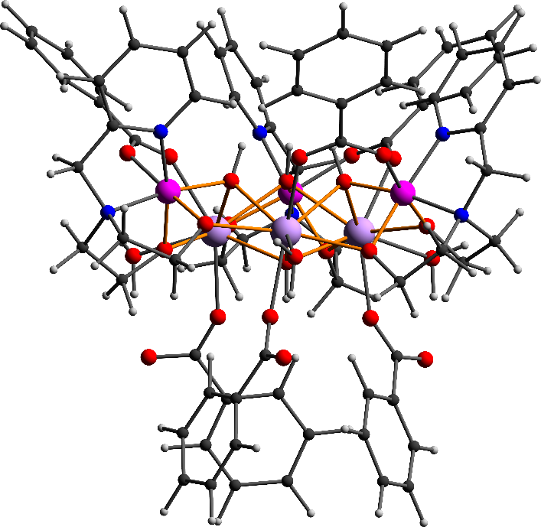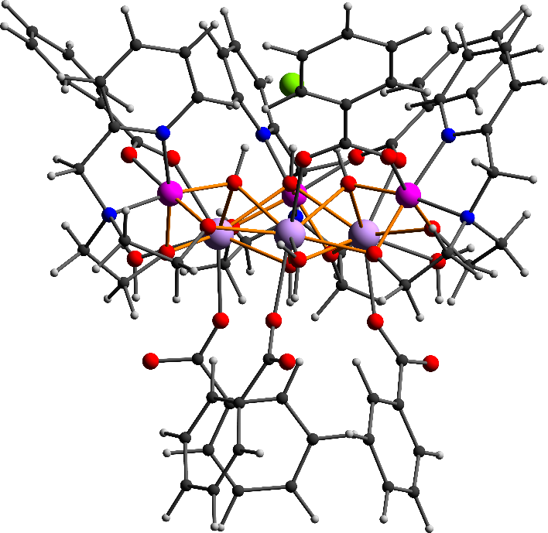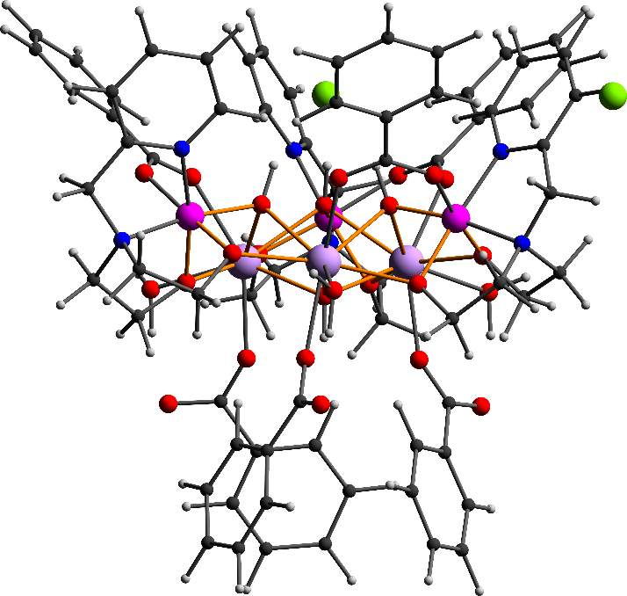
Fig S11. Three model systems used in CASSCF calculations: [Dy₃Co₃]²⁺ (left), [Dy₃Co₃Cl]⁺ (middle), and [Dy₃Co₃Cl₂] (right). C = black, N = purple, O = red, Cl = bright green, Co = blue, and Dy = cyan.

Although, the model systems [Dy₃Co₃]²⁺, and [Dy₃Co₃Cl]⁺ have C₃-symmetry axis that passes through the central Cl⁻ anion and μ₃-OH, the second Cl⁻ anion in [Dy₃Co₃Cl₂] breaks down this 3-fold symmetry. Thus, we calculated all model systems without symmetry idealization, that is, the CASSCF/SO-RASSI calculations were performed for each individual Dy^{III} ions separately while two others Dy^{III} ions were replaced with diamagnetic Y^{III} ions. In the CASSCF/SO-RASSI calculations ANO-RCC-VTZP and ANO-RCC-VDZP basis sets were used for Dy^{III} and all other atoms (H, C, N, O, and Co), respectively.^{28,29} However, due to the large size of the investigated model systems and to speed up the CASSCF/SO-RASSI calculations, ANO-RCC-MB basis set was employed for the C atoms of benzene ring of benzoic acid as well as for all C-H protons. To further speed up the calculations, the Cholesky decomposition was employed for two electron integrals with the threshold value of 10^{–8}. The scalar relativistic effects were taken into account using the exact two component (X2C) transformation.^{30,31} 9 electrons of Dy^{III} ion in seven 4f-orbitals give rise to 21 sextets, 224 quartets, and 490 doublets. All these states were solved in the state-average CASSCF calculations. Out of all these calculated states 21 sextets, 128 spin quartets, and 130 spin doublets were mixed by spin-orbit coupling in the subsequent restricted active space state interaction calculations (SO-RASSI).¹⁶ From the calculated SO-RASSI wave functions local magnetic properties of each individual Dy^{III} ions were extracted utilizing the SINGLE_ANISO routine.³²⁻³⁴ To investigate the total magnetic interactions (exchange and dipolar) between Dy^{III} ions in [Dy₃Co₃Cl]⁺ and [Dy₃Co₃Cl₂], the exchange interaction was first modelled using the Lines model and dipolar interaction was calculated as implemented in the POLY_ANISO program.^{35,36} The exchange coupling constant in Lines model ($J_{ij}^{exch}$) was obtained by fitting the calculated susceptibility and magnetization data to the experimental values, while increasing the value of$J_{ij}^{exch}$ in small increments of 0.001 cm^{–1}.³⁷ Two lowest lying spin-orbit states of each Dy^{III} ions were included into the exchange interaction. The effective Heisenberg Hamiltonian utilized in the Lines model is given in equation S1:

$H=-\sum_{\begin{aligned}i,j=1 \\ i≠j\end{aligned}}^{3}{J_{ij}S_{i}·S_{j}}$, (S1)

in which $S_{i}$ and $S_{j}$ correspond to local spins operators (S = 5/2) on the ith and jth sites, respectively, in the absence of the spin-orbit coupling. Moreover, due to the 3-fold symmetry of [Dy₃Co₃Cl]⁺ it can be estimated that $J_{12}^{exch}=J_{13}^{exch}=J_{23}^{exch}$. Thus, only one fitting parameter was used in the fitting procedure for [Dy₃Co₃Cl]⁺. To keep the number of fitting parameters in minimum also for [Dy₃Co₃Cl₂], we used this same approximation for it although it slightly deviates from the ideal C₃ system. After obtaining the $J_{ij}^{exch}$it was converted to Ising exchange parameter (${\tilde{J}}_{ij}^{exch}$) using the following equation:

${\tilde{J}}_{ij}^{exch}={25J}_{ij}^{exch}cosδ_{ij}$, (S2)

in which ${\tilde{J}}_{ij}^{exch}$ and $J_{ij}^{exch}$ are the exchange coupling constant in noncollinear Ising and Lines models, respectively, and 𝛿_{ij} is the angle between the main magnetic axes of the two interacting sites i and j.³⁵ Finally the total magnetic interactions between Dy^{III} ions in 1 were evaluated by calculating the total magnetic interactions for [Dy₃Co₃Cl]⁺ and [Dy₃Co₃Cl₂] employing the noncollinear Ising model with the following Hamiltonian:

$\tilde{H}=-\left[\left({\tilde{J}}_{12}^{exch}+{\tilde{J}}_{12}^{dip}\right){\tilde{S}}_{1,z}{\tilde{S}}_{2,z}+\left({\tilde{J}}_{13}^{exch}+{\tilde{J}}_{13}^{dip}\right){\tilde{S}}_{1,z}{\tilde{S}}_{3,z}+\left({\tilde{J}}_{23}^{exch}+{\tilde{J}}_{23}^{dip}\right){\tilde{S}}_{2,z}{\tilde{S}}_{3,z}\right]$, (S3)

in which ${\tilde{S}}_{i,z}$ (${\tilde{S}}_{j,z}$) is the projection of the pseudo-spin operator acting only on the anisotropy axis (z-axis) of site i (j), and ${\tilde{J}}_{ij}^{dip}$is a dipolar coupling constant given in equation S4:

${\tilde{J}}_{ij}^{dip}=μ_{B}^{2}g_{zi}g_{zj}\frac{cosϑ_{ij}-3cosϑ_{in}cosϑ_{jn}}{r^{3}}$. (S4)

In equation S4, μ_{B} is the Bohr magneton, $g_{zi}$ ($g_{zj}$) is the z-component of the g tensor of the ith (jth) center obtained from the CASSCF/SO-RASSI calculation, r is the distance between interacting ions, θ_{ij} is the angle between the main magnetic axes of the interacting ions, and θ_{in} (θ_{jn}) is the angle between the main magnetic axis of ith (jth) center and the vector connecting two interacting ions. The Ising approximation holds only if the exchange interaction is small enough and the interacting sites are strongly axial.³⁸ Thus, magnetic interactions were not evaluated for [Dy₃Co₃]²⁺ which deviated from the perfect axial system (see the main text). It should be also mentioned that axiality of each Dy^{III} ions in [Dy₃Co₃Cl]⁺ and [Dy₃Co₃Cl₂] also deviate slightly from the perfect axial Dy^{III} ion but the deviation is considerable smaller than for Dy^{III} ions in [Dy₃Co₃]²⁺.For the sake of the clarity, we use following notations J_{Lines_exch}, J_{Ising_exch} , and J_{Ising_dip} for $J_{ij}^{exch}$, ${\tilde{J}}_{ij}^{exch}$ , and ${\tilde{J}}_{ij}^{dip}$, respectively, in the text.
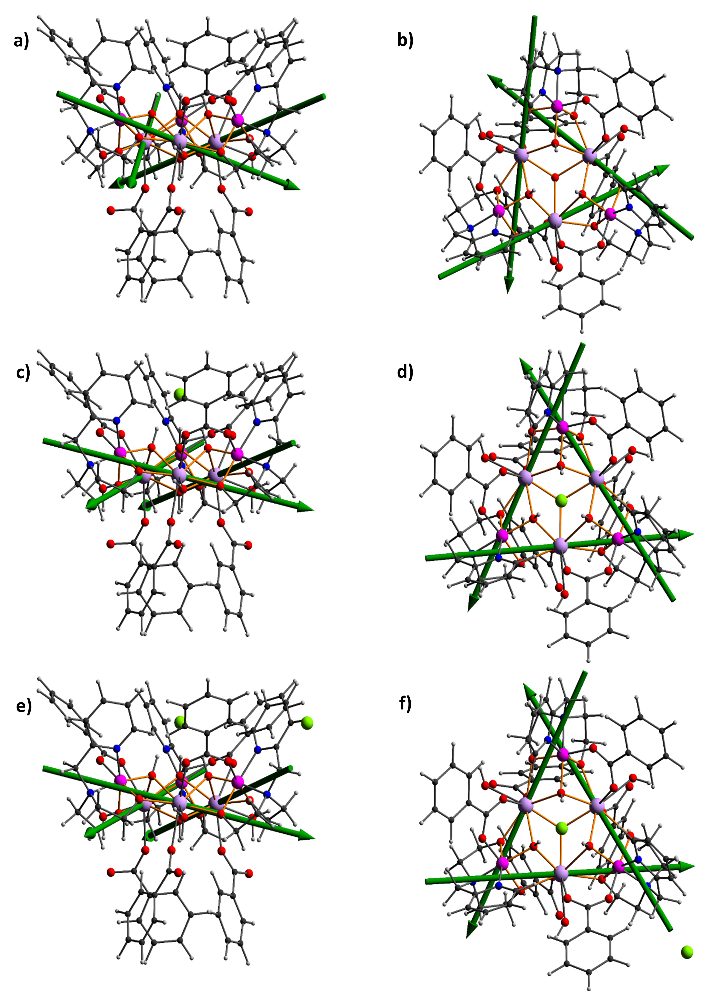
Fig S12. Orientation of the main magnetic axes of the ground KD (green solid lines) in [Dy₃Co₃]²⁺ (a-b), [Dy₃Co₃Cl]⁺ (c-d), and [Dy₃Co₃Cl]Cl (e-f).

a)
b)
c)
d)
Fig. S13. Experimental (green circles) vs. calculated magnetic susceptibility (green line) for [Dy₃Co₃Cl]⁺ (a) and [Dy₃Co₃Cl₂] (b). Experimental (circles) vs. calculated magnetization (lines) for [Dy₃Co₃Cl]⁺ (c) and [Dy₃Co₃Cl₂] (d). Color code: black = 2 K, red = 3 K, and blue = 5 K. Calculated plots were obtained by using the Lines parameter -0.089 and -0.094 for [Dy₃Co₃Cl]⁺ and [Dy₃Co₃Cl₂], respectively. 2 spin-orbit eigenstates from all three Dy^{III} centres were included into the exchange interaction.

Table S5. Calculated CASSCF/SO-RASSI energies (cm⁻¹) of the eight lowest Kramers doublets (KD) for each individual Dy^{III} ions in [Dy₃Co₃]²⁺, [Dy₃Co₃Cl]⁺, and [Dy₃Co₃Cl₂].
 | [Dy₃Co₃]²⁺ |  |  | [Dy₃Co₃Cl]⁺ |  |  | [Dy₃Co₃Cl₂]
 | Dy1 | Dy2 | Dy3 | Dy1 | Dy2 | Dy3 | Dy1 | Dy2 | Dy3
KD1 | 0.00 | 0.00 | 0.00 | 0.00 | 0.00 | 0.00 | 0.00 | 0.00 | 0.00
KD2 | 15.26 | 15.25 | 15.26 | 30.48 | 30.43 | 30.43 | 28.38 | 26.53 | 48.80
KD3 | 69.25 | 69.26 | 69.24 | 67.20 | 67.19 | 67.15 | 73.34 | 63.38 | 79.81
KD4 | 99.15 | 99.16 | 99.12 | 89.84 | 89.84 | 89.77 | 96.14 | 84.85 | 100.52
KD5 | 143.02 | 143.01 | 142.97 | 120.71 | 120.71 | 120.63 | 128.14 | 113.67 | 123.60
KD6 | 168.45 | 168.47 | 168.44 | 140.41 | 140.40 | 140.37 | 146.06 | 135.43 | 153.90
KD7 | 194.65 | 194.64 | 194.57 | 185.56 | 185.50 | 185.48 | 190.18 | 184.40 | 192.38
KD8 | 317.22 | 317.24 | 317.21 | 318.78 | 318.77 | 318.77 | 312.48 | 315.68 | 330.72

Table S6. Calculated angle (°) of the main magnetic axis of each Kramers doublet with respect to Dy-Dy-Dy plane in [Dy₃Co₃]²⁺, [Dy₃Co₃Cl]⁺, and [Dy₃Co₃Cl₂].
 | [Dy₃Co₃]²⁺ |  |  | [Dy₃Co₃Cl]⁺ |  |  | [Dy₃Co₃Cl₂]
 | Dy1 | Dy2 | Dy3 | Dy1 | Dy2 | Dy3 | Dy1 | Dy2 | Dy3
KD1 | 17.79 | 17.73 | 17.76 | 12.73 | 12.68 | 12.74 | 12.77 | 12.88 | 13.67
KD2 | 46.96 | 46.93 | 46.91 | 47.21 | 47.24 | 47.25 | 49.59 | 44.59 | 44.56
KD3 | 25.96 | 25.93 | 25.95 | 28.07 | 28.08 | 28.19 | 22.54 | 34.56 | 22.97
KD4 | 9.61 | 9.68 | 9.62 | 1.94 | 2.01 | 2.08 | 3.96 | 3.02 | 7.52
KD5 | 47.42 | 47.38 | 47.40 | 47.47 | 47.45 | 47.45 | 51.69 | 49.22 | 48.87
KD6 | 39.50 | 39.55 | 39.51 | 39.15 | 39.19 | 39.16 | 39.39 | 38.97 | 39.28
KD7 | 52.78 | 52.75 | 52.79 | 50.73 | 50.73 | 50.71 | 51.36 | 50.12 | 50.23
KD8 | 22.89 | 22.92 | 22.85 | 24.78 | 24.79 | 24.77 | 24.50 | 24.96 | 25.59
Table S7. Calculated g tensors for the eight lowest Kramers doublets (KD) in [Dy₃Co₃]²⁺, [Dy₃Co₃Cl]⁺, and [Dy₃Co₃Cl₂].
 | [Dy₃Co₃]²⁺
 | g_{x} (Dy1) | g_{y} (Dy1) | g_{z} (Dy1) | g_{x} (Dy2) | g_{y} (Dy2) | g_{z} (Dy2) | g_{x} (Dy3) | g_{y} (Dy3) | g_{z} (Dy3)
KD1 | 0.79 | 3.64 | 15.51 | 0.79 | 3.65 | 15.49 | 0.79 | 3.64 | 15.50
KD2 | 1.06 | 2.99 | 14.12 | 1.06 | 3.00 | 14.10 | 1.06 | 2.99 | 14.11
KD3 | 2.70 | 3.13 | 11.96 | 2.71 | 3.13 | 11.95 | 2.70 | 3.13 | 11.95
KD4 | 8.30 | 7.20 | 2.28 | 8.29 | 7.20 | 2.28 | 8.30 | 7.19 | 2.28
KD5 | 1.14 | 2.17 | 13.43 | 1.15 | 2.18 | 13.43 | 1.14 | 2.17 | 13.45
KD6 | 0.45 | 1.87 | 16.56 | 0.45 | 1.87 | 16.57 | 0.44 | 1.87 | 16.57
KD7 | 0.43 | 1.35 | 16.91 | 0.43 | 1.36 | 16.91 | 0.43 | 1.36 | 16.91
KD8 | 0.00 | 0.01 | 19.73 | 0.00 | 0.01 | 19.73 | 0.00 | 0.01 | 19.72
 | [Dy₃Co₃Cl]⁺
 | g_{x} (Dy1) | g_{y} (Dy1) | g_{z} (Dy1) | g_{x} (Dy2) | g_{y} (Dy2) | g_{z} (Dy2) | g_{x} (Dy3) | g_{y} (Dy3) | g_{z} (Dy3)
KD1 | 0.29 | 0.53 | 18.52 | 0.29 | 0.53 | 18.52 | 0.29 | 0.53 | 18.53
KD2 | 0.89 | 2.48 | 16.30 | 0.89 | 2.48 | 16.30 | 0.89 | 2.49 | 16.29
KD3 | 2.29 | 3.67 | 9.35 | 2.30 | 3.67 | 9.35 | 2.30 | 3.68 | 9.34
KD4 | 8.10 | 6.29 | 0.20 | 8.10 | 6.28 | 0.20 | 8.09 | 6.27 | 0.21
KD5 | 1.64 | 2.69 | 13.23 | 1.64 | 2.70 | 13.24 | 1.65 | 2.69 | 13.24
KD6 | 0.72 | 1.12 | 16.49 | 0.73 | 1.13 | 16.49 | 0.72 | 1.12 | 16.50
KD7 | 0.19 | 0.51 | 18.77 | 0.19 | 0.51 | 18.77 | 0.19 | 0.51 | 18.78
KD8 | 0.00 | 0.00 | 19.81 | 0.00 | 0.00 | 19.82 | 0.00 | 0.00 | 19.81
 | [Dy₃Co₃Cl₂]
 | g_{x} (Dy1) | g_{y} (Dy1) | g_{z} (Dy1) | g_{x} (Dy2) | g_{y} (Dy2) | g_{z} (Dy2) | g_{x} (Dy3) | g_{y} (Dy3) | g_{z} (Dy3)
KD1 | 0.29 | 0.53 | 18.64 | 0.38 | 0.78 | 18.28 | 0.08 | 0.13 | 18.97
KD2 | 0.38 | 1.46 | 17.30 | 0.83 | 2.70 | 16.01 | 1.38 | 3.47 | 15.61
KD3 | 2.69 | 2.80 | 11.16 | 2.33 | 3.80 | 8.80 | 0.65 | 3.70 | 8.38
KD4 | 9.25 | 6.16 | 0.88 | 8.10 | 5.85 | 0.30 | 8.11 | 6.62 | 0.92
KD5 | 1.79 | 2.55 | 13.03 | 1.86 | 2.50 | 13.33 | 2.51 | 3.59 | 12.50
KD6 | 0.70 | 1.00 | 16.05 | 0.48 | 0.68 | 16.73 | 0.56 | 0.99 | 16.82
KD7 | 0.22 | 0.66 | 18.57 | 0.18 | 0.43 | 18.93 | 0.24 | 0.61 | 18.76
KD8 | 0.00 | 0.00 | 19.79 | 0.00 | 0.00 | 19.82 | 0.00 | 0.00 | 19.81

Table S8. Calculated angle (°) between the ground Kramers doublet and each excited doublets for [Dy₃Co₃]²⁺, [Dy₃Co₃Cl]⁺, and [Dy₃Co₃Cl₂].
 | [Dy₃Co₃]²⁺ |  |  | [Dy₃Co₃Cl]⁺ |  |  | [Dy₃Co₃Cl₂]
 | Dy1 | Dy2 | Dy3 | Dy1 | Dy2 | Dy3 | Dy1 | Dy2 | Dy3
KD1 | - | - | - | - | - | - | - | - | -
KD2 | 49.39 | 49.33 | 49.42 | 79.68 | 79.74 | 79.74 | 83.50 | 79.83 | 78.46
KD3 | 34.49 | 34.49 | 34.57 | 51.99 | 52.01 | 52.01 | 54.63 | 56.12 | 49.35
KD4 | 145.96 | 145.99 | 145.95 | 135.28 | 135.26 | 135.26 | 141.88 | 136.54 | 48.19
KD5 | 40.68 | 40.74 | 40.69 | 48.09 | 48.15 | 48.15 | 55.73 | 46.05 | 45.68
KD6 | 120.23 | 120.25 | 120.25 | 119.41 | 119.39 | 119.39 | 109.64 | 120.53 | 119.18
KD7 | 50.59 | 50.70 | 50.57 | 42.59 | 42.62 | 42.62 | 42.86 | 42.76 | 43.39
KD8 | 113.96 | 113.95 | 114.03 | 129.94 | 129.98 | 129.98 | 131.23 | 130.45 | 129.50

Table S9. Squared composition of the SO-RASSI wave functions for each M_{J} state of the ground multiplet (J = 15/2) for Dy1 in [Dy₃Co₃Cl₂]. Values lower than 0.01 not presented in Table.
M_{J} | KD1 |  | KD2 |  | KD3 |  | KD4 |  | KD5 |  | KD6 |  | KD7 |  | KD8
-15/2 | 0.04 | 0.82 | 0.00 | 0.03 | 0.00 | 0.02 | 0.00 | 0.00 | 0.01 | 0.00 | 0.00 | 0.01 | 0.02 | 0.01 | 0.00 | 0.03
-13/2 | 0.00 | 0.00 | 0.01 | 0.01 | 0.02 | 0.14 | 0.05 | 0.12 | 0.16 | 0.06 | 0.06 | 0.05 | 0.11 | 0.05 | 0.00 | 0.15
-11/2 | 0.00 | 0.08 | 0.00 | 0.00 | 0.00 | 0.05 | 0.01 | 0.01 | 0.05 | 0.02 | 0.01 | 0.05 | 0.26 | 0.14 | 0.00 | 0.32
-9/2 | 0.00 | 0.00 | 0.02 | 0.00 | 0.04 | 0.10 | 0.02 | 0.04 | 0.03 | 0.06 | 0.04 | 0.05 | 0.19 | 0.11 | 0.00 | 0.29
-7/2 | 0.00 | 0.01 | 0.02 | 0.01 | 0.01 | 0.07 | 0.02 | 0.01 | 0.34 | 0.04 | 0.01 | 0.23 | 0.05 | 0.03 | 0.00 | 0.14
-5/2 | 0.00 | 0.01 | 0.08 | 0.03 | 0.08 | 0.11 | 0.07 | 0.11 | 0.03 | 0.17 | 0.13 | 0.13 | 0.01 | 0.00 | 0.00 | 0.05
-3/2 | 0.00 | 0.02 | 0.06 | 0.25 | 0.00 | 0.10 | 0.18 | 0.23 | 0.00 | 0.01 | 0.06 | 0.07 | 0.00 | 0.00 | 0.00 | 0.01
-1/2 | 0.01 | 0.00 | 0.43 | 0.06 | 0.05 | 0.20 | 0.07 | 0.04 | 0.01 | 0.01 | 0.02 | 0.08 | 0.01 | 0.00 | 0.00 | 0.00
1/2 | 0.00 | 0.01 | 0.06 | 0.43 | 0.20 | 0.05 | 0.04 | 0.07 | 0.01 | 0.01 | 0.08 | 0.02 | 0.00 | 0.01 | 0.00 | 0.00
3/2 | 0.02 | 0.00 | 0.25 | 0.06 | 0.10 | 0.00 | 0.23 | 0.18 | 0.01 | 0.00 | 0.07 | 0.06 | 0.00 | 0.00 | 0.01 | 0.00
5/2 | 0.01 | 0.00 | 0.03 | 0.08 | 0.11 | 0.08 | 0.11 | 0.07 | 0.17 | 0.03 | 0.13 | 0.13 | 0.00 | 0.01 | 0.05 | 0.00
7/2 | 0.01 | 0.00 | 0.01 | 0.02 | 0.07 | 0.01 | 0.01 | 0.02 | 0.04 | 0.34 | 0.23 | 0.01 | 0.03 | 0.05 | 0.14 | 0.00
9/2 | 0.00 | 0.00 | 0.00 | 0.02 | 0.10 | 0.04 | 0.04 | 0.02 | 0.06 | 0.03 | 0.05 | 0.04 | 0.11 | 0.19 | 0.29 | 0.00
11/2 | 0.08 | 0.00 | 0.00 | 0.00 | 0.05 | 0.00 | 0.01 | 0.01 | 0.02 | 0.05 | 0.05 | 0.01 | 0.14 | 0.26 | 0.32 | 0.00
13/2 | 0.00 | 0.00 | 0.01 | 0.01 | 0.14 | 0.02 | 0.12 | 0.05 | 0.06 | 0.16 | 0.05 | 0.06 | 0.05 | 0.11 | 0.15 | 0.00
15/2 | 0.82 | 0.04 | 0.03 | 0.00 | 0.02 | 0.00 | 0.00 | 0.00 | 0.00 | 0.01 | 0.01 | 0.00 | 0.01 | 0.02 | 0.03 | 0.00

Table S10. Squared composition of the SO-RASSI wave functions for each M_{J} state of the ground multiplet (J = 15/2) for Dy2 in [Dy₃Co₃Cl₂]. Values lower than 0.01 not presented in Table.
M_{J} | KD1 |  | KD2 |  | KD3 |  | KD4 |  | KD5 |  | KD6 |  | KD7 |  | KD8
-15/2 | 0.82 | 0.00 | 0.00 | 0.04 | 0.02 | 0.01 | 0.00 | 0.00 | 0.00 | 0.02 | 0.01 | 0.00 | 0.03 | 0.01 | 0.00 | 0.03
-13/2 | 0.00 | 0.00 | 0.01 | 0.01 | 0.05 | 0.05 | 0.13 | 0.02 | 0.06 | 0.17 | 0.10 | 0.05 | 0.17 | 0.03 | 0.00 | 0.15
-11/2 | 0.10 | 0.00 | 0.00 | 0.00 | 0.02 | 0.01 | 0.00 | 0.01 | 0.00 | 0.06 | 0.08 | 0.01 | 0.34 | 0.06 | 0.00 | 0.30
-9/2 | 0.00 | 0.00 | 0.03 | 0.01 | 0.06 | 0.05 | 0.06 | 0.00 | 0.02 | 0.09 | 0.07 | 0.04 | 0.23 | 0.04 | 0.00 | 0.28
-7/2 | 0.02 | 0.00 | 0.02 | 0.02 | 0.03 | 0.03 | 0.04 | 0.01 | 0.02 | 0.34 | 0.22 | 0.01 | 0.07 | 0.01 | 0.00 | 0.15
-5/2 | 0.01 | 0.00 | 0.07 | 0.05 | 0.03 | 0.15 | 0.09 | 0.10 | 0.03 | 0.13 | 0.18 | 0.09 | 0.01 | 0.00 | 0.00 | 0.06
-3/2 | 0.02 | 0.00 | 0.04 | 0.27 | 0.06 | 0.02 | 0.31 | 0.15 | 0.02 | 0.00 | 0.05 | 0.04 | 0.00 | 0.00 | 0.00 | 0.02
-1/2 | 0.00 | 0.01 | 0.33 | 0.09 | 0.33 | 0.06 | 0.04 | 0.04 | 0.01 | 0.01 | 0.04 | 0.00 | 0.00 | 0.00 | 0.00 | 0.01
1/2 | 0.01 | 0.00 | 0.09 | 0.33 | 0.06 | 0.33 | 0.04 | 0.04 | 0.01 | 0.01 | 0.00 | 0.04 | 0.00 | 0.00 | 0.01 | 0.00
3/2 | 0.00 | 0.02 | 0.27 | 0.04 | 0.02 | 0.06 | 0.15 | 0.31 | 0.00 | 0.02 | 0.04 | 0.05 | 0.00 | 0.00 | 0.02 | 0.00
5/2 | 0.00 | 0.01 | 0.05 | 0.07 | 0.15 | 0.03 | 0.10 | 0.09 | 0.13 | 0.03 | 0.09 | 0.18 | 0.00 | 0.01 | 0.06 | 0.00
7/2 | 0.00 | 0.02 | 0.02 | 0.02 | 0.03 | 0.03 | 0.01 | 0.04 | 0.34 | 0.02 | 0.01 | 0.22 | 0.01 | 0.07 | 0.15 | 0.00
9/2 | 0.00 | 0.00 | 0.01 | 0.03 | 0.05 | 0.06 | 0.00 | 0.06 | 0.09 | 0.02 | 0.04 | 0.07 | 0.04 | 0.23 | 0.28 | 0.00
11/2 | 0.00 | 0.10 | 0.00 | 0.00 | 0.01 | 0.02 | 0.01 | 0.00 | 0.06 | 0.00 | 0.01 | 0.08 | 0.06 | 0.34 | 0.30 | 0.00
13/2 | 0.00 | 0.00 | 0.01 | 0.01 | 0.05 | 0.05 | 0.02 | 0.13 | 0.17 | 0.06 | 0.05 | 0.10 | 0.03 | 0.17 | 0.15 | 0.00
15/2 | 0.00 | 0.82 | 0.04 | 0.00 | 0.01 | 0.02 | 0.00 | 0.00 | 0.02 | 0.00 | 0.00 | 0.01 | 0.01 | 0.03 | 0.03 | 0.00

Table S11. Squared composition of the SO-RASSI wave functions for each M_{J} state of the ground multiplet (J = 15/2) for Dy3 in [Dy₃Co₃Cl₂]. Values lower than 0.01 not presented in Table.
M_{J} | KD1 |  | KD2 |  | KD3 |  | KD4 |  | KD5 |  | KD6 |  | KD7 |  | KD8
-15/2 | 0.71 | 0.17 | 0.01 | 0.00 | 0.02 | 0.00 | 0.00 | 0.00 | 0.01 | 0.01 | 0.00 | 0.00 | 0.03 | 0.00 | 0.03 | 0.00
-13/2 | 0.00 | 0.00 | 0.02 | 0.02 | 0.12 | 0.03 | 0.05 | 0.13 | 0.21 | 0.01 | 0.05 | 0.05 | 0.16 | 0.01 | 0.13 | 0.01
-11/2 | 0.07 | 0.02 | 0.00 | 0.00 | 0.03 | 0.00 | 0.01 | 0.01 | 0.04 | 0.04 | 0.06 | 0.02 | 0.38 | 0.04 | 0.27 | 0.02
-9/2 | 0.00 | 0.00 | 0.02 | 0.03 | 0.08 | 0.05 | 0.03 | 0.02 | 0.08 | 0.01 | 0.06 | 0.05 | 0.25 | 0.03 | 0.27 | 0.02
-7/2 | 0.01 | 0.00 | 0.02 | 0.02 | 0.05 | 0.00 | 0.01 | 0.04 | 0.29 | 0.08 | 0.18 | 0.05 | 0.07 | 0.01 | 0.16 | 0.01
-5/2 | 0.00 | 0.00 | 0.07 | 0.06 | 0.13 | 0.02 | 0.04 | 0.16 | 0.10 | 0.04 | 0.15 | 0.14 | 0.01 | 0.00 | 0.06 | 0.00
-3/2 | 0.01 | 0.00 | 0.29 | 0.02 | 0.06 | 0.01 | 0.06 | 0.34 | 0.00 | 0.05 | 0.05 | 0.08 | 0.00 | 0.00 | 0.02 | 0.00
-1/2 | 0.00 | 0.00 | 0.10 | 0.29 | 0.36 | 0.03 | 0.08 | 0.01 | 0.02 | 0.02 | 0.05 | 0.00 | 0.01 | 0.00 | 0.01 | 0.00
1/2 | 0.00 | 0.00 | 0.29 | 0.10 | 0.03 | 0.36 | 0.01 | 0.08 | 0.02 | 0.02 | 0.00 | 0.05 | 0.00 | 0.01 | 0.00 | 0.01
3/2 | 0.00 | 0.01 | 0.02 | 0.29 | 0.01 | 0.06 | 0.34 | 0.06 | 0.05 | 0.00 | 0.08 | 0.05 | 0.00 | 0.00 | 0.00 | 0.02
5/2 | 0.00 | 0.00 | 0.06 | 0.07 | 0.02 | 0.13 | 0.16 | 0.04 | 0.04 | 0.10 | 0.14 | 0.15 | 0.00 | 0.01 | 0.00 | 0.06
7/2 | 0.00 | 0.01 | 0.02 | 0.02 | 0.00 | 0.05 | 0.04 | 0.01 | 0.08 | 0.29 | 0.05 | 0.18 | 0.01 | 0.07 | 0.01 | 0.16
9/2 | 0.00 | 0.00 | 0.03 | 0.02 | 0.05 | 0.08 | 0.02 | 0.03 | 0.01 | 0.08 | 0.05 | 0.06 | 0.03 | 0.25 | 0.02 | 0.27
11/2 | 0.02 | 0.07 | 0.00 | 0.00 | 0.00 | 0.03 | 0.01 | 0.01 | 0.04 | 0.04 | 0.02 | 0.06 | 0.04 | 0.38 | 0.02 | 0.27
13/2 | 0.00 | 0.00 | 0.02 | 0.02 | 0.03 | 0.12 | 0.13 | 0.05 | 0.01 | 0.21 | 0.05 | 0.05 | 0.01 | 0.16 | 0.01 | 0.13
15/2 | 0.17 | 0.71 | 0.00 | 0.01 | 0.00 | 0.02 | 0.00 | 0.00 | 0.01 | 0.01 | 0.00 | 0.00 | 0.00 | 0.03 | 0.00 | 0.03

Table S12. Squared composition of the SO-RASSI wave functions for each M_{J} state of the ground multiplet (J = 15/2) for Dy1 in [Dy₃Co₃Cl]⁺. Values lower than 0.01 not presented in Table.
M_{J} | KD1 |  | KD2 |  | KD3 |  | KD4 |  | KD5 |  | KD6 |  | KD7 |  | KD8
-15/2 | 0.46 | 0.38 | 0.02 | 0.01 | 0.02 | 0.01 | 0.00 | 0.00 | 0.02 | 0.00 | 0.00 | 0.00 | 0.04 | 0.00 | 0.00 | 0.03
-13/2 | 0.00 | 0.00 | 0.00 | 0.02 | 0.10 | 0.03 | 0.03 | 0.13 | 0.16 | 0.07 | 0.09 | 0.04 | 0.18 | 0.00 | 0.01 | 0.13
-11/2 | 0.05 | 0.05 | 0.00 | 0.00 | 0.03 | 0.01 | 0.01 | 0.00 | 0.05 | 0.01 | 0.02 | 0.07 | 0.39 | 0.00 | 0.01 | 0.29
-9/2 | 0.00 | 0.00 | 0.00 | 0.04 | 0.11 | 0.02 | 0.00 | 0.07 | 0.05 | 0.05 | 0.04 | 0.07 | 0.27 | 0.00 | 0.01 | 0.28
-7/2 | 0.01 | 0.01 | 0.02 | 0.02 | 0.04 | 0.02 | 0.00 | 0.03 | 0.31 | 0.03 | 0.12 | 0.12 | 0.09 | 0.00 | 0.01 | 0.15
-5/2 | 0.00 | 0.01 | 0.03 | 0.09 | 0.06 | 0.12 | 0.10 | 0.04 | 0.08 | 0.12 | 0.07 | 0.21 | 0.00 | 0.00 | 0.00 | 0.06
-3/2 | 0.01 | 0.01 | 0.13 | 0.18 | 0.03 | 0.01 | 0.19 | 0.29 | 0.01 | 0.02 | 0.06 | 0.03 | 0.00 | 0.00 | 0.00 | 0.02
-1/2 | 0.01 | 0.00 | 0.22 | 0.21 | 0.27 | 0.10 | 0.02 | 0.08 | 0.02 | 0.00 | 0.01 | 0.05 | 0.00 | 0.00 | 0.00 | 0.01
1/2 | 0.00 | 0.01 | 0.21 | 0.22 | 0.10 | 0.27 | 0.08 | 0.02 | 0.00 | 0.02 | 0.05 | 0.01 | 0.00 | 0.00 | 0.01 | 0.00
3/2 | 0.01 | 0.01 | 0.18 | 0.13 | 0.01 | 0.03 | 0.29 | 0.19 | 0.02 | 0.01 | 0.03 | 0.06 | 0.00 | 0.00 | 0.02 | 0.00
5/2 | 0.01 | 0.00 | 0.09 | 0.03 | 0.12 | 0.06 | 0.04 | 0.10 | 0.12 | 0.08 | 0.21 | 0.07 | 0.00 | 0.00 | 0.06 | 0.00
7/2 | 0.01 | 0.01 | 0.02 | 0.02 | 0.02 | 0.04 | 0.03 | 0.00 | 0.03 | 0.31 | 0.12 | 0.12 | 0.00 | 0.09 | 0.15 | 0.01
9/2 | 0.00 | 0.00 | 0.04 | 0.00 | 0.02 | 0.11 | 0.07 | 0.00 | 0.05 | 0.05 | 0.07 | 0.04 | 0.00 | 0.27 | 0.28 | 0.01
11/2 | 0.05 | 0.05 | 0.00 | 0.00 | 0.01 | 0.03 | 0.00 | 0.01 | 0.01 | 0.05 | 0.07 | 0.02 | 0.00 | 0.39 | 0.29 | 0.01
13/2 | 0.00 | 0.00 | 0.02 | 0.00 | 0.03 | 0.10 | 0.13 | 0.03 | 0.07 | 0.16 | 0.04 | 0.09 | 0.00 | 0.18 | 0.13 | 0.01
15/2 | 0.38 | 0.46 | 0.01 | 0.02 | 0.01 | 0.02 | 0.00 | 0.00 | 0.00 | 0.02 | 0.00 | 0.00 | 0.00 | 0.04 | 0.03 | 0.00

Table S13. Squared composition of the SO-RASSI wave functions for each M_{J} state of the ground multiplet (J = 15/2) for Dy2 in [Dy₃Co₃Cl]⁺. Values lower than 0.01 not presented in Table.
M_{J} | KD1 |  | KD2 |  | KD3 |  | KD4 |  | KD5 |  | KD6 |  | KD7 |  | KD8
-15/2 | 0.41 | 0.43 | 0.03 | 0.00 | 0.01 | 0.02 | 0.00 | 0.00 | 0.00 | 0.02 | 0.00 | 0.01 | 0.01 | 0.03 | 0.01 | 0.02
-13/2 | 0.00 | 0.00 | 0.02 | 0.01 | 0.00 | 0.14 | 0.13 | 0.04 | 0.01 | 0.21 | 0.06 | 0.07 | 0.04 | 0.14 | 0.06 | 0.08
-11/2 | 0.05 | 0.05 | 0.00 | 0.00 | 0.00 | 0.03 | 0.01 | 0.00 | 0.02 | 0.04 | 0.01 | 0.08 | 0.08 | 0.31 | 0.13 | 0.17
-9/2 | 0.00 | 0.00 | 0.01 | 0.03 | 0.01 | 0.11 | 0.05 | 0.02 | 0.00 | 0.09 | 0.04 | 0.07 | 0.05 | 0.22 | 0.13 | 0.16
-7/2 | 0.01 | 0.01 | 0.03 | 0.01 | 0.00 | 0.06 | 0.03 | 0.01 | 0.02 | 0.32 | 0.03 | 0.21 | 0.02 | 0.07 | 0.07 | 0.09
-5/2 | 0.00 | 0.01 | 0.08 | 0.05 | 0.03 | 0.16 | 0.07 | 0.06 | 0.03 | 0.17 | 0.09 | 0.19 | 0.00 | 0.01 | 0.03 | 0.03
-3/2 | 0.00 | 0.01 | 0.28 | 0.03 | 0.01 | 0.04 | 0.34 | 0.15 | 0.02 | 0.01 | 0.05 | 0.04 | 0.00 | 0.00 | 0.01 | 0.01
-1/2 | 0.01 | 0.00 | 0.14 | 0.28 | 0.17 | 0.20 | 0.02 | 0.08 | 0.01 | 0.01 | 0.00 | 0.05 | 0.01 | 0.00 | 0.00 | 0.01
1/2 | 0.00 | 0.01 | 0.28 | 0.14 | 0.20 | 0.17 | 0.08 | 0.02 | 0.01 | 0.01 | 0.05 | 0.00 | 0.00 | 0.01 | 0.01 | 0.00
3/2 | 0.01 | 0.00 | 0.03 | 0.28 | 0.04 | 0.01 | 0.15 | 0.34 | 0.01 | 0.02 | 0.04 | 0.05 | 0.00 | 0.00 | 0.01 | 0.01
5/2 | 0.01 | 0.00 | 0.05 | 0.08 | 0.16 | 0.03 | 0.06 | 0.07 | 0.17 | 0.03 | 0.19 | 0.09 | 0.01 | 0.00 | 0.03 | 0.03
7/2 | 0.01 | 0.01 | 0.01 | 0.03 | 0.06 | 0.00 | 0.01 | 0.03 | 0.32 | 0.02 | 0.21 | 0.03 | 0.07 | 0.02 | 0.09 | 0.07
9/2 | 0.00 | 0.00 | 0.03 | 0.01 | 0.11 | 0.01 | 0.02 | 0.05 | 0.09 | 0.00 | 0.07 | 0.04 | 0.22 | 0.05 | 0.16 | 0.13
11/2 | 0.05 | 0.05 | 0.00 | 0.00 | 0.03 | 0.00 | 0.00 | 0.01 | 0.04 | 0.02 | 0.08 | 0.01 | 0.31 | 0.08 | 0.17 | 0.13
13/2 | 0.00 | 0.00 | 0.01 | 0.02 | 0.14 | 0.00 | 0.04 | 0.13 | 0.21 | 0.01 | 0.07 | 0.06 | 0.14 | 0.04 | 0.08 | 0.06
15/2 | 0.43 | 0.41 | 0.00 | 0.03 | 0.02 | 0.01 | 0.00 | 0.00 | 0.02 | 0.00 | 0.01 | 0.00 | 0.03 | 0.01 | 0.02 | 0.01

Table S14. Squared composition of the SO-RASSI wave functions for each M_{J} state of the ground multiplet (J = 15/2) for Dy3 in [Dy₃Co₃Cl]⁺. Values lower than 0.01 not presented in Table.
M_{J} | KD1 |  | KD2 |  | KD3 |  | KD4 |  | KD5 |  | KD6 |  | KD7 |  | KD8
-15/2 | 0.84 | 0.00 | 0.03 | 0.00 | 0.02 | 0.01 | 0.00 | 0.00 | 0.02 | 0.00 | 0.01 | 0.00 | 0.04 | 0.00 | 0.03 | 0.00
-13/2 | 0.00 | 0.00 | 0.02 | 0.01 | 0.06 | 0.08 | 0.04 | 0.12 | 0.18 | 0.05 | 0.10 | 0.03 | 0.18 | 0.01 | 0.12 | 0.01
-11/2 | 0.10 | 0.00 | 0.00 | 0.00 | 0.02 | 0.02 | 0.00 | 0.01 | 0.05 | 0.01 | 0.08 | 0.01 | 0.37 | 0.02 | 0.27 | 0.03
-9/2 | 0.00 | 0.00 | 0.02 | 0.03 | 0.06 | 0.06 | 0.03 | 0.04 | 0.08 | 0.01 | 0.08 | 0.03 | 0.26 | 0.02 | 0.26 | 0.03
-7/2 | 0.02 | 0.00 | 0.02 | 0.02 | 0.03 | 0.04 | 0.00 | 0.03 | 0.33 | 0.02 | 0.24 | 0.00 | 0.09 | 0.00 | 0.14 | 0.02
-5/2 | 0.01 | 0.00 | 0.07 | 0.05 | 0.03 | 0.16 | 0.07 | 0.07 | 0.17 | 0.03 | 0.20 | 0.08 | 0.00 | 0.00 | 0.05 | 0.01
-3/2 | 0.02 | 0.00 | 0.28 | 0.02 | 0.03 | 0.02 | 0.17 | 0.32 | 0.01 | 0.02 | 0.06 | 0.04 | 0.00 | 0.00 | 0.02 | 0.00
-1/2 | 0.00 | 0.01 | 0.10 | 0.33 | 0.33 | 0.04 | 0.08 | 0.02 | 0.01 | 0.01 | 0.05 | 0.01 | 0.00 | 0.00 | 0.00 | 0.00
1/2 | 0.01 | 0.00 | 0.33 | 0.10 | 0.04 | 0.33 | 0.02 | 0.08 | 0.01 | 0.01 | 0.01 | 0.05 | 0.00 | 0.00 | 0.00 | 0.00
3/2 | 0.00 | 0.02 | 0.02 | 0.28 | 0.02 | 0.03 | 0.32 | 0.17 | 0.02 | 0.01 | 0.04 | 0.06 | 0.00 | 0.00 | 0.00 | 0.02
5/2 | 0.00 | 0.01 | 0.05 | 0.07 | 0.16 | 0.03 | 0.07 | 0.07 | 0.03 | 0.17 | 0.08 | 0.20 | 0.00 | 0.00 | 0.01 | 0.05
7/2 | 0.00 | 0.02 | 0.02 | 0.02 | 0.04 | 0.03 | 0.03 | 0.00 | 0.02 | 0.33 | 0.00 | 0.24 | 0.00 | 0.09 | 0.02 | 0.14
9/2 | 0.00 | 0.00 | 0.03 | 0.02 | 0.06 | 0.06 | 0.04 | 0.03 | 0.01 | 0.08 | 0.03 | 0.08 | 0.02 | 0.26 | 0.03 | 0.26
11/2 | 0.00 | 0.10 | 0.00 | 0.00 | 0.02 | 0.02 | 0.01 | 0.00 | 0.01 | 0.05 | 0.01 | 0.08 | 0.02 | 0.37 | 0.03 | 0.27
13/2 | 0.00 | 0.00 | 0.01 | 0.02 | 0.08 | 0.06 | 0.12 | 0.04 | 0.05 | 0.18 | 0.03 | 0.10 | 0.01 | 0.18 | 0.01 | 0.12
15/2 | 0.00 | 0.84 | 0.00 | 0.03 | 0.01 | 0.02 | 0.00 | 0.00 | 0.00 | 0.02 | 0.00 | 0.01 | 0.00 | 0.04 | 0.00 | 0.03

Table S15. Squared composition of the SO-RASSI wave functions for each M_{J} state of the ground multiplet (J = 15/2) for Dy1 in [Dy₃Co₃]²⁺. Values lower than 0.01 not presented in Table.
M_{J} | KD1 |  | KD2 |  | KD3 |  | KD4 |  | KD5 |  | KD6 |  | KD7 |  | KD8
-15/2 | 0.01 | 0.40 | 0.00 | 0.14 | 0.14 | 0.01 | 0.06 | 0.00 | 0.04 | 0.18 | 0.02 | 0.01 | 0.00 | 0.07 | 0.00 | 0.00
-13/2 | 0.01 | 0.31 | 0.00 | 0.08 | 0.08 | 0.03 | 0.11 | 0.00 | 0.02 | 0.15 | 0.01 | 0.01 | 0.00 | 0.13 | 0.00 | 0.01
-11/2 | 0.00 | 0.04 | 0.02 | 0.08 | 0.08 | 0.05 | 0.04 | 0.00 | 0.04 | 0.09 | 0.19 | 0.04 | 0.00 | 0.12 | 0.00 | 0.05
-9/2 | 0.01 | 0.04 | 0.03 | 0.11 | 0.11 | 0.03 | 0.07 | 0.02 | 0.03 | 0.00 | 0.13 | 0.03 | 0.00 | 0.27 | 0.01 | 0.17
-7/2 | 0.01 | 0.09 | 0.02 | 0.13 | 0.13 | 0.02 | 0.07 | 0.01 | 0.01 | 0.03 | 0.18 | 0.02 | 0.00 | 0.10 | 0.02 | 0.28
-5/2 | 0.02 | 0.01 | 0.04 | 0.20 | 0.20 | 0.00 | 0.03 | 0.01 | 0.02 | 0.07 | 0.13 | 0.01 | 0.01 | 0.16 | 0.03 | 0.22
-3/2 | 0.01 | 0.04 | 0.00 | 0.10 | 0.10 | 0.06 | 0.03 | 0.02 | 0.03 | 0.12 | 0.15 | 0.03 | 0.01 | 0.08 | 0.00 | 0.13
-1/2 | 0.01 | 0.01 | 0.01 | 0.04 | 0.04 | 0.10 | 0.22 | 0.30 | 0.01 | 0.14 | 0.04 | 0.00 | 0.02 | 0.03 | 0.04 | 0.04
1/2 | 0.01 | 0.01 | 0.04 | 0.01 | 0.01 | 0.00 | 0.30 | 0.22 | 0.14 | 0.01 | 0.00 | 0.04 | 0.03 | 0.02 | 0.04 | 0.04
3/2 | 0.04 | 0.01 | 0.10 | 0.00 | 0.00 | 0.19 | 0.02 | 0.03 | 0.12 | 0.03 | 0.03 | 0.15 | 0.08 | 0.01 | 0.13 | 0.00
5/2 | 0.01 | 0.02 | 0.20 | 0.04 | 0.04 | 0.06 | 0.01 | 0.03 | 0.07 | 0.02 | 0.01 | 0.13 | 0.16 | 0.01 | 0.22 | 0.03
7/2 | 0.09 | 0.01 | 0.13 | 0.02 | 0.02 | 0.00 | 0.01 | 0.07 | 0.03 | 0.01 | 0.02 | 0.18 | 0.10 | 0.00 | 0.28 | 0.02
9/2 | 0.04 | 0.01 | 0.11 | 0.03 | 0.03 | 0.03 | 0.02 | 0.07 | 0.00 | 0.03 | 0.03 | 0.13 | 0.27 | 0.00 | 0.17 | 0.01
11/2 | 0.04 | 0.00 | 0.08 | 0.02 | 0.02 | 0.24 | 0.00 | 0.04 | 0.09 | 0.04 | 0.04 | 0.19 | 0.12 | 0.00 | 0.05 | 0.00
13/2 | 0.31 | 0.01 | 0.08 | 0.00 | 0.00 | 0.12 | 0.00 | 0.11 | 0.15 | 0.02 | 0.01 | 0.01 | 0.13 | 0.00 | 0.01 | 0.00
15/2 | 0.40 | 0.01 | 0.14 | 0.00 | 0.00 | 0.07 | 0.00 | 0.06 | 0.18 | 0.04 | 0.01 | 0.02 | 0.07 | 0.00 | 0.00 | 0.00

Table S16. Squared composition of the SO-RASSI wave functions for each M_{J} state of the ground multiplet (J = 15/2) for Dy2 in [Dy₃Co₃]²⁺. Values lower than 0.01 not presented in Table.
M_{J} | KD1 |  | KD2 |  | KD3 |  | KD4 |  | KD5 |  | KD6 |  | KD7 |  | KD8
-15/2 | 0.30 | 0.11 | 0.14 | 0.00 | 0.04 | 0.03 | 0.06 | 0.00 | 0.14 | 0.08 | 0.02 | 0.00 | 0.00 | 0.07 | 0.00 | 0.00
-13/2 | 0.24 | 0.08 | 0.08 | 0.00 | 0.11 | 0.04 | 0.11 | 0.00 | 0.13 | 0.04 | 0.00 | 0.02 | 0.01 | 0.13 | 0.01 | 0.00
-11/2 | 0.02 | 0.02 | 0.06 | 0.04 | 0.19 | 0.10 | 0.04 | 0.01 | 0.05 | 0.07 | 0.11 | 0.13 | 0.00 | 0.12 | 0.05 | 0.00
-9/2 | 0.02 | 0.03 | 0.08 | 0.06 | 0.06 | 0.01 | 0.07 | 0.03 | 0.00 | 0.04 | 0.03 | 0.13 | 0.01 | 0.25 | 0.18 | 0.00
-7/2 | 0.05 | 0.05 | 0.10 | 0.04 | 0.01 | 0.00 | 0.07 | 0.02 | 0.04 | 0.00 | 0.09 | 0.12 | 0.00 | 0.11 | 0.30 | 0.00
-5/2 | 0.00 | 0.02 | 0.15 | 0.09 | 0.03 | 0.03 | 0.02 | 0.01 | 0.05 | 0.04 | 0.04 | 0.10 | 0.03 | 0.15 | 0.23 | 0.01
-3/2 | 0.02 | 0.02 | 0.09 | 0.01 | 0.13 | 0.12 | 0.02 | 0.03 | 0.10 | 0.06 | 0.07 | 0.11 | 0.00 | 0.09 | 0.13 | 0.00
-1/2 | 0.00 | 0.01 | 0.03 | 0.01 | 0.09 | 0.02 | 0.13 | 0.39 | 0.12 | 0.04 | 0.02 | 0.02 | 0.02 | 0.02 | 0.05 | 0.03
1/2 | 0.01 | 0.00 | 0.01 | 0.03 | 0.02 | 0.09 | 0.39 | 0.13 | 0.04 | 0.12 | 0.02 | 0.02 | 0.02 | 0.02 | 0.03 | 0.05
3/2 | 0.02 | 0.02 | 0.01 | 0.09 | 0.12 | 0.13 | 0.03 | 0.02 | 0.06 | 0.10 | 0.11 | 0.07 | 0.09 | 0.00 | 0.00 | 0.13
5/2 | 0.02 | 0.00 | 0.09 | 0.15 | 0.03 | 0.03 | 0.01 | 0.02 | 0.04 | 0.05 | 0.10 | 0.04 | 0.15 | 0.03 | 0.01 | 0.23
7/2 | 0.05 | 0.05 | 0.04 | 0.10 | 0.00 | 0.01 | 0.02 | 0.07 | 0.00 | 0.04 | 0.12 | 0.09 | 0.11 | 0.00 | 0.00 | 0.30
9/2 | 0.03 | 0.02 | 0.06 | 0.08 | 0.01 | 0.06 | 0.03 | 0.07 | 0.04 | 0.00 | 0.13 | 0.03 | 0.25 | 0.01 | 0.00 | 0.18
11/2 | 0.02 | 0.02 | 0.04 | 0.06 | 0.10 | 0.19 | 0.01 | 0.04 | 0.07 | 0.05 | 0.13 | 0.11 | 0.12 | 0.00 | 0.00 | 0.05
13/2 | 0.08 | 0.24 | 0.00 | 0.08 | 0.04 | 0.11 | 0.00 | 0.11 | 0.04 | 0.13 | 0.02 | 0.00 | 0.13 | 0.01 | 0.00 | 0.01
15/2 | 0.11 | 0.30 | 0.00 | 0.14 | 0.03 | 0.04 | 0.00 | 0.06 | 0.08 | 0.14 | 0.00 | 0.02 | 0.07 | 0.00 | 0.00 | 0.00

Table S17. Squared composition of the SO-RASSI wave functions for each M_{J} state of the ground multiplet (J = 15/2) for Dy3 in [Dy₃Co₃]²⁺. Values lower than 0.01 not presented in Table.
M_{J} | KD1 |  | KD2 |  | KD3 |  | KD4 |  | KD5 |  | KD6 |  | KD7 |  | KD8
-15/2 | 0.03 | 0.38 | 0.01 | 0.14 | 0.02 | 0.06 | 0.01 | 0.05 | 0.01 | 0.21 | 0.02 | 0.00 | 0.07 | 0.00 | 0.00 | 0.00
-13/2 | 0.03 | 0.29 | 0.01 | 0.07 | 0.05 | 0.10 | 0.02 | 0.10 | 0.00 | 0.17 | 0.00 | 0.02 | 0.13 | 0.00 | 0.01 | 0.00
-11/2 | 0.01 | 0.03 | 0.01 | 0.08 | 0.08 | 0.20 | 0.01 | 0.03 | 0.02 | 0.10 | 0.06 | 0.17 | 0.11 | 0.01 | 0.05 | 0.00
-9/2 | 0.02 | 0.03 | 0.04 | 0.10 | 0.04 | 0.03 | 0.06 | 0.03 | 0.03 | 0.01 | 0.01 | 0.14 | 0.26 | 0.01 | 0.18 | 0.00
-7/2 | 0.02 | 0.07 | 0.03 | 0.12 | 0.02 | 0.00 | 0.01 | 0.08 | 0.00 | 0.04 | 0.05 | 0.16 | 0.09 | 0.02 | 0.30 | 0.00
-5/2 | 0.02 | 0.00 | 0.05 | 0.19 | 0.01 | 0.05 | 0.01 | 0.02 | 0.01 | 0.08 | 0.02 | 0.12 | 0.17 | 0.00 | 0.24 | 0.00
-3/2 | 0.01 | 0.03 | 0.01 | 0.09 | 0.10 | 0.14 | 0.04 | 0.01 | 0.01 | 0.15 | 0.03 | 0.15 | 0.06 | 0.03 | 0.13 | 0.01
-1/2 | 0.01 | 0.01 | 0.00 | 0.04 | 0.09 | 0.01 | 0.49 | 0.03 | 0.05 | 0.11 | 0.02 | 0.02 | 0.03 | 0.01 | 0.06 | 0.02
1/2 | 0.01 | 0.01 | 0.04 | 0.00 | 0.01 | 0.09 | 0.03 | 0.49 | 0.11 | 0.05 | 0.02 | 0.02 | 0.01 | 0.03 | 0.02 | 0.06
3/2 | 0.03 | 0.01 | 0.09 | 0.01 | 0.14 | 0.10 | 0.01 | 0.04 | 0.15 | 0.01 | 0.15 | 0.03 | 0.03 | 0.06 | 0.01 | 0.13
5/2 | 0.00 | 0.02 | 0.19 | 0.05 | 0.05 | 0.01 | 0.02 | 0.01 | 0.08 | 0.01 | 0.12 | 0.02 | 0.00 | 0.17 | 0.00 | 0.24
7/2 | 0.07 | 0.02 | 0.12 | 0.03 | 0.00 | 0.02 | 0.08 | 0.01 | 0.04 | 0.00 | 0.16 | 0.05 | 0.02 | 0.09 | 0.00 | 0.30
9/2 | 0.03 | 0.02 | 0.10 | 0.04 | 0.03 | 0.04 | 0.03 | 0.06 | 0.01 | 0.03 | 0.14 | 0.01 | 0.01 | 0.26 | 0.00 | 0.18
11/2 | 0.03 | 0.01 | 0.08 | 0.01 | 0.20 | 0.08 | 0.03 | 0.01 | 0.10 | 0.02 | 0.17 | 0.06 | 0.01 | 0.11 | 0.00 | 0.05
13/2 | 0.29 | 0.03 | 0.07 | 0.01 | 0.10 | 0.05 | 0.10 | 0.02 | 0.17 | 0.00 | 0.02 | 0.00 | 0.00 | 0.13 | 0.00 | 0.01
15/2 | 0.38 | 0.03 | 0.14 | 0.01 | 0.06 | 0.02 | 0.05 | 0.01 | 0.21 | 0.01 | 0.00 | 0.02 | 0.00 | 0.07 | 0.00 | 0.00

Table S18. Four lowest exchange KDs (EKDs) and their calculated g tensors for [Dy₃Co₃Cl]⁺.
EKD | E (cm⁻¹) | g_{x} | g_{y} | g_{z}
1 | 0.00 | 0.00 | 0.00 | 12.22
2 | 3.68 | 18.79 | 16.33 | 0.30
3 | 3.70 | 4.22 | 3.40 | 0.14
4 | 3.71 | 20.75 | 16.35 | 0.30

References

1 Sheldrick, G. M. SHELXT - integrated space-group and crystal-structure determination. Acta Crystallogr. A 71, 3-8, doi:10.1107/S2053273314026370 (2015).
2 Sheldrick, G. M. Crystal structure refinement with SHELXL. Acta Cryst. C 71, 3-8, doi:10.1107/S2053229614024218 (2015).
3 Dolomanov, O. V., Bourhis, L. J., Gildea, R. J., Howard, J. A. K. & Puschmann, H. OLEX2: a complete structure solution, refinement and analysis program. J. Appl. Cryst. 42, 339-341, doi:10.1107/s0021889808042726 (2009).
4 Toellner, T. S., Hu, M. Y., Bortel, G., Sturhahn, W. & Shu, D. Four-reflection “nested” meV-monochromators for 20–30keV synchrotron radiation. Nucl. Instrum. Methods Phys. Res. A 557, 670-675, doi:10.1016/j.nima.2005.11.114 (2006).
5 Brown, D. E. et al. Partial Phonon Density of States of Dysprosium and its Compounds Measured Using Inelastic Nuclear Resonance Scattering. Hyperfine Interact. 153, 17-24, doi:https://doi.org/10.1023/B:HYPE.0000024710.30209.72 (2004).
6 Scherthan, L. et al. ¹⁶¹Dy Time-Domain Synchrotron Mossbauer Spectroscopy for Investigating Single-Molecule Magnets Incorporating Dy Ions. Angew. Chem. Int. Ed. 58, 3444-3449, doi:10.1002/anie.201810505 (2019).
7 Röhlsberger, R. Nuclear Condensed Matter Physics with Synchrotron Radiation Basic Principles, Methodology and Applications. (Springer, 2004).
8 Sturhahn, W. CONUSS and PHOENIX: Evaluation of nuclear resonant scattering data. Hyperfine Interact. 125, 149-172 (2000).
9 Ofer, S., Rakavy, M., Segal, E. & Khurgin, B. Mössbauer Effect in Dy¹⁶¹ in Metallic Dysprosium, DyFe₂, and DyAl₂. Phys. Rev. 138, A241-A246, doi:10.1103/PhysRev.138.A241 (1965).
10 Shvyd'ko, Y. V., Gerken, M., Franz, H., Lucht, M. & Gerdau, E. Nuclear resonant scattering of synchrotron radiation from ¹⁶¹Dy at 25.61 keV. Europhys. Lett. 56, 309-315, doi:https://doi.org/10.1209/epl/i2001-00521-4 (2001).
11 Greenwood, N. N. & Gibb, T. C. Mössbauer Spectroscopy. (Chapman and Hall, 1971).
12 Perfetti, M. Cantilever torque magnetometry on coordination compounds: from theory to experiments. Coord. Chem. Rev. 348, 171-186, doi:10.1016/j.ccr.2017.08.013 (2017).
13 Roos, B., Taylor, P. R. & Siegbahn, P. A complete active space SCF method (CASSCF) using a density matrix formulated super-CI approach. Chem. Phys. 48, 157-173, doi:https://doi.org/10.1016/0301-0104(80)80045-0 (1980).
14 Siegbahn, P., Heiberg, A., Roos, B. & Levy, B. A Comparison of the Super-Cl and the Newton-Raphson Scheme in the Complete Active Space SCF Method. Phys. Scr. 21, 323-327, doi:https://doi.org/10.1088/0031-8949/21/3-4/014 (1980).
15 Roos, B., Lindh, R., Malmqvist, P. A., Veryazov, V. & Widmark, P. O. Multiconfigurational Quantum Chemistry. (John Wiley & Sons Inc., 2016).
16 Malmqvist, P. A., Roos, B. O. & Schimmelpfennig, B. The restricted active space (RAS) state interaction approach with spin–orbit coupling. Chem. Phys. Lett. 357, 230-240, doi:https://doi.org/10.1016/S0009-2614(02)00498-0 (2002).
17 Andrae, D., Häußermann, U., Dolg, M., Stoll, H. & Preuß, H. Energy-adjusted ab initio pseudopotentials for the second and third row transition elements. Theor. Chem. Acta 77, 123-141, doi:https://doi.org/10.1007/BF01114537 (1990).
18 Perdew, J. P. & Wang, Y. Accurate and simple analytic representation of the electron-gas correlation energy. Phys. Rev. B 45, 13244-13249, doi:10.1103/physrevb.45.13244 (1992).
19 Eichkorn, K., Treutler, O., Öhm, H., Häser, M. & Ahlrichs, R. Auxiliary basis sets to approximate Coulomb potentials. Chem. Phys. Lett. 240, 283-290, doi:https://doi.org/10.1016/0009-2614(95)00621-A (1995).
20 Perdew, J. P., Burke, K. & Ernzerhof, M. Generalized Gradient Approximation Made Simple. Phys. Rev. Lett. 77, 3865-3868, doi:https://doi.org/10.1103/PhysRevLett.77.3865 (1996).
21 Eichkorn, K., Weigend, F., Treutler, O. & Ahlrichs, R. Auxiliary basis sets for main row atoms and transition metals and their use to approximate Coulomb potentials. Theor. Chem. Acc. 97, 119-124, doi:https://doi.org/10.1007/s002140050244 (1997).
22 Weigend, F. & Ahlrichs, R. Balanced basis sets of split valence, triple zeta valence and quadruple zeta valence quality for H to Rn: Design and assessment of accuracy. Phys. Chem. Chem. Phys. 7, 3297-3305, doi:10.1039/b508541a (2005).
23 Weigend, F. Accurate Coulomb-fitting basis sets for H to Rn. Phys. Chem. Chem. Phys. 8, 1057-1065, doi:10.1039/b515623h (2006).
24 Grimme, S., Antony, J., Ehrlich, S. & Krieg, H. A consistent and accurate ab initio parametrization of density functional dispersion correction (DFT-D) for the 94 elements H-Pu. J. Chem. Phys. 132, 154104, doi:10.1063/1.3382344 (2010).
25 Grimme, S., Ehrlich, S. & Goerigk, L. Effect of the damping function in dispersion corrected density functional theory. J. Comput. Chem. 32, 1456-1465, doi:10.1002/jcc.21759 (2011).
26 TURBOMOLE V7.2 2017, A development of University of Karlsruhe and Forschungszentrum Karlsruhe GmbH (Available from http://www.turbomole.com., 1989-2007).
27 Aquilante, F. et al. Molcas 8: New capabilities for multiconfigurational quantum chemical calculations across the periodic table. J. Comput. Chem. 37, 506-541, doi:10.1002/jcc.24221 (2016).
28 Roos, B. O., Lindh, R., Malmqvist, P. A., Veryazov, V. & Widmark, P. O. Main Group Atoms and Dimers Studied with a New Relativistic ANO Basis Set. J. Phys. Chem. A 108, 2851-2858, doi:https://doi.org/10.1021/jp031064+ (2004).
29 Roos, B. O. et al. New Relativistic Atomic Natural Orbital Basis Sets for Lanthanide Atoms with Applications to the Ce Diatom and LuF₃. J. Phys. Chem. A 112, 11431-11435, doi:https://doi.org/10.1021/jp803213j (2008).
30 Filatov, M. Comment on "Quasirelativistic theory equivalent to fully relativistic theory" [J. Chem. Phys. 123, 241102 (2005)]. J. Chem. Phys. 125, 107101, doi:10.1063/1.2338033 (2006).
31 Peng, D. & Reiher, M. Exact decoupling of the relativistic Fock operator. Theor. Chem. Acc. 131, 1081, doi:10.1007/s00214-011-1081-y (2012).
32 Chibotaru, L. F. & Ungur, L. Ab initio calculation of anisotropic magnetic properties of complexes. I. Unique definition of pseudospin Hamiltonians and their derivation. J. Chem. Phys. 137, 064112, doi:10.1063/1.4739763 (2012).
33 Ungur, L., Thewissen, M., Costes, J. P., Wernsdorfer, W. & Chibotaru, L. F. Interplay of strongly anisotropic metal ions in magnetic blocking of complexes. Inorg. Chem. 52, 6328-6337, doi:10.1021/ic302568x (2013).
34 Ungur, L. & Chibotaru, L. F. Ab Initio Crystal Field for Lanthanides. Chem. Eur. J. 23, 3708-3718, doi:10.1002/chem.201605102 (2017).
35 Chibotaru, L. F., Ungur, L. & Soncini, A. The Origin of Nonmagnetic Kramers Doublets in the Ground State of Dysprosium Triangles: Evidence for a Toroidal Magnetic Moment. Angew. Chem. Int. Ed. 120, 4194-4197, doi:10.1002/ange.200800283 (2008).
36 Ungur, L., Van den Heuvel, W. & Chibotaru, L. F. Ab initio investigation of the non-collinear magnetic structure and the lowest magnetic excitations in dysprosium triangles. New J. Chem. 33, 1224-1230, doi:10.1039/b903126j (2009).
37 Lines, M. E. Orbital Angular Momentum in the Theory of Paramagnetic Clusters. J. Chem. Phys. 55, 2977-2984, doi:10.1063/1.1676524 (1971).
38 Chibotaru, L. F. in Molecular Nanomagnets and Related Phenomena (ed Song Gao) 185-229 (Springer 2015).
39 Andersson, K., Malmqvist, P.-A., Roos, B. O., Sadlej, A. J. & Wolinski, K. Second-Order Perturbation Theory with a CASSCF Reference Function. J. Phys. Chem. 94, 5483-5488, doi:https://doi.org/10.1021/j100377a012 (1990).
40 Andersson, K., Malmqvist, P.-Å. & Roos, B. O. Second-order perturbation theory with a complete active space self-consistent field reference function. J. Chem. Phys. 96, 1218-1226, doi:10.1063/1.462209 (1992).
41 Perfetti, M. et al. Single Crystal Investigations Unravel the Magnetic Anisotropy of the "Square-In Square" Cr₄Dy₄ SMM Coordination Cluster. Front. Chem. 7, 6, doi:10.3389/fchem.2019.00006 (2019).
42 Vieru, V. et al. Magnetization Blocking in Fe₂^{III}Dy₂^{III} Molecular Magnets: Ab Initio Calculations and EPR Spectroscopy. Chem. Eur. J. 24, 16652-16661, doi:10.1002/chem.201803821.Detailsofabinitio (2018).

