Supplementary material 1
In this section, we explain definitions and concepts
Risk perception
The risk perception parameter β is used to capture bounded rationality. Following ¹Ruig et al. (2022) and ²Haer et al. (2020), we define β over t years, as in Equation S1, where c and d are constants:
${β }_{t}=c*{1.6}^{-d*t}+0.01$ (Eq. S1)
Spin up period
To start the model and simulate a situation in 2015, we ran the model for 15 periods, called “spin-up periods”. During this period, agents can experience floods, salt intrusion, damages and make a decision to adapt or migrate, however no population growth or GDP growth rate is taken into account. Runs are made so that agents with the ability to adapt or migrate in 2015 can adapt or migrate and ensure that the results for the first year of our simulation (2016) are stable and not affected by sudden changes.
Monte Carlo Simulations
The expected annual damage (EAD) is the combination of flood and salinization risk and is calculated as the average over 25* 50 = 1250 Monte Carlo simulations. Here, 25 simulations are parallel runs for the period from 2015 to 2080, during which households perceive risks, make decisions, experience hazards (such as floods and salt intrusion), while also experiencing economic and population growth throughout the model run. For each of these 25 runs, simulations for the year 2080 are repeated 50 times, assuming a constant behavioural state (i.e., households are in a fixed state of adaptation without decision-making). In these runs, there is no socio-economic change (no economic or population growth), but households still experience damage from randomly sampled flooding events. This approach is used to capture rare events that are less likely to occur but still significantly contribute to the overall EAD.
Single run
Figure 9 shows a single migration run for different regions, and the simulated flood events over the period 2015-2080. After every flooding event, it can be observed that most of the farmers in the Barisal floodplain move towards the Dhaka floodplain, which is due to its high average income and low migration cost (migration cost are a function of distance. This means that despite relocation, farmers households stay in the floodplain. It can also be observed that migration is high around the year 2028 (right after a flooding event), while migration is very low at the end of century (even after a low-probability event). This effect has three reasons: (a) first, most households with high utility associated to migration have already migrated, (b) households at high risk have already adapted and the potential damage after adaptation is too low to make a migration decision, (c) many households experience high place attachment costs, which are too high to offset the damage from flood
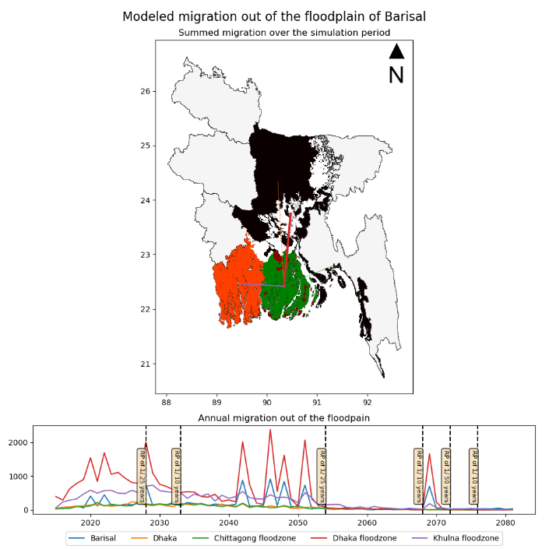
Figure 1 (top) Summed migration over the simulation period (2015-2080). 2(bottom) migration over time.

Migration cost
Migration cost is an important driver when modelling migration based on cost-benefit analysis. Migration cost is an exponential function of distance.
$C_{y}^{migration}=\frac{2*C^{fixed}}{1+e^{-0.05*{dist}_{xy}}}$ (Eq. S2)

Soil salinity maps
Hassani et al. (2020) provide a global-scale, quantitative, and gridded dataset (~1 km resolution) of soil salinity over the past four decades. However, the dataset has sparse coverage and requires interpolation in certain regions, especially in coastal areas.
To address the quadratic complexity of processing such a large dataset, we used a sliding window approach (window size=200, overlap=100) over a study grid of (21600,43200). To interpolate missing values in coastal zones and other grid cells where salinity data is unavailable, we first apply linear interpolation. When local values are insufficient for linear interpolation, we use nearest-neighbour interpolation instead. Figure 10 shows soil salinity for the year 2015 in south Asian floodplains(1/100 years). Soil salinity in 1 in a year flood plain varies from 0.15 dS/m to 9.07 dS/m.
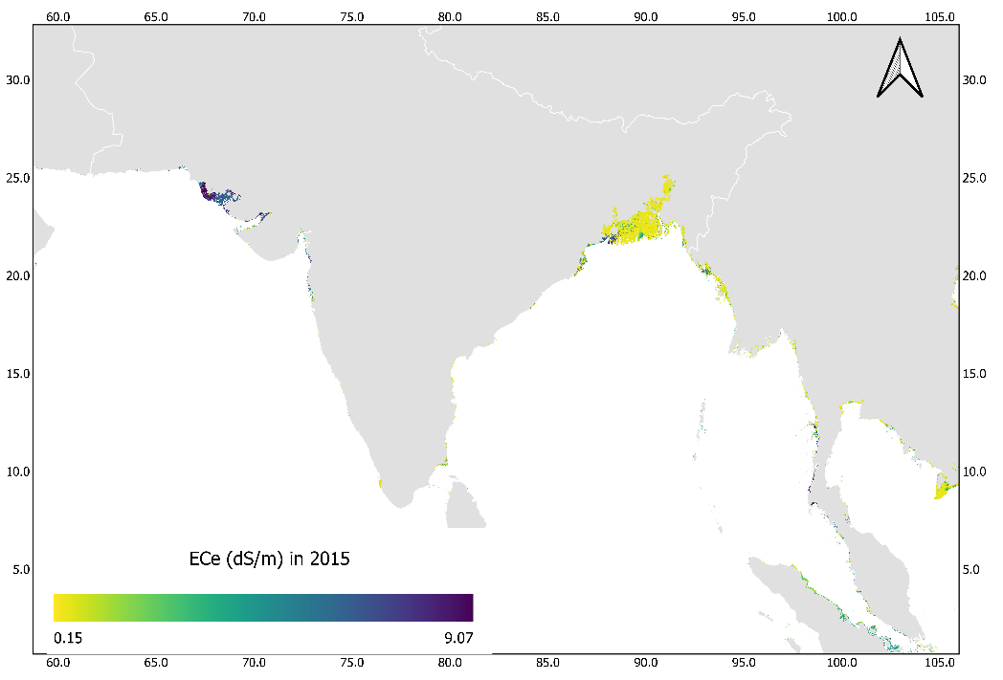
Figure 2 Soil salinity (dS/m) in 2015. The map was produced using QGIS version 3.30.0³
Adaptation cost for farmers
Adaptation cost($) is assumed to be a function of seed cost($/bag), bag size(kg seed/bag), seed yield(kg crop/kg seed), farm size(ha). Here α is the adaptation cost ratio.
$$C_{adapt}=α*seed cost*bag size*seed yield*farm size$$
The adaptation cost is then upscaled based on mean farm gate prices generated from GLOBIOM.
Time dynamics of population growth
Figure 11 shows coastal farming population(households) in 3 coastal zones of Bangladesh, Barisal, Chittagong and Khulna. It is observed that the farming population increases until mid-century and decreases after that.
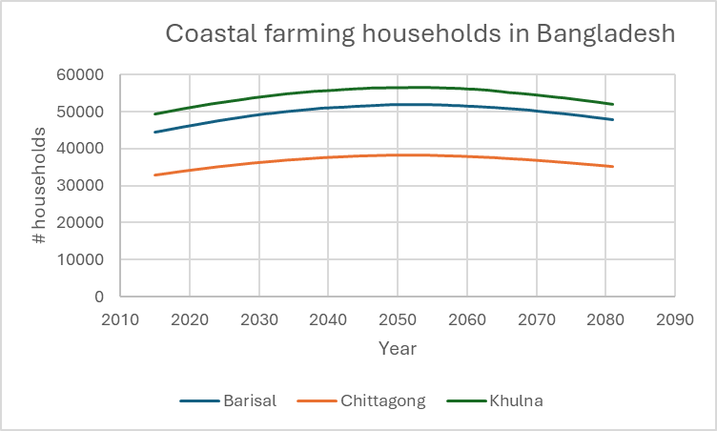
Figure 3 Coastal farming population in Bangladesh under RCP4.5-SSP2

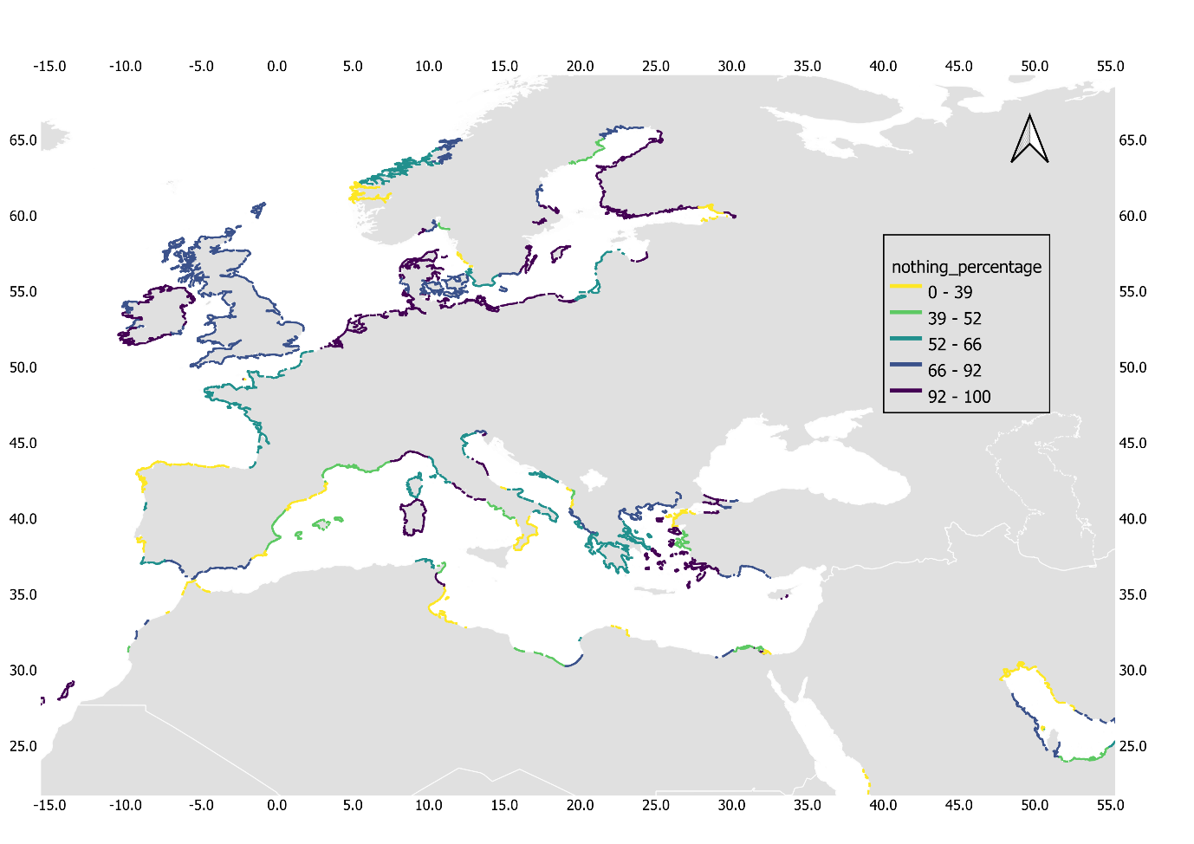
Figure 4 percentage of households that take actions of doing nothing

References
1. de Ruig, L. T. et al. An agent‐based model for evaluating reforms of the National Flood Insurance Program: A benchmarked model applied to Jamaica Bay, NYC. Risk Analysis (2022).
2. Haer, T., Husby, T. G., Botzen, W. J. W. & Aerts, J. C. J. H. The safe development paradox: An agent-based model for flood risk under climate change in the European Union. Global Environmental Change 60, (2020).
3. QGIS Development Team. QGIS Geographic Information System. (Version 3.30.0) [Computer software]. Open Source Geospatial Foundationhttps://qgis.org (2023).

Supplementary material 2
In this section, we provide processed data which could be useful for the community
Farm size probability : Probability distributions of farm size classes across 111 countries.
crop attributes: Includes salinity thresholds and yield response slopes for 23 crops used in the model.
Interest rates : Data relevant for evaluating annual adaptation cost based on adaptation loan.
Farmgate prices dataset : Based on GLOBIOM outputs, farmgate prices are provided for 59 regions under SSP2
and SSP5 scenarios. These prices have been further processed for 23 crops across all countries to estimate farmer losses and to scale adaptation costs at the farm level.

