Supplemental Information
HPF1 remodels PARP1 active site for ADP-ribosylation
of histones on serine
Fa-Hui Sun, Peng Zhao, Nan Zhang, Lu-Lu Kong, Catherine C L Wong
and Cai-Hong Yun

Materials and Methods
Cloning, expression and purification of HPF1 and PARP1
Full-length (FL) human and mouse HPF1 cDNA was synthesized by Tsingke Bio-tech® (Beijing) and full-length PARP1 plasmid was a kind gift from Professor Jia-Dong Wang’s lab in Peking University Health Science Center. The full-length and truncations of HPF1 and PARP1 (FL, CAT 661-1014 AA, CAT△HD 661-678-GSGSGSGG-787-1014 AA) were all sub-cloned into pET-28a vector. An N-terminal 6⨯His-tag followed by a tobacco etch virus (TEV) protease cleavage site (ENLYFQG) was added to the N-terminus of the constructs for the convenience to purify the protein. The mutations were introduced using the QuickChange Site-Directed Mutagenesis Kit (Strategene). All constructs were verified by sequencing in Ruibiotech® (Beijing).
The HPF1 and PARP1 proteins were expressed in Escherichia coli Rosetta (DE3). When expressing PARP1-CAT ΔHD, the inhibitor benzamide was added to the media to the final concentration of 10mM to reduce toxicity to host cells according to the previous report¹.
The same protocol was followed to purify HPF1 and PARP1 constructs. In brief, harvested bacteria cells were lysed by sonication in buffer A (20 mM Tris-pH 8.0, 500 mM NaCl, 1 mM TCEP, 5% glycerol) and the lysate was cleared by centrifugation (18,000 g at 4 °C for 20 min). The supernatant was loaded onto to a Ni²⁺ affinity column (GE Healthcare), washed sufficiently with buffer A supplemented with 35 mM imidazole, and then eluted using buffer A supplemented with 400 mM imidazole. The His-tag was then removed by incubating the eluent with His-tagged TEV protease in room temperature for 2 hours. The un-cleaved target proteins and His-tagged TEV protease were then removed by passing the sample through the Ni²⁺ affinity column for the second time. The flow-through was collected, concentrated, and applied to gel-filtration for the final round of purification using a Superdex 200 Increase column (GE Healthcare) in buffer B (20 mM Tris-pH 8.0, 150 mM NaCl, 1 mM TCEP, 1% glycerol). When purifying full-length PARP1, an ion-exchange step using anion exchange column was added after the first round of Ni²⁺ affinity chromatography. The final purified proteins samples were concentrated to a final concentration of 30mg/mL. Aliquots were made and flash-frozen in liquid nitrogen and stored in -80°C refrigerator.

Crystallization, data collection and structure determination
All HPF1 crystals used in this study were made by hanging drop vapor diffusion. The crystallization reservoir solution for human HPF1 34-346 was 0.1 M Tris-pH 8.1, 0.2 M potassium acetate, 20% w/v Polyethylene glycol (PEG) 3350, while for mouse HPF1 (mouse HPF1) 26-346 was 0.2 M Potassium citrate tribasic monohydrate, 20% w/v PEG 3350, pH7.9. Heavy atom derivative crystals of human HPF1 34-346 were made by soaking the native crystals in cryo-protectant (crystallization reservoir solution supplemented with 20% ethylene glycol) containing 1 mM ethylmercuric chloride (C₂H₅HgCl) for 10 to 30 minutes.
To obtain the HPF1/PARP1-CAT △HD complex crystals, human HPF1 26-346 and PARP1-CAT △HD were mixed at a molar ratio of 1:1 and adjusted to 0.5 mM prior to crystallization. The HPF1/PARP1-CAT △HD complex crystals were obtained by sitting drop vapor diffusion. The reservoir solution was 0.1 M Tris-pH 7.0, 0.2 M magnesium formate dehydrate, 20% w/v PEG 3350. The cryo-protectant for the complex crystals was the crystallization reservoir solution supplemented with 25% PEG 400.
All crystals were soaked in their corresponding cryo-protectants and then flash-frozen in liquid nitrogen. X-ray diffraction datasets were obtained in Shanghai Synchrotron Radiation Facility (SSRF) BL18U1 or BL19U1 at 100K, and the data were processed with HKL3000². The human HPF1 crystal structure was solved by single-wavelength anomalous diffraction (SAD) method using the ethylmercuric chloride derivative dataset and the SHARP software package³. The structure model was then refined against the native human HPF1 dataset with the higher resolution. The mouse HPF1 and human HPF1/PARP1-CAT △HD complex crystal structures were solved by molecular replacement with Phaser⁴, using human HPF1 structure and the previously reported PARP1-CAT △HD crystal structure (PDB 6BHV)⁵ as the search models. Iterative cycles of manual refitting and crystallographic refinement were performed using COOT⁶ and Phenix⁷. All structure figures were prepared using PyMOL program (Schrödinger LLC, http://www.pymol.org/). Statistics of diffraction data processing and structure refinement are shown in Supplemental Table S1.
The human HPF1 34-346, mouse HPF1 26-346 and human HPF1(26-346)/PARP1-CAT △HD crystal structures have been deposited in Protein Data Bank (http://www.rcsb.org) with the accession IDs 6M3G, 6M3H and 6M3I, respectively.

Size-exclusion chromatography
100μL samples (HPF1, CAT, CAT△HD, HPF1/CAT mixture, HPF1/CAT△HD mixture) containing 50μM of each proteins were prepared and incubated on ice for at least 30 minutes. The samples were then put on a Superdex 200 Increase column (GE Healthcare) and eluted with a buffer consisting of 20 mM Tris-pH 8.0, 150 mM NaCl, 1 mM TCEP, 1 mM MgCl₂. Samples from peak fractions were resolved on SDS-PAGE gel and detected using Coomassie blue staining.

Isothermal Titration Calorimetry assay
The isothermal titration calorimetric (ITC) assays were carried out using a MicroCalorimeter ITC200 (Microcal LLC) at 25°C in buffer composed of 20 mM Tris-pH 8.0, 150 mM NaCl, 1 mM TCEP, 1 mM MgCl₂. HPF1 WT and mutants were prepared as 0.3 or 0.4 mM solution and put in the syringe, while PARP1 CAT-ΔHD protein was prepared as 0.02 mM solutions in the calorimeter cell. When analyzing the full-length PARP1, the protein of 0.02 mM concentration was pre-incubated with 0.06 mM DNA hairpin (prepared by annealing 5'-GCCTACCGGTTCGTCTGGTGACGAACCGGTAGGC-3' DNA fragment) at 4 °C for at least 60 minutes. The titration data were processed with MicroCal Software.

ADP-ribosylation assay
This assay was conducted based on SDS-PAGE. The reaction system consisted of 5 μM HPF1, 5 μM full-length PARP1, and 10 μM 15bp DNA hairpin in a buffer composed of 20 mM Tris-pH 8.0, 150 mM NaCl, 1 mM TCEP, 1 mM MgCl₂ was utilized for these assays. The modified substrate H3/H4 tetramer and GFP-H3 were used all in 10 μM concentration. NAD⁺ was added to the mixture to the final concentration of 5 mM to start the reaction. The reaction was carried out at 20 °C for 10 minutes and then terminated with SDS-PAGE loading buffer that can denature the proteins. The samples were then resolved on a 12 or 15% polyacrylamide gel. The DNA hairpin used in this study was prepared by first denaturing the synthesized oligonucleotides (5'-GCCTACCGGTTCGTCTGGTGACGAACCGGTAGGC-3') at 95°C for 5 minutes and then quickly cooling down on ice. The double-strand DNA was confirmed by electrophoresis on an agarose gel.

Mass spectrometry assay
Sample preparation for LC-MS analysis
Two samples were analyzed in the study: the PARP1 and HPF1 R239A mixture prepared in the ADP-ribosylation assay and the pure HPF1 R239A as the control. The two samples were precipitated by 60μL acetone at -20°C for 4 hours, centrifuged at 16,000×g for 30min at 4°C. After removal of the supernatant, the precipitate was dried with vacuum concentrator (Labconco, USA). The dried precipitate was resuspended in 40μL 8 M Urea in 500mM Tris-HCl buffer (pH 8.5), incubated with 20mM (2-carboxyethyl) phosphine hydrochloride (TCEP) (500 mM in 100 mM Tris/HCl pH 8.5) at room temperature for 20 minutes, then alkylated with 40mM IAA in the dark for 30min. The mixture was diluted with 200μL 100 mM Tris-HCl buffer (pH 8.5) to the final concentration of 1.3M Urea. Then the two samples were equally divided into 4 equal parts, followed by digestion with trypsin, elastase, GluC or chymotrypsin protease at a 1/50 (w/w) protease to protein ratio, at 37°C overnight. The digestion was quenched by the addition of the formic acid at the final concentration of 5%. The samples were desalted using Monospin C18 column (GL Science, Tokyo, Japan). The purified peptides were vacuum-centrifuged to dryness and reconstituted in Milli-Q water with 0.1 vol.-% formic acid (FA). The hydrolysates of four proteases from two samples were mixed respectively for LC-MS analysis.
Liquid chromatography
We employed a nanoElute liquid chromatography system (Bruker Daltonics). Peptides (200ng of digest) were separated within 240 minutes at a flow rate of 300 nL/min on a 25 cm x 75 μm column with a laser-pulled electrospray emitter packed with 1.5 μm ReproSil-Pur 120 C18-AQ particles (Dr. Maisch). Mobile phases A and B were water and ACN with 0.1 vol.-% formic acid. The %B was linearly increased from 2 to 22% within 180 minutes, followed by an increase to 37% within 20 minutes and a further increase to 95% within 20 minutes before the last 20 minutes 95% process.
Mass Spectrometry
The two samples were analyzed on a hybrid TIMS quadrupole time-of-flight mass spectrometer (Bruker tims TOF Pro) via a Captive Spray nano-electrospray ion source. The mass spectrometer was operated in data-dependent mode. We set the accumulation and ramp time was 100 ms each and recorded mass spectra in the range from m/z 100–1700 in positive electrospray mode. The ion mobility was scanned from 0.6 to 1.6 Vs/cm². The overall acquisition cycle of 1.16 s comprised one full TIMS-MS scan and 10 PASEF MS/MS scans.
Data analysis
Protein and ADP-Ribosyl modification analysis were performed with Thermo Proteome Discoverer 2.3 (Thermo Fisher, San Jose, CA) and were searched against a homemade database (only reviewed entries) which combined the human UNIPROT database (only reviewed entries) with two protein (PARP1 and HPF1) entries. A decoy database containing the reversed sequences of all the proteins were employed to estimate the FDR (set at 0.01) at both peptide and protein levels. The search space included all fully and half-protease digested peptide candidates that fell within the mass tolerance window (MS scan, 20ppm; MS/MS scan, 0.1 Da). Carbamidomethylation (+57.02146 Da) of cysteine was considered as a static modification, while ADP-Ribosyl (+542.061 Da) on aspartic acid, glutamic acid, lysine, asparagine, serine, threonine were considered as variable modifications.

Supplemental Tables
Table S1. Data collection and refinement statistics of crystal structures obtained in this study§
 | H. sapiens HPF1  (Hg derivative) | H. sapiens HPF1  (Native) | M. musculus HPF1 | H. sapiens  HPF1/PARP1-CAT ΔHD
PDB ID |  | 6M3G | 6M3H | 6M3I
Data collection
Space group | R32 | R32 | P2₁2₁2₁ | P2₁
Cell dimensions
a, b, c (Å) | 90.0, 90.0, 230.0 | 90.0, 90.0, 226.9 | 42.0, 79.9, 106.7 | 49.9, 84.2, 81.7
α, β, γ (°) | 90.0, 90.0, 120.0 | 90.0, 90.0, 120.0 | 90.0, 90.0, 90.0 | 90.0, 107.5, 90.0
Resolution (Å) | 50.0-2.36 (2.44-2.36) | 50.0-1.57 | 50.0-1.71 (1.77-1.71) | 50.0-1.98 (2.03-1.98)
R_{pim}* | 0.035 (0.449) | 0.017 (0.340) | 0.023 (0.351) | 0.053 (0.385)
CC1/2 | 0.997 (0.753) | 0.998 (0.728) | 1.002 (0.753) | 0.989 (0.686)
I/σ | 21.3 (2.0) | 45.2 (2.2) | 31.1 (2.1) | 14.1 (2.1)
Completeness (%) | 100.0 (100.0) | 99.3 (85.1) | 99.3 (94.9) | 98.3 (99.0)
Redundancy | 19.4 (16.7) | 9.6 (8.4) | 5.7 (4.1) | 3.4 (3.4)
Refinement
Resolution (Å) |  | 45.9-1.57 | 44.4-1.71 | 27.4-1.98
No. reflections |  | 49462 | 39364 | 44217
R_{work} / R_{free} |  | 0.188/0.205 | 0.182/0.218 | 0.175/0.206
No. atoms
Protein |  | 2474 | 2493 | 4370
Ligand/ion |  | 0 | 0 | 9
Water |  | 341 | 274 | 323
B-factors
Protein |  | 26.6 | 24.4 | 30.8
Ligand/ion |  | n/a | n/a | 32.6
Water |  | 34.3 | 33.5 | 34.8
R.m.s. deviations
Bond lengths (Å) |  | 0.008 | 0.007 | 0.008
Bond angles (°) |  | 0.942 | 0.943 | 0.905
Ramachandran Plot
Favored regions |  | 96.97% | 97.40% | 97.97%
Allowed regions |  | 3.03% | 2.60% | 2.03%
Outliers |  | 0.00% | 0.00% | 0.00%
§Values in parentheses are for highest-resolution shell. One crystal was used for each data set.
*R_{p.i.m.}, a redundancy-independent R factor was used to evaluate the diffraction data quality as was proposed by Evans ⁸.

Supplemental Figures
Supplemental Figure S1. Architecture and overall structure of PARP1. The overall structure of human PARP1 (Zn1, Zn3, WGR, HD and ART) binding to a DNA break is shown as cartoons. This structure was reported by Langelier et al. (PDB 4DQY)⁹. The automodification domain (AD) containing a BRCT domain was absent in this structure. Based on the remaining parts of PARP1 in the crystal structure, Langelier et al. proposed a location of AD/BRCT, which is shown in this figure.

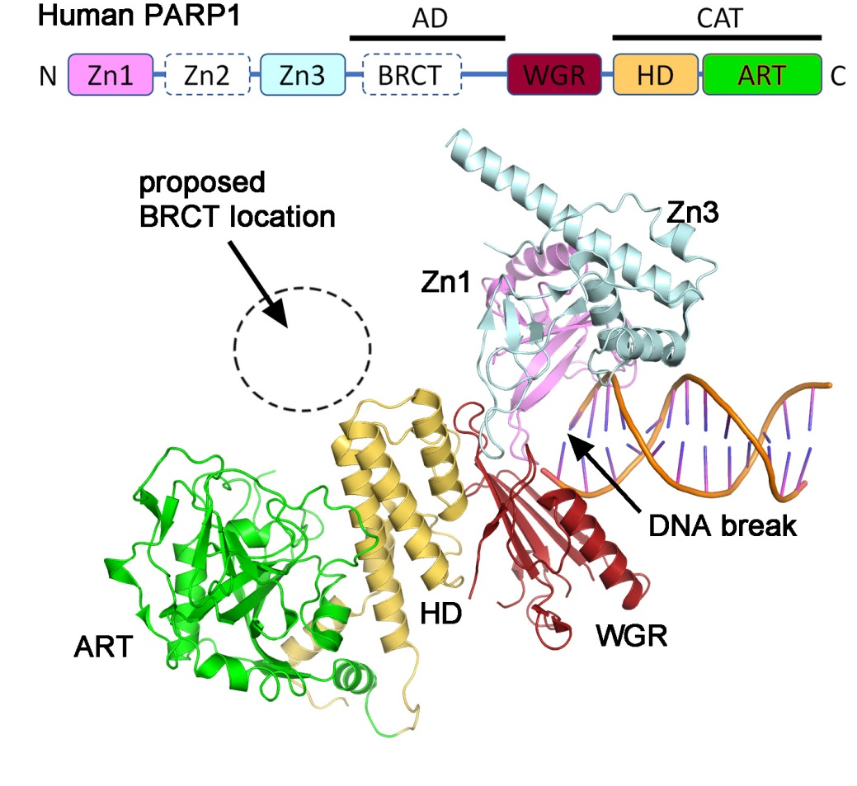

Supplemental Figure S2. Isothermal titration calorimetry (ITC) assays – raw data
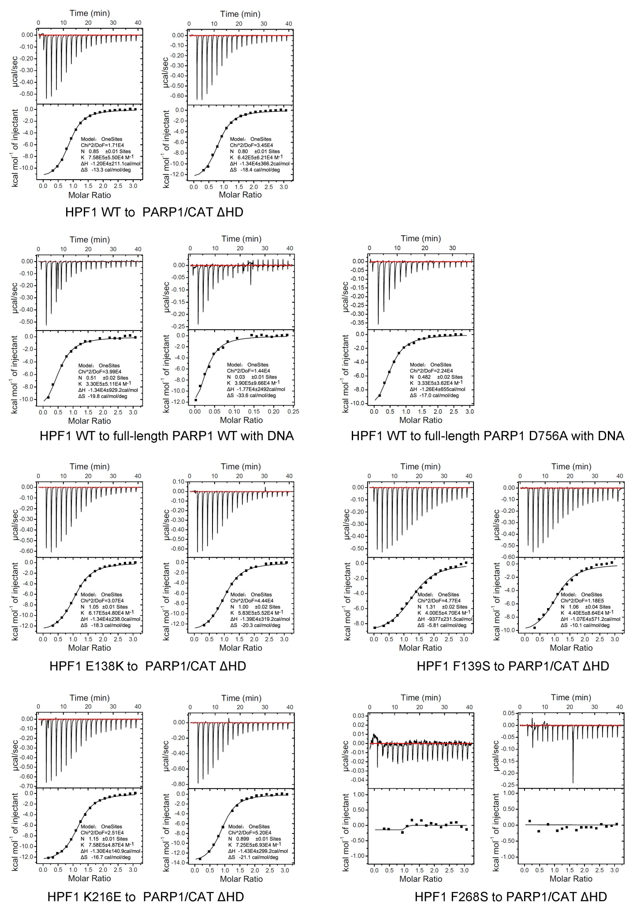
Supplemental Figure S3. Isothermal titration calorimetry (ITC) assays – raw data (continued)
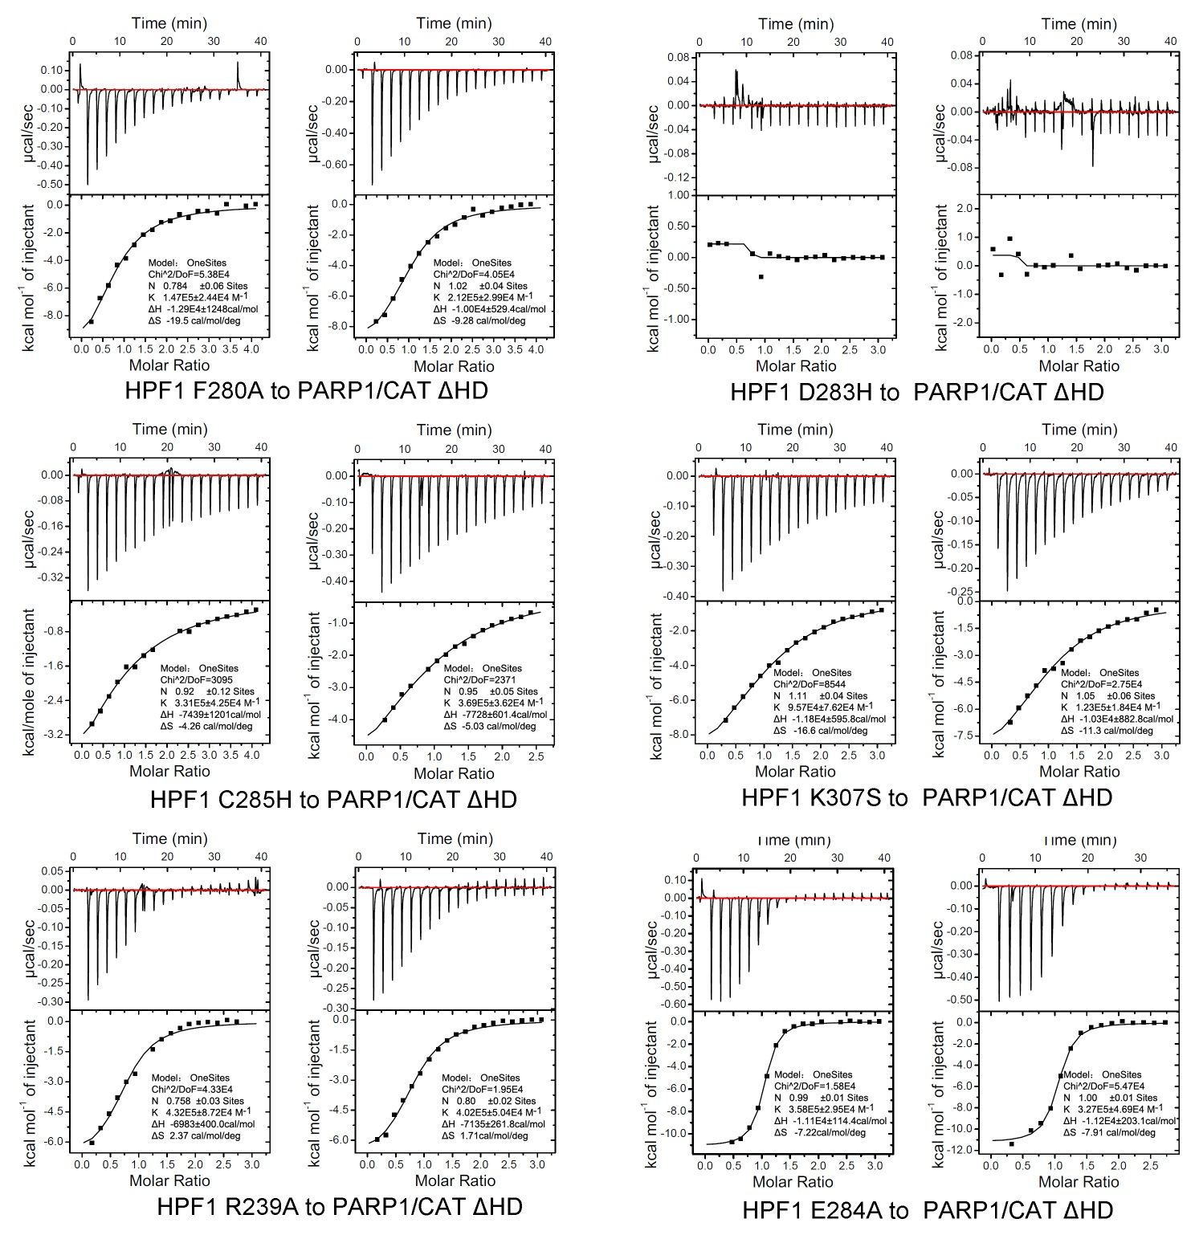

Supplemental Figure S4. Omit maps of the benzamide molecule in the active center of the HPF1/PARP1-CAT ΔHD crystal structure. The maps were calculated after removing the coordinates of benzamide and refining the structure by simulated-annealing. Blue and green meshes showed the 2Fo-Fc and Fo-Fc electron density maps contoured at 1.0σ and +2.5σ level, respectively.
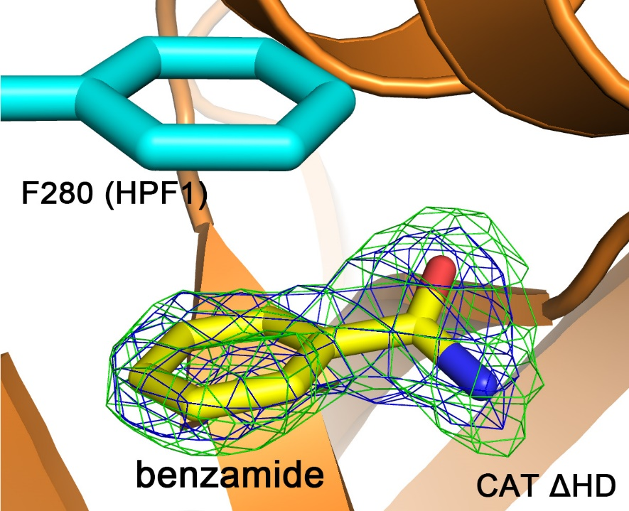

Supplemental Figure S5 Sequence alignment of HPF1 from representative species. Residues participating in inter-molecular interactions in interface I and II (see Figure 2a in main text) are annotated by round dots and triangles, respectively. Squares indicate the acidic amino-acid residues contributing to the acidic/negatively charged surface covering helix α9, α10 and the loops connecting helices α6 and α7. Stars indicate Glu 284 and Arg 239.
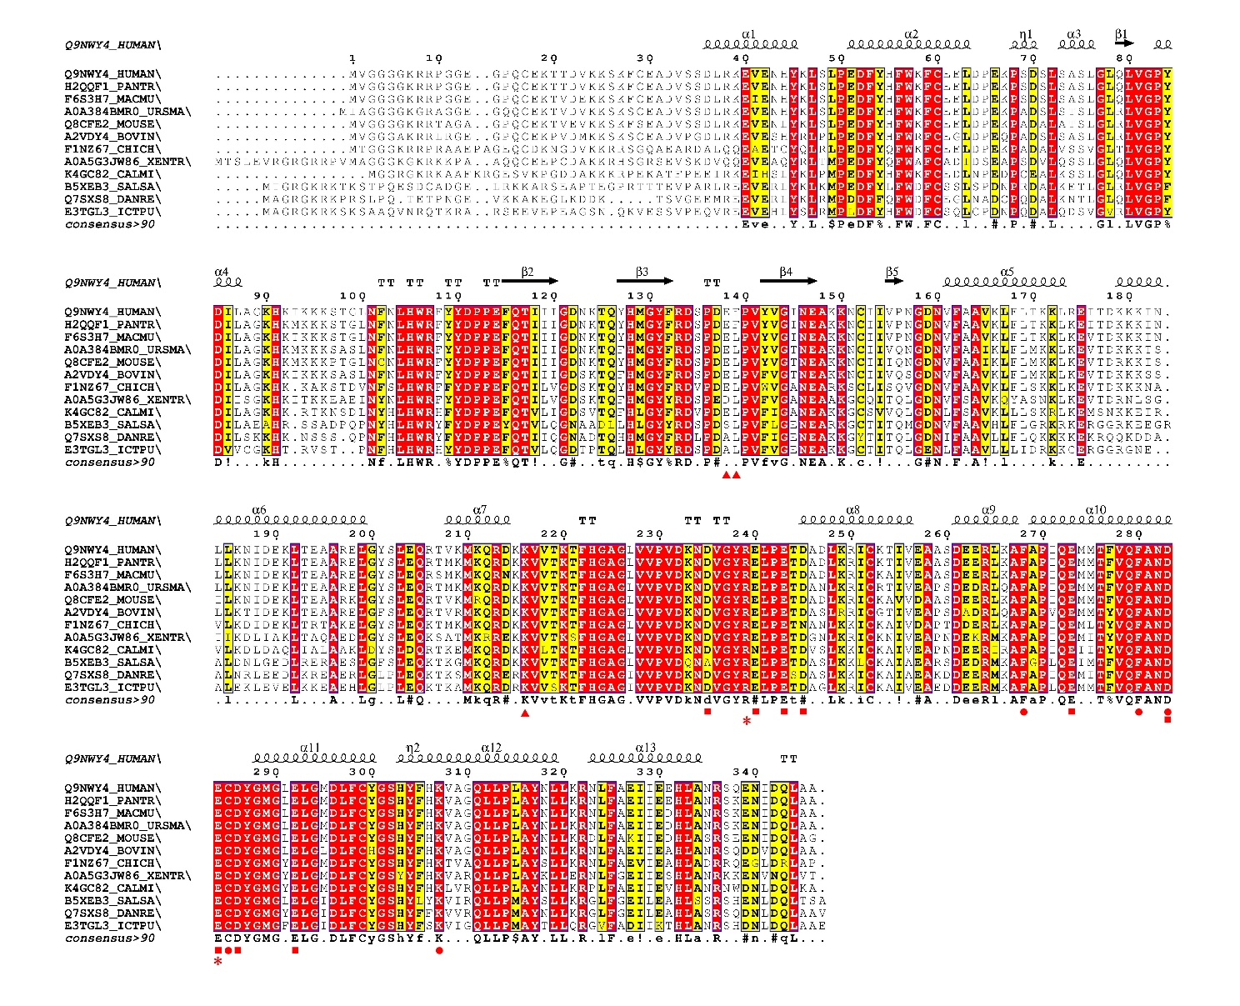

Supplemental Figure S6. Sequence alignment of human PARP1/2/3 CAT domain.
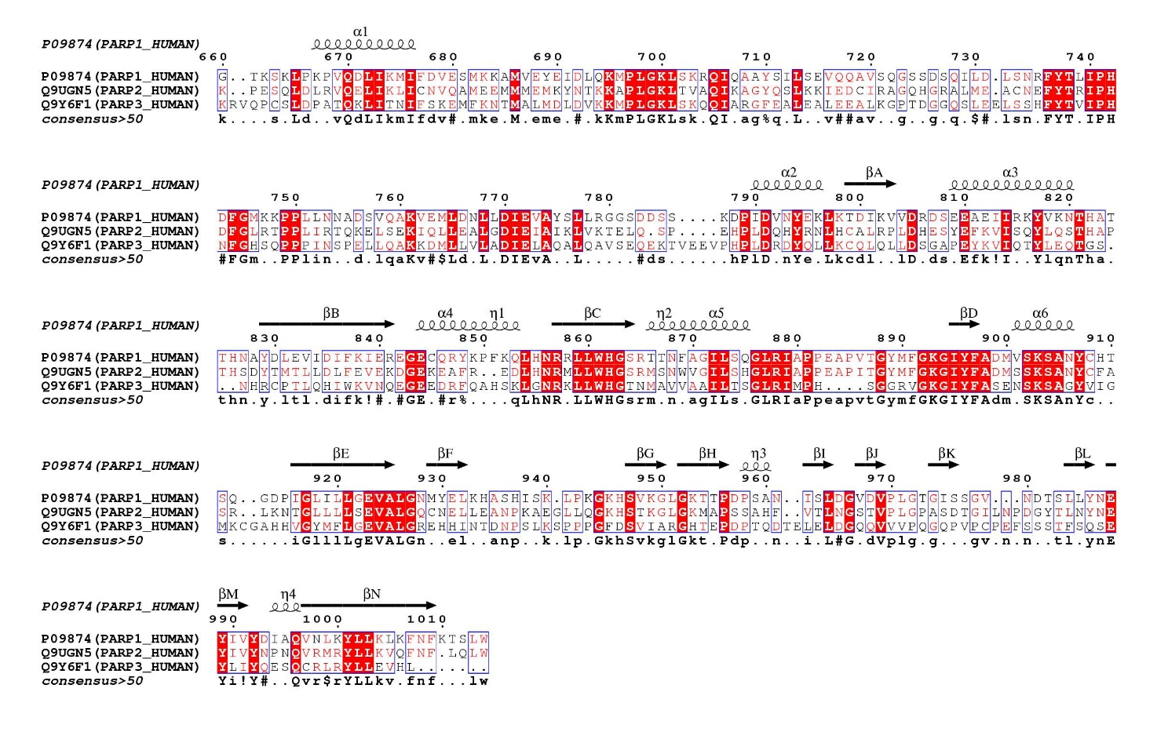

Supplemental Figure S7. Overall structure of HPF1. (a) Superimposition of human HPF1 (yellow) and mouse HPF1 (green) crystal structures. (b) Surface electrostatic potential of mouse HPF1.

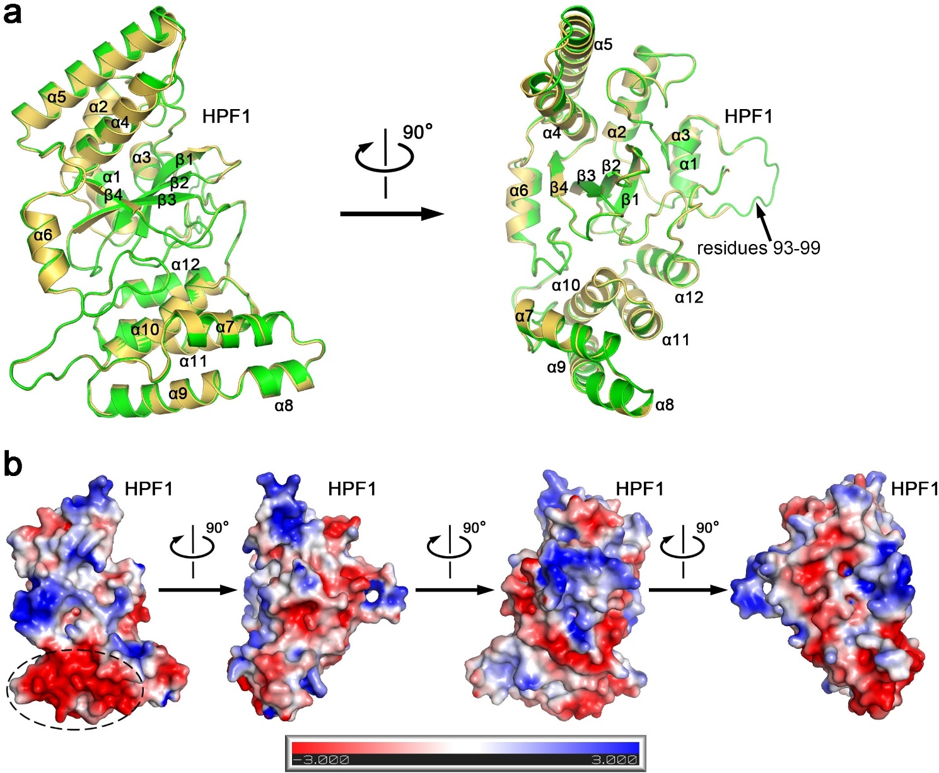

Supplemental Figure S8. Surface electrostatic potential of nucleosome. The cartoon presentation in the same view is shown on the right side to help readers understanding the structure. Histone/nucleosome ADP-ribosylation has been shown to preferentially take place at the Lys-Ser motif mainly residing on the N-terminal loop regions of Histones ^{10, 11}. However, since the terminal loop regions of histones stretch out from the nucleosome and are flexible, to date no available structure of human nucleosome showing these regions. We therefore draw this figure using the Xenopus laevis nucleosome crystal structure (PDB 1KX5)¹¹ which is highly similar to that of human nucleosome. It can be seen that most of the nucleosome/histone surface are basic/positively charged, including the putative ADP-ribosylation sites (the Lys-Ser motif, see labels and red arrows) that dominantly reside on H3 N-terminus, but also on H2A C-terminus and H2B N-terminus. The DNA double chains wrapping the nucleosome are shown as cartoons.
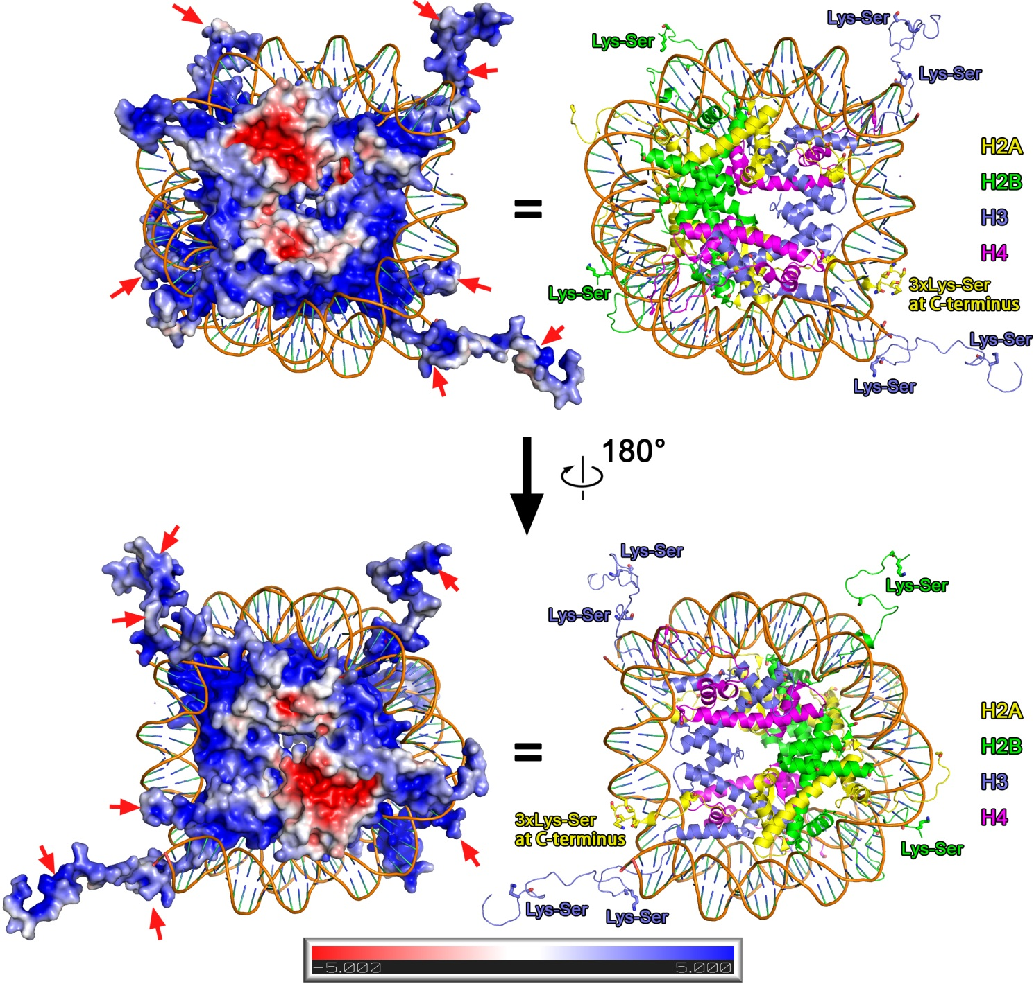

Supplemental Figure S9. Comparison of the HPF1 and HPF1/PARP-CAT ΔHD complex crystal structures determined by Suskiewicz et al.¹² and by us.

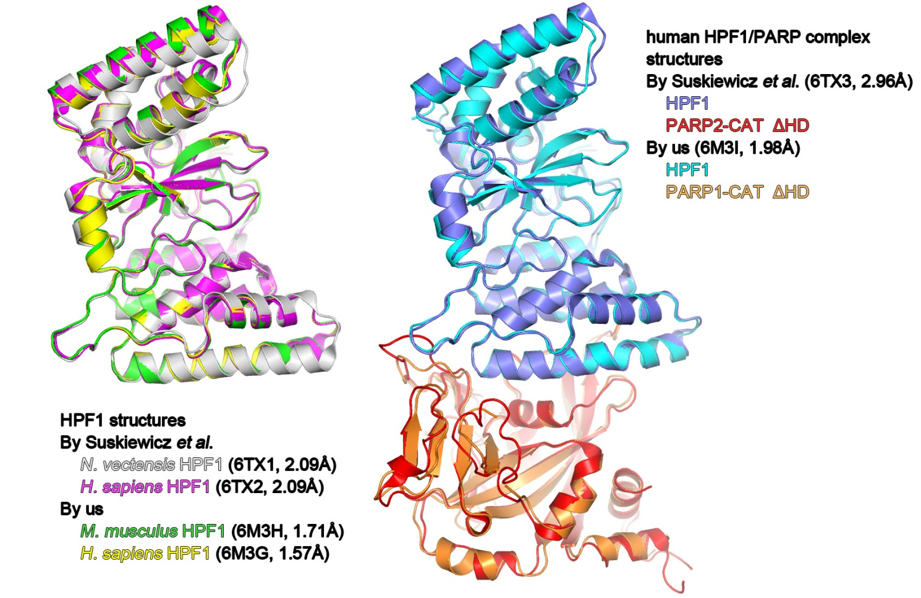
References
1. Dawicki-McKenna JM, et al. PARP-1 Activation Requires Local Unfolding of an Autoinhibitory Domain. Mol Cell 60, 755-768 (2015).

2. Minor W, Cymborowski M, Otwinowski Z, Chruszcz M. HKL-3000: the integration of data reduction and structure solution--from diffraction images to an initial model in minutes. Acta Crystallogr D Biol Crystallogr 62, 859-866 (2006).

3. Vonrhein C, Blanc E, Roversi P, Bricogne G. Automated structure solution with autoSHARP. Methods Mol Biol 364, 215-230 (2007).

4. Bunkoczi G, Echols N, McCoy AJ, Oeffner RD, Adams PD, Read RJ. Phaser.MRage: automated molecular replacement. Acta Crystallogr D Biol Crystallogr 69, 2276-2286 (2013).

5. Langelier MF, Zandarashvili L, Aguiar PM, Black BE, Pascal JM. NAD(+) analog reveals PARP-1 substrate-blocking mechanism and allosteric communication from catalytic center to DNA-binding domains. Nature communications 9, 844 (2018).

6. Emsley P, Lohkamp B, Scott WG, Cowtan K. Features and development of Coot. Acta Crystallogr D Biol Crystallogr 66, 486-501 (2010).

7. Adams PD, et al. PHENIX: a comprehensive Python-based system for macromolecular structure solution. Acta Crystallogr D Biol Crystallogr 66, 213-221 (2010).

8. Evans P. Scaling and assessment of data quality. Acta Crystallogr D Biol Crystallogr 62, 72-82 (2006).

9. Langelier MF, Planck JL, Roy S, Pascal JM. Structural basis for DNA damage-dependent poly(ADP-ribosyl)ation by human PARP-1. Science 336, 728-732 (2012).

10. Bonfiglio JJ, et al. Serine ADP-Ribosylation Depends on HPF1. Mol Cell 65, 932-940 e936 (2017).

11. Palazzo L, Leidecker O, Prokhorova E, Dauben H, Matic I, Ahel I. Serine is the major residue for ADP-ribosylation upon DNA damage. Elife 7, (2018).

12. Suskiewicz MJ, et al. HPF1 completes the PARP active site for DNA damage-induced ADP-ribosylation. Nature 579, 598-602 (2020).

