SUPPLEMENTAL MATERIALS

APPENDIX A Computation of indicators of access to abortion services

Service provision is likely to be an important determinant of abortion access. This includes the local accessibility of clinics that perform an abortion. To capture this, publicly available lists of English and Welsh locations that offer terminations of pregnancy were identified. Several sources were considered: For the years 2017 to 2021, the Department of Health and Social Care has published so-called ‘clinic data’, in which it lists abortion statistics separately for each location where terminations of pregnancy have been performed in a given year. In addition to that, data from the Care Quality Commission (CQC) was included, which in its ‘care directory’ provides extensive information on all locations registered with the CQC. Finally, the list of clinics and hospitals in the independent sector formally approved to perform pregnancy terminations by the Department of Health and Social Care was also utilised. The names of locations were extracted from all three sources, and they were synthesised together to identify overlap between the datasets. For the care directory, only those locations were extracted that were listed as having ‘termination of pregnancy’ as a registered service. In comparing the different lists, it became clear that the clinic data was the most comprehensive dataset, containing 92% of the clinics mentioned across all sources. The list of independent clinics did not include public service providers. Most independent clinics present therein was also found in the ‘clinic data’. The care directory had considerable inconsistencies across years and lacked many locations, with 47% of locations listed in the official abortion statistics not being mentioned in the Care Directory. It was decided to use the clinic data as the basis for the variable to be constructed. The clinic data is published with the official abortion statistics and is therefore based on the same data as the dependent variable of the analysis, the abortion rate. By merging the clinic data from each year of the observation period, a list with all locations active any time between 2017-2021 was obtained, including information on the specific year(s) each location was carrying out abortions in.
The CQC data was still used, as it provided useful additional information for some of the locations. Most importantly, the care directory included information on the local authority where a clinic or hospital is located, as well as its coordinates, which are pieces of information absent in the clinic data. Matching the care directory with the clinic data therefore yielded important geographical information for part of the abortion providers. For providers not mentioned in the CQC da-ta, the opencagegeo command in Stata was used to retrieve coordinates (1). For clinics the command was not able to generate coordinates for, a manual search was performed using the locations’ websites and/or Google Maps.

Travel distance to nearest clinic
The geocoded clinic data was compiled to construct a variable that captures how geographically accessible abortion service providers are in different local authorities. With the available data, three options were considered as potential service availability variables: (i) the number of active clinics in a local authority, (ii) the average time residents of a local authority need to reach the nearest abortion clinic, and (iii) the average number of abortion clinics reachable to residents of a local authority within a given radius.
It was decided not to use (i), i.e. the raw number of clinics active in a local authority as an independent variable, since this does not necessarily reflect the actual availability of abortion services to residents of said local authority. In fact, an individual is not restricted to seeking out a pregnancy termination within their local authority of residence but may also (need to) travel to other local authorities to do so. One’s NHS district might provide abortion care outside of one’s local authority of residence, or services might be more extensive and/or suitable in local authority’s other than one’s own. Sometimes, clinics outside one’s local authority of residence might be the only or the most accessible option, as depicted in Fig. A.1 for the example of Wales: with ArcGIS Online, for each population-weighted centroid of a middle layer super output area (MSOA) (orange dots), the quickest route to a nearby abortion clinic (blue squares) was calculated, and drawn as a blue line. It becomes apparent that many of the fastest routes cross the local authority boundaries marked in black.
In addition, the size of local authorities varies. One might, for example, consider counting clinics active in a local authority, plus its neighbors, as an indicator for abortion access. For a resident of Central London this would mean that all clinics considered accessible by such a variable would lie within a 30-40 km radius in Greater London, while for the county of Cumbria this computation method would imply counting clinics in East Riding of Yorkshire (around 200km of distance) as accessible service providers. The service accessibility measure would thus not be suited for comparisons across different local authorities
For these reasons, the first variable we used to measure accessibility to abortion services is the average travel time in minutes from all MSOAs centroids to the nearest clinic in a local authority in a given year.

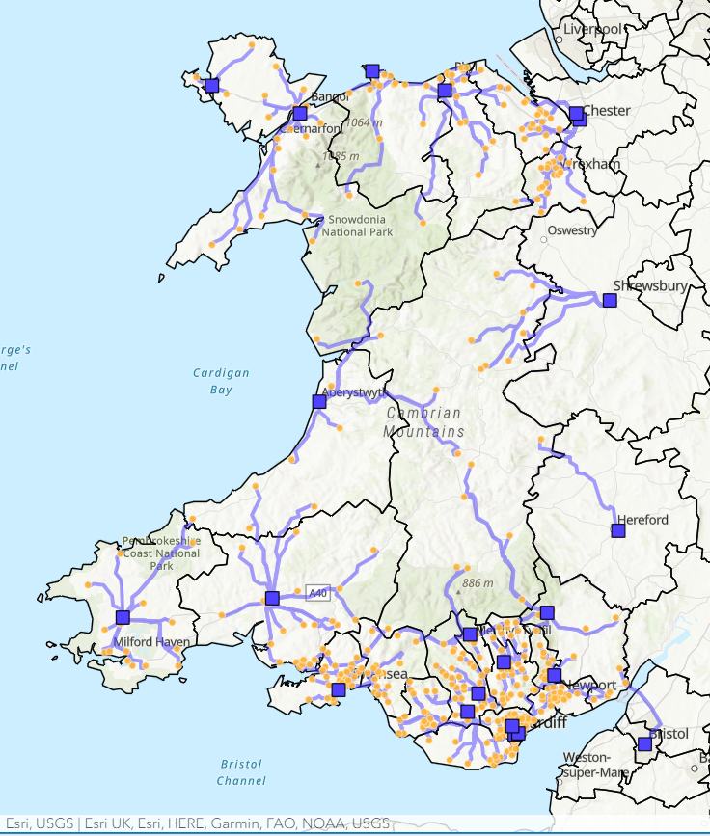
Figure A.1. Depiction of routes to abortion clinics that minimise travel time for each MSOA in Wales. Screenshot from ArcGIS Online. MSOA centroids in orange, abortion clinics in dark blue, routes in light blue. Source: Data from Department of Health and Social Care (2), Care Quality Commission(3, 4), Office for National Statistics (5), and own calculations. Map from Esri (6).

Number of clinics within 30 minutes travel time
However, using driving time to the nearest clinic as an indicator for abortion access might not estimate the actual availability of abortion care in a local area. Even though a clinic might be the closest to a patient’s place of residence, that does not necessarily mean the patient is actually able to access abortion care in that establishment. This can be the case for various reasons. A patient might not want to seek out care in a specific clinic because they know members of the personnel and value secrecy over proximity of the clinic; a GP might refer to a different clinic than the one nearby; a clinic could be closest by car but not by public transport; or a clinic might only offer certain types of abortion services (up to a certain gestational age, only a specific procedure, …), which might not be the one a patient needs. Given that abortion rates are studied at local-authority level, and that no specific information on the type of services offered by each clinic is provided by the Department of Health and Social Care, these limitations cannot be adequately addressed in this study, and another quantification method for abortion access is computed.
Therefore, another service availability variable was computed using travel time areas. Fig. A.2. provides an example for this procedure: a travel time area was built to comprise all points that are reachable within 30 minutes driving distance (purple) from a point of origin (black pin). All abortion providers (blue squares) within a travel time area would then be counted towards the service availability variable. To avoid distortions in travel time due to traffic conditions, travel time was calculated for a Sunday on 11:00 pm, which is assumed to be a time when there is little traffic and travel speeds are thus more comparable across local authorities.
Again, as some local authorities are quite large in size and heterogenous in regard to urbanity and infrastructure, it would be imprecise to construct one travel time area for each local authority (e.g. around its centroid or its most populous town) and count the number of clinics that lie within that area. Therefore, a finer level of analysis was chosen by looking at so-called middle-layer super output areas (MSOAs). MSOAs are groups of adjacent reporting areas for census data that are designed to have somewhat similar population sizes, with a minimum of 5000, and an average of 7200 residents per MSOA (7). Travel time areas were constructed using ArcGIS online for all population-weighted centroids of MSOAs, which were retrieved from the ONS Open Geography Portal (5). Subsequently, the ‘summarize within’ tool in ArcGIS online was used to compute the number of clinics that lie within each MSOA’s 30-minute travel time area.
As second indicator of accessibility to abortion services we use the average of the number of clinics within the 30 minutes areas at the local authority level in a given year.
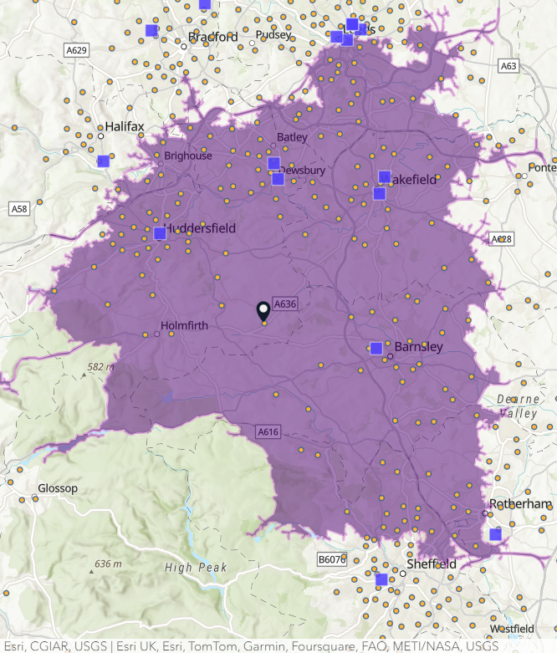
Figure A.2. Example calculation of the clin30min variable for one MSOA. Screenshot from ArcGIS online. MSOA centroids in orange, abortion clinics in dark blue, travel time area in purple. Source: Data from Department of Health and Social Care (2), Care Quality Commission(3, 4), Office for National Statistics (5), and own calculations. Map from Esri (6).

APPENDIX B Spatial analysis: technical note & model selection

Spatial descriptive analysis
To study the spatial pattern of abortion rates, the travel time to the nearest clinic and the number of clinics within 30 minutes travel time, we computed the Moran ‘s I statistic for spatial autocorrelation as follows:
$$I=\frac{n}{S_{0}}\frac{\sum_{i}{\sum_{j}{\left(y_{i}-\overline{y}\right)w_{ij}\left(y_{j}-\overline{y}\right)}}}{{\sum_{i=1}^{N}{\left(y_{i}-\overline{y}\right)}}^{2}}$$

Where $y_{i}$ is the variable of interest in local authority i, $\overline{y}$ is its mean, $w_{ij}$ is the spatial weight between county i and local authority j, n is the number of counties. $S_{0}$ is is defined as the aggregate of all spatial weights: $S_{0}=\sum_{i=1}^{n}{\sum_{j=1}^{n}{w_{ij}}}$. We computed normalized contiguity-based spatial weights $w_{ij}$.
Using this statistic, we test the presence of spatial dependence and reject the null hypothesis (H0) of the absence of spatial autocorrelation where $I^{2}$ ∼ 𝜒2(1) under H0 (8).

Spatial multivariate analysis

We followed a general to specific approach to select the spatial components of the model. We started with the general Cliff Order model (Manski model) which includes each type of spatial dependences: Wy is the spatial lag in the dependent variable, WX is spatial lag in explanatory variables, and Wu spatial lag in the error term, as follows:
y = $ρ$Wy +XB +WX$θ$ +u;
u = $λ$Wu+e
and computed Likelihood Ratio (LR) tests of alternative specifications ($ρ=0$ or/and $θ=0 or and λ=0$ ) to choose the best specification.
The regression of the abortion rate including the travel time to the nearest clinic has been specified as a Spatial Durbin Error Model (SDEM) with random effects (Table 2):
𝑌𝑡 = 𝛼𝜄𝑁 +𝑋𝑡𝛽+𝑊D𝑡𝜃+𝜇+𝜉𝑡𝜄𝑁 +𝑢𝑡,
𝑢𝑡 = 𝜆𝑊𝑢𝑡 +𝜀𝑡.
Where 𝑌𝑡 is the abortion rate in year t in a local authority,
𝑋𝑡 is a set of control variables, including ethnicity, education, income, gender pay gap, political party having control of a council, household characteristics, English proficiency, 𝑊D𝑡 is the spatial lag of the travel time to the nearest clinic that measure the influence of the travel time to the nearest clinic from the neighboring counties,
𝜇 is the county random effect.
𝑢𝑡 as well as the spatial lag in the error term ($λ$), and
𝜉𝑡𝜄 is i.i.d. error term.

The regression of the abortion rate including the number of clinics within 30 minutes travel time has been specified as a Spatial Error Model (SEM) with random effects (Table 3):
𝑌𝑡 = 𝛼𝜄𝑁 +𝑋t𝛽+𝜇+𝜉𝑡𝜄𝑁 +𝑢𝑡,
u𝑡 = 𝜆𝑊𝑢𝑡 +𝜀𝑡.
Where 𝑌𝑡 is the abortion rate in year t in a local authority,
𝑋𝑡 is a set of control variables, including the number of abortion clinics within 30 minutes travel time per 1,000 women aged 15-44 in a local authority ethnicity, education, income, gender pay gap, political party having majority at the local authority level, household characteristics, knowledge of the English language,
𝜇 is the local authority random effect.
𝑢𝑡 is the spatial lag in the error term ($λ$), and
𝜉𝑡𝜄 is i.i.d. error term.

APPENDIX C: Spatial multivariate Analysis: Full outputs and sensitivity analysis

SDEM outputs with the travel time to the nearest clinic
 | (1) | (2) | (3) | (4) | (5)
VARIABLES | Abortion rate | Abortion rate | Abortion rate | Abortion rate | Abortion rate
Nearest clinic (𝛽) | -0.0614* | -0.0587* | -0.0541* | 0.00686 | 0.00535
 | (0.0280) | (0.0272) | (0.0268) | (0.0268) | (0.0257)
Nearest clinic ($θ$) | -0.149** | -0.140** | -0.108* | 0.0380 | 0.0329
 | (0.0507) | (0.0473) | (0.0455) | (0.0425) | (0.0421)
Median annual pay |  | 2.710*** | 2.670*** | 2.254*** | 0.972**
 |  | (0.344) | (0.343) | (0.340) | (0.355)
Median annual pay: missing |  | 7.276*** | 7.065*** | 6.105*** | 2.495*
 |  | (1.041) | (1.050) | (1.039) | (1.072)
Education > level 2 |  | -0.205*** | -0.207*** | -0.381*** | -0.363***
 |  | (0.0337) | (0.0319) | (0.0453) | (0.0453)
Majority: LAB |  |  | 1.109*** | 0.443 | 0.433
 |  |  | (0.329) | (0.321) | (0.309)
Majority: NOC |  |  | 0.688** | 0.538* | 0.460*
 |  |  | (0.245) | (0.239) | (0.229)
Majority: Other |  |  | 0.0691 | 0.178 | 0.0577
 |  |  | (0.431) | (0.416) | (0.399)
Pay gap |  |  | -0.0347*** | -0.0283** | -0.0107
 |  |  | (0.00975) | (0.00961) | (0.00936)
Pay gap: missing |  |  | -1.051** | -0.796* | -0.204
 |  |  | (0.355) | (0.350) | (0.340)
% Single, separated or divorced women |  |  |  | 0.209*** | 0.205***
 |  |  |  | (0.0621) | (0.0617)
Ethnicity: % Asian |  |  |  | 0.0476 | 0.0590^
 |  |  |  | (0.0352) | (0.0352)
Ethnicity: % Black |  |  |  | 0.220** | 0.232**
 |  |  |  | (0.0719) | (0.0718)
Ethnicity: % Mixed |  |  |  | 0.383 | 0.480
 |  |  |  | (0.308) | (0.308)
Ethnicity: % Other |  |  |  | -0.171 | -0.127
 |  |  |  | (0.185) | (0.185)
English foreign language: can speak well |  |  |  | 0.133^ | 0.144^
 |  |  |  | (0.0759) | (0.0758)
English foreign language: cannot speak or not well |  |  |  | -0.343 | -0.540^
 |  |  |  | (0.308) | (0.307)
EMAH (year>2019) |  |  |  |  | 1.335***
 |  |  |  |  | (0.163)
Error lag ($λ$) | 0.784*** | 0.738*** | 0.724*** | 0.725*** | 0.738***
 | (0.0352) | (0.0423) | (0.0444) | (0.0448) | (0.0440)
Constant | 20.13*** | 23.66*** | 24.06*** | 19.69*** | 20.88***
 | (0.529) | (1.723) | (1.719) | (3.686) | (3.654)
N | 855 | 855 | 855 | 855 | 855
Local Authorities | 171 | 171 | 171 | 171 | 171
AIC | 3418 | 3352 | 3335 | 3256 | 3191
Wald test | 497.1 | 307.5 | 267.2 | 266.4 | 284
Table C.1. Regression output for the adjusted SDEM estimating the effect of predictors on local authority-level abortion rates in England and Wales. Standard errors in parentheses. *** p<0.001, ** p<0.01, * p<0.05, ^ p<0.1. Reference for the categorical variables: Ethnicity: % White, English main language, Majority: CON.

Sensitivity Analysis: adding of rurality and latitude in the SDEM specification
 | (1) | (2) | (3) | (4) | (5) | (6)
VARIABLES | Abortion rate | Abortion rate | Abortion rate | Abortion rate | Abortion rate | Abortion rate
Nearest clinic (𝛽) | -0.0614* | -0.0228 | -0.0228 | -0.0209 | 0.0244 | 0.0220
 | (0.0280) | (0.0286) | (0.0279) | (0.0276) | (0.0274) | (0.0262)
Nearest clinic ($θ$) | -0.149** | -0.0873^ | -0.0848^ | -0.0598 | 0.0438 | 0.0394
 | (0.0507) | (0.0509) | (0.0476) | (0.0456) | (0.0419) | (0.0415)
Is rural |  | -3.667*** | -3.330*** | -2.966*** | -1.604** | -1.670**
 |  | (0.768) | (0.723) | (0.689) | (0.600) | (0.597)
Latitude |  | 0.0420 | -0.140 | -0.288 | 0.130 | 0.124
 |  | (0.234) | (0.238) | (0.227) | (0.210) | (0.209)
Median annual pay |  |  | 2.614*** | 2.547*** | 2.221*** | 0.938**
 |  |  | (0.343) | (0.342) | (0.339) | (0.354)
Median annual pay: missing |  |  | 7.037*** | 6.745*** | 6.039*** | 2.424*
 |  |  | (1.038) | (1.046) | (1.038) | (1.070)
Education > level 2 |  |  | -0.209*** | -0.218*** | -0.356*** | -0.336***
 |  |  | (0.0347) | (0.0329) | (0.0457) | (0.0456)
Majority: LAB |  |  |  | 1.023** | 0.357 | 0.350
 |  |  |  | (0.331) | (0.323) | (0.310)
Majority: NOC |  |  |  | 0.670** | 0.500* | 0.424^
 |  |  |  | (0.245) | (0.240) | (0.229)
Majority: Other |  |  |  | 0.0214 | 0.147 | 0.0273
 |  |  |  | (0.428) | (0.415) | (0.398)
Pay gap |  |  |  | -0.0352*** | -0.0287** | -0.0110
 |  |  |  | (0.00971) | (0.00961) | (0.00935)
Pay gap: missing |  |  |  | -1.063** | -0.808* | -0.214
 |  |  |  | (0.354) | (0.350) | (0.340)
% Single, separated or divorced women |  |  |  |  | 0.172** | 0.166**
 |  |  |  |  | (0.0628) | (0.0624)
Ethnicity: % Asian |  |  |  |  | 0.0426 | 0.0538
 |  |  |  |  | (0.0346) | (0.0345)
Ethnicity: % Black |  |  |  |  | 0.261*** | 0.275***
 |  |  |  |  | (0.0721) | (0.0719)
Ethnicity: % Mixed |  |  |  |  | 0.199 | 0.284
 |  |  |  |  | (0.315) | (0.315)
Ethnicity: % Other |  |  |  |  | -0.130 | -0.0832
 |  |  |  |  | (0.182) | (0.182)
English foreign language: can speak well |  |  |  |  | 0.130^ | 0.140^
 |  |  |  |  | (0.0765) | (0.0763)
English foreign language: cannot speak or not well |  |  |  |  | -0.361 | -0.555^
 |  |  |  |  | (0.310) | (0.310)
EMAH (year>2019) |  |  |  |  |  | 1.336***
 |  |  |  |  |  | (0.163)
Error lag ($λ$) | 0.784*** | 0.774*** | 0.728*** | 0.715*** | 0.720*** | 0.733***
 | (0.0352) | (0.0357) | (0.0426) | (0.0445) | (0.0447) | (0.0439)
Constant | 20.13*** | 17.65 | 31.18* | 39.86** | 13.87 | 15.44
 | (0.529) | (12.29) | (13.28) | (12.62) | (11.18) | (11.12)
N | 855 | 855 | 855 | 855 | 855 | 855
Local Authorities | 171 | 171 | 171 | 171 | 171 | 171
AIC | 3418 | 3400 | 3335 | 3319 | 3252 | 3187
Wald test | 497.1 | 470.6 | 292.2 | 257.9 | 263.7 | 282
Table C.2. Regression output for the adjusted SDEM estimating the effect of predictors on local authority-level abortion rates in England and Wales, including the variables is rural and latitude. Standard errors in parentheses. *** p<0.001, ** p<0.01, * p<0.05, ^ p<0.1. Reference for the categorical variables: Ethnicity: % White, English main language, Majority: CON.

REFERENCES
1. Zeigermann L. Opencagegeo: stata module for forward and reverse geocoding. . http://fmwwwbcedu/repec/bocode/o/opencagepdf 2016.
2. Department of Health and Social Care. Abortion statistics in England and Wales: UK Government; 2023 [Available from: https://www.gov.uk/government/collections/abortion-statistics-for-england-and-wales.
3. Care Quality Commission. Care directory with filters. 30 August 2023 ed2023.
4. Care Quality Commission. Deactivated Locations. 01 August 2023 ed2023.
5. Office for National Statistics e. MSOA (Dec 2021) PWC in England and Wales. In: Statistics OfN, editor. 2023.
6. Esri, cartographer World Topographic Map: Esri; 2023.
7. National Health Service. Middle Layer Super Output Area 2023 [Available from: https://www.datadictionary.nhs.uk/nhs_business_definitions/middle_layer_super_output_area.html.
8. H. Kelejian H, Prucha IR. On the asymptotic distribution of the Moran I test statistic with applications. Journal of Econometrics. 2001;104(2):219-57.

