Supplementary data for
Protective role of mRNA demethylase FTO on axon guiding molecules of nigro-striatal projection system in manganese-induced Parkinsonism
Qi et al

Supplementary Figures
Supplementary Figure 1
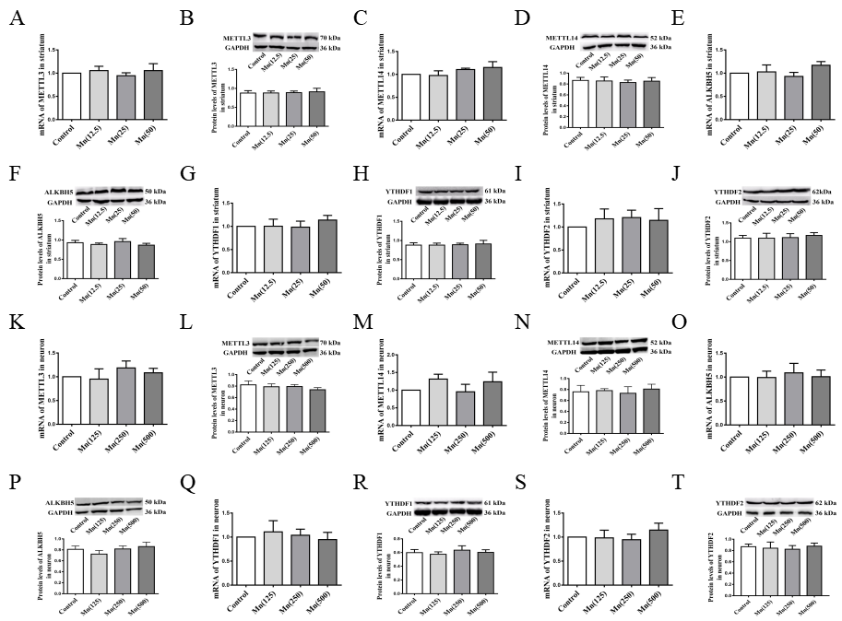
Supplementary Figure 1 The levels of several common m⁶A methylases in striatum after Mn exposure. A-B, K-L The levels of METTL3 in striatum and neuron. C-D, M-N The levels of METTL14 in striatum and neuron. E-F, O-P The levels of ALKBH5 in striatum and neuron. G-H, Q-R The levels of YTHDF1 in striatum and neuron. I-J, S-T The levels of YTHDF2 in striatum and neuron. Data are represented as mean±S.D. (n≥3).

Supplementary Figure 2
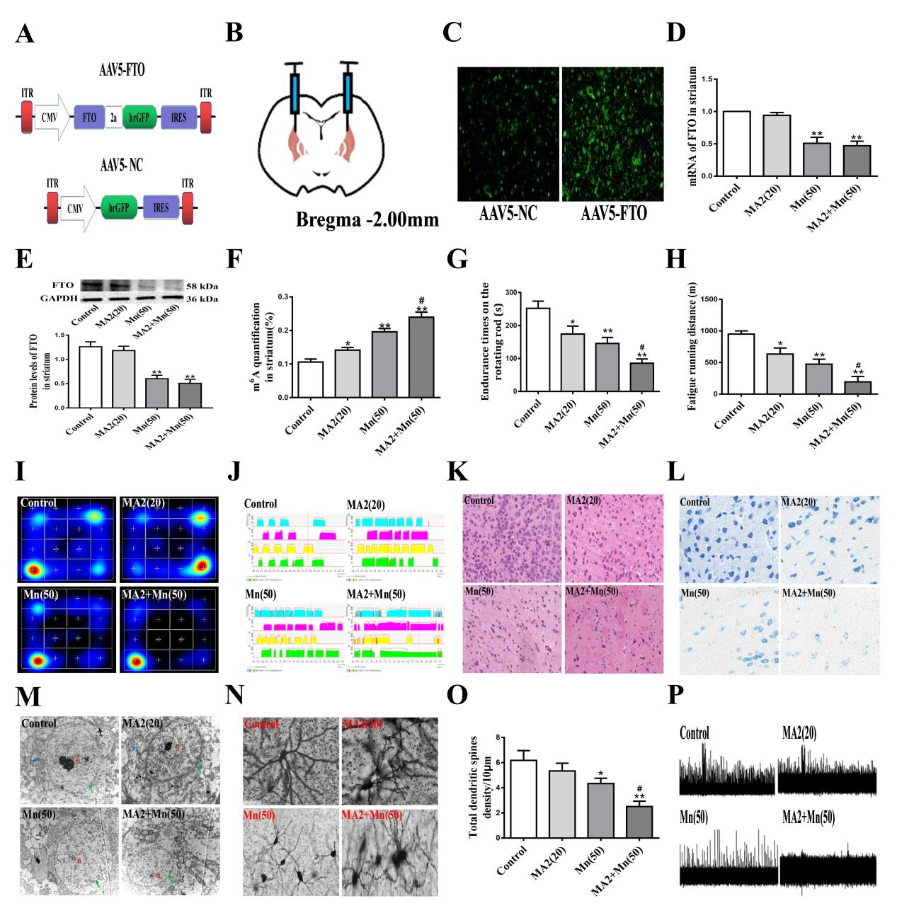
Supplementary Figure 2 Effect of FTO over-expression or inhibited FTO activity in motor and morphological changes after Mn exposure. A Schematics of AAV5 constructs over-expressing FTO (AAV5-FTO) or control (AAV5-NC). ITR, inverted terminal repeats; CMV, cytomegalovirus promoter; IRES, Internal ribosome entry site sequence. B Illustration of bilateral viral injections into the striatum of mouse. C Representative fluorescence images of the striatum after AAV5 infection. FTO co-expressed with hrGFP, green. D The mRNA expression of FTO in striatum. E The protein levels of FTO in striatum. F The total RNA m⁶A levels in striatum. G Endurance times on the rotating rod. H Fatigue running distance in the fatigue meter. I Heat map of activity in the open field. J Mean intensity in the gait tests. K HE staining of striatum. L Nissl staining of striatum. M Electron microphotograph of striatum. Green arrow-heads represent the nuclear membrane, n representative nuclei, blue arrow-heads represent mitochondria, black arrows represent endoplasmic reticulum. N-O Golgi-Cox staining of striatum. P Trace representative spontaneous firing recorded by MED64. The magnification of the sections stained with HE, Nissl, FG and Golgi-Cox was ×400. The magnification of electron microphotograph was ×4,000. Data are represented as mean±S.D. (n≥3). *P<0.05, **P<0.01 indicates statistical significance in contrast with the control group; #P<0.05 indicates statistical significance in contrast with the 50 mg/kg MnCl₂ group.

Supplementary Figure 3
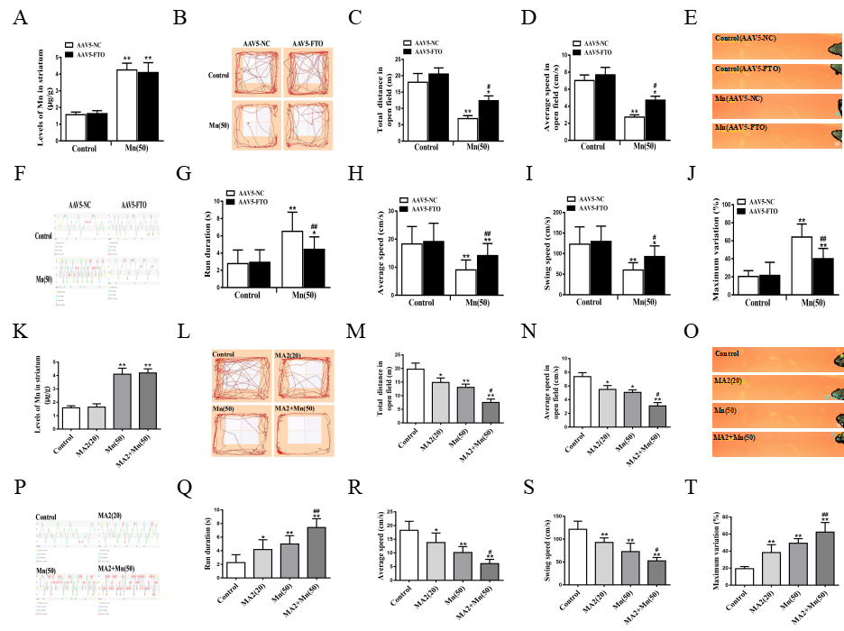
Supplementary Figure 3 Effect of FTO over-expression or inhibited FTO activity in motor function after Mn exposure. A, K Mn levels in striatum after re-expressing FTO or inhibited FTO activity. B, L Trajectory map in the open field. C, M Total distance in the open field. D, N Average speed in the open field. E, O Walking video in the gait tests. F, P Gait pattern in the gait tests. G, Q Run duration in the gait tests. H, R Average speed in the gait tests. I, S Swing speed in the gait tests. J, T Maximum variation in the gait tests. Data are represented as mean±S.D. (n≥3). *P<0.05, **P<0.01 indicates statistical significance in contrast with the control (with or without FTO-NC) group; #P<0.05, ##P<0.01 indicates statistical significance in contrast with the 50 mg/kg MnCl₂ (with or without FTO-NC) group.

Supplementary Figure 4
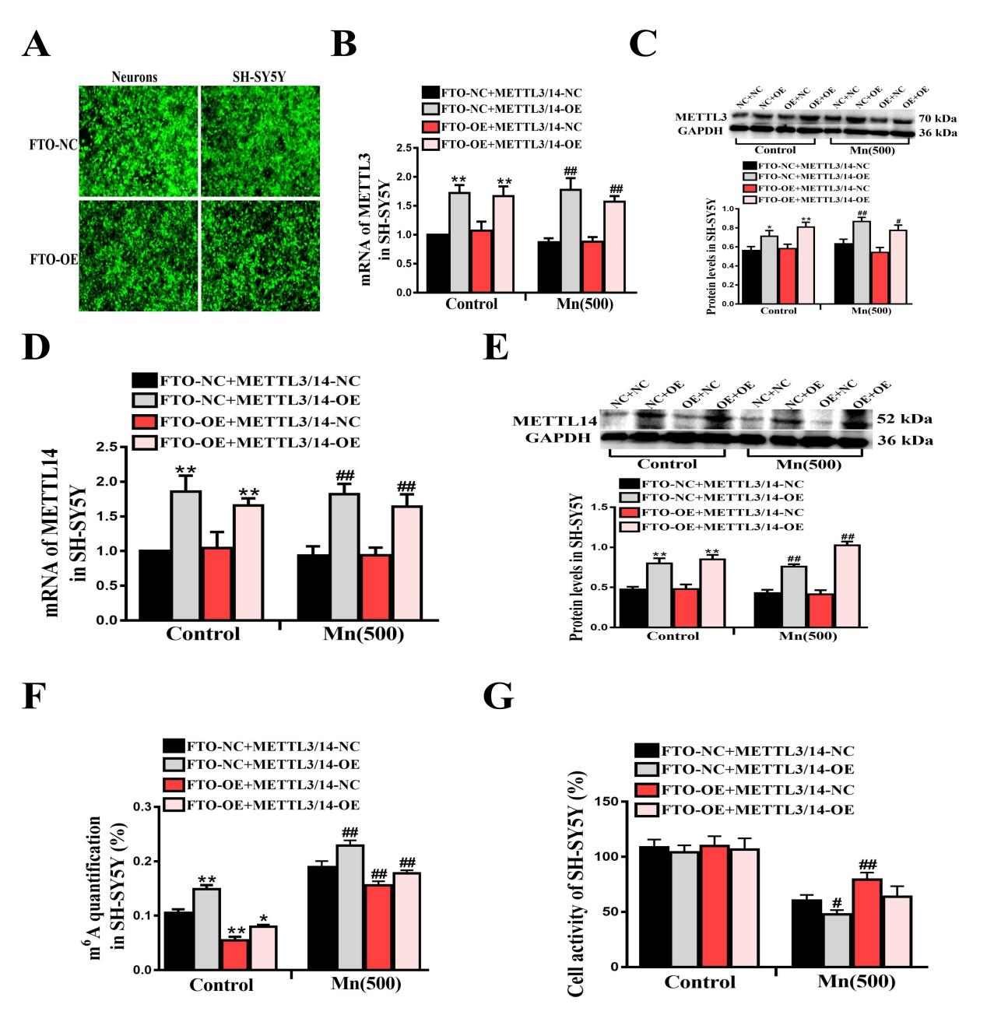
Supplementary Figure 4 The function of m⁶A in SH-SY5Y cells. A Representative fluorescence images of neuron and SH-SY5Y cells after FTO over-expression. B-C, D-E Confirmation of over-expression or inhibited activity of SH-SY5Y cells. F The total RNA m⁶A levels in SH-SY5Y cells. G Cell viability assay using SH-SY5Y cells. Data are represented as mean±S.D. (n≥3). *P<0.05, **P<0.01 indicates statistical significance in contrast with the control (FTO-NC+METTL3/14-NC) group; #P<0.05, ##P<0.01 indicates statistical significance in contrast with the 50 mg/kg MnCl₂ (FTO-NC+METTL3/14-NC) group.

Supplementary Figure 5
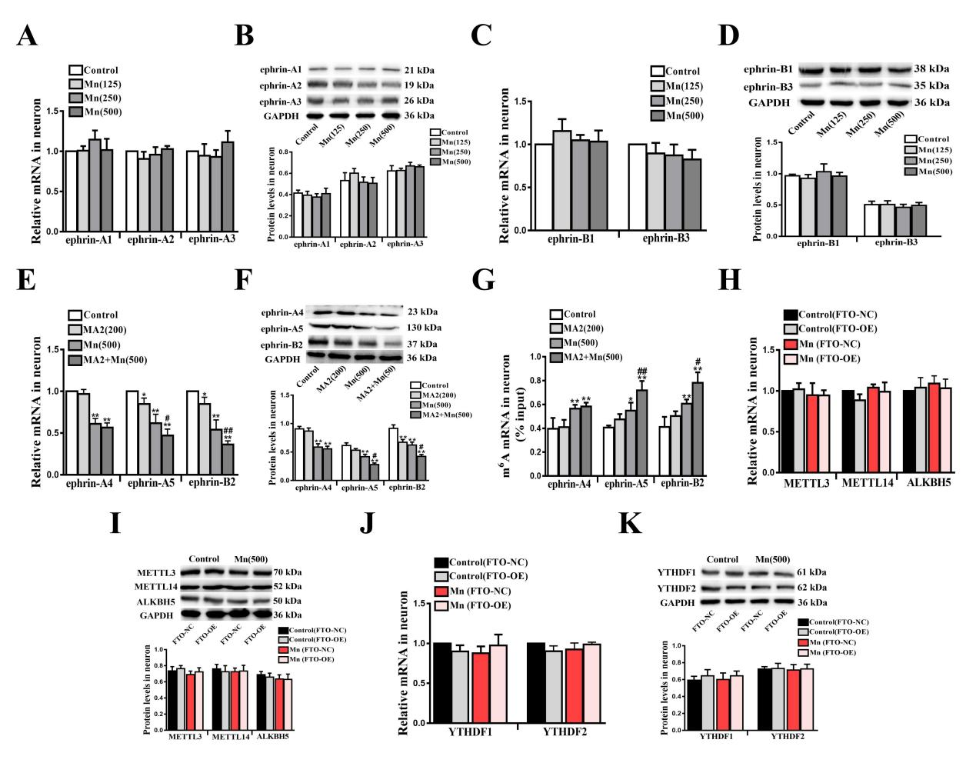
Supplementary Figure 5 The expression of ephrins in neuron cells. A-D The expression of ephrin-A1, ephrin-A2, ephrin-A3, ephrin-B1 and ephrin-B3 in neuron cells. E-F The expression of ephrin-A4, ephrin-A5, and ephrin-B2 in neuron cells. G The mRNA m⁶A levels of ephrin-A4, ephrin-A5, and ephrin-B2. H-K The expression of METTL3, METTL14, ALKBH5, YTHDF1 and YTHDF2 in neuron cells. Data are represented as mean±S.D. (n≥3).

Supplementary Figure 6
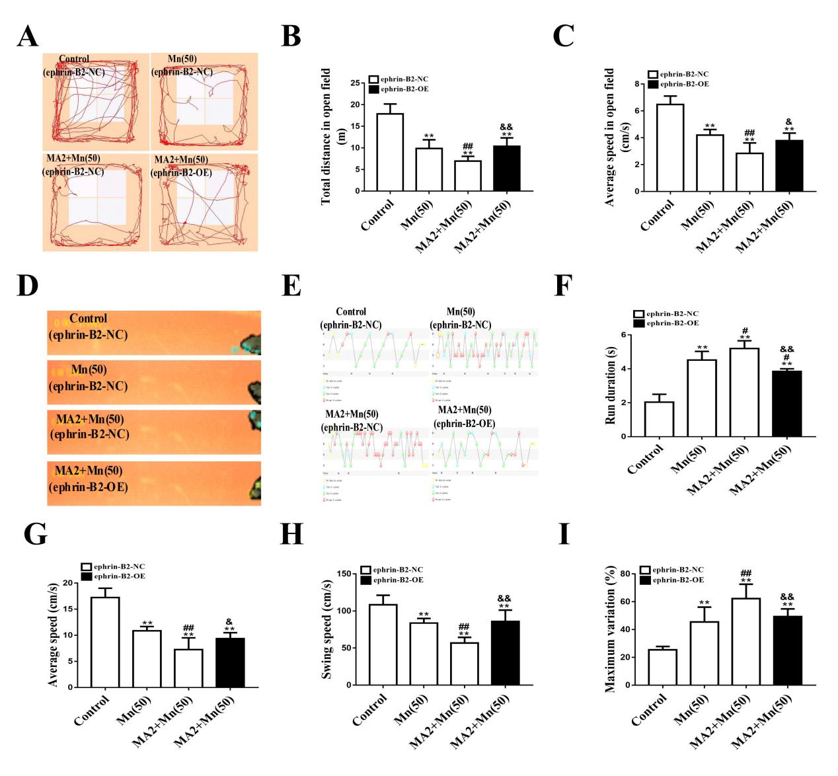
Supplementary Figure 6 Effect of ephrin-B2 and FTO in motor function after Mn exposure. A Trajectory map in the open field. B Total distance in the open field. C Average speed in the open field. D Walking video in the gait tests. E Gait pattern in the gait tests. F Run duration in the gait tests. G Average speed in the gait tests. H Swing speed in the gait tests. I Maximum variation in the gait tests. Data are represented as mean±S.D. (n≥3). **P<0.01 indicates statistical significance in contrast with the control (ephrin-B2-NC) group; #P<0.05, ##P<0.01 indicates statistical significance in contrast with the 50 mg/kg MnCl₂ (ephrin-B2-NC) group. &P<0.05, &&P<0.01 indicates statistical significance in contrast with the 20 mg/kg MA2+50 mg/kg MnCl₂ (ephrin-B2-NC) group.

Supplementary Table 1 Primers for RT-qPCR analysis
Name | Oligo | Primer sequence
Human β-actin | Sense primer | 5’–ACCTTCTACAATGAGCTGCG-3’
Human β-actin | Anti-sense primer | 5’–CCTGGATAGCAACGTACATGG-3’
Mouse β-actin | Sense primer | 5’–ACCTTCTACAATGAGCTGCG-3’
Mouse β-actin | Anti-sense primer | 5’–CTGGATGGCTACGTACATGG-3’
Human HPRT1 | Sense primer | 5’–TGCTGAGGATTTGGAAAGGG-3’
Human HPRT1 | Anti-sense primer | 5’–ACAGAGGGCTACAATGTGATG-3’
Human FTO | Sense primer | 5’–ACTTGGCTCCCTTATCTGACC-3’
Human FTO | Anti-sense primer | 5’–TGTGCAGTGTGAGAAAGGCTT-3’
Mouse FTO | Sense primer | 5’–TCACAGCCTCGGTTTAGTTC-3’
Mouse FTO | Anti-sense primer | 5’–GCAGGATCAAAGGATTTCAACG-3’
Human METTL3 | Sense primer | 5’–GAAAGACTATCTCCTGGCACTC-3’
Human METTL3 | Anti-sense primer | 5’–GTACCTTTGCTTGAACCGTG-3’
Mouse METTL3 | Sense primer | 5’-ATCCAGGCCCATAAGAAACAG-3’
Mouse METTL3 | Anti-sense primer | 5’-CTATCACTACGGAAGGTTGGG-3’
Human METTL14 | Sense primer | 5’–TTTCTCTGGTGTGGTTCTGG-3’
Human METTL14 | Anti-sense primer | 5’–AAGTCTTAGTCTTCCCAGGATTG-3’
Mouse METTL14 | Sense primer | 5’–AGACGCCTTCATCTCTTTGAG-3’
Mouse METTL14 | Anti-sense primer | 5’–CTCTGTACATCCGGTCAAGTATG-3’
Mouse ALKBH5 | Sense primer | 5’–AGTTCCAGTTCAAGCCCATC-3’
Mouse ALKBH5 | Anti-sense primer | 5’–GGCGTTCCTTAATGTCCTGAG-3’
Mouse YTHDF1 | Sense primer | 5’–CCCCAGAGAACAAAAGGACAAG-3’
Mouse YTHDF1 | Anti-sense primer | 5’–GACAGGTAAGGATCACTCATCG-3’
Mouse YTHDF2 | Sense primer | 5’–ACTATGAGAAACGCCAAGAGG-3’
Mouse YTHDF2 | Anti-sense primer | 5’–TTAGGATAAGGAGATGCAACCG-3’
Mouse ephrin-A1 | Sense primer | 5’–CATCTCCAAACCTATCTACCATCAG-3’
Mouse ephrin-A1 | Anti-sense primer | 5’–TGCAAAACCTGTACTTCCGG-3’
Mouse ephrin-A2 | Sense primer | 5’–CTTTGAGTTCCGGCCTGG-3’
Mouse ephrin-A2 | Anti-sense primer | 5’–TGTTACTGGTGAAGATGGGC-3’
Mouse ephrin-A3 | Sense primer | 5’–ACAGCCCCATCAAGTTCTC-3’
Mouse ephrin-A3 | Anti-sense primer | 5’–CTTCATCCTCAGACACTTCCAG-3’
Mouse ephrin-A4 | Sense primer | 5’–CACCCAATCTACTGGAACTCC-3’
Mouse ephrin-A4 | Anti-sense primer | 5’–GTATAATGCAAAGGTTTCCGGG-3’
Mouse ephrin-A5 | Sense primer | 5’–AGGTCCTGTCTAAAGCTCAAAG-3’
Mouse ephrin-A5 | Anti-sense primer | 5’–GGAACAGTAGGATTGCCAAAAG-3’
Mouse ephrin-B1 | Sense primer | 5’–AAGTTCCAAGAGTTCAGCCC-3’
Mouse ephrin-B1 | Anti-sense primer | 5’–ATCTTCATAGTGCGGGTGC-3’
Mouse ephrin-B2 | Sense primer | 5’–AGACAAGAGCCATGAAGATCC-3’
Mouse ephrin-B2 | Anti-sense primer | 5’–ACTTCTCCCATTTGTACCAGC-3’
Mouse ephrin-B3 | Sense primer | 5’–CATAATTGCCACATCAGACGG-3’
Mouse ephrin-B3 | Anti-sense primer | 5’–TTCAGACACAGGTTTTCGGG-3’
Mouse Grb4 | Sense primer | 5’–TGGTACTATGGCAACGTGAC-3’
Mouse Grb4 | Anti-sense primer | 5’–AGTGCTTGTTTCTCCCTGAC-3’
Mouse GIT1 | Sense primer | 5’–CACCCCATCAAGTCAGAGTTC-3’
Mouse GIT1 | Anti-sense primer | 5’–GTTTCCAAGTTGCCTGTTCG-3’

