Appendix A
Theoretical Justification for the Inclusion of Control Variables
The following text describes the reasons why we chose to control for household ownership, household composition, and the degree of urbanisation.
Household Ownership
Since homeowners may be more likely to invest in energy-efficient appliances and home improvements that reduce long-term energy and water costs (e.g., water-saving fixtures and solar panels) (27,61), we controlled for household ownership because it may be related to energy and water consumption.
Household Composition
Since research has found evidence that age shared an inversed U-shape relationship with transportation expenditures (62), household composition was controlled for our analyses.
The Degree of Urbanisation
We controlled for the degree of urbanisation as it may be related to different consumption components, such as travel and food consumption.
First, the degree of urbanisation may be related to access to public transportation such that households in extremely urbanised regions may have better access to public transportation, hence, are more likely to use public transportation than private transport (e.g., cars). Indeed, emissions from private transport consumption (e.g., petrol and diesel) and per capita transportation energy use are higher in rural areas than in urban areas .
Second, previous studies have found that the more urbanised a population is, the more meat is being consumed (66), as people in cities consume more food away from home and larger amounts of pre-cooked convenience foods than people in rural areas (67). Specifically, research has found that, in the Dutch context, people in more extremely urbanised municipalities like Amsterdam and Rotterdam eat more meat than in other Dutch municipalities (68).
Appendix B
Distribution of Control Variables
Table 4
Distribution of Control Variables
Covariates | Level | Percentage
Degree or urbanisation
 | Not urbanised | 8.95%
 | Hardly urbanised | 21.81%
 | Strongly urbanised | 32.5%
 | Moderately urbanised | 18.29%
 | Extremely urbanised | 18.49%
Household ownership
 | Rented  property | 75.73%
 | Owned property | 24.27%
No of children in a household
 | 0 | 81.32%
 | 1 | 8.62%
 | 2 | 8.05%
 | 3-7 | 2.00%
No of teenagers in a household
 | 0 | 88.59%
 | 1 | 7.82%
 | 2-3 | 3.58%
No of adults in a household
 | 0 | 14.96%
 | 1 | 28.15%
 | 2 | 46.46%
 | 3-6 | 10.42%
No of elderlies in a household
 | 0 | 81.23%
 | 1 | 9.80%
 | 2 | 8.97%
Appendix C
Correlation among the Eleven Indicators
Table 5
Correlation among the Eleven Indicators
Indicators | 1 | 2 | 3 | 4 | 5 | 6 | 7 | 8 | 9 | 10 | 11
Meat (1) | / | 0.21** | 0.34** | 0.42** | 0.08** | -0.02* | 0.12** | -0.05** | 0.20** | 0.14** | 0.07**
Fish (2) | 0.21** | / | 0.21** | 0.27** | 0.08** | 0.05** | 0.10** | 0.04** | 0.12** | 0.10** | 0.06**
Dairy (3) | 0.34** | 0.21** | / | 0.44** | 0.10** | 0.03** | 0.11** | 0.06** | 0.13** | 0.17** | 0.15**
Vegetables (4) | 0.42** | 0.27** | 0.44** | / | 0.12** | 0.05** | 0.10** | 0.07** | 0.14** | 0.18** | 0.15**
Fashion (5) | 0.08** | 0.08** | 0.10** | 0.12** | / | 0.11** | 0.12** | 0.04** | 0.07** | 0.04** | 0.02**
Flights (6) | -0.02* | 0.05** | 0.03** | 0.05** | 0.11** | / | 0.12** | 0.21** | 0.07** | 0.11** | 0.15**
Private (7) | 0.13** | 0.10** | 0.11** | 0.10** | 0.12** | 0.12** | / | 0.00 | 0.19** | 0.19** | 0.08**
Public (8) | -0.05** | 0.04** | 0.06** | 0.07** | 0.04** | 0.21** | 0.00 | / | -0.02* | 0.08** | 0.13**
Electricity (9) | 0.20** | 0.12** | 0.13** | 0.14** | 0.07** | 0.07** | 0.19** | -0.02* | / | 0.50** | 0.20**
Gas (10) | 0.14** | 0.10** | 0.17** | 0.18** | 0.04** | 0.11** | 0.19** | 0.08** | 0.50** | / | 0.50**
Water (11) | 0.07** | 0.06** | 0.15** | 0.15** | 0.02** | 0.15** | 0.08** | 0.13** | 0.20** | 0.50** | /
Note. Private = private transportation, public = public transportation. * p < .05, **p < .001.

Appendix D
Difference between Listwise Deletion and Mean-Imputation for Missing Values in Education
The results remained largely the same, with one exception in the independent variables. That is, the interaction between education and income in predicting the probability of belonging to “nomadic compensators” was not statistically significant (B = -0.049, z-score = -1.694) when we performed mean-imputation for all missing values in education levels, but it became statistically significant (B = -0.061, z-score = -2.040) upon listwise deletion (Figure 5)
Figure 5
Income-Education Interaction in Predicting the Probability of Belonging to “Nomadic Compensators”
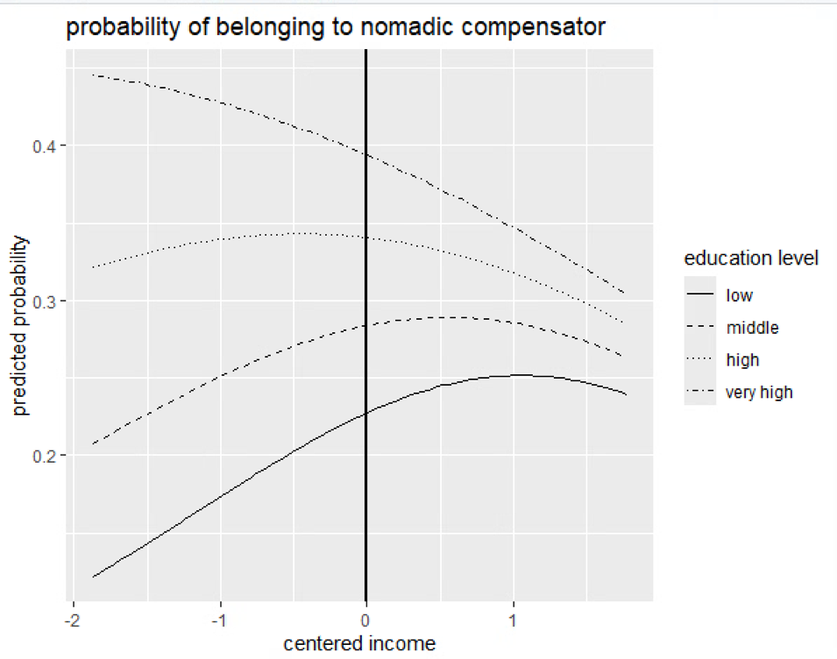
Note. Centered income ranged from -1.87 to 1.77. The solid line at x = 0 represents the mean income level.

Figure 5 shows that income decreased the probability of belonging to “nomadic compensators” for households with higher levels of education. In contrast, income increased the probability of belonging to “nomadic compensators” for households with lower levels of education. That said, it is noteworthy that the interaction is small relative to the interactions in predicting the probability of belonging to low (B = 0.114, z-score = 3.526) and high consumers (B = -0.111, z-score = -2.561) in the main text. Another point to note is that households in which their education level is missing are small households with elderlies. Thus, the interaction in the Appendix may only exist for younger and larger households.

Appendix E
Model Selection
In LPA, various models can be specified in terms of how variances (varying or equal) and covariance (varying, zero, equal) can be estimated. Since models with highly complex model specification (e.g., allowing variance of all indicators to vary and covariance to be non-zero) were unstable particularly as k goes up, it was difficult to find the optimal number of classes with such complex model specification. Therefore, we opted for a stepwise approach to determine which of the variances of the indicators should be varied. We first focused on the selection of the optimal number of profiles based on the most parsimonious model with respect to the variance matrix assumptions. Upon selection, we then started relaxing the variance assumption for one indicator at a time to determine whether freeing a specific indicator can improve the substantial model fit. In the end, we selected the five-profile model with varying variance in fish, flights and public transportation for further substantive analyses.
Step 1: Selecting the Reference Model
The first step was to select the optimal number of profiles based on the most parsimonious model. The selected model was served as a reference model to determine whether models with the same number of profiles, but more complex model specifications improved the model fit substantially. To select the reference model, we first ran ten models with the most parsimonious model specification, that is, one that assumes all indicator variances to be equal across profiles and the covariances to be zero. We then assessed the model fit based on the BIC scores of the ten models.
Since statistical research indicates that the BIC may overestimate the optimum number of profiles (69), we used the common ‘elbow method’ rather than selecting the model with the lowest absolute BIC value. Figure 6 provides the BIC scores for all fitted models in the analysis.
Figure 6
BIC Scores for the EEI Model with Number of Profiles Varying from 1 to 10
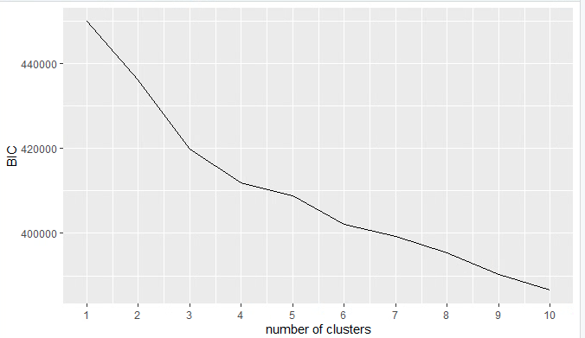

Figure 6 shows that the greatest decrease in BIC value was from two to three classes and from five to six classes. Thus, solutions with three or six profiles provided the best goodness of fit statistically. However, in addition to statistical goodness of fit, the final selection of the number of profiles depended on other considerations, such as the distinctiveness of profiles and whether additional profiles provide new theoretical insights. Because of the exploratory nature of our study, we examined models with the number of classes ranging from three to six and interpreted the results of all four models. Upon interpretation of the results, we concluded that the five-profile model was the most optimal one for further analysis.
First, the classification for the three-profile model was overly simplistic, as it only demonstrated that some households had relatively high consumption, while others slightly lower consumption. It is likely that the three-profile model grouped together smaller profiles, obscuring potentially valuable subgroups. Similarly, the four-profile model did not include an overall “high consumers” profile that existed in other model solutions, which was conceptually distinct and interesting profile to include in the analysis.
In contrast to the limited classification of the three-profile model, the six-profile model was too fragmented with unbalanced profile proportions. The six-profile model further distinguished two high consumption profiles that were qualitatively similar but deviated slightly on certain consumption domains. Since the additional profiles did not add a substantively meaningful and sufficiently large profile, we concluded that the six-profile model was not ideal.
In comparison to the other models, the five-profile model was the most parsimonious model, with interesting theoretical insights and balanced profile proportions. Therefore, we selected the five-profile model as the reference model for further model comparisons.
Step 2: Model Comparison
Next, we ran 11 models, each relaxing the equal variance assumption for one specific indicator. These models were compared against the reference model to evaluate whether the drops in BIC and AIC are substantiative. We concluded that the model was stable when we obtained consistent results more than three times. The results presented below are all based on models using 300 iterations for each of 50 random starting values.
To determine whether the drop in BIC /AIC is significant, we compared the individual decrease/increase across the models. Figure 7 illustrates the BIC and AIC for the reference and 11 models.
Figure 7
BIC and AIC Scores of the Reference Model and the 11 Models
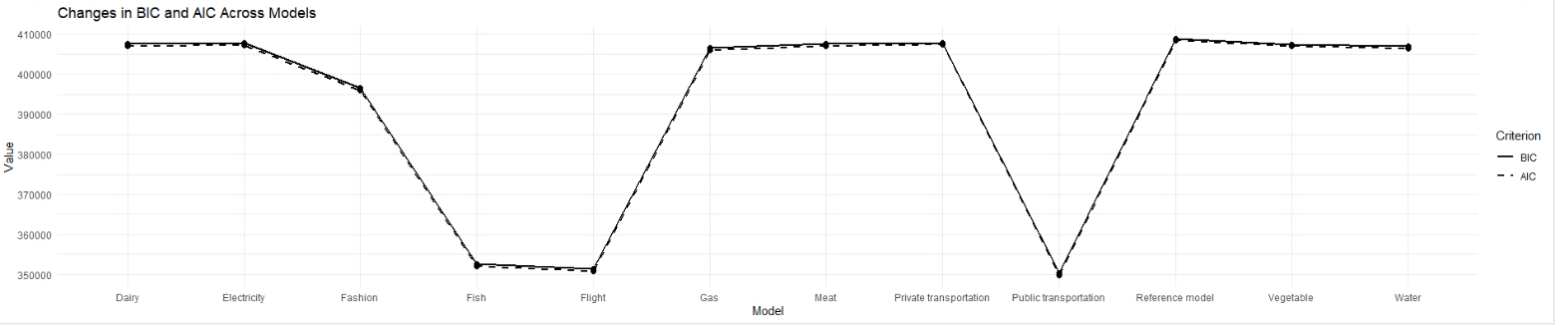

Figure 7 shows that the greatest decrease in BIC and AIC values was in the models that relaxed the equal variance assumption in the expenditures on fish, flight, and public transportation. Table 6 documents the BIC scores and the rate of change of BIC scores with increasing no. of profiles. Thus, we constructed a final model by relaxing the variance on fish, flight, and public transportation expenditures simultaneously. We obtained a final model by using 300 iterations for each of 50 random starting values.

Table 6
BIC scores for LPA with k Ranging from 1 to 10
Profile | BIC | ΔBIC (in%)
1 | 449988.235 | /
2 | 436063.203 | -3.09%
3 | 419739.345 | -3.74%
4 | 411900.087 | -1.87%
5 | 408910.349 | -0.73%
6 | 402157.193 | -1.65%
7 | 399353.504 | -0.70%
8 | 395448.374 | -0.98%
9 | 390406.818 | -1.27%
10 | 386559.713 | -0.99%
Note. ΔBIC represents the change in BIC score when moving to a model with k + 1 profiles, compared to the model with k profiles. It is calculated as $BIC= \frac{{BIC}_{k+1}-{BIC}_{k}}{{BIC}_{k}}$. A negative $BIC$ indicates a better model fit (e.g., a two-profile model is better than a one-profile model), and a positive $BIC$ indicates a worse model fit (e.g., a ten-profile model is worse than a nine-profile model.
Appendix F
Expenditures in Unstandardised Monetary Amounts across Domains and Profiles
Table 7
Distribution of Unstandardised Monetary Amounts across Profiles
Indicators | Consumption Profiles
 | Low consumers | High consumers | Nomadic  compensators | Local-based foodies | Average  consumers
Profile proportion | 27% | 12% | 31% | 18% | 12%
Meat | 370.12 | 440.62 | 280.40 | 382.27 | 271.46
Fish | 0 | 210.41 | 0 | 140.05 | 73.49
Dairy | 190.47 | 297.11 | 192.98 | 232.56 | 185.75
Vegetable | 213.36 | 357.77 | 216.59 | 273.01 | 217.46
Fashion | 660.53 | 1021.59 | 833.2 | 768.02 | 763.45
Flights | 0.02 | 193.86 | 164.78 | 0.03 | 135.54
Private  transportation | 642.10 | 952.52 | 745.05 | 704.59 | 623.81
Public transportation | 0.0015 | 28.13 | 26.02 | 0.002 | 23.49
Electricity | 294.83 | 346.32 | 283.56 | 296.85 | 247.51
Gas | 548.74 | 647.35 | 558.13 | 535.35 | 425.93
Water | 125.62 | 137.26 | 133.76 | 121.57 | 104.98

Appendix G
Distribution of SES and Control Variables across Profiles
Table 8
Distribution of SES and Control Variables across Profiles
 | Profiles
Variables | Low Consumers | High Consumers | Nomadic  Compensators | Local-based foodies | Average consumers
Centered income M (SD) | 0.34 (0.79) | 0.13(0.68) | -0.20(0.62) | -0.03(0.66) | -0.01 (0.75)
Education
Low | 7.02% | 3.48% | 4.33% | 7.87% | 4.39%
Medium | 25.60% | 11.59% | 16.17% | 21.48% | 16.22%
High | 21.53% | 24.06% | 25.84% | 21.44% | 26.86%
Very high | 10.19% | 20.41% | 20.79% | 12.34% | 23.09%
NA | 35.56% | 40.46% | 32.87% | 36.87% | 29.45%
Degree or urbanisation
Not urbanised | 10.43% | 6.61% | 7.53% | 11.03% | 8.50%
Hardly urbanised | 25.68% | 18.32% | 18.92% | 24.22% | 20.44%
Moderately  urbanised | 19.15% | 18.84% | 17.02% | 18.90% | 18.19%
Strongly  urbanised | 30.71% | 33.39% | 33.37% | 32.28% | 33.33%
Extremely urbanised | 14.04% | 22.84% | 23.16% | 13.58% | 19.54%
Household ownership
Rented  property | 28.28% | 17.79% | 27.98% | 21.94% | 15.93%
Owned property | 71.72% | 82.20% | 72.02% | 78.06% | 84.07%
No of children in a household
0 | 78.61% | 94.49% | 83.13% | 80.56% | 71.06%
1 | 9.70% | 3.19% | 8.30% | 8.99% | 11.82%
2 | 9.47% | <2% | 7.10% | 7.79% | 13.68%
3-7 | 2.22% | <1% | 1.47% | 2.66% | 3.43%

Table 8 (Continued.)
Variables | Low Consumers | High Consumers | Nomadic  Compensators | Local-based foodies | Average consumers
No of teenagers in a household
0 | 89.26% | 94.38% | 89.24% | 87.66% | 81.25%
1 | 7.46% | 4.29% | 7.46% | 8.25% | 12.33%
2-3 | 3.28% | 1.33% | 3.29% | 4.09% | 6.42%
No of adults in a household
0 | 15.07% | 20.35% | 11.48% | 19.48% | 11.66%
1 | 30.40% | 28.58% | 34.66% | 22.06% | 15.48%
2 | 45.52% | 20.70% | 44.58% | 47.71% | 56.98%
3-6 | 9.01% | 10.38% | 9.29% | 10.76% | 15.88%
No of elderlies in a household
0 | 89.42% | 86.49% | 91.86% | 88.62% | 93.64%
1 | 10.58% | 13.51% | 8.14% | 11.38% | 6.36%
Note. In accordance with CBS confidentiality guidelines, which require a minimum of 10 unweighted observations per cell, values based on fewer than 10 observations are reported as “<2%” or “<1%” to prevent the identification of households.

The elbow method relies on a visual inspection of a plot that shows how BIC changes as a function of the number of profiles and on selecting the ‘best’ number of profiles at the elbow(s) in the plot, that is, the point in which the decrease in BIC becomes notably smaller.
As a precaution against depending on a local maxima, that might lead to a false solution instead of a global maxima, many different parameter start values were used for many iterations in multiple runs of the analysis to verify that the same, optimal solution was reached (70).

