Circulating tumor DNA and Response Evaluation Criteria In Solid Tumors: ctDNA-RECIST proof-of-concept in HER2-positive metastatic breast cancer

Alessandra Fabi et al.

SUPPLEMENTARY METHODS
Patient Population details
Additional enrolment criteria were a left ventricular ejection fraction ≥50% on echocardiography or multiple-gated acquisition (MUGA; RRID:SCR_014072) scanning, an Eastern Cooperative Oncology Group performance status (ECOG-PS) of 0 or 1, a life expectancy >12 weeks, and adequate hematologic and end-organ function. Exclusion criteria included prior treatment with T-DM1; symptomatic central nervous system metastases, or treatment for these metastases within the last 2 months; history of symptomatic congestive heart failure or serious cardiac arrhythmia requiring treatment; history of myocardial infarction or unstable angina within the last 6 months; other prior malignancy, except for non-melanoma skin cancer and carcinoma in situ (of the cervix or bladder), unless diagnosed and/or successfully treated >5 years prior to accrual, and with no evidence of disease; any other comorbidity (including psychiatric illness) that could impair study participation or preclude informed consent; pregnant or lactating females; current or recent (i.e. in the last 4 weeks) participation in any interventional study.

Toxicity management
Dose delays, reductions, and discontinuation were as follows: the first dose reduction was to 3.0 mg/kg and the second one to 2.4 mg/kg (dose escalation was not allowed after a dose reduction). If a toxic event did not resolve to grade 1 level or baseline status within 42 days after the most recent dose, treatment was discontinued.

cfDNA pre-analytical processing
Blood was prospectively collected in K₂EDTA vacutainers, processed within 30 min by the so-called 2-spin protocol, and stored in single-use aliquots at -80°C until shipment (in dry ice) to the GIM21 central lab for testing. Circulating cell-free DNA (cfDNA) was purified by the QIAmp ctDNA kit (Qiagen), quantitated with Qubit, and retrospectively assessed by Next Generation Sequencing (NGS) and digital PCR (dPCR).

SUPPLEMENTARY RESULTS
cPD cut-off and study workflow
The number of patients with a cPD-compliant ctDNA increase was explored across wide Δ_{ctDNA} ranges (% change from ≥10% to ≥100%) including the default RECIST 1.1-like ≥20% cut-off value (Fig. S1). Since most Δ_{ctDNA} changes exceeded default value by far, numbers of cPD positives were either minimally or marginally affected (n. 1 and 3 patients cPD-less at ≥50% and ≥100% cut-offs). Therefore, a wide cut-off confidence interval allows for robust cPD assignment in the GIM21 study.
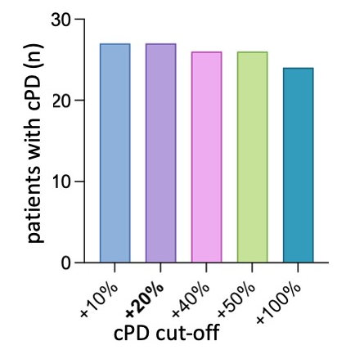
Fig. S1. cPD scoring criteria and study workflow. Impact of the stringency of cPD scoring criteria (cut-off range of variation displayed) on the number of cPD-positives.

Circulating genomic alterations
Targeted NGS at T₀ and/or T₆ and/or T_{p} from the entire dataset of 38 ctDNA-positive patients revealed circulating genomic alterations (n=54, of which 47 SNVs and 7 CNVs from 16 distinct genes) in 496 blood drawings. Alterations were 1 to 5 (median 2) per patient (Fig. S2a). Some alterations recurred in more than one patient, resulting in longitudinal monitoring of 78 mutational hits, e.g. 78 target ctDNAs altogether. ERBB2 was the only gene displaying both SNVs and CNVs. All 47 SNVs and 3 CNVs (HER2, MYC, and FGFR1) were monitored by bespoke digital PCR (dPCR), whereas NGS remained the sole testing method for the remaining 4 CNVs (CCND1, CCND2, CDK4, and FGFR3). Of 78 target ctDNAs, 72 were present at either or both T₀ and T_{p}, and were distributed as follows: 15 (20.8%) at T₀ only, 13 (18.1%) at T_{p} only, and 44 (61.1%) at both T₀ and T_{p} (Fig. S2b and c). Alterations exclusively detectable at T_{p} were tested retrospectively, and would have been missed by real-time prospective testing. Raw ctDNA measurements are provided in an annotated spreadsheet as Table S2. A single SNV (not shown in the Oncoprint) was associated with Clonal Hematopoiesis of indetermined Potential (CHiP), as confirmed by dPCR testing of genomic DNA from white blood cells.
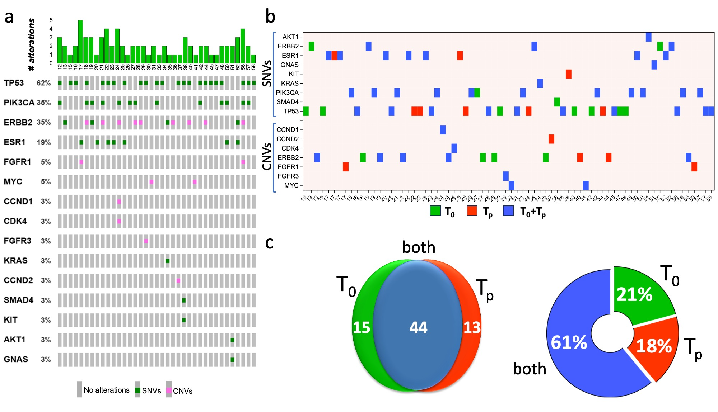
Fig. S2. Circulating genomic alterations during T-DM1 treatment. (a) Oncoprint of the 38 ctDNA-positive GIM21 patients, showing the number and gene distribution of genomic alterations (SNVs and CNVs) per patient. (b) SNVs and CNVs detectable at baseline (T₀), progression (T_{p}), or both, listed by gene. (c) Venn diagram and donut chart of the 72 mutational hits (out of 78 hits in total) detected at either or both T₀ and T_{p}.

From 56% to 85% of all mutation hits (depending on type and timing) were actionable at OncoKB level 1 (Fig. S3a and b). Due to opposing trends of different ctDNA species, overall ctDNA abundance (both SNVs and CNVs) was conserved between T₀ and T_{p} (Fig. S3b). Altogether, these results demonstrate extensive dynamic changes in oncogenic drivers during treatment.
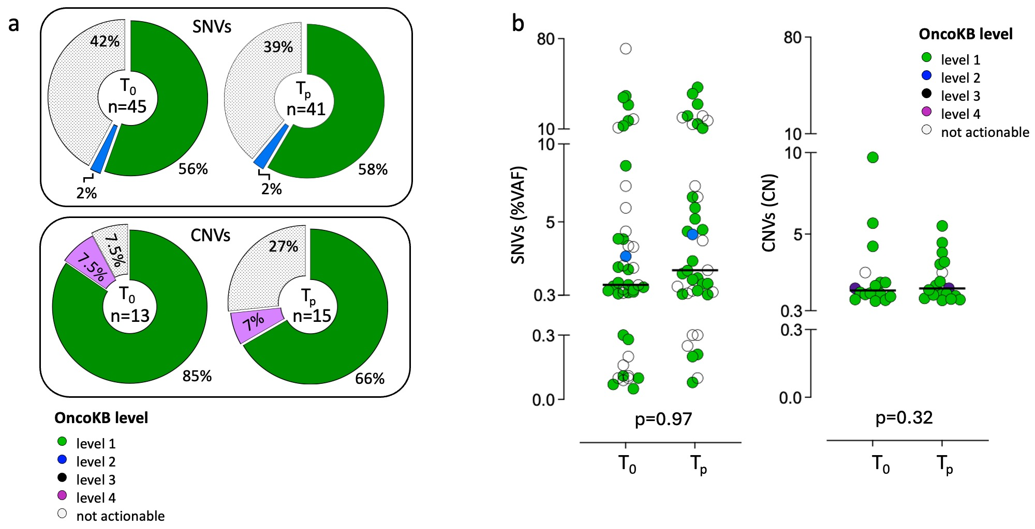
Fig. S3. Actionable genomic alterations during T-DM1 treatment. SNVs and CNVs in the blood of 38 ctDNA-positive patients classified by: (a) Pie chart of OncoKB level; and (b) dot plots of OncoKB level plus abundance (VAF and copy numbers), separately calculated at T₀ and T_{p}. Differences at t test non-significant.

Technical validation of ctDNA testing
To exclude trivial errors, technical validation was two-fold: (a) orthogonal NGS/dPCR testing, and (b) dPCR re-testing. Orthogonal testing was carried out on blood obtained at T₀. All SNVs called by NGS were confirmed by dPCR (47/47, 100%). Variant Allele Frequency (VAF) was remarkably concordant in 32 paired determinations, as shown by regression analysis (Fig. S4a, top: R²=0.98; 95% CI 0.95 to 1.06; beta coefficient 1.006), highlighting reproducibility

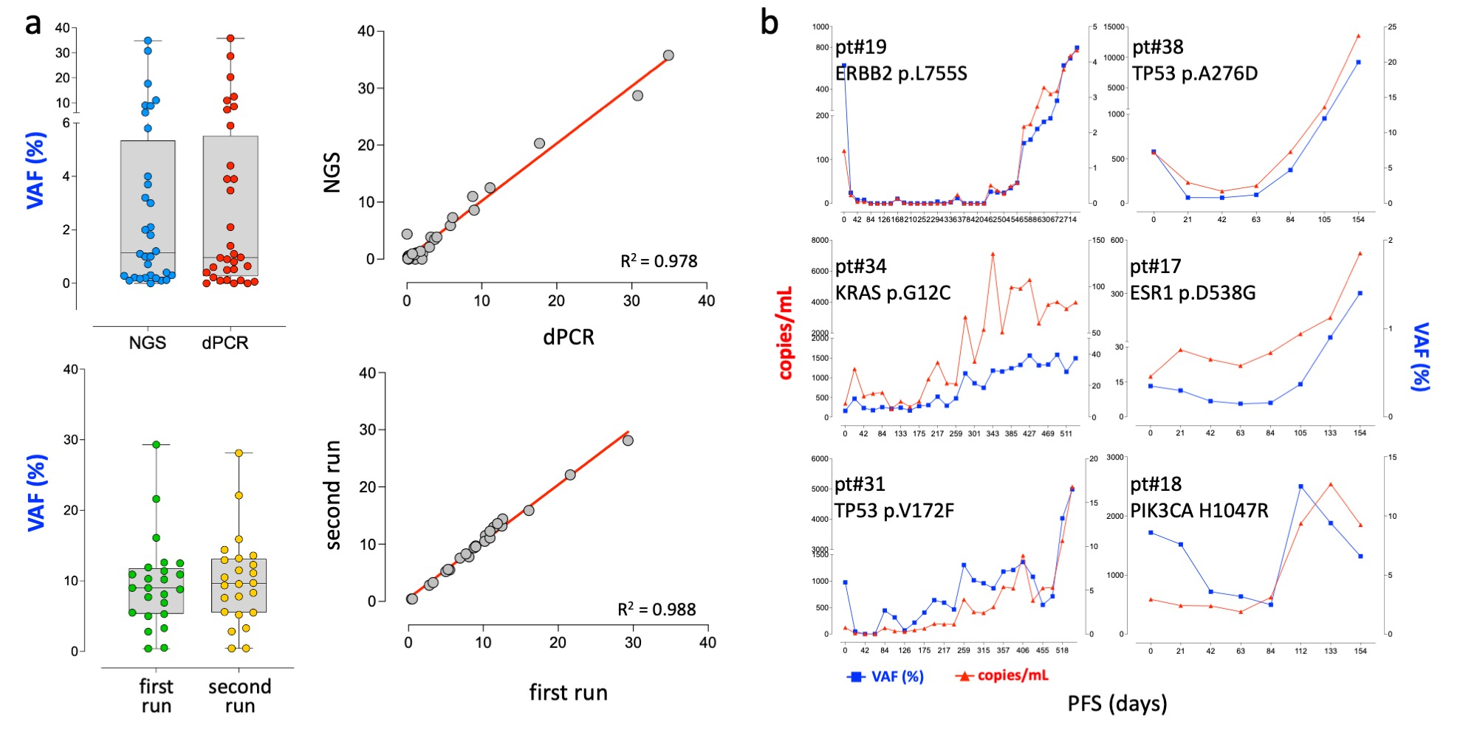
Fig. S4. dPCR accuracy, reproducibility, repeatability and preferred metric. (a) Top left: scatter plot of VAF values (raw data) detected by NGS/dPCR orthogonal testing of 32 representative cfDNAs collected at T₀. Next: regression analysis of the same data after NGS/dPCR pairing. Bottom left: scatter plot of VAF values (raw data) detected by repeated (first run vs second run) dPCR testing of 24 cfDNAs. Next: regression analysis of the same data (paired VAF values). (b) Metric comparison: ctDNA trajectories (VAF vs copies/mL) of serial dPCR testing from 6 representative patients.

in ctDNA measurements between different assays. dPCR repeatability was assessed by testing twice a randomly selected subset of 23 cfDNA samples. After the first testing round, cfDNAs were frozen again at -80°C, thawed 730 to 1278 days (median 1003 days) later, and re-tested using distinct aliquots of the same custom-designed primers and assays, and the same dPCR equipment, but with newly prepared dPCR amplification mixes.
Also in this case VAF values were essentially superimposable (R²=0.99; 95% CI 0.95 to 1.04; beta coefficient 0.991; Fig. S4a, bottom). Thus, inter-assay (NGS vs dPCR) and intra-assay (dPCR repeats) testing results were in excellent agreement for both SNVs and CNVs (not shown), showing that dPCR was accurate, reproducible, and repeatable enough to make duplicate testing unnecessary. dPCR repeatability, supported by robust digital microchip reading of up to 20.000 replicate nanowells and Poisson distribution analysis, as well as moderate cost, led to dPCR selection for systematic testing.

Identification of VAF and CN as the optimal cRECIST data inputs
SNVs may be measured by either copies/mL or Variant allele frequency (VAF), e.g. in absolute and relative (to the WT allele) units, respectively. In a subset of 12 patients, recruited at the Principal Investigator’s site, ctDNA testing was intensive, in that it was carried out at each T-DM1 cycle even after T₃ (w3 schedule instead of w3/w9), resulting in a more detailed ctDNA timeline. This data-dense subset was selected to compare ctDNA trajectories. Plotting copies/mL vs VAF revealed similar trajectories, but in at least some cases plots were less variable for VAF than copies/mL (representative results in Fig. S4b). Due to smoother ctDNA trajectories, VAF was selected as the primary data source for cRECIST scoring.

Divergent trajectories: target lesions vs target ctDNAs
For a detailed longitudinal point-by-point (T₀ to T_{p}) evaluation of the individual trajectories of all 113 tumor lesions and 78 target ctDNAs, lesion diameters and Δ_{ctDNA} values were elaborated as follows. Default RECIST 1.1 upper and lower cut-offs discriminating SD/cSD from PD/cPD and CR/cCR respectively (≥20% and ≤30%, see Fig. 1) were applied to each tumor lesion and ctDNA species, and relative changes were scored between consecutive time points (T_{n} vs T_{n-1}). For consistency between tumor and ctDNA, only default cut-offs were applied. One of 5 possible responses was noted at each time point, e.g. increase, decrease, no change, gain (de novo appearance) and loss (disappearance). Responses were color-coded consistently between lesions and ctDNAs, and displayed as timelines and donut charts. Timeline comparison (particularly from pts # 52, 17, 40, 16, 20 and 22) revealed that, compared to lesion diameter, changes in Δ_{ctDNA} values were more numerous, frequent, discordant, asynchronous and extreme, including occasional direct switch from loss to gain at immediately consecutive time points (Fig. S5a). Accordingly, presence of more than one change in a timeline was observed in only 33% of tumor lesions, but in 69% of ctDNAs. Viceversa, stability (no change exceeding cut-offs) was seen in 35% of tumor lesions but 8% only of ctDNAs (Fig. S5b).

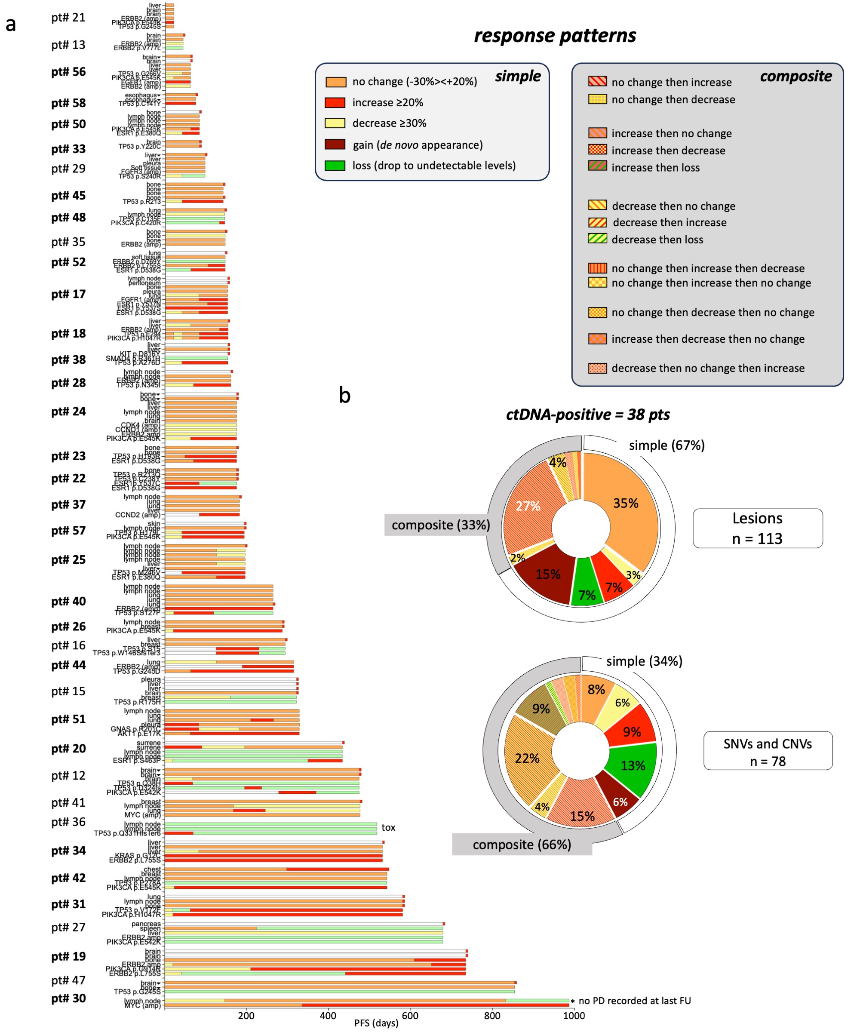
Fig. S5. Response patterns of circulating genomic alterations during T-DM1 treatment. (a) Paired timelines (individual tumor lesions, top; individual ctDNAs, bottom) displaying in succession one of five possible responses (color-coded and defined in the top left box). Identical response cutoffs (≥20%; ≤30% and undetectable) were applied to score tumor lesions and ctDNAs from the 38 ctDNA-positive patients. Responses at any given time point were calculated relative to the time point immediately before (T_{n} vs T_{n-1}). All 38 ctDNA-positives are shown; the 27 cPD-positive patients are boldface. Non-target tumor lesions are marked by a triangle. pt#36 discontinued T-DM1 due to toxicity (tox) while in complete response (both clinical and ctDNA). * pt#30: exceptional responder, still cPD⁺/PD⁻ at last follow up. (b) Donut charts enumerating simple and composite response patterns (defined in top grey boxes). Simple and composite patterns are coded by solid and stippled colors, the latter generated by combining the colors of the simple responses contributing to the observed composite pattern.
Donut charts also provide synoptic evidence for roughly reciprocal abundance of simple and composite (more than one change in the timeline) response patterns in tumor lesions (67% and 33%) vs ctDNAs (34% and 66%).

In summary, evolutionary divergence of ctDNA variants largely exceeded dissociated radiological responses among tumor lesions measured by CT scans. Conversely, stable disease was rare from the ctDNA standpoint.

Exploring a range of cSD/cPD and cSD/cPR scoring cut-offs: impact on cRECIST timelines, and cOR/best cOR assignments.
Cut-offs between ≥20% and ≥50% for cSD/cPD, and between ≤30% and ≤60% for cSD/cPR minimally affected the timelines, pie charts and Pearson’s matrices of Fig. 3 (compare Fig. S6 to Figs. S7-S9). Cut-offs had to be raised to ≥100%/≤100% to observe similar OR and cOR profiles resulting from drastic quenching of ctDNA progression/response, and hence increased cSD representation in the dataset. For instance, at these cut-offs cPD was completely missed in three patients, delayed slightly in one (pt 38) and delayed considerably (coincident with PD) in two (pts. 50 and 40), questioning the added value of ctDNA testing at such extreme cut-offs.

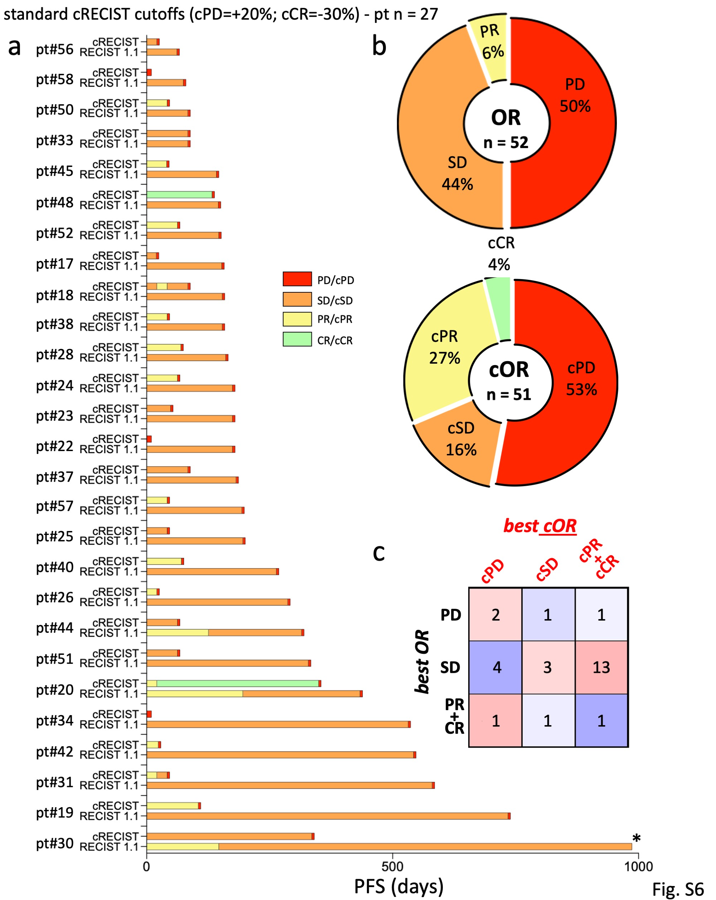
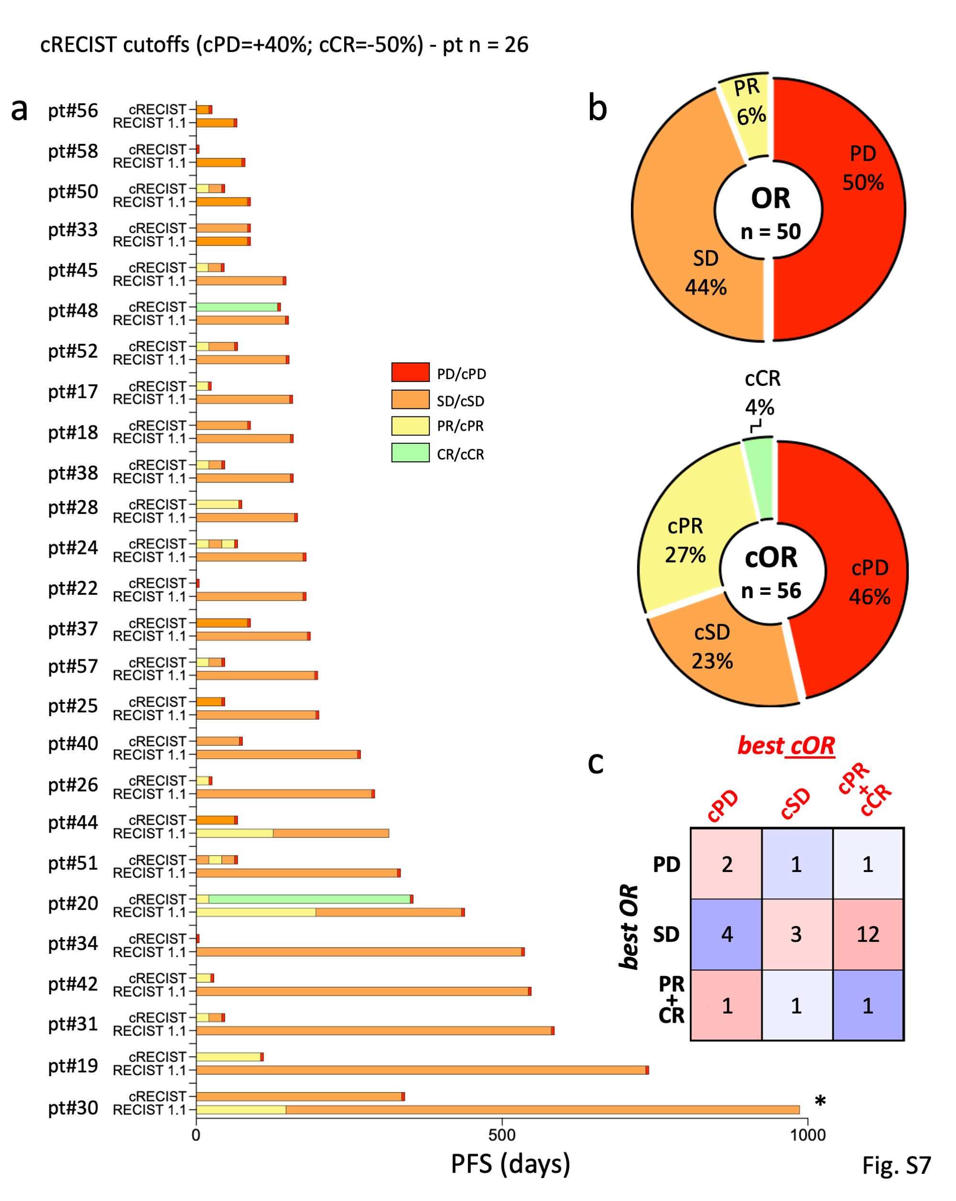

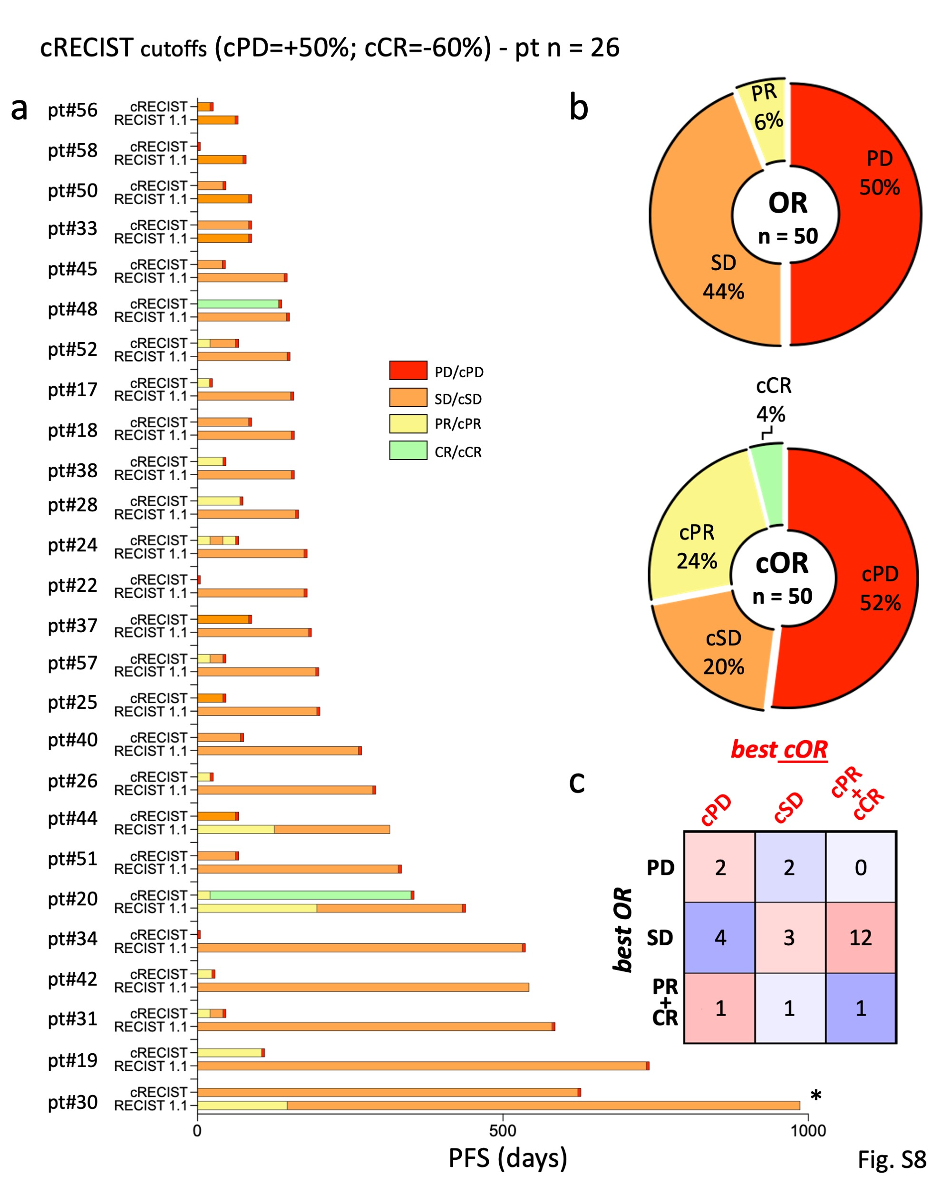

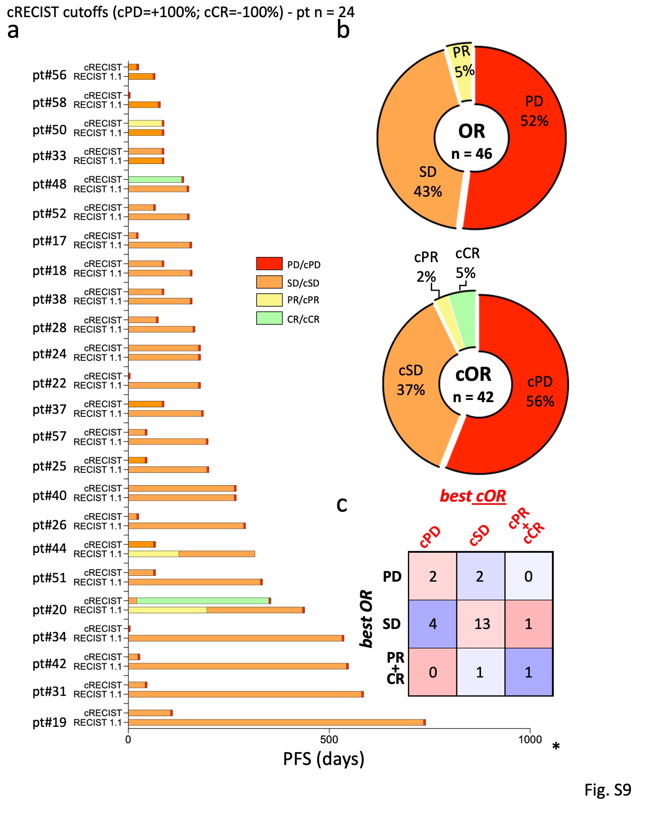

Fig. S6-S9. ctDNA amounts and outcome Effect of the stringency of cPD/cCR scoring criteria on the timelines, pie charts and Pearson’s correlation matrix presented in Fig. 3 (see legend). Results with default cut-offs are presented first (Fig. S6 is a replicate of Fig. 3), and then 3 simulations (S7-S9) are provided at the indicated, progressively more stringent upper and lower cSD cut-offs.

ctDNA amounts and outcome
Correlations with outcome were explored by comparing patients differing in absolute ctDNA levels and their dynamic changes. These were measured by diverse, continuous and discontinuous (cRECIST) variables. Discontinuous cRECIST variables were assessed by applying both default and more stringent cut-offs discriminating cSD from cPD and cPR. The following correlations were investigated (Fig. S10): (a and b) PFS in patients with ctDNA amounts (SNVs + CNVs) below study mean vs patients with ctDNA amounts above study mean; PFS in patients with ctDNA amounts (SNVs only) below study mean vs patients with ctDNA amounts above study mean (not shown); (c) PFS in patients with increases in ctDNA trends (T_{p}>T₀) vs patients with decreases (T₀>T_{p}); (d and e) PFS and OS in patients with an early objective ctDNA response at T₁ vs patients with no response; PFS and OS in patients with an early objective ctDNA response, as above, but at T₂ and T_{3,} vs no response (not shown); (f-i) PFS and OS in patients with early objective ctDNA response at T₁ (as above) vs no response, different cSD cut-offs; (j) patients with complete early (at T₁) clearance of at least one target ctDNA vs patients with no clearance; (k and l) PFS and LT by time to first increase (any individual ctDNA species); (m, n, o) PFS by early changes in SNV abundance at T₁, T₂ and T₃ vs T₀, calculated by a continuous ΔVAF scale (ratios). In summary, absolute ctDNA levels, the entity of their increase/decrease, and early kinetics did not correlate with the outcomes of either patient subsets or individual patients regardless of cSD cut-offs.

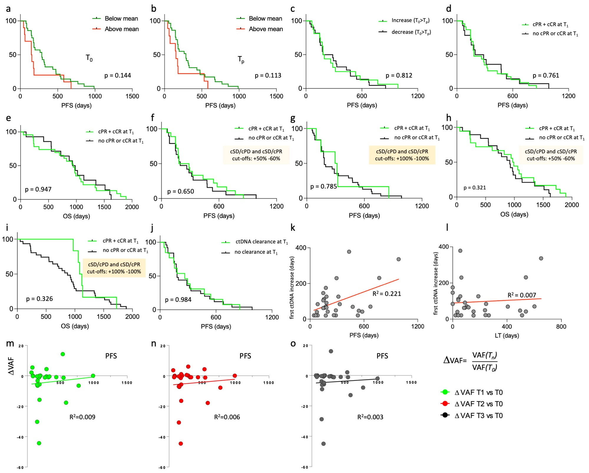
Fig. S10. ctDNA amounts and outcome. Kaplan-Meier and regression plots: outcome (PFS and/or OS as indicated) comparison between patients differing in: (a) absolute ctDNA levels (SNVs and CNVs altogether) calculated at T₀ as follows: Σ[VAF(T₀) + CN(T₀)], below mean vs above mean. (b) ctDNA levels calculated as above but at T_{p}: Σ[VAF(T_{p}) + CN(T_{p})], below mean vs above mean. (c) ctDNA increase vs decrease (means calculated as above), T₀ vs T_{p}. (d) Achievement of an objective response at T₁: responders vs non-responders, PFS. (e) As above, OS. (f; g) As above, PFS, different cut-offs. (h, i) As above, OS, different cut-offs. (j) Complete clearance of at least one target ctDNA at T₁ vs all others. (k) Time elapsed (T₀ to the time of the first recorded ≥20%increase in any individual ctDNA species), plotted vs PFS. (l) Same as above, plotted vs LT. (m) ΔVAF (T₁/T₀) vs PFS. (n) ΔVAF=T₂/T₀ vs PFS. (o) ΔVAF=T₃/T₀ vs PFS. ΔVAF is the ratio of average VAF values (all detectable SNVs). Negative ΔVAF values are possible when ctDNA decreases.

Impact of cPD/cCR scoring criteria on GIM21 metrics and outcome
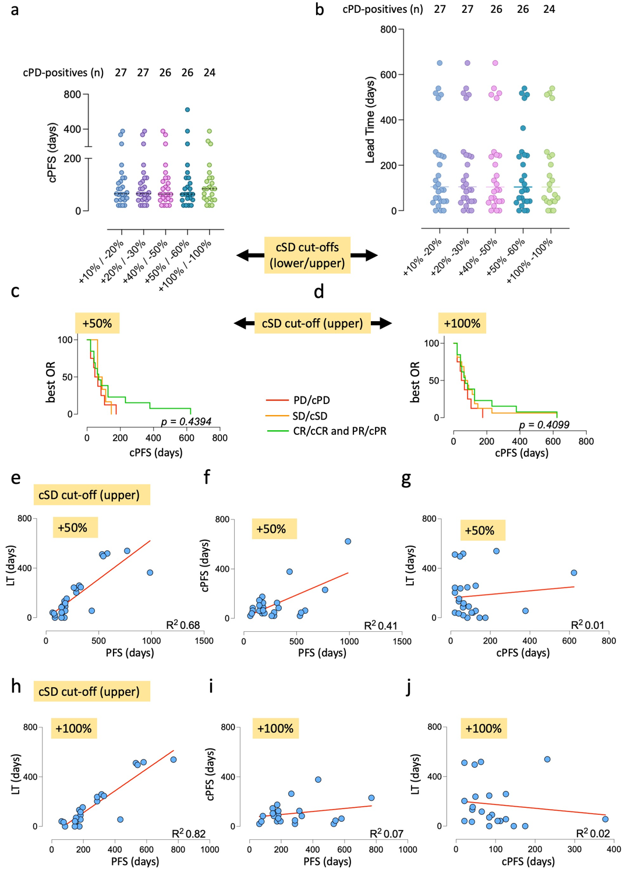
Different cSD upper and lower cut-offs, particularly when within the ≥50% to ≤60% range, had minimal effect on the number of patients scored as cPD-positive, as well as cPFS and lead time (LT), as shown by dot plot comparison (Fig. S11a and b). These changes, despite they were apparently of minor entity, had however a disruptive effect on best OR/PFS correlation (compare Fig. S11c and d with Kaplan Meyer analysis in Fig. 4c), but not on linear regression plots between LT and PFS (see in particular Fig. S11e and h). In summary, the post-cPD period (LT/PFS overlap) appears to be resilient to cut-off changes and to have the strongest impact on outcome in the GIM21 setting.
Fig. S11. cRECIST cut-offs and outcome. The impact of scalar deviations from the default upper and lower cSD cut-offs is evaluated on the following variables: (a, b) the number of patients with cPD, and the duration of cPFS and lead time (LT) visualized by dot plots; means of cPFS and LT are displayed. (c, d) Correlation between best OR and cPFS (same as Fig. 4c). (e-j) Linear regression plots between any two of LT, PFS and cPFS. For definition of the variables see main text.

Only post-cPD Tr correlates with outcome
When the first Tr drop was considered, regardless of its timing (whether before or after cPD), correlation with PFS was poor (Fig. S12 compared to Fig. 5c).

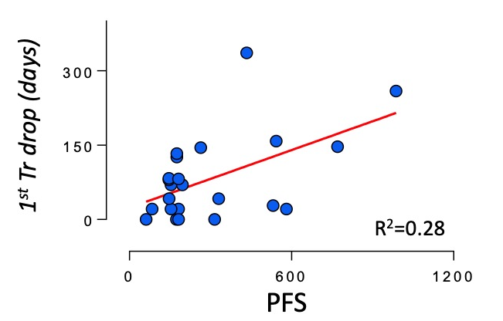
Fig. S12. Tr and outcome
Regression analysis: first observed Tr drop (regardless of cPD) vs PFS.

Table S1
Demographics and clinical pathological features of GIM21 patients

cPD-positive patients (n=27)
Age, years (range) | 57.8 (33-79)
Previous lines of therapy for metastatic disease*
0 | 0
1 | 27
Trastuzumab | 2
Trastuzumab + Chemotherapy | 3
Trastuzumab + Pertuzumab | 3
Trastuzumab + Pertuzumab + Chemotherapy | 18
Dominant Metastatic sites
Lymph Node | 17
Bone | 14
Lung | 11
Liver | 8
Brain | 4
Pleura | 4
Breast | 2
Soft tissues | 2
Number of metastatic sites per patient
1 | 5
2 | 12
> 3 | 10

cPD-negative patients (n=16)
Age, years (range) | 56.3 (41-82)
Previous lines of therapy for metastatic disease*
1 | 16
Trastuzumab | 2
Trastuzumab + Chemotherapy | 3
Trastuzumab + Pertuzumab | 2
Trastuzumab + Pertuzumab + Chemotherapy | 8
Dominant Metastatic sites
Brain | 7
Bone | 6
Liver | 6
Breast | 5
Lung | 4
Lymph node | 4
Pleura | 3
Soft tissues | 2
Number of metastatic sites per patient
1 | 6
2 | 3
> 3 | 7

*Previous lines: Lapatinib plus Capecitabine, Trastuzumab plus Vinorelbine, Trastuzumab plus Carboplatin.

