Development and Validation of a Model for Soil Wetting Geometry under Moistube Irrigation

T.L. Dirwai^{1,2,4*}, A. Senzanje², and t. Mabhaudhi³

¹ Crop-, Soil-, and Climate Sciences, University of the Free State, P.O.BOX 339, Bloemfontein 9300, South Africa
²School of Engineering, University of KwaZulu-Natal, P. Bag X01, Pietermaritzburg, 3209, South Africa
³ Centre for Transformative Agricultural and Food Systems, School of Agricultural, Earth and Environmental Sciences, University of KwaZulu-Natal, Pietermaritzburg, P. Bag X01, 3209, South Africa
⁴ Varmac Consulting Engineers, Scottsville, Pietermaritzburg, 3209, South Africa
*Corresponding author: TLD (dirwaitl@ufs.ac.za)

Correspondence to: TLD (tldirwai@gmail.com)

Appendix I
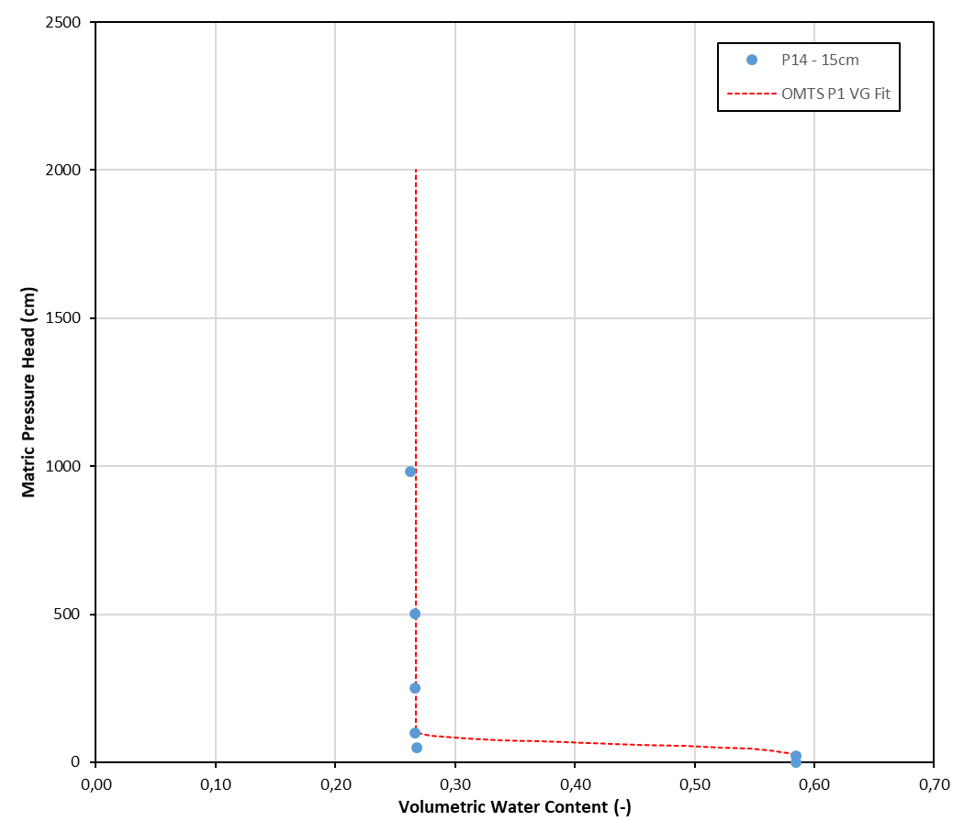
Figure 9 Soil matric – volumetric soil water content conversion chart for the silty clay loam soil

