Supplementary

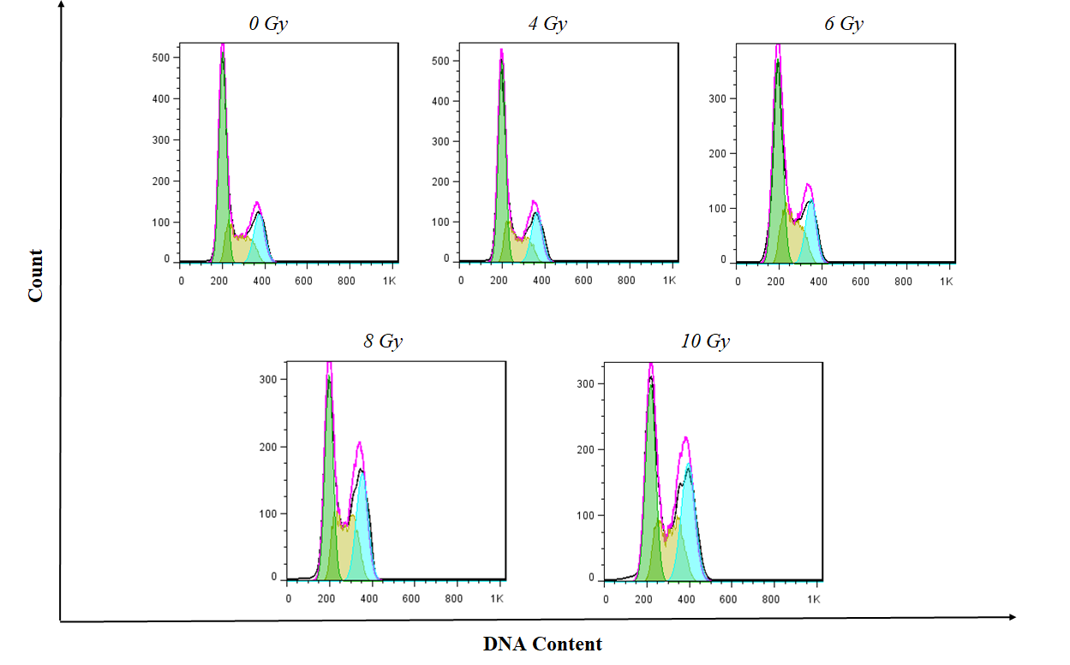

Flow cytometry histogram of different treatment.

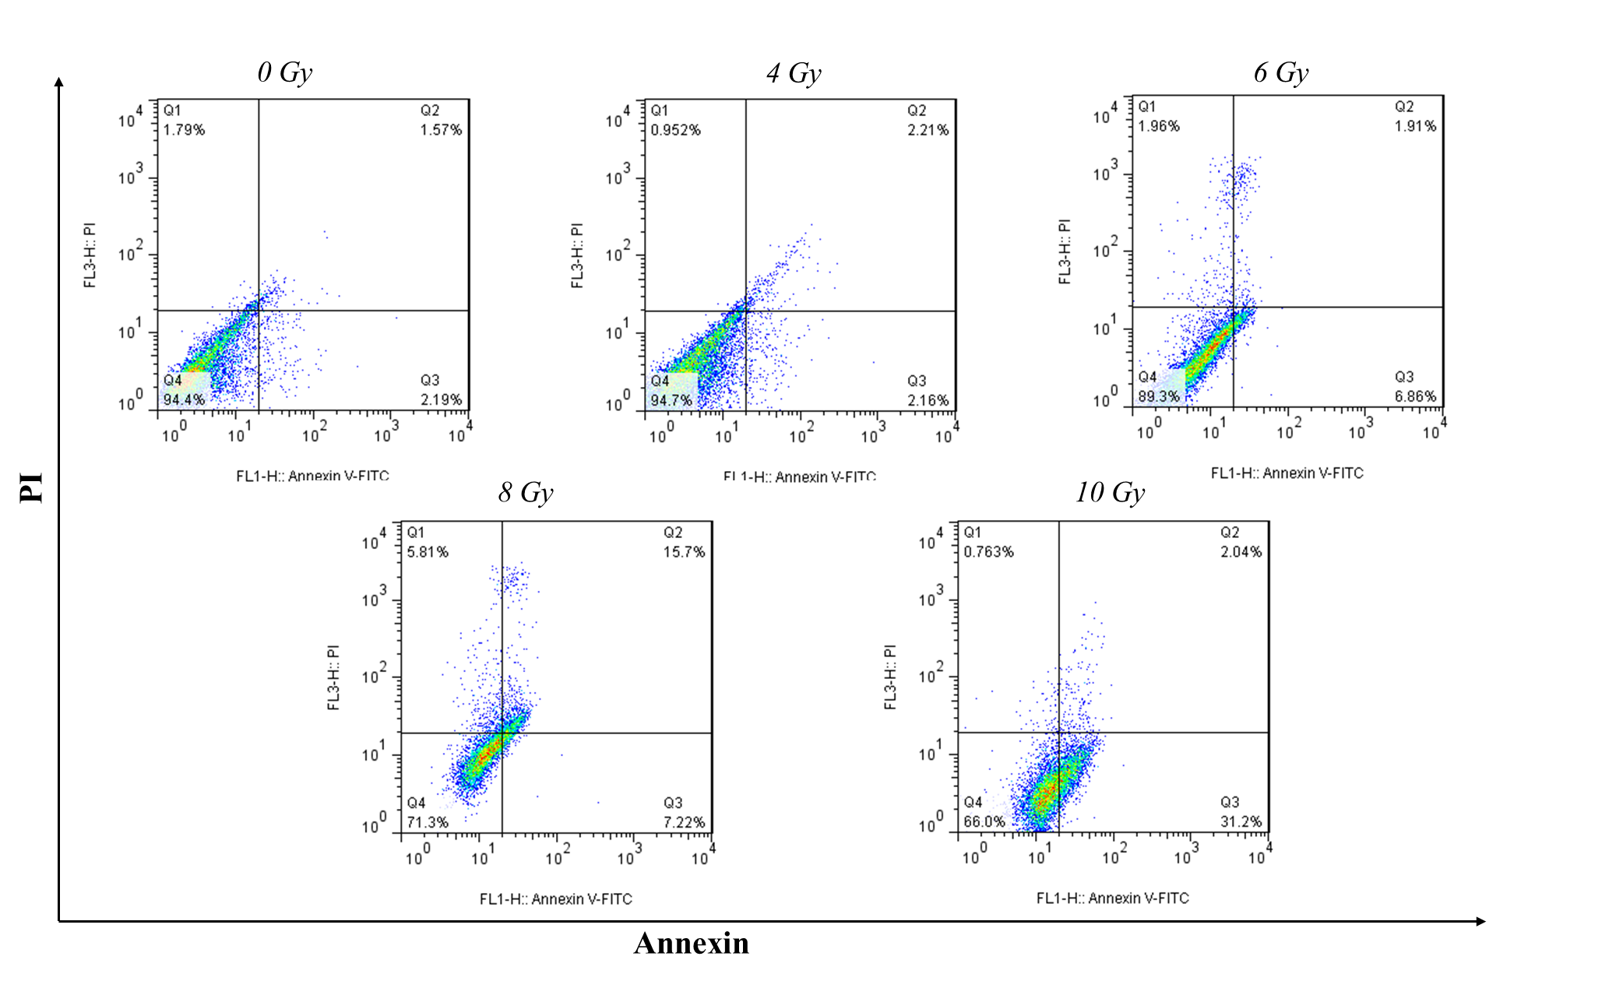

Dot plot of apoptosis assays by Annexin V and PI method in cells cells treated with gamma radiation after 24 h. Q4; live cells, Q3; early apoptosis cells, Q2; late apoptosis cells, Q1; necrosis cells.

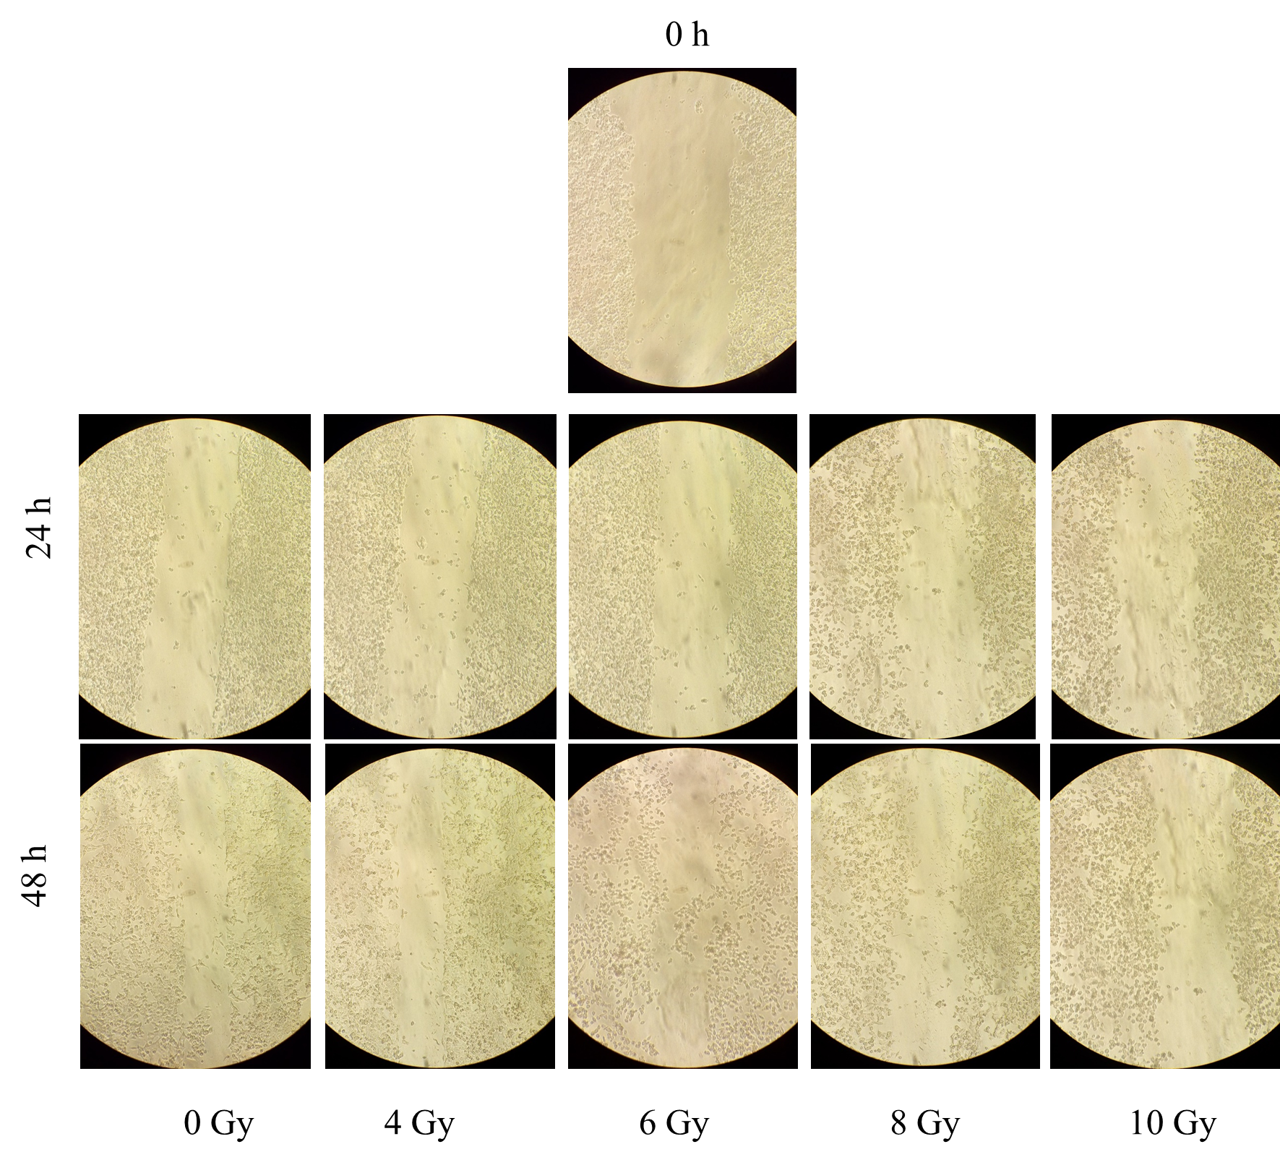
Scratching assay in different times and radiation doses

