Reconciling flood-risk reduction and wetland resilience behind coastal floodgates
Supplementary Information
Alessandro Michielotto^{1,2*}, Alvise Finotello¹, Riccardo Alvise Mel³, Eli D. Lazarus⁴, Luca Carniello⁵, Davide Tognin⁵, Andrea D’Alpaos^{1,*}
1) Department of Geosciences, University of Padova, Padova, Italy
2) Department of Land, Environment, Agriculture and Forestry, University of Padova, Padova, Italy
3) Italian Institute for Environmental Protection and Research (ISPRA), Roma, Italy
4) School of Geography and Environmental Science, University of Southampton, Southampton, United Kingdom
5) Department of Civil, Environmental, and Architectural Engineering, University of Padova, Padova, Italy
*) Corresponding authors
Email: alessandro.michielotto@unipd.it (A. Michielotto); andrea.dalpaos@unipd.it (A. D’Alpaos)

List of Contents
Supplemental Figures
Figure S1: Computational grid. 1
Figure S2: Flooding in Venice. 2
Figure S3: Salt marsh flooding. 3
Figure S4: Floodgate activations during the 2020-2023 period. 4
Supplemental Tables
Table S1: Model efficiency for water level. 8
Table S2: Maximum water level. 10

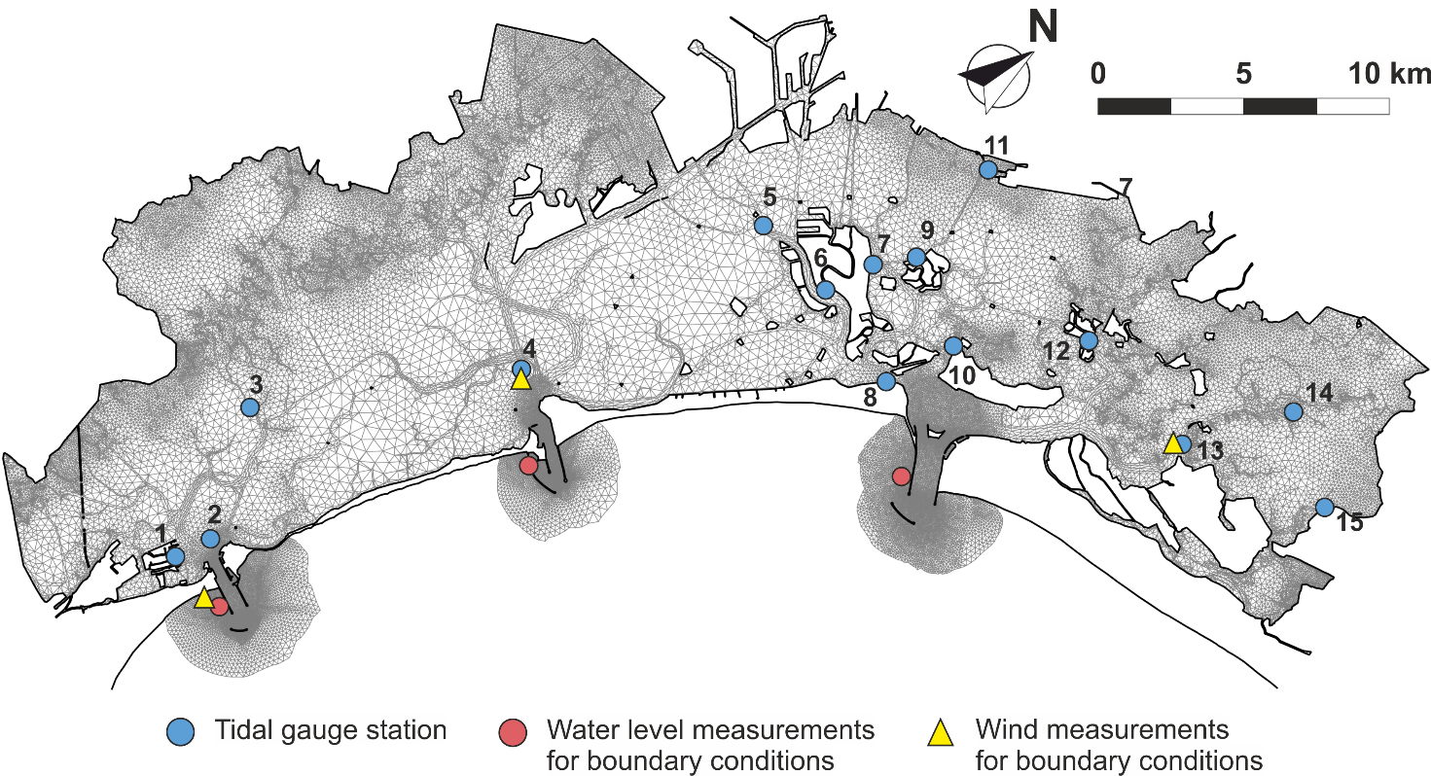
Figure S1: Computational grid. Red circles indicate water level measurement stations adopted as boundary conditions. Yellow triangles indicate wind measurement stations adopted as boundary conditions. Blue circles indicate tide gauges whose measurements are used to test the model (see Tables S1, S2). 1) Chioggia Città. 2) Chioggia Porto. 3) Petta de Bo. 4) Malamocco Porto. 5) San Giorgio. 6) Punta Salute. 7) Misericordia. 8) San Nicolò. 9) Murano. 10) Sant’Erasmo. 11) Tessera. 12) Burano. 13) Laguna Nord – Saline. 14) Canal Ancora. 15) Grassabò.

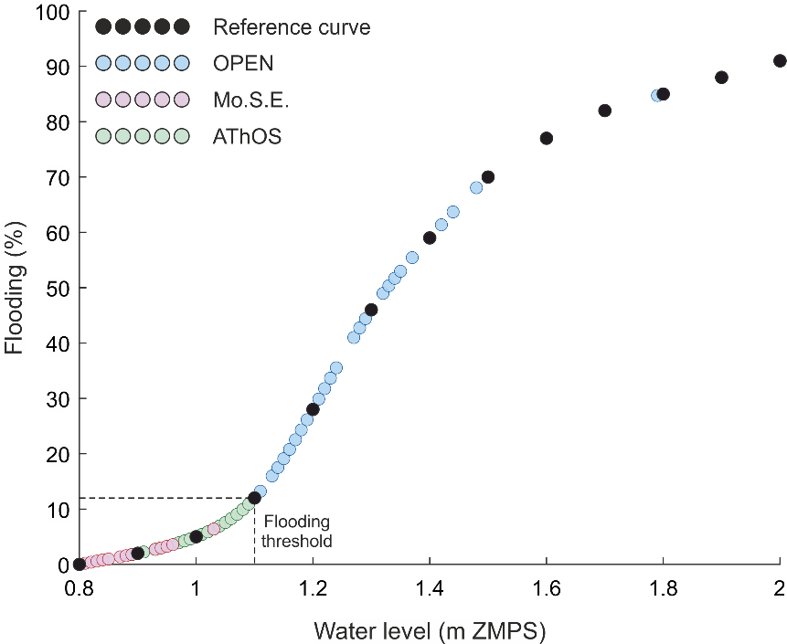
Figure S2: Flooding in Venice. Flooded area of Venice’s historic center as a function of water level during floodgate activations for the Open (blue), Mo.S.E. (red), and AThOS (green) scenarios. Black circles represent reference data from the Centro Previsioni e Segnalazioni Maree (comune.venezia).

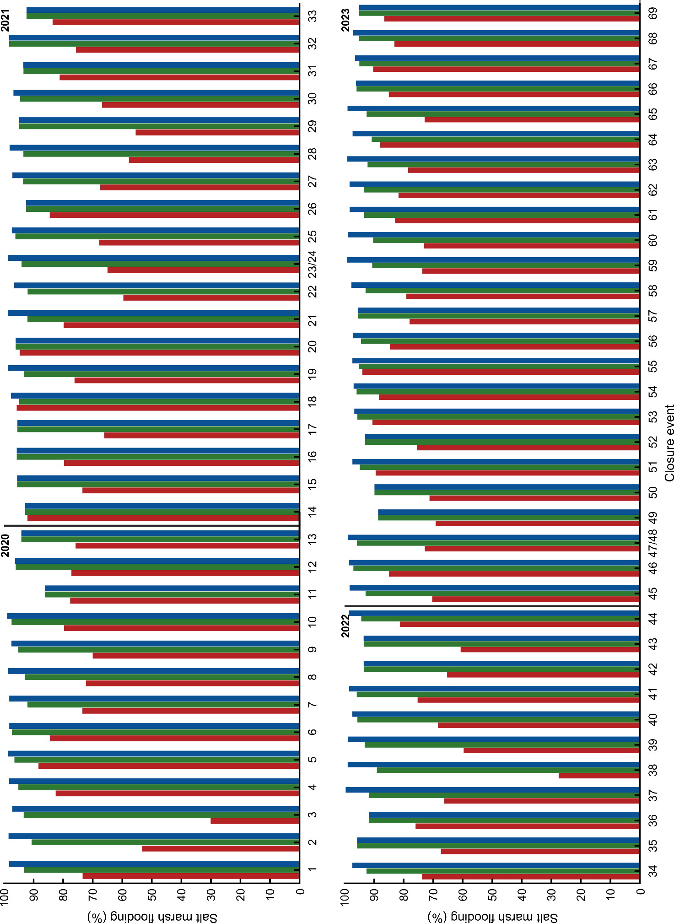
Figure S3: Salt marsh flooding. Salt marsh flooding extent during storm surge events from 2020 to 2023 under the “MoSE” (red), “AThOS” (green), and “Open” (blue) scenarios. Values indicate the percentage of salt marsh area submerged during each event. X-axis values correspond to the sequential number of Mo.S.E. activations over the study period.

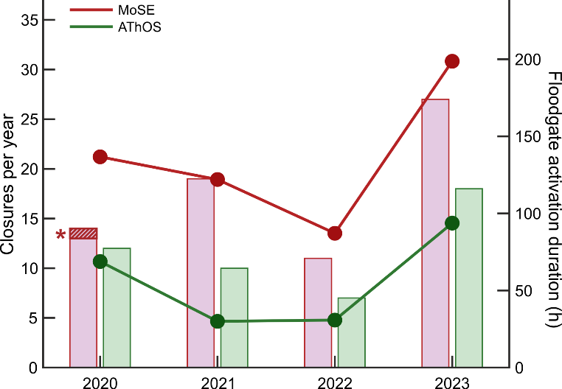
Figure S4: Floodgate activations during the 2020-2023 period. Bar chart shows the yearly number of floodgate activations under the recorded Mo.S.E. operations (red) and the hypothetical “AThOS” scenario (green). Lines indicate the corresponding cumulative duration of closures. [*] On 8 December 2020, the Mo.S.E. system was not activated despite being operational, resulting in the flooding of Venice.

 | Closure |  | MAE |  |  | RMSE |  |  | NSE
 | # | Date | min | max | mean (dev std) | min | max | mean (dev std) | min | max | mean (dev std)
2020 | 1 | Oct 03 | 0.010 | 0.033 | 0.019 ± 0.007 | 0.013 | 0.040 | 0.024 ± 0.009 | 0.796 | 0.992 | 0.922 ± 0.071
2020 | 2 | Oct 15 | 0.018 | 0.055 | 0.003 ± 0.001 | 0.020 | 0.077 | 0.004 ± 0.016 | 0.679 | 0.975 | 0.897 ± 0.007
2020 | 3 | Oct 16 | 0.013 | 0.049 | 0.023 ± 0.007 | 0.014 | 0.082 | 0.032 ± 0.012 | 0.607 | 0.987 | 0.879 ± 0.109
2020 | 4 | Dec 02 | 0.022 | 0.054 | 0.037 ± 0.007 | 0.028 | 0.070 | 0.045 ± 0.009 | 0.739 | 0.980 | 0.851 ± 0.067
2020 | 5 | Dec 04-06 | 0.024 | 0.039 | 0.031 ± 0.005 | 0.030 | 0.050 | 0.038 ± 0.006 | 0.728 | 0.902 | 0.823 ± 0.052
2020 | 6 | Dec 09 | 0.021 | 0.045 | 0.028 ± 0.007 | 0.023 | 0.054 | 0.033 ± 0.008 | 0.705 | 0.967 | 0.892 ± 0.079
2020 | 7 | Dec 10 | 0.011 | 0.038 | 0.024 ± 0.008 | 0.014 | 0.045 | 0.028 ± 0.009 | 0.770 | 0.990 | 0.914 ± 0.056
2020 | 8 | Dec 11 | 0.012 | 0.034 | 0.021 ± 0.006 | 0.015 | 0.039 | 0.025 ± 0.007 | 0.846 | 0.988 | 0.938 ± 0.056
2020 | 9 | Dec 12 | 0.013 | 0.027 | 0.019 ± 0.004 | 0.015 | 0.034 | 0.023 ± 0.005 | 0.719 | 0.929 | 0.879 ± 0.058
2020 | 10 | Dec 28 | 0.017 | 0.031 | 0.024 ± 0.005 | 0.020 | 0.044 | 0.032 ± 0.008 | 0.807 | 0.981 | 0.921 ± 0.064
2020 | 11 | Dec 29 | 0.011 | 0.043 | 0.021 ± 0.009 | 0.013 | 0.046 | 0.026 ± 0.009 | 0.886 | 0.988 | 0.951 ± 0.033
2020 | 12 | Dec 30 | 0.009 | 0.046 | 0.021 ± 0.012 | 0.011 | 0.051 | 0.025 ± 0.013 | 0.904 | 0.998 | 0.972 ± 0.029
2020 | 13 | Dec 31 | 0.016 | 0.047 | 0.025 ± 0.013 | 0.018 | 0.050 | 0.030 ± 0.010 | 0.925 | 0.989 | 0.959 ± 0.023
2021 | 14 | Jan 01 | 0.010 | 0.043 | 0.021 ± 0.010 | 0.011 | 0.046 | 0.023 ± 0.010 | 0.915 | 0.996 | 0.967 ± 0.028
2021 | 15 | Jan 02 | 0.010 | 0.040 | 0.022 ± 0.006 | 0.013 | 0.045 | 0.028 ± 0.007 | 0.748 | 0.984 | 0.855 ± 0.074
2021 | 16 | Jan 23 | 0.014 | 0.027 | 0.019 ± 0.004 | 0.017 | 0.036 | 0.024 ± 0.005 | 0.759 | 0.957 | 0.892 ± 0.058
2021 | 17 | Jan 31 | 0.017 | 0.041 | 0.027 ± 0.007 | 0.024 | 0.065 | 0.035 ± 0.011 | 0.937 | 0.992 | 0.987 ± 0.015
2021 | 18 | Feb 09 | 0.005 | 0.056 | 0.022 ± 0.015 | 0.008 | 0.057 | 0.026 ± 0.014 | 0.909 | 0.998 | 0.975 ± 0.025
2021 | 19 | Feb 10 | 0.018 | 0.052 | 0.031 ± 0.010 | 0.025 | 0.054 | 0.038 ± 0.010 | 0.784 | 0.978 | 0.918 ± 0.052
2021 | 20 | Feb 11 | 0.019 | 0.048 | 0.032 ± 0.009 | 0.023 | 0.051 | 0.035 ± 0.010 | 0.871 | 0.986 | 0.949 ± 0.032
2021 | 21 | Nov 01 | 0.027 | 0.055 | 0.037 ± 0.007 | 0.030 | 0.069 | 0.044 ± 0.010 | 0.701 | 0.968 | 0.906 ± 0.031
2021 | 22 | Nov 02 | 0.013 | 0.047 | 0.024 ± 0.011 | 0.017 | 0.055 | 0.029 ± 0.012 | 0.877 | 0.992 | 0.967 ± 0.032
2021 | 23-24 | Nov 03-04 | 0.022 | 0.036 | 0.028 ± 0.004 | 0.026 | 0.060 | 0.036 ± 0.008 | 0.777 | 0.961 | 0.920 ± 0.044
2021 | 25 | Nov 06 | 0.021 | 0.075 | 0.035 ± 0.015 | 0.024 | 0.116 | 0.045 ± 0.025 | 0.634 | 0.975 | 0.918 ± 0.092
2021 | 26 | Nov 28 | 0.008 | 0.044 | 0.019 ± 0.009 | 0.013 | 0.048 | 0.023 ± 0.009 | 0.803 | 0.991 | 0.952 ± 0.045
2021 | 27 | Dec 01 | 0.017 | 0.036 | 0.026 ± 0.006 | 0.020 | 0.041 | 0.030 ± 0.007 | 0.825 | 0.977 | 0.913 ± 0.049
2021 | 28 | Dec 02 | 0.012 | 0.031 | 0.019 ± 0.005 | 0.015 | 0.036 | 0.026 ± 0.006 | 0.822 | 0.968 | 0.912 ± 0.040
2021 | 29 | Dec 03 | 0.014 | 0.030 | 0.019 ± 0.005 | 0.016 | 0.042 | 0.024 ± 0.007 | 0.703 | 0.934 | 0.842 ± 0.079
2021 | 30 | Dec 05 | 0.017 | 0.038 | 0.027 ± 0.007 | 0.019 | 0.042 | 0.031 ± 0.007 | 0.782 | 0.980 | 0.886 ± 0.063
2021 | 31 | Dec 08 | 0.014 | 0.039 | 0.025 ± 0.006 | 0.018 | 0.047 | 0.031 ± 0.008 | 0.771 | 0.974 | 0.877 ± 0.050
2021 | 32 | Dec 08 | 0.017 | 0.043 | 0.024 ± 0.006 | 0.021 | 0.049 | 0.029 ± 0.007 | 0.804 | 0.976 | 0.935 ± 0.041
2021 | 33 | Dec 12 | 0.010 | 0.026 | 0.017 ± 0.005 | 0.011 | 0.042 | 0.021 ± 0.008 | 0.791 | 0.986 | 0.952 ± 0.048
2022 | 34 | Nov 04 | 0.016 | 0.036 | 0.024 ± 0.006 | 0.018 | 0.051 | 0.030 ± 0.009 | 0.747 | 0.974 | 0.904 ± 0.078
2022 | 35 | Nov 05 | 0.017 | 0.059 | 0.033 ± 0.012 | 0.022 | 0.080 | 0.040 ± 0.016 | 0.827 | 0.976 | 0.913 ± 0.045
2022 | 36 | Nov 21 | 0.010 | 0.069 | 0.027 ± 0.018 | 0.012 | 0.076 | 0.031 ± 0.019 | 0.889 | 0.997 | 0.970 ± 0.033
2022 | 37 | Nov 22 | 0.017 | 0.044 | 0.033 ± 0.009 | 0.020 | 0.050 | 0.039 ± 0.010 | 0.621 | 0.975 | 0.863 ± 0.124
2022 | 38 | Nov 23 | 0.020 | 0.035 | 0.027 ± 0.005 | 0.025 | 0.049 | 0.038 ± 0.008 | 0.736 | 0.944 | 0.891 ± 0.062
2022 | 39 | Nov 24 | 0.021 | 0.035 | 0.026 ± 0.004 | 0.025 | 0.042 | 0.031 ± 0.005 | 0.837 | 0.970 | 0.922 ± 0.031
2022 | 40 | Nov 25 | 0.014 | 0.033 | 0.020 ± 0.007 | 0.017 | 0.042 | 0.024 ± 0.009 | 0.635 | 0.970 | 0.894 ± 0.094
2022 | 41 | Dec 04 | 0.021 | 0.079 | 0.034 ± 0.016 | 0.026 | 0.090 | 0.041 ± 0.017 | 0.836 | 0.959 | 0.916 ± 0.040
2022 | 42 | Dec 05 | 0.013 | 0.052 | 0.022 ± 0.010 | 0.016 | 0.061 | 0.027 ± 0.012 | 0.849 | 0.964 | 0.940 ± 0.031
2022 | 43 | Dec 09 | 0.013 | 0.028 | 0.021 ± 0.005 | 0.016 | 0.036 | 0.025 ± 0.007 | 0.864 | 0.957 | 0.930 ± 0.027
2022 | 44 | Dec 16 | 0.016 | 0.029 | 0.023 ± 0.004 | 0.019 | 0.043 | 0.028 ± 0.007 | 0.784 | 0.963 | 0.916 ± 0.049
2023 | 45 | Jan 21 | 0.015 | 0.033 | 0.021 ± 0.0045 | 0.020 | 0.041 | 0.027 ± 0.007 | 0.865 | 0.976 | 0.948 ± 0.031
2023 | 46 | Jan 22 | 0.014 | 0.052 | 0.025 ± 0.011 | 0.018 | 0.055 | 0.031 ± 0.010 | 0.773 | 0.959 | 0.840 ± 0.13
2023 | 47 - 48 | Jan 22-23 | 0.019 | 0.039 | 0.026 ± 0.005 | 0.024 | 0.044 | 0.032 ± 0.006 | 0.840 | 0.948 | 0.914 ± 0.033
2023 | 49 | Jan 23 | 0.011 | 0.054 | 0.029 ± 0.011 | 0.015 | 0.065 | 0.029 ± 0.011 | 0.764 | 0.991 | 0.919 ± 0.067
2023 | 50 | May 16 | 0.017 | 0.034 | 0.024 ± 0.005 | 0.021 | 0.050 | 0.032 ± 0.009 | 0.612 | 0.949 | 0.859 ± 0.095
2023 | 51 | Aug 28 | 0.018 | 0.041 | 0.026 ± 0.006 | 0.020 | 0.045 | 0.030 ± 0.007 | 0.662 | 0.958 | 0.871 ± 0.082
2023 | 52 | Aug 29 | 0.015 | 0.046 | 0.029 ± 0.008 | 0.017 | 0.068 | 0.035 ± 0.012 | 0.884 | 0.992 | 0.954 ± 0.030
2023 | 53 | Oct 19 | 0.012 | 0.040 | 0.024 ± 0.008 | 0.016 | 0.045 | 0.029 ± 0.008 | 0.914 | 0.991 | 0.963 ± 0.023
2023 | 54 | Oct 20 | 0.013 | 0.039 | 0.022 ± 0.008 | 0.016 | 0.041 | 0.025 ± 0.008 | 0.679 | 0.951 | 0.877 ± 0.094
2023 | 55 | Oct 24 | 0.009 | 0.060 | 0.031 ± 0.016 | 0.011 | 0.068 | 0.035 ± 0.0176 | 0.902 | 0.997 | 0.9678 ± 0.031
2023 | 56 | Oct 24 | 0.016 | 0.033 | 0.024 ± 0.006 | 0.018 | 0.039 | 0.030 ± 0.007 | 0.745 | 0.986 | 0.911 ± 0.074
2023 | 57 | Oct 25 | 0.014 | 0.043 | 0.024 ± 0.009 | 0.019 | 0.059 | 0.030 ± 0.011 | 0.766 | 0.973 | 0.908 ± 0.066
2023 | 58 | Oct 26 | 0.013 | 0.044 | 0.025 ± 0.009 | 0.015 | 0.060 | 0.033 ± 0.015 | 0.576 | 0.985 | 0.877 ± 0.116
2023 | 59 | Oct 27 | 0.013 | 0.038 | 0.024 ± 0.070 | 0.016 | 0.045 | 0.031 ± 0.031 | 0.840 | 0.985 | 0.934 ± 0.041
2023 | 60 | Oct 28 | 0.017 | 0.047 | 0.027 ± 0.008 | 0.022 | 0.061 | 0.036 ± 0.014 | 0.841 | 0.976 | 0.935 ± 0.047
2023 | 61 | Oct 29 | 0.015 | 0.032 | 0.023 ± 0.005 | 0.019 | 0.042 | 0.028 ± 0.006 | 0.871 | 0.969 | 0.935 ± 0.031
2023 | 62 | Oct 30 | 0.020 | 0.045 | 0.030 ± 0.008 | 0.022 | 0.047 | 0.034 ± 0.008 | 0.742 | 0.961 | 0.868 ± 0.070
2023 | 63 | Oct 30 | 0.014 | 0.028 | 0.020 ± 0.004 | 0.017 | 0.036 | 0.026 ± 0.006 | 0.867 | 0.974 | 0.939 ± 0.033
2023 | 64 | Nov 02 | 0.017 | 0.035 | 0.024 ± 0.006 | 0.021 | 0.042 | 0.030 ± 0.007 | 0.872 | 0.956 | 0.931 ± 0.021
2023 | 65 | Nov 05 | 0.022 | 0.036 | 0.030 ± 0.004 | 0.027 | 0.045 | 0.038 ± 0.005 | 0.762 | 0.919 | 0.841 ± 0.047
2023 | 66 | Nov 10 | 0.015 | 0.039 | 0.028 ± 0.007 | 0.018 | 0.051 | 0.035 ± 0.009 | 0.692 | 0.983 | 0.841 ± 0.089
2023 | 67 | Nov 28 | 0.018 | 0.042 | 0.027 ± 0.008 | 0.021 | 0.045 | 0.031 ± 0.008 | 0.776 | 0.968 | 0.911 ± 0.064
2023 | 68 | Dec 02 | 0.014 | 0.050 | 0.028 ± 0.009 | 0.019 | 0.052 | 0.032 ± 0.009 | 0.730 | 0.920 | 0.868 ± 0.050
2023 | 69 | Dec 12 | 0.014 | 0.030 | 0.019 ± 0.005 | 0.017 | 0.033 | 0.025 ± 0.006 | 0.844 | 0.964 | 0.916 ± 0.045
Table S1: Model efficiency for water level. Model efficiency for water level computed in the available measurement stations (comune.venezia.it/node/7498; venezia.isprambiente.it/rete-meteo-mareografica) estimated through Mean Absolute Error (MAE), Root Mean Squared Error (RMSE) and Nash-Sutcliffe Efficiency (NSE), defined as 1-∑(d-m)/∑(d-D), where d is the measured datum, m is the corresponding model estimate, and D is the mean of the measured data. Performance categories can be defined as follows: NSE >0.65 excellent (***); ME = 0.65–0.5 very good (**); ME = 0.5–0.2 good (**); ME <0.2 poor (*).

 | Closure |  | Punta Salute (m ZMPS) |  |  | Chioggia (m ZMPS) |  |  | Burano (m ZMPS)
 | # | Date | MoSE | AThOS | OPEN | MoSE | AThOS | OPEN | MoSE | AThOS | OPEN
2020 | 1 | Oct 03 | 0.72 | 1.02 | 1.24 | 0.67 | 0.96 | 1.20 | 0.74 | 0.94 | 1.17
2020 | 2 | Oct 15 | 0.63 | 0.98 | 1.29 | 0.90 | 1.24 | 1.44 | 0.48 | 0.78 | 1.13
2020 | 3 | Oct 16 | 0.50 | 1.03 | 1.14 | 0.52 | 1.07 | 1.15 | 0.46 | 0.90 | 1.05
2020 | 4 | Dec 02 | 0.74 | 1.01 | 1.19 | 1.10 | 1.34 | 1.39 | 0.60 | 0.89 | 1.09
2020 | 5 | Dec 04-06 | 0.95 | 1.08 | 1.28 | 0.92 | 1.07 | 1.25 | 0.91 | 1.08 | 1.28
2020 | 6 | Dec 09 | 0.84 | 1.10 | 1.19 | 0.84 | 1.28 | 1.27 | 0.80 | 1.06 | 1.12
2020 | 7 | Dec 10 | 0.73 | 1.03 | 1.29 | 0.75 | 1.01 | 1.28 | 0.72 | 0.94 | 1.23
2020 | 8 | Dec 11 | 0.73 | 1.04 | 1.27 | 0.76 | 1.02 | 1.27 | 0.73 | 0.96 | 1.22
2020 | 9 | Dec 12 | 0.76 | 1.07 | 1.17 | 0.76 | 1.08 | 1.16 | 0.71 | 1.03 | 1.15
2020 | 10 | Dec 28 | 0.81 | 1.10 | 1.42 | 0.75 | 1.21 | 1.33 | 0.85 | 1.10 | 1.34
2020 | 11* | Dec 29 | 0.71 | 0.89 | 0.89 | 0.77 | 0.89 | 0.89 | 0.67 | 0.85 | 0.85
2020 | 12 | Dec 30 | 0.79 | 1.09 | 1.10 | 0.98 | 1.09 | 1.10 | 0.75 | 1.01 | 1.07
2020 | 13* | Dec 31 | 0.71 | 1.04 | 1.04 | 0.74 | 1.02 | 1.02 | 0.70 | 0.99 | 0.99
2021 | 14* | Jan 01 | 0.85 | 0.99 | 0.99 | 0.94 | 1.00 | 1.00 | 0.79 | 0.97 | 0.97
2021 | 15* | Jan 02 | 0.74 | 1.03 | 1.03 | 0.89 | 1.11 | 1.11 | 0.66 | 0.98 | 0.98
2021 | 16* | Jan 23 | 0.82 | 1.09 | 1.09 | 0.76 | 1.02 | 1.02 | 0.81 | 1.09 | 1.09
2021 | 17* | Jan 31 | 0.75 | 1.05 | 1.04 | 0.77 | 1.10 | 1.10 | 0.64 | 0.97 | 0.97
2021 | 18 | Feb 09 | 1.03 | 1.06 | 1.18 | 1.11 | 1.07 | 1.18 | 0.94 | 1.01 | 1.15
2021 | 19 | Feb 10 | 0.79 | 1.04 | 1.27 | 0.82 | 1.02 | 1.27 | 0.75 | 0.97 | 1.21
2021 | 20* | Feb 11 | 0.93 | 1.08 | 1.08 | 1.01 | 1.07 | 1.07 | 0.80 | 1.04 | 1.04
2021 | 21 | Nov 01 | 0.83 | 1.03 | 1.35 | 0.81 | 0.90 | 1.30 | 0.82 | 0.90 | 1.28
2021 | 22 | Nov 02 | 0.66 | 1.04 | 1.13 | 0.73 | 1.03 | 1.14 | 0.60 | 0.86 | 1.01
2021 | 23-24* | Nov 03-04 | 0.54 – 0.71 | 0.99 - 1.03 | 1.32 - 1.03 | 0.73 – 0.70 | 1.00 - 1.02 | 1.32 - 1.02 | 0.57 - 0.70 | 0.90 - 1.00 | 1.23 - 1.04
2021 | 25 | Nov 06 | 0.71 | 1.07 | 1.11 | 0.87 | 1.21 | 1.20 | 0.62 | 0.93 | 1.03
2021 | 26* | Nov 28 | 0.83 | 1.00 | 1.00 | 0.84 | 1.00 | 1.00 | 0.80 | 0.98 | 0.98
2021 | 27 | Dec 01 | 0.76 | 1.03 | 1.14 | 0.75 | 1.04 | 1.14 | 0.69 | 0.93 | 1.07
2021 | 28 | Dec 02 | 0.67 | 1.03 | 1.21 | 0.69 | 1.04 | 1.21 | 0.66 | 0.96 | 1.14
2021 | 29* | Dec 03 | 0.66 | 1.05 | 1.04 | 0.68 | 1.07 | 1.07 | 0.63 | 1.01 | 1.01
2021 | 30 | Dec 05 | 0.75 | 1.04 | 1.13 | 0.71 | 1.05 | 1.12 | 0.69 | 1.01 | 1.10
2021 | 31* | Dec 08 | 0.75 | 1.01 | 1.01 | 0.96 | 1.03 | 1.03 | 0.69 | 0.94 | 0.94
2021 | 32 | Dec 08 | 0.80 | 1.05 | 1.22 | 0.85 | 1.11 | 1.21 | 0.79 | 1.03 | 1.19
2021 | 33* | Dec 12 | 0.71 | 0.99 | 0.99 | 0.92 | 1.03 | 1.03 | 0.78 | 0.98 | 0.98
2022 | 34 | Nov 04 | 0.82 | 1.04 | 1.18 | 0.66 | 0.92 | 1.10 | 0.79 | 0.97 | 1.16
2022 | 35* | Nov 05 | 0.75 | 1.06 | 1.06 | 0.77 | 1.12 | 1.12 | 0.66 | 0.96 | 0.96
2022 | 36* | Nov 21 | 0.71 | 0.98 | 0.98 | 0.93 | 1.01 | 1.01 | 0.65 | 0.92 | 0.92
2022 | 37 | Nov 22 | 0.66 | 0.94 | 1.79 | 1.10 | 1.17 | 1.95 | 0.60 | 0.86 | 1.62
2022 | 38 | Nov 23 | 0.53 | 0.98 | 1.40 | 0.59 | 1.00 | 1.40 | 0.51 | 0.95 | 1.39
2022 | 39 | Nov 24 | 0.65 | 1.03 | 1.33 | 0.73 | 1.03 | 1.33 | 0.66 | 0.97 | 1.32
2022 | 40 | Nov 25 | 0.65 | 1.07 | 1.15 | 0.67 | 1.10 | 1.16 | 0.68 | 1.05 | 1.15
2022 | 41 | Dec 04 | 0.79 | 1.05 | 1.22 | 0.92 | 1.24 | 1.35 | 0.69 | 0.94 | 1.12
2022 | 42* | Dec 05 | 0.69 | 1.02 | 1.02 | 0.70 | 1.02 | 1.02 | 0.64 | 0.96 | 0.96
2022 | 43* | Dec 09 | 0.65 | 1.01 | 1.01 | 0.70 | 1.03 | 1.03 | 0.62 | 0.96 | 0.96
2022 | 44 | Dec 16 | 0.82 | 1.05 | 1.23 | 0.85 | 1.04 | 1.22 | 0.84 | 1.01 | 1.21
2023 | 45 | Jan 21 | 0.78 | 1.01 | 1.21 | 0.78 | 1.04 | 1.22 | 0.74 | 0.95 | 1.15
2023 | 46 | Jan 22 | 0.78 | 1.05 | 1.17 | 0.94 | 1.23 | 1.25 | 0.79 | 1.03 | 1.15
2023 | 47* - 48 | Jan 22-23 | 0.75 - 0.64 | 0.97 - 1.04 | 0.97-1.32 | 0.78 – 0.87 | 1.04 - 1.19 | 1.04-1.52 | 0.65 - 0.61 | 0.90 - 0.92 | 0.87 - 1.24
2023 | 49* | Jan 23 | 0.71 | 0.91 | 0.91 | 0.76 | 0.96 | 0.97 | 0.61 | 0.82 | 0.83
2023 | 50* | May 16 | 0.69 | 0.93 | 0.93 | 0.78 | 0.97 | 0.97 | 0.67 | 0.90 | 0.90
2023 | 51 | Aug 28 | 0.89 | 1.04 | 1.16 | 0.89 | 1.04 | 1.11 | 0.86 | 1.01 | 1.12
2023 | 52* | Aug 29 | 0.75 | 1.01 | 1.01 | 0.78 | 1.00 | 1.00 | 0.70 | 0.92 | 0.92
2023 | 53 | Oct 19 | 0.90 | 1.07 | 1.11 | 0.92 | 1.10 | 1.10 | 0.87 | 1.01 | 1.08
2023 | 54* | Oct 20 | 0.96 | 1.09 | 1.09 | 1.06 | 1.10 | 1.10 | 0.86 | 1.08 | 1.13
2023 | 55 | Oct 24 | 0.84 | 1.03 | 1.17 | 0.84 | 1.06 | 1.12 | 0.93 | 1.00 | 1.12
2023 | 56 | Oct 24 | 0.78 | 1.07 | 1.14 | 0.77 | 1.05 | 1.11 | 0.86 | 1.05 | 1.12
2023 | 57* | Oct 25 | 0.81 | 1.06 | 1.07 | 0.82 | 1.04 | 1.04 | 0.74 | 1.02 | 1.02
2023 | 58 | Oct 26 | 0.74 | 1.05 | 1.18 | 0.74 | 1.04 | 1.16 | 0.74 | 0.94 | 1.11
2023 | 59 | Oct 27 | 0.79 | 1.02 | 1.44 | 0.78 | 0.97 | 1.42 | 0.76 | 0.96 | 1.39
2023 | 60 | Oct 28 | 0.83 | 0.98 | 1.34 | 0.85 | 0.98 | 1.32 | 0.75 | 0.92 | 1.27
2023 | 61 | Oct 29 | 0.81 | 1.02 | 1.21 | 0.82 | 1.03 | 1.20 | 0.80 | 0.97 | 1.17
2023 | 62 | Oct 30 | 0.81 | 1.04 | 1.23 | 0.70 | 1.05 | 1.21 | 0.77 | 0.98 | 1.19
2023 | 63 | Oct 30 | 0.87 | 1.05 | 1.48 | 0.92 | 0.95 | 1.37 | 0.86 | 1.06 | 1.42
2023 | 64 | Nov 02 | 0.94 | 1.00 | 1.13 | 0.82 | 0.95 | 1.10 | 0.91 | 1.08 | 1.16
2023 | 65 | Nov 05 | 0.77 | 1.04 | 1.37 | 0.75 | 0.95 | 1.37 | 0.78 | 0.99 | 1.35
2023 | 66* | Nov 10 | 0.84 | 1.09 | 1.09 | 0.83 | 1.06 | 1.06 | 0.78 | 1.04 | 1.04
2023 | 67 | Nov 28 | 0.88 | 1.07 | 1.11 | 0.86 | 1.07 | 1.08 | 0.86 | 1.01 | 1.08
2023 | 68 | Dec 02 | 0.84 | 1.07 | 1.20 | 0.77 | 1.04 | 1.09 | 0.86 | 1.08 | 1.19
2023 | 69* | Dec 12 | 0.82 | 1.05 | 1.05 | 0.85 | 1.05 | 1.05 | 0.81 | 1.03 | 1.03
Table S2: Maximum water level. Modelled water levels maxima during storm surges at three reference stations for the MoSE, OPEN and AThOS scenarios. Safety threshold at Venice (Punta Salute) and Burano: 1.10 m ZMPS; Safety threshold at Chioggia: 1.30 m ZMPS. Grey lines indicate partial closure of the lagoon (i.e., floodgates were rise in one or two inlets out of three). Closures marked with (*) indicate an unnecessary floodgate activation.

